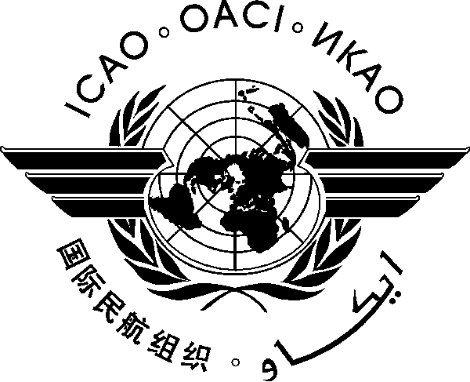
INTERNATIONAL CIVIL AVIATION ORGANIZATION
WESTERN AND CENTRAL AFRICA OFFICE
Twenty-fifth Meeting of the AFI Satellite Network Management Committee (SNMC/25)

(Freetown, Sierra Leone, 18-22 December 2017)

Registration Form

(Kindly fill and return to icaowacaf@icao.int with copy to amane@icao.intt and mathokenyanta@yahoo.fr )

First Name (in full) _____________________________________________________

Family Name (in full) _____________________________________________________

Title ______________________________________________________

State ______________________________________________________

Organization ______________________________________________________

Status Member/Observer__________________________________________________

Address ______________________________________________________

Telephone/Fax ______________________________________________________

E-Mail _____________________________________________________

Hotel in Abuja ______________________________________________________

