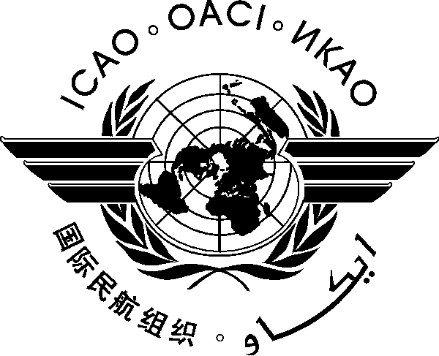
INTERNATIONAL CIVIL AVIATION ORGANIZATION
WESTERN AND CENTRAL AFRICA OFFICE
Twenty-second Meeting of the AFI Satellite Network Management Committee (SNMC/22)
(Lomé, Togo, 15-19 December 2014)

Registration Form

(Kindly fill and return to icaowacaf@icao.int with copy to fsalambanga@icao.int)

First Name (in full) _____________________________________________________

Family Name (in full)_____________________________________________________

Title ______________________________________________________

State ______________________________________________________

Organization ______________________________________________________

Status Member/Observer__________________________________________________

Address ______________________________________________________

Telephone/Fax ______________________________________________________

E-Mail _____________________________________________________

Hotel in Lomé ______________________________________________________

