ICAO Security Culture Customizable Resources – User Guide

This document lists the ICAO security culture customizable resources available for downloading and provides guidance on how to use them effectively to promote a positive security culture in your organization.

How to customize the resources?
A selection of these materials are intended to be customized, allowing you to add your organization’s name and logo to the documents. There is also the opportunity to add the contact details of your organization’s aviation security manager, so staff know who to speak to in the event of a security incident or if they wish to learn more about your organization’s security procedures.

Materials that display the ICAO logo should not be edited or customized, in whole or in part, in any form and by any organization, without the prior written permission of ICAO.

Customizing posters, wallet cards and other PDF documents
Open the PDF document using Adobe Acrobat DC. If you do not have access to Adobe Acrobat DC, please speak to your Communications/Marketing team, who should be able to assist you.

Adding customizable text to PDF documents
Once the file is open in Adobe Acrobat DC, click “Edit PDF”. Using the horizontal “Edit PDF” ribbon, users can customize the resources using the “add text” option. Draw a text box in the file designated for customization and add the information relevant for your organization. Once the resources have been updated, click “save as”. The document is now customized and ready for distribution.
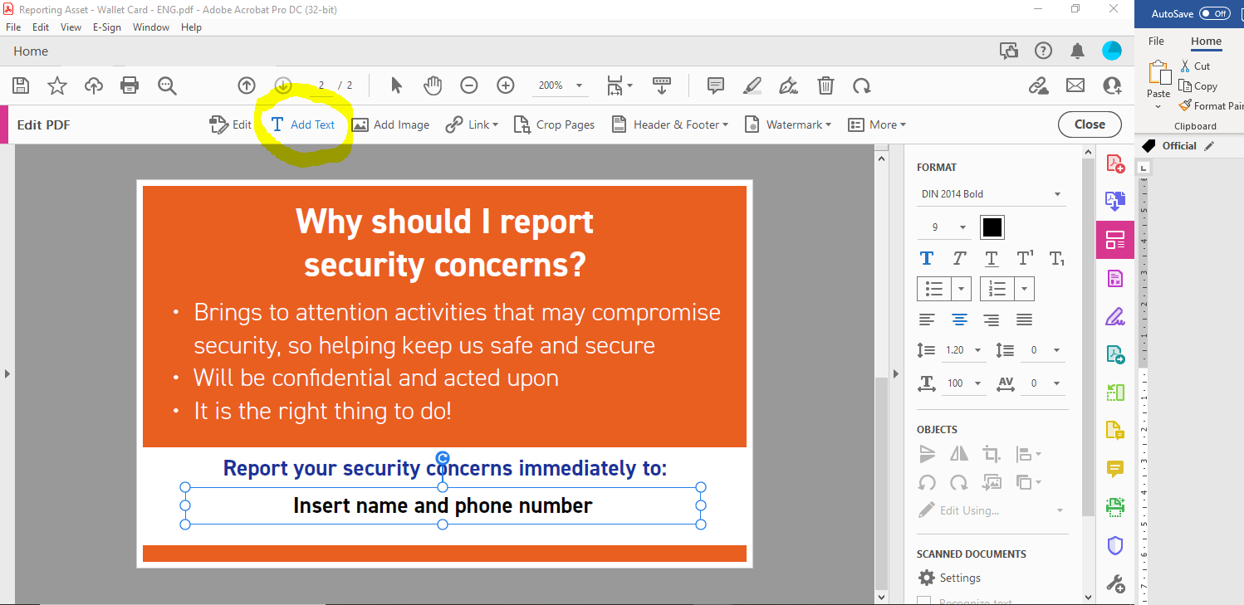

Adding customizable logos to PDF documents
Once the file is open in Adobe Acrobat DC, click “Edit PDF”. Using the horizontal “Edit PDF” ribbon, users can customize the resources using the “add image” option and select your organization logo from your files/network. Your organization logo should be placed over the “your logo here” placeholder in the top left-hand corner of the PDF. Once your logo has been imported to the file, resize it accordingly, and drag your logo using your mouse to the designated location. Once the resources have been updated with your logo, click “save as”. The document is now customized and ready for distribution.

Logos must only be added to files that show an “add logo here” icon. Materials that display the ICAO logo should not be edited or customized.

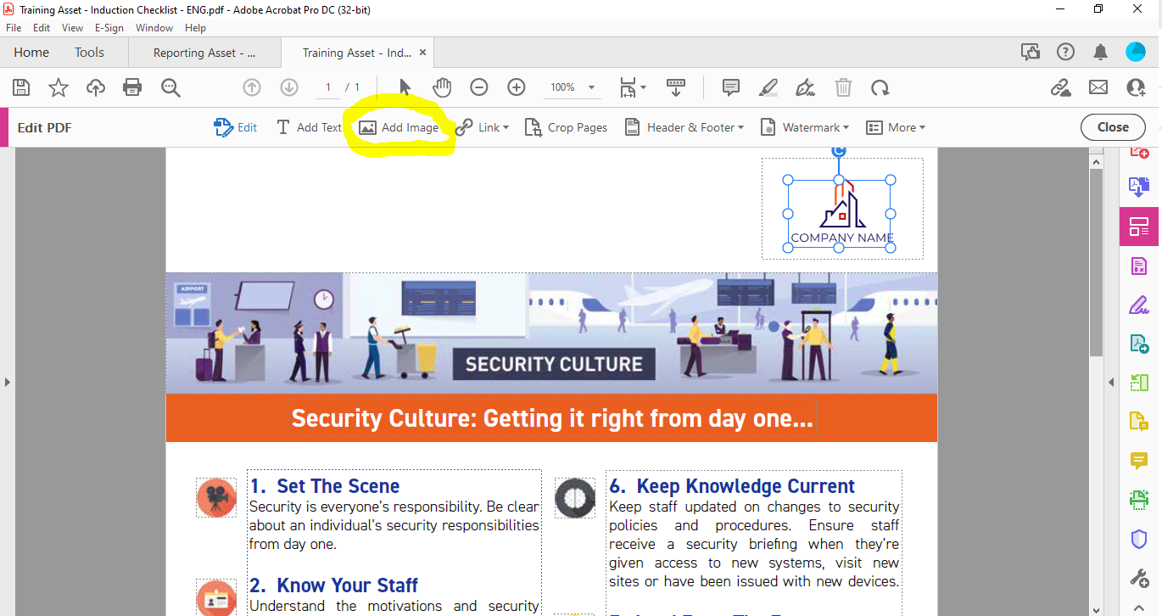

Customizing Microsoft resources
Several resources are supplied in Microsoft Word and PowerPoint format. There are several fields highlighted in yellow that can be customized for use in your organization.

Once the file is open in the relevant Microsoft Office program, please review and update the fields that require customizing. When you have updated all variable fields and are happy with the document, click “save as”. This document is now ready for dissemination.

What resources are available?
ICAO has developed a series of customizable resources that can be used in your organization to promote a positive security culture and to inform staff about the security behaviours expected of them.

The materials cover nine ‘security culture components’ and can be disseminated across a range of internal channels, including: back-office display posters, staff wallet cards, manager checklists, induction briefings, intranet blogs, CEO e-mail templates, and PowerPoint briefing packs.
# | Component | Resource | How to use it?
1 | Incident response | Checklist for management | Issue to management to check incident response plans are up to date and fit for purpose.
2 | Incident response | Wallet card | Issue to all staff and/or issue as part of the identification card issuance process. Provide contact details to report security incident on side 1.
3 | Incident response | Poster A | Put up in staff areas to remind staff of their role in a security incident.
4 | Information security | Poster A | Put up in staff areas to remind staff of their responsibility to protect information.
5 | Information security | Poster B | Put up in staff areas to remind staff of their responsibility to protect information.
6 | Leadership | Management declaration | Issue on the internal intranet to demonstrate leadership commitment to security. Organization logo can be added top left.
7 | Leadership | Article from CEO (or another senior leader) | Publish to demonstrate leadership commitment to security. This can be done after or independently from number 5 above. Organization logo can be added top left along with date of issue and organization name.
8 | Measures of effectiveness | Interview template | Use to measure the effectiveness of security culture efforts. This can be done prior to implementing an improvement (i.e., to see where efforts should be focused) or in follow up to a particular activity (i.e., to see if an improvement has been effective). The interview template can be issued anonymously or conducted in person.
9 | Positive work environment | Poster A | Put up in staff and public areas to support the creation of a positive work environment.
10 | Positive work environment | Poster B | Put up in staff and public areas to support the creation of a positive work environment.
11 | Positive work environment | Poster C | Put up in staff and public areas to support the creation of a positive work environment.
12 | Positive work environment | Security manager  e-mail | Send to all staff in conjunction with number 6 above. The e-mail should come from the security manager and should be issued after number 6 above. Organization logo can be added top right, CEO details can be added at paragraph one and the security manager signature can be added at the bottom.
13 | Reporting | Poster A | Put up in staff and public areas to remind everyone of the importance of reporting security concerns. Also share the poster with third-parties, suppliers, contractors and ancillary services.
14 | Reporting | Poster B | Put up in staff and public areas to remind everyone of the importance of reporting security concerns. Also share the poster with third-parties, suppliers, contractors and ancillary services.
15 | Reporting | Poster C | Put up in staff and public areas to remind everyone of the importance of reporting security concerns. Also share the poster with third-parties, suppliers, contractors and ancillary services.
16 | Reporting | Wallet card | Issue to remind staff of the importance of reporting security concerns. The wallet cards could also be issued during the collection of identification cards (airport passes) for new entrants. Organization-specific reporting details can be added at the bottom of side 2.
17 | Training | Briefing pack | Use to help train and educate all staff on security culture. The briefing pack could feature in induction/refresher security awareness training. Current threat assessment can be added at slide 7.
18 | Training | Induction checklist | Issue to managers of new entrants to help ensure security culture awareness is embedded from day one. Organization logo can be added top left and the security manager details can be added at the bottom.
19 | Understanding the threat | FAQs | Issue to security managers and supervisors to support their understanding of threats to civil aviation. Organization logo can be added top left.
20 | Understanding the treat | Flyer/pamphlet | Distribute to all staff to support their understanding of threats to civil aviation. Organization logo can be added top left and the security manager details can be added at the bottom.
21 | Vigilance | Poster A | Put up in staff areas to remind staff to be alert and vigilant and to highlight their responsibilities to report security concerns.
22 | Vigilance | Poster B | Put up in staff areas to remind staff to be alert and vigilant and to highlight their responsibilities to report security concerns.
23 | Vigilance | Poster D | Put up in staff areas to remind staff to be alert and vigilant and to highlight their responsibilities to report security concerns.
24 | Vigilance | Wallet card | Issue to all staff and/or issue as part of the identification card (airport pass) issuance process. Organization-specific reporting details can be added on side 2.

If you have any questions about these resources, please contact ICAO’s Implementation Support and Development - Security (ISD-SEC) team at isd@icao.int

