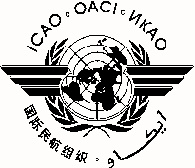 |  | CASC/7
 | International Civil Aviation Organization
 | North American, Central American and Caribbean Office (NACC)
 | Seventh Haiti Civil Aviation Steering Committee (CASC) Meeting
 | Port-au-Prince, Haiti, 5 August 2015

REGISTRATION FORM

1. | Name
2. | Position
3. | Organization
4. | Country
5. | Telephone
6. | E-mail

Please return this form to:
E-mail: icaonacc@icao.int /
Fax: + 52 55 5203 2757

