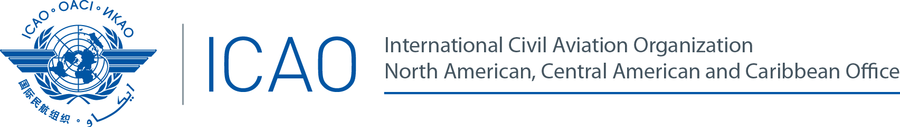

Sixth ICAO Collaborative Arrangement for the Prevention and Management of Public Health Events in Civil Aviation (CAPSCA) Americas Meeting
(CAPSCA/6)
Panama City, Panama, from 16 to 18 September de 2015

REGISTRATION FORM

1. | Position in your Delegation:  (Please select one option) | Chief Delegate |  |  |  |  |  |  | Delegate
 |  | Adviser |  |  |  |  |  |  | Observer
 |  | Speaker |  |  |  |  |  |  | Moderator
2. | Country / Organization
3. | Salutation |  | Mr. |  |  |  |  | Mrs. |  |  |  | Miss
4. | Name
5. | Official Position or Title
6. | Official Telephone
7. | Mobile (to contact you in case of an emergency)
8. | Official E-mail
9. | Hotel and address where you will be staying during the event
10. | Please indicate if accompanied by your family |  | Yes |  |  |  |  |  |  | #
11. | Dates of total stay in the venue Country
12. | Please indicate if you have any medical condition or allergies
13. | Emergency contact information in your country of origin |  | Name
 |  |  | Relationship
 |  |  | Telephone

Please send this form to:
E-mail: icaonacc@icao.int

