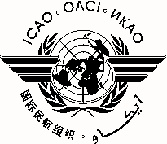 |  | MEVA/TMG/29
 | International Civil Aviation Organization
 | North American, Central American and Caribbean Office (NACC)
 | Twenty-ninth MEVA Technical Management Group Meeting
 | (MEVA/TMG/29)
 | Mexico City, Mexico 9 to 12 December 2014

REGISTRATION FORM

1. | Name
2. | Position
3. | Organization
4. | Country
5. | Telephone
6. | E-mail

Please send this form to:
E-mail: icaonacc@icao.int

