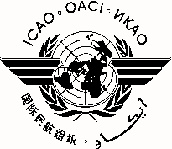
International Civil Aviation Organization
North American, Central American and Caribbean Office (NACC)
- ICAO International Aviation and Environmental Seminar, 1-2 April 2014
- ICAO State Action Plan Seminar, 3-4 April 2014
Mexico City, Mexico

I will attend:
ICAO International Aviation and Environmental Seminar  (1-2 April 2014) |  | ICAO State Action Plan Seminar  (3-4 April 2014)

REGISTRATION FORM

1. | Name
2. | Position
3. | Organization
4. | Country
5. | Telephone
6. | E-mail

Please send this form to:
E-mail: icaonacc@icao.int and env@icao.int

