To participate as an exhibitor at an ICAO Event, please complete pages 1-4.

- Confirmation: Confirmation of the exhibitor agreement will be guaranteed by return of this duly completed and signed agreement and payment of the total cost.

Company Name
Contact Person | Salutation Mr. Mrs. Ms. Dr.
First Name
Last Name
Title
Address
City |  | Province
Postal / Zip Code |  | Country
Tel No. |  | Fax No.
Email Address

- Renting an Exhibition Space
Indicate below the size of the exhibition space and the booth number which has been assigned to you via email from your event Product Manager. To see a list of exhibition services included with your rental, please see Appendix A. To view a list of the exhibition floor plan and booth space, please see Appendix B.

 | Exhibition Space | Dimensions in Feet | Dimensions in Metres | Selection | Booth Space Number (s) | Cost for Rental Only USD
 | Single | 6’ x 8’ (3 left) | 2 x 2.5 (3rd Floor) |  |  | $3,500
 | Single | 4’ x 6’ Sold Out | 1.3 x 2 |  |  | $7,200
 | Single | 4’ x 8’ (Sold Out) | 1.3 x 2.5 |  |  | $7,400
 | Single | 6’ x 8’ (3 left) | 2 x 2.5 |  |  | $7,400
 | Single | 8’ x 8’ (Sold Out) | 2.5 x 2.5 |  |  | $7,700
 | Single | 10’ x 10’ (Sold Out) | 3 x 3 |  |  | $8,100
 | Double | 6’ x 16’ (Sold Out) | 2 x 5 |  |  | $14,200
 | Double | 8’ x 16’ (Sold Out) | 2.5 x 5 |  |  | $14,700
 | Double | 10’ x 20’ (Sold Out) | 3 x 6 |  |  | $19,500
*All measurements are approximate.

Solutions workshop*  Speaking Slot Number  (see section #4 below for more details) | Select your  Number(s) | Day/Approximate Time | Fee in USD
1 (Sold Out) |  | Thursday, 09:00–09:20 | $5,600
2 (Sold Out) |  | Thursday, 09:20–09:40 | $5,600
3 (Sold Out) |  | Thursday, 09:40–10:00 | $5,600
4 (Sold Out) |  | Thursday, 10:00–10:20 | $5,600
5 (Sold Out) |  | Thursday, 10:20–10:40 | $5,600
6 (Sold Out) |  | Thursday, 11:15–11:35 | $5,600
7 (Sold Out) |  | Thursday, 11:35–11:55 | $5,600
8 (Sold Out) |  | Thursday, 11:55–12:15 | $5,600
*Must be a sponsor or an exhibitor. Times are subject to change.

Total Cost (Exhibition & Solutions Workshop)

- Exhibition Requirements

A company renting a 10×10 feet (3×3 metres) exhibition space or renting two adjoining exhibition space (any size) may:
- Contruct their own booth and display or
- Order a booth and accessories (furniture, lighting, facia, etc) through the company GES, the ICAO appointed official exhibition service provider.

If you are requesting one of these spaces, please indicate below if you intend to bring your own display that meets the specifications below.

Yes |  | We will bring our own display and accessories. Please see specifications below.
No |  | We will use the services of GES, the ICAO appointed official exhibition service provider.

Specifications:
- Display panels must not exceed 8 feet (2.5 metres) high
- Display panels must not extend more than 3 feet (1 metre) from the back wall.
- Any side dividers utilised in the display should not be more than 3 feet (1 metre) high.

A company renting a 4x6 feet (1.3 x 2 meters), 4x8 feet (1.3x2.5 metres), 6×8 feet (2×2.5 metres), or an 8×8 feet (2.5×2.5 metres) single exhibition space must order a booth and accessories (furniture, lighting, facia, etc.) through GES.
- Visibility Package
- One single sheet of printed promotional material (8” x 11.5” or A4) to be inserted into a pocket folder which will be distributed to each visitor during the event;
- A listing in the program directory displaying Company name, corporate logo, contact name, email, company url and a 100 word description of company, product or services;
- A directory listing in the TRIP partnership community website;
- Excerpts from up to three press releases issued by the exhibitor will be published in the corporate news section of the TRIP partnership community website, and;
- A free business card advertisement in the Fall symposium issue of the TRIP Report.

5. Solutions Workshop Speaking Slot*
Solutions-oriented 15-minute presentations, with five-minute question and answer periods if required, to be held prior to the opening of the Symposium. The table above (page 2) shows the current availability status of the speaking slots.

Fees - Solutions Workshop Speaking Slot*
The fee for this privilege is USD 5,600.

Making a Booking
Sponsorships and Solutions Workshop speaking slots will be allocated on a first-come, first-served basis.

See the table above for the availability of a Solutions Workshop speaking slot and then complete the relevant section of this Sponsor Booking Form. (See Section 2 - Renting an Exhibition Space)

- Program Directory
A logo, description of your company’s products/services and contact information will be included in the Symposium Directory. Please complete this form and email to Mrs. Caroline Casabon, ccasabon@icao.int.

Corporate Logo
Please send us via email your company corporate logo. The resolution must be at least 300 dpi in one of the following formats:
(1) .jpg;
(2) .tif;
(3) .bmp;
(4) .eps.

Contact Information and Description
Please complete the table below. All the fields are mandatory and the company description, products or services cannot exceed more the 100 words.

Company Name
Salutation | Mr. Mrs. Ms. Dr.
First Name
Last Name
Email Address
Website Address
Company Description
Max 100 words

- Invoicing and Payment
Upon receipt of the duly completed Sponsorship Agreement, ICAO will remit an invoice for the symposium sponsorship fee; which will be sent by e-mail in a pdf format and the original will be mailed to the sponsor/exhibitor.

Please select one of the following payments below. We prefer payment by credit card.

 | Bank Transfer |  | Cheque
 | American Express |  | Master Card |  | Visa

For payment with major credit cards, please provide your credit card details below.

Card Number |  | Expiry Date
Card Holder Number
Signature

Requirements for payment: payments must be made prior to the event and will be due upon receipt of the invoice. Methods of payment are: cheque, bank transfer or major credit card listed above. If payment is not received within fourteen (14) days, ICAO may not guarantee the customer’s first choice for the booth number or the sponsorship slot.

- Promotional Material Policy
Exhibitors are prohibited from placing flyers, pamphlets, brochures and other promotional items (i.e. Pens, USB sticks, mugs, memo pads, etc.) on tables or stands other than their own. These tables or stands are reserved for ICAO. Exhibitors may use their assigned tables to display their collateral materials.

Promotional materials must not promote military applications or make reference to the Republic of Taiwan.

8. Transportation and Customs clearance
ICAO will not be responsible for any transportation and customs clearance fees of the exhibition material.

Please, ensure that box 5 (Purchase’s name and address) of the Canada customs clearance form is completed by your company of shipping/transportation.

To view the Canada customs invoice form : http://www.cbsa-asfc.gc.ca/publications/forms-formulaires/ci1.pdf.

9. Cancellation Policy
This Exhibitor Agreement may be cancelled by the Agreement signatory, with no penalty, within seven calendar days of receiving the confirmation receipt of the Agreement from ICAO. If the request for cancellation is received by ICAO later than seven, but within 15 calendar days of receiving the confirmation, the exhibitor must pay, as a penalty charge, 25% of the applicable fee. Cancellations made after this 15-day period will be subject to a penalty charge of 50% of the fee. If the cancellation is, however, made during the 14 calendar days prior to the opening date of the event, the penalty will be 100% of the fee.

10. Acceptance
The undersigned hereby certifies that the terms and conditions set forth in this exhibitor agreement to exhibit at the
TRIP 12th Symposium ICAO Headquarters, 15 – 17 November 2016.

Signature: _______________________________________________ Date:

11. Return the Agreement
Confirmation of the allocated exhibition spaces(s) will be guaranteed by return of this duly completed and signed exhibitor agreement and payment of the fee. Please return the agreement by email (scan or pdf format) to Mrs. Caroline Casabon, ccasabon@icao.int.

Appendix A: Exhibitor Services
Services | Included | Not Included | Comments
At ICAO
Carpeting the Symposium exhibition space(s) | ✓ |  | Exhibition areas are carpeted. The ICAO building is air conditioned.
Electricity supply (one outlet per single space) with an extension cable and a multi-socket power bar | ✓ |  | 110V for a maximum of 15 ampere.
Unlimited wireless Internet connection | ✓
24-hour security of public areas | ✓ |  | Special security measures will be in place. ICAO is not, however, responsible for any loss or damage of property in the exhibition areas.
Exhibitor’s logo, contact, URL and description of the company’s products/services in the program directory | ✓
Free delegate or exhibitor passes and folder or delegate bag | ✓ |  | Two free pass each single Symposium exhibition space. Four free pass for double booth exhibition space.
Invitation to sponsored, coffee breaks, lunches and cocktail receptions | ✓ |  | For Symposium exhibitors holding delegate or exhibitor passes.
Daily cleaning of public areas | ✓
Official Service Providers Appointed by ICAO
Materials handling, advance warehouse storage, rental of extra furniture, chairs, tables, graphic banners, electrical accessories, transformers |  | ✓ | Should be arranged through the ICAO appointed official exhibition services provider.
Transportation and customs services |  | ✓ | Should be arranged through the ICAO appointed official customs broker.
Audio visual equipment, laptops, TV, DVD players, |  | ✓ | Should be arranged through the ICAO appointed official audio visual supplier.
Exhibition Booth Construction
Exhibition booth that are 4’x6’, 4’x8’,6’x8’ or 8’x8’ |  | ✓ | Must use the services of GES (Official service provider) to construct the Booth and provide basic setup
Exhibition booth that are 10’x10’ or any double booth space |  | ✓ | May construct their own booth or use the services of GES

Appendix B: Exhibition Floor Plan – 4th floor

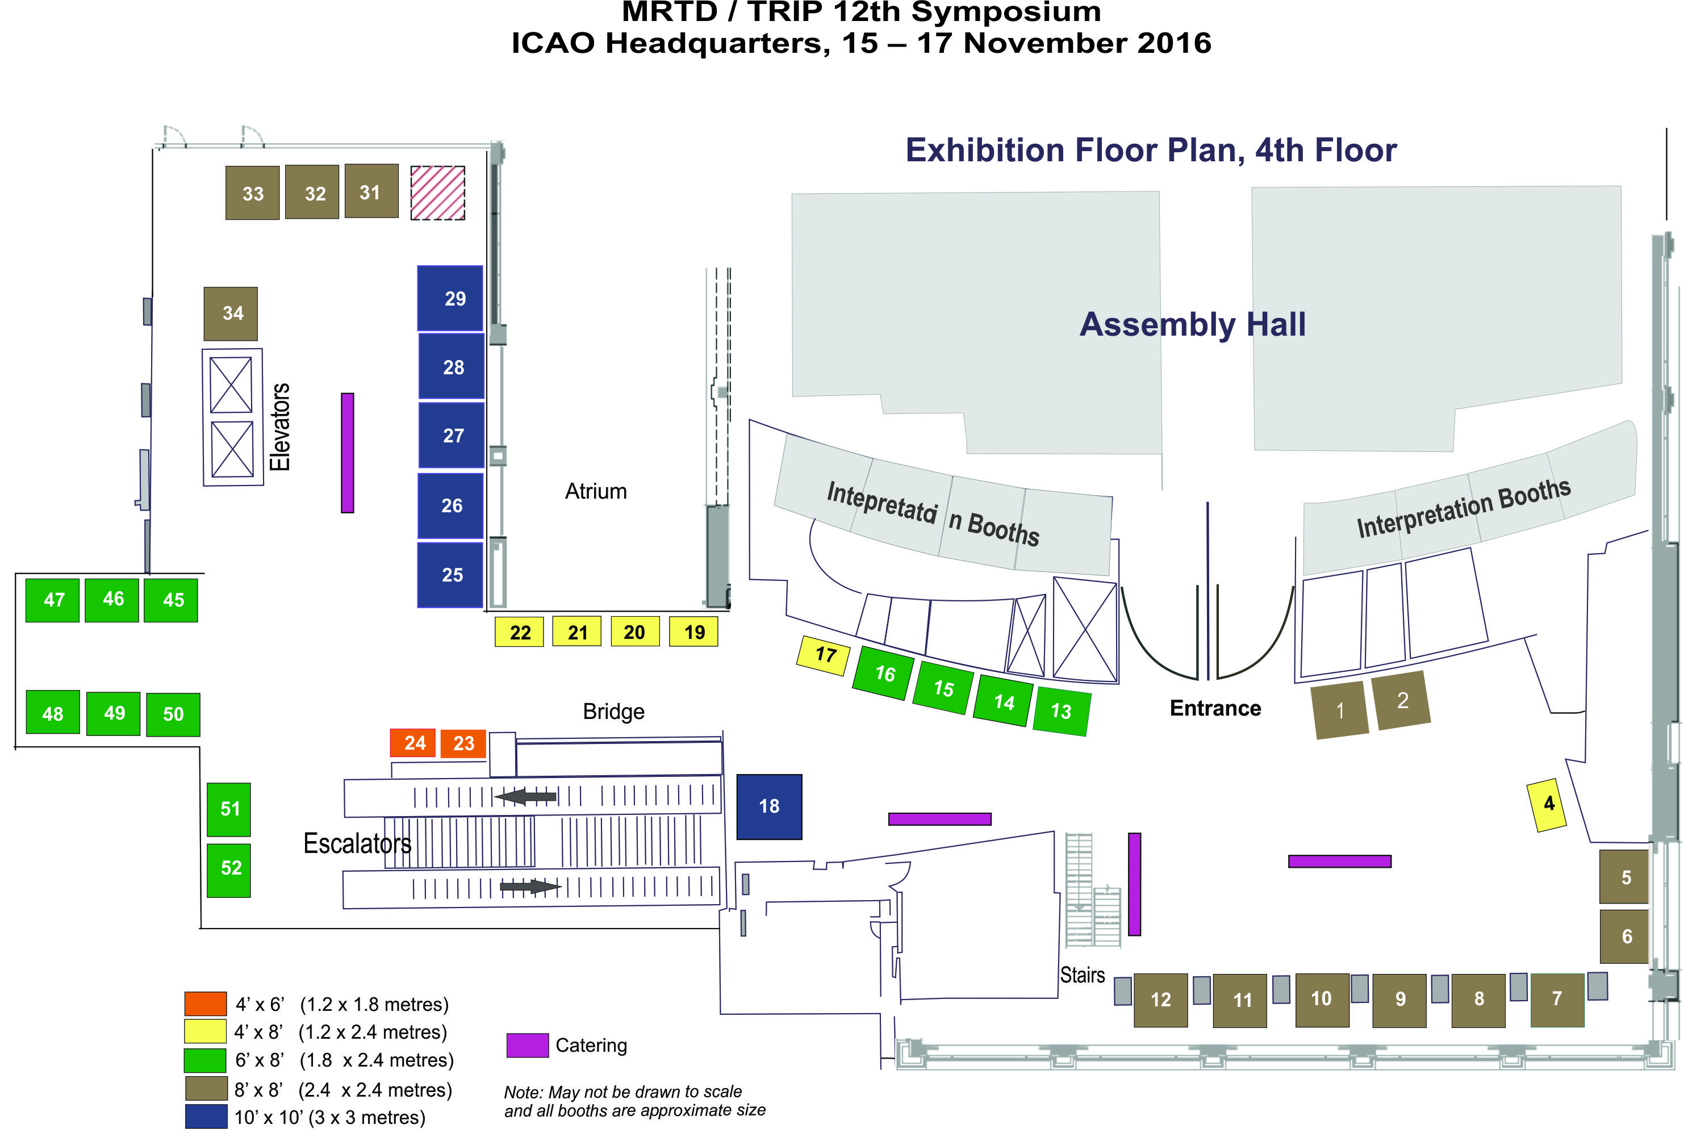

Appendix B: Exhibition Floor Plan – 3rd floor

