To participate as an exhibitor at an ICAO Event, please complete pages 1-3

- Confirmation: Confirmation of the exhibitor agreement will be guaranteed by return of this duly completed and signed agreement and payment of the total cost.

Company Name
Contact Person | Salutation Mr. Mrs. Ms. Dr.
First Name
Last Name
Title
Address
City |  | Province
Postal / Zip Code |  | Country
Tel No. |  | Fax No.
Email Address

- Booking an Exhibition Space

Indicate below the size of the exhibition space and the booth number which has been assigned to you via email from your event Product Manager.

To see a list of exhibition services by provided by ICAO, please see Appendix A.
To view a list of the exhibition floor plan and booth space, please see Appendix B.

 | Booth No | Dimensions in Feet | Dimensions in Metres | Selection | Booth Space Number (s) | Cost  USD
 | 1,2,3 | 10’ × 10’ | 2.5 x 2.5 |  |  | $7,900
 | 4 - 16 | 6’ × 8’ | 1.8 x 2.4 |  |  | $7,500
 | 17 - 23 | 4’ × 6’ | 1.2 x 2.4 |  |  | $5,500
 | 24 - 28 | 10’ × 10’ | 2.5 x 2.5 |  |  | $6,500

15% discount for organizations that are a member in one of the following association.
Please check the appropriate box.

Member of UVS International
Member of AUVSI

Promotion Material Distribution | Cost
Confirmation has been received from ICAO for one single sheet of printed promotional material ( 8.5” x 11” or A4 ) to be inserted into the delegate bag. | $1,500

Total Cost (Exhibitor Booth & Promotion Material)

- Exhibition Requirements

A company renting a 10×10 feet (3×3 metres) exhibition space or renting two adjoining exhibition space (any size) may bring their own display OR order a booth and accessories (furniture, lighting, facia, etc) through the ICAO appointed official exhibition service provider.

If you are requesting one of these spaces, please indicate below if you intend to bring your own display that meets the specifications below.
Yes |  | We will bring our own display and accessories.
No |  | We will use the ICAO appointed official exhibition service provider.

Specifications:
- Display panels must not exceed 8 feet (2.5 metres) high
- Display panels must not extend more than 3 feet (1 metre) from the back wall.
- Any side dividers utilised in the display should not be more than 3 feet (1 metre) high.

A company renting a 6×8 feet (2×2.5 metres) or an 8×8 feet (2.5×2.5 metres) single exhibition space must order a booth and accessories (furniture, lighting, facia, etc.) through the ICAO appointed official exhibition service provider.

- Program Directory
A logo, description of your company’s products/services and contact information will be included in the Symposium Directory. Please complete this form and email to Mr. Harvey Wong, hwong@icao.int

Corporate Logo
Please send us via email your company corporate logo. The resolution must be at least 300 dpi in one of the following formats:
(1) .jpg;
(2) .tif; or
(3) .bmp
(4) .eps

Contact Information and Description
Please complete the table below. All the fields are mandatory and the company description, products or services cannot exceed more the 100 words.

Company Name
Salutation | Mr. Mrs. Ms. Dr.
First Name
Last Name
Email Address
Website Address
Company Description
Max 100 words

- Invoicing and Payment
Following receipt of the duly completed Exhibitor Agreement, ICAO will prepare an invoice for the Symposium exhibition fee.
A copy of the invoice will be sent by e-mail in a pdf format and the original will be posted to the sponsor/exhibitor.
Payment will be due within 14 days of receipt of the invoice and can be made by bank transfer, cheque or credit card as indicated below. Please select one of the following payments below. We prefer payment by credit card.

 | Bank Transfer |  | Cheque
 | American Express |  | Master Card |  | Visa

For payment with major credit cards, please provide your credit card details below.

Card Number |  | Expiry Date
Card Holder Number
Signature

- Promotional Material
Exhibitors are prohibited from placing flyers, pamphlets, brochures and other promotional items on tables or stands other than their own. Promotional materials must not promote military applications or make reference to the Republic of Taiwan.

ICAO Conference Print Services
ICAO now offers exhibitors and sponsors a complete support program, which includes document printing, display and poster printing as well as our rapid turnaround print on demand services. To learn more, please refer to page 4.

- Cancellation Policy
This Exhibitor Agreement may be cancelled by the Agreement signatory, with no penalty, within seven calendar days of receiving the confirmation receipt of the Agreement from ICAO. If the request for cancellation is received by ICAO later than seven, but within 15 calendar days of receiving the confirmation, the exhibitor must pay, as a penalty charge, 25% of the applicable fee. Cancellations made after this 15-day period will be subject to a penalty charge of 50% of the fee. If the cancellation is, however, made during the 14 calendar days prior to the opening date of the event, the penalty will be 100% of the fee.

- Acceptance
The undersigned hereby certifies that the information set forth in this exhibitor agreement is accurate and agrees with the above cancellation policy and promotional material policy.

Signature: _______________________________________________ Date:

- Return the Agreement
Confirmation of the allocated exhibition spaces(s) will be guaranteed by return of this duly completed and signed exhibitor agreement and payment of the fee.
Please return the agreement by email (scan or pdf format) to Harvey Wong, hwong@icao.int

ICAO Conference Print Services

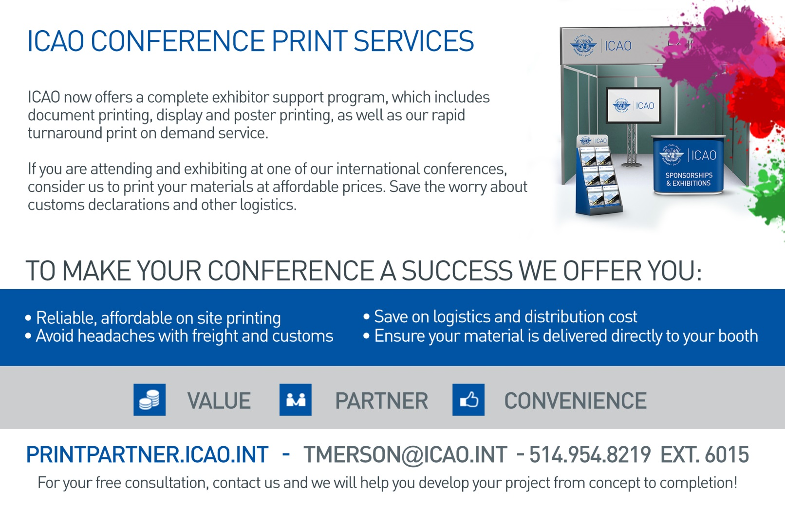

Services | Included | Not Included | Comments
Exhibition Booth Construction
Exhibition booth that are 6’x8’ or 8’x8’ |  | ✓ | Must use the services of GES (Official service provider) to construct the Booth and provide basic setup
Exhibition booth that are 10’x10’ or any double booth space |  | ✓ | May construct their own booth or use the services of GES
At ICAO
Carpeting the Symposium exhibition space(s) | ✓ |  | Exhibition areas are carpeted. The ICAO building is air conditioned.
Electricity supply (one outlet per single space) with an extension cable and a multi-socket power bar | ✓ |  | 110V for a maximum of 15 ampere.
Unlimited wireless Internet connection | ✓
24-hour security | ✓ |  | Special security measures will be in place. ICAO is not, however, responsible for any loss or damage of property in the exhibition areas.
Exhibitor’s logo, contact, url and description of the company’s products/services in the program directory | ✓
Free exhibitor pass and Symposium bag | ✓ |  | Two free pass each single Symposium exhibition space. Four free pass for double booth exhibition space.
Invitation to sponsored, coffee breaks, lunches and cocktail receptions | ✓ |  | For Symposium exhibitors holding delegate or exhibitor passes.
Daily cleaning of public areas | ✓
Official Service Providers Appointed by ICAO
Materials handling, advance warehouse storage, rental of extra furniture, chairs, tables, graphic banners, electrical accessories, transformers |  | ✓ | Should be arranged through the ICAO appointed official exhibition services provider.
Transportation and customs services |  | ✓ | Should be arranged through the ICAO appointed official customs broker.
Audio visual equipment, laptops, TV, DVD players, |  | ✓ | Should be arranged through the ICAO appointed official audio visual supplier.

Appendix A: Exhibitor Services

Appendix B: Exhibition Floor Plan

