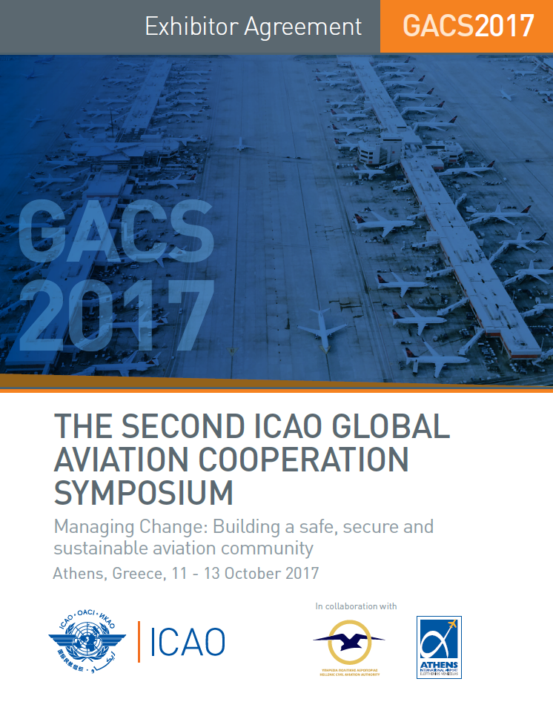

To exhibit at this event, please return pages 1-3
COMPANY INFORMATION
Company Name
Salutation
First Name |  | Last Name
Address
City |  | Province/State
Postal/Zip Code |  | Country
Telephone No. |  | Email Address

RENTING EXHIBITION SPACE
Floor Plan TBD
Exhibition  Space | Booth No | Dimensions  Metres | Selection | Indicate Booth Space No. | Cost for Rental Only - USD
Single | 1 - 10 | 3 x 3 |  |  | $4,500

EXHIBITION REQUIREMENTS
Please indicate below if you intend to bring / construct your own booth or use the services of the official supplier:
We will use the services of the ICAO appointed official exhibition service provider.
We will bring our own display and accessories. Please see specifications and Building Restrictions below.

Specifications

- Display panels must not exceed 8 feet (2.5 metres) high;
- Display panels must not extend more than 3 feet (1 metre) from the back wall;
- Any side dividers utilised in the display should not be more than 3 feet (1 metre) high.

Note: ICAO reserves the right to change the floor plan and/or booth configuration without notice, in order to
comply with fire, safety and accessibility regulations.

OTHER PROMOTIONS
These special promotions are only available for exhibitors or sponsors.
Select | Additional Promotions | Cost USD
 | Delegate Bag – Corporate logo and name of the Symposium. | $8,500
 | Lanyard - Corporate logo and name of the Symposium. | $7,000
 | One insert: One page pamphlet or flyer. | $2,000
 | USB Key – Corporate logo. | $7,500

PAYMENT OPTIONS

Payments must be made prior to the event and will be due 14 days upon receipt of the invoice.
Methods of payment are: cheque, bank transfer or major credit card.

If payment is not received within fourteen (14) days upon receipt of the invoice, ICAO may not guarantee the customer’s first choice for the booth number and/or the sponsorship slot.

Please select one of the following payment options: We prefer payment by credit card

 | Option 1 By cheque: Cheque should be payable to ICAO and mailed to
International Civil Aviation Organization
CP 11342
Succursale Centre-Ville
Montréal, Quebec, Canada, H3C 5H1

 | Option 2 By Bank Transfer: Bank Transfer Information
 | Pay to:  Bank Code  Transit Code  Swift code  For Credit to | Royal Bank of Canada  St. Catherine & Stanley Branch  Montréal, Quebec, H3B 1H7, Canada  003  05101  ROYCCAT2  400-416-4
 | Option 3 Visa MasterCard Amex
 | Card Number |  |  | Expiry Date
 | Card Holder Name |  |  | Validate Code
 | Signature
 | ICAO is committed in keeping your provided financial information safe and secure.

PROMOTIONAL MATERIAL
Exhibitors and sponsors are prohibited from placing flyers, pamphlets, brochures and other promotional items (i.e. pens, USB sticks, mugs, memo pads, etc.) on tables or stands other than their own. These tables or stands are reserved for ICAO. Exhibitors may use their assigned tables to display their collateral materials.

Promotional materials must not promote military applications or make reference to the Republic of Taiwan.

PAYMENT

Total Cost USD

Payments must be made prior to the event and will be due 14 days upon receipt of the invoice.
If payment is not received within fourteen (14) days, ICAO may not guarantee the customer’s
choice for the booth number or the sponsorship slot.

CANCELLATION POLICY

This agreement may be cancelled by the Agreement signatory. Cancellation request must be sent by email to your project manager and is subject to the penalty in the table below.

 | If the cancellation request is: | Penalty for cancellation
 | More than 29 days before the event | 0 % - Full refund
 | Between 22 to 28 days before the opening of the event | 25% charge
 | Between 14 to 21 days before the opening day of the event | 50% charge
 | Less than 14 days before the opening day of the event | No refund – 100% charge

RETURN THE AGREEMENT
Please return all the necessary pages and this signed agreement form via email to your project manager or to mcr@icao.int

ACCEPTANCE
The undersigned hereby certifies and agrees to the terms and conditions set forth in this agreement.

Signature: ______________________________________________ Date:

EXHIBITION SERVICES
Services Provided by the Hotel | Included | Not Included | Comments
Carpeting the Symposium exhibition space(s) | ✓ |  | Exhibition areas are carpeted.  The hotel is air conditioned.
Electricity supply (one outlet per single space) with an extension cable and a multi-socket power bar | ✓
Unlimited wireless Internet connection | ✓
Security and safety at the premise.  Security at registration, exhibition area, main hall and catering station. | ✓ |  | Special security measures will be in place.  ICAO is not, however, responsible for any loss or damage of property in the exhibition areas.  Exhibitors are responsible for safeguarding their goods, materials and equipment at all times.
Free delegate or exhibitor passes and folder or delegate bag | ✓ |  | Two free passes for each single Symposium exhibition space.
Invitation to sponsored, coffee breaks, lunches and cocktail receptions | ✓ |  | For Symposium exhibitors holding delegate or exhibitor passes.
Daily cleaning of public areas | ✓
Services offered by the Event Supplier
Materials handling, advance warehouse storage, rental of extra furniture, chairs, tables, graphic banners, electrical accessories, transformers, etc |  | ✓ | Should be arranged through the event supplier.
Audio visual equipment, laptops, TV, DVD players |  | ✓ | Should be arranged through the event supplier for audio and video equipment.
Exhibition booth construction |  | ✓ | Exhibitors may construct their own booth or use the services of the event supplier.

EVENT SUPPLIER
INTERFORMA
Contact: Sevi Portokalidou
Email: sportokalidou@interforma.gr
Mobile: +30 6948 727
Website: www.interforma.de

