Asia Pacific Common Regional Virtual Private Network (CRV)
- What is CRV?
CRV is a cross-border, cost-effective, and dedicated communication network for States provided by a common network service provider, PCCW Global limited, after a selection process.
It enables or facilitates a number of ASBU modules, including B1-SWIM, B1-FICE, B1-DATM, B1-NOPS and B1-AMET, and solves current limitations (obsolescence, lack of standardization, poor escalation processes) and aeronautical communication deficiencies.
The APANPIRG CRV Operations Group oversees the implementation, holding regular meetings and webconferences.
A common contractual package was designed as a sound basis for national contracts, but allows also some flexibility to cope with a number of local factors: national laws, local loop providers, etc.
- When?
The first implementation has started and is scheduled for completion end 2017/early 2018 with four States involved: Australia, Fiji, New Zealand and the United States.
The target of implementation for all Asia Pacific States is around 2020, starting with High Density FIR.
- Elsewhere?
The European region has implemented the Pan-European Network Service (PENS).
North American region has FAA Telecommunication Infrastructure (FTI) to support Canada and USA to distribute AFS data.
South America has REDDIG and Caribbean has MEVA.
The Middle East Region considers using CRV framework for their own MID IP network.

- Different connectivity packages can be chosen by CRV users depending on the requirements:
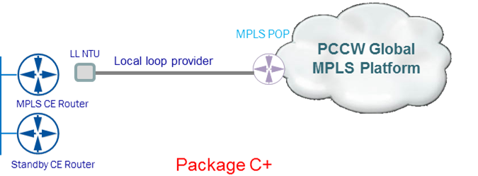
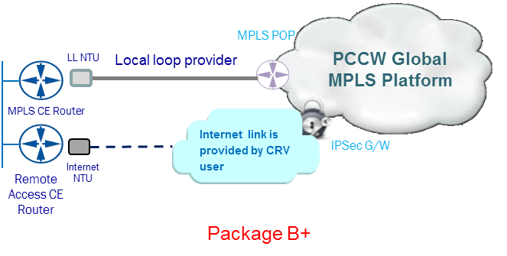
7

