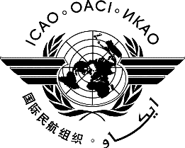 | International Civil Aviation Organization  WORKING PAPER | LC/39-WP/  --/--/24

LEGAL COMMITTEE – 39TH SESSION
(Montréal, 25 – 28 June 2024)

Agenda Item : | xxxxxxxxxxx

TITLE

(Presented by )

- INTRODUCTION
  - XXX
- XXX
  - XXX Conventions – Rules of Procedure).
  - XXX
- XXX
  - XXX

— END
Please submit your working paper(s) to Officeleb@icao.int

