FREQUENCY SPECTRUM MANGEMENT PANEL (FSMP)

Fourth Working Group meeting

Bangkok, Thailand, 29 March – 7 April 2017

Agenda Item 5: Development of (planned) material for ITU-R Studies

Liaison Statement from ITU-R WP5B, titled:
QUESTIONS ABOUT THE SYSTEMS TO BE USED,
AND THE SPECTRUM REQUIREMENTS,
OF GADSS

Presented by the Secretary

SUMMARY and ACTION
The attached liaison statement, relevant to the development of material for WRC-19 Agenda Item 1.10 (Global Aeronautical Distress and Safety System or GADSS), was received from ITU-R WP5B.
(the attached was also circulated to FSMP members by email on 19 Dec 2016)

Action: FSMP WG/4 is invited to review the attached and take action as appropriate.

 | Radiocommunication Study Groups |  | 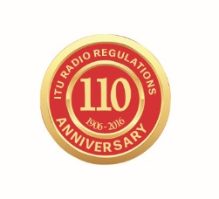
INTERNATIONAL TELECOMMUNICATION UNION
Source: Document 5B/TEMP/62
 |  | 16 December 2016
 |  | English only
Working Party 5B
Liaison statement TO ICAO
(Copied for Information to ITU-R Working PartY 5D)
QUESTIONS ABOUT THE SYSTEMS TO BE USED, AND THE SPECTRUM REQUIREMENTS, OF GADSS

ITU-R Working Party (WP) 5B wishes to inform the International Civil Aviation Organization (ICAO) that it has not begun drafting CPM text, however it has initiated a working document towards a preliminary draft new report in support of WRC-19 agenda item 1.10, with some initial material regarding the global aeronautical distress and safety system (GADSS). The working document towards a preliminary draft new Report ITU-R M.[GADSS] (as attached) provides an initial outline of proposed report text, taking into account that the GADSS is still under development within ICAO. The material is primarily addressing quantification and characterization of radiocommunication requirements related to GADSS.
WP 5B would note that currently only one document (5В/783) has been provided to the ITU-R on this topic. It contains some elements of the draft concept of operations (ConOps) for the GADSS version 4.4. In Section 1.2 “Scope of the Concept of Operations” it is noted that: “The ConOps does not prescribe specific technical solutions for Aircraft tracking but provides a framework of scenarios that can be used to verify whether a specific solution complies with the Concept. The ConOps includes a roadmap outlining the steps necessary to move from today’s system to the target concept.”
ICAO has published updates to GADSS ConOps, however those also do not have any description of specific technical solutions that can be used for the GADSS agenda item. As a result, there is a lack of information to conduct the studies on WRC-19 AI 1.10.
In order for WP 5B to start the studies on WRC-19 agenda item 1.10 and facilitate ICAO to choose the potential frequency bands and technical solutions which allow to implement the Concept of operations for the GADSS, WP 5B requests from ICAO the following generic information about GADSS:

Does ICAO plan to use new systems for implementation of the ConOps for the GADSS? If so:
1) Will these systems operate in the frequency bands having been already allocated to the aeronautical services, or are new frequency bands required for their operation?
2) What are the assumed operational characteristics and performance requirements of such systems that will be used for implementation of the ConOps for the GADSS?
WP 5B will be grateful to ICAO for the information on the above mentioned issues and for any other information on WRC-19 agenda item 1.10 that ICAO considers necessary to submit to WP 5B. WP 5B will provide additional updates as the material progresses, including the expected timelines for the report and WRC-19 CPM text.

Status: For action
Deadline: 1 May 2017
Contact person: Loftur Jonasson Email: ljonasson@icao.int

Attachment: 1

ATTACHMENT
Working Document Towards a Preliminary Draft New
Report ITU-R M.[GADSS]
The global aeronautical distress and safety system (GADSS)
[Editor’s note: Except where highlighted, text is paraphrased from ICAO GADSS CONOPS Version 5.5, or the ITU-T Focus Group on Aviation Applications of Cloud Computing for Flight Data Monitoring (Deliverable 4 - Avionics and Aviation Communications Systems - Rev.1)]
Scope
TBD
Keywords
TBD
Glossary of abbreviations
ADS-B - Automatic Dependent Surveillance – Broadcast
ATTF - Aircraft Tracking Task Force
ConOps - Concept of Operations
GADSS - Global Aeronautical Distress and Safety System
GFT - Global Flight Tracking
ICAO - International Civil Aviation Organization
TTFD - Triggered Transmission of Flight Data

1 Background
The International Civil Aviation Organization (ICAO) held a Special Meeting on Global Flight Tracking (GFT) of Aircraft in Montreal May 2014, and formed two groups to address the near-term priority to track airline flights, no matter their global location or destination. Those groups were an ICAO ad hoc Working Group to develop a concept of operations (ConOps) to support future development of a Global Aeronautical Distress and Safety System (GADSS) and an industry led group under the ICAO framework called the Aircraft Tracking Task Force (ATTF) to identify near term capabilities for normal flight tracking using existing technologies. In combination, those efforts will address issues such as:
– Aircraft tracking under normal and abnormal conditions
– Autonomous distress tracking
– Automatic deployable flight recorder
– Procedures and information management
Close collaboration will ensure ATTF solutions fit within the GADSS ConOps.

The collective urgency of the situation was highlighted by the decision of the International Telecommunication Union (ITU) Plenipotentiary Conference, through Resolution 185, to instruct WRC‐15, pursuant to No. 119 of the ITU Convention, to include in its agenda, as a matter of urgency, the consideration of global flight tracking, including, if appropriate, and consistent with ITU practices, various aspects of the matter, taking into account ITU‐R studies.

2 Discussion
2.1 ICAO Discussion
The effectiveness of the current alerting of search and rescue services should be increased by addressing a number of key improvement areas, and by developing and implementing a globally integrated system, the GADSS, which addresses all phases of flight under all circumstances including distress. This system will maintain an up-to-date record of the aircraft progress and, in case of a forced landing or ditching, the location of survivors, the aircraft and recoverable flight data.
Though specific elements of GADSS are still being defined, Figure 1 below gives a high level overview and identifies the main functions:
– Aircraft Tracking
– Autonomous Distress Tracking
– Flight Recorder Data Recovery
– GADSS Procedures and Information Management
Figure 1
Main functions of GADSS
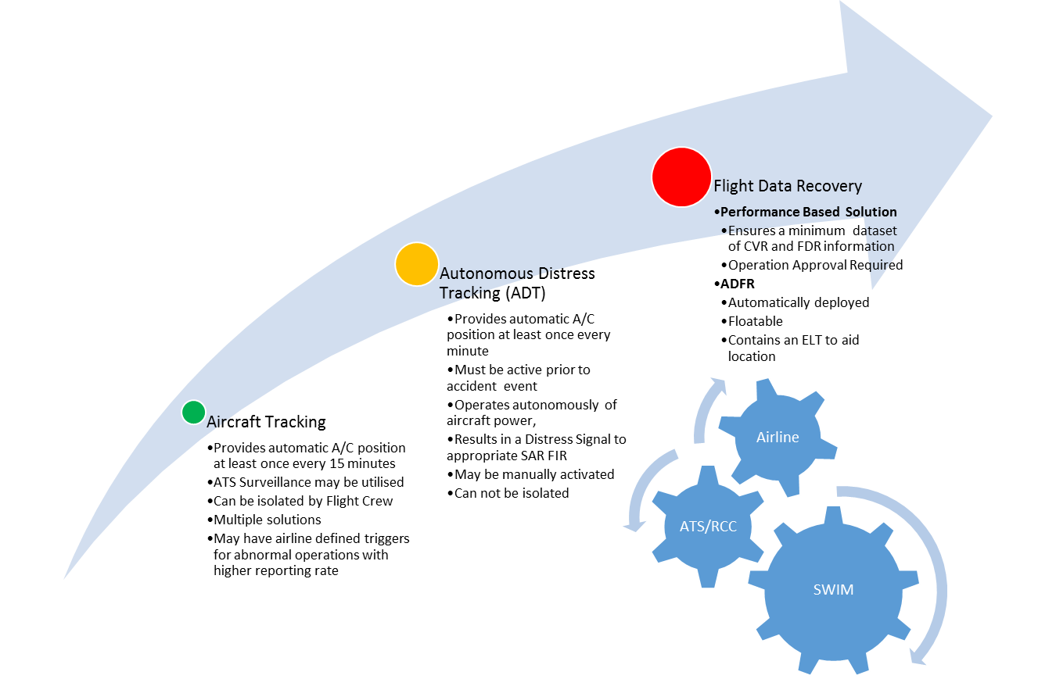

As mentioned, ICAO is developing a GADSS ConOps on the sequence of events before and after the occurrence of an accident which should include all identified phases of such a sequence including:
– detection of an abnormal situation,
– alert phase,
– distress phase, and
– search and rescue activities
The full GADSS concept can be realized in an evolutionary manner through the execution of actions in the short, medium and long term with each action resulting in benefits. While the concept is still under development, at a high-level implementation of the GADSS ConOps should:
– Ensure the position of the aircraft is continuously known
– Improve search and rescue (SAR) capabilities and improve timely availability of aircraft position data
– Ensure the timely identification of the location of the accident site
– Function worldwide
– Expedite retrieval of flight recorder data
– Be seamless across air traffic services unit boundaries
– Ensure the sharing of relevant information in support of emergency situations
– Ensure relevant stakeholders are contactable when required
– Ensure clarity of responsibilities for inflight emergency response
– TBD …
Furthermore, in implementing the GADSS it shall be ensured that GADSS functions:
– are specified using performance based provisions when possible and independent of any one prescriptive technology
– are sufficiently flexible to accommodate diverse regional needs
– do not cause degradation of the existing SAR service
– are resilient to any on-board technical failures
– ensure there is a minimal or positive impact on Flight Crew workload
– provide adequate redundancy in the systems utilized
– TBD…
2.2 ITU-T TSAG Work
It should be noted that TSAG studies have recommended that solutions enabling Triggered Transmission of Flight Data (TTFD) be employed for aircraft used on Extended Overwater Operations (EOO). In particular, the United States’ National Transportation Safety Board proposed that “(flight) data should be captured (and transmitted) from a triggering event until the end of the flight and for as long as a time period before the triggering event as possible.” This approach to TTFD introduces a higher bandwidth requirement for an aircraft in distress as there may only be a short time period to send the required data. However, with a low number of distress situations the global bandwidth needs will be a fraction of that that would be required to accommodate continuous routine real-time data streaming.

3 ITU actions
As noted above, development of GADSS and the GADSS ConOps are the purview of ICAO, hence it is important that there not be conflicting information in ITU and ICAO documents such that there is the appearance of distinct “ICAO GADSS” and “ITU GADSS”. ITU has recognized the importance of the effort however, and included an agenda item for WRC-19 to “consider spectrum needs and regulatory provisions for the introduction and use of the Global Aeronautical Distress and Safety System (GADSS) in accordance with Resolution 426 (WRC-15)” (see Annex 1).
Concepts for flight data recovery should take into account Articles 4.9 and 4.16 of the Radio Regulations (RR) when considering spectrum requirements and in particular any new spectrum allocations.

4 GADSS spectrum requirements
[Editor’s note: The material that follows in this section is place-holder based on latest discussions within ICAO. At this point the GADSS requirements have not been fully defined.]
Two functions have been identified that may require additional spectrum, and as a result ITU action. Those are flight tracking, and download of flight data in the event of an emergency. Each of these will be addressed separately below.
4.1 Flight Tracking
Main issues:
– Two types: tracking and surveillance.
– Will be a performance requirement likely be airspace dependent
– Satellite reception of ADS-B messages was addressed by WRC-15
4.2 Download of Flight Data
Main issues:
– Two concepts have been postulated: real-time streaming of aircraft data, or event-driven TTFD.
– It is difficult to make a business case to install a system dedicated to flight data recovery.
– The flight data recovery requirement will likely be a performance requirement similar to “following the detection of an incident, the following messages shall be transmitted within xx seconds”.

__________________

Article 4.9: “No provision of these Regulations prevents the use by a station in distress, or by a station providing assistance to it, of any means of radiocommunication at its disposal to attract attention, make known the condition and location of the station in distress, and obtain or provide assistance.”
Article 4.16: “However, in circumstances involving the safety of life, or the safety of a ship or aircraft, a land station may communicate with fixed stations or land stations of another category.”

