FREQUENCY SPECTRUM MANGEMENT PANEL (FSMP)

EIGHTEENTH MEETING

Montreal, Canada, 06 to 16 February 2024

Agenda Item 9: Any Other Business

Space-Based VHF Technical and Operational Overview

(Presented by Craig Benson)

SUMMARY
After the AMS(R)S allocation for Space-VHF was granted at WRC-23, this paper provides provides details on the technology, a representative satellite and a representative constellation to help with the work that is requried within the FSMP to update Annex 10 Volume 5 and Doc 9718. In addition, some considerrations about operations of the service both from a Voice and Data perspective are discussed.
The paper seeks feedback and guidance from the FSMP on specifics on the work program that will assist in sequence, specific elements of study and any other considerations with a view to undertaking the work necessary to assist the expert group in its work.

- Introduction
  - The frequency band 117.975 – 137 MHz VHF band is allocated by the ITU to the Aeronautical Mobile (Route) Service (AM(R)S) and is used for air-ground voice and for air-ground and air-air data link communications. The air-ground communications is a key enabler for air traffic management on a global basis, with the planning and coordination of frequency band is performed by competent organisations under standards defined by the International Civil Aviation Organisation (ICAO).
  - Air Ground VHF Communications is limited by line of sight when using Terresterial based ground stations. This limitation leaves vast areas of the globe, and more specifically large areas of key aviation flight routes not serviced by the VHF network operated under the AM(R)S.
  - Changes in technologies enabling an influx in Low Earth Orbit satellites combined with the increased tempo of manufacture and launch of satellites, the concept of a space-based aviation VHF communication network that reaches beyond the terrestrial coverage areas is close to becoming a reality. This has the potential to reduce separation minima and improve airspace efficiency on a global scale.
- Background
  - At the 2019 World Radio Conference (WRC-19) there was a proposed agenda item for WRC-23 to consider an Aeronautical Mobile Satellite (Route) Service (AMS(R)S) allocation for both the uplink and downlink of aeronautical VHF applications without the modification of the airborne systems, where it is geographically remote or cost-prohibitive to provide and maintain terrestrial VHF voice services.
  - WRC-19 approved a new agenda time for WRC-23 and studies began with a view to consider compatibility and sharing implications both in-band and out-of band services. This work program was undertaken under Agenda Item 1.7, of the World Radio Conference 2023 (WRC23).
  - Throughout the work of the WRC-23 cycle it became evident that there was strong interest in the introduction of the AMS(R)S in the VHF band between national aviation regulators and industry manufacturers. Several technical contributions were made from both the AMS(R)S proponents as well as the adjacent service operators with sharing studies culminating in possible solutions being developed for the final stages of the WRC-23 study cycle. There were at least two AMS(R)S providers participating in the WRC-23.
  - The WRC-23 decided to allocate the entire band, 117.975 – 137 MHz to the AMS(R)S on a primary basis, effectively making it co-primary to the AM(R)S. A new resolution and footnote effectively offered a level of protection to both the in band Primary AM(R)S as well as the Adjacent band Primary services. Further an agreeable requirement was that operation of AMS(R)S as a safety service would be on the basis of ICAO planning considerations. Full details of the outcomes can be found in the WRC-23 Final Acts.
- Technology

This paper provides information on an Australian based manufacturers technology. In this section we explore changes in the technologies of recent years, and the opportunities that exist to provide the AMS(R)S with an opportunity to have a global footprint.
  - Changes in launch and electronics
    - Satellite technology and capabilities are on a very rapid growth curve at present. This is driven by improvements in electronics and a reduction in space launch costs.
    - Electronics are improving due to compounding growth in embedded systems processing power dovetailing into an insatiable demand for wireless communications. As a result, radio communication systems now offer remarkable performance at very affordable costs.
    - The space domain can be differentiated into Low Earth Orbit (LEO) and non-LEO. Low Earth Orbits are those below around 1000km above the Earth’s surface. In this region satellites are to a large extent protected by the Earth’s magnetic field from much of the radiation present outside of this zone. In addition the thermal environment can be moderated by maintaining good thermal radiation transfer between the LEO satellite and the Earth. This tends to make it relatively easy to keep temperatures in the normal range for human habitation. As a result of these characteristics, conventional aerospace, industrial and automotive grade components are typically suitable for operation in LEO, especially where care is taken in their selection. On the other hand, non-LEO orbits, including the traditional Geostationary Earth Orbit (GEO) belt, experience extremely high radiation doses. Therefore radiation tolerant components are normally required, which has dramatic impacts on capability, power efficiency and cost.
    - The shorter design life of New Space LEO constellations, which is normally around 5 years versus the 15 years more common for GEO, also mitigates long term radiation damage. In addition, the shorter timelines on which New Space LEO systems operate also facilitates rapid replacement of consumed on-orbit spares. Finally, a typical 5 year lifespan provides opportunities for services to be demonstrated and introduced into service more rapidly than for assets with longer effective lives.
    - Launch costs have reduced by a factor of five (GAO numbers 2017), driven largely by Falcon 9. There is scope for this to reduce further, as this cost reduction predates Falcon 9 reuse, which should provide savings approaching 70%. 2024 is likely to see both New Glenn and Starship reach orbit, with New Glenn costs three times lower than Falcon 9 and Starship promising costs of under US$10m for in excess of 100 tonnes to orbit. Although Starship promises under US$100/kg it is plausible that pricing will only undercut the competition, which in this case would be around US$1000/kg with SpaceX retaining the vast majority of the launch fee for reinvestment.
    - Due to these advances in appropriate electronics and affordable and available launch capacity there is potential for a substantial increase in provision of services from space in the near term.
    - VHF is, however, a difficult market to serve from space, since directional antennas are large due to the wavelength. This runs counter to much of the New Space market to date, which has focussed on smaller satellites, especially cubesats. On the other hand, reductions in launch cost argue against minimising the size or mass of the satellite, so to some extent cubesats and other attempts at volume minimisation should be viewed as an anomaly. Although early implementations of space-based VHF systems are likely to pay close attention to launch mass, it is plausible that by the end of this decade (2030) satellites may be substantially larger with consequent improvements in directivity and service area control.
  - Representative Contemporary Satellite

This section describes an exemplar of an aviation specific satellite, representing a point in time description of the Skykraft satellite bus. This is strongly anchored in the two proof of concept missions flown during 2023, with a total of 10 satellites launched and operated.
    - A representative satellite comprises 6 crossed Yagi antennas, each consisting of independent V and H components with nominal 6 dBi of gain in the aviation frequency band (118-137 MHz). The driving power is 20 dBW per element. For avoidance of doubt this means that the effective radiated isotropic power (EIRP) is 26 dBWi in both the vertical and horizontal polarisations, with the phasing controlled to give right-hand circular polarisation for a total of 29 dBWic EIRP.
- It is possible to drive and phase up adjacent antennas if required, but for simplicity we opt to include a beam shape loss and assume a single RHCP antenna at the satellite in transmit.
- These antennas are pointed just below the horizon as seen by the satellite. The optimal depression angle being selected by the satellite designer. For the purposes of this paper we assume a 33 degree depression which is 6 degrees below the horizon for a 800 km altitude satellite. We note that with a 6dBic antenna the coverage pattern on the Earth is not sensitive to modest variation in this parameter as the Full Width Half Maxima (3 dB) beamwidth of the antenna is 72 degrees, and 6 degrees offset gives a beam shape loss of 0.04 dB. (diagrams below)

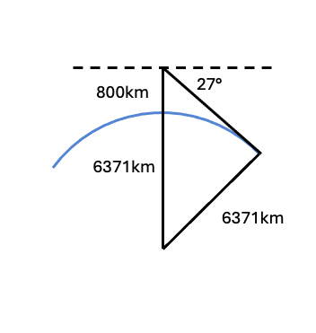
Figure 1 Satellite-Earth horizon is 27.3° below the satellite horizontal for an 800km orbit.

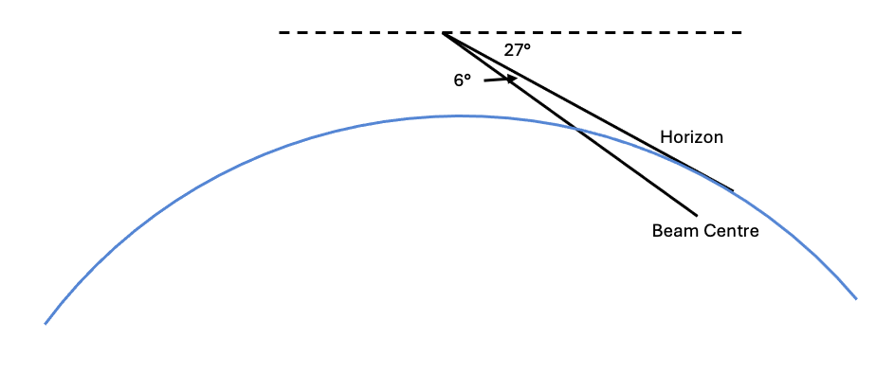
Figure 2 Satellite beam points 33° below the satellite horizontal

- Transmit power management at the satellite is possible, so that transmit power can be reduced for aircraft where the anticipated path losses are less severe than the bounding case. This backoff may reduce the area subject to interference.
- As a modern system, the transmitter is digitally controlled, with a waveform generator and linear amplifier. This means that the transmitter could radiate a waveform that is tailored to mitigate the difficulties posed from Low Earth Orbit (LEO) space-based VHF. This could include: pre-compensation for the doppler shift expected in the service area, reduction or omission of one of the sidebands of the AM voice signal to reduce interference and tailoring of the VDL M2 power spectral density.
    - On reception the representative satellite receives both the vertical and horizontal polarisations from each antenna, with scope to either synthesise the correct slant polarisation for the signal of interest, or to take a diversity approach (choose the strongest). More advanced signal processing to reject co-channel signals based on the relative phase and amplitude at each antenna is obvious, but we exclude description of these for simplicity at this stage. For rulemaking purposes it seems sufficient to be aware that there is almost no limit to the ability of a space-based constellation to simultaneously receive many overlapping transmissions from terrestrial sources, such development and implementation of this technology is best left to the ingenuity (and risk and cost) of the constellation provider.
    - Each satellite is assumed to be half duplex for VHF. Specifically this means that while transmitting, a satellite cannot receive other VHF channels. The impact of this on receive coverage is mitigated because other satellites will have a line of sight to the service area at the same time, so receive coverage on all channels is provided by non-transmitting satellites. This also allows the constellation to independently monitor it’s own transmitters in real time. The option of transmitting multiple signals simultaneously from a single satellite is a design trade e best left to the satellite designer, with the complexity of each satellite being traded against launching a greater number of simpler satellites.
    - Looking forwards, as cost of launch falls ($/kg), the total mass of the constellation will increase, as the value created by the space-based VHF constellation is likely to substantially exceed the cost of providing it. Thus mid-term planning should allow capture of the improved performance available from larger satellites and/or larger constellations. Specifically, larger satellites can offer improved directivity of the VHF transmit beam, and larger constellations allow wider choice of where unwanted radiation impacts the Earth’s surface.
    - As an illustration of how additional launch mass and volume could be used, the Starlink block 2 satellites are 7 m x 3.5 m in planform, and have a mass of approximately 1250 kg. Such a form-factor could have VHF booms approaching 7m in length per section (ie without folding). The directivity available from such a space vehicle at VHF is substantial, dramatically reducing the interference footprint that results from space-based VHF. These satellites require the new SpaceX Starship launch vehicle, however it appears probable that Starship will reach orbit in 2024, and initially lift around 100,000 kg to Low Earth Orbit (LEO) per launch. Catching the booster is tractable on the one year horizon, while reliable re-entry of the upper stage may be challenging due to lost tiles and may take a few years to achieve. However, even without reuse of the upper stage, Starship will represent an order of magnitude reduction in launch cost per kilogram compared to Falcon 9 and this will likely be reflected in both satellite size and constellation density.

  - Representative Constellation
    - This section provides an exemplar of an aviation specific constellation, representing a point in time description of the Skykraft constellation plan, as described in the ITU filing of 16-Dec-23. Near-term (2026/27), and long-term (2029 and beyond) are provided, to bring into sharp relief the impact of denser constellations on the 7 year horizon.
    - There were four plausible constellations filed on 16-Dec-23 to deliver space-based VHF, and their total satellite counts were Startical 320, Eutelsat 1336, Airbus 2252, and Skykraft 2976. This indicates that VHF constellations will be comprised of fleets of many hundreds or thousands of satellites. As the number of satellites in the constellation increases, the service area per satellite beam can be selected with greater precision, the elevation angle of arrival at the aircraft can be selected for best reception, the path losses can be reduced, and so forth.
    - Near-term exemplar (notional 2026/27): For this initial service a mid-inclination orbit is used to gain maximum benefit from a modest number of satellites, with a small number of polar satellites to provide polar coverage. Specific details are in the table below.
Inclination | Longitude | Altitude | # in plane
53 deg | A | 800 km | 10
53 deg | A+45deg | 800 km | 10
53 deg | A+90deg | 800 km | 10
53 deg | A+135deg | 800 km | 10
53 deg | A+180deg | 800 km | 10
53 deg | A+225deg | 800 km | 10
53 deg | A+270deg | 800 km | 10
53 deg | A+315deg | 800 km | 10
SSO | B | 800 km | 12
SSO | B+90 (6hr) | 800 km | 12
    - The early use of this configuration is for integration and development of procedures and operational confidence, and serving initial contracts. This configuration may also be useful in airspace currently served by HF.
    - Long-term exemplar (notional 29 or beyond): By the end of the decade, constellations with in excess of a thousand satellites are plausible. In addition each satellite is likely to grow in mass and aperture. At this point, the transmission duty cycle of each satellite is likely to be low, as VHF spectrum is very much the constraining factor. However this is actually the driver for the constellation density – the scarce VHF spectrum is best utilised by careful control of the unwanted service area (interference). A competent constellation designer and operator achieves this by firstly reducing the interference area through larger VHF aperture at the satellite (greater directivity), and secondly by choosing the interference area so that it does not intersect co-channel service areas. In essence this means: reduce the total interference and then make sure the residual interference (spillover) does no harm.

- Concept of Operations
  - VHF Voice
    - The operational interface between the space-based VHF service and the ANSP is expected to be a dedicated ethernet port in the ANSPs facility. This port will send and receive packetized voice signals with standardised control and telemetry messages to maximise commonality with existing infrastructure. Any customer specific tailoring is intended to remain in the interface box on the customer premises (Customer Service Point – CSP in Skykraft parlance), allowing adaption to new or unique protocols without unnecessarily impacting on the certification of the remainder of the system.

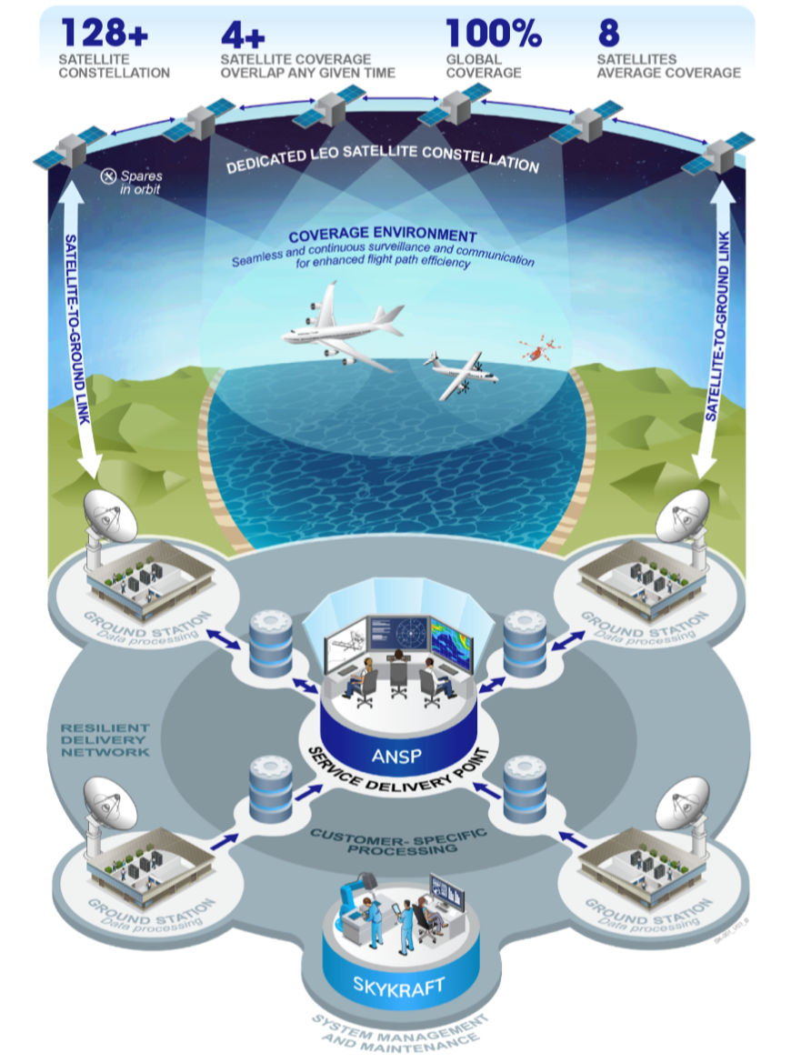
Figure 3 Space-Based VHF Data Flows
    - From the CSP the packetized voice is sent to the applicable Ground Station (GS), from where it is uplinked to the constellation. It is then routed within the constellation using Inter-Satellite Links (ISL) via multiple hops to the transmitting satellite. The ISL is structured to minimise latency, our modelling indicates that the end-to-end transit speed from the ground station to the aircraft is approximately half the speed of light (ie 150km/ms), depending on the scenario. This loss of speed includes the ISL latency as well as the impact of the indirect routing path. The transmitting satellite then transmits the signal to the aircraft. The return path is similar, although the receiving satellite is not necessarily the same as the transmitting satellite, and more than one receiving satellite may be nominated per sector of airspace. The multiple received signals may be blended for best Signal to Interference, Noise and Distortion (SINAD) at the CSP before being provided to the ANSP.
    - Selection of the transmitting satellite (assuming that the design supports only one transmit channel per satellite) is a function of ensuring that a transmitter is available for every serviced airspace sector at all times, and then minimising the impact of interference due to unwanted coverage (ie spill outside the desired service area). Finally, minor considerations such as energy balancing within the constellation, satellite thrust manoeuvres and the link have a small effect on such choices.
    - In the event that there is a failure of a satellite serving a particular airspace, a hot spare is available which is automatically switched in with no loss of service. Specifically this means that the VHF signal is not interrupted for a duration or in a way which prevented the transfer of operational information between pilot and controller. The provision of hot spares naturally improves as the constellation density increases, which is one of the considerations when choosing between fewer, more complex satellites, and a greater quantity of less complex satellites.
  - VHF Data (VDL M2)
    - The VDL M2 service mirrors the VHF voice service in many ways that we assume are obvious to the reader. This section will highlight issues unique to VDL M2 that the working group may consider.
    - A key issue in negotiations at WRC-23 was the viability of transmitting on the VDL M2 Common Signalling Channel (CSC, 136.975 MHz) from satellites. The changes agreed to at WRC-23 include protections for users of the adjacent band that make it questionable whether a space-based transmitter could provide a useful CSC VDL M2 service.
    - Previous discussions have indicated that there is also a strong desire to protect existing ground stations on 136.975MHz from potential interference from satellites, with suggestions of buffer zones of around 200 nautical miles to ensure aircraft served by terrestrial transmitters do not suffer from the hidden node problem where the satellite does not see the terrestrial station and thus does not respect the CSMA access protocol.
    - There may be scope to consider trials of space-based VDL M2 links in regions of the world that have no congestion, or even no current VDL M2 service.
    - The rationale for providing a vacant 25kHz channel between VDL M2 channels might be revisited, with a view to assessing whether space-based VHF might safely serve aircraft in remote areas on these channels, thereby achieving better spectral efficiency in the aviation band.

- ICAO current arrangements
  - The radio frequency spectrum is a valuable yet limited natural resource facing growing demand. Aeronautical services, overseen by the ICAO, are globally recognized as key users of radio frequencies, which are crucial for ensuring safe, efficient, and cost-effective aircraft operations. The Handbook on Radio Frequency Spectrum Requirements for Civil Aviation (Doc 9718) and Annex 10 to the Convention on International Civil Aviation Volume V, Aeronautical Radio Frequency Spectrum Utilization (SARPS) offer a comprehensive and justified overview of aviation needs. They serve as up-to-date references, consolidating agreed spectrum requirements for aeronautical services and reflecting ICAO policies in frequency bands utilised by civil aviation. Additionally, they provide valuable insights into relevant International Telecommunication Union (ITU) regulations, resolutions, recommendations, and associated ITU-Radiocommunication Sector information.
  - The frequency band 117.975 - 137 MHz is extensively used for VHF air-ground and air-air voice and data communications, including Air Traffic Control (ATC) and Airline Operational Communications (AOC). It serves as the primary communication band for air-ground communications in all phases of flight, and various short-range tasks in general aviation and recreational flying (e.g., gliders and balloons). The 117.975 – 137 MHz band also accommodates other services, including the Aeronautical Mobile Off-Route (AM(OR)) Services in some countries. These AM(OR) Services operate under the provisions outlined in footnote RR Nos. 5.201 and 5.202. The RR Nos. 5.201 and 5.202 pertain to the utilization of 132 -136 MHz and 136 -137 MHz, respectively, for national off-route services on a primary basis. A comprehensive description of the utilization in the 117.975 - 137.0 MHz frequency band is given in Section 7-II of Doc 9718 and Chapter 4.1 of the SARPS.
  - The specific allocation of frequencies within the 117.975 -137 MHz band is outlined in Table 4-1 of the SARPS. Within the 117.975 - 137 MHz frequency band, some frequencies are allocated for distinct functions, as outlined in Section 4.1.3 of the SARPS. For instance,
- 121.5 MHz: Allocated as the emergency channel (Section 4.1.3.1) for genuine emergency purposes, such as to provide a clear channel between aircraft in distress or emergency and a ground station when the normal channels are being utilized for other aircraft.
- 123.450 MHz: Allocated as an air-to-air VHF communications channel (Section 4.1.3.2) to facilitate communication among aircraft operating over remote and oceanic areas where VHF ground stations are out of range.
- 136.975 MHz: Reserved globally as a Common Signalling Channel (CSC) for the VHF digital link Mode 2 (Section 4.1.3.3)
- 123.1 MHz: Utilized as an auxiliary search and rescue channel (Section 4.1.3.4) in accordance with the characteristics outlined in Annex 10, Volume III, Part II, Chapter 2.
  - In order to address growing demand and to decrease frequency congestion in high-density traffic areas, the channel width within the 117.975 -137 MHz band has been reduced on several occasions. Section 4.1.2 of the SARPS recognises that both 25 kHz and 8.33 kHz channel spacing exists and that they may continue to co-exist within one region or area.

- Considerations/questions
  - It is understood that the introduction into use of the AMS(R)S requires changes to standards, procedures and practices that are maintained by the ICAO. The two key documents identified above contain the VHF AM(R)S spectrum provisions. To maintain the integrity of the incumbent primary system, as well as protect the adjacent services as detailed in the outcomes of the WRC-23 Agenda Item 1.7 it is recognised that studies of existing usage, identification of channel opportunities in given areas and compatibility analysis needs to be undertaken.
  - It is also recognised that ICAO will promote the work required to a correspondence group and the sub-set of experts can consider the results of studies and analysis to ensure that all factors are considered.
  - Australia would seek guidance on a specific work program that would assist an introduction into service of the new AMS(R)S as soon as practicable, considering the protection requirements of other radiocommunications users. Australia seeks guidance on specifics within he work program that will assist in sequence, specific elements of study and any other considerations with a view to undertaking the work necessary to assist the expert group in its work.

- Action By The Meeting

The meeting is invited to:
- note and review the contents of this working paper;
- consider the requests for guidance in section 6; and
- agree that correspondence group begin its work on this proposal, with a view to finalisation by FSMP WG-20.
— END —

