FREQUENCY SPECTRUM MANAGEMENT PANEL (FSMP)

Fifth Working Group Meeting

Paris, France, 4 to 8 September 2017

Agenda Item 4A: 5GHz Band Planning – AeroMACS status

AeroMACS and AMT operating at C-band – interference tests

(Presented by Luiz Fernando de Souza, Embraer)

(Prepared by Hialina Lima do Nascimento and Luiz Fernando de Souza, Embraer)

SUMMARY
At World Radio communication Conference 2007 (WRC-07) the band of 5091 to 5150MHz is assigned to Aeronautical Mobile Airport Communications System (AeroMACS) application and also the Aeronautical Mobile Telemetry (AMT) according the footnotes 5.444B.
The intention of this paper is to show the results of a simulation of both services operating at same time, and note if the coexistence of systems at band 5091-5150MHz is feasible.

INTRODUCTION
Embraer, Siemens and Brazilian ATM (Air Traffic Management) perform tests with the AeroMACS system and Embraer’s AMT operating at C-band in order to stablish the optimal frequency separation between the both systems.

DISCUSSION

Data Sources (Systems under test)
Embraer provided a Pulse Code Modulation (PCM) data source with a bit rate the 7Mbps, with 40W of power; the channels are separated by 10MHz.
In other hand, the WiMAX transmitter (AeroMACS) was placed 30m high (in the air traffic control tower), and the transmitter was configured to transmit in the maximum power and full band occupancy.

General Considerations of the test (steps of the test)
- To let the tracking telemetry antenna in the line of sight of the aircraft and verify the noise outside of the band. In addition, to monitoring the interference between the services and, finally, the quality of PCM link.
- To verify the frequency separation conditions, in order to prevent the interference between by simulating the of band frequency separation.
- To measure the both signals (PCM link and WiMAX radio) by a spectrum analyzer.
- To decrease the C-band transmitter (PCM link) into level that simulates the reception of a signal from an aircraft 300km away.
- To take note of the spectrum analyzer and Telemetry receivers to see the PCM signal under influence by WiMAX radio.
- To verify the Bit Error rate (BER) and the bad frames quantity of PCM decommutation.
- To measure the both signals (PCM link and WiMAX radio) by spectrum analyzer.

AMT characteristics
- Frequency band: 5091-5150MHz
- Transmitted power: 40W
- Signal modulation: PCM/FM
- Antenna type and gain (aircraft): Omnidirectional, 3dBi
- Antenna type and gain (ground): Parabolic, 35dBi
- Receptor lower level: -85dBm
- Link range: 320km
- Brazilian C-band AMT channels :
- Data: 5091 – 5095MHz, 5101MHz – 5105MHz, 5111MHz – 5115MHz, 5121MHz – 5125MHz, 5131MHz – 5135MHz, 5141MHz – 5145MHz;
- Video: 5095MHz – 5101MHz, 5105MHz – 5111MHz, 5115MHz a 5121MHz, 5125MHz – 5131MHz, 5135MHz – 5141MHz, 5145MHz – 5151MHz.

AeroMACS characteristics
- Frequency band: 5091-5150MHz
- Transmitted power: 125mW
- Signal modulation: 64QAM
- Antenna type and gain (aircraft): 6dBi
- Antenna type and gain (ground): 17dBi
- Receptor lower level: -87dBm
- Link range: 3km
- AeroMACS channels:
Figure 1: AeroMACS frequency band

Figure 2: Test scenario

Figure 3: Block diagram

TESTS

Test #1: AMT and AeroMACS with a separation of 45MHz

Test setup
- AMT transmitter: f0= 5100MHz @ 40W
- AeroMACS transmitter: f0 = 5145MHz @ 125mW
- AMT and AeroMACS operating at maximum power
- AeroMACS transmitter in line of sight with the AMT antenna

Test results
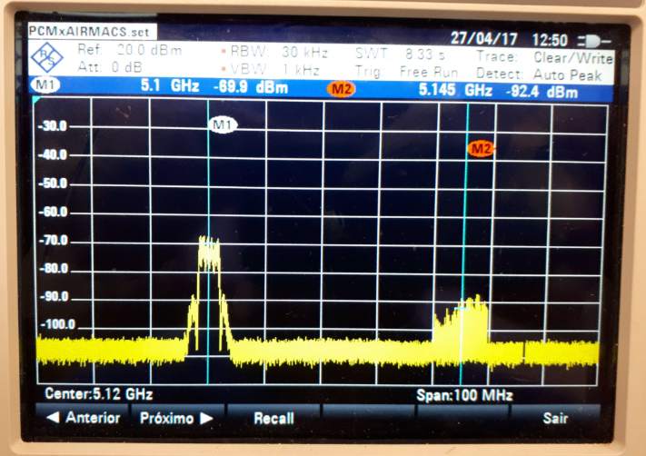
Figure 4 : left side – AMT, right side – AeroMACS; Separation of 45 MHz.
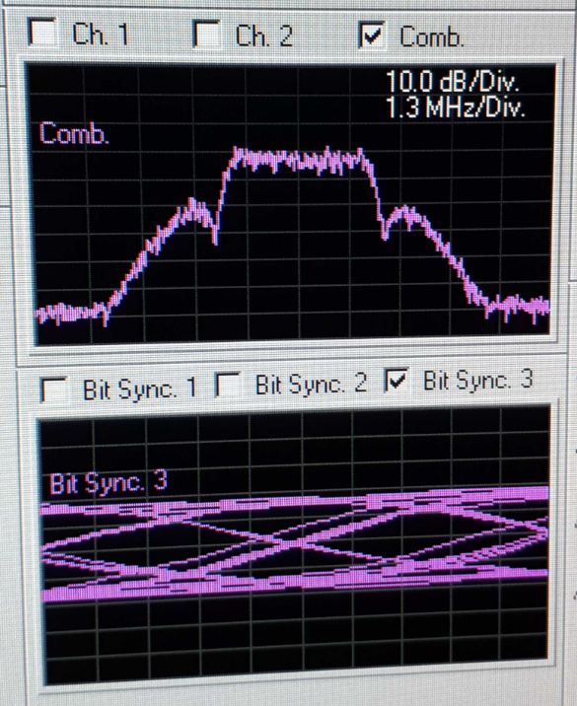
Figure 5: AMT bandwidth and signal quality at AMT ground station
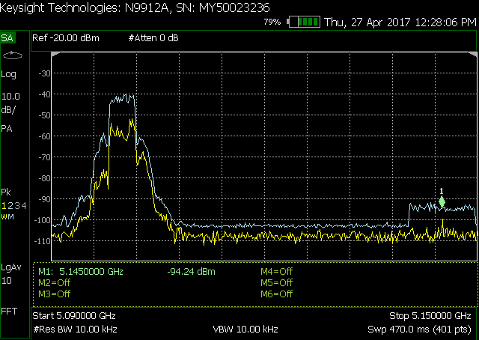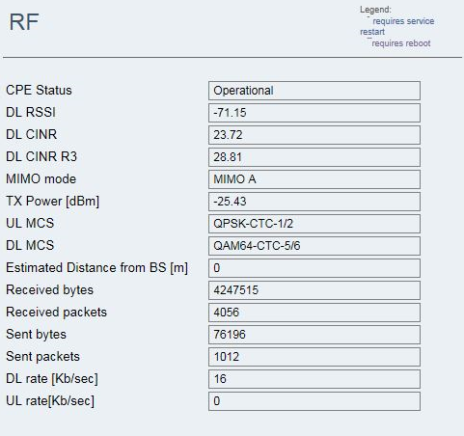
Figure 6: left side - Spectrum analyzer measurement, right side – CPE report. AeroMACS using omnidirectional antenna.
Note: It was observed a low level of modulation in the AeroMACS subscriptor transmission, probably, due an issue regarding the RF1 port. The reception modulation of the equipment was in maximum value.
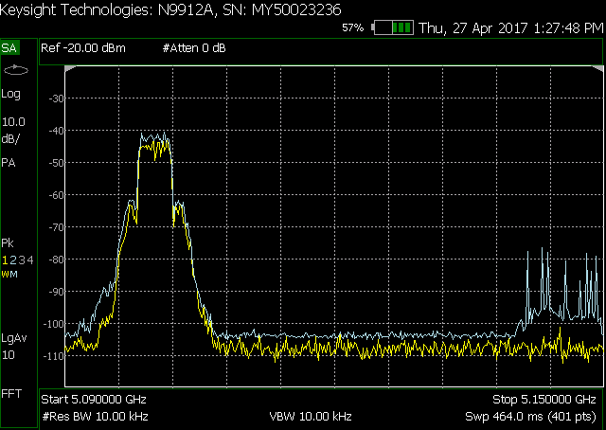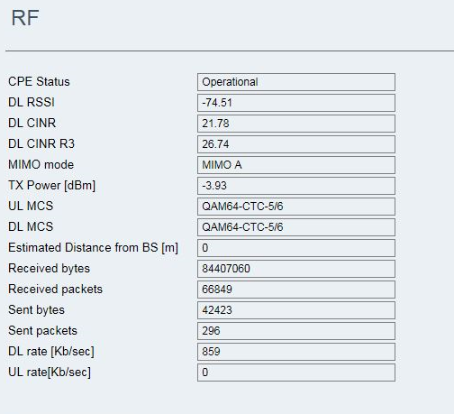
Figure 7: left side - Spectrum analyzer measurement, right side – CPE report. AeroMACS using Shark antenna.

Test #2: AMT and AeroMACS with a separation of 45MHz; and AMT at minimum power

Test setup
- AMT transmitter: f0 = 5100MHz @ 40,27µW (EIRP – Equivalent Isotropic Radiated Power)
- AeroMACS transmitter: f0 = 5145MHz @ 125mW
- AeroMACS operating at maximum power and, AMT operating at minimum power (signal reception is simulating an aircraft 300km away)
- AeroMACS transmitter in line of sight with the AMT antenna.

Test results
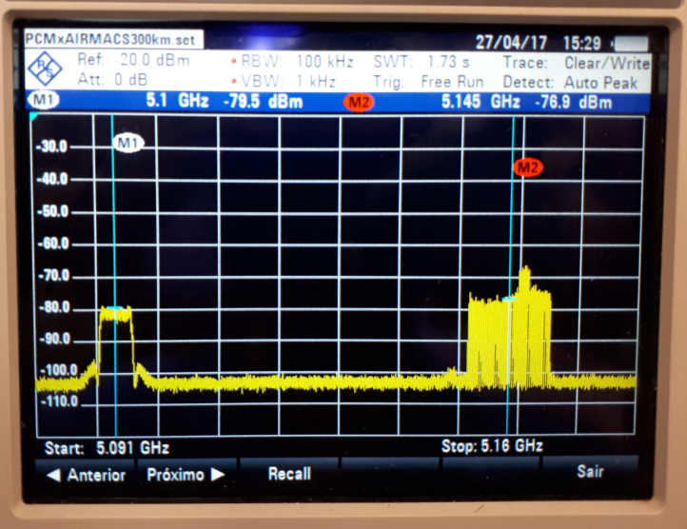
Figure 8: left side – AMT, right side – AeroMACS; Separation of 45 MHz.
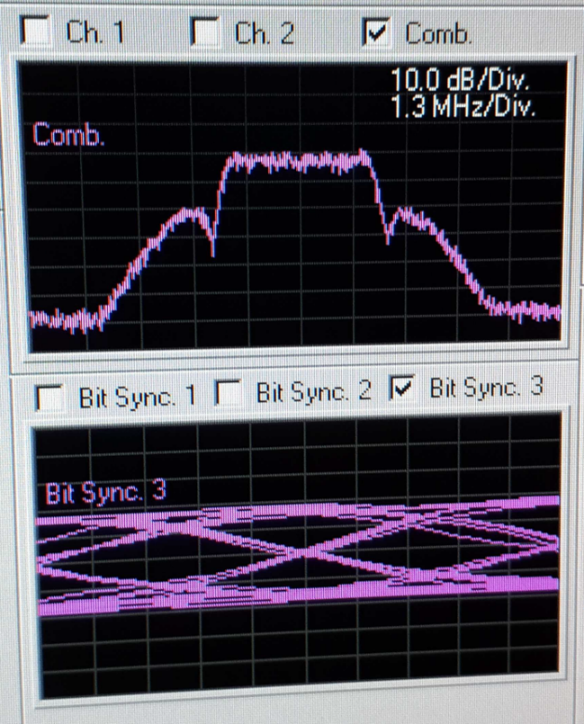
Figure 9: AMT bandwidth and signal quality at AMT ground station; separation of 45MHz
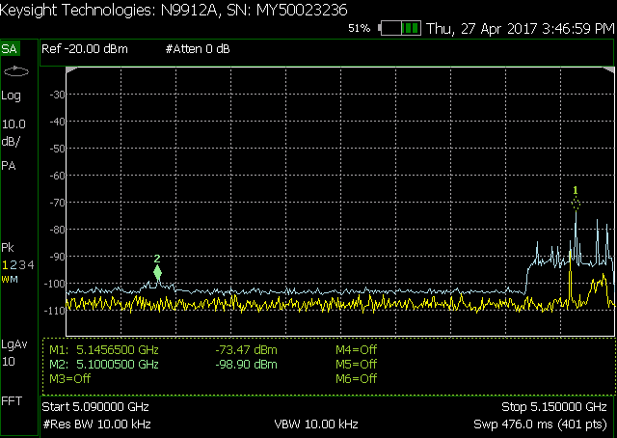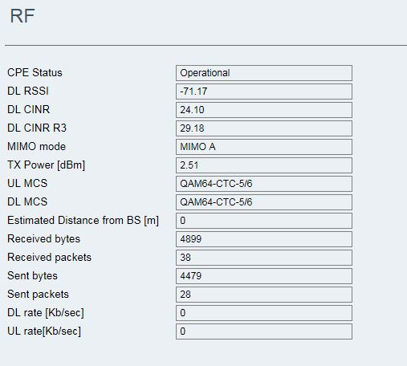
Figure 10: left side - Spectrum analyzer measurement, right side – CPE report; separation of 45MHz.

Test #3: AMT and AeroMACS with a separation of 20MHz; and AMT at minimum power

Test setup
- AMT transmitter: f0 = 5100MHz @ 40,27µW (EIRP)
- AeroMACS transmitter: f0 = 5120MHz @ 125mW
- AeroMACS operating at maximum power and, AMT operating at minimum power (signal reception is simulating an aircraft 300km away)
- AeroMACS transmitter in line of sight with the AMT antenna.

Test results
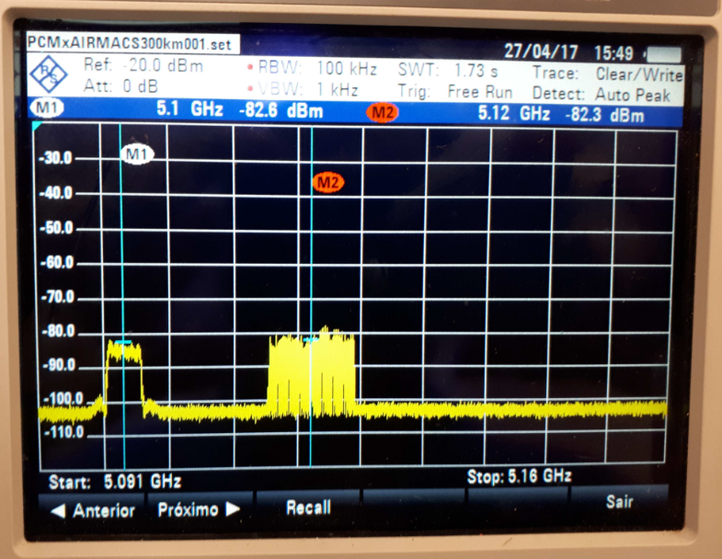
Figure 11: left side – AMT, right side – AeroMACS; Separation of 20 MHz.
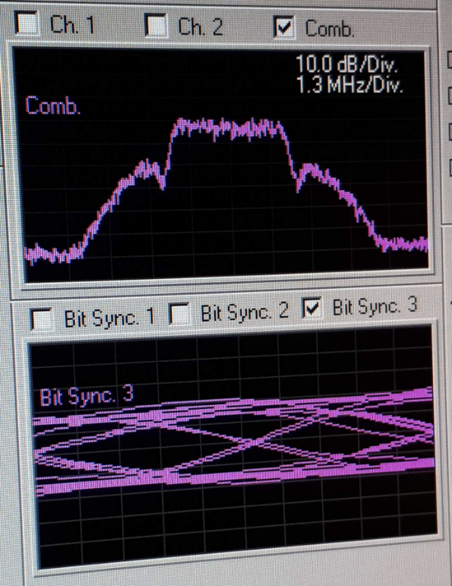
Figure 12: AMT bandwidth and signal quality at AMT ground station; separation of 20MHz
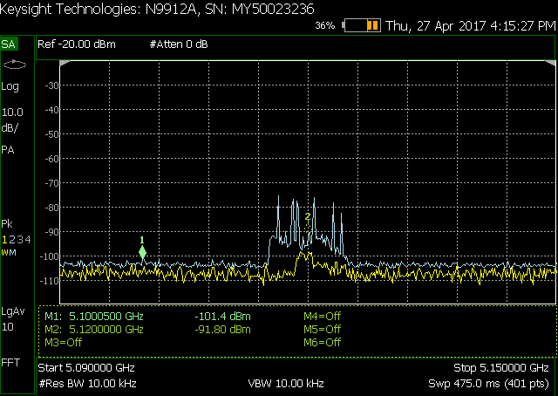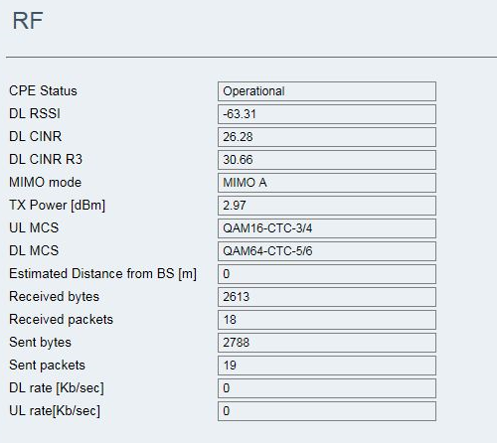
Figure 13: left side - Spectrum analyzer measurement, right side – CPE report; separation of 20MHz.

Test #4: AMT and AeroMACS with a separation of 10MHz; and AMT at minimum power

Test setup
- AMT transmitter: f0 = 5100MHz @ 40.27µW (EIRP)
- AeroMACS transmitter: f0 = 5110MHz @ 125mW
- AeroMACS operating at maximum power and, AMT operating at minimum power (signal reception is simulating an aircraft 300km away)
- AeroMACS transmitter in line of sight with the AMT antenna.

Test results
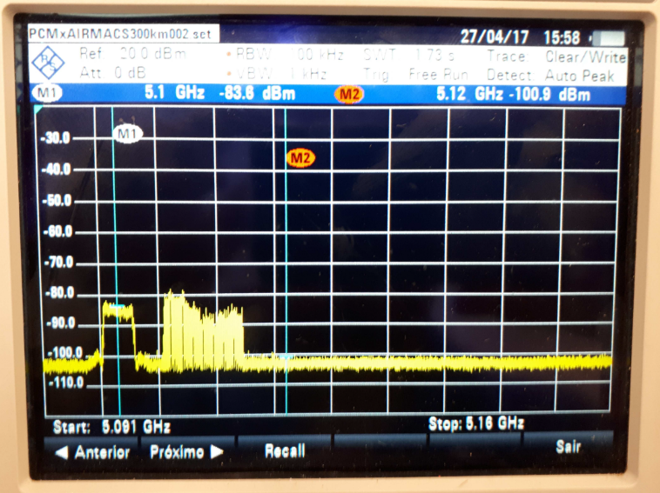
Figure 14: left side – AMT, right side – AeroMACS; Separation of 10MHz.
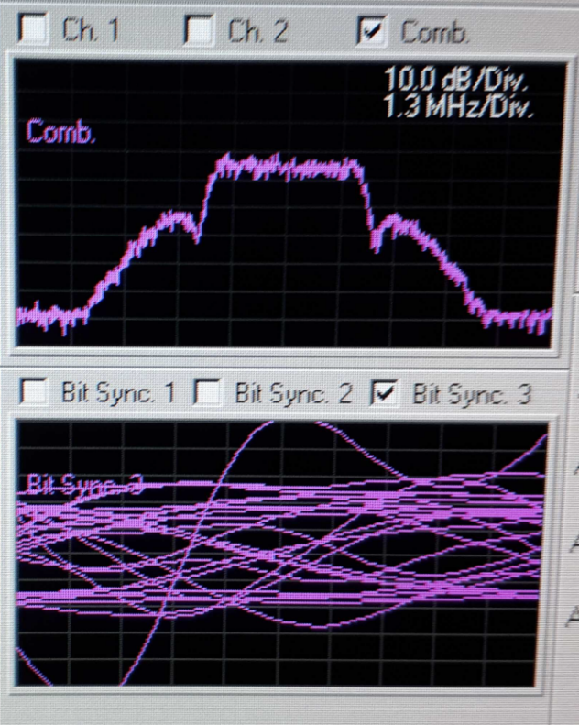
Figure 15: AMT bandwidth and signal quality at AMT ground station; separation of 10MHz
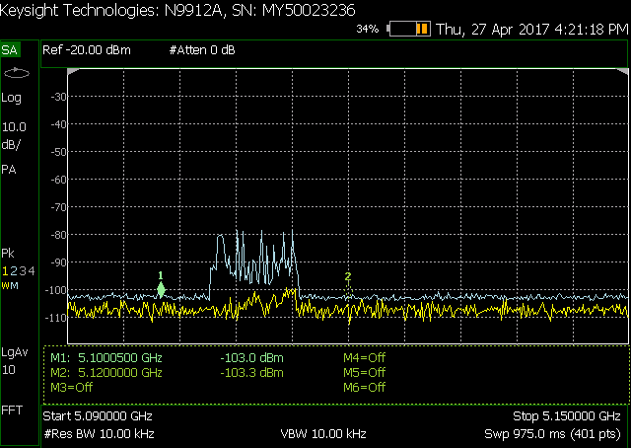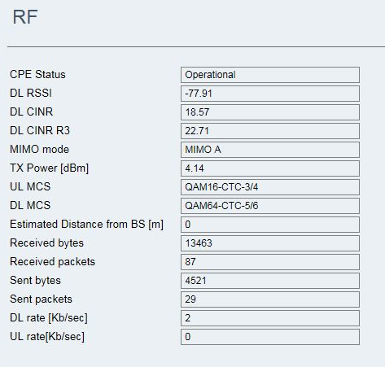
Figure 16: left side - Spectrum analyzer measurement, right side – CPE report; separation of 10MHz.

Test #5: AMT and AeroMACS with a separation of 5MHz; and AMT at minimum power

Test setup
- AMT transmitter: f0 = 5100MHz @ 40.27µW (EIRP)
- AeroMACS transmitter: f0 = 5105MHz @ 125mW
- AeroMACS operating at maximum power and, AMT operating at minimum power (signal reception is simulating an aircraft 300km away)
- AeroMACS transmitter in line of sight with the AMT antenna.

Test results
Figure 17: left side – AMT, right side – AeroMACS; Separation of 5MHz.
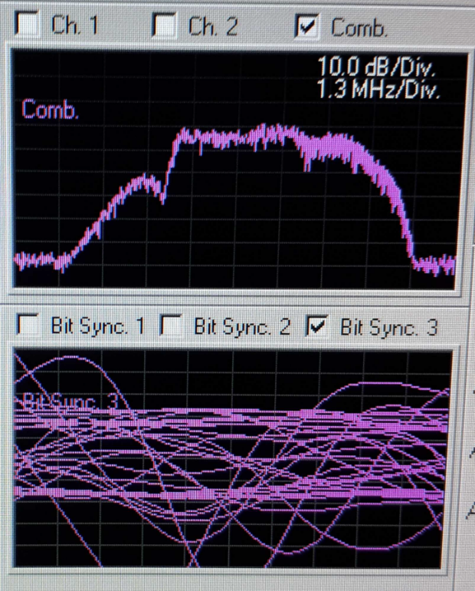
Figure 18: AMT bandwidth and signal quality at AMT ground station; separation of 5 MHz.
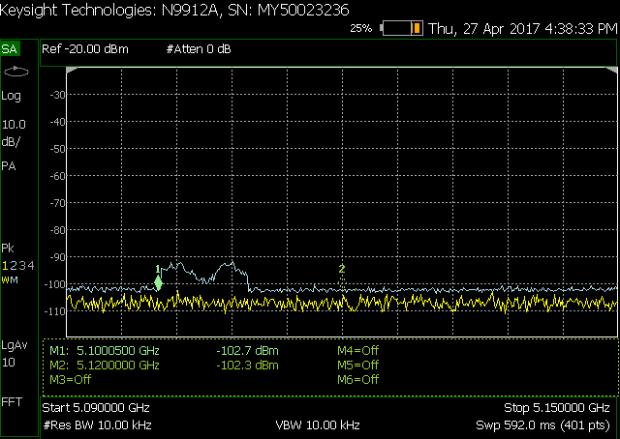
Figure 19: Spectrum analyzer measurement; separation of 5MHz.
Note: the Customer Premises Equipment (CPE) did not able to stablish a connection, thus it was not possible to generate a report page.

Test #6: AMT and AeroMACS with no separation; and AMT at minimum power

Test setup
- AMT transmitter: f0 = 5100MHz @ 40.27µW (EIRP)
- AeroMACS transmitter: f0 = 5100MHz @ 125mW
- AeroMACS operating at maximum power and, AMT operating at minimum power (signal reception is simulating an aircraft 300km away)
- AeroMACS transmitter in line of sight with the AMT antenna.

Test results
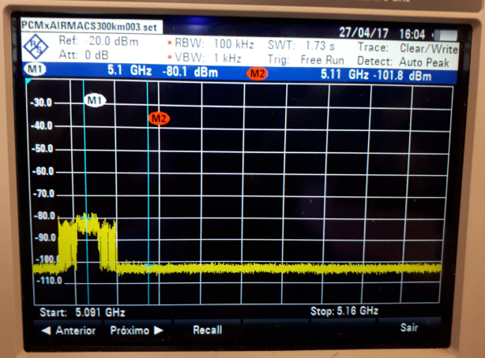
Figure 20: left side – AMT, right side – AeroMACS; No separation.
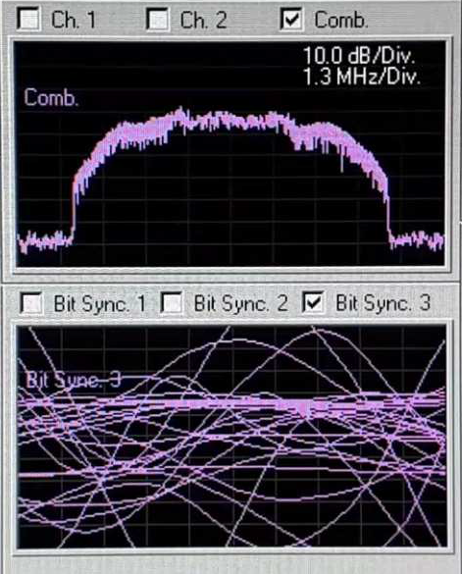
Figure 21: AMT bandwidth and signal quality at AMT ground station; No separation.

CONCLUSION
According the tests described above and taking in consideration the results of Test #3 (Section 3.3) and Test #4 (Section 3.4), it is possible to stablish the minimum separation between the two services as 20MHz. In addition, with the separation of 10MHz it was observed, in the eye diagram of PCM signal (Figure 15), an initial level of degradation can be observed, this degradation causes error on PCM demodulation.
Separation with lower values of frequency was simulated in the sections 3.5 and 3.6, and the results show, in those cases, that the systems coexistence it is not feasible.
It is important to emphasize that those results are applicable only for this test case. There is no intention to stablish a frequency separation considering all scenarios.

