FREQUENCY SPECTRUM MANGEMENT PANEL (FSMP)

THIRD MEETING

Montreal, Canada, 6 – 14 September 2016

Agenda Item 8: 5 GHz Band Planning

Testing of AeroMACS Mobile Applications

(Presented by Robert J Kerczewski)
(Prepared by Rafael D. Apaza and Robert J. Kerczewski

SUMMARY
Aeronautical Mobile Airport Communication System (AeroMACS) standards development is reaching maturity. Extensive testing of basic AeroMACS prototype operations has occurred at several locations worldwide. Initial AeroMACS deployments in the US have supported fixed subscriber station access supporting such applications as airport surface multilateration-based surveillance. Mobile AeroMACS applications are now undergoing extensive trial and test. Described herein are two such trials conducted at the NASA Glenn Research Center CNS Test Bed in Cleveland, Ohio, USA to illustrate the progress of mobile AeroMACS application development.

- INTRODUCTION
  - The Aeronautical Mobile Airport Communications System (AeroMACS) is intended to be capable of supporting many types of aviation safety communication services on the airport surface. AeroMACS operates using an AM(R)S spectrum allocation covering 5000-5030 MHz and 5091-5150 MHz. AeroMACS is based on the IEEE 802.16e standard, which also supports the well-known WiMAX implementation, operating over 5 MHz channels.
  - Over a number of years, testing of the AeroMACS standards has taken place at several locations, including the National Aeronautics and Space Administration (NASA) Glenn Research Center (GRC) CNS Testbed installed at the Cleveland Hopkins International Airport and the adjacent NASA GRC facility in Cleveland, Ohio, USA. Initial AeroMACS prototypes were installed and tested there, providing significant technical support to standards developments within RTCA SC-223, EUROCAE WG-82 and ICAO WG-S. These tests focused on prototype AeroMACS system performance and emphasized fixed subscriber station (SS) connectivity along with some mobility testing. Initial AeroMACS installations at some U.S. airports have supported fixed SS connectivity, supporting applications such as airport surface surveillance based on multi-lateration. With no available aircraft AeroMACS applications, and thus no AeroMACS aircraft installations yet available, the fixed SS applications have supported the funding of the first AeroMACS systems.
  - More recently, with standards development activities reaching maturity and fixed SS applications beginning to be implemented, testing has been focused on mobile applications. A number of mobile applications tests and trials have been completed at the NASA GRC CNS Testbed, measuring such parameters as quality of service (QoS), mobility, stability and throughput for applications such as SWIM Accessibility, SWIM data exchange with aircraft, and mobile video and GPS tracks. Two of these trials are described in the following sections, followed by a description of planned future tests.
- AeroMACS Mobile Applications Trials and Testing
  - RTCA Compliant Prototype Field Trials – Hitachi Prototype

The National Aeronautics and Space Administration (NASA) in partnership with Hitachi, Ltd. and Hitachi Communication Technologies America, Inc. conducted field trials to evaluate communications system technical performance and conformance to Minimum Operational Performance System (MOPS) standards. Description of test bed, tests and results follow.
    - To test the Hitachi prototype, the NASA GRC CNS Test Bed was configured to host three AeroMACS Base Stations (BS) deployed at the Airport Rescue and Fire Fighting (ARFF) facility, and four AeroMACS Subscriber Stations (SS) located at the Cleveland Maintenance Facility (CMF), Approach Lighting System with Sequenced Flashing Lights (ALSF), Terminal C and mobile NASA vehicle, Figure 1. Test frequency assignments for BS equipment consisted of 5100 MHz, 5120 MHz and 5125 MHz for BS1, BS2 and BS3 respectively. The experiment control room, located at the NASA GRC campus Building 110 (B110), is connected to ARFF facility using an 11 GHz microwave backhaul communications system. The backhaul communications system enables remote BS parameter configuration, test setup and configuration, data collection and system performance monitoring. As noted in Figure 1, BS architecture configuration is deployed to provide coverage primarily to runways, taxiways and apron areas. The control room located on the NASA campus hosts monitoring systems, Authentication, Authorization and Accounting (AAA) server, Access Service Network (ASN) gateway equipment, routers, local area network infrastructure and hardware required for the configuration, monitoring and data collection of experiments.
    - Each SS equipment station is accessorized with a communications test box equipped with a local area network (LAN) switch, single board computer system, surge protection equipment and power, as illustrated in Figure 2. Access to individual SS components for configuration, maintenance and monitoring is achieved through Secure Shell (SSH), Telnet or Browser software. Test bed infrastructure includes a network architecture configured with level two switches that provide virtual local area network to enable separation of control, monitoring and data.

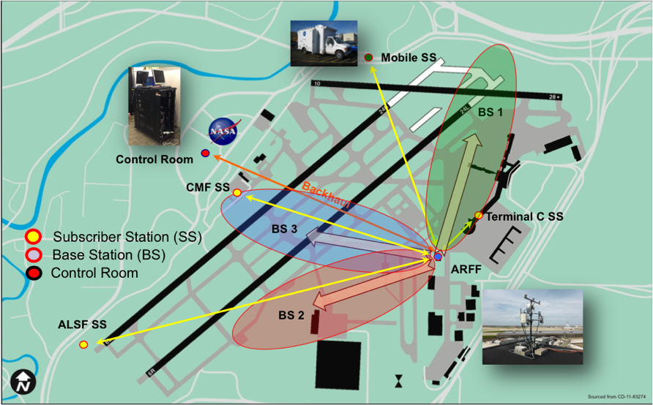
Figure 1 - NASA GRC CNS Test Bed

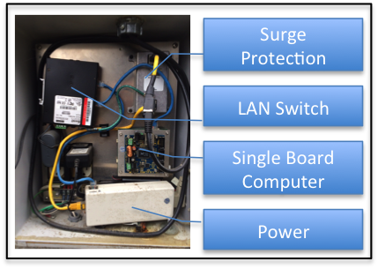
Figure 2 - Subscriber Station

    - Initial Network Entry Test (INE) - The INE test measures the time it takes for a subscriber station to access the AeroMACS network. ICAO’s SARPs for AeroMACS requires that the network entry time be less than 90 seconds. The tests were executed in i) an environment in which a single BS was available (stationary state), ii) an environment in which multiple BSs are available (stationary state), and iii) on the Runway where multiple BSs are available (mobile state) in order to validate that the technical requirement in the SARPs is executable.
    - The INE process is initiated by the MS and it scans available BSs within the frequency range allocated to AeroMACS. In the tests, we applied three ways of scanning, i.e. i) fixed channel (no scan), ii) 5 MHz step scan and iii) 250 kHz step scan. The second and third ways need to scan 11 channels and 201 channels respectively from the lowest frequency channel through the highest frequency channel.
    - Figure 3 shows the result of the single BS (stationary state) test case. The difference among the three cases lies in the scanning time that increases in proportion to the number of scanning channels. The longest INE time obtained was less than 26 seconds, which is within the technical requirements of the SARPs.
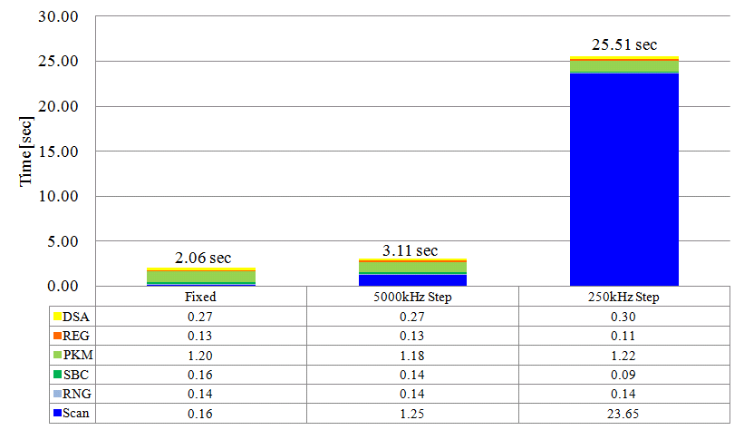
Figure 3 - Initial Network Entry Times

    - Throughput Test - AeroMACS offers high throughput digital wireless broadband communication. The RTCA MOPS technical standard provides flexibility to choose optimal Down Link (DL)/Up Link (UL) symbol ratios, i.e. 26:21, 29:18, 32:15 and 35:12. The established direction of data traffic is defined such that DL direction is from the BS to the MS and the UL is from the MS to the BS. The throughput test exchanged digital data (UDP, iperf) between the Application Server at NASA B110 and the Single Board Computer (SBC) located at each SS site. Best Effort (BE) was applied as the QoS class. Multiple Input Multiple Output (MIMO)-A was applied to the DL, while the Single Input Multiple Output (SIMO) was applied to the UL.
    - The basic capability test consisted of measuring the throughput of a single MS connected to a base station. Figure 4 shows the measured results. The throughput values are averages of the measurement results taken for the three BSs. The total throughput (DL + UL) is approximately 11 Mbps per 5 MHz channel and the result is similar to measurements obtained at the laboratory.
    - The next test evaluated the performance when multiple MSs are connected to one BS. In this test it was anticipated that the MS throughput will be reduced. This is because DL burst region (used for data) becomes smaller to allocate bigger DL-MAP region (for control messages) for additional MSs. For this trial, two MSs were used for the Multiple MSs Sector Throughput Test. The measured results shown in Figure 5 reveal that the total throughputs are the same as the results for Single MS Peak Throughput Test, while the DL throughputs decrease and UL throughputs increase for 0.1 Mbps order, which within the measurement error.

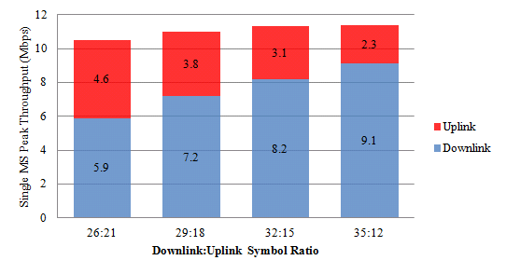
Figure 4 - Single MS to BS Throughput
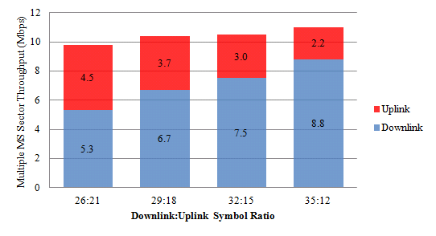
Figure 5 Multiple SS to one BS

    - Quality of Service (QoS) Test - Five classes of QoS (i.e. Extended Real Time Polling Service (ertPS), Real Time Polling Service (rtPS), Non Real Time Polling Service (nrtPS), Unsolicited Grant Service (UGS) and Best Effort (BE)) are available for AeroMACS and they can be implemented by defining the traffic parameters of the Service Flows (SFs) in the configuration file of the proxy AAA server as shown in Figure 6. In this case, four SFs are defined for a single MS: two (UGS and BE) for DL and two (UGS+BE) for UL. We prepared four pairs of Service Flows (i.e. ertPS/BE, rtPS/BE, nrtPS/BE and UGS/BE) for test cases and implemented them into both of DL and UL. BE was used for temporary increase of data traffic in all cases.
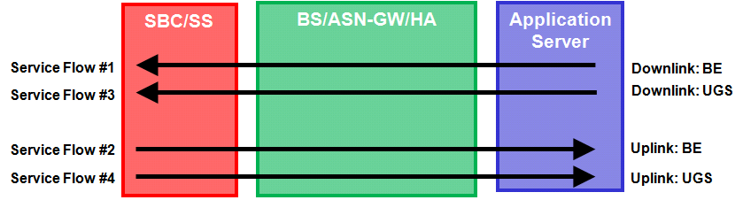
Figure 6 - Service Flow Definitions

    - As a result of the test cases, the guaranteed bandwidth (200 kbps) was reserved while BE data traffic of several Mbps was added in all test cases regardless of the SF pairs. Figure 7 shows a result for UL pair of ertPS and BE when BS3 and CMF SS were used. The upper chart shows the UL throughput for entire test period and the lower chart shows the UL Packet Error Rate (PER) for the period while BE traffic was added. Data traffic of ertPS was added at time=0 (sec) and BE data traffic was added at time=180 (sec). No effect was observed in the throughput of the ertPS data traffic from time=180 (sec) until time=480 (sec) when the BE data was stopped.
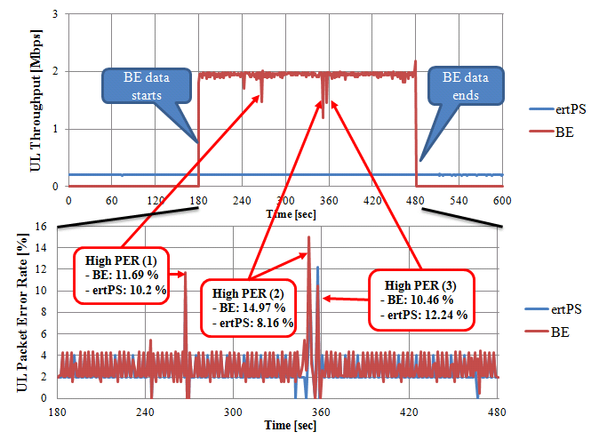
Figure 7 - QoS Test Results

    - Handover Test: This test evaluates a MS transition, or handover (HO) between two base station systems. In this test, a vehicle drove on the Runway 6L/24R and 6R/24L in the directions of northeast and southwest where BS1 (green arrow) and BS2 (blue arrow) were available for HO with DL data traffic (DL:UL=29:18, UDP, iperf, 15 Mbps) as shown in Figure 8.
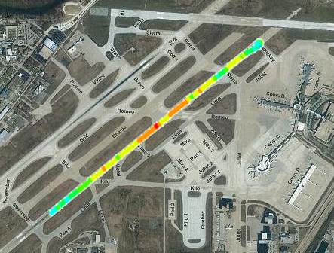
HO
Figure 8 - Handover Test

    - All of the handover trials (10 times at 50 knots and another 10 times at 22 knots) were successfully completed as Controlled HO (where MS connection information was exchanged between Serving BS and Target BS during HO process) with latency of 160-200 msec. Figure 9 shows an example result of vehicle speed and DL throughput during the HO process while the vehicle was moving north-eastward on Runway 6R/24L at 50 knots when HO was conducted. This test confirmed that HO on the airport surface (Runway and Taxiway) can be successfully accomplished by applying Mobile WiMAX technology on which AeroMACS is based.
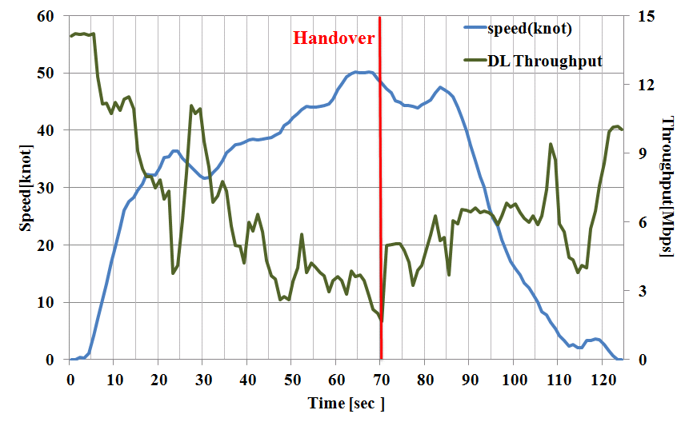
Figure 9 - Handover Throughputs with Speed
  - SWIM Data to the Aircraft over AeroMACS Trial

The principal objective of this trial is to evaluate the performance of an AeroMACS prototype developed by Hitachi, Ltd., for a mobile application, specifically the transport of System Wide Information Management (SWIM) data to an aircraft. AeroMACS was evaluated in three distinct scenarios. The first scenario consisted of transporting SWIM information with no other data occupying the network as shown in Figure 10. The second scenario tested SWIM information transfer along with other test data using a single subscriber station. The third scenario resembled scenario number two with the addition of an external fixed station transporting emulated radar data. To accomplish these three trial scenarios, a Bombardier aircraft furnished by FAA was accessorized with AeroMACS subscriber station equipment and Hitachi base station and subscriber station equipment was installed at the NASA Cleveland Test Bed Facility. The SWIM products transported during the trial included route preference data in the form of Trajectory Option Sets (TOS) and weather information (METAR, TAF, AIRMET, SIGMET, PIREP, NEXRAD). To perform these three test scenarios, the FAA aircraft performed three taxi operations down a runway.
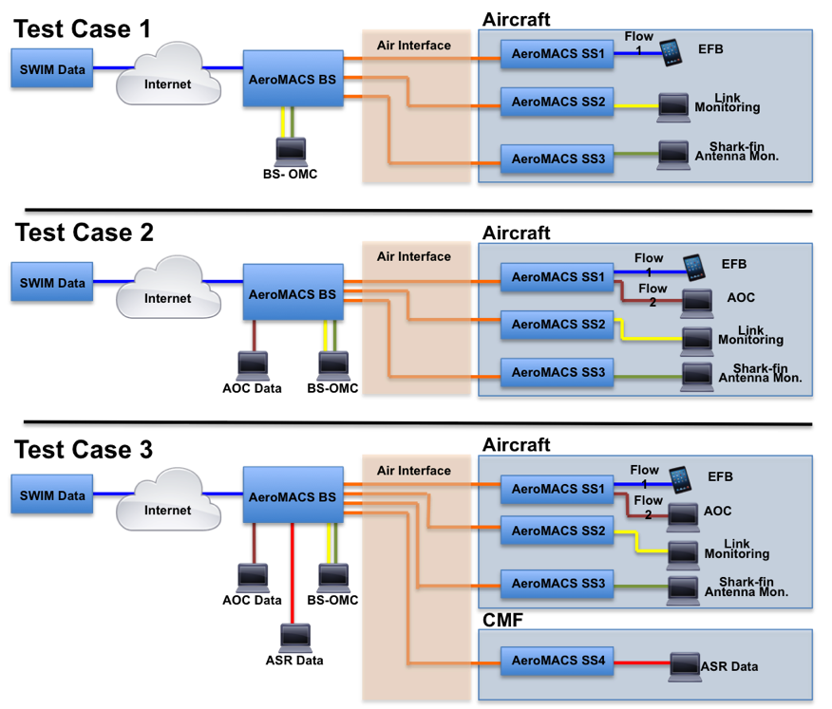
Figure 10 - Test Cases

    - Demonstration Architecture
      - NASA CNS Test Bed - To accomplish all trials, the NASA CNS Test Bed was configured as shown within the green dashed line in Figure 11.
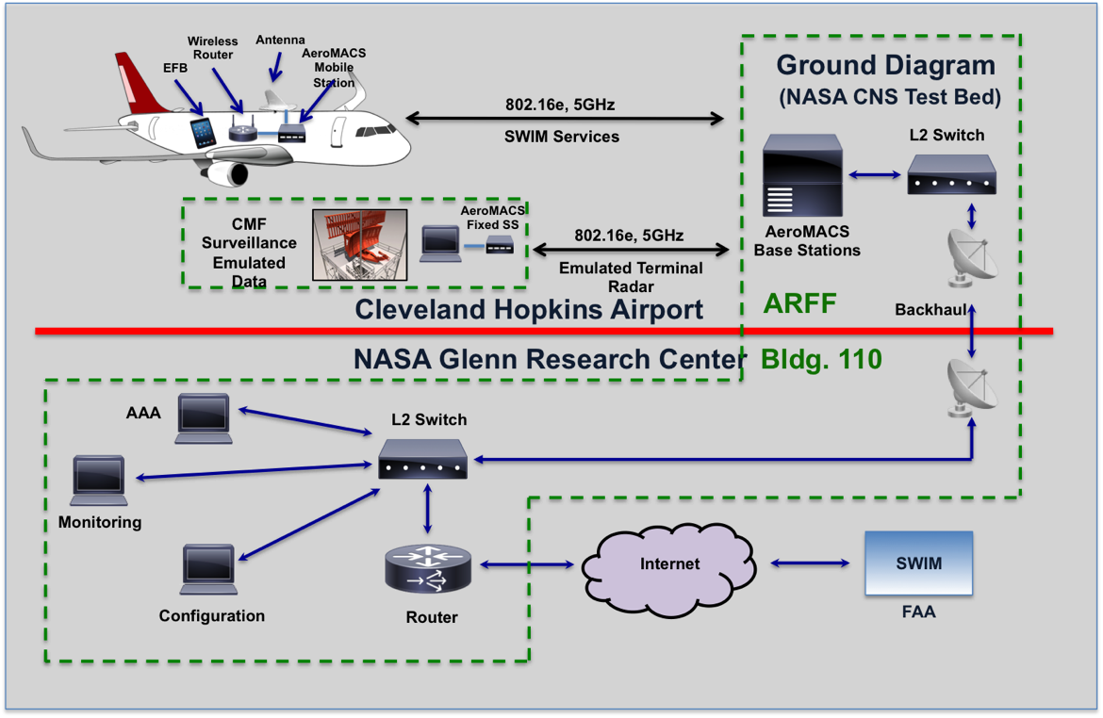
Figure 11 - NASA CNS Test Bed Configuration
      - Aircraft Configuration - Three SS with respective antennas were utilized. SS-1 was used for SWIM and AOC data transmission. SS-2 was used for system performance monitoring and SS-3 was used to monitor performance of aircraft tail antenna mount. Figure 12 illustrates how the SS antennas were implemented on-board the aircraft. SS-1 and SS-2 antennas were attached on the windows, so the antenna coverages were as shown. A shark fin type antenna with omnidirectional coverage was implemented for SS-3 in the radome on the vertical stabilizer. The antenna gains and stability of the window antenna and radome antenna performance were evaluated.
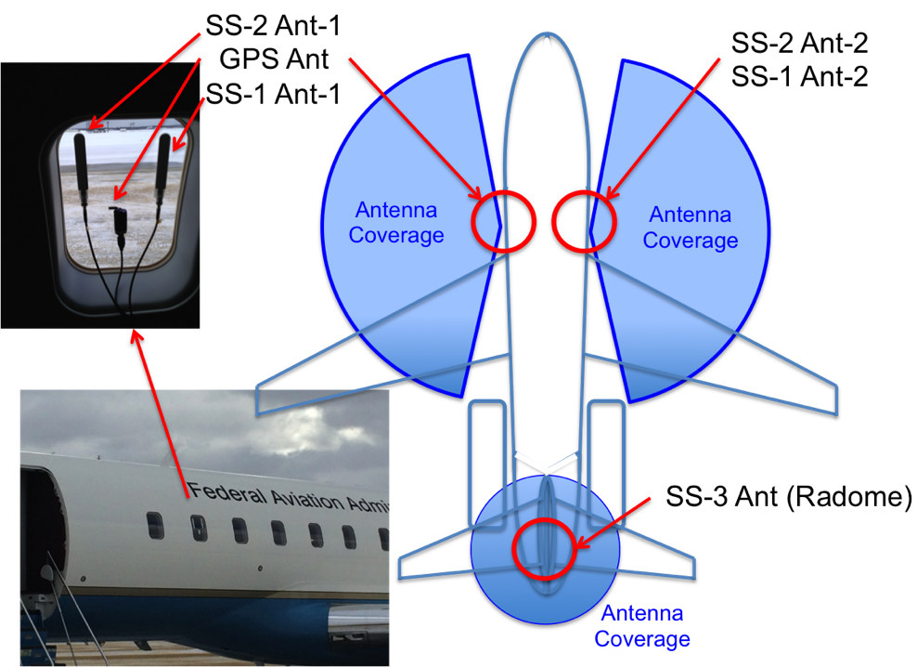
Figure 12 - Aircraft Antenna Configuration
    - Test Case 1 - Figure 13 depicts the test route and measured DL CINR for Test Case 1. The aircraft started from Pad-2 and travelled counter-clockwise. The DL CINR near BS exceeded 25 dB while the DL CINR on the taxiway parallel to the antenna beam was relatively low because of the BS antenna coverage limitation. Handover happened twice, first on the taxiway and a second time on the runway. The trial to connect to SWIM was conducted after completion of SS entry to the AeroMACS network.
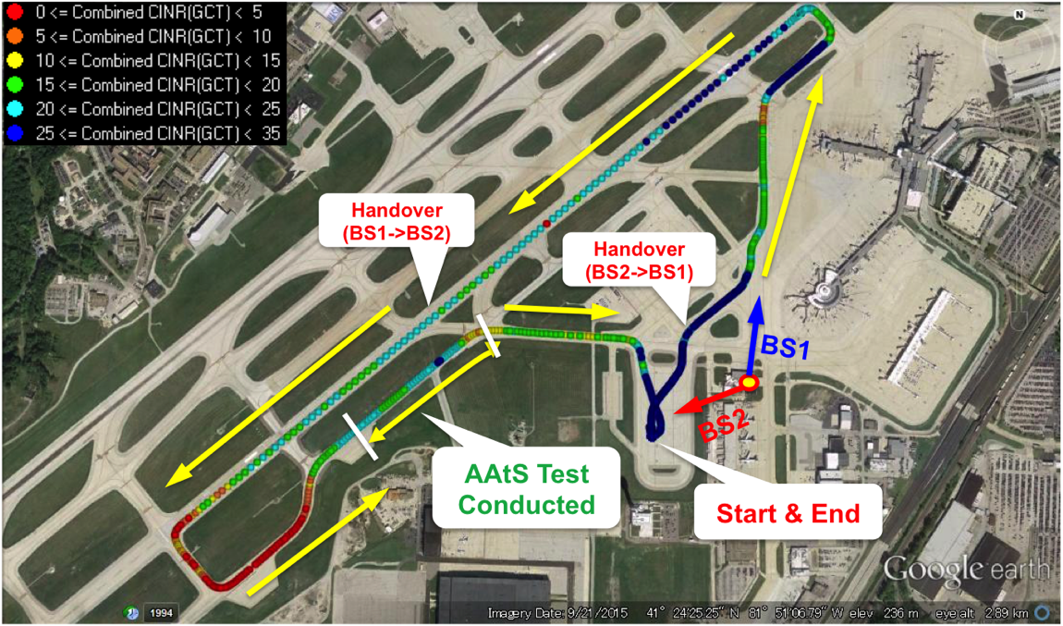
Figure 13 - Aircraft Test Trajectory and Signal Strength
    - In Figure 14, the airplane speed and DL CINR are shown relative to elapsed time. The simulated touchdown was expected at time 350-400 seconds, and as the airplane slowed to 45 knots, the SS started network entry procedure. However, while the airplane was moving at the end of the runway, the SS lost connection due to terrain blockage, as expected. When the BS came into sight, the SS started network entry procedure and SWIM data exchange test was conducted here. The DL CINR was better than 15 dB.
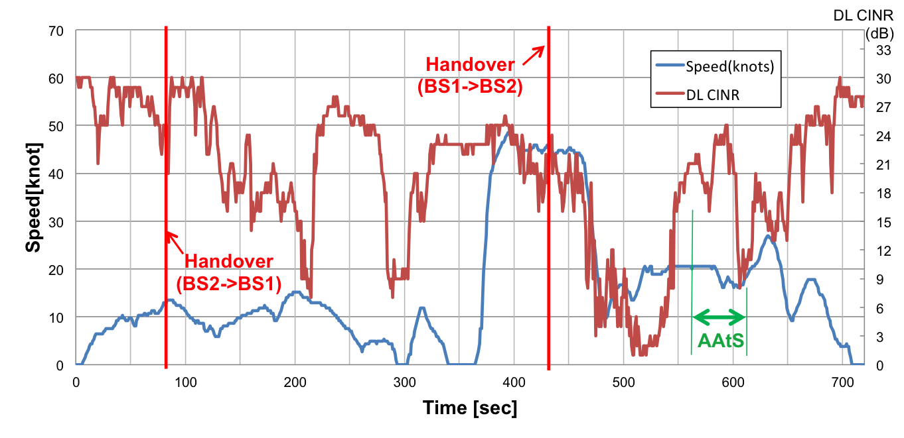
Figure 14 - Test Case 1 Results

    - Test Case 2 - Figure 15 shows the results of Test Case 2. In this test, SWIM data and simulated AOC data streams were used. The total data exchanged during the test period of 50 seconds was 30.9 MB and it was similar to the results of Test Case 1. Required AOC data transfer of 10 MB for DL and 2 MB for UL were completed within 23 sec (DL) and 16 sec (UL). Increased channel load data traffic attributed to the AOC information had no effect on SWIM data flow.
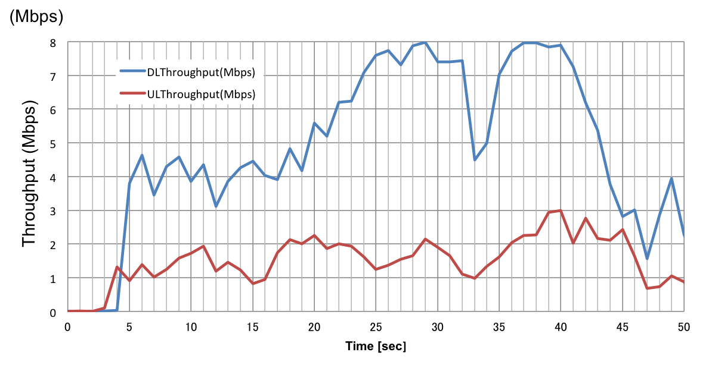
Figure 15 - Test Case 2, Data Throughput

    - Test Case 3 - The principal objective of Test Case 3 was to verify that an electronic flight bag (EFB) on-board an aircraft is able to access SWIM data via AeroMACS while additional data is exchanged between other airport systems using other SSs connected to the same BS. This case is similar to Test Case 2 but adds loading on the AeroMACS communications system to emulate the exchange of radar data from a fixed station to the Air Traffic Control Tower (ATCT). The aircraft followed the same procedure as Test Case 2. Emulated surveillance was captured from a system operating in the NAS.
Surveillance specific information:
- Terminal Airport Surveillance 11
- Data Rate: 14 Kbps Throughput
- Frame Rate: 25 FPS
- Emulated using iperf
- Source: FNT, MI Airport

    - Results for Test Case 3 showed the additional loading of the AeroMACS system had no impact on SWIM and AOC system performance.

- Future AeroMACS Mobile Application Trials and Testing
  - NASA GRC is in the process of developing mobile AeroMACS test plans moving to a higher level of complexity. The next set of tests under consideration will be based on an end-to-end trial in which we will have two airports equipped with AeroMACS. This trial configuration will enable the test and evaluation of security performance, system entry, interoperability, AAA server configuration, latency and other important system parameters. The test will include installation of AeroMACS at Detroit Metropolitan (DTW) airport and accomplish end-to-end trials with Cleveland Hopkins (CLE) airports as shown in Figure 16.

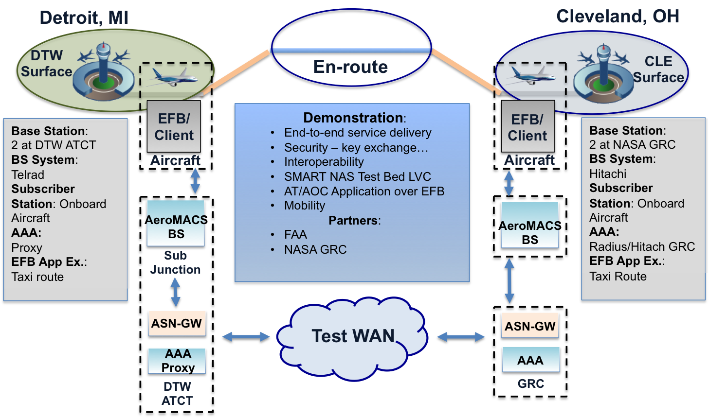
Figure 16 - AeroMACS End-to-End Trial

  - AeroMACS trial will focus on:
1 - Interoperability testing
- Evaluation of hardware and software subscriber station compatibility between two different AeroMACS technology developers
- Test Access Service Network (ASN) configurations and Communication Service Network (CSN) possible implementations
2 - Security Trial: Evaluate different system security concepts and configurations
- System access request authentication
- Service access authorization
- Certificate authority, management, revocation, etc.
3 - Application performance test
- VoIP
4 - Internet Protocol Suite Trial and Evaluation
- IPv6, IPv4, 6To4
- Roaming scenarios
- ASN and CSN option configurations
5 - End-to-end Service Delivery

- CONCLUSION
  - AeroMACS has progress from initial concept through design and prototype development and validation. Testing at several airport locations worldwide has supported standards development through RTCA, EUROCAE and ICAO. Initial deployment of AeroMACS at several U.S. airports has been enabled through programs supporting fixed AeroMACS applications, in particular airport surface multi-lateration-based surveillance systems.
  - True mobile applications of AeroMACS require development, testing and validation of applications and equipage of aircraft, normally a relatively long process. To advance this process, trial and testing of mobile AeroMACS applications is now underway. In this paper we have described two such trials - the RTCA Compliant Prototype Field Trials demonstrating the ability of AeroMACS equipment to meet approved standards in the provision of mobile applications, and SWIM Data to the Aircraft over AeroMACS Trial, demonstrating the delivery of SWIM data to the aircraft. Connectivity of aircraft to SWIM is expected to be a primary driver of the mobile use of AeroMACS.
  - More extensive and complex trials of mobile AeroMACS are now under development, intended to facilitate the eventual future deployment of mobile AeroMACS applications to the aircraft.

— END —

