 | International Civil Aviation Organization  INFORMATION PAPER
  FSMP WG-F33/IP-01
  2015-08-11

FREQUENCY SPECTRUM MANGEMENT PANEL (FSMP)

Thirty-Third meeting of Working Group F (Frequency)

Montreal, Canada, 24 to 28 August 2015

Agenda item 9 | Any Other Business

Introduction of Development of Wireless Relay Communication System using Small Unmanned Aircraft and Request Information of Allocation of Frequency Band
For Unmanned Aircraft Used Locally As Public or Commercial Use.

(Presented by NICT)

SUMMARY
This Information Paper gives an introduction of development of wireless relay communication system using small unmanned aircraft and some experimental results using 5GHz band allocated for CNPC links. And we also invite WG-F members to provide their efforts or comments of the frequency usage that realize their safety operations of small or medium-sized unmanned aircrafts used locally as public or commercial applications.

- Introduction
  - In Japan, there is a growing interest in the use of unmanned aircraft for measures against geographic structure inherent to island nation and natural disasters. Until now, we have developed a radio relay system using small unmanned aircraft, and have conducted research and development to ensure communications at the time of disaster. We have done also studies of the propagation characteristics and interference to/from other systems in the 5GHz band which was newly assigned to CNPC at WRC-12.
  - Recently with the progress of unmanned aircraft system (UAS) technologies, UAS has received a lot of attention in recent years in the world for several applications or commercial services such as weather observations and distribution services. It is also expected to expand the use of small and medium-sized unmanned aircrafts (UAs) and to operate them in a short range with relatively small transmission power because of their flexibility and ease of manageability.
  - Recognizing the increased need for the short-range usages of UAs for public uses or several applications, we began to look into the feasibility of frequency allocations for control and application links of small or medium-sized UAs in Japan.
- Discussion
  - National Institute of Information and Communications Technology (NICT) has developed a prototype equipment that provides the communications infrastructure using unmanned aircraft in the event of a disaster, and performed experiments using a small unmanned aircraft to confirm its effectiveness and to obtain propagation data in the 5 GHz band. The details of the overview and result of the development mentions in Appendix 1.
  - Contrary to hobby uses of UAs and taking into account the reliability of C2 link for public or commercial uses and the safety operations of UAs, discussion for the frequency band for small or medium-sized UAs operations and air traffic control (ATC) services that realize coexistence with existing services should be required.
- Action by the meeting
This Information Paper gives an overview of the relay network system using small UA and satellite telecommunication systems and some of the experimental results of the characteristic analysis in the 5GHz band allocated for UAS CNPC links. And we also invites WG-F members to provide their efforts or future planes of the frequency usage that realize their safety operations and ATC services of small or medium-sized unmanned aircrafts which are used locally as public or commercial applications. For example, we are interested in their utilization form and their use plan of the 5GHz band which was used in our development.
Appendix 1

1. Introduction
The frequency band from 5030 MHz to 5091 MHz was allocated to control and non-payload communications (CNPC) links for unmanned aircraft systems (UAS) and the characteristics of the frequency band is being discussed because CNPC links for UAS must be secure and stable to realize safety operations and ATC services of UAS. Specifically propagation characteristic of CNPC links is considered to be one of the important research issues.
Meanwhile National Institute of Information and Communication Technology (NICT) in Japan has started R&D on a wireless relay system using small-unmanned fixed-wing aircraft (UA) systems and a satellite telecommunication system for large-scale disasters where the wireless relay system using UAs can cooperate with cellular network because we had experienced large-scale disasters in Japan and realized that most advanced and popular mobile phones become almost useless under large-scale disasters due to physical damages, electricity outages, and traffic congestions. In addition, many areas in mountains or islands were isolated due to the total damage of roads, harbors, and communication infrastructures. Under such situation, it is desired to provide temporal communication lines rapidly deployable to the isolated areas until the recoveries of ground infrastructures and to monitor the situation in the whole of disaster areas. We developed an evaluation system for the wireless relay system using small UAs in which the frequency band from 5030 MHz to 5091 MHz was chosen to establish the CNPC link and communication link and to evaluate the characteristics of the frequency band and the communication quality. This paper describes an overview of the evaluation system using small UA with 5GHz band and some of the experiment results.

2. Overview of evaluation system using UA and satellite systems
Figure 1 shows an overview of an evaluation system using an integrated relay network by a small-unmanned aircraft and satellite telecommunication systems. The system consists of a small UA-based wireless bridge system, a satellite telecommunication system and a cellular network. In the small UA-based wireless bridge system, a small UA serves as a moving relay among the ground stations (GS). The GS1 (or GS2) is transmitting information to the distant GS2 (or GS1) and the UA assists its communication as a relay. The specifications of small UA system vital to wireless bridge system are shown Table 1. The frequency for control and non-payload communications (CNPC) of small UA system was chosen from 5035MHz to 5085MHz.

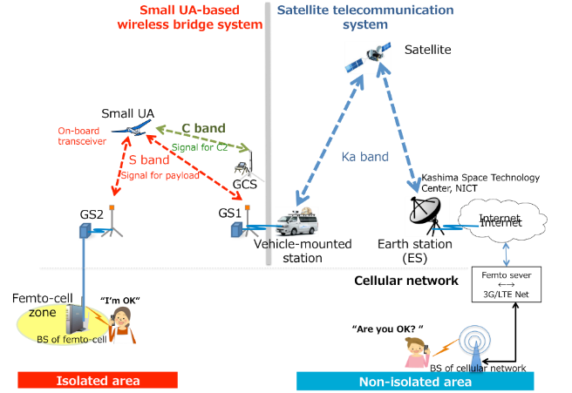

Fig. 1 An overview of evaluation system using UA and satellite

Table 1 Specifications of small UA system
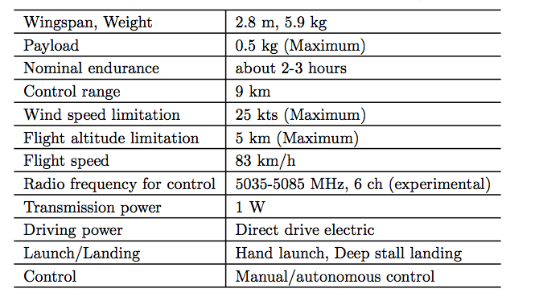

3. Experimental deployment
The area for experimental measurement is located in the depths of mountains (1400 feet above sea level) in Kochi prefecture, Japan and it is out of coverage of cellular network. The wind direction at launch/landing area changes frequently due to the depths of mountains. The fixed-wing UA is considered to be suitable for the case of the environment and at the time of disasters in Japan since it is difficult for rotary-wing UA to launch/landing in such situation. The flight altitude above see-level of small UA was set at about 2900 feet and the speed of wind was about 4 knot in this experimental measurement. The ground control station (GCS) for UA was located 2 km from UA.

4. Results
Figure 2 shows an example of characteristic of radio propagation for UA with 5060 MHz. The UA orbited at the flight altitude (2900 feet (MSL)) during this measurement. The turning radius of UA was about 200m. It was observed that the received signal strength varied from -75 dBm to -98 dBm.

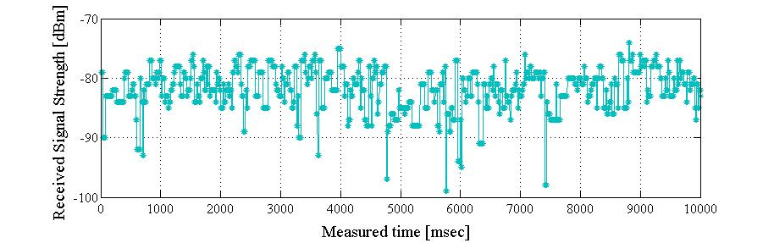
Fig. 2 Characteristic of radio propagation of 5060MHz

5. Conclusion
This document provides overview of experimental measurement using small UA with 5GHz band and some of the results. We obtained measurement data for the analysis of the propagation characteristics of 5 GHz band and confirm the success of the cooperation with cellular network using the system and the effectiveness of small UA with 5GHz band for disaster in Japan.

Acknowledgments
This work was supported in part by Shikoku Bureau of Telecommunications, the Japanese Ministry of Internal Affairs and Communications (MIC), KDDI, Softbank, docomo and TOYO corporation. The part of according to 5GHz was supported by the MIC in R&D on Cooperative Technologies and Frequency Sharing Between Unmanned Aircraft Systems (UAS) Based Wireless Relay Systems and Terrestrial Networks.

— END —

