FREQUENCY SPECTRUM MANGEMENT PANEL (FSMP)

Nineteenth Working Group Meeting

Montreal, Canada, 16 to 26 July 2024

Agenda Item 8: Any Other Business

Terminal Operations Using RF-based Vision Navigation and Landing Systems

(Prepared by Carlo Tiana and Sai Kalyanaraman, Collins Aerospace)

SUMMARY
Currently, low visibility aircraft operations are greatly aided by infrared-based systems, but these have reached the physical limits of their capabilities. Longer range vision through atmospheric and other obscurants is required in support of terminal area operations for a wide variety of airborne platforms, including commercial air transport, regional aircraft, helicopters and other advanced air mobility platforms, piloted or otherwise.
Since the performance of passive infrared based systems has reached its limits, the avionics industry has generally been developing a number of radio frequency (RF) based imaging and ground mapping solutions, aimed at extending the range of operations currently covered by legacy systems.
Collins Aerospace and various other organizations have been developing and testing such systems over the last few years; these have reached a level of maturity that enables us to move to the next phase of development in support of meeting global low visibility operations requirements.
As a result, Collins Aerospace plans to deploy these systems in 31.8 – 33.4 GHz (Ka band) and 95 – 100 GHz (W band). Both frequency bands are allocated to radionavigation services (RNS) as primary services in the Radio Regulations within ITU and are also allocated to other services with which the vision systems have to coexist.

- Introduction
  - The frequency band 31.8 – 33.4 GHz (Ka band) and 95 – 100 GHz (W band) are allocated to radionavigation services (RNS) as primary services in the Radio Regulations within ITU.
  - These frequency bands are key enablers for the deployment of systems designed to provide navigation and collision avoidance functions to a wide range of airborne platforms. Systems operating in these frequency bands can penetrate many water based atmospheric obscuration (e.g. fog, snow) as well as other obscurations (e.g. carbon particulates, smog, smoke, sand) that cause low visibility conditions that increasingly prevent operations at many locations around the world.
  - Low visibility operations today are enabled by infrared-based systems that deliver some mitigation of the issues caused by low visibility by replacing vision thru atmospheric obscurants with “Enhanced” vision from camera systems. These systems are generally known in the industry as “Enhanced Flight Vision Systems” (EFVS), but their effectiveness is limited in range of vision due to fundamental physical limits of atmospheric penetration in the visual thru infrared spectral bands. In the lowest visibility conditions – for example, 100m or less – these systems do not provide enough atmospheric penetration to be useful. The aviation industry is looking for alternate means of producing EFVS systems with the ability to see further and in lower visibility conditions than current EFVS systems. A useful range of operation would be in the 3-10 Km range, which is supported by the atmospheric characteristics at the identified bands.
  - Evolution in technologies for transmitting and receiving radiation at these bands has caused the feasibility and affordability of RF based EFVS systems to become viable for broad deployment in the civilian and military airspace: this has the potential to enable low-visibility operations broadly around the world at facilities lacking advanced ground infrastructure, as well as enabling and increasing the safety of operations in dense airspace, both around current facilities impacted by frequent visibility impairments or new dense urban air traffic environments where safe separation and avoidance of potentially uncooperative traffic must be ensured.
ICAO FSMP has had earlier discussions re: spectrum for EFVS applications. These addressed the 31.8 – 33.4 GHz band in relevant detail (although the 95 - 100 GHz band is also allocated to Radionavigation and FIXED services and considered for EFVS). The following material covered EFVS related discussions in previous FSMP meetings: WG15: IP06, WP21; WG16: WP13.
- Technology

This paper provides information broadly based on what is known about technologies that are under development at a number of global manufacturers. Collins Aerospace in particular is leading the development of systems operating at Ka and W bands and much of the background of this section derives from those efforts. In this section we describe recent advances brought to the performance and affordability of Ka and W band technologies that finally enable broad deployment of EFVS systems operating at these bands.

  - The demand side: high density, all-weather airborne operations
    - Global aviation operations have been rapidly increasing (excluding the short-lived dip during the SARS-CoV-2 pandemic), both in developed markets with mature airspace, and in underdeveloped regions showing rapid growth of air travel and delivery demands to remote places. The buildout of ground infrastructure for aviation at all locations has been rapid and often the facilities being built (airfields, helipads, vertiports) provide only the most basic support for low visibility operations – with little or none of the expensive ground infrastructure capabilities that exist at very few legacy airports around the globe (for example, high-performance Autoland support in the form of advanced Instrument Landing Systems installations) are being built out. In addition, economic and competitive pressures on the air travel system have caused great scrutiny on the cost of aircraft-side equipment: Autoland systems are expensive to acquire, deploy, maintain and train for. Thus cheaper, lighter technologies - such as EFVS systems - have seen broad adoption as low-visibility operational enablers.
    - Further pressures on the airspace are coming from additional concepts of operations for a myriad of new airborne vehicles designs. These proposed vehicles and operations will potentially increase the requirements to both reliably support operations in visibility conditions as well as ensuring safe deconfliction of airborne traffic in dense environments, potentially not in the vicinity of traditional airfield locations.
    - Finally, there are concerns about the long-term reliability of GNSS-based navigational support systems. Recent experience has shown GNSS systems to be vulnerable to jamming and spoofing, subverting a fundamental assumption from the last few decades that these systems would increasingly form the foundation of navigational systems worldwide. The technologies supported by the allocated spectrum provide independent confirmation of navigation solutions needed to operate with confidence around the globe.
  - The supply side: high-volume, low-cost components from adjacent markets
    - The explosion of ground-based telecom bandwidth demands has caused rapid and substantial advances in the component design and production for systems radiating and sensing generally in the mm-wave spectral bands.
    - The tremendous demand for these components has largely come from the telecom industry, which consumes them in large quantities. For example, millions of cellular phone towers around the world in use today, and soon to be deployed, typically incorporate electronically scanned antennas radiating and sensing at mm-wave frequencies. The supporting mixed-RF electronics to generate, sense, digitize and steer the signals are now commonly available from dozens of global manufacturers.
    - Volume manufacturing of semiconductor components based on Gallium Nitride (GaN), Gallium Arsenide (GaAs) and Silicon-Germanium (Si-Ge) substrates has led to the development of dense integrated systems operating in the mm-wave spectral bands.
    - The demand and optimization of RF components for telecom consumption has driven down manufacturing costs and optimized global production of these key devices with sources distributed around the world. This is appealing as a broad supply base is important for global deployment, as well as to decrease concerns about the global exportability of these systems, as the capabilities to design and produce them exist in every developed country.

  - Representative Technologies

This section describes current technologies deployed on aircraft globally for low visibility operational expansion, and their limitations. We then describe how current technologies can be enhanced or replaced by RF systems operating in the requested spectrum.

The governing arguments related to atmospheric absorption hinge on the plots shown in Figure 1 below.

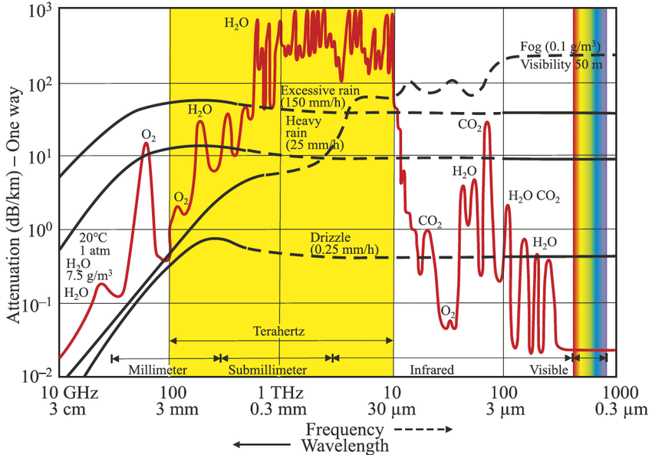

Figure 1 – Atmospheric attenuation for Radio-Frequency thru Ultraviolet spectrum. Source: ().
    - Infrared-based Enhanced Vision Flight Systems (EFVS). Today most fixed wing aircraft can be fitted with camera systems that “see” through atmospheric obscurants that generally impair pilots’ natural vision and prevent normal “visual” landing operations. As the visibility decreases at a desired landing locations below that for which the location is able to support operations, aircraft are required to divert to alternate sites. With today’s Enhanced Vision Flight Systems, pilots’ natural vision can be “replaced” or augmented by real time imagery from the EFVS systems, and the operation can be completed in lower visibilities than normally approved. These operations are supported by global regulations that are leveraged daily for improved airspace throughput and safety, as well as sustainability benefits from the lack of diversions and displaced passengers and goods.
    - Infrared based technologies suffer from a couple of limitations. One is fundamental considerations of the propagation characteristics of the infrared spectrum through the atmosphere. A combination of absorption and scattering phenomena prevent penetration at ranges much beyond those achieved today by modern EFVS systems, and therefore prevent additional operational benefits from being derived from these systems. Another challenge comes from the transition of airfield lighting systems from legacy incandescent-filament technologies to modern, efficient Light-Emitting Diode (LED) lighting technologies. Incandescent systems provide a strong other-than-visible spectrum signature that can be leveraged to exceed the performance of the human visual system. LED emissions largely overlap pilots’ visual performance and are therefore subject to the same low visibility extinction challenges. While this issue is being addressed with inventive methods, fundamentally the visible through infrared spectral bands have today been exploited to close to their theoretical maximum.
    - Certain portions of the Radio-Frequency spectrum provide advantageous atmospheric penetration compared to the infrared spectrum. In particular, referring to Figure 1., the dips in absorption due to water vapor (red curve) and aqueous typology (rain, fog) in the 33-35 GHz and 94-95 GHz bands is of great interest. These spectral bands overlap with the spectrum allocated for radionavigation and are ideal for atmospheric penetration in support of low visibility operations in the terminal phases of flights, where the useful and required ranges of penetration are only of the order of 10 Km or less, not hundreds. A representative Radio-Frequency based EFVS system therefore operates in these frequency bands, emitting a signal with sufficient power and 3D resolution to reach the airfield environment through the challenging obscurants and return to the aircraft with sufficient residual Signal-to-Noise, Signal-to-Clutter and Signal-to-Background characteristics for detection and processing aimed at generating a visual depiction of the airfield in real time for presentation to the flying crew, much like infrared-based EFVS systems do today. The resulting image presented to the crew must be of sufficient quality and meet the specification of current regulations detailed, for example, in the Radio Technical Commission for Aeronautics (RTCA) guidance document DO-341 “Minimum Aviation System Performance Standards (MASPS) for an Enhanced Flight Vision System to Enable All-Weather Approach, Landing and Roll-Out to a Safe Taxi Speed” and similar harmonized guidance and regulations produced by certification authorities around the globe. Additionally, other concepts are being investigated for exploitation of the proposed RF systems that go well beyond the presentation of an image to a pilot and are suitable for monitoring, confirmation or automatic generation of navigation signals for piloted, optionally piloted and autonomous airborne systems.
    - Radio-Frequency systems delivering the performance of the named MASPS and operating in the named spectral bands take the form of a RADAR system, either Frequency-Modulated, Continuous Wave (FMCW) or other possible designs, and typically require a spectral bandwidth of about 120 MHz to support the required resolutions. Multiple spectral slots of this bandwidth are required in support of this operation to deconflict a small number of systems operating in the same geographic location, for example when a number of aircraft are sequenced to land on the same runway at close spacing and are all emitting within the allocated spectral band.
    - The antennas for these systems are Electronically Scanned Antennas (ESAs) that need to be as compact as possible to minimize aerodynamic impact to the flying platform. Mechanically scanned systems do not typically deliver the long-term reliability required for modern commercial platform deployment. The ESAs must also be or large enough size and contain enough transmitting and receiving elements to achieve the required round trip range (~10Km) and resolution (discrimination of the runway, helipad or landing zone environment from the surrounding ground context; detection and discrimination of the regulatorily “required visual references”) to support the operation.
    - Systems meeting these requirements therefore transmit the desired signal, which reached the landing environment and reflects back to the aircraft for appropriate processing and exploitation, either visual or automatic. For a visual presentation an image-like perspective depiction of the environment is presented to the flying crew. An example of this type of presentation can be seen at: https://www.youtube.com/watch?v=KKxa0GnvG_0 This is the proof of operation of a 94GHz FMCW Radar built by the now-defunct Lear Astronics Corporation and flown in the 1990s under DARPA sponsorship to demonstrate the viability of this type of technology and operational concept. A frame capture from this (rather poor quality) historical video clip is reported in Figure 2. Multiple piloted demonstrations and evaluations of this system resulted in the general consensus that a system such as this could be developed to fully support the desired operations. While this system at the time was not viable from a commercial standpoint, modern technological advances mentioned in previous sections of this document have now enabled the commercial viability of these types of systems, and current prototypes deliver just the type of output required to support the low-visibility operational desires of the aviation industry.
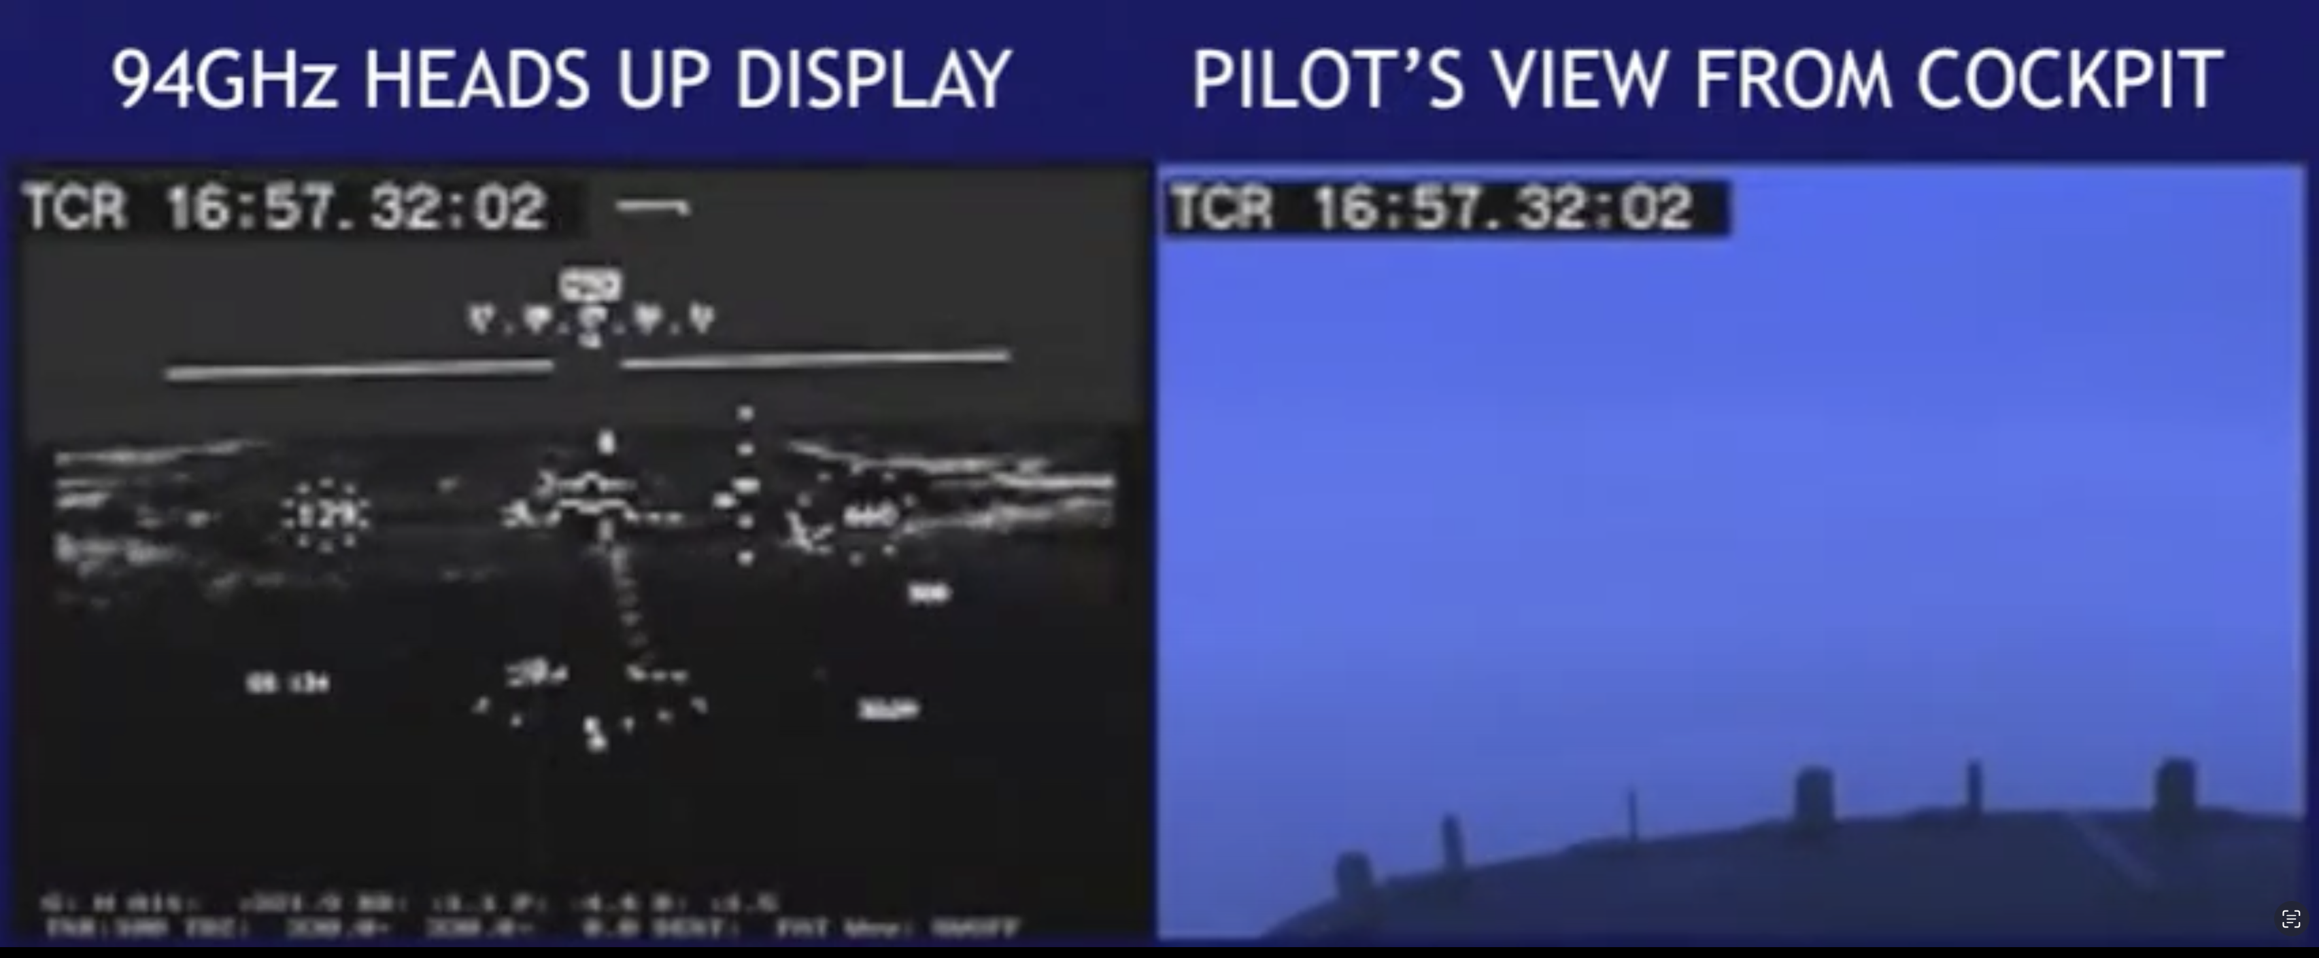
Figure 2 – Frame capture from https://www.youtube.com/watch?v=KKxa0GnvG_0 This system demonstrated low-visibility airborne operations at 94GHz.
- Considerations/questions
  - It is understood that spectrum is available for Radio-Navigation applications in the frequency bands of 31.8 – 33.4 GHz (Ka band) and 95 – 100 GHz (W band). Both frequency bands are allocated to radionavigation services (RNS) as primary services in the Radio Regulations within ITU and are also allocated to other services with which the vision systems have to coexist.
  - It is also recognised that the ICAO FSMP group can promote the work required to help facilitate applications of these spectral allocations to low-visibility operational enhancements required by the global aviation industry today. Systems demonstrating such operational suitability are being developed and tested globally.
  - The appropriate set of experts can consider the results of studies and analysis to ensure that all factors are considered.
- Action By the Meeting

The meeting is invited to:
- note and review the contents of this working paper and provide feedback on the same;
- consider the formation of a working group of experts to evaluate and finalize details of the utilization of the allocated spectrum for the purposes described in this working paper
— END —

() Source: https://www.researchgate.net/figure/Terahertz-Channel-Model-Classification_fig3_337266839

