FREQUENCY SPECTRUM MANAGEMENT PANEL (FSMP)

Nineteenth Working Group Meeting

Montreal, Canada, 15 to 26 July 2024

Agenda Item 3 Development of Material for ITU-R Studies
b) Non-WRC material for the ITU

Unmanned Aircraft System Control and Non-Payload Communications Links operating in the aeronautical mobile (route) service and aeronautical mobile satellite (R) Service in the band 5 030-5 091 MHz

(Presented by Katsuyuki ARAKAWA)

SUMMARY
This paper recommends ICAO to inform the ITU-R WP5B about the current status of standardization works at ICAO related to 5GHz UAS CNPC, and to ensure standardization works at ITU and ICAO will be carried out in a harmonised manner.

- INTRODUCTION
  - It was agreed by the ITU-R WRC-12 that use of the frequency band 5 030-5 091 MHz by the aeronautical mobile (R) service and aeronautical mobile satellite (R) service is limited to internationally standardized aeronautical systems as described in Radio Regulations (RR) No. 5.443C and No. 5.443D.
  - Characteristics and protection criteria of Terrestrial and Satellite Unmanned Aircraft System Control and Non-Payload Communications Links operating in the aeronautical mobile (route) service and aeronautical mobile satellite (R) Service in the band 5 030-5 091 MHz (5GHz UAS CNPC) are being developed as an ITU-R recommendation with the ITU-R WP5B.
  - At the ITU-R meetings, there are difficulties in developing the ITU-R recommendation related to 5GHz UAS CNPC because some States expressed their concerns that remotely piloted aircraft systems as the internationally standardized aeronautical systems are not yet established. They claim that the ICAO SARPs for the UAS CNPC of the 5 030-5 091 frequency band have not been developed yet.
- DISCUSSION
  - The ICAO has already developed the Standards and Recommended Practices (SARPs) related to the 5GHz UAS CNPC for the operation of remotely piloted aircraft systems (RPAS).
  - Proposed amendment 90 to Annex10 Volume V was developed by the thirteenth meeting of the Remotely Piloted Aircraft Systems Panel (RPASP/13). The proposal addresses the specifics of the frequency bands which can be used for the C2 Link. The frequency bands with an allocation to tha fixed satellite service (FSS) are also listed in it. After ANC reviews and States consultation process, Amendment 90 to Annex10 Volume V was adopted by the Council at the fifth meeting of its 222nd Session on 1 March 2021.
  - Proposed Annex 6, Part IV was developed by the eighteenth meeting of the Remotely Piloted Aircraft Systems Panel (RPASP/18) and addresses the international operation of remotely piloted aircraft systems (RPAS). After ANC reviews and States consultation process, Annex6 Part IV, a brand new Part, was adapted by the Council at the fifth meeting of its 231st Session on 18 March 2024.
  - Both SARPs will become applicable on 26 November 2026.
  - In order to ensure flexibility of RPAS operations, many options need to be available for the CNPC links. The ICAO should inform to the ITU-R WP5B the current status of development of the RPAS SARPs and related documents to achieve the above objective that maintain the flexibility with RPAS operations.
  - By sharing the progress of developing the ICAO SARPs and related documents, the ICAO should encourage that the both international standards, the ITU-R Radio Regulation and the ICAO SARPs, are developed in a harmonized manner and ensure international interoperability through alignment.
  - In accordance with the ITU WP5B, the UAS CNPC links consist of a conbination of a terrestrial based component, a high-altitude relay-based component and a satellite-based component.
Figure: Example command and non-payload communications link system components (ITU WP5B)
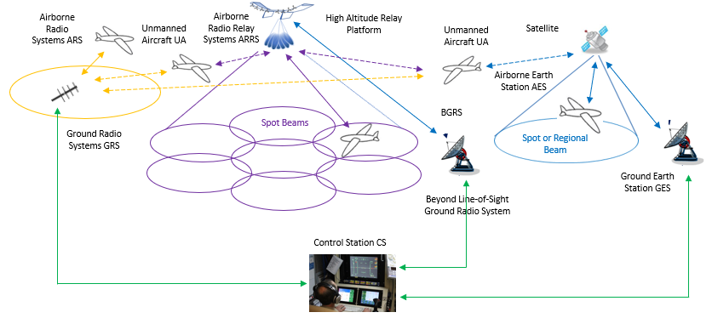
  - Recognizing that the standards development prosess have been carried out simaltaniusly at the ITU and the ICAO, it is also necessary to share relevant information to the RPAS panel continiusely, such as the progress of the development of the ITU documents and the status of discussions at the ITU-R meetings.

- ACTION BY THE MEETING
  - The Meeting is invited to:
- Note the contents of this paper;
- Recommend the ICAO to inform the ITU-R WP5B about the current status of standardization works at ICAO related to 5GHz UAS CNPC, and to ensure standardization works at ITU and ICAO will be carried out in a harmonised manner.

— END —

