FREQUENCY SPECTRUM MANAGEMENT PANEL (FSMP)

Nineteenth Working Group Meeting

Montréal, Canada, 15 to 26 July 2024

Agenda Item 5c: Aeronautical band planning – 5000 – 5150 MHz

Proposal of the use of 5030 – 5091 MHz frequency band for C2 links

(Presented by Guillaume Novella)

SUMMARY
This working paper introduces preliminary elements to be taken into account for initiating the use of the frequency band 5030 – 5091 MHz for control and command (C2) links.

- INTRODUCTION
  - First version of the RPAS SARPs has been submitted to RPAS plenary for finalization in order to be submitted to ANC. RPAS Panel is now working on a C2 Link manual which identifies 3 types of C2 Link systems operating in the same 5030 – 5091 MHz frequency band: ground-based C2 Link, airborne relay C2 Link and satellite-based C2 Link. The coexistence between these different solutions is currently investigated by Eurocae and RTCA groups. ICAO is in charge to provide guidance on how spectrum should be shared among the different aeronautical systems for which those bands are allocated. Dedicated processes to develop channel plans in collaboration with the responsible authorities from the member states could be defined.
  - To this purpose, this working paper introduces preliminary elements to be taken into account for initiating the use of the frequency band 5030 – 5091 MHz.
- DISCUSSION
  - FSMP-WG18-IP05 contains examples of spectrum use for both terrestrial and satellite based C2 Link systems in the 5030-5091 MHz frequency band. In particular, it analyses the two following possibilities for sharing the frequency band 5030 -5091 MHz:
- Split band, among non_compatible systems, e.g. with different TDD timeframes
- Flexible planning among systems with compatible TDD timeframes

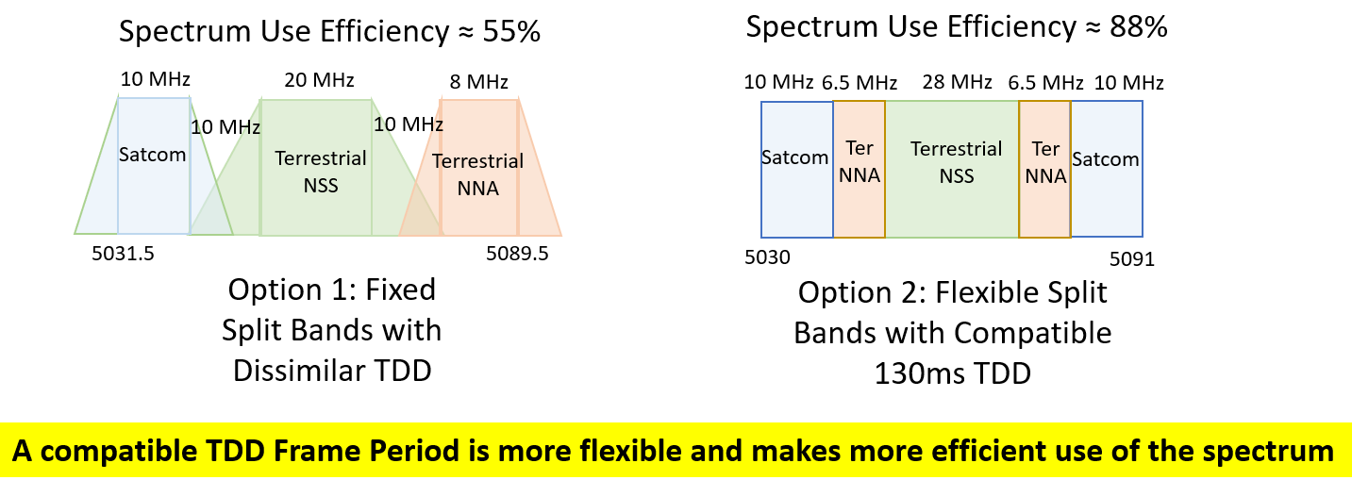
  - In addition, FSMP-WG18-IP05 contains consideration about potential frequency channelization and geographical frequency reuse of this frequency band (see picture below).

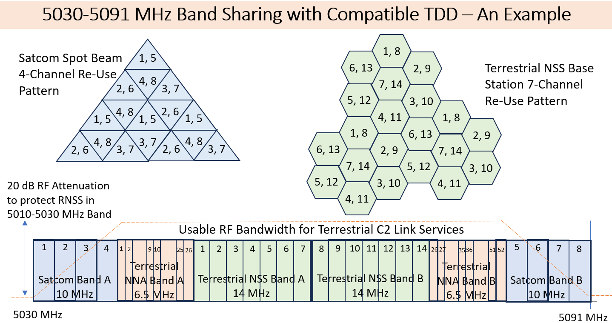

  - High level principles enabling sharing and optimal usage of the 5 030 - 5 091 MHz band by AM(R)S and AMS(R)S
    - Systems compatible with both terrestrial and satellite standards are being actively developed. Each system will be designed to be able to operate in the whole band, or in any part, of the 5030 – 5091 MHz band, supporting RPAS operation. In order to enable their deployment and adoption a regulatory framework needs to be developed for national and international operations
    - The following principles are proposed in order to enable sharing and optimal usage of the 5 030 - 5 091 MHz band by AM(R)S and AMS(R)S:
      - The standards for such systems need to guarantee that coexistence and band sharing between terrestrial and satellite systems operating in the same area are possible
      - Channel plan for both systems are expected to be performed under the guidance of ICAO, noting that some rules may vary between different regions.
      - Study work to assess potential constraints required to guarantee coexistence between RTCA and EUROCAE standards is ongoing. More details on these technical and operational constraints and the related spectrum sharing considerations will be available when the standardisation of such systems are finalised.
      - International operations shall be guaranteed and a minimum (TBD) number of channels should be allocated to each system in each region.

- ACTION BY THE MEETING
  - The meeting is invited to:
- note and review the contents of this working paper;
- agree and endorse the high level principles introduced in section 2.3
- continue studies and support the ongoing work, in particular within Eurocae WG-105 and RTCA SC-228, on the coexistence and spectrum sharing possibilities between aeronautical systems operate in this band and on the efficiency of the use of the 5030 – 5091 MHz band, identifying solutions to accommodate constraints of the different C2 Link systems;
- setup an FSMP task group to develop a proposal for a “time limited harmonised channel plan" for operations outside of international waters to enable the short term deployment and usage of systems in this band to provide C2 Link services, with report to FSMP-WG/20.
— END —

