FREQUENCY SPECTRUM MANAGEMENT PANEL (FSMP)

Seventeenth Working Group Meeting

Cairo, Egypt – 30 August – 7 September 2023

Agenda Item 4: Radio Altimeter issues – FSMP.006.02

Co-existence between 5G Systems & Radio Altimeter in Canada

(Presented by: Abed Ferr, Seyed Rastaghi)

(Prepared by NAV CANADA & TCCA)

SUMMARY
This Working Paper presents the action taken, by the Administration of Canada, to protect aircraft’s radio altimeter operating in 4200-4400 MHz band against the 5G operations in the 3450-3900 MHz Bands. This paper retraces the establishment of regulatory texts dealing with the 3500MHz, 3800MHz, and 3900MHz bands, and their amendments with regard to 5G roll out in Canada. The results obtained from studies led by ISED in this context show that Radio Altimeters could be subject to 5G radio interferences; consequently, they require sufficient protection.

- INTRODUCTION

Radio Altimeters are essential sensors providing input to several safety and navigational functions during all phases of flight. These functions include terrain awareness and warning systems (TAWS), traffic alert and collision avoidance systems (TCAS) and on-board collision avoidance systems (ACAS), detection systems wind shear, flight control systems and automatic landing systems.
The ubiquitous use of radar altimeters is not just a matter of convenience; therefore, State Civil Aviation Authorities require a reliable use of radio altimeters. During the initial consultation for policy and licencing framework for spectrum in the 3500 MHz band, Innovation, Science and Economic Development Canada (ISED) received concerns regarding the potential interference from 5G services to radio altimeters in the adjacent band, 4200-4400 MHz, leading to implementing a series of mitigation measures to protect the radio altimeters without compromising the development and expansion of the 5th generation of mobile network. The process which included a comprehensive study along with numerous consultations with multiple stakeholders took more than two years to make final decisions based on a balanced approach. These measures are reflected in the standards setting out the technical requirements of fixed and/or mobile systems, including flexible-use broadband systems, in the band 3450-3900MHz, that this paper presents.

- HISTORY

In spring 2020, Innovation Science and Economic Development Canada (ISED) published two technical standards: SRSP-520, issue 1 (Technical Requirements for Fixed and/or Mobile Systems, Including Flexible Use Broadband Systems, in the Band 3450-3650 MHz), and RSS-192, issue 4 (Flexible Use Broadband Equipment Operating in the Band 3450-3650 MHz), based on the Policy and Licensing Framework for Spectrum in the 3500 MHz Band with no specific mitigation measures for Radio altimeters.
In May 2021, ISED became aware of studies that had shown a possibility of interference to radio altimeters from signals outside their band of operation, which could include signals from flexible use deployment of 5G systems in 3500 and 3800 MHz bands around airports and heliports (see Fig.1). ISED continued to monitor and investigate this issue as it evolved to update the technical rules in the 3500 MHz band to mitigate potential interference with radio altimeters.
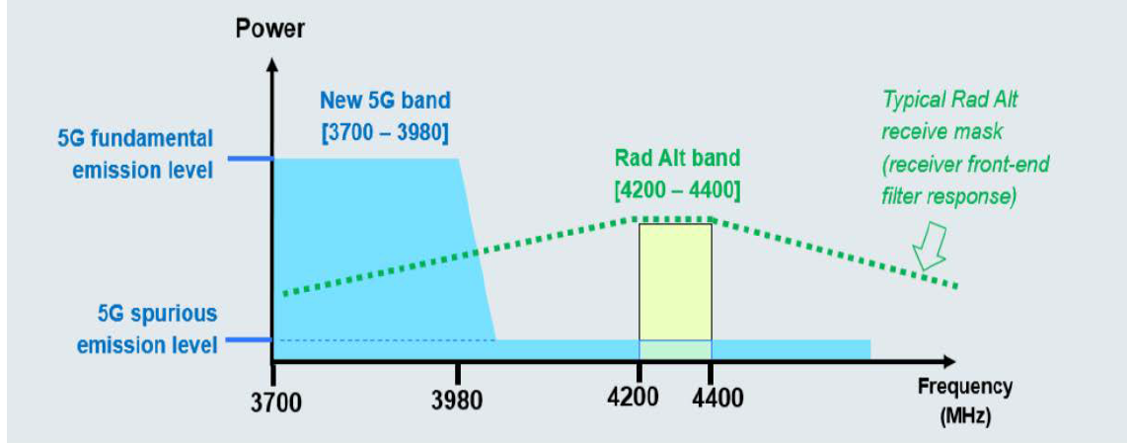
Fig. 1: Spectrum illustration showing the 5G Fundamental and Spurious Emission.

In August 2021, Transport Canada (TC) published the Civil Aviation Safety Alert (CASA) No. 2021-08: “Potential Risk of Interference of 5G Signals on Radio Altimeter”, to raise awareness of the potential risk of 5G interference, and to recommend precautionary operational measures before confirmation of impact of 5G signals on radio altimeters.
In November 2021, ISED published SRSP-520, issue 2 to impose measures to address the protection of radio altimeters operating in the frequency band 4200-4400 MHz from harmful interference of signals from 5G systems in 3500 MHz and 3800 MHz bands. These measures consisted of:
- “Exclusion and protection zones to mitigate interference to aircraft around certain airport runways where automated landing is authorized (see Fig. 2).
- A national antenna down-tilt requirement to protect aircraft used in low altitude military operations, search and rescue operations and medical evacuations throughout the country.”
Fig.2: A sample of the Exclusion and Protection zones from SRSP-520, issue 2.

The exclusion zones were developed to protect radio altimeters when aircraft are operating at 200 feet above ground – where an error in a radio altimeter reading could be catastrophic for automated landing systems. Protection zones were developed to protect radio altimeters when aircraft are operating between 200 feet and 1000 feet above ground.
Outside of the exclusion and protection zones, 5G systems could operate at a maximum e.i.r.p. of 68 dBm/5 MHz (or 61 dBm/MHz) for non-AAS systems and a maximum total radiated power (TRP) of 47 dBm/5 MHz (or 40 dBm/MHz) for AAS systems in urban and rural areas, with an unwanted emission limit of -13 dBm/MHz (TRP or conducted).¹
It should be noted that ISED developed the exclusion and protection zones based solely on the Radio Technical Commission for Aeronautics (RTCA) report for category 1 radio altimeters.
In December 2021, Transport Canada issued a second Civil Aviation Safety Alert (ASAC #2021-08, Issue 2) following the ISED 3450-3650 MHz auction, in June 2021.
In June 2022, ISED decided to extend the mitigation measures for the 3500 MHz band to the 3800 MHz band (SPB-002-22, Policy and Licensing Framework for Spectrum in the 3800 MHz Band). A set of studies was launched let by ISED on the co-existence between radio altimeters and 5G operations to update the technical requirements in the SRSP-520, issue 2 and RSS-198, issue 4.
In December 2022, ISED had completed a series of studies, including laboratory testing of several radio altimeter models, qualitative and quantitative over-the-air (OTA) testing with the use of various radio altimeters, and a computational analysis.
Consequently, ISED commenced a public consultation on a new SRSP-520, issue 3 and RSS-192, issue 5, bringing together all the radiocommunication players in Canada, providing them the opportunity to provide their comments on proposed modifications. Similarly, reply to comments have been accepted until June 2, 2023.
In July 2023, ISED published its decision, based on the consultations, in two documents: Standard Radio System Plan SRSP-520, issue 3, Technical Requirements for Fixed and/or Mobile Systems, Including Flexible Use Broadband Systems, in the Band 3450-3900 MHz (the SRSP) and Radio Standards Specification RSS-192, issue 5, Flexible Use Broadband Equipment Operating in the Band 3450-3900 MHz (the RSS).

1 Consultation on SRSP-520, issue 3 and RSS-192, issue 5 (canada.ca)

- STUDY
Since late 2021, ISED has conducted a series of studies to assess the potential interference between 5G systems operating in the 3500 MHz, 3800 MHz, and 3900-3980 MHz (3900 MHz) bands and radio altimeters operating in the 4200-4400 MHz band (Fig. 3). The results of these studies were taken into account when developing the standards for 3500-3900 MHz bands.

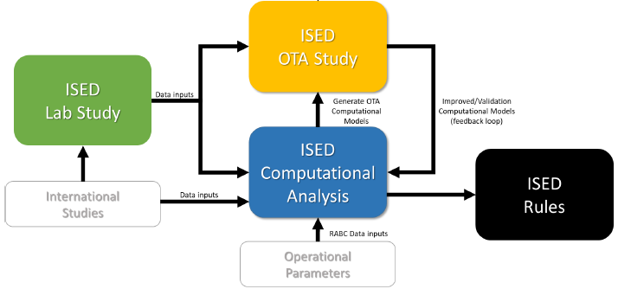
Fig. 3: Type of studies conducted for the co-existence 5G-Radi altimeter.

  - Laboratory study
The study aimed to quantify the susceptibility thresholds of different radio altimeters when exposed to fundamental and spurious emissions from 5G systems operating in the 3500 MHz, 3800 MHz, and 3900 MHz frequency bands. Eleven radio altimeters were selected along with band-pass filters to determine their effectiveness in mitigating radio altimeter susceptibility to 5G fundamental emissions.
    - Laboratory test setup and measurement procedure:
A simulation at different flight altitudes (i.e., 50, 200, 1000 and 2000 ft) was performed on three different categories of radio altimeters based on the RTCA report:
- Category 1 represents radio altimeters on commercial aircraft,
- Category 2 represents radio altimeter on regional/business aircraft, and
- Category 3 represents radio altimeter on helicopters.
Interfering signals consisted of Additive White Gaussian Noise (AWGN) to simulate spurious emissions from 5G systems and 5G New Radio (NR) signals to simulate fundamental emissions from 5G systems operating in 3500-3900 MHz frequency bands.
The two interfering signal components were tested independently to assess the impact of each potential interference mechanism. The susceptibility thresholds were then determined for each of the eleven radio altimeters.
    - Results of 5G spurious emissions on radio altimeters
Table 1 summarizes the results of spurious emission levels (dBm/MHz) creating impairment at different simulated altitudes. These results show that under study-specific test conditions, AUT.02, AUT.06, AUT.10 and AUT.12 were found to be most susceptible to spurious emissions at lower altitudes when compared to all other radio altimeters tested.
As indicated in Table 1, AUT.10, a pulse modulated radio altimeter, was the radio altimeter most susceptible to spurious emissions at higher altitudes by a considerable margin when compared to other AUTs.

Altimeter  Under Test | Category | Signal Processing type | Modulation type | 50 ft | 200 ft | 1000 ft | 2000 ft
AUT.01 | 1 | Digital | FMCW | -51.5 | -53.5 | -75.5 | -86.0
AUT.02 | 1 | Digital | FMCW | -69.9 | -70.5 | -70.5 | -72.5
AUT.03 | 1 | Digital | FMCW | -44.9 | -61.2 | -66.2 | -70.7
AUT.04 | 2&3 | Digital | FMCW | -38.9 | -45.7 | -67.2 | -75.2
AUT.05 | 2&3 | Digital | FMCW | -39.4 | -45.4 | -67.6 | -75.1
AUT.06 | 2&3 | Analog | FMCW | -91.0 | -81.0 | -85.5 | -87.5
AUT.07 | 2 | Analog | FMCW | -53.0 | -65.0 | -78.0 | -90.5
AUT.08 | 1 | Digital | FMCW | -46.7 | -60.7 | -76.7 | -82.2
AUT.09 | 1 | Digital | FMCW | -43.8 | -61.3 | -75.3 | -77.3
AUT.10 | 2&3 | Analog | Pulse | -65.7 | -73.2 | -94.2 | -105.7
AUT.12 | 2&3 | Analog | FMCW | -85.9 | -82.4 | -82.4 | -83.8
Table 1: Spurious emissions (dBm/MHz) on radio altimeters at different altitudes.

    - Results of 5G fundamental emissions on radio altimeters
On the other hand, AUT.01, AUT.06, AUT.08, AUT.09 AUT.10 and AUT.12 were found to be susceptible to 5G fundamental emissions at all altitudes tested.
    - Results of mitigation measures and conclusion.
Although adding a 4200-4400 MHz band-pass filter at the receiver port of susceptible radio altimeters eliminated 5G fundamental emissions interference it could not mitigate radio altimeter susceptibility to 5G spurious emissions.

  - OVER-THE-AIR (OTA) STUDY
The test plan for the OTA was developed in consultation with multiple stakeholders including the government, telecommunication, and aviation with the aim to assess, quantitatively and qualitatively, the susceptibility of different radio altimeters as configured in the aircraft to 5G operations in the 3500 MHz, 3800 MHz and 3900 MHz bands.
(Radio Altimeter Over the Air study video prepared by ISED: HTTPS://YOUTU.BE/FCDZ5B2F3H4)

    - OTA test setup and measurement procedure
The tests were performed using a 5G station with the following parameters (Table 2 and Figure 4):

5G station parameters |  | 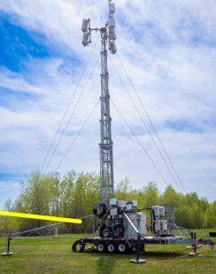
Power/BW | 240 W 20/30 MHz  120 W 60 MHz
Antenna | 24.5 dBi (peak gain)  17 mechanical uptilt
Test Frequencies | - 3640 MHz (3500 MHz)  - 3870 or 3885 MHz  - 3950 or 3965 MHz
Test Scenarios | 5G Off/ 5G On  Single band (3500 MHz or 3800 MHz or 3900 MHz).  Dual band (3500 + 3800)
Channel Bandwidths | 20 MHz 3500 band  30/60 MHz 3800 band  30/60 MHz 3900 band
Antenna height | 50 feet
Table 2: 5G station parameters. Fig. 4: illustration showing the 5G station
used for the test of Radio Altimeter.

The specifications of radio altimeters (AUT) under test were as follow (Table 3):

Altimeter  Under Test | AUT.01 | AUT.04 | AUT.06 | AUT.08 | AUT.10 | AUT.11 | AUT.12
Category | 1 | 2&3 | 2&3 | 1 | 2&3 | 2&3 | 2&3
Signal Processing type | Digital | Digital | Analog | Digital | Analog | Analog | Analog
Modulation type | FMCW | FMCW | FMCW | FMCW | Pulse | Pulse | FMCW
Altitude output  format | Digital | Digital/  Analog | Digital/  Analog | Digital | Analog | Analog | Digital/  Analog
Table 3: Specifications of radio altimeters (AUT) under test.

The OTA study was performed with seven radio altimeters (Table -4) to further assess 5G susceptibility and consisted of:
- Fly-bys at 50, 200, 500, and 1000 ft,
- Touch and go flights over the runway,
- East and West beams were configured and energized simultaneously to allow for efficient flight routes,
- 50 and 200 ft fly-bys were performed from the West while 500 and 1000 ft fly-bys were from the East
- Effective uptilt angles (combination of mechanical tilt and beam steer) were set in different positions as:

-3 degrees | Touch-and-go flights
0 degrees | 50 ft fly-bys
12 degrees | 200 ft fly-bys
18 degrees | 500 ft fly-bys
18 degrees | 1000 ft fly-bys
Table 4: Antenna Tilt at different altitudes.
It should be noted that all test scenarios were repeated with the 5G base station turned off and on and the susceptibility events were determined based on multiple factors such as:
- altitude deviations (radio altimeter reported altitude versus corrected DGPS altitude)
- 5G power levels at the radio altimeter receive port,
- 5G on versus 5G off flight comparisons,
- aircraft telemetry readings,
- ISED’s laboratory break points.
    - Results of assessment and Conclusion
Although no anomalies on the avionics onboard of the aircraft have been observed by the pilots, the OTA measurements indicated that three radio altimeters, classified as category 2 and 3, were susceptible to 5G fundamental emissions (AUT.06, AUT.10, and AUT.12 across the 3500 MHz, 3800 MHz and 3900 MHz bands and at all fixed-flight altitudes. These susceptibility events ranged from approximately 0.5 to 9 seconds, with an average duration of approximately 2.3 seconds. Also, a strong correlation was observed between the OTA results and ISED’s laboratory break points.
three radio altimeters, classified as category 2 and 3 (AUT.06, AUT.10, and AUT.12), were found to be susceptible to 5G fundamental emissions.

  - COMPUTATIONAL ANALYSIS
The main objective of the computational analysis was to determine the impact of different 5G base station parameters operating in the 3450-3980 MHz range on radio altimeters installed on fixed wings and helicopters.²
The computational analysis provided flexibility to vary various 5G and aviation parameters to determine their impact on co-existence between these services. The computational analysis took into account the results of spurious and fundamental emission break points of specific radio altimeters tested in ISED’s laboratory study.
2 Consultation on SRSP-520, issue 3 and RSS-192, issue 5 - Annexes (canada.ca)

    - Baseline and deployment simulators
The baseline simulators, developed in MATLAB, analyzed the effectiveness of exclusion and protection zones around airports, including the national antenna down-tilt requirement. On the other hand, the deployment simulators analyzed the effectiveness of 5G deployments in the existing commercial mobile infrastructures. The scenarios covered landing of an aircraft and hovering of a helicopter at different altitudes including landing and departing from an elevated H1 heliport. The simulators placed 5G base stations at a variety of locations along a flight path, with the base station’s main beam pointing in the azimuth of the aircraft.
It should be noted that a good correlation was observed between results of the simulations and the OTA test.

    - 5G and aviation parameters in simulators
The Base station parameters are as below (Table 5):

Parameter(s) | Value(s)
Antenna model | AAS and non-AAS
Transmit frequency | - Fundamental: 3650 MHz, 3850 MHz and 3950 MHz  - Spurious: 4300 MHz
Mechanical tilt | 0° for baseline simulators  ISED also performed some simulations for angles of 6°, 13° and 20° to validate the zone sizes predicted by the heliport and runway simulators  Values in ISED’s Spectrum Management System (SMS) for deployment simulators
Digital tilt relative to mechanical tilt | - Three digital tilt angles - one above the highest possible angle, one at typical angle and one at lowest possible angle for baseline simulators  - Values in ISED’s SMS for deployment simulators
Elevation of beam relative to digital tilt | - For AAS: Three scan angle values - maximum/minimum possible scan angles and 0° relative to the digital tilt angle  - For Non-AAS: N/A
Antenna azimuth | - - Toward aircraft for baseline simulators  - Values in ISED’s SMS for deployment simulators
Beam azimuth relative to boresight | 0°
Number of simultaneous beams | One
Fundamental e.i.r.p. | 77.5 dBm
Feeder loss | 1 dB
Spurious TRP or conducted power | -13, -30 and -48 dBm/MHz
Height above ground | 15, 30 and 50 metres for baseline simulators  Values in ISED’s SMS based on AWS/PCS height distribution for deployment simulators
Table 5: Base station parameters

The aircraft and radio altimeter parameters for both baseline and deployment simulators are shown in the Table 6:

Parameters | Value
Antenna model | Patch antenna and pyramidal horn patterns measured in ISED’s laboratory
Receive frequency | Spurious: 4300 MHz  Fundamental: 3650/3850/3950 MHz
Cable loss (dB) between antenna and receiver port | 3 dB
Combinations of pitch/roll angles | Pitch/roll combinations: 0°/15°, -4°/0°, 10°/0°, 0°/0°
Flight path for runway scenario | Based on two glide slopes of 2.5° and 3°; and flown at edge of aircraft approach area boundary with pitch/roll combinations specified above
Flight path for heliport/multi-dwelling scenarios | Two types of models:  1) Hover at constant altitude of 50, 200, 500 and 1000 ft  2) Confined area take-off approach procedure for St. Michael’s Hospital heliport
Table 6: Base station parameters

The most vulnerable altimeter’s break point was selected for each altitude listed in Table 7. The Interference Tolerance Mask (ITM) values for category 1 radio altimeters were revised accordingly. Then, the new values, were used to define the exclusion and protection zones around specific airports where automated landing is authorized.

Rules | ITM at 50 ft altitude | ITM at 200 ft altitude | ITM at 500 ft altitude | ITM at 1000 ft altitude
Current Values | N/A | -19 dBm | NA | -26 dBm
New Values | -10 dBm | -17 dBm | -20 dBm | -25 dBm
Table 7: Category 1 ITM at different altitude for 3500 MHz, 3800 MHz and 3900 MHz bands

    - Results for exclusion and protection zones around airports
The exclusion zones have been modified according to the results of the computational analysis as shown in the figures 5 below:
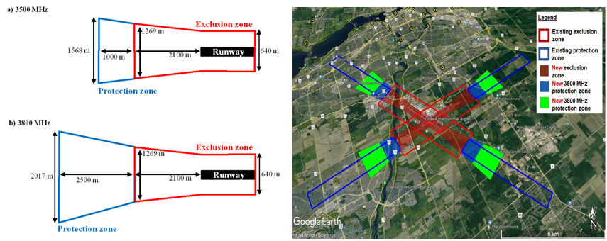
Fig. 5: illustration showing the Exclusion and protections zones/ SRSP-520, issue 3.
The proposed exclusion zone boundary was aligned with the location where the aircraft would be at 350 feet (a critical flight altitude) above the ground and based on worst-case base station emissions, with an assumed total e.i.r.p. of 77.5 dBm (61 dBm/MHz e.i.r.p. with a channel bandwidth of 45 MHz). considering an overestimation of 6.2 dB.
New pfd values were derived for the protection zone accordingly (Table 8):

Parameter | 350 ft above ground | 500 ft above ground | 1000 ft above ground
Power flux density (dBW/m2/100 MHz) | -17.84 | -22.34 | -30.34
Equivalent e.i.r.p. towards the sky (dBm/MHz) | 43.32 | 42.3 | 40.19
Table 8: Power flux density values and equivalent e.i.r.p. skywards

In order to protect an aircraft located between 1000 ft and 350 ft above ground, the limiting e.i.r.p. of a base station is the one to protect an aircraft at 1000 feet, 40.19 dBm/MHz towards the sky. Using this most limiting e.i.r.p., a new pfd value at 350 feet was derived, which is equalled to -21.31 dBW/m2/100 MHz.

Equally, pfd values, including equivalent e.i.r.p. values of a base station, were derived to protect an aircraft at 325 feet or less by limiting the power of a base station towards runways, as shown in the table 9 below:

Parameter | 50 ft above ground | 200 ft above ground | 300 ft above ground | 325 ft above ground
Power flux density (dBW/m2/100 MHz) | 2.82 | -4.74 | -7.72 | -10.45
Equivalent e.i.r.p. towards the runway (dBm/MHz) | 90.31 | 76.77 | 64.86 | 57.25
Table 9: Power flux density values and equivalent e.i.r.p. towards the runway

In order to protect an aircraft located at 325 feet above ground and lower, the limiting e.i.r.p. of a base station is the one to protect an aircraft at 325 feet, 57.25 dBm/MHz towards the runway. A pfd value of -10.45 dBW/m2/100 MHz at 325 feet above ground at the boundary of the exclusion zone would protect an aircraft in the critical phase of its final descent.³
    - Results for antenna down-tilt requirement to protect aeronautical search and rescue operations
The results of the simulations demonstrated that the emissions, between 50 feet to 1000 feet above ground, from base stations in an up-tilt configuration are far less attenuated in rural areas in comparison to urban centres.
In urban centres, where base stations would be up tilted to serve multi-dwellings, clutter and building shadowing will reduce the emissions towards aircraft significantly. However, the antenna down-tilt requirement does provide additional protection to aircraft flying in rural locations.
    - Results for exclusion and protection zones around elevated H1 heliports
Simulation results indicated that an exclusion zone of 80-metre radius around the FATO’s centre would be sufficient to protect an aircraft from outdoor base station emissions. Also, the results showed that adequate protection can be derived by capping the power of outdoor base stations within 500-1000 metres of the FATO’s centre (i.e., protection zone) towards these aerodromes at a pfd value of -41 dBW/m2/5 MHz at a heliport surface (Fig 6).

3 Consultation on SRSP-520, issue 3 and RSS-192, issue 5 - Annexes (canada.ca)

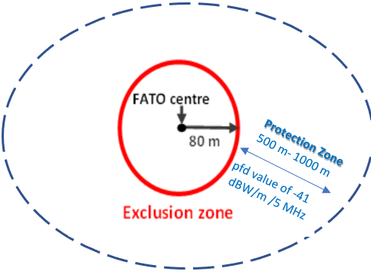
Fig 6: Illustration of 80 metre exclusion zone for H1-classified heliports & Protection Zone

    - Results for spurious emission levels of base stations
Spurious emission levels of -13, -30 and -48 dBm/MHz, were analyzed for an aircraft above a base station with specific clearances of:
- 50 feet (15.2 metres): represents the clearance of an aircraft flying above a base station located on the obstacle clearance surface, and
- 35 feet (10.7 metres): represents the minimum distance for a category A helicopter flying above an obstacle per rules mandated by Transport Canada.
A spurious emission level of -33 dBm/MHz would be required to meet the ITM of -91 dBm/MHz for both clearance distances.

    - Conclusion
Based on the computational analysis, as it was mentioned at the section 3.3.3, 3.3.5, and 3.3.6:
- An isosceles trapezoidal shaped exclusion zones of 320 metres from either side of the runway edge and extending 2100 metres from the runway thresholds, with an ending base width of 1269 metres would protect category 1 aircraft landing at ILS runways.
- An isosceles trapezoidal shaped protection zones with a length of 1000 metres from the edge of the exclusion zones, with an ending base width of 1568 metres for 3500 MHz and a length of 2500 metres from the edge of the exclusion zones, with an ending base width of 2017 metres for 3800 MHz would provide protection to category 1 aircraft landing at ILS runways.
- Exclusion zones of an 80-metre radius and protection zones with a radius between 500 and 1000-metres around H1classified heliports would protect helicopters landing or departing from these aerodromes from outdoor base stations. Within the protection zones, base station emissions towards these aerodromes would be required to meet a pfd limit of -41 dBW/m2/5 MHz.
- Finally, a spurious emission level of -33 dBm/MHz would protect radio altimeters with an ITM threshold of -91 dBm/MHz (50 foot to 200-foot aircraft altitude).³

- POST-ISED STUDY CONSULTATION WITH AVIATION STAKEHOLDERS IN CANADA
Following the conclusion of ISED's study and consultation with aviation stakeholders in Canada, a new balanced approach has been proposed by Transport Canada Civil Aviation (TCCA) to establish exclusion zones and protection zones based on the Obstacle Clearance Surface (OCS) to allow air operations to be conducted safely at aerodromes.
It should be noted that the previous adopted approach for setting exclusion and protection zones to develop the SRSP-520, issue 3 draft was based on ILS approach that considers less volume than the OCS (Fig. 9 Annex 1).
According to the TCCA, the new proposal of the exclusion and protection zone will be aligned with those set out by the FAA. TCCA affirmed the need for Canada to adopt a comparable approach to spectrum mitigation measures implemented in the U.S., including spurious emissions limits, in order to provide an equivalent level of safety and seamless operations in Canadian & U.S. airspace for aircrafts that are equipped with 5G tolerant radio altimeters.
Consequently, ISED reviewed its proposal and issued on July 11, 2023, a final decision regarding the use of frequency spectrum adjacent to the Radio Altimeter band: “Decision on SRSP-520, issue 3 and RSS-192, issue 5”. The decisions are as following:

- Imposing exclusion and protection zones (Fig.7 a and b) for both 3500 MHz and 3800 MHz bands considering the OCS and adopting Transport Canada’s proposed e.i.r.p. spectral density curves around 35 airports identified in the Map of Exclusion Zones and Protection Zones. These 35 airports represent over 93% of public & cargo traffic in Canada.
This mitigation measure will apply until January 1, 2026.
- Imposing a national e.i.r.p. mask. This mitigation measure will apply until January 1, 2026.
- Imposing an airport e.i.r.p. mask around the 35 protected airports for both 3500 MHz and 3800 MHz bands until January 1, 2026.
From January 2, 2026, to December 31, 2027, this airport e.i.r.p. mask will only apply to the 3800 MHz bands in former exclusion zones and in protection zones.
- No exclusion and protection zones around H1 classified heliports across Canada.
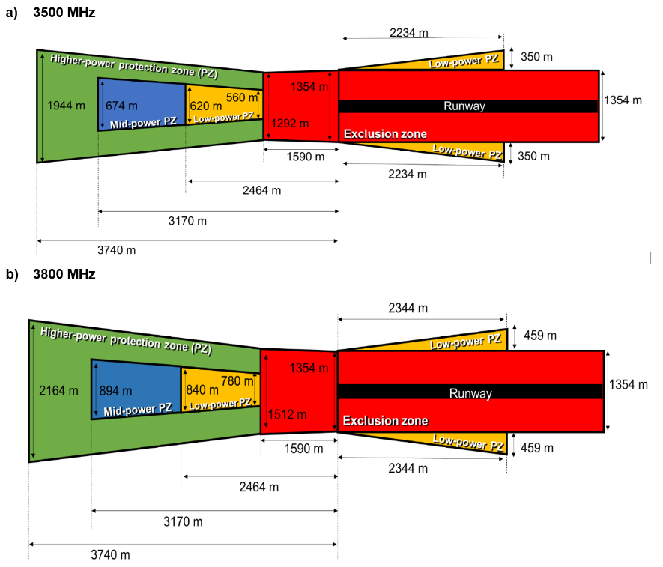
Fig. 7 a & b: illustration showing the Exclusion and protections zones/ SRSP-520, issue 3, (Final).

Base station height above runway threshold | Low-power protection zone | Mid-power protection zone | Higher-power protection zone
25 m | 61 dBm/MHz | 61 dBm/MHz | 61 dBm/MHz
30 m | 57.5 dBm/MHz | 61 dBm/MHz | 61 dBm/MHz
40 m | No deployment | 61 dBm/MHz | 61 dBm/MHz
45 m | No deployment | 61 dBm/MHz | 61 dBm/MHz
50 m | No deployment | 58 dBm/MHz | 61 dBm/MHz
55 m | No deployment | 58 dBm/MHz | 59.5 dBm/MHz
60 m | No deployment | No deployment | No deployment
Table 10: Base station height and power limits in different protection zones for the 3500 MHz band.

Base station height above runway threshold | Low-power protection zone | Mid-power protection zone | Higher-power protection zone
10 m | 55 dBm/MHz | 58 dBm/MHz | 60 dBm/MHz
15 m | 55 dBm/MHz | 58 dBm/MHz | 59 dBm/MHz
20 m | 55 dBm/MHz | 55 dBm/MHz | 58 dBm/MHz
25 m | 53 dBm/MHz | 58 dBm/MHz | 58 dBm/MHz
30 m | 52 dBm/MHz | 58 dBm/MHz | 58 dBm/MHz
35 m | No deployment | 55 dBm/MHz | 56.5 dBm/MHz
40 m | No deployment | 52 dBm/MHz | 56 dBm/MHz
45 m | No deployment | 52 dBm/MHz | 55 dBm/MHz
50 m | No deployment | 51 dBm/MHz | 54 dBm/MHz
55 m | No deployment | 49 dBm/MHz | 53 dBm/MHz
60 m | No deployment | No deployment | 51 dBm/MHz
Table 11: Base station height and power limits in different protection zones for the 3800 MHz band.

Concerning the RSS-192, issue 5.
ISED will adopt the different power level set out in the table 12.

Power | Equipment | level | Frequency Band
Maximum power limit | for indoor base stations | 39 dBm TRP | 3450-3900 MHz
Maximum power limit | For mobile subscriber equipment | 30 dBm/channel bandwidth e.i.r.p | 3450-3900 MHz
Unwanted emission limit | for outdoor equipment | -13 dBm/MHz | above 3900 MHz
Out-Of-Band unwanted Emission limit | for indoor base stations | -30 dBm/MHz | above 3980 MHz
Spurious emission limit | - | -30 dBm/MHz | 4200-4400 MHz
Table 12: limit of maximum power, unwanted emission, OOBE, and spurious emission

- SPECTRUM LAYOUT FOR 5G USE IN THE FREQUENCY RANGE 3450 - 3980 MHz
In regard to the co-existence 5G- Radio Altimeter in Canada, presently, ISED is seeking comments on two more standards consultation, namely, the SRSP-303.65, issue 3: “Technical Requirements for Wireless Broadband Services (WBS) in the Band 3650-3700 MHz” and the SRSP-521, issue 1: “Technical Requirements for Non-Competitive Local Licensed Services, including Fixed and/or Mobile Systems, and Flexible Use Broadband Systems, in the Band 3900 - 3980 MHz”.
With these upcoming standards, the 5G rollout will occupy the whole 3450-3980 MHz in Canada and will share that band with other service (Fig. 8, Table12).
- Concerning the 5G WBS operations in 3650-3700 MHz band: no interference to radio altimeters from the out-of-band emission limit is expected since the power of any emissions outside the frequency band 3650-3700 MHz shall be attenuated below the channel transmitter power P(dBW) by 43 + 10 Log (p) and will be at maximum -13 dBm/MHz.
- Concerning the non-Competitive Local Licensed Services, including Fixed and/or Mobile Systems, and Flexible use Broadband Systems, in the Band 3900 - 3980 MHz equally: no interference expected to radio altimeters from the out-of-band emission limit, as the unwanted emission limits for all equipment will not exceed -13 dBm/MHz.

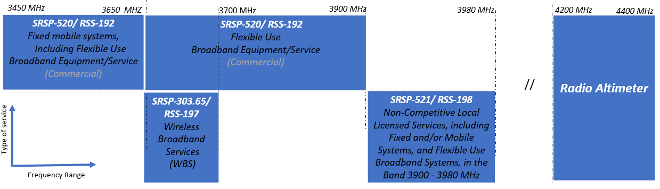
Fig. 8: Spectrum layout 3450 – 3980 MHz

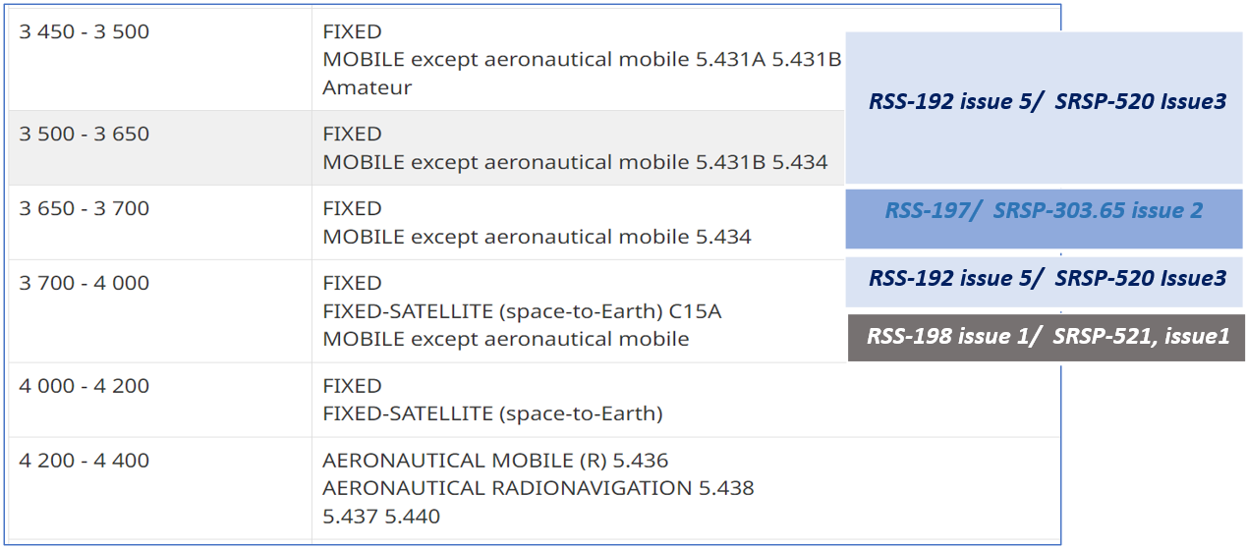
Table 13: 5G standards involving in the Co-existence 5G-Radio Altimeter/ Canadian Table of Frequency Allocations – MHz

- Further Aviation Mitigation Measures

TCCA is monitoring with ISED the deployment of 5G in Canada and assessing whether further mitigations would be applicable. Measures that could be applied are:

- Prohibitions of certain operations requiring radio altimeter at airports not covered by ISED’s Map of Exclusion Zones and Protection Zones.
- Specific aircraft models limitation.
- Direct agreements between telecommunication and aviation operators for additional spectrum limitations, subjected to ISED’s and TCCA’s approval.
- Additional notifications to air operators – Notices To Airmen (NOTAM) and Civil Aviation Safety Alerts (CASA)

These measures are being considered in coordination with other civil aviation authorities.

TCCA is also consulting with air operators and industry on a feasible timeline for the fleet upgrade to 5G tolerant Radio Altimeters.

- ACTION BY THE MEETING

  - The meeting is invited to:

- note and review the contents of this working paper including the results obtained from the ISED studies led in Canada on the co-existence between 5G systems and Radio Altimeters.

- endorse the line of actions taken in Canada so that other administrations could use the Canadian experience as a baseline for developing their regulatory context with regard to the protection of Radio Altimeters operating in the 4200-4400 MHz from the 5G systems operating in the adjacent band.

— END —

Annex 1:
Obstacle Clearance Surface (OCS)/ ICAO

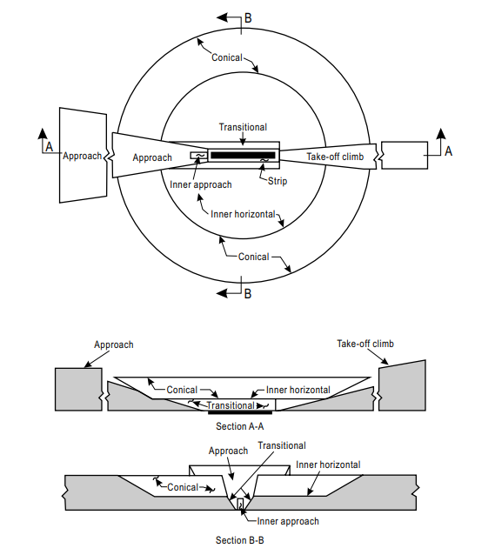
Réf: ICAO Annexe 14 — Aérodromes, Volume 1

Fig. 9 : Obstacle limitation surfaces/ ICAO

Reference :

- Consultation on SRSP-520, issue 3 and RSS-192, issue 5
https://ised-isde.canada.ca/site/spectrum-management-telecommunications/en/learn-more/key-documents/consultations/consultation-srsp-520-issue-3-and-rss-192-issue-5

- Decision on SRSP-520, issue 3 and RSS-192, issue 5
https://ised-isde.canada.ca/site/spectrum-management-telecommunications/en/learn-more/key-documents/decision-srsp-520-issue-3-and-rss-192-issue-5

- SRSP-520 — Technical Requirements for Fixed and/or Mobile Systems, Including Flexible Use Broadband Systems, in the Band 3450-3900 MHz, July 2023, issue 3.
https://ised-isde.canada.ca/site/spectrum-management-telecommunications/en/devices-and-equipment/standard-radio-system-plans/srsp-520-technical-requirements-fixed-andor-mobile-systems-including-flexible-use-broadband-systems

- RSS-192 — Flexible Use Broadband Equipment Operating in the Band 3450-3900 MHz
https://ised-isde.canada.ca/site/spectrum-management-telecommunications/en/devices-and-equipment/radio-equipment-standards/radio-standards-specifications-rss/rss-192-flexible-use-broadband-equipment-operating-band-3450-3900-mhz

