FREQUENCY SPECTRUM MANGEMENT PANEL (FSMP)

EIGHTH MEETING

Montreal, Canada, 21 to 29 January 2019

Agenda Item 5: 5 GHz Band Planning
…
b) Global UAS/ Remote Piloted Aircraft System (RPAS) channel plan

Analysis and recommendations on the interference protection between Terrestrial and Satellite C2 link system models in the 5030-5091 MHz band

(Presented by Florian RIBAUD, Axel GARCIA-PENA, Christian FLEURY, Christophe MACABIAU)

SUMMARY
The study presented in this paper analyses the required interference protection between transmitters and receivers of Terrestrial and Satellite C2 link systems. The Terrestrial system considered is standardized in the MOPS RTCA DO-362. The Satellite system considered is inspired from the system currently developed by EUROCAE WG-105.
The interference protection criterion is based on a minimum Signal-to-Interference ratio. Every interference scenario involving Terrestrial or Satellite systems interferers and victims is considered, including Terrestrial intra-system interference, Satellite intra-system interference and Terrestrial-Satellite inter-systems interference.
According to the results of this analyses, different recommendations are provided concerning the respect of a minimum interferer-victim distance, signals frequency offsets and eventually additional attenuation of the interfering signal.
- INTRODUCTION
  - Context of the study
    - In 2012, ITU WRC-12 has adopted a new terrestrial assignment to AM(R)S in the 5030-5091 MHz band. As well, ITU WRC-12 adopted footnote No. 5.443D, which outlines the interest of the 5030-5091 MHz part of the C-band AMS(R)S allocation: “In the frequency band 5030-5091 MHz, the aeronautical mobile-satellite (R) service is subject to coordination under No. 9.11A. The use of this frequency band by the aeronautical mobile-satellite (R) service is limited to internationally standardized aeronautical systems” [1] [2].
    - These allocations make possible implementation of the C2 link via both terrestrial and satellite systems on the 5030-5091 MHz band, as mentioned in [1]. In that context, the DGAC (French Civil Aviation Organization) signed a convention with the ENAC (French Civil Aviation School) Telecom research lab. The ENAC working group is tasked to investigate technical solutions to implement both terrestrial and satellite C2 link systems in the 5030-5091 MHz band.
    - Compatibility studies performed by the RPAS Panel of the EUROCAE WG-105 [1] [2] between Satellite and Terrestrial system models proposed some recommendations on the division of the 5030-5091 MHz band in distinct sub-bands assigned to the two systems. This proposed division is represented in Figure 1. The blue blocks represent the frequency bands reserved for the satellite system (two distinct blocks for the Forward and the Return links as proposed in [1] and [2]). The yellow block represent the frequency band reserved for the terrestrial system (in the middle of the 5030-5091 MHz band as proposed in [1] and [2]). The green blocks represent frequency offsets to prevent interference between terrestrial and satellite systems.
    - The Satellite system Forward and Return links are implemented on two separate frequency bands, separated by at least 20 MHz [5]. The frequency band of the Terrestrial system occupies the middle of the band (around frequency 5060 MHz). The study presented in [5] recommends minimum frequency separation between Terrestrial and Satellite systems, represented by the green blocks on Figure 1.

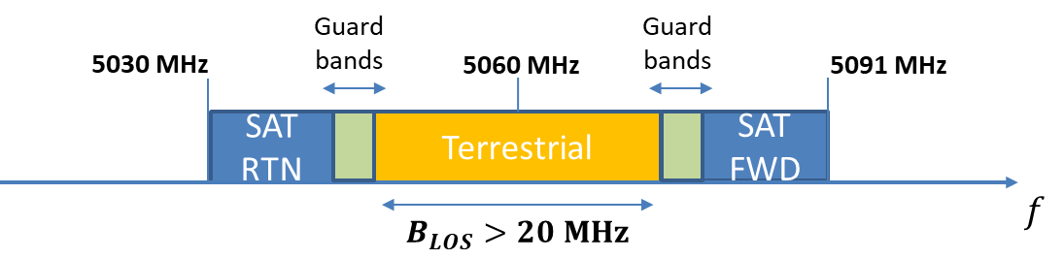
Figure 1: Proposed sharing of the 5 GHz band between terrestrial and satellite systems
    - In that context, the ENAC working group proposes a three-point study to propose a methodology of frequency assignment process to Satellite and Terrestrial system UAS (Unmanned Aircraft Systems) in the 5030-5091 MHz band. This study has been initiated in 2017 and already proposed results and recommendations. This study is divided in three major axes:
- Development of methodologies to assign C2 link frequency channels to UAS on the terrestrial system. A paper was presented to the FSMP WG 07 to present the results of this study [5]. Moreover, the study presented in this paper details the interference protection required between transmitters and receivers of the Terrestrial system (Terrestrial intra-system interference).
- Development of methodologies to assign C2 link frequency channels to UAS on the satellite system. No frequency channel assignment methodologies were analysed yet, but the study presented in this paper details the interference protection required between transmitters and receivers of the Satellite system (Satellite intra-system interference).
- Study of the interference protection required between Terrestrial and Satellite system interference (Terrestrial-Satellite system interference). This study is presented in this paper.
    - NASA Phase 1 of the C2 (Command and Control) sub-project of the NASA’s UAS integration in the National Airspace (NAS) has been completed (2012-2016). The results of the Phase 1 NASA sub-project supported the completion of C2 Terrestrial Minimum Operational performance Standards (MOPS) DO-362 by the RTCA SC-228 in Sept. 2016 [3]. It provided the development and testing of a prototype C2 link for terrestrial communications, implemented in C-band and L-band. All the assumptions on the Terrestrial C2 link system that have been considered in this study can be considered in line with the recommendations of MOPS DO-362.
    - Phase 2 of the NASA sub-project is underway. The results of the study of Phase 2 should support the completion of C2 Satellite MOPS by the RTCA SC-228. Moreover, a MOPS dedicated to the Satellite system developed by THE EUROCAE WG-105 is also underway [6]. However, none of these two MOPS are published yet. Therefore, all the assumptions about the Satellite C2 link system considered in this study are inspired from the EUROCAE WG-105 contributions [1], [2], [4].
  - Goal of the study
    - The main objective of this paper is to analyse the compatibility between the Terrestrial system model standardized by the MOPS DO-362 [3] and the Satellite system model proposed by the EUROCAE WG-105 [1], [2], [4].
    - To do so, all the interference scenarios involving transmitters and receivers of the Terrestrial and Satellite systems will be investigated. Those interference scenarios can be divided in three groups (see Terminology in Annex 2 for definitions of acronyms:
- Terrestrial intra-system: Interference scenarios between a transmitter of the Terrestrial system (from the LOS UA or from the LOS GRS Tx) to a victim of the terrestrial system (to a LOS UA or LOS GRS Rx).
- Satellite intra-system: Interference scenarios between a transmitter of the Satellite system (from the SAT UA or from the Sat PL Tx) to a victim of the Satellite system (to a SAT UA or Sat PL Rx).
- Terrestrial-Satellite inter-system: Interference scenarios between a transmitter of the Satellite or Terrestrial system (from the LOS UA, LOS GRS, SAT UA or SAT PL Tx) to between a receiver of the Satellite or Terrestrial system (to the LOS UA, LOS GRS, SAT UA or SAT PL Rx).
    - An interference protection criterion will be presented. It relies on a minimum signal-to-interference ratio, defined by a required Energy per Symbol to Noise depending on the receiver and an additional OACI coordination criterion.
    - The results of the different interference scenarios will provide minimum interferer-victim distance and signal minimum frequency offsets in each case required to respect the interference protection criterion mentioned above.
    - These results will lead to some recommendations on the necessary frequency separation between Terrestrial and Satellite systems frequency bands, as well as frequency channel separations between the Terrestrial or Satellite signals of two distinct UAS users. Moreover, if the interferer is likely to be close to the victim (interference between two UAs or between an UA and a GRS for example), the minimum interferer-victim distance imposed by the interference protection criterion will be provided. In some cases, an additional attenuation of the interfering signal in the band of the victim receiver will be recommended, in order to allow realistic minimum distances between interferer and victim.
  - Organization of the paper
    - First, the different assumptions on the Terrestrial and Satellite systems considered in this study will be presented in section 2.1.
    - Then, the interference protection criterion considered for the compatibility study will be presented in section 2.2.
    - Then, the results of the interference protection study for all the interference scenarios will be presented in section 2.3, as well as some recommendations to respect the interference protection criterion.
    - Section 3 will conclude the study.
    - Note also that important terminology and definitions are provided in Annex 2.

- DISCUSSION
  - Assumptions on the Terrestrial and Satellite systems
    - Communication architecture

The communication architecture considered in this study is composed of two communication systems: Terrestrial and Satellite C2 link. Figure 2 illustrates the architecture considered for the Terrestrial and Satellite communication systems.
- The Terrestrial system is composed of the C2 link between the Unmanned Aircraft connected to the Terrestrial system (noted LOS UA) and its Ground Radio Station (noted LOS GRS). The communication link between LOS UA and LOS GRS is on the frequency band 5030-5091 MHz.
- In the case of the Satellite system, the C2 link signal between the ground station and the drone is relayed by a geostationary satellite. Therefore, the Satellite system is composed of two communication links:
  - The C2 link between the UA connected to the Satellite system (noted SAT UA) and the Satellite (noted SAT PL). This communication link is on the frequency band 5030-5091 MHz.
  - The C2 link between the Ground Radio Station of the Satellite system (noted SAT GRS) and the Satellite (noted SAT PL). This communication link is not on the frequency band 5030-5091 MHz (it is supposed that another frequency-band will be used, like Ku/Ka bands for example).

This study is focused on the 5030-5091 MHz frequency band. Therefore, only the link between the SAT UA and the SAT PL will be considered.

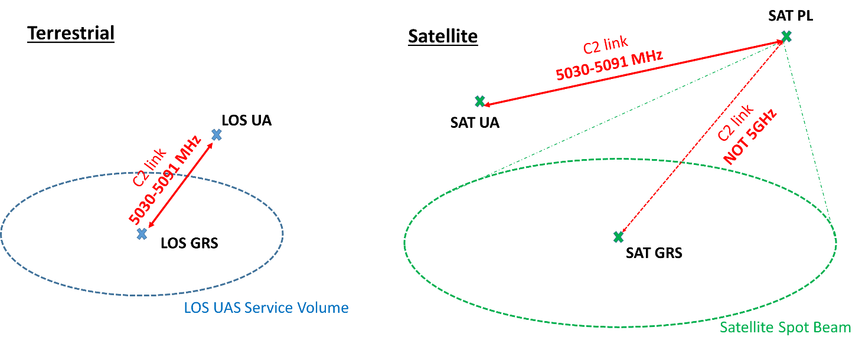
Figure 2: Terrestrial and Satellite communication systems

    - Assumptions on the Terrestrial system

The assumptions on the Terrestrial system are all provided by the MOPS DO-362 [3].
      - Terrestrial system data classes

The UAS have been divided in 3 classes of UAS (Class 1, 2 and 3), depending on functions of the C2 link required by the UAS, as it is proposed in [3]. Note that this classification does not correspond to a standard. However, it was already considered in the Terrestrial C-band capacity study presented in [5].The different functions of the C2 link associated to the 3 classes of UAS, as well as the altitude of flight and maximum speed have been described in [5] (Annex 5):
- The Class 1 UAS only uses the Telecommand and telemetry functions.
- The Class 2 UAS uses the same functions as Class 1 plus Air Traffic Control communication (Voice), Navaid Settings and Detect and Avoid targets.
- The Class 3 UAS uses the same functions as Class 2 plus Weather Radar Data from the UA to the Remote Piloted Station (RPS).

Note that a detailed definition of all of these functions is provided in [3].
      - Terrestrial system UAS Service Volume

The Service Volume (SV) of the UAS depend on the Class of UAS considered. It is defined by the position of the center of the SV $C_{SV}$, the radius of the SV $R_{SV}$ (provided by the line $d_{max}$ in Table 2) and by the maximum altitude of flight of the UA $H_{SV}$ (provided by the line $h_{max}$ in Table 2).
      - Terrestrial system transmitter and receiver characteristics

The characteristics of the transmitters and receivers of the Terrestrial system (Tx power, Tx/Rx antenna gains, and signal bandwidth) depend on the targeted Class of UAS. The characteristic values for all UAS classes are provided in Table 1 and Table 2.
      - Terrestrial system communication duplexing
        - As proposed in [3], the C2 link transmitted by the GRS to the UA (Uplink) is separated from the C2 link transmitted by the UA to the GRS (Downlink) of a given UAS using TDD (Time Division Duplexing). Then, Downlink and Uplink signals are transmitted on the same carrier (same frequency channel).
        - The C2 link signals of two different UAS on the Terrestrial system are separated using FDMA (Frequency Division Multiple Access). Then, each UAS disposes of its own frequency channel. This frequency channel is a single carrier, divided in 50 ms frames. These frames are divided in one Uplink time slot (23 ms) and one Downlink time slot (23 ms) and guard time slots of 1.3 ms and 2.7 ms, as represented on Figure 3.

        - An important hypothesis on the future terrestrial C2 link is provided in [3]: the UL and DL time slots of each UAS user are synchronized with a reference time frame common to all users. Therefore, all the UAS of the territory have synchronized UL and DL slots and thus are in UL or DL mode at the same instants of time.
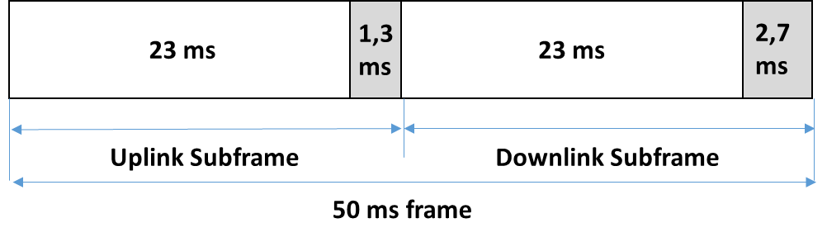
Figure 3: UAS Uplink/Downlink duplexing
    - Assumptions on the Satellite system

The assumptions on the Satellite system are provided by [1], [2], [4] and [6].
      - Satellite system data classes
No UAS classification is proposed in [6]. Only one class of UAS is proposed with one single channel bandwidth for the UA transmitted signal (40 kHz). However, it is mentioned in [6] that the signal bandwidth transmitted on the Return link has a variation rage from 40 kHz to 150 kHz. Therefore, it has been decided for this study to consider three classes of satellite system UAS which are defined from the UAS Return link channel bandwidth (from the UA to the SAT PL). Note that the UAS classes only differ in the Return link assigned bandwidth.
- The Class 1 UAS is the less demanding in terms of C2 link frequency resources (40 kHz per UA on the return link).
- The Class 3 UAS is the most demanding in terms of C2 link frequency resources (150 kHz per UA on the return link).
- The Class 2 has an intermediate bandwidth requirement (100 kHz per UA on the return link).
      - Satellite system UAS Service Volume
No Service Volume are considered for the Satellite system. Theoretically, a SAT UAS user is able to fly within the whole Satellite spot beam.
      - Satellite system spot beams

According to [6], each satellite is composed of multiple spot beams. The spot beams are considered circular spots of diameter approximately equal to 1500 km. No information is provided in [6] about the interference isolation between two adjacent spots. However, it will be considered in this study that a same frequency channel cannot be used by to UAS users in two adjacent spot beams (neither on the Forward link nor on the Return link). Frequency reuse is possible for two non-adjacent spot beams. It is considered in this study that each spot has 6 adjacent spot.

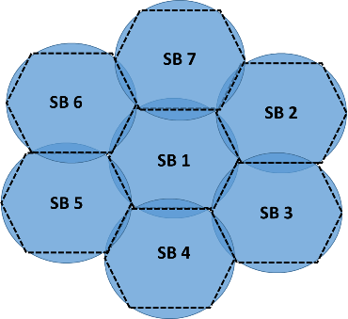
Figure 4: Satellite spot beams
No satellite transmitter or receiver antenna diagrams were available for this study. Therefore, no hypothesis on the signal isolation between two distinct spot beams is available. However, it is considered that one given frequency channel cannot be used in two adjacent spot beams.
      - Satellite system transmitter and receiver characteristics
The characteristics of the transmitters and receivers of the Satellite system (Tx power, Tx/Rx antenna gains, and signal bandwidth) depend on the Targeted Class of UAS considered. The values for all UAS classes are provided by Table 3 and Table 4.
      - Satellite system communication duplexing
        - As proposed in [1] and [2], the C2 link transmitted from the SAT PL to the SAT UA (Forward link) is separated from the C2 link transmitted from the SAT UA to the SAT PL (Return link) using FDD (Frequency Division duplexing). The frequency band reserved for the Return link channels is located at the beginning of the 5030-5091 MHz band and the frequency band reserved for the Forward link channels is located at the end of the 5030-5091 MHz band, as represented on Figure 1.
        - The C2 link signals transmitted to two different UAS users on the Forward link are separated using TDMA (Time Division Multiple Access), on a single carrier per spot beam, divided in time slots, with one time slot for each UAS [6]. The bandwidth of the carrier is 800 kHz.
        - The C2 link signals transmitted by two different UAS users on the Return link are separated using FDMA (Frequency Division Multiple Access). Each UAS user uses an individual frequency channel to transmit the C2 link [6]. The bandwidth of the UAS transmitted carriers varies in a range from 40 kHz to 150 kHz
  - Interference protection criterion

The interference protection criterion is defined by a minimum signal to interference ratio that must be respected ${[\frac{S}{I}]}_{min}$, in order to guarantee the minimum Energy per Symbol relative to Noise (${E_{s}/N_{0}}_{req}$) required by the system’s signal modulation and channel coding. According to [3] (Annex R), the signal-to-interference ratio must respect:
$$[\frac{S}{I}]>{E_{s}/N_{0}}_{req}+3 dB$$ | Eq. 1

Moreover, it is recommended in [3] to consider an attenuation due to implementation losses $IL$ (considered 1 dB in [3]) and an OACI safety margin $∆_{OACI}$ (considered 6 dB in [3]). Then, the minimum required signal to interference ratio ${SIR}_{min}$ is given by Eq. 2:
$${SIR}_{min}={E_{s}/N_{0}}_{req}+3 dB+IL+∆_{OACI}$$ | Eq. 2

The signal-to-interference ratio SIR is defined in [3] by:
$$SIR=\left[\frac{S}{I}\right]=\left(P_{T_{x}}^{D}-P_{T_{x}}^{U}\right)+\left(G_{T_{x}}^{D}-G_{T_{x}}^{U}\right)+20\log_{10}\left(\frac{d_{U}}{d_{D}}\right)+\left(G_{R_{x}}^{D}-G_{R_{x}}^{U}\right)-\sqrt{{M_{T}}_{min}^{2}+{M_{T}}_{max}^{2}}-FDR\left(∆f\right)+X_{polar}$$ | Eq. 3
Where:
- $P_{T_{x}}^{D}$ and $P_{T_{x}}^{U}$ are the Desired and Undesired transmitters output power in dBm (see Table 3 and Table 5).
- $G_{T_{x}}^{D}$ and $G_{T_{x}}^{U}$ are the Desired and Undesired transmitters maximum antenna gain in dBi (see Table 3 and Table 5).
- $d_{D}$ is the distance between the Desired UA and its GRS or between the desired GRS and its UA.
- $d_{U}$ is the distance between the Undesired UA and the victim GRS or between the Undesired GRS and the victim UA.
- $G_{R_{x}}^{D}$ and $G_{R_{x}}^{U}$ are the gains of the victim receiver antenna in the direction of the Desired and Undesired transmitters (see Table 4 and Table 6).
- ${M_{T}}_{min}$ and ${M_{T}}_{max}$ denote the minimum and maximum attenuation of the signal powers due to multipath and airframe losses. Note that this parameter is considered in the MOPS DO-362 standardized model of Terrestrial C2 link system [3], but not in the EUROCAE study of Satellite C2 link system [4]. Therefore, the same ${M_{T}}_{min}$ and ${M_{T}}_{max}$ values (respectively 6.7 dB and -23.3 dB) have been considered for both Terrestrial and Satellite systems. The attenuation of the $SIR$ due to the multipath and airframe losses is $\sqrt{{M_{T}}_{min}^{2}+{M_{T}}_{max}^{2}}≈24 dB$ according to [3] (Annex L).
- $X_{polar}$ is an attenuation of the interferening signal due to the difference of polarization between the Desired and Undesired signals (0 dB if D and U have the same polarization, -3 dB if different polarizations).
The frequency Dependant Rejection $FDR$ is the attenuation of the interfering signal in the bandwidth of the receiver due to the frequency offset $∆f$ between the desired and undesired signals. It is given by Eq. 4:
$$FDR\left(∆f\right)=10*\log_{10}\frac{\int_{-∞}^{+∞}{S\left(f\right) df}}{\int_{-∞}^{+∞}{S\left(f\right)R\left(f+∆f\right) df}}$$ | Eq. 4
Where:
- $S\left(f\right)$ is the normalized power spectral density of the interfering signal.
- $R\left(f\right)$ is the frequency dependant response of the victim receiver.

  - Compatibility of the Satellite and Terrestrial systems

This section is dedicated to the study of the protection required between the different transmitters and receivers of the Terrestrial and Satellite systems in order to respect the interference protection criterion displayed in paragraph 2.1.4. The signal to interference ratio of one given desired and one given undesired signal, as it is defined in 2.1.4 (Eq. 3), depends on the distance between the interferer and the victim and on the Frequency Offset between the central frequency of the carriers of the desired and undesired signals. Therefore, knowing the minimum signal-to-interference ratio (${SIR}_{min}$) of a given receiver (Eq. 1), it is possible to compute the minimum distance interferer-victim ($d_{min}$) and the minimum frequency offset (${∆f}_{min}$) that must be jointly respected.

In order to plan the channel assignment process to UAS using the Terrestrial or the Satellite system, all the interference scenarios between the different transmitters (Tx) and receivers (Rx) of the two systems must be considered. Three groups of interference scenarios will be addressed:
- Interference between Tx and Rx of the terrestrial system (Terrestrial intra-system interference protection).
- Interference between Tx and Rx of the satellite system (Satellite intra-system interference protection).
- Interference between Tx or Rx of the Terrestrial system with Tx or Rx of the Satellite system (Terrestrial-Satellite inter-system interference).

    - Terrestrial intra-system interference protection

The Terrestrial system transmitters and receivers characteristics provided in Table 1 and Table 2, as well as the power spectrum density masks and receiver frequency response illustrated on Figure 1 in the Annex 3 have been used to compute the $SIR$ for the different interference scenarios. Note that the $SIR$ depends on the distance interferer-victim and on the frequency offset $∆f$ between Desired and Undesired signals. The minimum distance UA-GRS that must be respected in the different cases so that $SIR>{SIR}_{min}$, depending on $∆f$, has been represented on Figure 7 and Figure 8, and is noted $d_{min}(∆f)$.
      - Interference scenarios for the Terrestrial system:
- Interference from LOS UA Tx to the LOS GRS Rx of another UAS (considering the 3 different UAS classes).
- Interference from LOS GRS Tx to the LOS UA Rx of another UAS (considering the 3 different UAS classes).

Note that an UA cannot cause interference to another UA (or a GRS to another GRS) because the terrestrial TDD communication system is synchronized among all the UAS users (all users communicate in Downlink or Uplink mode at the same instants).
      - Minimum signal-to-interference ratio:

The minimum Energy per Modulation Symbol (${E_{s}/N_{0}}_{req}$) is the same for the UA and the GRS receivers on the Terrestrial system. Therefore, LOS UA Rx and LOS GRS Rx have the same minimum Signal-to-Interference ratio (${SIR}_{min}$). Using the ${E_{s}/N_{0}}_{req}$ of Terrestrial system receivers provided in Table 2, the ${SIR}_{min}$ of LOS UA Rx and LOS GRS Rx is given by Eq. 2:${ SIR}_{min}=13.5 dB$.
      - Considering that $B_{Tx}$ is the bandwidth of the interfering signal and $B_{Rx}$ is the bandwidth of the victim receiver, 3 types of frequency offsets are considered (co-channel, adjacent channel and non-adjacent channel):
- Co channel offset: $∆f<(B_{Tx}+B_{Rx})/2$.
- Adjacent channel offset: $(B_{Tx}+B_{Rx})/2<∆f<B_{Tx}+B_{Rx}$.
- Non-Adjacent channel offset: $∆f>B_{Tx}+B_{Rx}$
      - Results:

The minimum distance $d_{min}$ for the 3 types of frequency offset is recorded in Table 5 and Table 6 in Annex 4. Different results must be underlined:
        - If the interferer and the victim are co-channel, the minimum signal-to-interference ratio cannot be respected, for any $∆f$.
        - If the interferer and the victim use adjacent channels, $d_{min}$ is significant: from 2 km to 6.9 km depending on the interference scenario.
        - For non-adjacent channel frequency offsets, it can be observed on the different plots of Figure 7 and Figure 8 that $d_{min}(∆f)$ reaches an asymptote. Indeed, $d_{min}(∆f)$ is constant for $∆f>B_{Tx}+B_{Rx}$. This is due to the fact that the LOS UA and LOS GRS transmitter and receiver masks are constant for an offset superior to $∆f>B$, with $B$ the bandwidth of the signal. Therefore, even with significant non-adjacent channel $∆f$, a minimum distance interferer-victim $d_{min}$must be respected, from 600 m to 1.5 km depending on the interference scenario.
        - In order to decrease the minimum distances computed in 2.2.1.4.3, additional interference attenuations should be considered. Table 7 represents the required additional attenuation $A_{add}$ depending on the frequency offset $∆f$ and the targeted $d_{min}$, so that $SIR\left(∆f,d_{min}\right)+A_{add}>{SIR}_{min}$. Note that the interference scenario considered in this example involves two UAS Class 3 (worst case interference scenario). An additional attenuation of $A_{add}=$23.5 dB is required to decrease $d_{min}$ to $d_{min}<100 m$.
      - Recommendations:
        - Two different UAS cannot receive co-channel frequency assignments if the GRS of one of these UAS is in the Radio Line of Sight (RLOS) coverage of the UA of the other UAS.
        - Two different UAS should not receive adjacent-channel frequency assignments if the GRS of one of these UAS is in the Radio Line of Sight (RLOS) coverage of the UA of the other UAS. Otherwise, the UA would not be allowed to fly closer than 2 km (6.9 km in worst case) of the GRS of the other UAS.
        - Even for large frequency offsets between interferer and victim, the minimum distance $d_{min}$ that must be respected between different UAS users is significant (from 600 m to 1.5 km). In the case of high density UAS traffic, each UA would encounter numerous exclusion zones around the GRS of other UAS users. This may lead to severe constraints in the management of UAS traffic. Therefore, it could be recommended consider additional interferer attenuations. The values of the required attenuation to decrease $d_{min}$ to different targeted distances are recorded in Table 9.
        - For example, additional out-of-band filters to the transmitter and receiver masks of the Terrestrial system standardized in the MOPS DO-362 [3] could be considered. Therefore, different additional out-of band rejections have been tested, noted $A_{add}$ In order to apply the rejection $A_{add}$, the maximum out-of-band rejection of the transmitter and receiver masks of the Terrestrial system (65 dB without additional rejection) have both been increased to $65 dB+A_{add}/2$. Figure 9 represents the minimum interferer-victim distance corresponding to the interferer and victim masks augmented with different out-of band rejections $A_{add}$, considering two UAS of Class 3 (worst case interference scenario). A rejection $A_{add}=23.5 dB$ is necessary so that $d_{min}<100 m$.

    - Satellite intra-system interference protection

The Satellite system transmitters and receivers characteristics provided in Table 3 and Table 4, as well as the power spectrum density masks and receiver frequency response illustrated on Figure 2 in the Annex 3 have been used to compute the $SIR$ for the different interference scenarios. Note that the distance interferer-victim $d$ is fixed (distance UA-satellite). It has been decided that $d=36000 km$, corresponding to the altitude of a geostationary satellite. Therefore, the signal-to-interference ratio depends on the frequency offset between the Desired and Undesired signals $∆f$ only. The interference scenarios involving one transmitter and one receiver of the satellite system may be divided in 3 categories:
- Return link interference: interference from a transmitter of the Return link (SAT UA Tx class 1, 2 or 3) to a receiver of the Return link of another UAS (SAT PL Rx class 1, 2 or 3).
- Forward link interference: interference from a transmitter of the Forward link (SAT PL Tx) to a receiver of the Return link of another UAS (SAT UA Rx).
- Forward link – Return link interference: interference from a transmitter of the Forward link (SAT PL Tx) to a receiver of the Return link (SAT PL Rx) or a transmitter of the Return link (SAT UA Tx ) to a receiver of the Forward link (SAT UA Rx).
      - Return link interference:
        - Interference scenarios for the Satellite system (Return link):
- Interference from a SAT UA Tx to a SAT PL Rx that is connected to another UAS.
        - Minimum signal-to-interference ratio:

Using the ${E_{s}/N_{0}}_{req}$ of Satellite system Return link receivers provided in Table 4, the ${SIR}_{min}$ of SAT PL Rx is given by Eq. 2: ${SIR}_{min}=8.75 dB$.
        - Results:

The minimum frequency offset required between the SAT UT Tx Class 1, 2 or 3 and the SAT PL Rx Class 1, 2 or 3 of another UAS to respect the interference protection criterion ($SIR<{SIR}_{min}$) has been recorded in Table 8 in Annex 4. The signal-to-interference ratio $SIR(∆f)$ depending on the frequency offset has been represented on Figure 10. Different results must be underlined:
          - The frequency channels assigned to two different UAS to transmit on the Satellite system return Link must be separated by at least 60 kHz if they are both Class 1,100 kHz if one is Class 1 and the other Class 2 and 130 kHz if one is Class 1 and the other Class 3.
          - The frequency channels assigned to two different UAS to transmit on the Satellite system return Link must be separated by at least 110 kHz if they are both Class 2, and 140 kHz if one is Class 2 and the other Class 3.
          - The frequency channels assigned to two different UAS to transmit on the Satellite system return Link must be separated by at least 160 kHz if they are both Class 3.
        - Recommendations:

The frequency channels assigned to two different UAS on the Return link (of width $B_{1}$ and $B_{2}$) should be separated by at least $∆f=\frac{B_{1}+B_{2}}{2}+10 kHz$
      - Forward link interference:
        - Interference scenarios for the Satellite system (Forward link):
- Interference from a SAT PL Tx to a SAT UA Rx that is connected to another satellite Forward Link.
        - Minimum signal-to-interference ratio:

Using the ${E_{s}/N_{0}}_{req}$ of Satellite system Forward link receivers provided in Table 4, the ${SIR}_{min}$ of SAT UA Rx is given by Eq. 2: ${SIR}_{min}=10.6 dB$.
        - Results:

The minimum frequency offset required between the SAT PL Tx and the SAT UA Rx of another UAS to respect the interference protection criterion ($SIR<{SIR}_{min}$) has been recorded in Table 9 in Annex 4. The signal-to-interference ratio for the different frequency offsets $SIR(∆f)$ has been represented on Figure 12. It can be observed that two different carriers on the Satellite Forward link must be separated by at least 800 kHz (which is the bandwidth of one Forward link carrier).
      - Forward link – Return link interference:
        - Interference scenarios for the Satellite system (Forward-Return links):
- Interference from a SAT UA Tx to a SAT UA Rx of another UAS.
- Interference from a SAT PL Tx to the SAT PL Rx (of a different or the same satellite).
        - Minimum signal-to-interference ratio:
- The ${SIR}_{min}$ of SAT UA Rx is computed in 2.2.2.2.2 ${SIR}_{min}=10.6 dB$.
- the ${SIR}_{min}$ of SAT PL Rx is computed in 2.2.2.1.2: ${SIR}_{min}=8.75 dB.$
        - Results:
          - Figure 12 represents the signal to interference ratio depending on the frequency offset for interference from SAT UA Tx to SAT UA Rx. The minimum frequency offset between one UA transmitting on the Satellite system Return link (SAT UA Tx) and the UA of another UAS receiving on the Satellite system Forward link (SAT UA Rx) is 2.2 MHz.
          - Figure 13 represents the signal-to-interference ratio for interference from SAT PL Tx to a SAT PL Rx. As mentioned in section 2.1.3, no information is available about the interference protection between satellite transmitters and receivers. Table 11 provides the necessary interference attenuation between SAT PL Tx and SAT PL Rx to satisfy the interference protection criterion. It is mentioned in [4] that the minimum frequency separation between the sub-bands reserved for Satellite Forward and Return links is 20 MHz. Then, the interference attenuation provided by the satellite system between SAT PL Tx and SAT PL Rx must be at least 59 dB.
    - Terrestrial-Satellite inter-system interference protection
      - Interference scenarios between Satellite and Terrestrial systems:
- Interference from a SAT UA Tx to a LOS UA Rx or LOS GRS Rx
- Interference from a LOS UA Tx or a LOS GRS Tx to a SAT UA Rx.
- Interference from a SAT PL Tx to a LOS UA Rx or LOS GRS Rx.
- Interference from a LOS UA Rx or LOS GRS Rx to SAT PL Tx.
      - Minimum signal-to-interference ratio:
- The ${SIR}_{min}$ of LOS UA Rx and LOS GRS Rx is computed in 2.2.1.2: ${SIR}_{min}=13.5 dB$.
- The ${SIR}_{min}$ of SAT UA Rx is computed in 2.2.2.2.2: ${SIR}_{min}=10.6 dB$.
- The ${SIR}_{min}$ of SAT PL Rx is computed in 2.2.2.1.2: ${SIR}_{min}=8.75 dB.$
      - Results:
        - Interference scenarios a) and b): Figure 14, Figure 15, Figure 16 and Figure 17 represent the minimum distances $d_{min}$ that must be respected between a SAT UA and LOS UA or a LOS GRS depending on the frequency offset $∆f$ required by the interference protection of the scenarios a) and b) (of paragraph 2.2.3.1). It can be observed that $d_{min}(∆f)$ reaches an asymptote for $∆f>1 MHz$, meaning that $d_{min}$ cannot be decreased by augmenting the frequency offset after $∆f>1 MHz$. In order to decrease the minimum distance $d_{min}$, other sources of interference attenuation, noted $A_{add}$, should be considered. Table 12, Table 13, Table 14 and Table 15 provide the attenuation required on the interfering signal so that $SIR\left(∆f,d_{min}\right)+A_{add}<{SIR}_{min}$, depending on the targeted value of $d_{min}$ and frequency offset, for interference scenarios of a) and b). It can be observed that the SIR must be enhanced by a factor that varies from 17 dB to 50 dB depending on the interference scenario, for a frequency offset $∆f>1 MHz$, to reach the minimum distance $d_{min}=100 m$.
        - Interference scenarios c) and d): Figure 18 represents the signal to interference ratios corresponding to the interference scenarios c) and d). Table 16 provides the minimum frequency offset for which $SIR\left(∆f\right)<{SIR}_{min}$ for different scenarios. Note that $SIR$ does not depend on the interferer victim distance in these case because the distance UA-satellite is considered fixed (36000 km). It can be observed in Table 16 that the minimum frequency offsets to prevent interference from SAT PL Tx to LOS UA Rx and from SAT PL Tx to LOS GRS Rx are respectively ${∆f}_{min}=350 kHz$ and ${∆f}_{min}=500 kHz$. The minimum frequency offset to prevent interference from LOS UA Tx to Sat PL Rx and from LOS GRS Tx to SAT PL Rx is ${∆f}_{min}=200 kHz$ in both cases.
      - Recommendations:
        - It has been mentionned that $d_{min}(∆f)$ reaches an asymptote for $∆f>1 MHz$ (even for lower $∆f$ for some interference scenarios). Then, the minimum distance between a SAT UA and LOS UA/GRS cannot be decreased even with larger $∆f$. This result is likely to impose significant no-fly zones to UAS on the Terrestrial or Satellite systems around other UAs or around LOS GRS. Then, as already proposed in 2.2.1.5, some additional attenuation of the interfering signals should be considered, in order to decrease the minimum distance requirement to acceptable values (typically$d_{min}<100 m$).
        - Therefore, like in 2.2.1.5, it has been decided to increase the out-of-band rejection of the transmitters and receivers masks with a factor $A_{add}(dB)$, with $A_{add}/2$ on the interferer out-of-band emissions and $A_{add}/2$ on the victim receiver out-of-band rejections, for the interference scenarios of a) and b). Figure 14, Figure 15, Figure 16 and Figure 17 represent the minimum distances $d_{min}$ that must be respected between a SAT UA and LOS UA or a LOS GRS depending on the frequency offset $∆f$ and on the attenuation $A_{add}$considered.
          - The enhancements of the SIR necessary to reach $d_{min}<100 m$ for the different interference scenarios are significant (from 17 dB to 50 dB in the worst case). Then, other possibilities to increase the SIR should be considered, like off-axis fading of antenna gains of the Satellite system and a more specific multipath and airframe loss model for the Satellite system.
          - It can be observed that the minimum distance depending on the frequency offset is not decreased after $∆f>1 MHz$ for the interference scenario a) and after $∆f>750 kHz$ for interference scenario b). Moreover, the frequency separations between SAT PL and LOS UA/GRS required by interference scenarios c) and d) are lower than 750 kHz.
        - Therefore, a minimum required frequency separation of 1 MHz could be recommended between the sub-bands reserved for Satellite Forward link and Terrestrial systems. A minimum required frequency separation of 750 kHz could be recommended between the sub-bands reserved for Satellite Return link and Terrestrial systems.

.
- CONCLUSION
  - Conclusion on the compatibility study

The implementation of both Terrestrial and Satellite system models considered in this study in the 5030-5091 MHz is possible if the following recommendations on the interference protection are satisfied:
    - Separation between two frequency channels assigned to two distinct UAS on the Terrestrial system of width $B_{1}$ and $B_{2}$:
      - If the GRS of one UAS is never in the Radio-Line-of-Sight horizon of the UA of the other UAS, these two UAS may receive co-channel or adjacent frequency channel assignments.
      - If the GRS of one UAS is possibly in the Radio-Line-of-Sight horizon of the UA of the other UAS, these two UAS should receive non-adjacent frequency channel assignments (frequency separation $∆f$ larger than ${(B}_{1}+B_{2})/2$).
      - Even with significant frequency channel offsets, the minimum distance between the UA and the GRS of another UAS may be challenging. Therefore, an additional out-of-band attenuation of the interfering signal should be considered (23.5 dB so that the minimum distance is inferior to 100 m). This study showed that a possible way to apply this out-of band interferer rejection is to increase the out-of-band attenuation of the transmitted power spectrum density and the out-of-band rejection of the receiver frequency response (+12 dB attenuation for the frequency offsets $∆f>B$ of both masks).
    - Separation between two frequency channels assigned to two distinct UAS on the Satellite system Return link of width $B_{1}$ and $B_{2}$:
      - The frequency channels assigned to ${UAS}_{1}$ and ${UAS}_{2}$ on the Satellite Return sub-band should be separated by at least $∆f>{(B}_{1}+B_{2})/2+10 kHz$.
    - Separation between two frequency channels assigned to two distinct Satellite Forward channel links of width $B$:
      - The frequency channels assigned to Forward link 1 and Forward link 2 on the Forward link sub-band should be spaced by at least $∆f>B$ (with $B=800 kHz$) according to the assumptions of [4].
    - Separation between a frequency channel assigned to an UAS on the terrestrial system and an UAS on the Satellite system:
      - A minimum separation of $∆f>1 MHz$ is recommended between the frequency channel assigned to one UAS on the Terrestrial system and any Satellite Forward link frequency channel.
      - A minimum separation of $∆f>750 kHz$ is recommended between the frequency channel assigned to one UAS on the Terrestrial system and the frequency channel of any UAS on the Satellite Return link.
      - Even with significant frequency channel offsets, the minimum distance between any UA of the Satellite system with UA or GRS of an UAS on the Terrestrial system may be challenging. Therefore, an additional out-of-band attenuation of the interfering signal should be considered (50 dB so that the minimum distance is inferior to 100 m). Different solutions should be envisaged to increase the Signal-to-interference ratio in this case:
- Increase the out-of-band attenuation of the transmitted power spectrum density and the out-of-band rejection of the receiver frequency response.
- Consider an off-axis attenuation of the gain of the transmitted interfering signal.
- Consider another multipath and airframe loss model more specific to Satellite systems.
  - Perspectives of the study
    - The results presented all along this study showed that for some interference scenarios, even large frequency offsets between interferer and victim could not provide sufficient interference protection, leading to eventually non-realistic minimum distances between interferer and victim. In those cases, additional interferer attenuations are required. Different possibilities were proposed in paragraph 3.1.4.3 to enhance the signal-to-interference ratio (out-of-band rejection, off-axis gain attenuation, multipath model …). Those different possibilities should be investigated in more details and tested in another study.
    - In this study, the assumptions on the Satellite system currently developed by the EUROCAE WG-105 were only partially available. When this MOPS will be published, this study should be conducted on the standardized Satellite C2 link system provided in the MOPS, for more consolidated results.
    - It was also mentioned that the NASA Phase 2 sub-project of UAS integration in the National Airspace (NAS) is underway. This project should lead to another standardized Satellite C2 link model. The compatibility of this Satellite system with the Terrestrial C2 link standardized in the MOPS DO-362 [3] should also be investigated.

— END —
ANNEX 1 – REFERENCE DOCUMENTS

ID | Date | Document | Authors | Reference of the document
[1] | Sept. 2016 | On the Sharing of the AMS(R)S assignment in the 5030-5091 MHz frequency band between a satellite and a terrestrial system to provide UAS C2 | C. Fleury  N. Van Wambecke  J. Mettrop  A. Munro | FSMP-WG/03-WP/10
[2] | March 2017 | Considerations for establishment of channel plans for the AMS(R)S and AM(R)S assignments in the 5030-5091 MHz frequency band for use by satellite and terrestrial systems supporting UAS C2 Links | C. Fleury  N. Van Wambecke  M. Neale  D. Nellis | FSMP-WG/04-WP/09
[3] | Sept. 2016 | Command and Control (C2) Data Link Minimum Performance Standards (MOPS) (Terrestrial): RTCA MOPS DO-362, Updated version | RTCA Inc. | RTCA SC-228 DO-362
[4] | March 2018 | RPAS 5030-5091 MHz Control and Non-Payload Communications (CNPC) LOS and BLOS Compatibility Study | EUROCAE Inc. | ER-016
[5] | Sept. 2018 | On the Methodologies to Assign Terrestrial C2 link Frequency Channels within the 5030-5091 MHz Frequency band to a Realistic UAS Traffic | F. Ribaud  C. Macabiau  A. Garcia-Pena  C. Fleury  C. Ronfle-Nadaud | FSMP-WG/07-WP/10
[6] | Sept. 2018 | A Potential new Aeronautical Mobile Satellite Route Service System in the 5 GHz Band for the RPAS C2 link | Thales Alenia Space Inc. | FSMP-WG/07- WRC19WrkShp41
[7] | Nov. 2009 | Characteristics of unmanned aircraft systems and spectrum requirements to support their safe operation in non-segregated airspace | ITU | ITU-R M.2171

ANNEX 2 – TERMINOLOGY

- Drone communication definition
- C2 link: Control and Command communication between the drone (UA) and the Remote Pilot (RPS). It has been further defined in [3]. It includes all the functions mentioned in the document ITU-R M.2171 [7].
- Terrestrial System:
  - LOS system: Terrestrial C2 link communication system between an UA and a GRS/RPS.
  - LOS UA (Unmanned Aircraft): It is the drone aircraft, which is connected to the Ground Radio Station (LOS GRS) and communicating with the Remote Pilot Station (RPS) on the Terrestrial system.
  - RPS (Remote Pilot Station): Station where the Remote Pilot commanding the UA is located.
  - LOS GRS (Ground Radio Station): Radio station on the ground connected to the UA, which transmits and receives the C2 link signal supporting the RPS-UA communication on the Terrestrial system.
  - LOS UAS (Unmanned Aircraft System): Set formed by one Unmanned Aircraft (LOS UA) and its Remote Pilot Stations (RPS), connected to one Ground Radio Station (LOS GRS), on the Terrestrial system.
  - UL (Uplink): Communication link from GRS to UA in the Terrestrial system.
  - DL (Downlink): Communication link from UA to GRS in the Terrestrial system.
- Satellite system:
  - SAT system (Satellite): Satellite system relaying the C2 link communication between a GRS and an UA (if the Satellite system is used).
  - SAT UA (Unmanned Aircraft): It is the drone aircraft, which is connected to the Satellite Payload (SAT PL).
  - SAT PL (Satellite Payload): It is the satellite relaying the C2 link signal between the ground radio station (SAT GRS) and the drone (Sat UA).
  - SAT GRS (Ground Radio Station): Radio station on the ground connected to the Satellite Payload (SAT PL), which transmits and receives the C2 link signal supporting the RPS-UA communication on the Satellite system.
  - FWD (Forward Link): Communication link from SAT GRS to SAT UA (from SAT GRS to SAT PL, and then from SAT PL to SAT UA).
  - RTN (Return Link): Communication link from SAT UA to SAT GRS (from SAT UA to SAT PL, and then from SAT PL to SAT GRS).
- Transmitters and receivers:
  - Tx (Transmitter): Transmitter of one equipement of one system. For example, a LOS UA Tx is the transmitter of an UA communicating on the Terrestrial system.
  - Rx (Receiver): Receiver of one equipement of one system. For example, a SAT UA Rx is the receiver of an UA communicating on the Satellite system.
- Technical definitions
- $R_{H}$ (Radio Horizon): the Radio Horizon of an antenna is the locus of the most remote points on Earth to which the antenna can transmit electromagnetic signal in direct path, depending on the UA altitude$h$. It is due to the curving of the Earth and atmospheric propagation.
$$R_{H}(km)=4.21\sqrt{h(m)}$$ | Eq. 3
- RLOS (Radio-Line-Of-Sight): a UA and a GRS are in RLOS of each other if the distance between the GRS and the UA is closer than the${ R}_{H}$.
- BRLOS (Beyond Radio Line Of Sight): when the UA and the GRS are not in RLOS of each other.
- SV (Service Volume): delimitation of the volume in which an UA is assumed to fly (defined by radius$R_{SV}$, maximum altitude $H_{SV}$ and position of the center $C_{SV}$ at ground level).
- E.I.R.P (Equivalent Isotropic Radiated Power): Transmitter’s power plus the transmitter’s antenna gain in the direction of maximum radiated power.
- SIR (Signal-to-Interference Ratio): Power of the desired signal in dB minus the Power of the undesired signal interferer in dB radiated in the direction of the victim receiver minus the FDR (Frequency Dependant Rejection).
- FDR (frequency Dependant Rejection): Attenuation of the interference power due to the frequency offset between the Desired and Undesired (interferer) signal.
- $d_{min}$: In this document, $d_{min}$ refers to the minimum distance between the interferer and the victim required to respect the interference protection criterion.
- $∆f$: Frequency separation between two signals. In this document, ${∆f}_{min}$ refers to the minimum distance a Desired and an Undesired signal required to respect the interference protection criterion.

ANNEX 3 -CHARACTERISTICS OF UAS SYSTEMS

This annex records all the different hypotheses on the C2 link signal, UAS transmitters (Tx) and receivers (Rx) of the Terrestrial and Satellite systems. These hypotheses have been considered to compute the signal-to-interference ratios in the system compatibility studies presented in section 2.2.

- Characteristics of the Terrestrial UAS systems
The useful hypotheses on the Terrestrial transmitters and receivers have been recorded in Table 1 and Table 2.
Table 1: Transmitter characteristics of the UA and GRS on the Terrestrial system
 | Unit | UA |  |  | GRS
 | Unit | Class 1 | Class 2 | Class 3 | Class 1 | Class 2 | Class 3
$$P_{T_{x}}$$ | dBm | 37.2 | 39.2 | 40 | 37.2 | 39.2 | 40
$G_{T_{x}} max$ *¹ | dBi | 0 |  |  | 23
$G_{T_{x}} slb$ *¹ | dBi | -12 |  |  | 5.4
$$B$$ | kHz | 85 | 170 | 205 | 85 | 170 | 205
Polarization | - | Vertical |  |  | Vertical

Table 2: Receiver characteristics of the UA and GRS on the Terrestrial system
 | Unit | UA |  |  | GRS
 | Unit | Small | Medium | Large | Small | Medium | Large
$G_{R_{x}} max$ *² | dBi | 0 |  |  | 23
$G_{R_{x}} slb$ *² | dBi | -12 |  |  | 5.4
$$B$$ | kHz | 85 |  |  | 170
$d_{max}$ *³ | km | 65 | 130 | 185 | 65 | 130 | 185
$$h_{max}$$ | m | 1500 | 6000 | 14000 | - | - | -
$${E_{s}/N_{0}}_{req}$$ | dB | 3.5 |  |  | 3.5

(*¹): The signal link margins provided in [3] consider 2 different levels of the transmitter gain. The on-axis Tx gain (in the direction of the desired receiver) that will be noted $G_{T_{x}} max$, and the off-axis Tx gain (in the other directions) that will be noted $G_{T_{x}} slb$. The angle width of the maximum gain lobe is not provided in [3]. However, it is recommended for the different interference scenarios to consider that the desired receiver is located in the maximum transmitter gain area, and that the undesired receivers (Rx of another UAS) are located in the side lobe of the Tx antenna ($G_{T_{x}} slb$ antenna gain).
(*²): The signal link margins provided in [3] consider 2 different levels of the receiver gain. The on-axis Rx gain (in the direction of the desired transmitter) that will be noted $G_{R_{x}} max$, and the off-axis Tx gain (in the other directions) that will be noted $G_{R_{x}} slb$. The angle width of the maximum gain lobe is not provided in [3]. However, it is recommended for the different interference scenarios to consider that the desired transmitter is located in the maximum receiver gain area, and that the undesired transmitters (Tx of another UAS) are located in the side lobe of the Rx antenna ($G_{R_{x}} slb$ antenna gain).
(*³): The parameter $d_{max}$ represents the maximum distance between the receiver and the desired transmitter (distance UA-GRS in the case of the Terrestrial system).
The transmitted signal power density masks and receiver frequency dependent responses are the same as those provided by [3] and used in [5]. The same masks are used for the UA and GRS transmitters, as well as for the UA and GRS receivers. They are displayed on Figure 5.
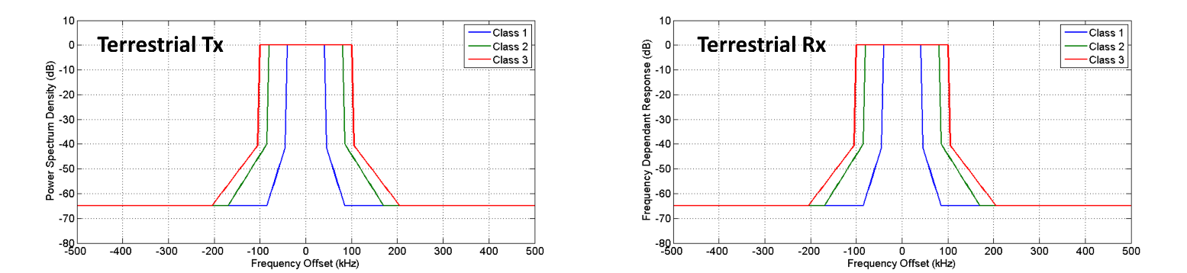
Figure 5: Terrestrial system transmitter and receiver masks

- Characteristics of the Satellite system
The useful hypotheses on the Satellite transmitters and receivers have been recorded in Table 3 and Table 4.
Table 3: Transmitter characteristics of the UA and Satellite on the Satellite system
 | Unit | UA |  |  | SAT PL
 | Unit | Class 1 | Class 2 | Class 3 | SAT PL
$$P_{T_{x}}$$ | dBm | 40 |  |  | 40
$G_{T_{x}}$ *¹ | dBi | 7 |  |  | 41
$$B$$ | kHz | 40 | 100 | 150 | 800
Polarization | - | Circular |  |  | Circular
Table 4: Receiver characteristics of the UA and Satellite on the Satellite system
 | Unit | UA | SAT PL
 | Unit | UA | Small | Medium |  |  | Large
$G_{R_{x}}$ *² | dBi | 5 | 30.5
$$B$$ | kHz | 1050 | 50 |  | 100 | 150
$d_{max}$ *³ | km | 36000 | 36000
$${E_{s}/N_{0}}_{req}$$ | dB | 0.6 | -1.25
(*¹): No side-lobe antenna gain is considered in [6]. Therefore, only isotropic Tx antennas have been considered.
(*²): No side-lobe antenna gain is considered in [6]. Therefore, only isotropic Rx antennas have been considered.
(*³): The distance between the UA and the satellite payload is the distance of a geostationary satellite (considered 36000 km).
The transmitter power spectrum density masks of the UA and SAT PL are provided in [4], as well as their frequency responses. They are displayed on Figure 6.
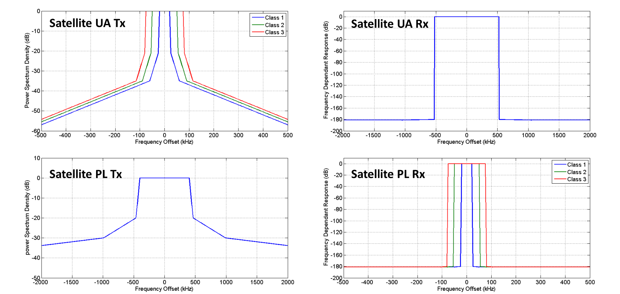
Figure 6: Satellite system transmitter and receiver masks

ANNEX 4 –RESULTS OF THE INTERFERENCE PROTECTION STUDY

This annex is dedicated to the illustration of the results of the interference analysis presented and commented in section 2.2. The interference scenarios are divided in 3 groups of scenarios:
- Terrestrial intra-system interference protection.
- Satellite intra-system interference protection.
- Terrestrial-Satellite inter-system interference protection.

- Terrestrial intra-system interference protection
Table 5 provides the minimum distance $d_{min}$ between an UA and the GRS of another UAS required to respect the interference protection criterion, depending on the frequency offset between the Desired and Undesired signals (co-channel, adjacent-channel or non-adjacent channel) and the UAS Class, considering interference from the UA to the GRS. Table 6 provides the same $d_{min}$ parameter but considering interference from the GRS to the UA.
Figure 7 and Figure 8 represent the same minimum distance $d_{min}$ as Table 5 and Table 6 respectively, for different values of frequency offsets $∆f$.
These results are analysed in paragraph 2.3.1.4.

Table 5: Minimum Interferer-Victim distance depending on the frequency offset with UA interferer and GRS victim (no additional rejection)
Victim | Interferer | $$d_{min}$$
Victim | Interferer | Co-channel | Adjacent channel | Non-Adjacent channel
LOS GRS Rx Class 1 (of another UAS) | LOS UA Tx Class 1 | $$∞$$ | 2,0 km | 600 m
LOS GRS Rx Class 1  (of another UAS) | LOS UA Tx Class 2 | $$∞$$ | 3,7 km | 800 m
LOS GRS Rx Class 1  (of another UAS) | LOS UA Tx Class 3 | $$∞$$ | 3,9 km | 900 m
LOS GRS Rx Class 2  (of another UAS) | LOS UA Tx Class 1 | $$∞$$ | 3,4 km | 800 m
LOS GRS Rx Class 2  (of another UAS) | LOS UA Tx Class 2 | $$∞$$ | 5,2 km | 1,1 km
LOS GRS Rx Class 2  (of another UAS) | LOS UA Tx Class 3 | $$∞$$ | 5,5 km | 1,2 km
LOS GRS Rx Class 3  (of another UAS) | LOS UA Tx Class 1 | $$∞$$ | 4,2 km | 1,0 km
LOS GRS Rx Class 3  (of another UAS) | LOS UA Tx Class 2 | $$∞$$ | 6,5 km | 1,4 km
LOS GRS Rx Class 3  (of another UAS) | LOS UA Tx Class 3 | $$∞$$ | 6,9 km | 1,5 km

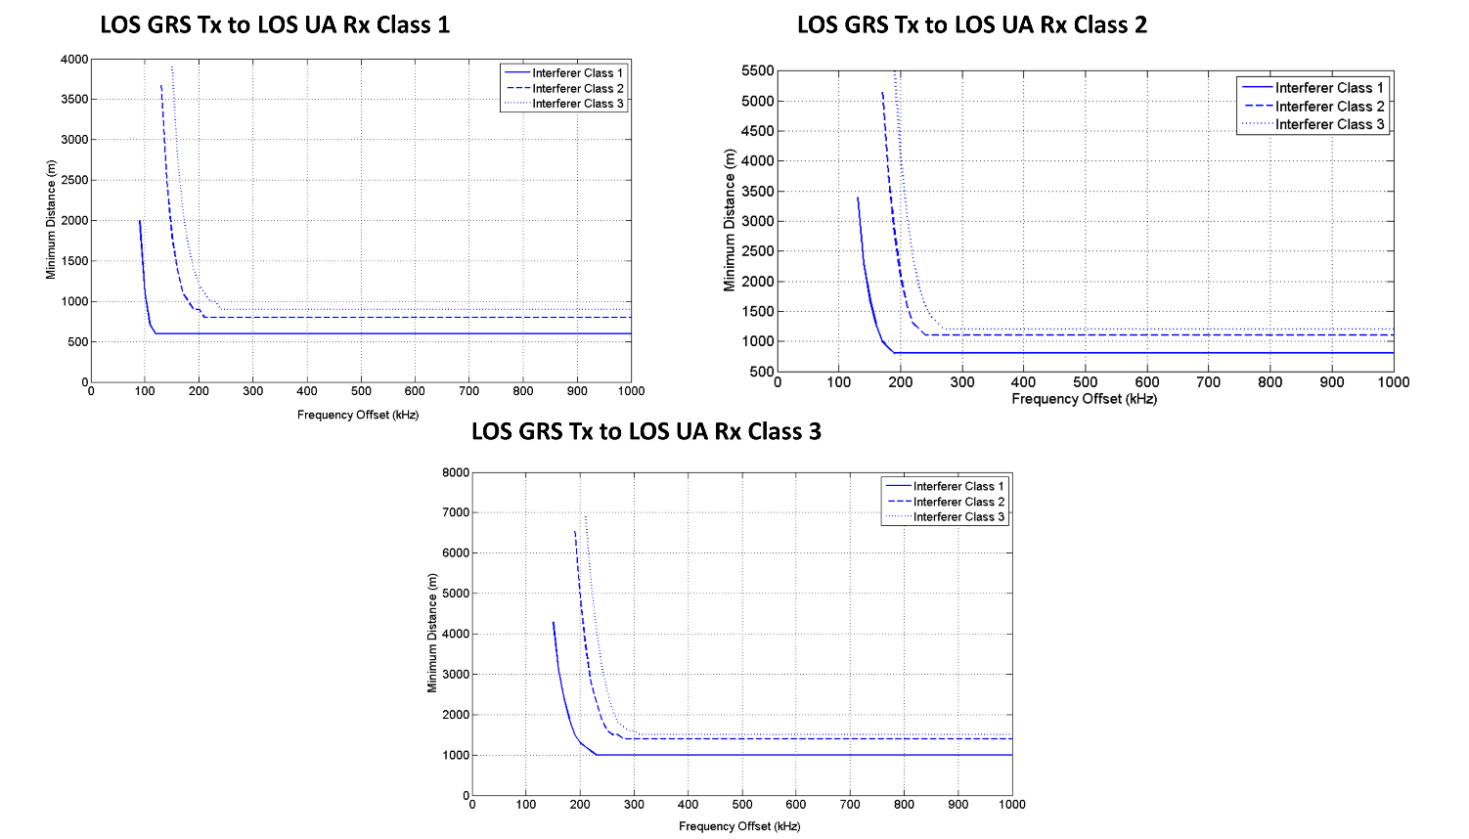
Figure 7: Minimum Interferer-Victim distance depending on the frequency offset with UA interferer and GRS victim (no additional rejection)

Table 6: Minimum Interferer-Victim distance depending on the frequency offset with GRS interferer and UA victim (no additional rejection)
Victim | Interferer | $$d_{min}$$
Victim | Interferer | Co-channel | Adjacent channel | Non-Adjacent channel
LOS UA Rx Class 1  (of another UAS) | LOS GRS Tx Class 1 | $$∞$$ | 2,0 km | 600 m
LOS UA Rx Class 1  (of another UAS) | LOS GRS Tx Class 2 | $$∞$$ | 3,7 km | 800 m
LOS UA Rx Class 1  (of another UAS) | LOS GRS Tx Class 3 | $$∞$$ | 3,9 km | 900 m
LOS UA Rx Class 2  (of another UAS) | LOS GRS Tx Class 1 | $$∞$$ | 3,4 km | 800 m
LOS UA Rx Class 2  (of another UAS) | LOS GRS Tx Class 2 | $$∞$$ | 5,2 km | 1,1 km
LOS UA Rx Class 2  (of another UAS) | LOS GRS Tx Class 3 | $$∞$$ | 5,5 km | 1,2 km
LOS UA Rx Class 3  (of another UAS) | LOS GRS Tx Class 1 | $$∞$$ | 4,2 km | 1,0 km
LOS UA Rx Class 3  (of another UAS) | LOS GRS Tx Class 2 | $$∞$$ | 6,5 km | 1,4 km
LOS UA Rx Class 3  (of another UAS) | LOS GRS Tx Class 3 | $$∞$$ | 6,9 km | 1,5 km

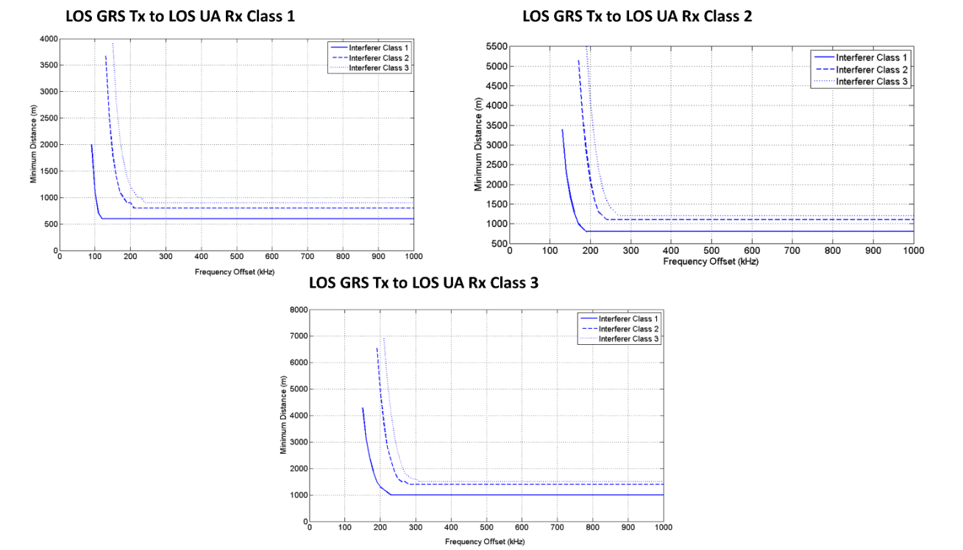
Figure 8: Minimum Interferer-Victim distance depending on the frequency offset with GRS interferer and UA victim (no additional rejection)
Table 7 represents the required additional attenuation $A_{add}$ depending on the frequency offset $∆f$ and the targeted $d_{min}$, so that $SIR\left(∆f,d_{min}\right)+A_{add}>{SIR}_{min}$. In that case, $d_{min}$ represents the minimum distance between a Class3 UA and the GRS of another UAS Class 3 (worst case scenario). Figure 9 represents $d_{min}$ depending on the frequency offset for different values of $A_{add}$ (attenuation applied to the interferer and victim masks). These results are analysed in paragraph2.3.1.4.4.

Table 7: Required additional interferer attenuation depending on the targeted minimum interferer-victim distance and frequency offset
Minimum distance | Co-channel | Adjacent channel | Non-Adjacent channel
100 m | 89 dB | 54 dB | 23.5 dB
300 m | 76 dB | 28 dB | 13.5 dB
1.0 km | 66 dB | 16 dB | 3.5 dB
1.5 km | 61 dB | 13.5 dB | 0 dB

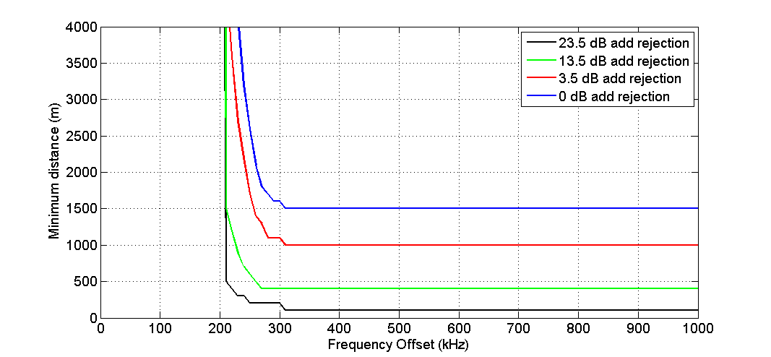
Figure 9: Minimum interferer-victim distance depending on the frequency offset for different additional interferer attenuation

- Satellite intra-system interference protection
Table 8 provides the minimum frequency offset required between the SAT UT Tx Class 1, 2 or 3 and the SAT PL Rx Class 1, 2 or 3 of another UAS to respect the interference protection criterion ($SIR<{SIR}_{min}$) The signal-to-interference ratio $SIR(∆f)$ depending on the frequency offset has been represented on Figure 10. These results are commented in paragraph 2.3.2.1.3.

Return Link:
Table 8: Minimum frequency offset between SAT UA Tx interferer and SAT PL Rx victim
Victim | Interferer | $${∆f}_{min}$$
SAT PL Rx Class 1  (of another UAS) | SAT UA Tx Class 1 | 60 kHz
SAT PL Rx Class 1  (of another UAS) | SAT UA Tx Class 2 | 80 kHz
SAT PL Rx Class 1  (of another UAS) | SAT UA Tx Class 3 | 100 kHz
SAT PL Rx Class 2  (of another UAS) | SAT UA Tx Class 1 | 100 kHz
SAT PL Rx Class 2  (of another UAS) | SAT UA Tx Class 2 | 110 kHz
SAT PL Rx Class 2  (of another UAS) | SAT UA Tx Class 3 | 130 kHz
SAT PL Rx Class 3  (of another UAS) | SAT UA Tx Class 1 | 130 kHz
SAT PL Rx Class 3  (of another UAS) | SAT UA Tx Class 2 | 140 kHz
SAT PL Rx Class 3  (of another UAS) | SAT UA Tx Class 3 | 160 kHz

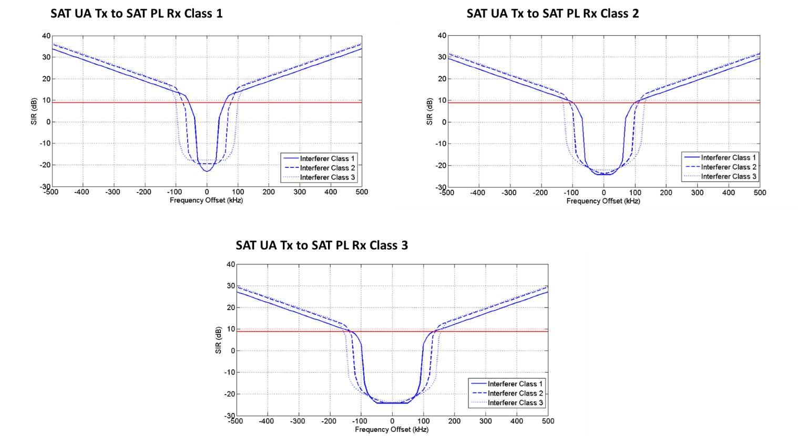
Figure 10: Signal-to-interference ratio SIR depending on the frequency offset for the Return link interference scenarios

Forward Link:
Table 8 provides the minimum frequency offset required between the SAT PL Tx and the SAT UA Rx of another UAS to respect the interference protection criterion ($SIR<{SIR}_{min}$). The signal-to-interference ratio for the different frequency offsets $SIR(∆f)$ has been represented on Figure 11. These results are commented in paragraph 2.3.2.2.3.

Table 9: Minimum frequency offset between SAT PL Tx interferer and SAT UA Rx victim
Victim | Interferer | $${∆f}_{min}$$
SAT UA Rx  (of another UAS) | SAT PL Tx | 800 kHz

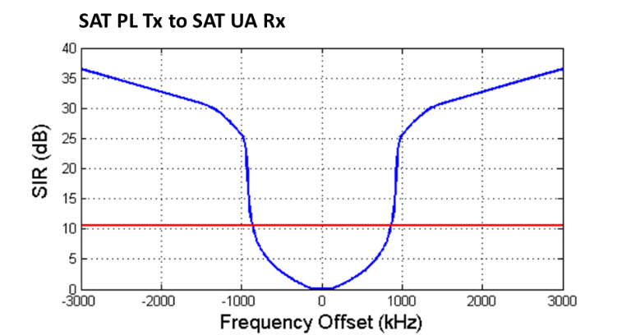
Figure 11: Signal-to-interference ratio SIR depending on the frequency offset for the Forward link interference scenarios
Return-Forward Link:
Figure 12 represents the signal to interference ratio depending on the frequency offset for interference from SAT UA Tx to SAT UA Rx. Table 10 provides the minimum frequency offset between SAT UA Rx and SAT UA Tx. These results are commented in paragraph 2.3.2.3.3.
Table 10: Minimum frequency offsets for interference from SAT UA Tx to SAT UA Rx
Victim | Interferer | $${∆f}_{min}$$
SAT UA Rx | SAT UA Tx | 2,2 MHz

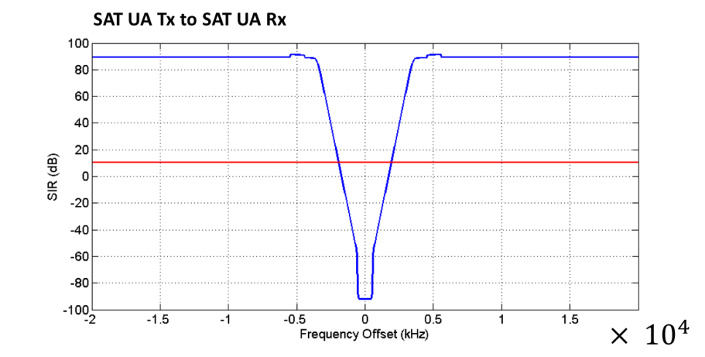
Figure 12: Signal-to-interference ratio SIR depending on the frequency offset for interference from SAT UA Tx to SAT UA Rx

Figure 13 represents the signal-to-interference ratio for interference from SAT PL Tx to a SAT PL Rx. Table 11 provides the necessary interference attenuation between SAT PL Tx and SAT PL Rx to satisfy the interference protection criterion.

Table 11: Required protection between a SAT PL Tx and a SAT PL Rx for different frequency offsets between the Forward link and Return link sub-bands
Victim | Interferer | $${∆f}_{min}$$ | Required rejection
SAT UA Rx | SAT UA Tx | 10 MHz | 84 dB
SAT UA Rx | SAT UA Tx | 20 MHz | 59 dB
SAT UA Rx | SAT UA Tx | 30 MHz | 25 dB
SAT UA Rx | SAT UA Tx | 40 MHz | 0 dB

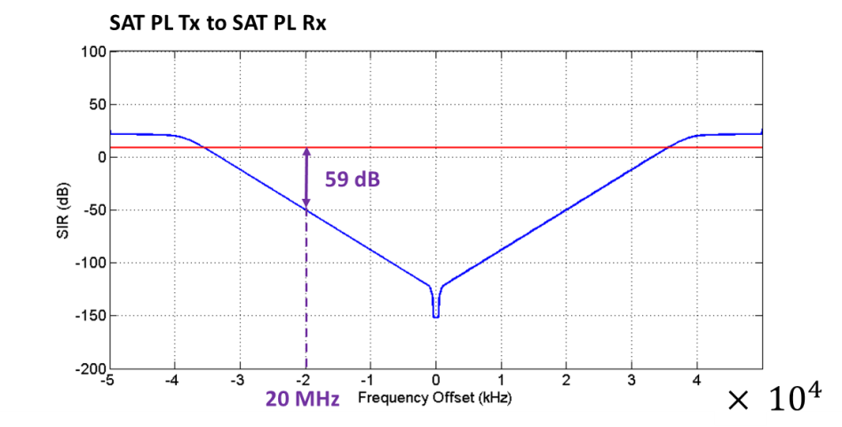
Figure 13: Signal to interference ratio for the interference from SAT PL Tx to SAT PL Rx without any interference protection between the Tx and the Rx

- Terrestrial-Satellite inter-system interference protection
Figure 14, Figure 15, Figure 16 and Figure 17 represent the minimum distances $d_{min}$ that must be respected between a SAT UA and LOS UA or a LOS GRS depending on the frequency offset $∆f$ required by the interference protection for different scenarios. Different additional interferer attenuations have been considered (from 0 dB to 50 dB depending on the interference scenario). Table 12, Table 13, Table 14 and Table 15 provide the attenuation required on the interfering signal so that $SIR\left(∆f,d_{min}\right)+A_{add}<{SIR}_{min}$, depending on the targeted value of $d_{min}$ and frequency offset, for interference scenarios of a) and b). These results are analysed in paragraph 2.3.3.3.1.
Table 12: Required additional interferer attenuation depending on the targeted minimum interferer-victim distance and frequency offset for SAT UA Tx to LOS UA Rx interference
Minimum distance | $$∆f=0 kHz$$ | $$∆f=250 kHz$$ | $$∆f=500 kHz$$ | $$∆f=750 kHz$$ | $$∆f=1 MHz$$
100 m | 83 dB | 43 dB | 30 dB | 20 dB | 17 dB
300 m | 73 dB | 34 dB | 21 dB | 15 dB | 9 dB
1.0 km | 63 dB | 23 dB | 9 dB | 1 dB | 0 dB
1.5 km | 59 dB | 20 dB | 8 dB | 0 dB | 0 dB

Table 13: Required additional interferer attenuation depending on the targeted minimum interferer-victim distance and frequency offset for SAT UA Tx to LOS GRS Rx interference
Minimum distance | $$∆f=0 kHz$$ | $$∆f=250 kHz$$ | $$∆f=500 kHz$$ | $$∆f=750 kHz$$ | $$∆f=1 MHz$$
100 m | 90 dB | 50 dB | 37 dB | 28 dB | 24 dB
300 m | 80 dB | 40 dB | 28 dB | 19 dB | 15 dB
1.0 km | 69 dB | 30 dB | 18 dB | 8 dB | 5 dB
2.0 km | 63 dB | 24 dB | 12 dB | 2 dB | 0 dB

Table 14: Required additional interferer attenuation depending on the targeted minimum interferer-victim distance and frequency offset for LOS UA Tx to SAT UA Rx interference
Minimum distance | $$∆f=0 kHz$$ | $$∆f=250 kHz$$ | $$∆f=500 kHz$$ | $$∆f=750 kHz$$ | $$∆f=1 MHz$$
100 m | 102 dB | 102 dB | 99 dB | 44 dB | 44 dB
300 m | 92 dB | 92 dB | 90 dB | 34 dB | 34 dB
1 km | 82 dB | 82 dB | 80 dB | 24 dB | 24 dB
5 km | 68 dB | 68 dB | 66 dB | 11 dB | 11 dB
10 km | 62 dB | 62 dB | 60 dB | 4 dB | 4 dB
20 km | 56 dB | 56 dB | 54 dB | 0 dB | 0 dB

Table 15: Required additional interferer attenuation depending on the targeted minimum interferer-victim distance and frequency offset for LOS GRS Tx to SAT UA Rx interference
Minimum distance | $$∆f=0 kHz$$ | $$∆f=250 kHz$$ | $$∆f=500 kHz$$ | $$∆f=750 kHz$$ | $$∆f=1 MHz$$
100 m | 107 dB | 107 dB | 105 dB | 50 dB | 50 dB
300 m | 99 dB | 99 dB | 97 dB | 41 dB | 41 dB
1 km | 88 dB | 88 dB | 86 dB | 30 dB | 30 dB
10km | 67 dB | 67 dB | 65 dB | 11 dB | 11 dB
20 km | 62 dB | 62 dB | 60 dB | 4 dB | 4 dB
40 km | 55 dB | 55 dB | 53 dB | 0 dB | 0 dB

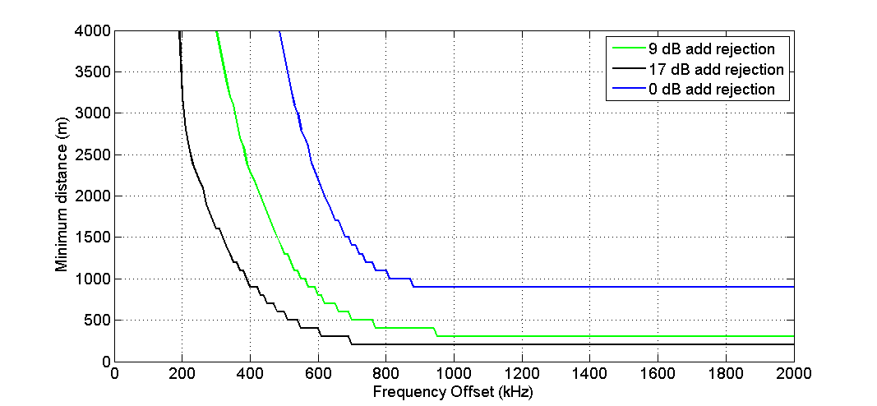
Figure 14: Minimum interferer-victim distance depending on the frequency offset for different additional interferer attenuation for SAT UA Tx to LOS UA Rx interference

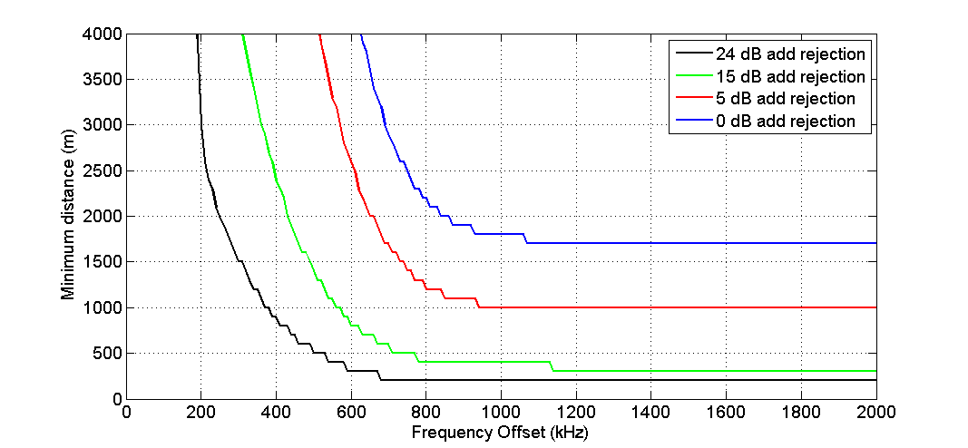
Figure 15: Minimum interferer-victim distance depending on the frequency offset for different additional interferer attenuation for SAT UA Tx to LOS GRS Rx interference

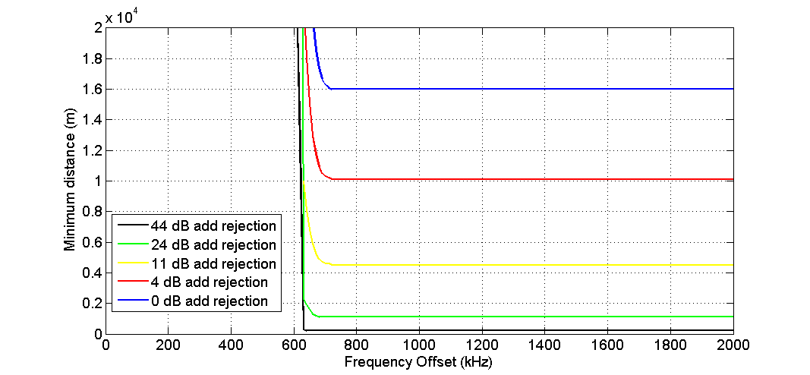
Figure 16: Minimum interferer-victim distance depending on the frequency offset for different additional interferer attenuation for LOS UA Tx to SAT UA Rx interference

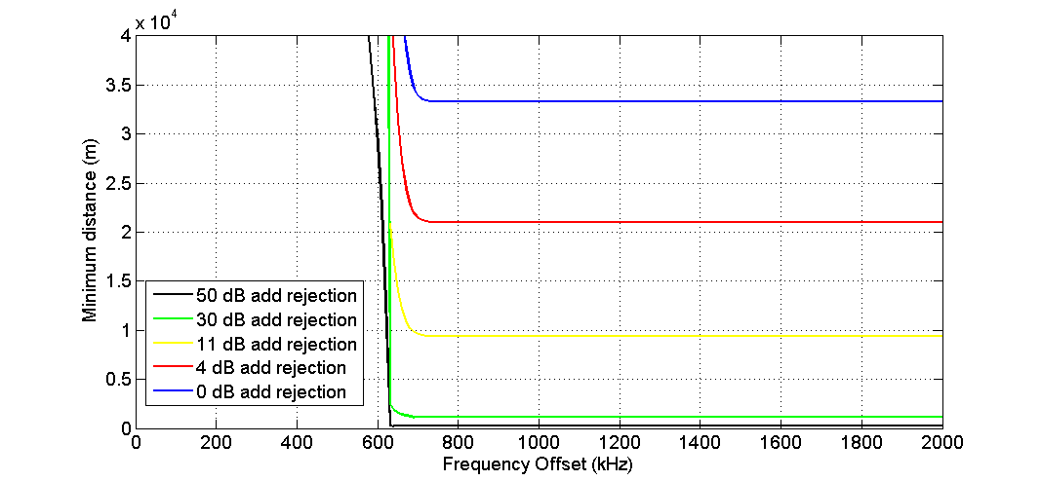
Figure 17: Minimum interferer-victim distance depending on the frequency offset for different additional interferer attenuation for LOS GRS Tx to SAT UA Rx interference

Figure 18 represents the signal to interference ratios corresponding to different interference scenarios. Table 16 provides the minimum frequency offset for which $SIR\left(∆f\right)<{SIR}_{min}$ for the different scenarios. These results are analysed in paragraph 2.3.3.3.2.
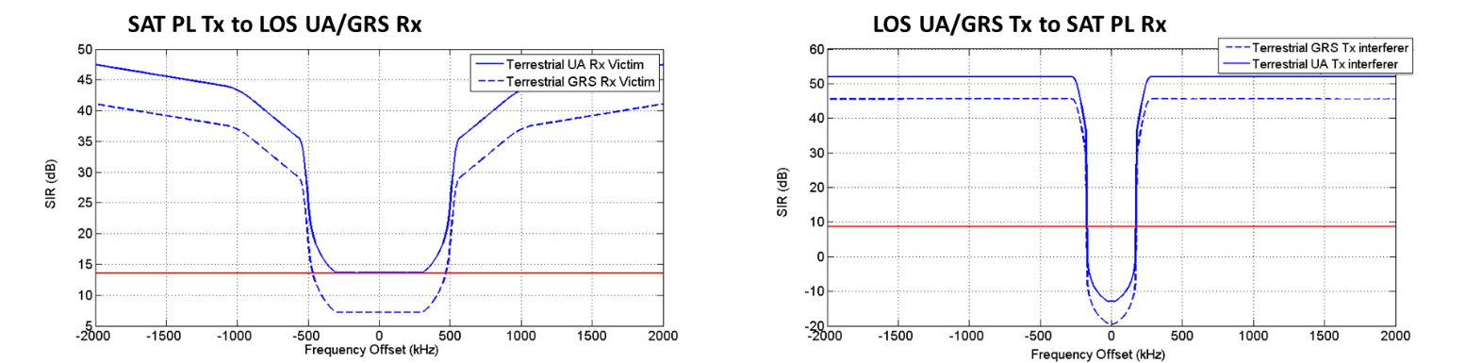
Figure 18: Signal-to-interference ratio SIR depending on the frequency offset for the interference from SAT PL Tx to LOS UA/GRS Rx and from LOS UA/GRS Tx to SAT PL Rx

Table 16: Minimum frequency offset for the interference from SAT PL Tx to LOS UA/GRS Rx and from LOS UA/GRS Tx to SAT PL Rx protection
Victim | Interferer | $${∆f}_{min}$$
LOS UA Rx | SAT PL Tx | 350 kHz
LOS GRS Rx | SAT PL Tx | 500 kHz
SAT PL Rx | LOS UA Tx | 200 kHz
SAT PL Rx | LOS GRS Tx | 200 kHz

