Cir NNN
AN/NNN

Guidance on Safeguarding measures to protect Radio Altimeter from potential harmful interference from Cellular 5G Communications
________________________________

Approved by the Secretary General
and published under his authority

International Civil Aviation Organization

Published in separate English, Arabic, Chinese, French, Russian
and Spanish editions by the
INTERNATIONAL CIVIL AVIATION ORGANIZATION
999 University Street, Montréal, Quebec, Canada H3C 5H7

For ordering information and for a complete listing of sales agents
and booksellers, please go to the ICAO website at www.icao.int

Cir NNN, Guidance on Safeguarding measures
to protect Radio Altimeter from potential harmful interference
from Cellular 5G Communications
Order Number: CIRNNN
ISBN 978-92-9249-474-2

© ICAO 2023

All rights reserved. No part of this publication may be reproduced, stored in a
retrieval system or transmitted in any form or by any means, without prior
permission in writing from the International Civil Aviation Organization.

TABLE OF CONTENTS

Page

Abbreviations and acronyms (v)

References (vii)

Executive Summary 9

Chapter 1 - Background on 5 G and frequency band allocation 11

Chapter 2 - Potential impacts of 5G on Radio Altimeters during aircraft operations 13

Chapter 3 – Short Term Safeguarding measures adopted at regional and global levels /Long Term Planning 19

Chapter 4 - Methodologies for defining safeguarding measures for aerodromes & heliports 32

______________________

ABBREVIATIONS AND ACRONYMS

CITC Communications and Information Technology Commission
CNS SG Communication, Navigation, and Surveillance Sub-Group
dBi decibel isotropic
dBm decibels relative to one milliwatt
EIRP Effective Isotropic Radiated Power
EUROCAE European Organization for Civil Aviation Equipment
FCC Federal Communications Commission
FMCW Frequency Modulated Carrier Wave
FMSP Frequency Spectrum Management Panel
ICAO International Civil Aviation Organization
IMT International Mobile Telecommunications
ITU International Telecommunications Union
ITU-R International Telecommunications Union-Radiocommunications sector
LFMCW Linear Frequency Modulation Continuous Wave
MIDANPIRG Middle East Air Navigation Planning and Implementation Regional Group
NCD No Computed Data
NFAT National Frequency Allocations Tables
PPT PowerPoint Presentation
RADALT Radio Altimeter
RASG-MID Regional Aviation Safety Group for the Middle East
RF Radio Frequency

RR Radio Regulations
RTCA Radio Technical Commission for Aeronautics
SDO Standards Developing Organizations
TAWS Terrain Awareness Warning System
TCAS Traffic Collision Avoidance System
TX/RX Transmitter/Receiver
WP Working Paper
WRC World Radio-communication Conference.

______________________

____________________

Executive Summary

The radio altimeter operates in the frequency band 4.2-4.4 GHz. It is a mandated critical aircraft safety system used to determine an aircraft’s height above terrain and obstacles. Its information is essential to enable safety-related flight operations and navigation functions on all commercial aircraft as well as a wide range of other civil aircraft. Such functions and systems include terrain awareness, aircraft collision avoidance, wind shear detection, flight controls, and functions to automatically land an aircraft. If not properly mitigated, harmful interference to the function of the radio altimeter during any phase of flight may pose a serious safety risk to passengers, crew and people on the ground.

ICAO has received studies from several States and organizations regarding the potential interference to radio altimeters. These studies generally conclude that several makes and models of radio altimeters will not operate as required if new cellular broadband technologies (i.e. 5th generation cellular network technology ( 5G)) are deployed in frequency bands close to the radio altimeter’s frequencies of operation (4.2-4.4 GHz). Several States have already implemented temporary technical, regulatory, and operational mitigations on new 5G systems to protect radio altimeters while the aviation industry is working on long-term solutions to update and retrofit altimeters in order to ensure compatibility between cellular broadband technologies (5G) and aviation systems.
19th meeting of the Middle East Air Navigation Planning and Implementation Regional Group (MIDANPIRG) held in Riyadh, Saudi Arabia from 14 to 17 February 2022 was apprised of the ICAO State Letter (dated 25 March 2021) on the potential impact of 5G on radio altimeters in the MID Region. Acknowledging the safety concerns and potential operational impacts, the meeting agreed to

establish a Radio Altimeter (RADALT) Action Group (AG) to develop guidance material to protect aircraft operations from potential radio altimeter interference.

This guidance was originally developed by the AG and was provided to the Frequency Spectrum Management Panel (FSMP) for their endorsement as a global guidance. This circular is composed of four chapters as follows.
- Chapter 1 - Background on 5 G and frequency band allocation. This chapter describes the working arrangements and regulatory framework managed by Radio communications sector of the International Telecommunications Union for the allocations of radiofrequency (RF) spectrum and adoption of radio regulation. It also provides an overview on the current allocations of 5G at global level including in the Middle East

- Chapter 2 - Potential impacts of 5G on Radio Altimeters during aircraft operations provides an overview on RADALT characteristics, its critical safety functions, the technical concerns raised following the allocations of 5G bands close to RADALT frequency band. This chapter also provides a list of potential operational safety hazards and their severity that may be caused by interference associated with the deployment of cellular broadband 5G ground infrastructure

- Chapter 3 – Short Term Safeguarding measures adopted at regional and global levels/Long Term Planning provides a summary on the safeguarding measures adopted by States at regional and global levels to protect Radio Altimeter from potential harmful interference from Cellular 5G Communications. It also summarizes the on-going and planned activities by regional organizations and SDOs to define new RADALT specifications

- Chapter 4 - Methodologies for defining safeguarding measures for aerodromes & heliports: provides a summary on approach and methodology that can be used to set protection zones considering aircraft height/altitude during the approach to reduce the probability of interference occurring by imposing limitations on the deployment of 5G base stations at aerodromes and in areas surrounding aerodromes. It also provides a set of requirements and guidance that should be implemented by aircraft operators to restrict use of 5G user equipment and devices on board an aircraft.

________________________

Chapter 1 - Background on 5 G and frequency band allocation

The Role of ITU-R

    - ITU-R is the Radio communications sector of the International Telecommunications Union. ITU-R is responsible for ensuring efficient and economical use of the radiofrequency (RF) spectrum by all radio communication services. It develops and adopts the international spectrum allocations and associated regulations on the use of the RF spectrum.

    - The Radio Regulations (RR) are an internationally binding treaty on Member States regulating how RF spectrum is used. It is the basis for the global harmonization of RF spectrum use for all users of spectrum, including aviation and International Mobile Telecommunications (IMT) users. To enable new technologies and changes in spectrum usage, an ITU World Radiocommunication Conference (WRC) is held every 4 years where the Radio Regulations are revised and updated.

    - The radio regulations allow use of 5G in the frequency range 3400 – 4200 MHz. In Region 1, radio regulations allocate the frequency band 3400-3600 MHz to the mobile, except aeronautical mobile, service, and is identified for International Mobile Telecommunications (IMT). This identification does not preclude the use of this frequency band by any application of the services to which it is allocated and does not establish priority in the Radio Regulations.

    - For the allocation of frequencies in the RR, the world is divided into three Regions as shown in Figure 1 below:

Global Spectrum Situation for 5G

    - The growth in demand from mobile broadband requires access to regionally or globally harmonized spectrum to provide additional IMT services including higher data rates.

    - The frequency ranges 3300–4200 MHz and 4400-4900 MHz provide good propagation and data rates and are of global interest to IMT proponents. Variations of usage are seen regionally. The main band used in Europe is 3400–3800MHz, while China and India are planning for 3300–3600MHz and in Japan 3600–4100MHz is considered. Similar frequency ranges are considered in North America (3450–3980MHz), Latin America, the Middle East, Africa, India, Australia, etc. A total of 45 countries signed up to the IMT identification of the 3300–3400MHz band at ITU WRC-15. There is also interest in China to utilize the 4800– 5000 MHz frequency range and the 4500–4900 MHz frequency range in Japan. The following table provides the bands that were identified by some of the MID States for 5G deployments.

    - Each State has responsibility to develop spectrum management policies and regulations that comply with the international treaty obligations of the Radio Regulations while meeting national spectrum needs. One of the main tools to manage the spectrum is National Frequency Allocations Tables (NFAT). NFAT shows how the spectrum can be utilized for each radio frequency service.

    - States and national spectrum regulators all over the world are considering (or have considered) allowing 5G cellular systems to operate in parts of the frequency ranges 3.4-4.2 GHz and 4.4 -4.9 GHz (“C-band”). These potential allocations are adjacent to the band used by radio altimeters and pose potential safety hazards if no mitigations are implemented. It is of paramount importance that, in support of safety of aircraft operations, member States and national regulators note Article 4.10 of the ITU Radio Regulations which states, “ITU Member States recognize that the safety aspects of radionavigation and other safety services require special measures to ensure their freedom from harmful interference. It is necessary therefore to take this factor into account in the assignment and use of frequencies.”
_________________

Chapter 2 - Potential impacts of 5G on Radio Altimeters during aircraft operations

Introduction

    - The band 4 200-4 400 MHz is allocated to the aeronautical radionavigation service (ARNS) and is reserved for radio altimeters installed onboard aircraft by ITU Radio Regulations Art. 5 – Frequency Allocations, footnote No. 5.438.

    - Radio altimeters are critical sensors used to enable and enhance several different safety and navigation functions throughout all phases of flight on all commercial aircraft and a wide range of other aircraft.

    - The radio altimeter is the only sensor onboard the aircraft capable of providing a direct measurement of the clearance height above the terrain and any obstacles, it plays a crucial role in providing situational awareness to the flight crew and is an essential component of aeronautical safety-of-life during aircraft operations. The main radio altimeters functions are illustrated in the following figure.

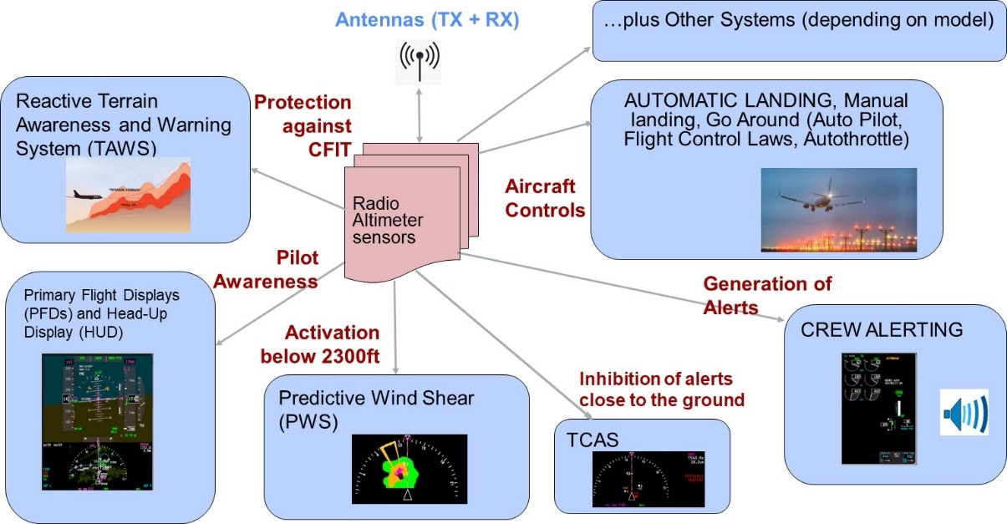
    - Radio altimeter systems are designed to operate for the entire life of the aircraft in which they are installed. The installed life can exceed 30 years, resulting in a wide range of equipment age, performance, and tolerance.

Radio altimeters characteristics (based on ITU-R M.2059)

General Characteristics

      - Technical characteristics for several types of radio altimeters operating within the frequency band 4200-4400 MHz can be found in Recommendation ITU-R M.2059. In particular, Table 1 & and Table 2 give technical parameters of several radio altimeters.

      - Because of the importance of radio altimeters to safely operate an aircraft, they are included in the minimum equipment list on aircraft certified for passenger service. Furthermore, they must be certified at a safety criticality rating or Design Assurance Level (DAL) of “A”, “Where a software/hardware failure would cause and/or contribute to a catastrophic failure of the aircraft flight control systems” for all transport aircraft and a DAL of “B”, “Where a software/hardware failure would cause and/or contribute to a hazardous/severe failure condition in the flight control systems” for business and regional aircraft. Design assurance level is a safety criticality rating from level A to E, with level A/B being the most critical and requiring the most stringent certification process.

      - Radio altimeter systems on a single aircraft consist of up to three identical radio altimeter transceiver (Tx/Rx) units with their associated equipment. All Tx/Rx units operate simultaneously and independently from one another. The radio altitude is computed from the time interval a signal, originating from the aircraft is reflected from the ground. Radio altimeters designed for use in automated landing systems are required to achieve an accuracy of 0.9 meters (3 feet). The following figure is an illustration of the TX/RX beams of radio altimeter signals.
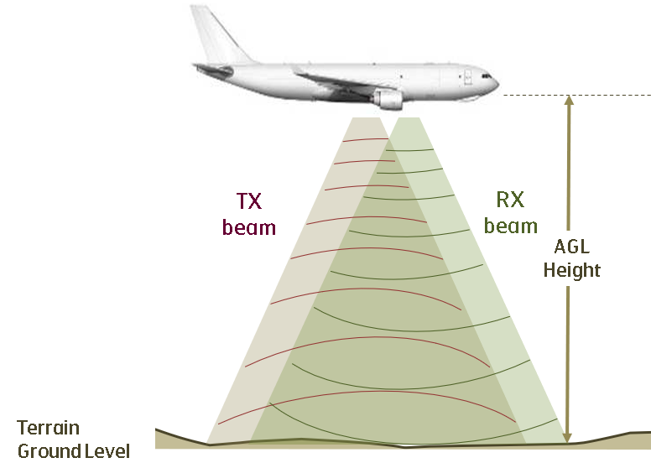

      - There are two types of radar waveform modulation methods for radio altimeters:
- Continuous-wave of linear frequency modulation continuous wave (LFMCW) or frequency modulated carrier wave (FMCW) radio altimeters; and
- Pulsed modulation.

FMCW radio altimeters

      - FMCW radio altimeters operate by a Tx/Rx working in conjunction with separate transmit/receive antennas. Operation requires a signal from the transmit antenna to be directed to the ground. When the signal hits the ground, it is reflected back to the receive antenna. The system then performs a time calculation to determine the distance between the aircraft and the ground, as the altitude of the aircraft is proportional to the time required for the transmitted signal to make the round trip.

      - It is important to note that FMCW radio altimeters do not have a fixed frequency. One can find the chirp bandwidth of each FMCW radio altimeter type in Table 1 of Recommendation ITU-R M.2059.

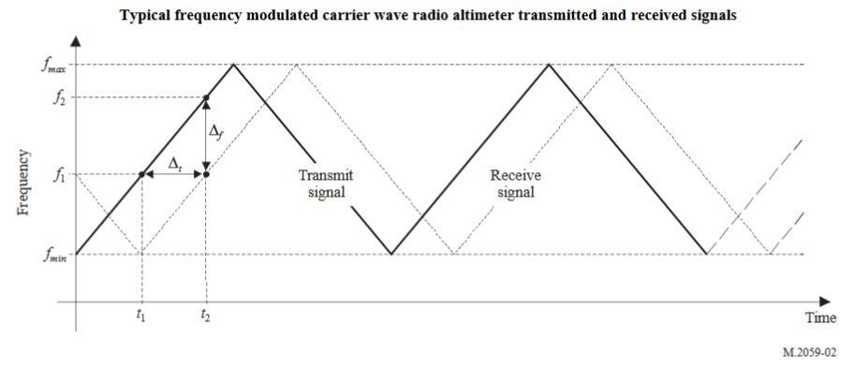

Pulsed radio altimeters

      - The pulsed-type radio altimeter uses a series of pulses of radio frequency energy transmitted towards the Earth to measure the absolute height above the terrain immediately underneath the aircraft. The time difference between the transmitted pulse and the received pulse is measured, and that time is proportional to the height of the aircraft. Pulsed radio altimeters are emitting at a fixed frequency (generally 4300 MHz). However, the emission bandwidth could vary (see for example D4 within the Table 1 from ITU-R M.2059).

Technical concerns

      - Standardized in 1980s, the radio altimeters, even though developed and deployed fully in compliance with national regulations and industry standards, have not been designed to fully withstand the high level of terrestrial interferences in its adjacent and near bands that may cause a blocking and/or spurious phenomenon. The fundamental terrestrial 5G energy is not filtered by all radio altimeters models.

      - In the United States, following an auction by the Federal Communications Commission (FCC) of the 3.7–3.98 GHz frequency band, Radio Technical Commission for Aeronautics (RTCA) formed a task force to assess the interference impact of wireless broadband operations in the 3.7–3.98 GHz band on radio altimeters. Based on the work of the task force, RTCA published a report entitled, “Assessment of C-Band Mobile Telecommunications Interference Impact on Low Range Radar Altimeter Operations” where it identified potential risk of interference that can be caused by 5G base stations operating within the band 3.7–3.98 GHz.

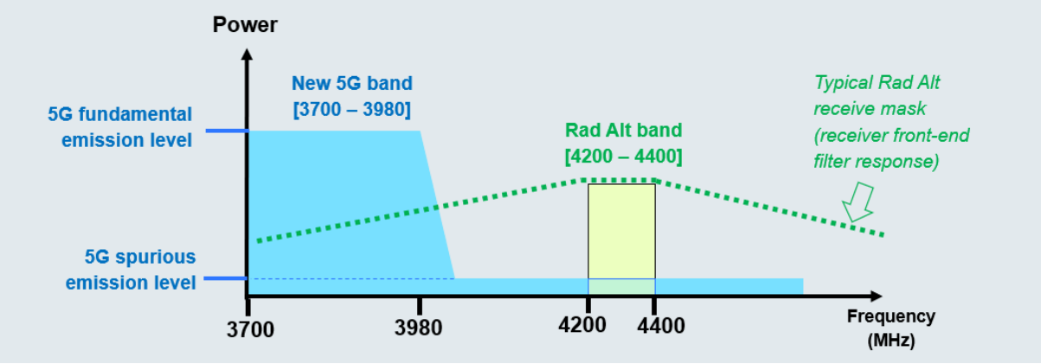
Source: RTCA Paper No. 274-20/PMC-2073 – (Figure 3-1: Spectrum Illustration Showing 5G Fundamental and Spurious Emissions, page 20).

Potential operational impacts of 5G on Flight Crew and Aircraft

Loss of Situational Awareness

      - On all types of aircraft, situational awareness of the flight crew is paramount to ensuring safe flight operations, especially flying in busy airspace, close to the ground, or in low-visibility scenarios such as Instrument Meteorological Conditions (IMC). The radio altimeter plays a critical role in providing situational awareness in these operating conditions, in particular. Not only do radio altimeters provide a displayed indication of height above terrain to the flight crew, but they also form the basis of auditory altitude callouts during terminal landing procedures, as well as Traffic Alert and Collision Avoidance System/Airborne Collision Avoidance System (TCAS/ACAS) and Terrain Awareness Warning System (TAWS) advisories and warnings.

      - Erroneous or unexpected behavior of the radio altimeter directly leads to a loss of situational awareness for the flight crew. Not only does this loss of situational awareness present an immediate impact to the ability of the flight crew to maintain safe operation of the aircraft in its own right, it also requires the flight crew to attempt to compensate for the lack of reliable height above ground information using other sensors and visual cues, if available. This further leads to a risk of task saturation for the flight crew, particularly during operations or phases of flight which require continuous crew engagement, such as final approach and landing procedures.

Controlled Flight into Terrain

      - In the most extreme cases, loss of situational awareness may lead to an occurrence of Controlled Flight into Terrain (CFIT), which is when the pilot flies the aircraft into the ground. This situation is nearly always a devastating event resulting in aircraft hull loss and a high likelihood of loss of life or severe injuries to the flight crew and passengers. The frequency of CFIT accidents in earlier generations of aircraft operations was unacceptably high, providing the key motivating factor for the introduction of radio altimeters in civil and commercial aviation in the 1970s, as well as the subsequent development of TAWS. This implementation has greatly reduced the risk of CFIT, as long as the radio altimeter and associated systems are functioning properly.

      - However, CFIT may still occur in modern aircraft operations due to undetected erroneous output from the radio altimeter(s), which may be considered Hazardously Misleading Information (HMI) during certain phases of flight or operational conditions (such as IMC). If HMI is presented to the flight crew, TAWS, or the AFGCS, it may lead to incorrect and dangerous flight operations, and there may not be sufficient time to correct the error before a catastrophic result such as CFIT occurs.

Specific Operational Impacts on Aircraft

      - On commercial air transport and regional aircraft, high-end business aviation aircraft, and some general aviation aircraft and helicopters, the radio altimeter serves far more purposes than providing situational awareness of the terrain clearance height to the flight crew. In these cases, in addition to providing a displayed indication of the aircraft height above terrain, the radio altimeter will be used as a safety-critical navigation sensor by the Automatic Flight Guidance and Control Systems (AFGSC) and will also feed into systems such as TCAS/ACAS, Predictive Wind Shear (PWS), and TAWS. This usage by a wide variety of systems onboard the aircraft leads to the possibility of specific operational impacts that go beyond a general loss of situational awareness or risk of CFIT.

      - The table below illustrates typical radio altimeter failures with specific operational impacts that may be encountered due to undetected erroneous readings or unanticipated loss of output (indicated as a No Computed Data, or NCD, condition) from the radio altimeter on commercial or civil aircraft which utilize the radio altimeter for functions such as those mentioned in the preceding paragraph. For each impact, the severity is assessed in accordance with Federal Aviation Administration (FAA) system safety analysis guidelines. The severity of each condition may be determined to be Minor, Major, Hazardous/Severe Major, or Catastrophic, with each severity classification having its own allowable occurrence rate. The allowable occurrence rate 1 x 10⁻³ per flight hour or less for Minor failure conditions, 1 x 10⁻⁵ per flight hour or less for Major failure conditions, 1 x 10⁻⁷ per flight hour or less for Hazardous/Severe Major failure conditions, and 1 x 10⁻⁹ per flight hour or less for Catastrophic failure conditions.

Radio Altimeter Failure | Operational Impact | Flight Phase | Severity
Undetected Erroneous Altitude | Just prior to touchdown, the aircraft performs a flare maneuver to avoid a hard landing. The flare may be performed manually by the flight crew, using auditory callouts of radio altimeter readings, if sufficient visibility is available. In low-visibility conditions, the flare may be controlled by an auto-land function. Erroneous radio altimeter readings in either case can result in the potential for CFIT with little or no time for the flight crew to react. | Landing – Flare | Catastrophic
Undetected Erroneous Altitude | Erroneous input to the AFGCS affects aircraft attitude commands and altitude, as well as flight control protection mechanisms | All Phases of Flight | Catastrophic
Unanticipated NCD | Undetected loss of PWS display to flight crew, preventing awareness of wind shear impact to vertical profile in front of the aircraft | Landing | Hazardous/Severe Major
Unanticipated NCD | Undetected loss of TCAS/ACAS inhibition near the ground, leading to potential erroneous descent advisory alert and associated possibility of CFIT in low-visibility conditions | Approach, Landing, Takeoff | Hazardous/Severe Major
Undetected Erroneous Altitude | Erroneous triggering of TAWS reactive terrain avoidance maneuver, forcing mandatory response from flight crew and leading to potential traffic conflicts in surrounding airspace | Approach, Landing, Takeoff | Major
Unanticipated NCD | Aircraft landing guidance flight control laws violated leading to unnecessary missed approach and go-around, jeopardizing safety of surrounding airspace | Approach, Landing | Major
Unanticipated NCD | Loss of capability to perform approach and landing in low-visibility conditions (Category II/III approach), leading to unnecessary diversion and jeopardizing safety of surrounding airspace | Approach, Landing | Hazardous/Severe Major
Unanticipated NCD | Loss of capability to warn flight crew in case of excessive aircraft descent rate or excessive terrain closure rate (TAWS Mode 1 and 2 alert protection not active) | All Phases of Flight | Major
Unanticipated NCD | Loss of capability to warn flight crew of potentially dangerous loss of height after takeoff (TAWS Mode 3 alert protection not active) | Takeoff, Go-around | Major
Unanticipated NCD | Loss of capability to warn flight crew of potentially dangerous aircraft configuration—e.g., landing gear, slats, flaps—based on height above terrain (TAWS Mode 4 alert protection not active) | Landing | Major
Unanticipated NCD | Loss of capability to warn flight crew that aircraft is dangerously below glide path during precision instrument approach (TAWS Mode 5 alert protection not active) | Landing | Major

      - The operational impacts listed in the table above are not exhaustive, and other operational impacts which can compromise aviation safety may be encountered. The examples provided are intended to give a general idea of the types of specific impacts that may be experienced and their severity.
__________________

Chapter 3 – Short Term Safeguarding measures adopted at regional and global levels /Long Term Planning

Introduction

    - The aviation community has raised concerns about potential interference to radio altimeters operating in the frequency band 4.2 – 4.4 GHz from 5G networks deployed in adjacent and nearby bands. To this end, a detailed technical analysis was performed by RTCA, and a report was published in October 2020. The RTCA report studies the impact of 5G operations in the 3.7 – 3.98 GHz band based on US Federal Communication Commission (FCC)’s decision to allow the deployment of mobile networks in this band. Two main interference mechanisms are considered:
- spurious emissions from 5G transmitters falling into the main altimeter operating band and causing the altimeter receiver desensitization; and
- emissions from the main 5G operating band falling into altimeter sidebands and causing the altimeter receiver blocking.

    - The RTCA report considers the protection criteria established in ITU-R Recommendation M.2059 for altimeters. It describes the measurement tests conducted to determine interference tolerance thresholds for different aviation commercial altimeter models. The test results were presented for three user categories: Category 1 representing commercial air transport airplanes; Category 2 representing regional, business and general aviation airplanes; and Category 3 covering helicopters. For each user category, 5G interference levels are then calculated for different 5G deployment scenarios (urban, suburban, and rural) and compared against measured threshold levels. The report concludes that there is a risk of exceeding altimeter interference threshold levels by interference caused by 5G networks operating in 3.7 – 3.98 GHz band. The values are potentially based on worst-case noting that no information is available on the specific altimeters considered.

    - Within ICAO, the Frequency Spectrum Management Panel (FMSP) has considered the issue and reviewed submissions from several States. In addition, a group has been established to collect information related to 5G/Radio Altimeter compatibility and a State Letter has been produced advising ICAO member States of the issue.

    - Several States have already implemented temporary technical, regulatory, and operational mitigations on new 5G systems in order to protect the RA while more permanent solutions are being explored.

Measures adopted by States, Regional Organizations & SDOs

Australia

      - The Australian spectrum regulator (the ACMA) held a public consultation in May 2022 on replanning parts of the frequency band 3 400-4 000 MHz for 5G and wireless broadband expansion. Currently, 5G operates in Australia in the frequency range 3 565-3 700 MHz. The Australian Civil Aviation Safety Authority (CASA) published an Airworthiness Bulletin asking operators to report any Radio-Altimeter interference that occurs below 2500 feet.

      - In late December 2021, CASA issued an exclusion from the Operation of Airworthiness Directives FAA AD 2021-23-12 and FAA AD 2021-23-13. This Exclusion applies to any Australian registered aircraft when it as operated outside the airspace of the United States of America.

Canada

      - Transport Canada Civil Aviation (TCCA) has published a Civil Aviation Safety Alert (CASA) (2021-08) Potential Risk of Interference of 5G Signals on Radio Altimeters (June 2021 and Dec 2021) to raise awareness of the potential risk of 5G interference worldwide and to recommend precautionary operational measures before confirmation of the impact of 5G to Radio Altimeters. It also recommends switching off all 5G passenger/flight crew devices and in case of interference, to report the event to the Air Traffic Service as soon as possible and to file a Radio Altimeter disturbance/interference report on a provided form.

      - In August 2021, Innovation, Science and Economic Development Canada (ISED) consulted the telecom and aviation industry on the interim technical mitigations to protect Radio Altimeters from 5G interference in the 3450-3650 MHz band. On Nov 18th, 2021, ISED established temporary restrictions to 5G based on available information and mitigations taken in France and Japan. ISED protection measures include:
  - exclusion and protection zones to mitigate interference to aircraft around certain airport runways where automated landing is authorized
  - a national antenna down-tilt requirement to protect aircraft used in low altitude military operations, search and rescue operations and medical evacuations all over the country.
  - Outdoor non-Active antenna system (AAS) and AAS fixed point-to-point and multipoint stations with a positive angle with reference to the horizon with limiting power.
  - Airborne operations (e.g., drones) are not permitted in the 3450-3650 MHz band.
  - Active antenna system (AAS), Non time division duplexing (TDD) systems, fixed point-point stations restriction.
  - Frequency divided into 20 unpaired blocks of 10 MHz each as shown in the following figure.

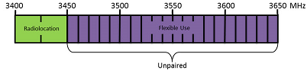
This figure shows the 3500 MHz band deployment in Canada as of Dec 2021, which includes the frequency range of 3400 to 3650 MHz. The frequency range of 3400 to 3450 MHz is allocated for radiolocation. The frequency range of 3450 to 3650 MHz is divided into 20 unpaired blocks of 10 MHz each and allocated for fixed and mobile (flexible use).

- Maximum power is 68 dBm/5 MHz up to 305 metres and 61 dBm/MHz for channel bandwidth less than 5 MHz Antenna above 305 m need to calculate the maximum power emission

      - ISED has completed the Over-The-Air (OTA) testing and it is currently analyzing the enormous amount of data from the OTA testing to determine the in-flight susceptibility of interference of various radio altimeters to 5G operating in the 3500 MHz, 3800 MHz and 3900 MHz bands under specific test conditions. In addition, ISED is currently testing and analyzing a few additional radio altimeters in the laboratory setting and the analysis is on-going.

Europe

      - In Europe, Electronic Communications Committee (ECC) has adopted a work item that covers the analysis of unwanted emissions from Mobile/Fixed Communications Networks (MFCN) i.e., 5G operating in 3400 – 3800 MHz into 4200 – 4400 MHz radio altimeters band as well as the impact of blocking of radio altimeters from 3400 – 3800 MHz MFCN in-band emissions. The meeting further agreed to work on long-term Mobile Fixed Communication Network (MFCN) operational parameters for the update of the Minimal Operational Performance Standards (MOPS) to be provided to RTCA/EUROCAE. The target date for the ECC report as the deliverable for the analyses is set for July 2023.

France

      - The National Frequency Agency (ANFR), the spectrum regulator in France allows flexible use of networks and technology (including 5G) in the frequency band 3400-3800 MHz. The allocation of the band to the operators is illustrated in the following figure and the power spectral density (PSD) of the base stations varies according to the operators between 62.44dBm/5MHz to 67.34 dBm/5MHz. However, these limits are not binding and can evolve upwards.

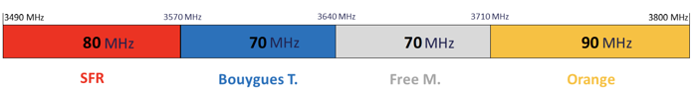

      - Based on RTCA report, French Civil Aviation Authority (DGAC) in coordination with ANFR have defined provisional precautionary measures relating to the geographical location of some 5G antennas in the vicinity of airports with IFR procedures in mainland France to mitigate the risk interference from 5G systems into Radio altimeter system. These measures can be summarized as follows:
- Operators must implement only downward tilt; (Following a complaint and legal threats from an operator, this constraint has been lifted during 2021 following a high-level political decision but his constraint remains valid in the “zone de précaution ”.)
- Operators have to take measures to avoid grating lobes as far as practicable;
- Special protection zones are applied to all IFR aerodromes equipped with ILS CAT III facilities (during the same decision as for the antenna tilt,, it was decided to limit these restrictions to airfields equipped with ILS CAT III. These decisions were made out of concern for the loss of all means of mitigation).and to some helicopter platforms. The methodology used for the calculation of the dimensions of special protection zones is provided in Appendix A to this document.

      - Measure 3) are verified by Civil aviation authority (DGAC) on the basis of the information provided by mobile operators and in close cooperation with National Frequency Agency (ANFR). Moreover, French DGAC has also published a Safety info leaflet in addition to the mitigation measures implemented around all IFR aerodromes.

      - The Special protection zones around all IFR aerodromes, as illustrated hereafter, are defined as follows:

- Safety Zone: where 5G base stations are not authorized to transmit and defined to protect the Radio altimeters in the phase where the aircraft is at or below 200 ft (61 m). Safety zone based on the following assumption:
    - 3° slope with a tolerance of 0.375° (i.e. 2.625°). Therefore, the aircraft may be below 200 ft (61 m) on the approach path to the runway threshold extended by 1130 m each side of a Base Station with a maximum Effective Isotropic Radiated Power (EIRP).
    - 6 dB ICAO Safety margin
    - 0 dBi maximum Radio altimeters antenna gain below 3.8 GHz based on RTCA Report
    - -19 dBm interference threshold based on RTCA report (Cat.1 below 200 ft)
The rectangular safety zone has a width on each side of the runway (protection distance) calculated with pervious assumptions and a length extended from each runway threshold by (1130 m + the protection distance). The protection distance value depends on the max EIRP of the BASE Station (e.g., for a Base Station with the Maximum EIRP of +78dBm, the protection distance value is 910m)

- Precaution zone: where 5G base stations implementation are coordinated and defined on each side of the Safety Zone to protect the landing approach below 1000 ft (305 m)

      - The protection zones dimensions are based on Minimum Coupling Loss (MCL) calculations and take into account the free space model (ITU-R P.525) at the frequency of 3750 MHz.
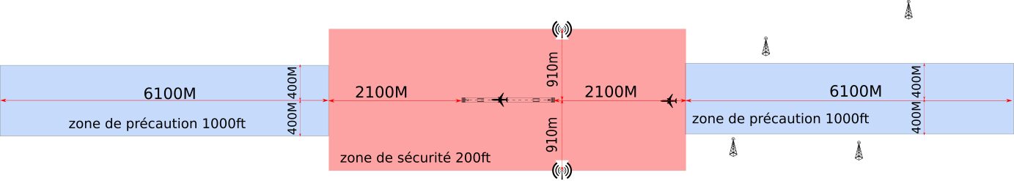
Special protection zones around all IFR aerodromes in mainland France

Japan

      - In Japan, 5G allocations are in the bands 3.6 – 4.1 GHz and 4.5 – 4.6 GHz which imply a 100 MHz guard band relevant to the radio altimeters band. The Ministry of Internal Affairs and Communications, the spectrum regulator in Japan, in coordination with specialized Institutes conducted a compatibility study using the parameters described in Recommendation ITU-R M.2059. The study has considered the following main factors:
  - The BS deployment model is divided into 4 types of areas that have different densities and ratios of the 5G BSs as shown in the following figure. The angle of the range for aggregation is 170 degrees downward, and the area on the surface is calculated by the flight altitude. The maximum radius of the dense urban area model is 564m (1km2). The urban area model is placed surrounding the dense urban area model if the radius of the range of considerations is exceeding the maximum radius of the dense urban area model according to the flight altitude

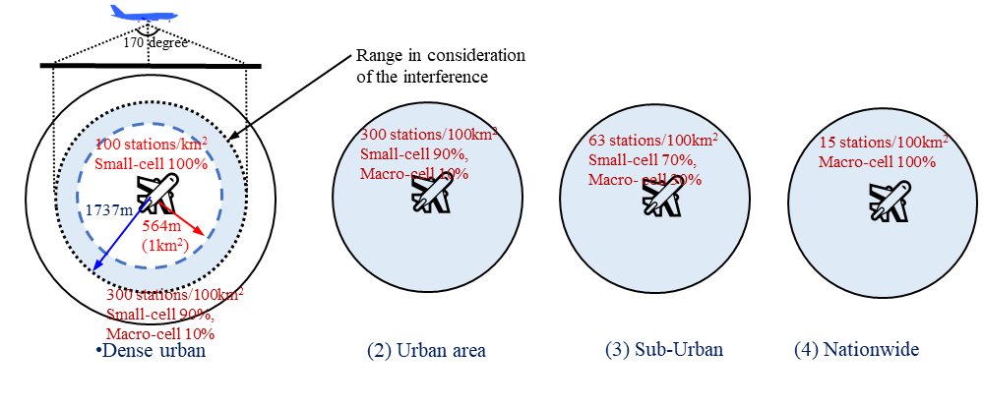
BS Deployment model considered in the compatibility study between 5G base stations and radio altimeters in Japan

  - Two types of 5G BS were considered as typical models for study. One is the macro-cell BS (with the higher power radiation and higher antenna height) and another is the small-cell (with the lower power radiation and lower antenna height). The specifications of the 5G BS are described in the following Table.
 | Small-cell BS | Macro-cell BS
Maximum EIRP (dBm/MHz) | 25 | 48
Maximum Antenna Gain (dBi) | 23 | 23
Ohmic loss of Active Antenna System (AAS) (dB) | 3 | 3
Mechanical tilt (degrees) | 10 | 6
Antenna Height (m) | 10 | 40
Spurious Level | -16 dBm/MHz | -4 dBm/MHz

      - Considering the results of the compatibility study between the RAs and 5G Base Station (BS), the Ministry of Internal Affairs and Communications set the following regulation for 5G BS:
  - To avoid harmful interference to the RAs, a 100 MHz guard band is mandated.
  - Additional requirement for the compatibility to the RAs near the aerodromes are applicable:
    - To avoid unwanted emission interference, unwanted emission of the 5G BS into the RA band should be reduced.
    - To avoid the blocking of radio altimeters, the location of the bands 4.0 – 4.1 GHz and 4.5 – 4.6 GHz used for 5G base station should be avoided within 200 m from the approaching path of aircraft.
    - For the heliports, the bands 4.0 – 4.1 GHz and 4.5 – 4.6 GHz used for 5G BS should be kept the physical separation more than 50 m for macro-cell and 20m for small-cell.

Saudi Arabia

      - The Communications and Information Technology Commission (CITC) is responsible for managing radio spectrum for all users in the Kingdom of Saudi Arabia. CITC has planned allocation of 5G IMT in the band 3.4 – 4.0 GHz as shown hereafter.
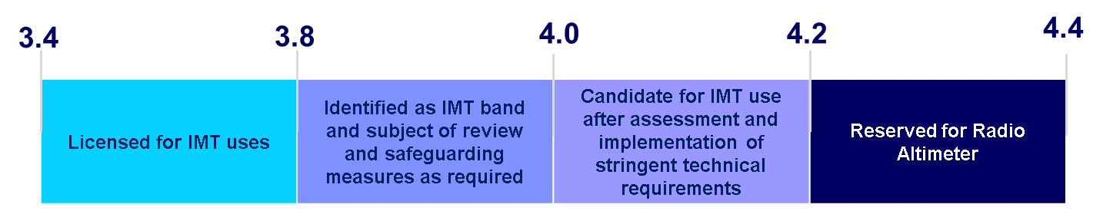
      - CITC conducted consultation with aircraft manufactures and operators in February 2021to take views and comments on the impact of 5G deployment in 3.8 – 4.0 GHz band on the RADALT. The main recommendations can be summarized as follows:
- The allocation in the band 3.8-4.0 GHz must be subject to protection criteria, technical and operational requirements considering the performance of RADALT to avoid any harmful interferences, which may include but not limited to (separation distance, antenna height, tilt, and power).
- Consideration should be given to the protection of altimeters operating on-board helicopters using helipads in built-up areas where 5G deployment is likely to be high-density.
- These arrangements need to be reviewed once the aviation industry has developed new radio altimeter standards taking account of 5G deployments and developed a transition plan. Once new standards are deployed for RADALT, the allocation for 5G IMT may be extended in the band 4.0-4.2 GHz.

      - CITC and General Authority of Civil Aviation (GACA) are collaborating with “Spectrum Advisory Group” to develop protection criteria for the altimeter systems to avoid harmful interference from the 5G networks. Interim measures using the French approach where exclusion and protection zones are established around major airports, are under consideration.

      - GACA published an Advisory Circular to all operators of aircraft equipped with radio altimeters and air traffic service providers within the Kingdom of Saudi Arabia, informing them about the likelihood of 5G interferences on aircraft system. This Circular provides operational recommendations and invite aircraft operators, pilots, and Air Traffic Service Units to report to GACA any 5G interference events.

Sultanate of Oman

      - The Civil Aviation Authority (CAA - Sultanate of Oman) published an Aeronautical Information Circular (AIC). The purpose of this Civil Aviation Safety Alert is to raise awareness of the potential risk of 5G interference and to recommend precautionary operational measures before confirmation of impact of 5G radio waves on radio altimeters.

United Arab Emirates

      - Telecommunications and Digital Government Regulatory Authority is responsible for managing radio spectrum in UAE. 5G allocations in UAE are in the band 3.3 – 3.8 GHz as illustrated in the following figure.

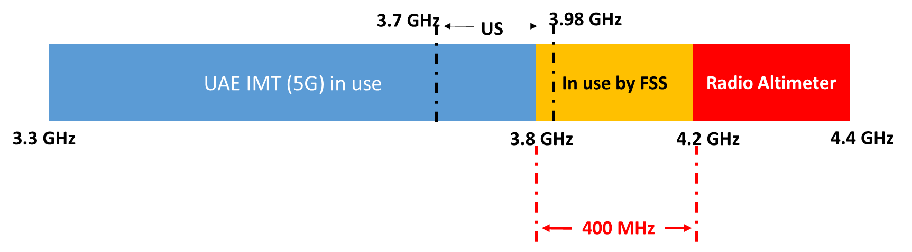
      - The UAE gives high priority to RADALT protection in 4.2- 4.4 GHz. The UAE plans to use the band 3.8 – 4.0 GHz for IMT only after completion of technical studies to protect RADALT in 4.2- 4.4 GHz and in the future may extend this use up to 4.2 GHz.

      - The General Civil Aviation Authority (GCAA – UAE) published a Safety Alert at the attention of United Arab Emirates Aircraft Operator, informing them about the likelihood of 5G interferences on aircraft systems. This safety alert also recommends monitoring and reporting any 5G interference events.

United Kingdom

      - In the UK, Ofcom are responsible for managing the radio spectrum for all users in UK. In consultation with the Civil Aviation Authority and the Ministry of Defence, Ofcom decided to release the frequency band 3.6-4.2 GHz for mobile applications.. The frequency band was split in two with the 3.6-3.8 GHz being auctioned off for 5G mobile services and 3.8-4.2 GHz was made available through coordinated local licenses to meet local wireless connectivity needs and innovation in rural areas with a lower radiated power.
      - Prior to the release of the consultation document for both frequency bands, UK conducted a number of theoretical study with respect to the potential impact on radio altimeters. Various scenarios based on International Telecommunication Union, European Commission & UK regulations and taking into account that signals will continue to roll-off in the spurious emission domain as well as other perceived reasonable assumptions. The initial study did not consider the impact of active antenna system due to modelling difficulties and user equipment was ignored as the power levels are significantly lower and therefore presumed not to be a threat. Subsequent studies have taken into account active antenna.

      - Whilst Ofcom, the Civil Aviation Authority and the Ministry of Defence were confident that the deployment of 5G services, especially around airports, would not pose a threat to radio altimeters. However, given the results of the RTCA studies the UK has monitored the situation carefully but there has been no evidence of interference caused by the introduction of high power 5G services in the frequency band 3.6-3.8 GHz or rural wireless services.

USA

      - The USA allocated 3.7-3.98 GHz to services including 5G in Feb 2020 in 20 MHz license blocks that can be aggregated by the same operator up to 100 MHz. The FCC limited the fundamental power to 65 dBm/MHz maximum EIRP for rural areas, and 62 dBm/MHz in urban areas, though no limits were placed on antenna positioning or vertical direction of the signal. Additionally, the FCC limited out of band spurious emissions levels to -13 dBm/MHz though 3rd Generation Partnership Project (3GPP) standards recommend -30 dBm/MHz. In some cases, based on testing, the aviation community has recognized the need for emission levels to be as low as -48 dBm/MHz to ensure adequate performance of the radio altimeter system.

      - The United States Federal Aviation Administration (FAA) on 23 December 2021 issued a Special Airworthiness Information Bulletin (SAIB) on the Risk of Potential Adverse Effects on Radio Altimeters , as well as, a Safety Alert for Operators (SAFO) on the Risk of Potential Adverse Effects on Radio Altimeters when Operating in the Presence of 5G C-Band Interference. Concurrently, two Airworthiness Directives (ADs), FAA ADs 2021-23-12 and 2021-23-13,were issued:An Airworthiness Directive on altimeter interference for fixed wing aircraft , and an Airworthiness Directive on altimeter interference for rotary wing aircraft Subsequently, seven additional ADs have been issued. These ADs revise the landing requirements, and in certain cases, prohibit landing at certain airports due to the reliance aircraft systems have on radio altimeters. The FAA issued Notices to Air Missions NOTAMs prohibiting certain operations. Therefore, FAA ADs must be followed when operating in the USA where a NOTAM is in place.

      - The FAA has defined protection areas around active runways as follows:

- Runway Safety Zone (RSZ) ‒ The RSZ is defined as the volume where aircraft are highly likely to be operating during low altitude operations near the runway with 5G C-band emissions meeting maximum power requirements. The RSZ is based on instrument approach procedure (IAP) obstacle clearance surfaces (OCS) applicable to these low altitude operations (e.g., below 500 feet AGL) near the runway, specifically, the approach, missed approach, and CAT II/III OCS. Therefore, the RSZ is a 3D volume that begins at the surface on and near the runway, extends approximately 2 nm into the approach area along the extended runway center line, and slopes up based on the OCS as defined by the IAP glide path angle. The width of the RSZ is based on the OCS width at a specific distance from the landing threshold, and varies between 1300 and 3000 feet each side of the runway center line. In this area unreliable Radio Altimeter function can lead to a catastrophic outcome. Acceptance criteria: The Radio Altimeter must function accurately and reliably in the RSZ.

- Performance Buffer (PB) ‒ Initially, the FAA defined PB as the zone in which 5G base stations were turned off based on an assessment of radio altimeter performance. Through collaboration with the aviation and wireless industry, this evolved into the current approach, where the 5G signal in space must meet specific power spectral density (PSD) requirements in the RSZ volume. Specific PSD requirements vary based on altitude above ground level, and are based on minimum required RA performance. These PSD requirements will continue to evolve as more minimum required RA performance increases (e.g., as more RAs are retrofitted or replaced), to support increased wireless base station power..
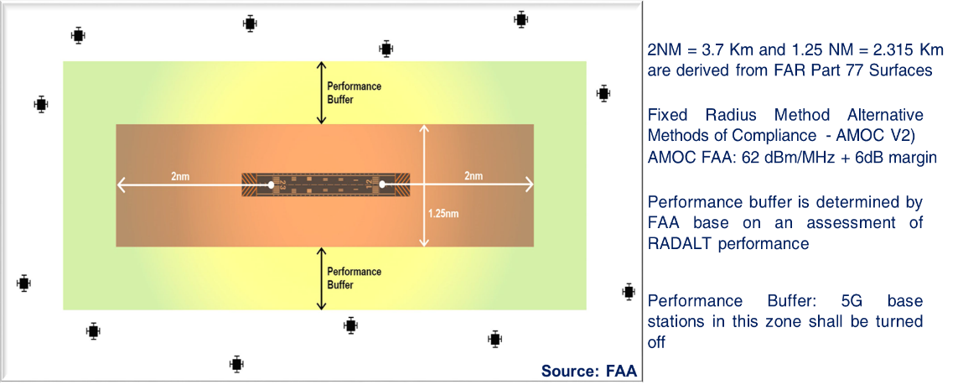

      - Since January 2022, the FAA has issued monthly Alternative Means of Compliance (AMOC) based on the performance capabilities of the Radio Altimeter while also considering antennas, cabling, and any other system integration issues. The method aims to determine the minimum distance away from a 5G antenna the aircraft needs to be to meet the acceptance criteria of the RSZ.

      - More information on historical FAA assessment, documentation, and actions can be found at www.faa.gov/5g.

Arab Civil Aviation Organization (ACAO)

      - Air Navigation Committee endorsed the following recommendation:
  - Urge ACAO member states to take appropriate measures to reduce the impact of the installation of 5G cellular networks on the air traffic movement in coordination with the concerned national authorities of each country (national telecommunications regulatory bodies) including determining the levels of use of 5G cellular networks near airports and their future plans…..
  - Task the General Administration of ACAO in coordination with the recently established 5 G Working Group of ICAO Middle East Regional Office to work on the development of a mechanism at the national and regional levels to report and analyze interference reports resulting from the use of 5G networks
  - Urge ACAO member states to support ICAO's position during the 2023 World Telecommunications Conference WRC-23 meeting to be held on 2023 through coordination with the national tele-communications regulatory bodies of each member State.

EASA

      - European Aviation Safety Authority issued a Safety Bulletin: SIB No. 2021-16 on the subject of Operations to aerodromes located in United States with potential risk of interference from 5G ground stations.

IATA

      - IATA continues engaging with governments to mitigate threats to the civil aviation spectrum, including encouraging responsible deployments of 5G. IATA activities focus under four strategic pillars including:

      - Safe and uninterrupted airline operations - civil aviation should not be negatively impacted by any spectrum deployments.
      - Cooperative coordination - government agencies should plan spectrum deployments collaboratively together with industry stakeholders.
      - Protection of civil aviation spectrum resources and establishment of predictable global spectrum environment
      - Robust aircraft and avionics design with clear and cost-effective migration path

      - IATA and its member airlines understand the economic importance of 5G deployments. However, in line with Article 4.10 of the International Telecommunications Union Radio Regulations (pdf) and ICAO Standards and Recommended Practices, IATA insists that maintaining current levels of safety for civil aviation must continue to be one of the governments’ highest priorities.

      - IATA has developed a website that includes the Global 5G C-Band status Dashboard and be accessed at: https://www.iata.org/en/programs/ops-infra/air-traffic-management/5g/

ICAO – FSMP

      - Within ICAO, the Frequency Spectrum Management Panel (FMSP) has considered the issue and reviewed submissions from several States and International Organizations. In addition, a Working Group (WG) has been established to collect information on 5G/Radio Altimeter compatibility. Based on a proposal from FSMP-WG, the ICAO Secretary General issued a State Letter expressing potential safety concerns regarding interference to radio altimeters (ICAO SL 21/22 “Potential safety concerns regarding interference to radio altimeters”, published on 25 March 2021). This letter encourages administrations to consider as a priority, public and aviation safety when deciding how to enable cellular broadband/5G services in radio frequency bands near that used by radio altimeters. The FSMP-WG continues to work on the subject and expects additional contributions from States, and specialized international organizations. The material produced by FMSP is publicly available through this link: https://www.icao.int/safety/FSMP/Pages/default.aspx.

      - Based on WP30 presented jointly by Air Transport Association (IATA), the International Business Aviation Council (IBAC), the International Coordinating Council of Aerospace Industries Associations (ICCAIA), the International Federation of Air Line Pilots’ Associations (IFALPA) and RTCA on “Safety concerns regarding interference to aircraft radio altimeters”, ICAO High Level Conference On COVID-19 (HLCC 2021) adopted the following Recommendation:
Recommendation 5/5 — Mitigating the risk of 5G implementation to safety-critical radio altimeter functions That States:
a) consider, as a priority, public and aviation safety when deciding how to enable cellular broadband/5G services;
b) consult with aviation safety regulators, subject matter experts and airspace users, to provide all necessary considerations and regulatory measures to ensure that incumbent aviation systems and services are free from harmful interference;
and That ICAO:
c) continue coordinated aviation efforts, particularly at the International Telecommunication Union (ITU), to protect radio frequency spectrum used by aeronautical safety systems.
      - The Technical commission of the ICAO Assembly 41st session held from 29 September to 5 October 2022 reviewed several working papers on potential interference from 5G deployment to the radio altimeter and has encouraged States and regions to actively participate in spectrum protection activities and to endorse the ICAO position for the International Telecommunication Union World Radiocommunication Conference 2023 (ITU WRC-23) (ICAO State letter E 3/5-21/37).

      - Based on a proposal of the technical commission, the Assembly adopted a resolution: Support of the ICAO policy on radio frequency spectrum matters, which supersedes Assembly Resolution A38-6.. This resolution urges Member States to consider, as a priority, public and aviation safety when deciding how to enable new or additional services, and to consult with aviation safety regulators, subject matter experts and airspace users, to provide all necessary considerations and to establish regulatory measures to ensure that incumbent aviation systems and services are free from harmful interference.
      - In addition, ICAO MID region adopted the following additional actions:

- Updating its positions on Frequency spectrum use to highlight concerns on 5G band allocations and potential interference with RADALT. The position will be submitted for ITU World Radiocommunication Conference (WRC) 2023 highlighting the concerns.
- Amending ICAO-MID Frequency Management Ad-hoc working group ToRs to add a task to Collect and share information on the best practices implemented by States and Regional Organizations to mitigate potential radio altimeters (RADALT) interference caused by 5G operation
- Updating ICAO Spectrum Policy and Handbook to strengthen the need to protect the radio altimeter.
- Raising awareness and emphasizing the importance of the issue with State regulators, both aviation and spectrum, through its regional offices and meetings.
- Issuing of several ICAO liaison statements to the European spectrum regulator (CEPT) highlighting the need to protect the radio altimeter and to encourage conditions on 5G deployment that can ensure the functionality of current radio altimeters and thus can be accepted by aviation stakeholders.

RTCA-EUROCAE

      - Following the US national Communication Regulator i.e., Federal Communication Commission (FCC)’s decision to allow 5G services in the 3.7-3.98 GHz, an additional study was encouraged given the questions raised by the aviation community. With this respect, RTCA established a public multi-stakeholder group under its Special Committee 239 (SC-239) that conducted an extensive theoretical study of the simulated 5G interference, assessing it against radio altimeter performance data from the major manufacturers in common and real-world scenarios. With the regulatory limits defined by the US FCC for base stations and handsets, combined with data from the 5G interests, the RTCA SC-239 Report found that all aircraft types and multiple operations received interference from both simulated fundamental and spurious 5G emissions. The RTCA Report concluded that “5G base stations present a risk of harmful interference to radio altimeters across all aircraft types, with far-reaching consequences and impacts to aviation operations”. RTCA published YouTube presentation of the Radio Altimeter issue.

      - RTCA and EUROCAE (SC-239/WG-119) have jointly initiated the drafting of new minimum operational performance standards (MOPS) for the Radio Altimeter, the completion of the work is scheduled for December 2023 as described in the following section.

Long Term Plan for Radio Altimeter

    - While the aviation industry has recognized that changes to the RF environment in which radio altimeters operate are inevitable and performance standards must be updated accordingly, this process necessarily takes a significant amount of time given the extreme rigor and caution with which aviation systems manufacturers, aircraft manufacturers, aircraft operators, and Civil Aviation Authorities (CAAs) work to develop and implement such changes. Even a technical solution which may be viable for retrofit installations, would take several years to properly validate, and deploy across all affected civil aircraft operating in the world. Therefore, it is critical that the performance of radio altimeters which are currently in service across tens of thousands of civil aircraft (The number of commercial aircraft in MENA is 2126 of which 1919 in MID Region) be understood and the risks and operational impacts due to interference be acknowledged.

    - New Radio Altimeter Standards are being developed to sustain planned 5G environment The effort for updating equipment standards for future radio altimeters has already started with the development of new Minimum Operational Performance Standards (MOPS) by the RTCA Special Committee SC-239 and EUROCAE working Group WG-119. The plan calls for completely re-write the MOPS document including the addition of new RF interference and test procedures and to release a new doc. DO-XXX/ED-XXX “Technical Standard on RF Interference Environment for Radio Altimeter “in December 2022 followed by document DO-155A/ED-30A MOPS revision in December 2023. While this new radar altimeter standard will define significantly more interference immunity to external RF sources, the limits of current technology will still have boundaries to the protection against all possible interference. Aircraft operating in close proximity to high power cellular towers with frequencies near the edges of the radar altimeter’s 4 200 – 4 400 MHz band will still require national regulator action to protect certain aircraft operations.

    - Once the MOPS is completed, ICAO in coordination with IATA and ICCAIA has agreed to include the new equipment standards into the ICAO Annexes. Moreover, ICAO has also agreed to assist with future coordination with ITU for the inclusion of important regulatory provisions into ITU global telecommunication treaty – the ITU Radio Regulations - aiming to provide appropriate legal protections for future radio altimeters.

    - After the MOPS are updated, it is anticipated that they will be referenced by CAAs, to define new performance standards that must be met for equipment-level design approvals of radio altimeters. However, the new MOPS will only result in improved radio altimeter designs in the future—currently installed radio altimeters on commercial and civil aircraft will still be exposed to 5G and would operate for many years.

    - Below figure shows the plan and schedule for the development of new RTCA/EUROCAE Radio Altimeter standards:

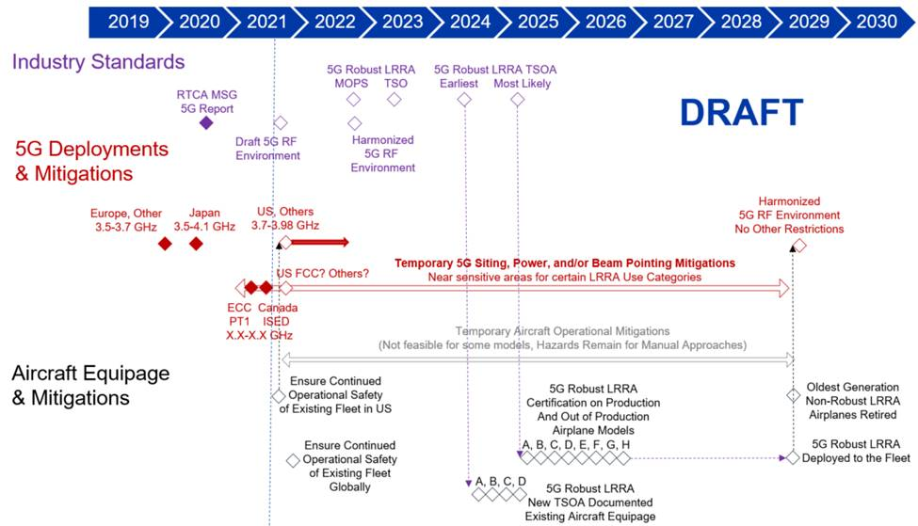

Chapter 4 - Methodologies for defining safeguarding measures for aerodromes & heliports

Introduction

    - Recommendation ITU-R M.2059 explains three primary electromagnetic interference coupling mechanisms between radio altimeters and interfering signals from other transmitters: receiver overload, desensitization, and false altitude generation.

    - Any compatibility analysis between radio altimeters and other systems must utilize those protection criteria for the maximum acceptable degradation for a radio altimeter. These criteria are defined as followed:
- Receiver front-end overload where the value depends on each radio altimeters type
- Receiver desensitization which is the common I/N protection criteria of -6dB, and
- the False altitude reports which are defined by -143 dBm/100 Hz (–143 dBm considering 100 Hz detector bandwidth following the instantaneous altimeter local oscillator (LO) frequency).

    - It should be understood that any interference that is unpredictable and that can mix with the linear FM waveform, thereby causing the radio altimeter to mistake the mixed signal as terrain has the potential to cause a radio altimeter to report a false altitude. The fact that all radio altimeter antennas are necessary pointing at the Earth’s surface makes the system vulnerable to all possible interference sources illuminated during the approach.

    - The radio altimeter antennas, due to their location on aircraft, do not have the benefit of being shielded or screened from many of the possible interference sources on the Earth’s surface. Instead, it can virtually “see all possible radiation sources “as they escape buildings and via direct transmission from devices operating outside of any structure.

    - For studies focusing on emissions into the frequency band 4200-4400 MHz, only the false altitude reports and the receiver desensitization are applicable. A false altitude report is a serious radio altimeter error that may cause critical aircraft systems such as ground proximity warning, weather radar, traffic collision avoidance system (TCAS), flight controls and other critical systems to respond inappropriately. In the case of FMCW-based radio altimeters, false altitude reports occur when interference signals are detected as frequency components during spectral frequency analysis of the overall IF bandwidth.

    - As described in Chapter 3 of this document, the safeguarding measures and mitigations adopted by competent spectrum regulators and aviation authorities around the world, to protect RADALT from 5G BS deployment are mainly focusing on setting protection zones considering aircraft height/altitude above the BS. These measures are aimed to reduce the probability of interference occurring by imposing limitations on the deployment of 5G base stations at aerodromes and in areas surrounding aerodromes. Chapter 3 provides an overview of protection zones measures applied in France, Canada, Japan, and USA.

    - The main practical measures that have been codified in national telecommunication regulations and successfully deployed include:

      - Ensure through testing sufficient spectrum separation between 5G C-band deployments and 4.2-4.4 GHz frequency band used by existing radio altimeters
      - Clearly codify and enforce the maximum power limit for 5G C-band transmission and downward tilting (electronically or mechanically) of 5G C-band antenna.
      - Establishment of sufficient 5G C-band prohibition and pre-cautionary zones around airports.

Methodology for the protection of Radio altimeters

General approach and Main considerations

      - To identify the protection areas around airports and heliports for proper mitigations, ICAO recommends to consider the following parameters when performing the analysis:
  - The aircraft can have a maximum roll of up to +/-30 degrees from the horizontal in all directions,
  - The air-to-ground propagation model (Recommendation ITU-R P.528-4 ) with a minimum time percentage should be used. It should be noted that Rule of Procedure on RR 5.441B was adopted by the ITU Radio Regulatory Board and proposes to use this Recommendation with a time percentage of 1% for the calculation of IMT interference into non-safety aircraft applications. As a result, for safety applications such as radio altimeters a percentage value less than 1% should be considered. If the Recommendation is not capable of calculating path losses with time percentage less than 1%, then 1% should be used and appropriate margins added.

      - The characteristics of 5G BS are key information to check whether the protection criteria are met for an airplane flying at different heights (50, 200, 1000 ft and 2000 ft (15, 61, 310 and 610 meters)) above the base station. The figure below shows the geometry of the scenario.
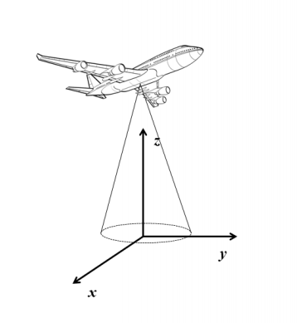
      - With reference to the coordinate systems in this figure:
- The base station is located at (0,0,0);
- The aircraft is flying along a horizontal path defined by the coordinates (0, ya, ha). The altitude ha of the aircraft is fixed, so that its position varies along the axis y only;
- The radio-altimeter antenna beam is modeled based on the antenna pattern formula available in Report ITU-R M.2319 (§A-3.1.1).

      - The analysis should be based on a single base station to verify whether it can pose a threat to the aeronautical systems in the band (for simplicity the aircraft can have zero roll and pitch). If a single base station is predicted to not cause interference, the analysis can be expanded to consider the aggregation of multiple interferers and the roll and pitch of the aircraft.

      - As the main concern with aircraft being provided with erroneous radio altimeter data or loss of radio altimeter data during approach is infringement of minimum safe altitude/height above terrain/obstacles and incorrect execution of the flare. The flare is the pitch up movement of the aircraft just before touchdown that reduces the vertical speed and ensures a 'soft' touch down. The data provided by the radio altimeter is essential to determine the height above the terrain/obstacles and runway at which the flare is initiated.

      - As radio altimeter data is more critical during the approach phase for landing, the analysis of the impact of 5G BS should focus on the approach path considering the location of the Base station (BS). This would identify the minimum possible distance between the aircraft path and base station ensuring proper protection of the altimeter while providing height information to the autopilot during landing.

      - The assessment of the impact (Risk of interference) of deployment of a 5G network on radio altimeters is a complex activity (identification of protection areas) and depends on many parameters and factors such as:

- Power of the 5G base station (xxx dBm) call TRP (True Radiated Power)
- Antenna gain (yy dBi) depending on the type of antenna: Two different technologies are available for 5G antennas with different antenna gain:
- AAS antenna (Active Antenna System) is the general term used to describe antenna using adaptive beamforming. Depending on the information available, the gain can exceed 25dBi.
- Non AAS antennas are antennas with a fixed beam, usually 120° where the gain where the gain is constant around 15dBi.

- Maximum Effective Isotropic Radiated Power (E.I.R.P = power of the 5G base station (xxx) + antenna gain (yy))
- The location of the Base station antenna
- The antenna tilt should be below the horizon, and therefore the maximum gain towards the aircraft is lower (about 5dB) than the maximum gain of the antenna.
- The vertical scan (Scan angle): There are no restrictions on the vertical scan angle in the Telecommunication regulations. The level of the grating lobes depends directly on the amplitude of the vertical scan angle.
- The rate of use of a base station: The power radiated by a base station depends on the data traffic passing through it. By the end of 2021, in France, data transmitted in 5G represents less than 1.5% of mobile data but since the number of 5G subscriptions doubles every 3 months.
- The ground scattering and altitude: The susceptibility of radio altimeters also depends on the ratio of the 5G signal to the radio altimeter return signal. The higher the ground scattering is, the more resistant the radio altimeter is. The altitude of the aircraft increases the path loss of the Radio altimeter signal, and therefore makes its receiver more sensitive, but at the same time the altitude of the aircraft moves it away from the 5G base stations and increases 5G the path loss. Studies and simulations have shown that the most unfavorable altitude is around 200ft.
- The frequency band used.
- Aggregated unwanted emission level
- Filtering characteristics of each radio altimeters and associated installation

Main activities to define protection criteria

      - To identify the protection criteria for RADALT systems from the 5G networks, the regulators should perform the following approach is proposed for joint activities by relevant national spectrum and aviation regulatory authorities:
  - Development of detailed report summarizing the main findings of the international working groups and the corresponding administrations. The results and recommendations will be used as temporary and interim measures to protect the radio altimeters until the review of technical standards for RADALTs has been completed;
  - Conduct a detailed scientific technical study including simulations, and lab experiments. The study should accurately determine the level of coexistence between the RADALT systems and the 5G networks based on national 5G deployment plans in relation to the aviation environment. The study shall include at least the procedures, used tools and software, path loss model, references and findings. The findings shall include the following but not limited to:
- The level of potential harmful radio interference;
- The effect on the RADALT systems in case of potential interference;
- A clear technical parameters or separation distance in case of a potential harmful interference.
- The spectrum and aviation regulators should share the detailed report summarizing the main findings of scientific studies and lab experiments with all stakeholders;
- The protection criteria will be updated according to the reported findings of scientific studies and lab experiments.
- The research project team, in coordination with national spectrum and aviation regulators should perform a field trial, if feasible, to validate the scientific studies, simulations, and lab experiments findings and to ensure the coexistence between the RADLAT and 5G networks based on the applied protection criteria. The research project team should prepare a detailed report summarizing the main findings of field trials.
- Finally, the protection criteria should be updated based on the reported findings of field trials.

      - In States with limited resources, consideration of work conducted in other States is acceptable, but care must be taken to ensure it is relevant to the national plan and scenario for the deployment of 5G networks.

Recommended methodology for the technical study

      - The UK presented a study at FSMP-Working Group (WG)/11 WP/27 outlining a methodology which could be used to assess the impact of 5G on RADALT. It investigates the potential interference from 5G base stations operating in the frequency range 3.6-4.2 GHz into radio altimeters under various scenarios as defined by the information contained in International Telecommunication Union, European Commission and UK regulations/documents. The methodology used in the study is based on the receiver overload threshold and it can be summarized as the following:
- The study considers the separation distance relative to the mobile base station’s antenna required between a rural mobile base station and an aircraft in flight level flight, as illustrated in the next Figure.
- The study does not consider the impact of active antenna systems due to modelling difficulties and user equipment as the power levels are significantly lower and therefore presumed not to be a threat.

Scenario considered

(Source: WG/27 Rev.1 presented by John Mettrop, FSMP Eleventh Working Group meeting)

- For each angle during the approach of an aircraft, the required separation distance is calculated using the following ITU formula assuming free space path loss:

PRx=PTx+ GTx+AFTx-FSPL+GRx+RxRej-FLRx+SM
Where:
PRx = Power received (assumed to be the receiver overload threshold)
PTx = Mobile base station power supplied to the antenna port
GTx = Gain of the mobile base station antenna in the direction of the aircraft
AFTx = Transmitter activity factor
FSPL = Free space path loss (=32.4+20log(FMHz)+20Log(Dkm)
FMHz = Frequency
Dkm = Separation distance
GRx = Gain of the radio altimeter antenna in the direction of the mobile base station
RxRej = Adjacent channel rejection of the radio altimeter receiver
FLRx = Feeder loss in the radio altimeter
SM = Safety margin (assumed to be 6dB)
Note:The above parameters might be changed according to the considered environment, i.e. based on the aerodromes, heliports. The radio altimeter information were taken from the ITU reports and studies.

After re-arranging the above equation, it can be re-written as follow:

DKM=10(PTx+GTx+AFTx+GRx+RxRej-FLRx-32.4 20 Log FMHz+SM20)
- Having established the above baseline scenario, the following variations in the baseline scenario should be investigated for radio altimeters A1 and A3 taken from Recommendation ITU-R M.2059.
- The following parameters ware considered in the study:
    - Pitch/Roll: The impact of the aircraft pitching/rolling by 15°, 30°, 45° towards the mobile base station antenna.
    - Mobile Antenna Heigh & Tilt: Variations in the height and down tilt angle of the mobile base station for urban (25m & 6°) and suburban masts (20m & 10°) and this is based on
    - Aggregate Effects: The level of aggregate interference that should be applied assuming a standard rural macro deployment scenario taken from Recommendation ITU-R M.2101 &Report ITU-R M.2292
    - Radio Altimeter Receiver Frequency Dependent Rejection: Use the frequency dependent rejection at 3.75 GHz based on ITU-R M.2059 assuming the octave is based on the size of the frequency band & band edge frequency, radio regulatory guidance, RTCA worst case measured results.

Recommended Safeguarding and Interference Mitigation Measures

      - As a minimum, the list of regulatory actions and measures that need to be taken to protect Radio Altimeters may include the following:

- Regulators to consider safety notices or circulars to aircraft operators highlighting the potential interference of 5G network emissions with aircraft RADALTs which may include:

- PEDs be turned off (or in airplane mode) during flight.
- Passengers must be advised to ensure that all electronic devices in checked baggage are turned off.
- Operators must advise the air traffic service provider of any disturbance to the radio altimeter and report the occurrence to the CAA using normal company safety reporting procedures. Flight crew should include as much as possible, details regarding the type of malfunction, including duration and location (particularly if during an approach or departure phase), the runway in use and the height above the ground that the malfunction was observed
- Air Traffic Service Providers are encouraged to inform their controllers of the possibility of such reports by crews.
- Operators should ensure their flight crew are aware of the possible implications of radio altimeter malfunctions for the types of aircraft operated; this may be particularly relevant when conducting Precision Instrument Approaches during Low Visibility Operations
- Where a State, based on the safety analysis of its own 5G roll out, has issued a NOTAM or similar directive, OT operators are required to adhere to any state operational restrictions. The absence of a NOTAM does not necessarily imply that interference will not be encountered.
- Flight crew experiencing radio altimeter or auto flight malfunctions should not assume that this has been caused by 5G interference and should follow normal operating procedures for any malfunctions or failures. Although flight crew should be aware of the possibility of 5G interference, any malfunctions observed may well be caused by other factors such as radio altimeter and associated antenna technical failures.

      - State spectrum management authorities in coordination with Civil aviation authorities should consider adopting the following measures when approving the installation of 5G Ground stations around aerodromes:
- through testing by aviation subject matter experts and validation by aviation safety authorities, ensuring sufficient spectrum separation between 5G C-band deployments and 4.2-4.4 GHz frequency band used by existing radio altimeters
- clearly codifying and enforcing the maximum power limit for 5G band transmission which has been proven to the satisfaction of the State aviation safety regulators to not harmfully interfere with all existing aircraft radio altimeters
- prescribing a downward-looking radiation pattern for 5G C-band transmitting stations (Antenna downward tilting)
- establishing two protection zones, namely Safety and Precautionary zones, around aerodromes with sufficient technical conditions (such as restricting 5G transmission power) for each zone. Example of these protection zones as published by a State spectrum regulator are provided below:
- ‘Safety zone’ around the airport for the protection of the RA where the aircraft is below 200 ft (61m)
- Precaution zone on each side of the ‘safety zone’ to protect the landing approach below 1000ft (305m)
- 5G service providers have to take measures to avoid grating lobes as far as practicable.

      - For such efforts to be effective, timely transparency and cooperation from 5G network service providers in coordination with State spectrum regulators with regards to the provision of location information for their stations as well as details of the transmission characteristics (e.g., antenna radiation patterns, power levels) is required.

5G devices used on board aircraft

      - A number of 5G user equipment and devices are expected to be transmitting on board an aircraft while the radio altimeter is operational. Many safety advisories and leaflets published by civil aviation authorities address this issue. An example is the Advisory Circular (AC) issued by General Authority of Civil Aviation (GACA – KSA) defines operational recommendations for aircraft operators and pilots related to this subject. The following rules are the first three statements of the AC:

Operators and pilots of aircraft equipped with radio altimeters:
- Remind passengers that all portable electronic devices allowed for transport in checked baggage (including smartphones and other devices) should be turned off and protected from accidental activation.
- Remind passengers to set all portable electronic devices in the cabin and any carried on the aircraft to a non-transmitting mode or turn them off.
- Instruct crew to use 3G or 4G communication devices only when essential communication is required, such as during emergency medical service operations.

      - Similar rules may be adopted as interim measures to protect radio altimeter from any interference that may be caused by 5G user equipment and devices used onboard an aircraft.
____________________

Appendix A – French Methodology to set the dimensions of Special Protection Zones around airports

A.1 The French frequency management authority (ANFR) in coordination with the Civil Aviation Authority (CAA) adopted interim arrangements to protect aircraft RADALT from any interference of the 5G network deployed around the aerodromes. The main technical considerations and the dimensions of the protection areas are described in the following sections.
A.2 Protection areas
The protection areas identified around the French aerodrome used for IFR operations are divided into two types:
- Safety area/zone where no 5G network infrastructure deployment is allowed.
- Precautionary zone/area where 5G BS may be allowed only after case-by-case assessment..

The main criteria and the dimensions of the protection areas are illustrated in the following figure.
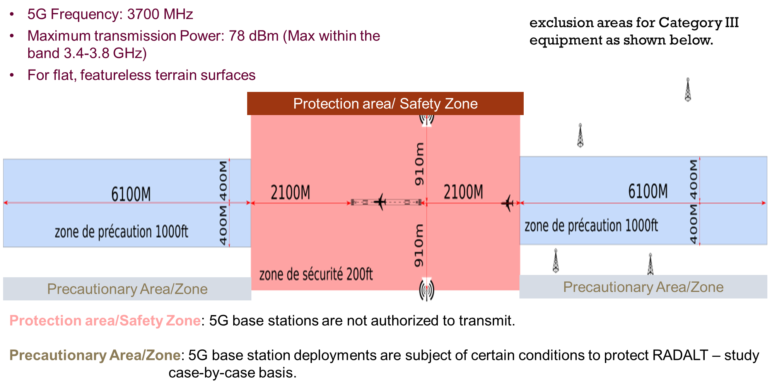
The width of the safety zone is calculated based on the attenuation of maximum effective radiated power (e.g. 78 dBm) increase by the fundamental tolerance threshold defined under the RTCA report and ICAO safety margin (6 dB) that should be considered for compatibility study. The length of the safety area/zone is based on the calculation of the distance required for an aircraft in the final approach phase at 200 ft until the touchdown zone with 3° slope with a tolerance of 0.375° (i.e. 2.625°)Glide Slope. The following illustrations provide details on the calculation of the dimensions of the safety zone.
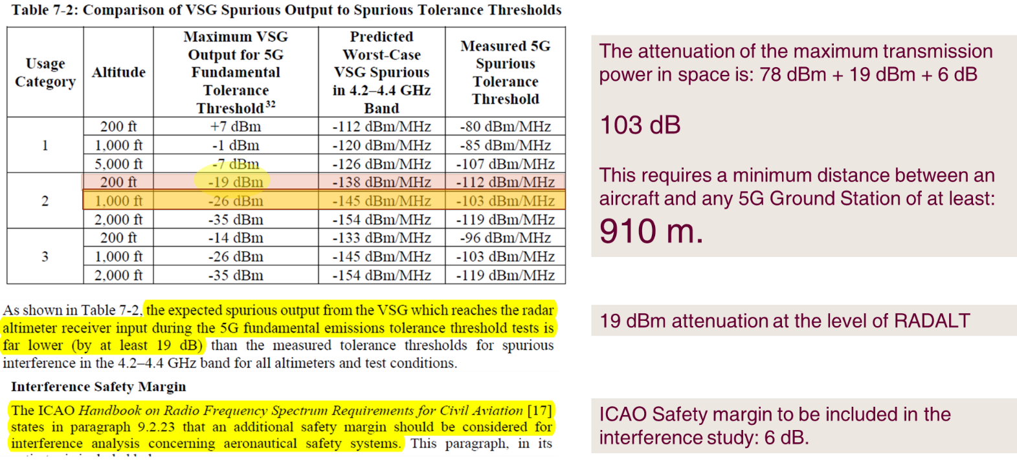
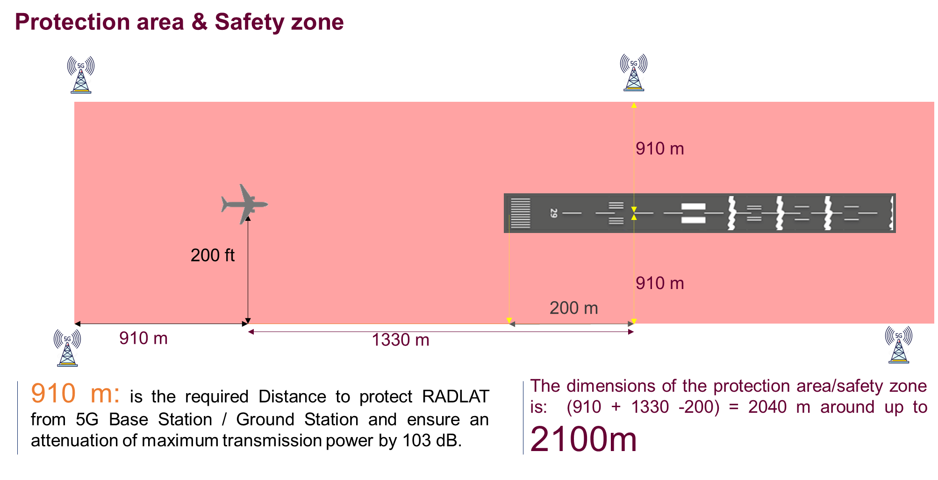
The dimensions of the precautionary area/zone are calculated based on the attenuation of true radiated power (53 dBm) increase by the fundamental tolerance threshold defined under RTCA report and the antenna gain as defined by ITU. The length of the precautionary area/zone is based on the calculation of the distance required for an aircraft in the final approach path at 1000 ft above terrain until the touchdown zone with a 3ºGlide Slope. The following illustrations provide details on the calculation of the dimensions of the precaution area/zone.

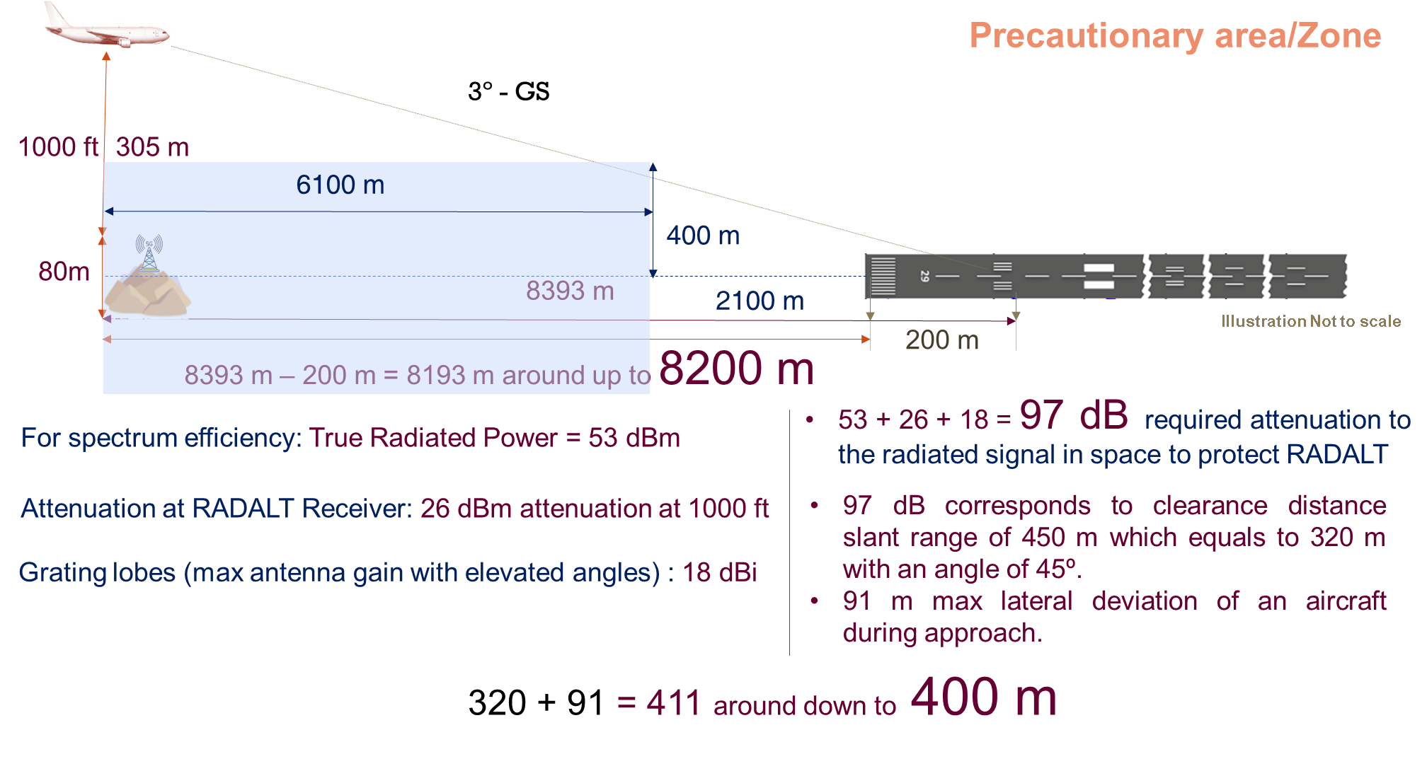
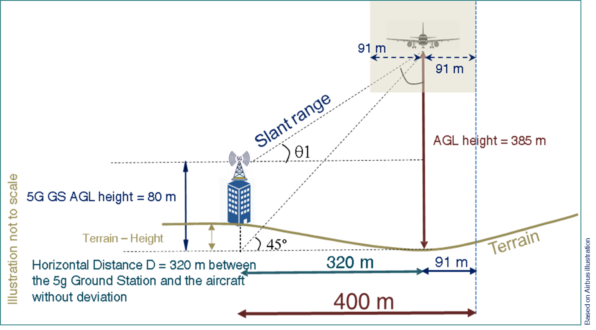
________________________

In some aviation publications it is also known as the radar altimeter or Low Range Radar Altimeter.
https://www.itu.int/dms_pubrec/itu-r/rec/m/R-REC-M.2059-0-201402-I!!PDF-E.pdf
Descriptions from RTCA report, https://www.rtca.org/wp-content/uploads/2020/10/SC-239-5G-Interference-Assessment-Report_274-20-PMC-2073_accepted_changes.pdf
See references in RTCA report paragraph 5.3, https://www.rtca.org/wp-content/uploads/2020/10/SC-239-5G-Interference-Assessment-Report_274-20-PMC-2073_accepted_changes.pdfhttps://www.rtca.org/wp-content/uploads/2020/10/SC-239-5G-Interference-Assessment-Report_274-20-PMC-2073_accepted_changes.pdf
https://www.casa.gov.au/files/awb-34-020-issue-3-potential-interference-radio-altimeter-systems
https://www.legislation.gov.au/Details/F2021L01909
https://tc.canada.ca/en/aviation/reference-centre/civil-aviation-safety-alerts/potential-risk-interference-5g-signals-radio-altimeter-civil-aviation-safety-alert-casa-no-2021-08
Following a complaint and legal threats from an operator, this constraint has been lifted during 2021 following a high-level political decision but his constraint remains valid in the “zone de précaution”.)
During the same decision as for the antenna tilt (Previous footnote refers), it was decided to limit these restrictions to airfields equipped with ILS CAT III. These decisions were made out of concern for the loss of all means of mitigation
https://www.ecologie.gouv.fr/sites/default/files/Safety_Info_Leaflet_2021_01_5G_interferences.pdf
Protection distance =( λ/ (4π)) x 10^((Max EIRP- interference threshold + ICAO Safety margin)/20)
GACA Advisory Circular
https://www.caa.gov.om/upload/files/AIC 04-21.pdf
https://www.gcaa.gov.ae/en/epublication/admin/Library Pdf/Safety Alerts/SAFETY ALERT 2021-03 - REQUIREMENTS TO MITIGATE 5G INTERFERENCE OPERATIONAL RISKS - ISSUE 01.pdf
https://rgl.faa.gov/Regulatory_and_Guidance_Library/rgSAIB.nsf/dc7bd4f27e5f107486257221005f069d/379cfb187d16db10862587b4005b26fc/$FILE/AIR-21-18R1.pdf
https://www.faa.gov/other_visit/aviation_industry/airline_operators/airline_safety/safo/all_safos/media/2021/SAFO21007.pdf
https://www.faa.gov/sites/faa.gov/files/2021-12/FRC_Document_AD-2021-01169-T-D.pdf
https://www.faa.gov/sites/faa.gov/files/2021-12/FRC_Document_AD-2021-01170-R-D.pdf
https://www.icao.int/safety/FSMP/Documents/5G and Radio Altimeters/StateLetter_2021_022e.pdf
https://www.icao.int/safety/FSMP/Pages/default.aspx
https://www.icao.int/Meetings/HLCC2021/Documents/WP/EN/SAF/wp_030_en.pdf
https://www.icao.int/Meetings/a41/Documents/WP/wp_623_en.pdf - from page 10 to 12.
https://www.rtca.org/wp-content/uploads/2020/10/SC-239-5G-Interference-Assessment-Report_274-20-PMC-2073_accepted_changes.pdf
https://www.youtube.com/watch?v=OpYhjK2MDqM
Note: The analysis of 5G BS is assuming that the proposed height is meeting the requirements of obstacle limitations surfaces defined under ICAO Annex 14, Chap. 4 Vol. I (aerodromes) and Vol. II for heliports
https://www.itu.int/rec/R-REC-P.528/en
https://www.itu.int/dms_pub/itu-r/opb/rep/R-REP-M.2319-2014-PDF-E.pdf
Although this is often dependent on the choice of the mobile operator and confidential, the knowledge of the elevation of the Radiation pattern, of the 5G antenna, is an important element to accurately assess the interference risks.
Until now, there is no restriction in Europe.
https://www.icao.int/safety/FSMP/MeetingDocs/FSMP%20WG11/WP/FSMP-WG11-WP27_Mobile%20vs%20Radalt%20REv.1.docx
The Advisory Circular issued by General Authority of Civil Aviation (GACA – KSA)

