Space-based VHF Datalink

Concept of Operations

February 2023

Table of Contents

1 Introduction 4
2 Scope of the document 6
3 Acronyms 6
4 Characteristics and main features of ACARS and VDLM2 8
4.1 VHF fundamentals 8
4.2 POA vs. VDLM2 9
4.2.1 POA fundamentals 9
4.2.2 VDLM2 fundamentals 10
4.2.2.1 AOA vs. ATN 12
4.2.2.1.1 AOA fundamentals 12
4.2.2.1.2 ATN fundamentals 12
4.2.3 Similarities and differences between POA and VDL2 13
5 Radio frequency management 14
5.1 Introduction 14
5.2 Frequency global allocation for ACARS and VDLM2 15
5.3 Use of VHF frequencies in the avionics 17
5.3.1 Use of the frequency scan mask in the avionics 17
5.3.2 Frequency Search process depending on avionics 18
5.3.3 Management of priorities between ACARS and VDL 24
5.3.4 Certification aspects when modifying the VHF frequencies in the CMU 24
6 Mode of operations for space-based VHF 25
6.1 Use cases for aircrafts using space-based VHF 25
6.1.1 Use case: VDLM2 extension of coverage 25
6.1.1.1 Scenario 1: Extension of coverage using an alternate VDL channel 26
6.1.1.2 Scenario 2: VDLM2 extension of coverage using the CSC frequency 28
6.1.2 Use case: VDLM2 additional capacity through a specific alternate frequency (different to the frequencies already in use) 30
6.1.2.1 Characteristics of the deployment for that specific alternate frequency 32
6.1.2.2 Compatibility aspects for aircraft avionics considering the use of an alternate frequency in the VDL spectrum 34
6.1.3 Use case: POA over space-based VHF 35
6.2 Potential impact on the current ground infrastructure 36
6.2.1 Impact on the CSPs: SITA, Collins Aerospace, DECEA (Brazil), ENAV (Italy) and AVICOM (Japan) 36
6.3 Possible operational considerations for the airlines 37
7 Conclusions 37
8 References 38

Table of figures

Figure 4-1: ACARS network overview 8
Figure 4-2 Example of POA World Operational Coverage (from Collins Aerospace) 9
Figure 4-3 Example of VDLM2 World Operational Coverage (from Collins Aerospace) 11
Figure 4-4: Example of POA World Operational Coverage (from SITA) 11
Figure 4-5:Sub-layers of the Generic ISO Network Layer [8] 12
Figure 4-6: Functional architecture of ACARS and ATN capable avionics 13
Figure 5-1: POA Base frequencies deployed worldwide by Collins. 16
Figure 5-2: Example of ‘World Map’ window (provided by Honeywell) 17
Figure 5-3 Successful Switch from ACARS to AOA [6] 20
Figure 5-4 Link establishment to Service Provider process 22
Figure 6-2: Use case scenario: VDLM2 extension of coverage using a different alternate VDL channel 25
Figure 6-3: Use case scenario: VDLM2 extension of coverage using a different alternate VDL channel through intermediate mechanisms (SATCOM, HF …) to ensure continuity of service. 26
Figure 6-4: Use case scenario: VDLM2 extension of coverage using a different alternate VDL channel using CSC frequency only in regions without satellite and terrestrial coverage overlap. 27
Figure 6-5: Use case scenario: VDLM2 extension of coverage using CSC frequency with POA channel as fallback solution. 28
Figure 6-6: Use case scenario: VDLM2 extension of coverage using CSC frequency with POA channel as fallback solution with continuity of service provided through other means (SATCOM, HF, …). 28
Figure 6-1: Use case scenario: VDLM2 additional capacity 30
Figure 6-7: Use case scenario: POA extension of coverage 33

List of Tables
Table 4-1: Comparison of POA and VDLM2 13
Table 5-2: ACARS frequencies allocation 15

Introduction
During the ICAO FIFTEENTH MEETING of the Working Group of the Frequency Spectrum Management Panel (FSMP-WG/15), 22 August-1 September, 2022, a large number of papers were received and discussed on the topic of WRC-23 agenda item 1.7. The presentations of the papers resulted in considerable discussion. In the end the meeting noted a number of points:
- Consistent with the agenda item Resolution, implementation shall be made without changes to VDL Mode 2 avionics, and the proponents believe, subject to confirmation, this will be possible.
- In the view of the proponents, implementation of the Space-Based VHF system could require configuration changes or database update to the existing VDL Mode 2 avionics, i.e., the CMUs/CMFs/etc., depending on the terminology used by each specific avionics manufacturer. The proposed configuration changes or database updates should be fairly simple and even applicable by the airlines themselves, again, depending on the specific particularities of each avionics vendor. Those changes would not impact the ability of the existing avionics (CMUs/CMFs/etc.) to operate with terrestrial VDL Mode 2 networks. The group agrees that further investigation in ICAO on this aspect is needed.
- No changes to VDL Mode 2 emissions would be required neither on protocols nor on interfaces impacting existing avionics (CMUs/CMFs/etc.).
Following the above discussion, a voluntary working group was created to investigate if the implementation of the Space-Based VHF system could require configuration changes to existing VDLM2 avionics radios.
It is important to note that this document is not intended to deal with the performances of the new Space Based VHF network. The target of the Space-based VHF Data link in combination with ground-based VHF and other links is that the performances shall not negatively impact the required E2E performances, but provides at least the same E2E performances. This aspect is crucial, first, to reinforce that no modification will be required on existing onboard equipment and second, to assess the appropriateness of the SB VHF network to cope with all services that are supposed to be delivered by VDLM2. Therefore, it is expected that the performances of the new Space Based VHF network will be addressed in a future update of this document or in another separate but complementary document. The performance analysis should also bring some evidence that the consideration of Space based VHF network as a complementary VHF network will not impact the existing ground network.
These studies and investigations, with the contributions from many participants of main stakeholders of Air Traffic sector, ANSPs, Communications Services Providers, VHF Radio manufactures, aircraft manufacturer, avionic VHF radio manufactures, etc., are recorded in this document.
The objective of this document is to provide evidence required from Resolution 428 (WRC-19) in the considering a) “that the optimization of air traffic management (ATM) over oceanic and remote areas necessitates appropriate aeronautical surveillance and communication means, in order to meet the required communication performance for reduced separation minima, without modification to aircraft equipment”; and the scope of Agenda Item 1.7 (WRC-23) defined in the Resolution 811 (WRC-19): “1.7 to consider a new aeronautical mobile-satellite (R) service allocation in accordance with Resolution 428 (WRC-19) for both the Earth-to-space and space-to-Earth directions of aeronautical VHF communications in all or part of the frequency band 117.975-137 MHz, while preventing any undue constraints on existing VHF systems operating in the aeronautical mobile (R) service, in the aeronautical radionavigation service, and in adjacent frequency bands;”.
This being said, it is important to note that although the proposed SB-VHF system is intended for VHF voice and VHF data, only VHF data will be carefully detailed and analysed in the present document. The reason for this is that based on the tests carried out in lab environments, it has been proved that the Doppler shift and other common effects that must be considered for satellite communications have a higher impact on VHF data communications.
In any case, it is also relevant to understand that this document does not explain how these issues can be solved. This is not the intention of this document. The aim of this document, as stated before, is to address and explain in detail the concept of operations for the SB-VHF system.
Additionally, it must be noted that the proposed SB-VHF system is initially intended to provide VDL coverage in oceanic, remote continental and polar (ORP) areas. Once this first step is accomplished, the proposed SB-VHF system could also be used in continental areas upon undertaking the appropriate frequency coordination. This is extensively explained in the use cases included in section 6.1.
This document will address POA (Plain Old ACARS) and VDLM2. The proposed SB-VHF system may carry POA and VDLM2 payload. Based on the identified use cases and the mode of operation, especially in case of connection loss, having both of them on board the LEO satellites could be required.
Although it is still a bit premature to enter into frequency coordination details, the drafting team of this document recognizes that it will be needed to establish some coordination mechanisms with local and regional administrations to make the best use of the proposed aeronautical VHF frequencies. This is not explicitly addressed in this document because it is considered out of scope but the required coordination with the local and regional administrations is tangentially mentioned.
The proposed solution does not harm nor produce any interference on existing AM(R)S services. The identified use cases clearly explain how the service will be provided in continental areas where there are already terrestrial systems in operation and how the service will be provided in remote and oceanic areas where there are no other means, except for conventional Satcom systems, i.e., commercial solutions by Inmarsat and Iridium.
This document will clearly state that there is no need to undertake any major change or modification in the avionics. This is a prerequisite in order to get acceptance from the users and to ensure that the system may be easily and rapidly deployed. It is true that some minor changes may be needed in order to include the VHF frequencies that may be used by the on board radios. Nonetheless, this is a minor software change and does not require any kind of recertification activity.
It is also important to note that the underlying strategy for the proposed SB-VHF system is not to create an additional communication service provider, like SITA or Collins Aerospace. It is rather to become an extension of their Datalink infrastructure enlarging their coverage in remote and oceanic areas and adding more POA and VDLM2 capacity if needed and where needed to accommodate in a transparent manner all kind of traffic that is today supported by the existing VHF terrestrial network (e.g. ATC and ACARS AOC).
Finally, the drafting team made up of Enaire, Indra, Collins Aerospace, SITA, Honeywell, , Airbus, Boeing, etc. would like to thank the members and individuals that have taken part in the elaboration of this document.

Scope of the document

The document is divided into the following chapters:
- Chapter 1, INTRODUCTION, describes the origin and the purpose of this document.
- Chapter 2, SCOPE OF THE DOCUMENT, is this chapter detailing the document structure.
- Chapter 3, ACRONYMS, includes all the acronyms used along the document.
- Chapter 4, CHARACTERISTICS AND MAIN FEATURES OF ACARS AND VDLM2, contains:
  - VHF FUNDAMENTALS presents the main ACARS and VDL technologies topics that will be developed later on.
  - POA vs. VDLM2 explains the basic concepts and characteristics of POA (VDL Mode 0/A) and VDL Mode 2 and clarifies the similarities and differences between them.
- Chapter 5, RADIO FREQUENCY MANAGEMENT, describes, taking ARINC standards as a reference, how POA and VDLM2 frequencies are managed and how aircraft are transferred from one to another.
- Chapter 6, MODE OF OPERATIONS FOR SPACE-BASED VHF, is the core part of the document where the different use cases and scenarios are explained in terms of frequency use, how the aircraft hands off from one frequency to another, etc. This section also addresses what are the potential impacts of this behavior in the current existing infrastructure, mainly, for the CSPs, and the airlines. There are three main use cases for aircrafts using space-based VHF:
  - Deployment of VDLM2 additional capacity on an alternate frequency.
  - VDLM2 extension of coverage using a different alternate VDL channel and using the CSC frequency.
  - POA over space-based VHF provided not just as a part of the fallback mechanism, but as a service.
- Chapter 7, CONCLUSIONS, presents the main conclusions of the analysis summarizing the key messages.
- Chapter 8, REFERENCES, provides the identification of those documents that apply to the present document or have served as reference for its preparation.

Acronyms

Term | Definition
A/C | Aircraft
ACARS | Aircraft Communications Addressing and Reporting System
ACR | Avionics Communications Router
ADS-C | Automatic Dependent Surveillance - Contract
A/G | Air/Ground
AMI | Airline Modifiable Information
ANSP | Air Navigation Services Provider
AOA | ACARS Over AVLC
AOC | Airline Operations Center
AOC | Aeronautical Operational Control
ATC | Air Traffic Control
ATCO | Air Traffic Controllers
ATM | Air Traffic Management
ATMS | Air Traffic Management System
ATN | Aeronautical Telecommunication Network
ATS-B2 | Aeronautical Telecommunication Network Baseline 2
ATS | Ait Traffic Service
ATSU | Air Traffic Services Unit
AU | Air Space User
AVLC | Aviation VHF Link Control
CMF | Communication Management Function
CMU | Communication Management Unit
CNS | Communication Navigation Surveillance
CPDLC | Controller–Pilot Data Link Communications
CSC | Common Signaling Channel
CSMA | Collision Sense Multiple Access
CSP | Communications Service Provider
DECEA | Departamento de Controle do Espaço Aéreo
DLS | Data Link Service
DSP | Datalink Service Provider
ENR | Enroute VDL frequency
FSL | Frequency Support List
GSIF | Ground Station Information Frames
MAC | Media Access Control
POA | Plain Old ACARS
SNSME | Subnetwork-System Management Entity
TRM | Terminal VDL frequency
VDLM2 | VHF Data Link Mode 2
VHF | Very High Frequency
VMD | Vendor Modifiable Data
VME | VDL Management Entity

Characteristics and main features of ACARS and VDLM2

VHF fundamentals
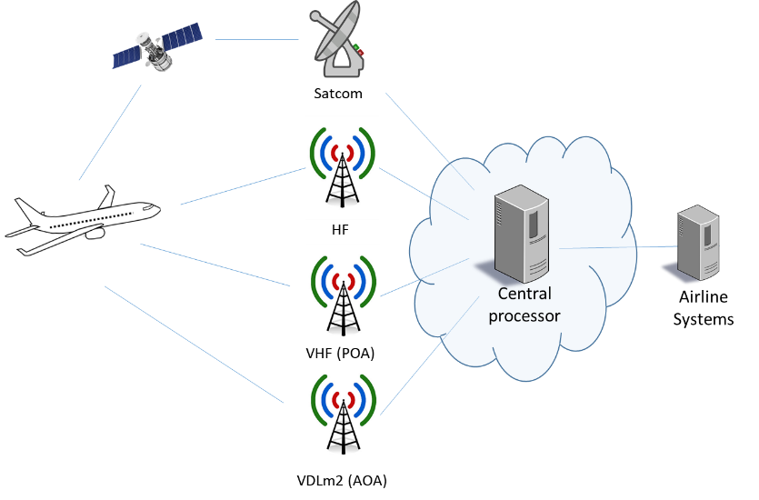
The VHF-reserved bandwidth, from 118 to 137 MHz and known as aircraft band or air band, was initially mainly used for radiotelephony services. In 1978, it was introduced the first data link means, known as Aircraft Communications Addressing and Reporting System (ACARS) to reduce flight crew workload by automatically reporting phase of flight changes and more generally to transport messages no larger than approximately 3.5 kilobytes (kB). The protocol is described in several ARINC documents: ARINC 724 [11] Characteristic Aircraft Communications Addressing and Reporting System, ARINC Specification 620 [7] (ground-ground interface), ARINC Specification 618 [6] (air-ground interface). The first application was OOOI (Out, Off, On, in) allowing communicating accurately and immediately when the aircraft leaves the gate, takes off, lands and is in the gate. But ACARS has been enhanced by new applications, and its use extended to other communications means such as VDL Mode 2 (VDLM2) in continental airspace and L band Satcom (Inmarsat, Iridium) or HFDL links in oceanic airspaces.
Figure 4-1: ACARS network overview

The format and protocols used to transfer messages between the ACARS User’s ground system and the Communication Service Provider’s network differ from the format and protocols used to exchange messages between the airborne user and the Communication Service Provider. It is the responsibility of the Datalink Service Provider to provide translation between these formats and to provide message routing. Those two functions are described in ARINC Specification 620 [7]. The protocols used onboard the aircraft by subsystems participating in ACARS are defined in ARINC Specification 619: ACARS Protocols for Avionic End Systems [10].

POA vs. VDLM2
This section explains the basic concepts and characteristics of POA (VDL Mode 0/A) and VDL Mode 2.

POA fundamentals
The legacy VHF ACARS technology known as POA (Plain Old ACARS) is sometimes referred to as VDL Mode 0 or VDL Mode A.
The method of coding data on the air/ground path is by modulating the amplitude of the VHF signal. The name of the modulation scheme applied is Minimum Shift Keying (MSK). This is equivalent to sending a succession of tones which have either a high or low pitch. A synchronization process enables the receiver to identify the first bit of the transmission and its value (1 or 0). The data rate is 2400 bits per second ±0.02 percent.
The channel access algorithm to be executed by the ACARS CMU is Non-Persistent Carrier Sense Multiple Access (CSMA).
A Base frequency is defined as the frequency for each ground network with which the aircraft may attempt to establish contact. Service providers may use alternative frequencies to offload traffic from its Base frequency. A service provider should utilize the same base VHF frequency worldwide but due to the unavailability of using single worldwide frequencies, today CSPs may have two or more base frequencies dedicated to a particular region. Each ground service provider will broadcast periodically a standard squitter message on the Base frequency that should be accepted by the ACARS CMU.
ACARS squitter may be used to indicate when and where VDL Mode 2 is available. The squitter data can indicate whether only AOA is supported, only ATN is supported, or both are supported. The squitter data provides the VDL mode 2 frequency and optionally a list of VDL Mode 2 Ground Station address(es) that are expected to be within range on that frequency for each service (AOA/ATN) supported. The Squitter Version 2 uplink is defined in ARINC Specification 620 [7].
Squitter data should reflect real-time availability of AOA and ATN. For example, if the AOA processor fails, then the squitter data changes from indicating support for both to support for ATN only.
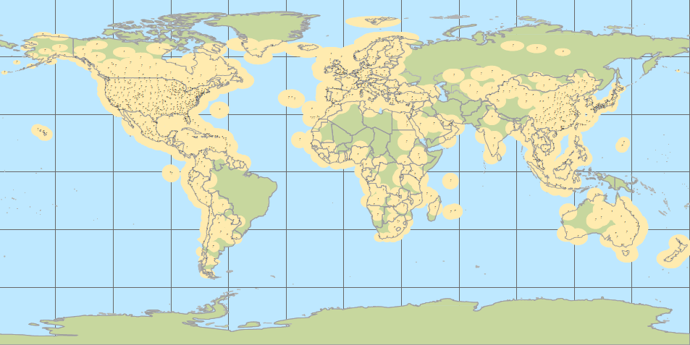
Figure 4-2 Example of POA World Operational Coverage (from Collins Aerospace)

VDLM2 fundamentals
VDLM2 is an aeronautical wireless data communication technology, standardized by the International Civil Aviation Organization (ICAO) in 1996/97. It was defined by the Aeronautical Mobile Communications Panel (AMCP) of ICAO. The primary purpose of VDLM2 is to exchange data between aircraft and ground stations at a higher data rate and more reliably than ACARS, carrying both ACARS and ATN messages. For ACARS applications, it uses ACARS over Aviation VHF Link Control (AVLC) (AOA) protocol and for ATN applications it uses ISO 8208 (ITU X.25) protocol.
VDLM2 handles layers 1, 2, and the sub-network access sub-layer of layer 3 of the OSI seven-layer protocol stack.
Layer 1, the physical layer, uses differential 8-phase (D8PSK) modulation at a symbol rate of 10.5k symbols per second. Each VDLM2 symbol carries 3 bits of information, thereby yielding a raw channel data rate of 31.5 kbits per second. A worldwide common signaling frequency (CSC) was allocated to VDLM2, 136.975 MHz, on which all stations must transmit their identification messages. This protocol layer is also responsible for R-S FEC coding, bit interleaving and scrambling.
Layer 2, the data link layer, has two sub-layers. One is the MAC (Media Access Control) that implements the p-persistent CSMA (Collision Sense Multiple Access) algorithm (the radio listens to the channel and if it is free it transmits with probability p (persistence), and waits before trying again with probability 1 – p). There is no priority mechanism in VDLM2. The second Data Link sub-layer called AVLC (Aviation VHF Link Control) is derived from the ISO High-Level Data Link Control (HDLC) protocol. This layer is responsible for error detection, sequencing and addressing. This sub-layer includes also the VDL Management Entity (VME). The VME creates a Link Management Entity (LME) for each connection, where the LME then establishes and maintains the connection to peers.
Layer 3, the network layer, is partly implemented using the ISO 8208 protocol (X.25 Packet Layer Protocol) and acts as an adaptive layer which for instance reassembles packets delivered by the data link layer. The system definition permits ACARS over AVLC (AOA) to coexist with ISO 8208 and share the same AVLC Frame structure and AVLC resources.
In the current implementation, VDLM2 is mainly connection-based, unless the messages are broadcasted.
A common frequency referred to as the Common Signaling Channel (CSC) is to be used for initial contact. The ground service providers should periodically transmit their Ground Station Information Frames (GSIFs) in the CSC. These frames identify the airport closest to the ground station, all frequencies and protocols that the ground station supports, the operational parameters (MAC persistence, M1, TM2, T4, TG5, k, and N2) for use by all aircraft connected to the station. Using appropriate algorithms, the VGS ground station monitors the availability of ATN air-ground router as well as the ACARS processor and modifies the contents of the GSIF frames in accordance.
The protocol is described in several documents such as VDLM2 SARPs (Doc 9776 [5]), ARINC 631 Specification [8]…
VDLM2 is currently utilized in the United States for AOC and is the only subnetwork available for US domestic continental CPDLC operations (FANS1/A services). In Europe it was implemented for AOC as well as ATC over ATN (FANS 2/B) services. VDL Mode 2 services are also available in Japan, Brazil, China, NAT Region when coverage allows it...
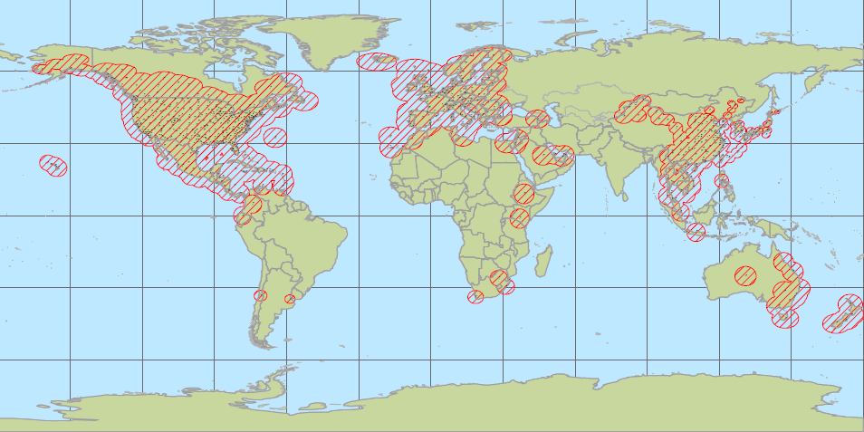
Figure 4-3 Example of VDLM2 World Operational Coverage (from Collins Aerospace)

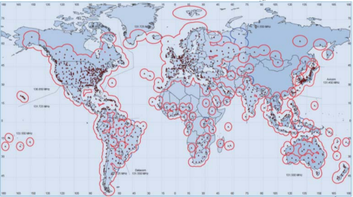
Figure 4-4: Example of POA World Operational Coverage (from SITA)

AOA vs. ATN
The aim of this section is to explain the basic concepts and characteristics of AOA and ATN.

AOA fundamentals
The ACARS over AVLC (AOA) protocol is defined in the ARINC 618 document [6]. AOA is a connection-oriented service that is used to facilitate the migration of legacy datalink ACARS services to the VDLM2 standards.
AOA uses the services provided by the AVLC and VME/LME functions as defined in ARINC Specification 631 to transport ARINC 618 ACARS blocks using ACARS routing over VHF Digital Link (VDL) Mode 2 Datalink Layer. The ISO 8208 layer is not operated within AOA.

ATN fundamentals
The Aeronautical Telecommunications Network (ATN) is a bit oriented, Open System Interconnection (OSI) based network that supports air-ground and ground-ground applications. ATN was designed starting in the mid-1980s as an ICAO-compliant network for ATS applications (ICAO Doc 9705, 2002 [3]). Although intended to handle AOC applications, the associated business case never materialized. ATN is only deployed in Europe and VDLM2 was chosen to support the ATC communications.
In the ATN environment, the Network Layer has been divided into three Sublayers as shown in Figure 4-5. These are the Subnetwork Access Protocol (SNAcP) Sublayer (e.g., ISO 8208), the Subnetwork Dependent Convergence Function (SNDCF) Sublayer and the Subnetwork Independent Convergence Protocol (SNICP) Sublayer (e.g., ES_IS/CLNP/IDRP).

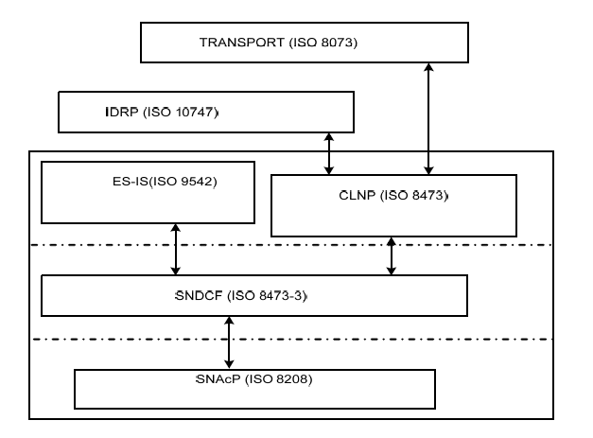
Figure 4-5:Sub-layers of the Generic ISO Network Layer [8]
The network layer of the data link systems is expected to evolve towards the future ATN/IPS, currently under standardization in the different groups (ICAO, AEEC and EUROCAE / RTCA). In particular, EURCAE WG-92 / RTCA SC214 are starting to draft the transition to ATN/IPS for VDLM2 systems. In this sense, the SB-VHF will be able to support the ATN/IPS network layer transparently as it will not differentiate network layer traffic.

Similarities and differences between POA and VDL2
The table below summarizes the main characteristics of POA and VDLM2:
System | VHF ACARS (POA) | VDLM2
Channel Separation | 25 kHz | 25 kHz
Modulation | AM-MSK | D8PSK
Transmission Bit Rate | 2400 bps | 31500 bps
Information Unit | Character | Bit
Error handling | Error detection and packet retransmissions | Error detection and correction
Access Scheme | Non-persistent CSMA | p-persistent CSMA
Broadcast message | Squitter | GSIF
Avionics Standards | ARINC 716 VDR /724B MU  ARINC 750 VDR /758 CMU | ARINC 750 VDR /758 CMU
Supported protocols | ACARS through POA | ACARS through AOA
Table 4-1: Comparison of POA and VDLM2
Radios compliant with ARINC 750 VDR standard are capable of supporting 25 and 8.33 kHz voice, POA and VDLM2 data link communications.
Figure 4-6 represents the functional architecture of the ACARS and ATN capable avionics.
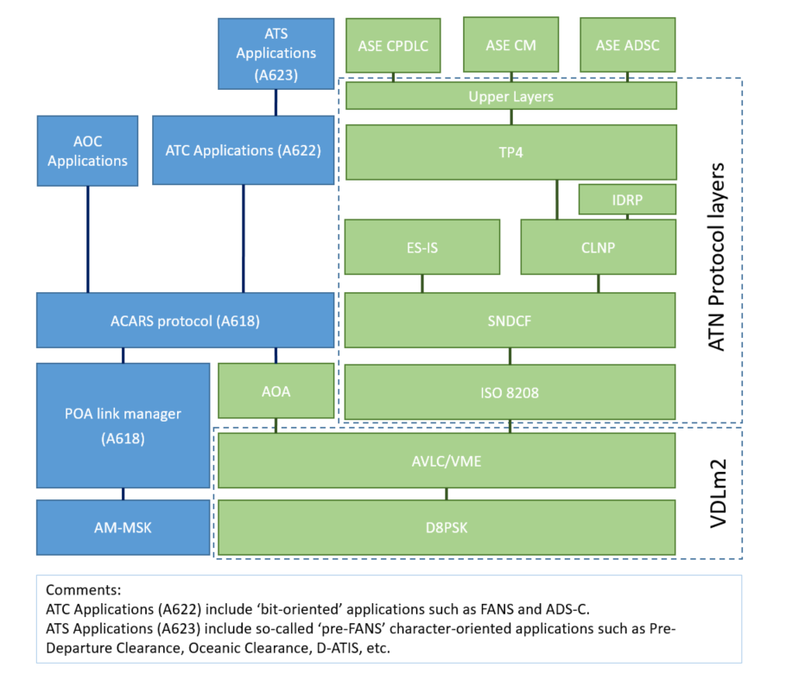
Figure 4-6: Functional architecture of ACARS and ATN capable avionics

Radio frequency management

Introduction
In VDLM2, a tiered structure of operating frequencies and zones is used such that communications are optimized for individual enroute and terminal area requirements.
VDLM2 started working on a single frequency but, due to capacity reasons, it was given the possibility of operating on multiple frequencies. This initially unique common frequency referred to as the Common Signaling Channel or CSC is to be used for initial contact. The CSC provides a ready means for an aircraft user to first enter the system (log on). It also serves as a common or base channel to be used in emergency or light traffic areas. A fallback (default) channel whenever communication is lost for any reason could also be available in some region but this alternate channel is not standardized.
The ground service providers should transmit their Ground Station Information Frames (GSIFs) in the CSC. GSIF messages contain all the necessary information for the CMU to establish VDLM2 communications with the ground station. All data link service providers should make their presence and availability known by transmitting GSIFs on the CSC. The avionics equipment must be capable of operating on the CSC. In fact, it should be able to tune to any discrete frequency within the assigned frequency range. Tuning may be automatically performed by the CMU based on the Frequency Support List (FSL) or commanded by the ground systems (GRAIHO). Very rarely tuning is commanded by the flight crew: only in very special scenarios the crew can manually select the type of service and the associated frequency.
When VDL service is available the Subnetwork-System Management Entity (SNSME) commands the VDL Management Entity (VME) to start the DSP acquisition process on the assigned frequency. The aircraft VME attempts to tune the avionics to the assigned frequency. It is worth noting that in some avionic, GSIFs could be filtered on the DSP Id and as a consequence, airborne system only considers GSIFs corresponding to the configured DSP.
Alternatively to a direct connection to VDL Mode2, as described above, in areas where ACARS VHF and VDLM2 coverages are available, during a transition phase the ACARS squitters, as specified in ARINC Specifications 618 and 620, should convey the VDLM2 frequency to the Data Link Manager, which initiates the VDL Mode-2 (AOA/ATN) communication process.
If CMU cannot establish a VDLM2 link, then it can revert to POA and wait for possible VDLM2 frequency provided by ACARS squitters. There are several triggers for a CMU to switch from POA to VDLM2:
1. Receipt of version 2 ACARS Squitters indicating VDLM2 availability
2. Receipt of a VHF ACARS (POA) to VDLM2 Retune command that provides at least the target VDL frequency.
Most recently produced CMUs today include VDLM2 CSC either in the VHF scan mask of frequencies or for a geographic region so the aircraft can go straight to VDL on a power up without even hearing a squitter on POA.
Finally, as an alternative option, some specific avionics gives the possibility to tune to the VDLM2 frequency provided through a SATCOM connection and then establish a link with a VDLM2 service provider. This transition can be carried out in two jumps, using POA as transition phase: SATCOM to POA and then POA to VDLM2.
More detailed information will be provided in the following sections.

Frequency global allocation for ACARS and VDLM2
VDLM2 CSPs services are announced on the CSC frequency (136.975 MHz), frequency already known by the avionics, and the alternate VDLM2 frequencies are received by the ACs through the CSC by means of standard mechanisms.
To note that there is no need to have a table with AOA/ATN (VDLM2) frequencies corresponding to the service provider(s) of choice in the region (no VDLM2 frequencies are defined in the CMU) because all VDLM2 CSPs offer service or are announced on the CSC frequency (136.975 MHz) and alternate AOA/ATN (VDLM2) frequencies used by CSPs are not published. The alternate VDLM2 is received by the aircraft through the CSC by means of standard mechanism.
Table 5-1 includes the list of ACARS (POA) base frequencies allocated worldwide:

Usage | Group | Region | Frequencies [MHz]
ACARS | SITA | Europe Africa | 131.725
ACARS | SITA | North America | 131.725
ACARS | SITA | Latin America | 131.725
ACARS | SITA | Pacific | 131.550
ACARS | ARINC | Europe | 131.825
ACARS | ARINC | Europe [before 2004] | 136.925
ACARS | ARINC | America | 131.550
ACARS | ARINC | Africa | 131.825
ACARS | ARINC | Korea | 131.450
ACARS | ARINC | Asia [China and Thailand] | 131.450
ACARS | ARINC | Russia | 131.550
ACARS | ARINC | Austral | 131.450
ACARS | ARINC | Middle East | 131.475
ACARS | AVICOM | Japan | 131.450
ACARS | DEPV | Brazil | 131.550
Table 5-1: ACARS frequencies allocation

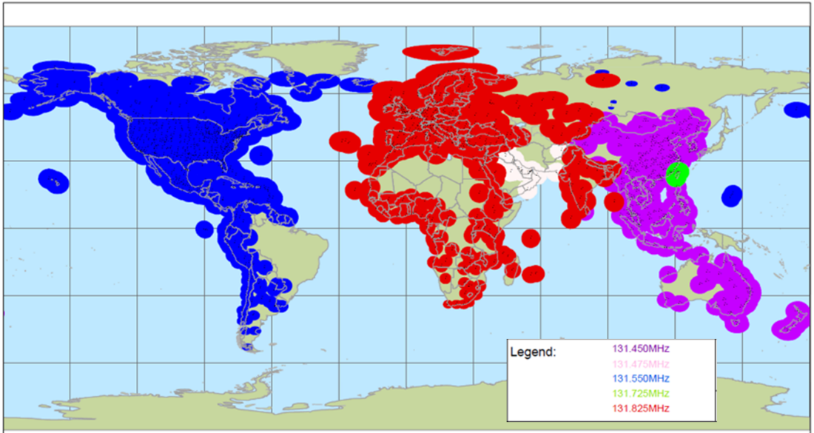
Figure 5-1: POA Base frequencies deployed worldwide by Collins.

Use of VHF frequencies in the avionics

Use of the frequency scan mask in the avionics
Basically, there are several ways to handle the frequency scan mask in the avionics:
- A flat list (“Search Table”) of frequencies to scan with the associated provider identification:
  - List of preferred CSP base frequencies for POA.
  - List of preferred service providers for VDLM2.
- Specifying the list of frequencies and service providers per region (“Geo Logic”) geographically based (as the example in the figure below from the Honeywell):
  - In each region the CMU provides the ability to assign POA frequencies corresponding to the service provider(s) of choice in that region, select from a list of VDLM2 service providers and define VHF channel preferences.
The next configuration option is an example from Honeywell of a “per region” configuration. Actually, there is no standard for configuring CSP and Media preferences, it varies by manufacturer and even by model of CMU or CMF.

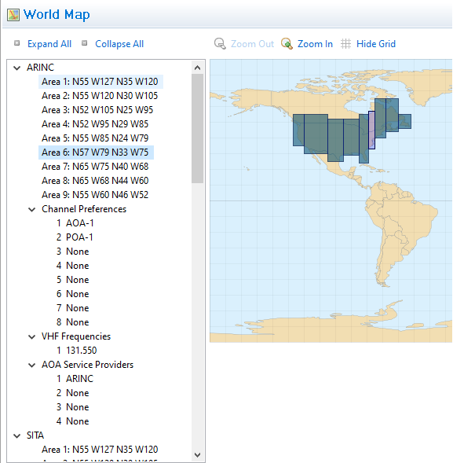
Figure 5-2: Example of ‘World Map’ window (provided by Honeywell)

Every region is described basically by:
- Region number and name
- List of areas that compose the region, defined by its top left corner and its bottom right corner.
- Channel Precedence
  - In each region it is provided the ability to define channel preferences. A list of a selection of connectivity networks ordered by priority.
  - Options:
    - AOA (specific or any)
      - If the "Channel Precedence" selection is "Any AOA", then CMU tries to establish a link with any of the defined AOA (VDLM2) CSPs.
    - POA (specific or any)
      - If the "Channel Precedence" selection is "Any POA", then CMU tries to find ACARS coverage with any of the defined POA (VDLM0/A) frequencies.
- POA frequencies
  - List of POA (VDLM0/A) VHF frequencies (MHz) associated with the region (ordered by priority) used in ‘Channel Precedence’ list.
- AOA service providers
  - List of service providers corresponding to AOA (VDLM2) associated with the region used in ‘Channel Precedence’ list.

Frequency Search process depending on avionics
As it is the configuration, the specific procedure is also highly vendor proprietary:
- Some CMUs arrive on the CSC via POA; others search the CSC directly.
- Once on the CSC, they listen to the GSIF and apply their CSP of choice depending on the type of configuration related in the previous chapter:
  - This can be setup by a VDLM2 CSP preference file or table.
  - Others have a list of MEDIA and VDLM2 CSPs and allow the customer to develop a list of CSP preferences.
- The transition from CSC to alternate frequency (based on many factors: location, destination, channel usage) can be done using these options:
  - Broadcasted FSL: the CSP can indicate to the aircraft through a parameter in the GSIF frame that service is available on an alternate frequency.
  - GRAIHO handover mechanism.
- The previous mechanism to switch to the alternate frequency can be done from a channel different from the CSC, as a Terminal Frequency
The transition from POA to VDLM2 follows the following procedure that will be detailed later:
- Once the avionics receives POA traffic through the POA configured frequency, it is possible to receive an ACARS squitter.
- If the ACARS squitter announces VDLM2, then it tries to establish the AOA/ATN (VDLM2) link with the service provider and the VDLM2 frequency received in the squitter.
Following a general view of the process is included.
- Just one VDLM2 frequency (the CSC frequency 136.975 MHz) is configured in the CMU application: all VDLM2 CSPs are announced or offer service on the CSC, so there is no need to have other VDLM2 frequencies defined in the CMU application (the CSC frequency is the first to be checked). What must be configured in the CMU is the selection of VDLM2 service providers to be used in each region or, in the case of avionics with “search table”, the flat list that applies worldwide.
  - [ARINC-631, chapter 4.1]
    - A common frequency referred to as the CSC is to be used for initial contact providing a ready means for an aircraft user to first enter the system.
    - The service providers should transmit their GSIF in the CSC. All datalink service providers should make their presence and availability known by transmitting GSIF s on the CSC.
    - The avionics equipment must be capable of operating on the CSC.
- Nevertheless, there are several POA frequencies (each DSP utilizes at least one frequency worldwide, trying to be exclusive frequencies) and in the CMU must be configured the selection of POA frequencies to be used in each region or, in the case of avionics with “search table”, the flat list that applies worldwide.
  - [ARINC-618, chapter 5]
    - Since the frequency over which VHF data communications will be conducted is not fixed, ACARS MUs may need to have a frequency management capability. The CMU can be programmed with the different available frequencies and attempt link establishment on each frequency.
- (Usually, the first ‘Channel precedence’ selection is VDLM2) CMU tries to establish a VDLM2 link with the VDLM2 CSPs selected for the applicable region or worldwide in the case of avionics with “search table” in the CMU application on the CSC frequency (136.975 MHz) according to its preference order defined via the “Service Providers” selections.
  - [ARINC-631, chapter 4.1]
    - The service provider may transfer an aircraft to an alternate frequency at any time by issuing an Autotune command.
    - The avionics equipment should be able to tune to any discrete frequency within the assigned frequency range. Tuning may be commanded by the ground systems.
- (Usually, after VDLM2, CMU Application allows POA (VDLM0/A) in the ‘Channel Precedence’ of the applicable region) If CMU cannot establish a VDLM2 link with any VDLM2 CSP selected for the applicable region or worldwide in the case of avionics with “search table” in the CMU application, then it reverts to POA (VDLM0/A) using the POA frequency(ies) indicated in the ‘Channel precedence’ selection.
If ACARS coverage is found, then CMU waits for possible VDLM2 frequency provided in the ACARS squitter messages. The following text extracted from relevant ARINC documents supports the process description:
  - [ARINC-631, chapter 4.1]
    - In areas where VDLM2 coverage is available during a transition phase, the ACARS squitters should convey the VDLM2 frequency to the Datalink Manager which initiates the VDLM2 communication process.
    - The aircraft VME attempts to tune the radio to the assigned frequency. The source of the frequency may be obtained from an ACARS squitter. The VME then monitors uplink transmissions (GSIF, or other uplink) to discover the available VHF service providers operating on that frequency.
  - [ARINC-631, chapter 4.1.1]
    - If an aircraft is within ACARS coverage, the CMU commands the VDR to tune to the VDLM2 frequency provided by the ACARS squitter in order to search for available service providers who are advertising their services via ACARS squitters.
    - If the avionics is both ACARS and VDLM2 capable, the power-up initial mode should be based on owner preference. If the preferred mode is VDLM2, then the avionics tunes to CSC to discover available VDLM2 DSP(s), and if no VDLM2 service is detected on the CSC, the avionics may fall back to VDL Mode 0/A based on owner preference.
  - [ARINC-618, chapter 11.5.1.1]
    - ACARS squitters may be used to indicate when and where VDLM2 is available. The squitter data can indicate whether only AOA is supported, only ATN is supported, or both are supported. The squitter data provides the VDLM2 frequency and optionally a list of VDLM2 Ground Station address(es) that are expected to be within range on that frequency for each service (AOA/ATN) supported.
    - Squitter data should reflect real-time availability of AOA and ATN.
  - [ARINC-618, ATTACHMENT 18]
    - Successful Switch from ACARS to AOA Based on Ground Station Announcement of AOA Availability:

Figure 5-3 Successful Switch from ACARS to AOA [6]

Figure 5-3 shows a general view of the link establishment to service provider process, including the frequency search process.
The configured channel precedence list indicates what is the first and next connectivity networks to which the connection will be attempted. As previously stated, normally the first option is VDLM2 and the alternative is POA:
- AOA/ATN service provider
  - If the precedence list element indicates an AOA or ATN service provider (or a set of AOA/ATN service providers), the avionics radio is tuned to CSC frequency and tries to find the existing service providers in the area through the received GSIF frames.
  - The avionics try to establish a link with the found service providers that matches with the one to be connected with (or with any in the set).
  - Once the AOA/ATN link is established to service provider through CSC, the service provider can tune the avionics radio to establish the link through an alternate frequency.
  - If, for any reason, the link with the AOA/ATN service provider is not possible, the process jumps to the next element of the channel precedence list.
- POA frequency
  - If the next precedence list element indicates a POA frequency (or a set of POA frequencies) the avionics radio is tuned to this frequency (or frequencies) in order to detect service in the region.
  - Once the avionic has a connection through the POA frequency indicated in the channel precedence list (or with one of the set of POA frequencies), it can receive an ACARS squitter to tune the frequency provided in it and try to establish an AOA/ATN link with the service provider.
    - In this case, no CSC is required: a switch from POA frequency to a VDLM2 frequency different than CSC is feasible.
  - If, for any reason, it is not possible to detect POA service, the process jumps to the next element of the channel precedence list.

Figure 5-4 Link establishment to Service Provider process

Management of priorities between ACARS and VDL
When the aircraft has to be connected for the first time (or after losing the link it had established) the avionics start the process explained in previous chapter 5.3.2 whose parameters (shown in previous chapter 5.3.1) have been previously configured.
The priorities between ACARS (POA) frequencies and VDLM2 (AOA/ATN) service providers are established thanks to the channel precedence list: a list of a selection of connectivity networks ordered by priority defined in each region or, in the case of avionics with “search table”, worldwide.
In regions where ATN is used, priority is always on VDL2/ATN. If the aircraft has to switch back to POA (e.g. loss of VDL2), it will try again to reconnect to VDL2 when a timer expires.
In case the establishment process indicates connection with ACARS (POA) and ACARS coverage is found, the CMU waits for possible VDLM2 frequency provided by ACARS squitters (through which available service providers are advertising their service) that should convey that frequency to the Datalink Manager which initiates the VDLM2 communication process (the aircraft VME attempts to tune the avionics to the assigned frequency). The VME then monitors uplink transmissions (GSIF, or other uplink) to discover the available VHF service providers operating on that frequency.
ACARS squitters are used by service providers to indicate when VDLM2 is available in the area. The squitter data can indicate whether only AOA is supported, only ATN is supported, or both are supported. The squitter data provides the VDLM2 frequency and optionally a list of VDLM2 Ground Station address(es) that are expected to be within range on that frequency for each service (AOA/ATN) supported.

Certification aspects when modifying the VHF frequencies in the CMU
There is no need to carry out a certification process to change the VHF frequency scan mask, as it represents a configuration change or, simply, a database update, but, definitely, not a core SW modification. Vendors usually provide the necessary aircraft loadable files for installation in the avionics.
The installation procedure is vendor dependent but, in any case, addressed to upload the configuration changes. Even if such a change may not require initiating a formal certification process, it is worth noting that any configuration change require to perform a minimum set of verification.
In the case of Collins avionics, the frequency scan mask is referenced as Vendor Modifiable Data (VMD). This VMD includes a list of frequencies and the corresponding providers, which are needed. This is delivered to the airlines and loaded through the Portable/Cockpit Data Loader in the cockpit. Collins just files a new document registering the changes that have been made. For airlines, this is done once a year.
In the case of Honeywell avionics, the configuration is handled by means of the Airline Modifiable Information (AMI). The Data/Cockpit Loader concept is also applicable but, in this case, the uploaded data is usually structured per regions containing the corresponding frequency definition.
For Airbus avionics, ATSU and ACR, the frequencies which are specifically needed can also be loaded. Again, Airbus also applies a Data/Cockpit Data Loader where all the information for the required frequencies is defined.
As will be seen in the next section, most of the use cases will not require any change in the avionics VHF frequency scan mask, as by definition the frequencies will be known by the avionics without any configuration change. Only in the case of adding new regions or new frequencies, a configuration change or database update will be required.

Mode of operations for space-based VHF
This section will demonstrate that the underlying principle for SB-VHF is that it will use the same mechanisms that the ground-based system already has in place. Then, the SB-VHF does not represent a significant change in terms of architecture. As a consequence, this section put the emphasis on the advantages of the Space-based VHF solution for the users, the airlines and the ANSPs.
SB-VHF will support both, POA and VDLm2. It is important to consider this because POA may be used as a fallback situation even recognizing that its performance is not as good as the performance offered by VDLm2.
The analysis provided in this chapter will demonstrate that with the current frequencies SB-VHF system can work and that there is no need to allocate additional frequencies.
In this regard, for the specific use case of dedicated frequencies, any of the existing POA/VDLM2 frequencies could be used.

Use cases for aircrafts using space-based VHF

Use case: VDLM2 extension of coverage
This use case shows the concept of extending the coverage of the existing ground-based POA and VDLM2 networks using space-based POA and VDLM2 networks.
In order to ensure continuity of service, the transition between ground-based POA and VDLM2 networks and the space-based POA and VDLM2 one should be seamless. Overlap between ground-based coverage and space-based coverage ensures continuity of service and makes it possible for aircraft to transition from ground-based POA and VDLM2 services to space-based POA and VDLM2 service (without or with frequency change).
One of the classical goals is how POA and VDLM2 service could be provided in the oceanic airspace between North America and Europe (over the North Atlantic), but other existing issues must be overcome, e.g., coverage in the Gulf of Mexico, coverage in the middle of Australia, Polar routes, Tango routes in Europe, etc.
The extension of the coverage of the existing ground-based VDLM2 networks can be achieved using CSC or an alternative or auxiliary VDLM2 frequencies from the existing VHF spectrum on a geographical basis depending on the specific needs and/or concerns. The service could be easily deployed based on the needs from the airlines and on the needs of the ANSPs.
This concept allows to create “no-service areas” in specific regions that don’t want to have the service; it also gives the possibility of having a stand-alone service in areas where there are no terrestrial coverage areas with overlapped zone with the satellite coverage.

Scenario 1: Extension of coverage using an alternate VDL channel
In the event that there are any concerns about possible interaction between VDLm2 traffic handled through the satellite-based service and VDLm2 traffic handled by the ground-based network, the satellite-based service could be operated on an alternate channel to which the aircraft would be directed by the VDL Management Entity (VME): the VME is the entity that commands aircrafts to switch from one frequency to another based on specific business rules parameters, e.g., aircraft position with respect to coverage and aircraft trajectory. The transition procedure from the ground-based frequency to the SB-VHF frequency will be managed by the VME and it is compatible with all multifrequency capable avionics.
This solution ensures that aircraft would transition seamlessly from the ground-based service in continental airspace to the satellite-based service in oceanic airspace and vice versa by doing a handoff with frequency change.
The proposed alternate frequency could be any VHF frequency within the aeronautical band and that would, again, not imply any change in the avionics because the frequency change is commanded by the VME. Now there is a need of a frequency change using GRAIHO commands (again, defined in the already business rules of the VME) and that will be managed by the VME. The VME will command the aircraft to move to another specific alternate VDLm2 channel.
The scenario for VDLm2 service is presented in the following figure.
Figure 6-1: Use case scenario: VDLM2 extension of coverage using a different alternate VDL channel

- As a fallback mechanism, the process would be as follows
  - If the connection through the alternate VDLm2 frequency through the SB-VHF system is lost, the fall back would be to a POA, as shown in the figure above, which again doesn’t impose any requirement on the avionics. In any case, the behavior from one avionics to another may be different in terms of the frequencies that are scanned for this fallback procedure. This approach is based on the current deployment approach and policies followed by the CSPs.
  - In this case, the avionics keeps scanning CSC for 4 minutes. When it detects that there is no CSC available, then it reverts to POA and starts scanning POA. Then, when the POA is found, it tunes to the available POA base frequency.
  - If the aircraft receives an ACARS squitter to switch to VDLm2, it will execute that transition (no avionics modification is required): the aircraft could be commanded to return to the alternate VDLm2 channel.
As a subcase of previous figure, the following figure presents the case of a region in which the ATC traffic through SB-VHF system is not used. In this scenario, the case also addresses the possibility of having an ATC service activated through the SB-VHF in areas where there is no overlapping between the terrestrial coverage and the satellite coverage, meaning that the direct transition from terrestrial VHF to SB-VHF is not possible. As shown in the figure, the process would be as follows:
- Continuity of ATC service is assumed to be given as in the area without VHF terrestrial or SB-VHF coverage, the ATC service for the aircraft can be provided through other means (SATCOM, HF data link…).
- When the aircraft arrives to the zone with satellite coverage, it can establish a connection through POA, which again doesn’t impose any requirement on the avionics (but on SB-VHF system that must deploy POA base frequency as well). If the aircraft lately receives an ACARS squitter to switch to VDLm2, it may execute that transition to the alternate VDLm2 channel (no avionics modification is required).
Figure 6-2: Use case scenario: VDLM2 extension of coverage using a different alternate VDL channel through intermediate mechanisms (SATCOM, HF …) to ensure continuity of service.

For completeness, the following figure presents another subcase based on being able to use the CSC only in regions without satellite and terrestrial coverage overlap. In the case the fallback of the alternate frequency would be directly the CSC. This would make the process more efficient. Since the CSC is already available, the fallback mechanism would just use the CSC making this process simpler, more efficient and faster.
Figure 6-3: Use case scenario: VDLM2 extension of coverage using a different alternate VDL channel using CSC frequency only in regions without satellite and terrestrial coverage overlap.

Scenario 2: VDLM2 extension of coverage using the CSC frequency
In oceanic regions and in areas where there are no concerns about possible interaction between VDLm2 traffic handled through the satellite-based service and VDLm2 traffic handled by the ground-based network, the most efficient and direct way to provide these services would be to operate the satellite-based VDLm2 service on the CSC channel and to locate it in such a way that there would be an overlap with ground-based CSC coverage near the boundary areas.
This would ensure that aircraft would transition seamlessly from the ground-based service in continental airspace to the satellite-based service in oceanic airspace and vice versa by doing a handoff without frequency change.
The only hand-off that will occur is the one from/to the ground-based VGS to/from the SB-VGS, because the CSC will be continuously used. This solution is compatible with existing avionics without any modification.
As this second scenario only affects VDLm2 service, the scenario for POA service is the same as the one presented in the previous “Scenario 1”.
If the space-based VHF datalink through CSC channel ceases to be established for any reason outside of continental areas, there is the possibility to fall back to POA, which again doesn’t impose any requirement on the avionics. In any case, the behavior from one avionics to another may be different in terms of the frequencies that are scanned for this fallback procedure. This approach is based on the current deployment approach and policies followed by the CSPs. This case is shown in the following figure.
Figure 6-4: Use case scenario: VDLM2 extension of coverage using CSC frequency with POA channel as fallback solution.
As a subcase of previous figure, the following figure presents the case of a region in which the ATC traffic through SB-VHF system is not used (e.g., a specific country may be reluctant to use this service for any specific concern). In this scenario, the case also addresses the possibility of having an ATC service activated through the SB-VHF in areas where there is no overlapping between the terrestrial coverage and the satellite coverage, meaning that the direct transition from terrestrial VHF to SB-VHF is not possible. As shown in the figure, the process would be as follows:
- Continuity of ATC service is assumed to be given as in areas without terrestrial or satellite coverage, the ATC service for the aircraft can be provided through other means (SATCOM, HF data link…).
- When the aircraft arrives to the zone with satellite coverage, it can perform a Link Establishment using CSC channel. It is a procedure compatible with existing avionics without any modification.
- As a fallback or as a mechanism to log to the SB-VHF, the service can be given by a connection through POA, which again doesn’t impose any requirement on the avionics as its frequency is configured in the avionics (see section 5.3.1). The SB-VHF system needs also to deploy existing POA base frequency as well. If the aircraft lately receives an ACARS squitter to switch to VDLM2, it may execute that transition to VDLM2 CSC channel (no avionics modification is required).
Figure 6-5: Use case scenario: VDLM2 extension of coverage using CSC frequency with POA channel as fallback solution with continuity of service provided through other means (SATCOM, HF, …).

Use case: VDLM2 additional capacity through a specific alternate frequency (different to the frequencies already in use)

One of the modes of operations for space-based VHF (SB-VHF), is indicated in this section. This use case is specific and intended for providing additional capacity in a certain area where there is already VDLM2 coverage.
In this use case, the proposed approach is to use a specific alternate frequency, which will be different to the frequencies already in use. This way it is ensured that there will be no interference issue between the ground-based VHF (terrestrial VDL network keeps using the allocated frequencies) and the space-based VHF (space VDL network will use different aeronautical VDL frequencies to the ones already in use by the terrestrial VDL network).
It must be clearly understood that there is no intention to replace the current terrestrial VDL infrastructure by a new space based VDL infrastructure. The rationale and motivation for this approach is to add or increase the existing capacity already provided by the terrestrial VHF infrastructure with the contribution of the space-based VDL infrastructure.
Nowadays, there are currently four geographical regions in the world where VDLM2 datalink services are widely available:
- North America
- Europe
- Brazil
- Different countries in Asia, including Japan.
In North America and Europe, the volume of traffic handled by the VDLM2 network has increased so much that in addition to the Common Signaling Channel (CSC) supplemental capacity has been deployed on alternate channels, two by SITA and two by Collins.
The driving factor behind this deployment is that traffic handling performance, in terms of latency and availability, is impacted by the volume of traffic. Increasing the amount of traffic that the channel is asked to handle reduces the end-to-end performance because of the Carrier Sense Multiple Access (CSMA) channel access characteristics, and in particular the well-known problem of hidden transmitters.
Network operators needs to constantly monitor the channel utilization, measure specific Key Performance Indicators (KPI) and plan to deploy additional capacity to prevent a degradation in the quality of service. However, deploying additional capacity on a ground-based network is a complex and expensive process that requires:
- Requesting a channel allocation from a spectrum management authority
- Capital expenditure to procure the necessary equipment
- Selecting an appropriate deployment location, obtaining all the required licenses and authorizations at each location
- Deploying the ground stations and integrating them into the existing network
Of all the steps listed above, it is in fact step 1 that is the most complex one because it is difficult to find a channel with the required separation necessary to protect it from interference generated by RF activities on other channels.
Steps 3 and 4 are definitely linked and are also very challenging. A space-based system certainly alleviates and solves the issue of having to deploy multiple VHF ground stations to provide VDL coverage in a big area, especially, if it is a remote continental area where power supply and IP connectivity is not easily achieved. Instead, this could be done with just one space-based station that would provide the same coverage and capacity than several VGS stations.
Typically, when designing a terrestrial VHF network, frequency or distance separation is required. In terms of frequency separation, 100 kHz separation is necessary to avoid RF interference among nearby VGS stations, although some stations can be deployed with 50 kHz separation. In terms of physical separation, usually, a distance of hundreds of meters or even a few kilometers separation is needed to avoid RF interference.
However, if the ground stations are operated from a satellite-based transceiver then it is possible to provide service on adjacent VDLM2 channels, separated only 25 kHz, whenever these space-based transceivers are not co-located in the same SB-VHF station. In addition, an aircraft logged to the space-based frequency could interfere to a ground station operating in the adjacent channel if it is located close enough. This scenario is considered unlikely as the CSP can coordinate the use of its channels to prevent such aircraft to log to the Space-based system instead of the ground one.
Obviously, for space-based stations there is no requirement in terms of physical separation because the own topology of the LEO constellation already ensures that the space-based stations are thousands of km away one another.
The advantages, then, of deploying VDLM2 service for the purpose of adding additional capacity through a satellite-based system are the following:
- Increased efficiency of the VDLM2 channel due to the absence of the hidden transmitter effect,
- Availability of a larger pool of VDLM2 channels due to the possibility of deploying services on adjacent VDLM2 channels,
- Simplified licensing since only one license will be required per country instead of one license for every location in the same country, and,
- Simplified and much cheaper deployment to cover new areas once the space-based constellation is fully operational (it is a matter of enabling specific VDL frequencies in specific areas upon having made all the coordination required for the use of that/those specific frequency/ies).
A graphical representation of the principle of this use case is shown below relying on the basic scenario of one ground station, one aircraft and one satellite:
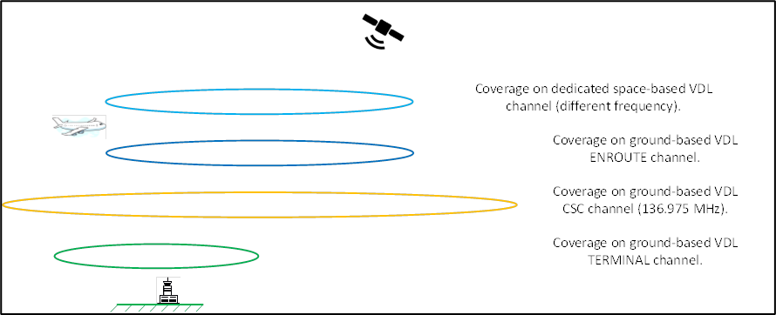
Figure 6-6: Use case scenario: VDLM2 additional capacity
Figure 6-6 does not represent the footprints of the SB-VHF nor the terrestrial VDL systems. This figure shows the coverage offered by the different systems in this first use case. The light blue ellipse shows the coverage provided by the SB-VHF system. Ideally, this coverage should be very similar to the terrestrial VDL coverage through the ENR VDL frequency. Usually, ENR VDL frequency shown in dark blue in this figure is used to offload traffic from the CSC VDL frequency, which should only be used to access the VDL network.
Yellow ellipse represents the terrestrial VDL coverage through the CSC VDL frequency. The coverage area provided by the CSC VDL frequency is the widest one because of the strategy followed by the CSPs when deploying VDL networks. By default, all VGS stations being equipped with VDL have, a radio for the CSC VDL frequency. Depending on the location and purpose of each specific VGS station, these VGS stations may have additional VDL frequencies for ENR and TER VDL frequencies or not.
Green ellipse depicts the terrestrial VDL coverage through the TRM VDL frequency. Usually, TRM VDL frequency is used in the vicinities of the airports and TMAs and its purpose is also to offload traffic from the CSC VDL frequency. Normally, the coverage area for the TRM VDL frequency is the smallest one because its main purpose, as mentioned before, is to provide additional capacity and offload traffic from the CSC VDL frequency in the surroundings of airports and TMAs.

Characteristics of the deployment for that specific alternate frequency
The use case explained in 6.1.2 details very clearly how a space-based system can provide additional capacity using different alternate VDLM2 frequencies to the ones already in use for terrestrial VDL. This is based on the fact that adjacent VDL channels can be used in the space-based stations while it is not possible, or, at least, very difficult for the ground-based stations.
VDLM2 uses a Differential 8-Phase Shift Keying (D8PSK) modulation, to allow a maximum data throughput of 31.5 kbps at the physical layer. It uses a CSMA protocol to avoid message collisions, which allows a maximum throughput at 38% RF channel utilization considering current VDLM2 implementation.
According to ELSA study, ground logs data collected for this study have shown that the channel utilization (CU) during peak hours seen by the ground at some airport locations such as FRA and CDG was often over 40%. Channel Utilization (observed at the ground) calculated at peak hour for FRA and CDG shows some peak at 50%. Knowing that the CU seen by the airborne is roughly 20% higher, this leads to a minimum 70% during peak time of the peak hours.
This study found out that, in average, more than one third of the frames uplinked towards an airborne receiver collided and were therefore lost, which lead to additional re-transmissions that increased the CU, and also increased the probability of collision.
VDLM2 frame collisions can therefore be identified as the main RF issue. In this regard, these potential collisions grow as the number of stations in the VDL network also grows. It is impossible to avoid collisions since they are embedded in the p-CSMA protocol behavior which is based on sensing the channel. Therefore, in essence, a p-CSMA protocol always has hidden transmitters.
The goal, therefore, is to minimize this impact. A space-based system would reduce this issue because from the station on board the satellite there would not be any hidden transmitter minimizing therefore the number of retransmissions due to RF collisions. It should be noted that the hidden transmitter effect depends on where the transmitter is located. Aircraft wise, this hidden transmitter effect is not experienced because the aircraft is able to see many surrounding terrestrial VHF stations and therefore, the number of collisions is reasonably low. However, ground-based station wise, the hidden transmitter effect occurs because the ground stations don’t see each other, and they may transmit at the same time without noticing this.
Another important aspect to consider is that with the current VDL infrastructure available today, the capacity of the network and the access to specific VDLM2 frequencies can be efficiently managed through the VDL Management Entity (VME).
The VME manages the VDLM2 aircraft having link connections with the current ground system. The ground VME creates one LME for every aircraft that is logged-on to the VDLM2 ground system and similarly, the airborne VME will create one LME for each ground system that it is communicating with.
These peer LMEs use the information provided by the received XID’s (lat/long position parameter, airport destination, acceptable alternate ground stations, etc.) and other information sources (transceiver’s signal quality/strength of received frames) to establish and maintain reliable links between the aircraft and the VDL ground system.
The behavior mentioned above for the VME and the aircrafts establishing LMEs would be exactly the same within a space-based system. The only difference is that ground-based stations would be substituted by space-based stations, but the management of the LMEs and the way that the overall system would behave, would be exactly the same.
Then, the VME in a space-based system would definitely help manage the capacity for the alternate frequency allowing or preventing aircrafts from connecting and making use of the space-based VDL frequencies and, therefore, optimizing the capacity of the SB-VHF system to ensure the maximum performance of the system.

Compatibility aspects for aircraft avionics considering the use of an alternate frequency in the VDL spectrum
Today, one of the most important aspects when looking at the different alternatives and technologies to improve ATC communications between ATCOs and pilots is not to change or modify the avionics on board. This is an important premise that must be always observed in order to ensure the success of any new potential development.
Modifying or changing some avionics equipment on board is very expensive and time-consuming and if it is strictly needed, there must a sound business case that clearly benefits the targeted airlines.
This is, precisely, the situation for the SB-VHF system. In this case, the existing avionics will benefit from this initiative without the need for any modification. The aircraft can make use of the frequency allocated to the SB-VHF stations using the current mechanisms already available in the ground- based infrastructure.
The frequency or the set of frequencies that may be used for space-based VHF system will be any of the existing VHF frequencies already allocated to the aeronautical VDL frequency band. Then, again, there is no need to make any modification in the avionics because the avionics are already prepared for using any VHF frequency within the aeronautical VDL frequency band.

Use case: POA over space-based VHF

As it was previously said, the SB-VHF system will support both, POA and VDLM2 services. POA will be provided not just as part of the fallback mechanism, but as a service. It is important to highlight that POA service will be provided, for example, to avionics that do not support VDLM2 service.
Generally, the logistics of offering datalink POA services through the space-based system will follow similar spectrum management practices and constraints as VDLM2. If space-based POA service is offered in a region where terrestrial service already exists, it will have to be on a dedicated alternate frequency. Service providers will use the autotune command defined in ARINC 618 to move aircraft between their base frequency and the alternate frequency. Per ARINC standard 618, an aircraft that loses communications on the POA alternate channel will always fall back to the CSP’s specific base frequency defined for that geographic region.
The primary objective of space-based POA will be to extend the service into regions such as oceanic and remote locations where it is not available today. In these regions, it will be expected to operate on the specific POA base frequencies assigned to the CSPs for those geographic regions. Table 5-1 identifies the POA base frequencies, by region, for all CSPs. The aircraft datalink equipment is configured with preferred CSP’s base frequencies to facilitate the automatic acquisition of the service but some data link avionics may require updates to their geographic databases to recognize that POA coverage has been expanded to a new region.
As it is done in previous use cases, the scenario for POA service extension of coverage is presented in the following figure.
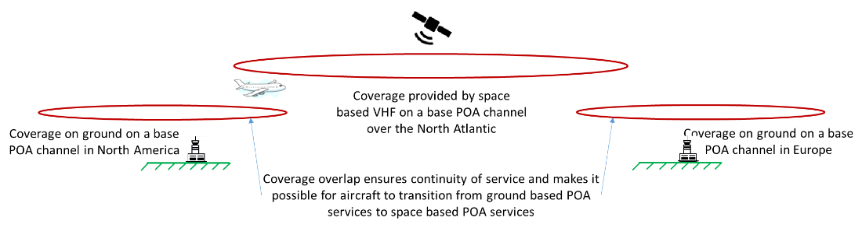
Figure 6-7: Use case scenario: POA extension of coverage

Space-based POA service will have to ensure the appropriate contents in the Squitter messages in order to correctly identify to the aircraft the ACARS CSP that is operating in specific regions where it will be deployed.
It is expected that if space-based POA service will be used for recovery when aircraft lose VDL services then a version #2 squitter will have to be used with appropriate contents for the CSP ID, RGS name, latitude, longitude and VDL frequency parameters. The space-based POA service will use a single “remote ground station” (RGS) identifier to cover a larger specific region and frequency.

Potential impact on the current ground infrastructure
The SB-VHF system will have a positive impact on the current VDL ground infrastructure. This positive impact has been previously mentioned before but this section will highlight some of the aspects that maximize that positive impact.
On top of the positive impact introduced by the concept itself: additional capacity and extension of the coverage in areas where is no VDL coverage nowadays, there are two other significant aspects, which are especially remarkable among all the others.
One of them is that SB-VHF system will provide continental-like performance in Oceanic, Remote and Polar (ORP) areas. This may allow decreasing the separation minima between the aircrafts in those specific areas, and it could also allow achieving RCP and RSP values, which are currently used for continental airspaces, e.g., RCP-130 and RSP-160.
The other significant advantage is that SB-VHF will drastically reduce the hidden transmitter effect, which is the main cause of the huge number of collisions in congested airspace degrading the performance of the overall system.
The following section will address specific scenarios that have been identified for the current CSPs.

Impact on the CSPs: SITA, Collins Aerospace, DECEA (Brazil), ENAV (Italy) and AVICOM (Japan)
The current CSPs, SITA, Collins, as well as the countries that are following a specific approach for which they behave as CSPs, will observe a positive impact on their VDL networks.
Indeed, SB-VHF system with all the SB-VHF stations, i.e., satellites that will be covering all the airspaces in the world will be considered a normal evolution of the ground VDL network. Actually, it may be considered an enhancement in terms of coverage and capacity over the existing VDL networks.
Obviously, some coordination is needed, because all those new SB-VHF stations must be integrated in the overall ecosystem of VDL networks in the world. One of the aspects that must be carefully considered is the update of the configuration in the VMEs for the CSPs and for the states operating their own infrastructure, for instance, Brazil or Italy.
An additional activity is also the integration of the SB-VHF stations in the Supervision systems for all the CSPs and for the states operating their own infrastructure. Again, this needs coordination, but, initially, that shouldn’t be a problem whenever the appropriate agreements are sufficiently discussed and approved.
Finally, it must not be forgotten that technical staff will be trained and informed about the new SB-VHF stations, their characteristics and how they interact with the existing VDL networks.
Overall, what can be definitely stated is that SB-VHF does not have any operational impact on the CSPs nor on those countries running their own VDL service. This is extremely important for all VDLM2 stakeholders to make them aware that the introduction of SB-VHF system will be completely transparent for all of them and that they even get the additional advantages described in this document.

Possible operational considerations for the airlines
The solution does not require any software modification, it is completely seamless for the airlines.
At most, some modification limited to defining some additional POA frequencies over the SB-VHF coverage in the data base may be necessary. Airlines may need to update CSP coverage maps for the expanded coverage use case (just for the avionics with region definition). For the ones with just a worldwide list it is just necessary to make sure that the space-based POA frequency is in the list.
At ICAO level, it might be necessary to review procedures, manuals and training for flight crew to make use of SB-VHF and ATN CPDLC over the new regions.
For those airlines that do not have a contract to use the SB-VHF service, there are mechanisms to reject the connection. In those areas where the SB-VHF is provided using the CSC, the VME would not accept the connection attempt. In the areas where an alternate frequency would be used, those aircrafts would not be allowed to access this frequency.

Conclusions
This document presents the concept of operation of a Space-based VHF system, in particular, of VHF data service over VDLM2 and POA, giving response to several questions and concerns raised in the frame of ICAO FSMP meetings (WG 15). In particular, the concept of operation presented demonstrates that a smooth integration of the Space-based system with currently deployed terrestrial networks is feasible making use of the VDL (both VDLM2 and POA) network mechanism and without impacting the currently used avionics.
The concept of operation of the Space-based VHF is presented for the following use cases:
- Extension of the coverage of the VHF networks to oceanic and remote continental areas smoothly coexisting with existing terrestrial networks.
- POA over Space based VHF, covering both cases, additional capacity and extension of coverage.
- Deployment of additional capacity mainly on an alternate frequency
For the additional capacity use case, the document presents the advantages of providing additional capacity over a Space-based VHF system in areas already having VDL networks. In particular, deploying a Space-based system can cover a wider area with a cheaper deployment in areas lacking enough terrestrial infrastructure. In addition, the Space-based system avoids the hidden transmitter problem that occurs between ground stations not in view.
For the use case related to the extension of coverage to oceanic and remote continental areas, the concept presented in this document is flexible enough to integrate the Space-based system in different regions not affecting the operation of terrestrial networks operating in the same area. In this sense, the concept of operation for the extension of coverage is synthesized as follows:
- For VDLM2 the extension of coverage is based on:
  - The use of an alternate frequency for the Space-based VHF system with a seamless transition from terrestrial to satellite coverage making use of the multi-frequency mechanism already available.
  - The use of the CSC controlled by the CSP in regions with low traffic or in regions with only satellite coverage.
  - POA will be also supported as fallback channels for the case of only satellite coverage.
As described for the use case POA over Space-based VHF, the system will support POA making use of the CSP frequencies as defined by them. The transition from/to terrestrial to/from satellite makes use of the existing mechanism.
As mentioned through the document, to support the described concept of operation, the currently in use avionics do not need any modification. As also pointed out, it may require changing their data base only if:
- The frequency scan table is based on the definition of regions that are not currently defined.
- Or a service provider prefers to define a new POA frequency in the frequency scan list.
In addition, as the Space-based system will be integrated in the CSPs networks, there are existing standard mechanisms that prevents the log of aircrafts from airlines or in regions in which the Space-based system will not be used.
In summary, Satellite based datalink services could be integrated in existing low density areas CSPs datalink (POA/VDLm2) infrastructure using current operational procedures without any modification in current avionics, with potentially and not strictly necessary database update of the datalink avionic (also supported by standard operational procedures).
Based on the considerations explained in this document, satellite-based datalink services could be provided assuring no interference with the current terrestrial VDL infrastructure.

References
- RESOLUTION 428 (WRC-19) - Studies on a possible new allocation to the aeronautical mobile-satellite (R) service within the frequency band 117.975-137 MHz in order to support aeronautical VHF communications in the Earth-to-space and space-to-Earth directions.
- RESOLUTION 811 (WRC-19) Agenda for the 2023 world radiocommunication conference.
- ICAO Doc 9705. Manual of Technical Provisions for the Aeronautical Telecommunication Network (ATN).
- ICAO Doc 9776. Manual on VHF Digital Link (VDL) Mode 2 Part II Edition 2 published in 2015.
- Digital Data Communications Systems, November 6, 1997.ICAO Doc. 9776 – Manual on VHF Data Link (VDL) Mode 2.
- ARINC-618, Air-Ground Character-Oriented Protocol Specification.
- ARINC-620, Datalink Ground System and Interface Specification.
- ARINC-631, VHF Digital Link Implementation Provisions Functional Description.
- ARINC Characteristic 750: VHF Data Radio.
- ARINC Specification 619: ACARS Protocols for Avionic End Systems. ICAO EUR Frequency Management Manual for Aeronautical Mobile and Aeronautical Radio Navigation Services.
- ARINC 724 Characteristic Aircraft Communications Addressing and Reporting System.

DECEA (Departamento de Controle do Espaço Aéreo - Ministério da Defensa - Brazil) will migrate the Brazilian VHF POA (Plain Old ACARS) Base frequency, from 131.550 MHz to 131.825 MHz, in September 2023 [AIC-A 15/22 BRAZIL DATA LINK VHF BASE FREQUENCY CHANGE; July 07, 2022]

