International Civil Aviation Organization
FIFTTH WORKING GROUP MEETING OF THE FREQUENCY SPECTRUM MANAGEMENT PANEL (FSMP-WG/5)
Paris, France, 4 – 8 September 2017

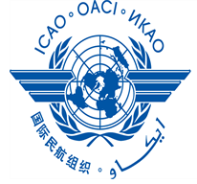

DRAFT AGENDA

Agenda Item 1: Opening and working arrangements
- Action Item review
- Status of tasks identified on Job Cards

Agenda Item 2: Radio Altimeter and WAIC issues
- Status of compatibility testing

Agenda Item 3: Development of (planned) material for ITU-R Studies on:
- FSS for UAS
- GADSS
    - ITU RR non-Article 5 changes
- Status of proposed update to Recommendation ITU-R SM.1009

Agenda Item 4: 5 GHz Band Planning
- AeroMACS status
- Global UAS/RPAS channel plan

Agenda Item 5: New provisions to support aeronautical radiocommunications
- LDACS, status update CP WG-T

Agenda Item 6: Interference from non-aeronautical sources
- Programme Making and Special Events (PMSE)

Agenda Item 7: Any Other Business

_ _ _ _ _ _ _ _ _ _ _ _ _ _

