FREQUENCY SPECTRUM MANAGEMENT PANEL (FSMP)

Fourteenth Working Group meeting

Web Meeting, 25 – 29 April 2022

Agenda Item 5 d) : Development of (planned) Material for ITU-R Studies on AI 1.9

WRC-23 AI 1.9 Wideband HF

(Presented by ITU/ BR)

SUMMARY
During the discussions of draft CPM Report on agenda item 1.9 at the March-April 2022 meeting of ITU-R Working Party 5B, the issues of aggregation of frequency channels under the current AP27 arrangements and the interpretation of AP27/20 were raised.

This working document provides additional information on these issues.

Action: FSMP WG/14 is invited to take the document into account in its deliberations on AI 1.9.

- INTRODUCTION
  - During the extraordinary meeting of WP 5B in March -April 2022, questions were raised on:
- the scope of AP27/20;
- possibilities of carrier aggregation of contiguous channels under the current AP27.
- DISCUSSION
  - Consideration of AP27/20.
Provision AP27/20 gives a possibility of assigning the channels, which are not allotted by the AP27 Plan, to aeronautical stations. Such assignment can be, however, made only under the condition of not reducing protection to the same frequencies in the allotted areas.

“27/20 It is recognized that not all the sharing possibilities have been exhausted in the allotment Plan contained in this Appendix. Therefore, in order to satisfy particular operational requirements which are not otherwise met by this allotment Plan, Administrations may assign frequencies from the aeronautical mobile (R) bands in areas other than those to which they are allotted in this Plan. However, the use of the frequencies so assigned must not reduce the protection to the same frequencies in the areas where they are allotted by the Plan below that determined by the application of the procedure defined in Part I, Section II B of this Appendix.”

It may be understood that this provision mainly considers using adjacent channels, which have not as a rule been allotted to the same MWARA, RDARA or VOLMET areas, according to AP27/16.

Other non-allotted channels could be also assigned to aeronautical stations. Nevertheless, before assignment of any non-allotted channel, the responsible administration must check its compatibility with the allotted frequencies using the methodology of AP27/23 to AP27/31 and ensure that their protection is not reduced.

  - Examples of carrier aggregation under the current Radio Regulations.

Possibilities of carrier aggregation of adjacent channels under the current AP27 provisions have been considered. Two cases have been analysed, see the Annex to this document.

For one case, the aggregation of adjacent 3 contiguous channels leads to a reduction of the protection of allotted frequencies and thus is not possible without coordination with affected administrations. For the other case, the aggregation of 3 adjacent frequencies into one 9 kHz wide-band channels is possible, but addition of the 4th adjacent channel cannot be made.
- CONCLUSIONS

Combination of some adjacent carriers into wide-band channels under the current AP27 provisions is possible. However, only a limited number of frequencies in the AP27 Plan can be combined without reducing protection to the same frequencies in allotted areas.

Such combination has also limitations in the number of allotment areas for which the aggregation is feasible and in the size of the bandwidth of combined channels. This might raise question of practicability of the aggregation of contiguous channels for switching to digital wide-band communications without changing AP27.
- ACTION BY THE MEETING
FSMP WG/14 is invited to take this document into account in its deliberations on AI 1.9.
ANNEX
Example of adjacent channel aggregation under the current AP27 arrangements

Case 1: The Administration of IRQ located in allotment area 5A wishes to assign the channel of frequency (reference) 5 583 kHz to combine with the channels of the adjacent frequencies 5 580 kHz and 5 586 kHz which are not allotted to the area 5A, to form a wideband channel using 3 continuous channels. The allotment areas 5A, 2C, 3A and 6A are located close to each other. The allotment areas are shown on the figure below.

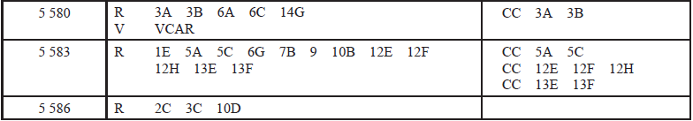
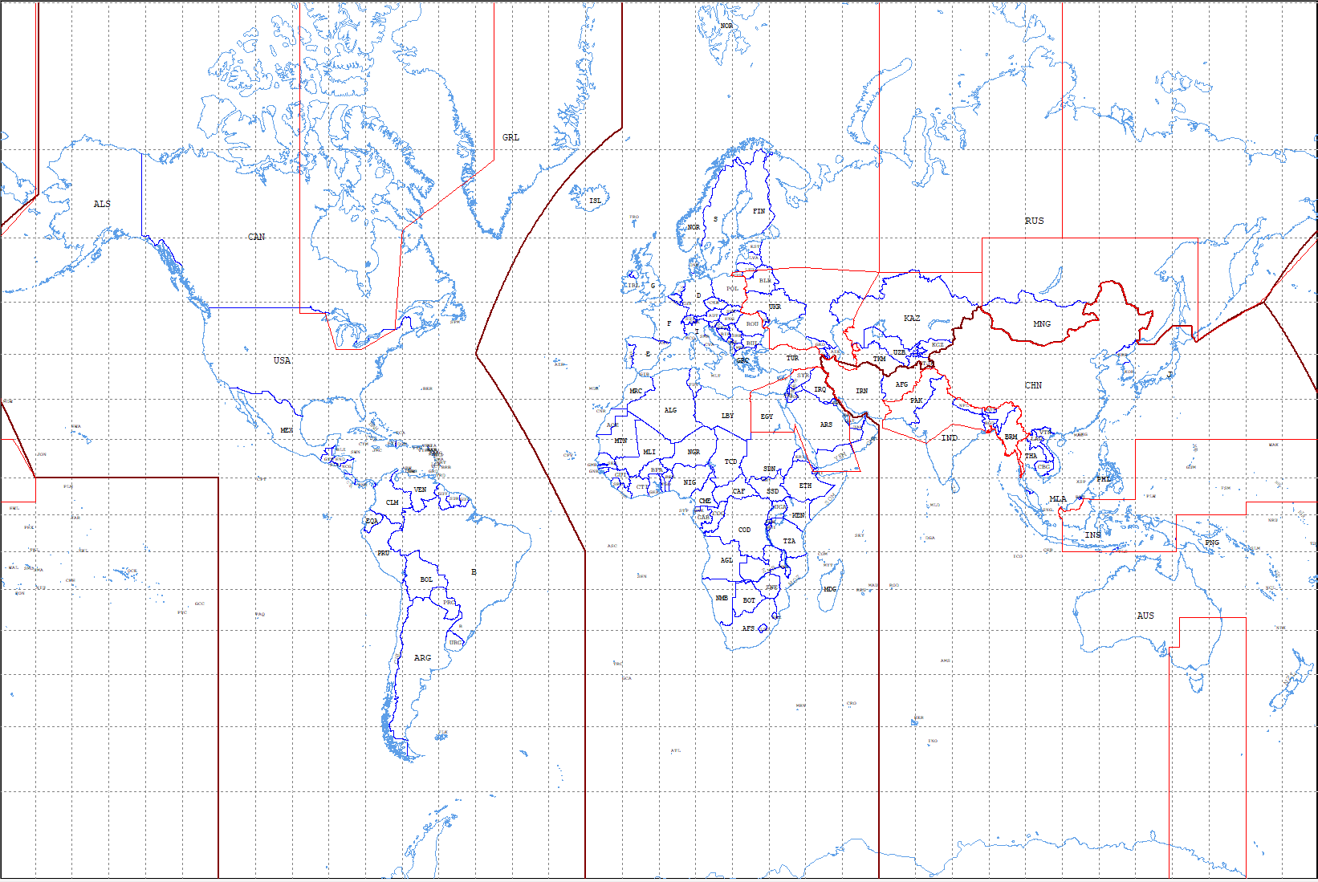
VCAR
6C
2C
5A
3A
10D
Allotment Area 6A
3C
14G
3B

After using the Bureau’s AP27 calculation software for the criteria and methodology of AP27/23 to AP27/31 to verify, the protection ratio of 15dB for allotment areas 2C for channel 5 586 kHz, 3A and 6A for channel 5 580 kHz is not met, which is shown below. It’s not in conformity with AP27/20.
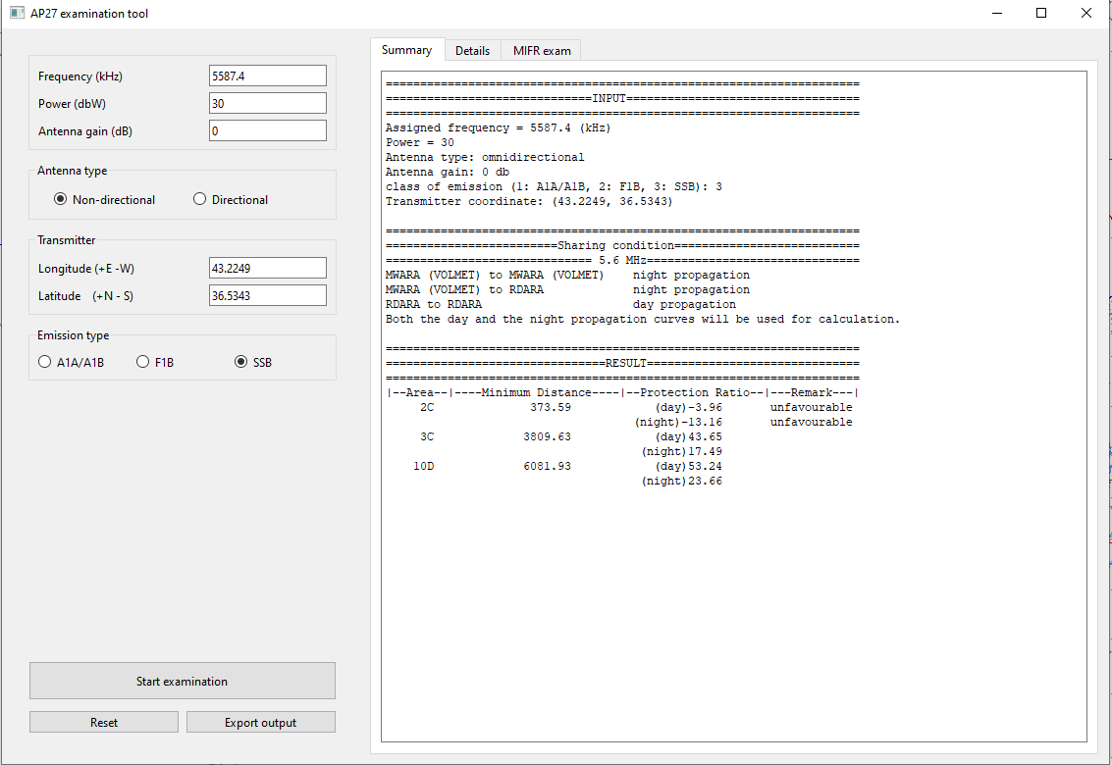
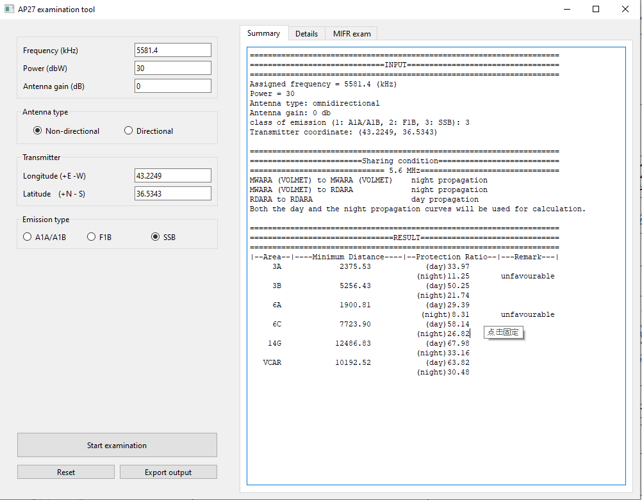

Therefore, if the Administration of IRQ wishes to use these two adjacent channels, it should seek agreement with all administrations included in the allotment areas 2C, 3A and 6A in accordance with AP27/16.

Case 2: The Administration of CUB located in allotment area 12C wishes to assign the channel of frequency (reference) 5 613 kHz and to combine with the channels of the adjacent frequencies 5 610 kHz, 5 607 kHz and 5 604 kHz, which are not allocated to the allotment area 12C, to form a wideband channel using 4 continuous channels.
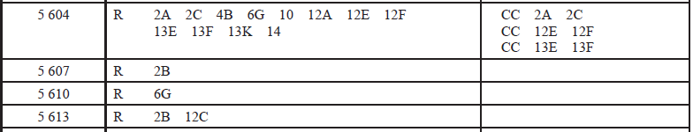

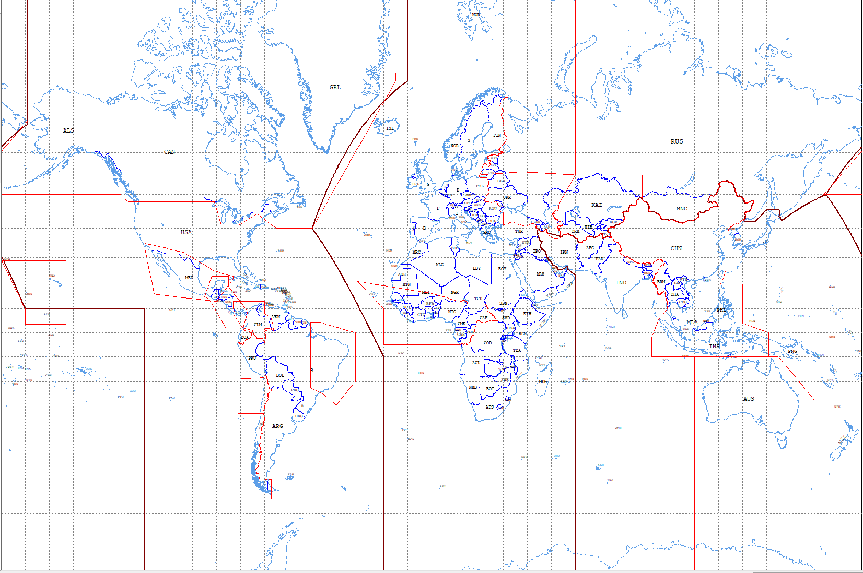
14
13K
13F
13E
12F
12E
12A
10
4B
2C
2A
2B
6G
12C
After using the AP27 calculation software to verify, the protection ratio of 15 dB for channels 5 610 kHz and 5 607 kHz is met, i.e., in conformity with AP27/20. However, the protection criteria for channel 5 604 kHz is not met.

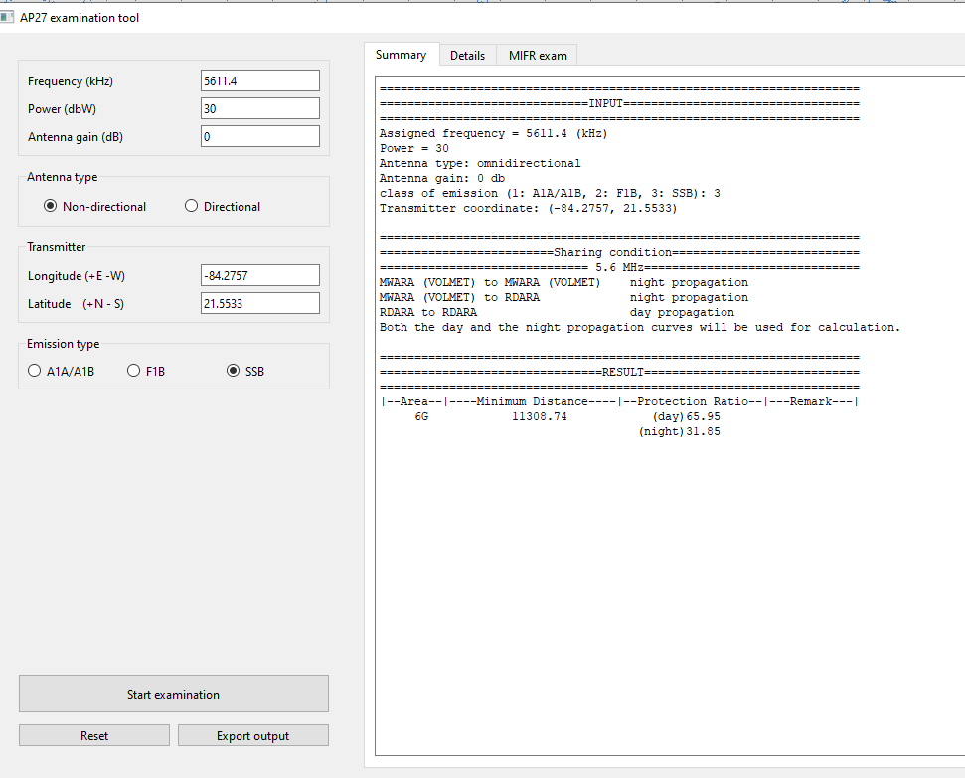

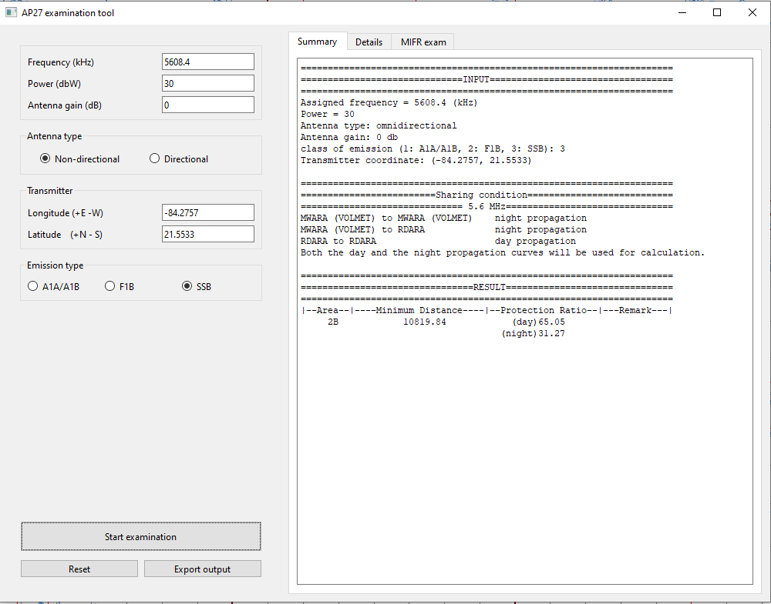
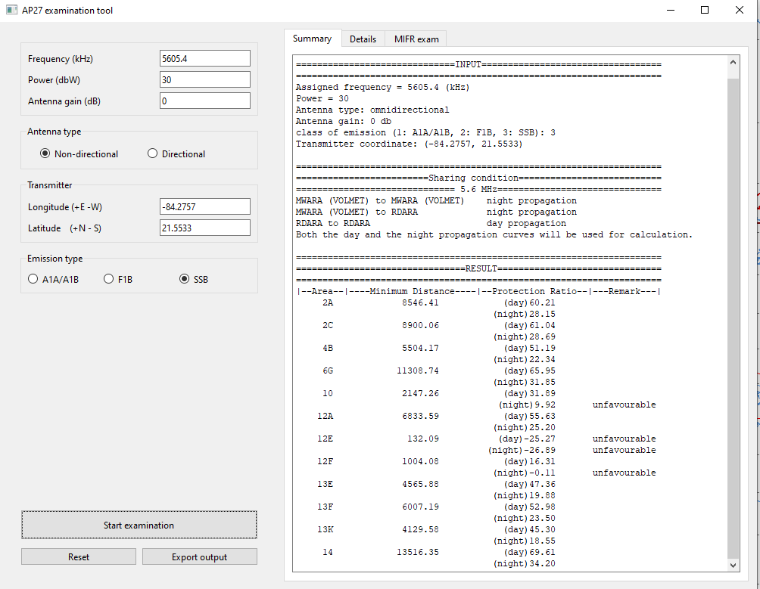

Therefore, if the Administration of CUB wishes to use the four adjacent channels to form the wideband channel, it should seek agreement with all administrations included in the allotted area 10, 12E and 12F in accordance with AP27/16.
_____

