
Sharing Studies and operation for Space-based VHF Communications in the 117.975 to 137 MHz Frequency Band

Report

Ref.: RP-2022-01
Issue/Rev.: 2.1
Date: 23/08/2022

Contents
1 Introduction 5
1.1 Description of Space-based VHF System Concept 5
1.2 European Funded Project 6
1.3 Document Structure 7
1.4 Reference Documents 7
1.5 Acronyms 7
2 RELEVANT OPERATIONAL REQUIREMENTS IDENTIFIED 10
2.1 ANSP Operational Perspectives 10
2.1.1 Introduction. 10
2.1.2 PBCS concept. 10
2.1.3 PBCS (RCP and RSP) enhancements. 11
2.1.4 New ATS Functionalities based on new datalink services.) 11
2.1.5 Operational added-value in terms of safety 13
2.1.6 ATCOs operational procedures. 13
2.2 Airlines Operational Perspectives 14
2.2.1 Communication, navigation and surveillance requirements for Aircraft Operators 14
2.2.2 SB-VHF Support of AOC Communications Requirements 15
2.2.3 Strong interest from different European Aircraft Operators 15
2.2.4 Pilots operational procedures 16
3 INCUMBENT SERVICES IN THE BAND 117.975-137 MHZ 17
3.1 Sharing Studies in the band 117.975-137 MHz 17
3.1.1 Impact of the operation of the space-based VHF system without considering frequency shift in the system operating in the adjacent channel 17
3.1.2 Assessment of the operation of space-based VHF system into the adjacent channel in the out-of-band domain 18
3.2 Outcome of the sharing studies 19
4 ANALYSIS OF THE DOPPLER EFFECT AND COMPATIBILITY WITH CURRENT AVIONICS 20
4.1 VDLm2 Doppler effect analysis 20
4.1.1 VDLm2 Frequency Specifications 20
4.1.2 Frequency Error Computation 20
4.1.3 Example of VDLm2 Operation 23
4.1.4 Considerations of the CSMA mechanism and the pre-compensation Doppler approach 25
4.2 VHF Voice Doppler effect analysis 25
4.2.1 VHF Voice Frequency Specifications 25
4.2.2 Voice Frequency Error Computation 25
4.2.3 Example of VHF Voice Operation 25
4.3 Main Outcome from the Analysis 27
5 OPERATION OF THE SPACE-BASED VHF SYSTEM – DATA SERVICE 29
5.1 Terrestrial and satellite coverage 29
5.1.1 Channel allocation and handoff management 29
5.2 Only satellite coverage 31
5.3 Flight User Case 31
6 OPERATION OF THE SPACE BASED VHF SYSTEM – VOICE SERVICE 34
7 STANDARS AND RECOMMENDATIONS APPLICABLE FOR AN AMS(R)S/ AM(R)S/ AM(OR)S COORDINATION 35
7.1 Reference document 35
7.1.1 ITU – Radio Regulations 35
7.1.2 ICAO – SARPS 35
7.2 Current planning and tools for frequency assignment coordination 56
7.2.1 Global, regional and national planning 56
7.2.2 Tools for frequency assignment coordination 59
7.3 Current global statistic of VHF assignments 60
7.4 Global AM(R)S VHF coverage 65
7.5 Regulatory considerations 67
7.5.1 Timeline for ITU-R and ICAO developments on new allocation to AMS(R)S 68
7.5.2 Current status 68
7.5.3 Others considerations 71
7.5.4 Conclusions 71
7.6 AMS(R)S, AM(R)S and AM(OR)S Coordination 71
7.7 Understanding of ITU Allocation and ICAO Allotment and Administration Assignment 73
8 SUMMARY and CONCLUSIONS 74

List of Tables
Table 1-1: Acronym List 9
Table 3-1: Ground station receiver parameter 17
Table 3-2: Space-based VHF parameters 17
Table 3-3: Assessment of the signal received by the ground VDL mode 2 station from an aeronautical mobile satellite (route) system operating in channel with 25 kHz frequency separation 18
Table 4-1: Computation of expected Aircraft – Satellite Doppler shifts 21
Table 4-2: Frequency error budget 23

List of Figures
Figure 1-1 The Space-Based VHF Communication Concept 5
Figure 3-1: Example of VHF data link mode 2 modulation spectral roll-off. D8PSK modulation with 10.5 ksymbols/s rate (Example of VHF Radio) 18
Figure 4-1: Aircraft – Satellite Doppler shifts time evolution over visibility interval 21
Figure 4-2: Aircraft – Satellite Doppler rate time evolution over visibility interval 21
Figure 4-3: Satellite - Aircraft Doppler shift expected over satellite footprint 22
Figure 4-4:: Satellite - Aircraft Doppler rate expected over satellite footprint 22
Figure 4-5: Example of Broadcast pre-compensation: areas with Aircraft Frequency Error below specification for each frequency offset intrioduced 24
Figure 4-6: Example of Doppler pre-compensation using directional antennas 24
Figure 4-7: Example of Satellite Transmission Coverage Overlapp 26
Figure 4-8: Frequency difference between VHF Voice Transmissions from two satellites at the aircraft receiver using offset carrier in Hz 27
Figure 5-1:Operation using the CSC 30
Figure 5-2:Operation using an alternative frequency 31
Figure 5-3: Overlap of Satellite and Terrestrial VHF systems coverage to allow for seamless transition to take place 32
Figure 5-4: Illustration of the aircraft progression under the coverage of the satellite system 32
Figure 5-5: Overlap of Satellite and Terrestrial VHF systems coverage to allow for seamless transition to take place 33
Figure 6-1: FIRS and sectors 34
Figure 7-1: Special frequencies and allotments (Annex10) 43
Figure 7-2: Figure ATT I-1 from Annex 10 – Volume III – Communications Systems 48
Figure 7-3: Example of CMF setting for VHF frecuencies use 52
Figure 7-4: Relationship between global, regional and national plans (ICAO-EUR) 56
Figure 7-5: Example of frequency coordination process in EUR region 60
Figure 7-6: Extract of CSC (136.975 MHz) ground stations worldwide 66
Figure 7-7: Details of masive overlaping of CSC (136.975 MHz) ground stations in EUR region 66
Figure 7-8: VHF ground stations operating in 133.500 MHz in EUR region (SAFIRE/Frequency Finder) 67
Figure 7-9: : Typical time line ICAO / ITU-R regarding WRC-23 AI 1.7 68

Introduction

Description of Space-based VHF System Concept
Space-based VHF communication is a concept in which aircraft operating in remote regions and oceanic areas provide communications between the aircraft and air traffic control (ATC) via satellite-based Very High Frequency VHF. This concept, when implemented, is expected to support air traffic management and flight operations in oceanic and remote airspace and will complement current aviation use of satellite-based navigation and surveillance technologies (e.g. ADS-B, ADS-C).
While currently there are other long-range communication systems, such as HF, satellite voice and controller to pilot data link communications (CPDLC) over SATCOM, available to facilitate communications between aircraft and ATC in remote and oceanic airspace, the performance of these current systems is not adequate to safely support close aircraft-to-aircraft separation in a similar fashion as to what is being applied in dense airspace where terrestrial VHF communications infrastructure is predominant. Therefore, this leads to constraints in airspace capacity and efficiency in oceanic and remote areas, where it is not practical to deploy VHF terrestrial infrastructure.
Figure 1-1 is an illustration of the space-based VHF communication concept. The space segment is able to receive and transmit to standard VHF radios already installed onboard aircraft and is designed to behave as if it was just another VHF-tower located in the sky, with a larger footprint than terrestrial towers noting that feeder link would be in a different frequency band.
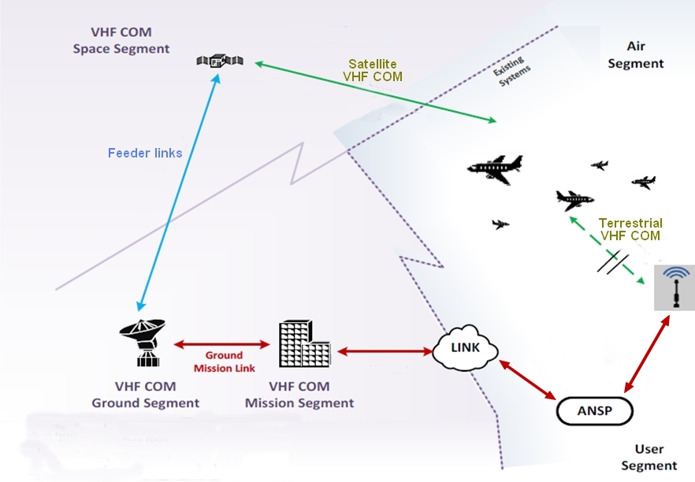
Figure 1-1 The Space-Based VHF Communication Concept
Under World Radiocommunication Conference (WRC-23) Agenda Item 1.7 and Resolution 428 (WRC-19), International Telecommunication Union (ITU) has the task to define the relevant technical characteristics and to study the compatibilitiesbetween possible AMS(R)S systems within the band 117.975-137 MHz and existing primary services in-band and in adjacent bands. Such satellite systems would provide aeronautical VHF communications over oceanic and remote areas.
Note the feeder link is out-of-scope of this report.

European Funded Project
Two projects have been funded by the European commission in regards to space based VHF activities, VOICE and ECHOES.
VOICE:
The SESAR Joint Undertaking (SJU) contributes with some 4 million euros to the VOICE project led by ENAIRE, Indra, Eurocontrol and Gomspace. The objective of the Very Large Demonstration project (VLD2 – VOICE) is to demonstrate that, in combination with Satellite-based ADS-B surveillance, traffic in remote airspace can be handled through the Satellite-based VHF systems providing voice and Datalink ATS as in a continental airspace, and the current aircraft separation could be reduced without compromising safety. In addition, VOICE project will perform some cross-border operations between adjacent Flight Information Region (FIRs) belonging to different countries. Demonstration will cover operations in Canarias and SAL FIRs with Air Traffic Controllers (“ATCOs”), communicating in real time with aircraft at distances bigger than 800NM.
The demonstration will use one small satellite operating in Low Earth Orbit (LEO). Both design and launch of the satellite are out of the scope of this very large-scale demonstration and are considered as an external contribution to the project. Besides, the demonstration using the LEO satellite will be complemented with tests using a HAPS (High Altitude Platform System), which are scheduled to be performed as an early demonstration activity.
Parallel exercises will be executed in both Canarias and SAL ACCs, this will consolidate the proof of concept and provide a bigger number of flights to take part on the assessment.
Demonstration exercises will use these satellite-based Communication and Surveillance systems as support of the feasibility of the ADSP (ATS Data Service Provider) concept by permitting controllers sited far away of the airspace, where an aircraft is flying, to provide Air Traffic Control (ATC) services. In this way, controllers from SAL centre will visualize aircraft positions, interchange flight data and voice communications with aircraft flying over Canarias airspace, and vice versa.
The exercises will target the use of satellite-based communication and surveillance systems serving as contingency measures, for covering problems on ground-based systems, or for complementing its use. This will be performed in Canarias ACC by using the facilities provided by the satellite-based technology with flights overflying continental airspace, in addition to the normally used ground-based CNS, permitting an alternative/redundant way for data interchange.
During the VOICE project, satellite VHF communications, providing both voice and data (VDLm2) services will be used.
ECHOES:
As a second step forward, ECHOES continues the investments aimed at the development of these technologies within SESAR's VOICE project. At the same time, its launch confirms the high expectations that airports, air navigation service providers and airlines, as well as the European Commission, have expressed in relation to the Startical project and its transformative capacity to support the European Digital Sky, during the last edition of the World ATM Congress, held in Madrid last June.
The Executive Agency for Climate Infrastructure and environment (CINEA), through the European fund Connecting Europe Facility (CEF), will contribute some 15 million euros to the ECHOES project, led by Startical, ENAIRE and Indra, with the aim of validating and quantifying the advantages, reliability and availability, with which this space infrastructure will revolutionize the air navigation sector, making it much more sustainable and bringing the decarbonisation target, set for 2050, closer.
Under the ECHOES demonstrator, two small satellites will be launched into space to provide VHF voice and data communications services and ADS-B surveillance in combination to meet the needs of air traffic controllers and airlines.
The objective is to provide a quality service in oceanic, polar and remote areas that the ground systems existing today cannot cover. This avoids that aircraft have to increase the safety separation when they arrive, slowing down and congesting traffic on some of the busiest routes on the planet.
The project will demonstrate the feasibility and ability to reduce the environmental impact and cost-benefit that ATM services provided from Space could offer, paving the way for regulators and standardization entities to establish the rules for their deployment and for the optimization of air routes.
The ECHOES project consortium, coordinated by Startical, is also made up of ENAIRE, Indra, Mitiga, NAV Portugal and DLR, and has the collaboration of a group of 21 entities from all over the continent representing industry, Airlines, Universities, Navigation service providers, National safety agencies and other institutions, including some of the most important regulatory bodies and very relevant actors in the sector.

Document Structure
The document is structured as follows:
- This chapter, chapter 1, is the document introduction, and contains a brief description of the Space-based VHF concept, a summary of European funded projects, the list of reference documents and acronyms.
- Chapter 2 contains the identified most relevant requirements that a Space-based VHF system can provide from the perspective of ANSPs and Airlines Operators.
- Chapter 3 presents the result of the technical analysis to assess the impact of the sharing of the VHF band by the Space-based system, evaluating the interference levels in the adjacent band (within the VHF band).
- Chapter 4 presents the technical studies to assess the impact of the satellite Doppler in the VHF Voice and data (VDLm2) communications, and describes potential approaches to compensate it.
- Chapter 5 contains a technical summary describing the operation of the Space based VHF data system and its compatibility with terrestrial VHF data networks.
- Chapter 6 summarizes operational aspects for the Space –based VHF voice system to be compatible with terrestrial VHF voice systems.
- Chapter 7 presents standards and recommendations applicable to the coordination of AMS(R)S and AM(R)S systems, and contains a summary of existing tools used for frequency coordination and presents statistics of their usage.
- Chapter 8 contains the document summary and conclusions.

Reference Documents
- ICAO Standards and Recommended Practice. Annex 10 to the Convention on International Civil Aviation – Aeronautical Telecommunications, Volume III Communications Systems, Part I – Digital Data Communication Systems and Part II – Voice Communication Systems.
- ICAO Doc 9776, Manual on VHF Digital Link (VDL) Mode 2
- RTCA DO-224D, Signal-In-Space Minimum Aviation System Performance Standards (MASPS) For Advanced VHF Digital Data Communications Including Compatibility with Digital Voice Techniques
- EUROCAE ED-92C. Minimum Operational Performance Standard (MOPS) for an Airborne VDL Mode-2 System Operating in the Frequency Range 118-136.975 MHz
- ITU-R SM.328, Spectra and Bandwidth Emissions
- ICAO Supplement to EUR Frequency Management Manual (EUR DOC 011) for Aeronautical Mobile and Aeronautical Radio Navigation

Acronyms
Acronym | Description
AC | Aircraft
ACC | Area Control Center
ADS-B | Automatic Dependent Surveillance – Broadcasting
ADSP | ATM Data Service Provider
AM(R)S | Aeronautical Mobile (Route) Service
AMS(R)S | Aeronautical Mobile Satellite (Route) Service
ANSP | Air Navigation Service Provider
AOA | ACARS over AVLC
AOC | Airlines Operational Control
ATCO | Air Traffic Controller Operator
ATM | Air Traffic Management
AVLC | Aviation VHF Link Control
CPDLC | Controller to Pilot Data Link Communications
CSC | Common Signalling Carrier
CSP | Communications Service Provider
CVME | Central VHF Management Entity
D/U | Desired / Undesired
FIR | Flight Information Region
GSIF | Ground Station Information Frames (“
HAPS | High Altitude Platform System
HSL | High Speed Link
ICAO | International Civil Aviation Organization
IOD | In Orbit Demonstration
ITU | International Telecommunication Union
LEO | Low Earth Orbit
LME | Link Management Entity
MSS | Mobile Satellite Service
NM | Nautical Miles
OoB | Out of Band
POA | Plain Old ACARS
PFD | Power Flux Density
RF | Radiofrequency
SAL | Sal Oceanic ACC
SB-CNS | Space-based Communication, Navigation and Surveillance
SB VHF | Space-based VHF
SC | SpaceCraft
TBC | To Be Confirmed
Tx | Transmission
VDL | VHF Data Link
VDLm2 | VDL Mode 2
VDR | VHF Data Radio
VHF | Very High Frequency
VLD | Very Large Demonstration
Table 1-1: Acronym List

RELEVANT OPERATIONAL REQUIREMENTS IDENTIFIED

ANSP Operational Perspectives

Introduction.
The ITU-R Working Party 5B (WP 5B) made assumptions on a number of future AMS(R)S applications that include data-based services which are important to the future of aeronautical concept of operations. Several reasons are provided below to justify the need of data communications within the AMS(R)S and consequently, support the inclusion of data services as part of the cases which ITU-R WP 5B should study.
The WRC-15 allocated spectrum for space-based Automatic Dependent Surveillance – Broadcast (ADS-B) services. Following the frequency allocation, space-based ADS-B has been implemented via a satellite constellation to overcome the line-of-sight (LOS) limitations of terrestrial ADS-B sensors. It has extended surveillance coverage over remote continental and oceanic airspace, without modification to aircraft equipment.
However, to apply radar-like separation for civil aaircraft, surveillance must be complemented with effective communications. Indeed, space-based ADS-B has to be complemented with Direct Controller-Pilot Communications (DCPC) such as VHF voice communication means and with the exchange of datalink services as Controller Pilot Data Link Communications (“CPDLC”) and ADS-C.
In this way, the SB-VHF concept must be based on the use of existing airborne equipment. The system will be able to interact with standard on-board ADS-B and VHF system, both for Data Link using VDL-Mode 2 and the standard radio communication for the VHF-Voice.
The major expected operational ATM benefits from the SB-VHF concept are:
- The use of the same operational procedures for ATCOs in continental and oceanic and remote continental areas..
- Added value in safety for the aircraft operation in oceanic and remote continental areas since now full CNS services are provided to the aircraft.
- Significant increase of capacity in oceanic and remote continental areas.
- No additional training for ATCOs, as operation is the same as in continental areas.
- Significant reduction in fuel burnt and therefore CO₂ emissions thank to the use of optimal and efficient routes (e.g. i4D and TBO).
- Increase of situational awareness for ATCOs that have more accurate information about the position of the aircrafts and their flight intent.
ANSPs are requiring more data communication for more ATC automation, allowing extra capacity while improving safety. This new automation related communication requirements shall however be combined with the AOC evolutions for a smooth integration onboard the aircraft while mastering the overall infrastructure cost.

PBCS concept.
The ICAO Performance-Based Communications and Surveillance (PBCS) Manual (Doc 9869) defines a performance framework to quantify the datalink system performance needed to meet operational requirements. It introduces two concepts:
- Required Communication Performance (RCP) applicable to two-way Controller-Pilot Data Link Communication (CPDLC) dialogues, and
- Required Surveillance Performance (RSP) applicable to one way transfer of surveillance data by contract based Automatic Dependent Surveillance (ADS-C).
PBCS is needed to ensure that operator systems and infrastructure meet global required performance. Some ICAO Regional Planning Groups concluded to develop an RCP Implementation Plan that would propose to mandate RCP in these ICAO regions.
ICAO intends to improve safety and maximize operational benefits by promoting the PBCS concept and its general application through emerging technologies for communication and surveillance supporting ATM operations.
SB-VHF concept (both voice and data) appears as a clear facilitator for implementing this PBCS concept enhancing the provision of communications and surveillance services. Supporting voice but not data in SB-VHF systems would not allow the implementation of the full PBCS concept, not being able to take the benefits highlighted in this chapter.
In consequence, it is highly recommended to support the Agenda Item 1.7 of the WRC-23 to ensure a new allocation to AMS(R)S in the whole band 117.975-137 MHz.

PBCS (RCP and RSP) enhancements.
The transition to a performance-based airspace system is a critical aspect of evolving to a safe and efficient global ATM environment. As ATM evolves, it is necessary to ensure acceptable operational performance, taking into account the current and new technologies.
The communication and surveillance capabilities and performance required for a given operational capability depend on the capabilities and performance of the available navigation and other air traffic management functions, including those on the aircraft.
To meet the demands on airspace capacity and operational efficiency, the operational communication capability is increasingly playing an essential role in air traffic management using both data and voice communication.
The RCP and RSP concepts assess operational communication and surveillance, respectively, transactions in the context of an ATM function taking into account human interactions, procedures, and environmental characteristics.
An RCP type is a label (e.g., RCP 130) that defines a performance standard for operational communication transactions. Each RCP type denotes values for communication transaction time, continuity, availability, and integrity applicable to the most stringent operational communication transaction supporting an ATM function.
Similarly, an RSP type (e.g., RSP 180) defines a performance standard for operational surveillance transactions. Likewise, it also denotes values for transaction time, continuity, availability, and integrity applicable to the most stringent operational surveillance transaction.
The application of RCP and RSP capabilities shows a number of significant advantages over conventional (HF voice) communication means. Some of these advantages are:
- Reduced separations;
- Increase capacity;
- Better and more efficient use of the airspace; and,
- More automated exchange of flight information between the aircrafts and the ATS units.
SB-VHF, as a facilitator of the PBCS concept, can implement better RCP and RSP based procedures allowing the same ATS functionalities over remote and oceanic areas as if the aircrafts were flying over continental areas, which obviously represents a major advantage over the current situation.

New ATS Functionalities based on new datalink services.)
The use of VHF voice together with VHF data (CPDLC and ADS-C) complemented with surveillance information through ADS-B will allow the implementation of functionalities such as Trajectory Based Operations (TBO), Free Route Airspace (FRA) and 4D Trajectory Datalink (4DTRAD).
All these concepts are related and even covered by the European Regulation EU 2021/116 for the establishment of the Common Project One (CP1) supporting the implementation of the European Air Traffic Management Master Plan.
ICAO supports TBO, for instance, through the Global Air Navigation Plan (GANP) emphasizing the benefits that this mode of operation brings to ANSPs and to aircraft operators.
Today, all these concepts are applicable to the continental areas in virtue of the communication systems remote and oceanic areas provided that the required technology is available. This is precisely what SB-VHF can do as it was mentioned at several times in this document.
TBO allows to share the trajectory information and to provide access to the best data, eventually leading to a common more accurate view of the trajectory. TBO also allows the use of the trajectory which is shared and managed as a common plan for the flight by providing a common intent to be achieved during execution of the flight.
Ultimately, the use of trajectory Information exchange by automation allows the provision of more accurate, consistent and relevant operational information to human actors. This better supports them performing their roles and responsibilities.
FRA enables airspace users to fly as closely as possible to their preferred trajectory without being constrained by fixed airspace structures or fixed route networks. This results in lower fuel burn and less CO2 emissions.
The enhancements provided by FRA allow the airlines to take better advantage of meteorological conditions or to adapt to network disruptions.
The 4D Trajectory concept is based on the integration of time into the 3D aircraft trajectory. It aims at ensuring aircrafts an optimum trajectory whenever possible rather than imposing an accurate arrival time at a designated point.
Some of the most significant advantages that 4DTRAD bring to ATM are:
- Improvement of air traffic operations by increasing the overall predictability of traffic;
- Optimal operations for airlines (aircraft using preferred routes and levels);
- Better and easier traffic management for the ATCOs (fewer conflicts, information comes well in advance);
TBO, FRA and 4DTRAD are very important for the following reasons:
- The Increase of the capacity by:
  - A better predictability of traffic and reduced separations allow increasing the offered capacity.
  - Reducing the communication workload and better organizing the tasks of the ATCOs favouring an increased sector capacity.
- The Improvement of efficiency by:
  - Reducing the separation among aircrafts allowing flexible routings and vertical profiles closer to the user-preferred ones.
- Maximizing flexibility by:
  - Permitting easier route changes through ADS-C.
  - Allowing the modification of task allocation so that Planning Controllers can support Tactical Controllers by carrying out CPDLC communications with the pilots.
- The increase of safety by:
  - Increasing ATCO’s situational awareness;
  - Monitoring route adherence;
  - Early warning of danger area infringement;
  - Providing a better support to Search and Rescue services; and,
  - Reducing potential misunderstandings.
SB-VHF concept appears again as a facilitator for the implementation of these concepts allowing the provision of required VHF data complemented with surveillance information through ADS-B in oceanic and remote continental areas.

Operational added-value in terms of safety
SB-VHF will definitely improve safety overall considering the advantages and enhancements that VHF voice and VHF data (CPDLC and ADS-C) will bring in remote and oceanic areas as it is the case today for continental areas.
VHF voice overcomes the limitations of HF voice, which is the only voice system we can use excluding Satvoice in remote and oceanic areas, bringing all the benefits of VHF communications and increasing safety, mainly, by improving the quality of the audio and by avoiding possible misunderstandings.
Additionally, VHF voice also offers a much better performance in terms of continuity, availability and integrity than HF voice.
VHF data has been recently implemented in Europe following the European Datalink mandate IR 29/2009 amended by EU 2015/310. One of its main targets is to improve safety due to possible misunderstandings and a heavy workload for both ATCOs and pilots.
Since 2018 the use of CPDLC has widely demonstrated that there is a significant increase in terms of safety and an important reduction in terms of workload for ATCOs and pilots.
SB-VHF can provide in remote and oceanic areas the required performance and interoperability for the required safety levels. This is the case today for CNS in continental areas and we must not forget that the main target of communications and surveillance in aviation is to seek the most efficient and safe way to provide the required services.
The safety improvements are already provided in continental areas by ground-based VHF systems. Therefore, SB-VHF will bring to remote and oceanic areas the same safety targets that we already have in continental areas.
When it comes to PBCS, we have to recall that RCP and RSP specifications include communication and surveillance performance requirements, respectively, which are allocated to system components in terms of the communication and surveillance to be provided and associated transaction time, continuity, availability, integrity, safety and functionality needed for the proposed operation in the proposed airspace.
Therefore, safety is always considered when suggesting RCP and RSP values supporting PBCS.
Indeed, PBCS concept provides means to establish a safety policy with objectives to ensure responsible parties manage, commit, and account for achieving acceptable level of performance for communication and surveillance systems.
The PBCS concept provides a basis for initial and ongoing compliance determination, including hazard identification, risk assessment, and mitigation, through the application of RCP/RSP specifications to communication and surveillance systems.
PBCS also supports safety oversight by providing allocated functional, safety and performance requirements, which are contained in RCP/RSP specifications, and a means of compliance framework for approval of the different communication and surveillance system components, and identify substandard performance for appropriate action. These components include, for example, the aircraft operator, aircraft type/system, ANSP, CSP/SSP, and others, as appropriate.

ATCOs operational procedures.
SB-VHF allows the use of the current operational procedures used by the ATCOs continental areas to be extended to oceanic and remote continental ones..
The voice and data communications between ATCOs and pilots would remain exactly the same, these communications are completely transparent for ATCOs and pilots and they are not aware about the underlying technology that supports these communications.
This important advantage together with the fact that there is no change required either in the avionics on board means that ATCOs and pilots will continue using the operational procedures they use today.
This is a relevant aspect to take into account because it implies that there is no need for additional training or further certification for the ATCOs.
As a result and bearing in mind that there will be no change in the operational procedures for ATCOs and pilots, there will not be either additional costs or required extra time for ATCOs and pilots using SB-VHF as underlying technology.

Airlines Operational Perspectives

Communication, navigation and surveillance requirements for Aircraft Operators
In Europe, (EU) 965/2012 lays down the technical requirements and administrative procedures related to air operations that Aircraft Operators must comply with.
According to this European Regulation (EU) No 965/2012, (“AIR-OPS”), its implementing rule CAT.IDE.A.345 establishes that radio communication equipment shall include at least two independent radio communication systems necessary under normal operating conditions to communicate with an appropriate ground station from any point on the route, including diversions. This requirement is in the line of ICAO (Annex 6 – volume II, paragraph 2.5.1.2).

To comply with this requirement, aeroplanes operating in oceanic/remote airspace are commonly equipped with 2 HF, in addition to VHF (at least two). Currently, SATCOM-voice is not used in all oceanic/remote areas. Airborne HF system is a heavy and expensive equipment.

CAT.IDE.A.345 section within the above EU Regulation addressing communication, navigation and surveillance equipment for operations under IFR indicates:
- Aeroplanes operated under IFR or under VFR over routes that cannot be navigated by reference to visual landmarks shall be equipped with radio communication, navigation and surveillance equipment in accordance with the applicable airspace requirements.
- Radio communication equipment shall include at least two independent radio communication systems necessary under normal operating conditions to communicate with an appropriate ground station from any point on the route, including diversions. This requirement is in the line of ICAO (Annex 6 – volume II, paragraph 2.5.1.2).
- Notwithstanding point (b), aeroplanes operated for short haul operations in the North Atlantic high-level (NAT HLA) airspace and not crossing the North Atlantic shall be equipped with at least one long range communication system, in case alternative communication procedures are published for the airspace concerned.
- Aeroplanes shall have sufficient navigation equipment to ensure that, in the event of the failure of one item of equipment at any stage of the flight, the remaining equipment shall allow safe navigation in accordance with the flight plan.
To comply with this requirement, aeroplanes operating in oceanic/remote airspace are commonly equipped with 2 HF, in addition to VHF (at least two). Currently, SATCOM-voice is not used in all oceanic/remote areas. Airborne HF system is a heavy and expensive equipment.
According to this requirement, SB-VHF could easily be considered as an additional independent radio communication system that would allow availability of more than one link with global coverage.
Thus, SB-VHF would easily support the accomplishment of (EU) 965/2012 with the clear advantage of having no impact either on the aircrafts because no new equipment is required or on the operational procedures that pilots have to follow.
The major expected operational airline benefits from the SB-VHF concept are:
- Reduce flight crew workload using the same communication system (VHF) is all airspace, regardless of whether it is continental or oceanic/remote. This would contribute to simplify/standardize communication procedures and reduce potential communication errors and/or issues.
- No additional training for pilots/aircrew, as operation is the same as in continental areas.
- Simplify the airborne equipment needed to comply with the requirement to have two independent systems along the route. Availability of VHF space-based would contribute to reduce the communication equipment, in special HF equipment. This means a reduction in costs. Also, a reduction in weight, thus diminishing fuel consumption and emissions.
- No need of additional equipment onboard the aircraft. No impact at all on the current avionics system.
- Added value in safety for the aircraft operation in oceanic and remote continental areas since now full CNS services are provided to the aircraft.
- Significant increase of capacity in oceanic and remote continental areas.
- Significant reduction in fuel burnt and therefore CO₂ emissions thank to the use of optimal and efficient routes (e.g. i4D and TBO).
- Increase of situational awareness for pilots that have more accurate information about the position of the aircrafts and their flight intent.

SB-VHF Support of AOC Communications Requirements
Today, Aircraft Operators and Regulators recognize the importance of AOC communications.
ICAO defines AOC communications as the communications required for the exercise of authority over the initiation, continuation, diversion or termination of flight for safety, regularity and efficiency reasons.
It is true that not all AOC communications are safety or time critical and Aircraft Operators rely on the appropriateness of the communications means that transport this information.
Most of the AOC communications are data communications. This is constantly increasing, especially nowadays, with the introduction of new aircraft generation providing more data from the engines or with the new functionalities or systems such as the Electronic Flight Bag (EFB), whose use is becoming more and more important among the aircrews.
Based on the technical requirements met by SB-VHF in terms of latency, continuity, availability and integrity, SB-VHF could perfectly support AOC communications in remote and oceanic areas providing the same performance as over continental areas, which definitely represents a significant advantage.

Strong interest from different European Aircraft Operators
Aircraft Operators are more and more concerned about air traffic routes optimization.
Route optimization brings paramount benefits: cost savings, less fuel burnt, less CO₂ emissions, better service to passengers, etc.
This is why airlines embrace new technologies, new functionalities and new concepts that allow optimizing the routes they fly over all the different airspaces.
SB-VHF is one of these concepts that permits route optimization by ensuring in remote and oceanic areas the PBCS that is used in continental areas.
Some important European airlines have demonstrated a strong interest in this concept considering the significant benefits that SB-VHF will bring them in remote and oceanic areas. In particular, several airlines provided letter of interest in participating in the trials of the European projects (VOICE and ECHOES) (see section 1.2).
The drivers for these airlines to participate in these flight trials are that they will fly optimal routes saving costs and time, they will not have to change any avionics on board and, finally, they won’t have to change any operational procedure for their aircrews.

Pilots operational procedures
As mentioned before in section 2.1.6, SB-VHF does not introduce any change in the operational procedures used either by the ATCOs or by the pilots.
As a result, no change is needed in the operational manuals the pilots use on a daily basis and no training process is required.
As mentioned before, one of the main advantages of SB-VHF is that ATCOs and pilots will continue using the operational procedures they use today.
In any case, pilots can be briefed about SB-VHF so that they are aware about this new concept and understand that every operational procedure will remain as it is now since SB-VHF does not introduce any change.

INCUMBENT SERVICES IN THE BAND 117.975-137 MHZ

Sharing Studies in the band 117.975-137 MHz

Impact of the operation of the space-based VHF system without considering frequency shift in the system operating in the adjacent channel
Parameters
The VDL mode 2 characteristic on the receiver side is provided in Table 3-1
Min. signal at receiver antenna input (dBm) | ‑93
Table 3-1: Ground station receiver parameter

The space-based VHF characteristics are given in Table 3-2
Altitude (km) | 600
Maximum Power level (W) | 85
Antenna | Max gain 8 dBi (at the edge of coverage)
Feeder loss (dB) | 1
Table 3-2: Space-based VHF parameters

The effective bandwidth of the transmitter is 14 kHz (DO-224: Signal-In-Space Minimum Aviation System Performance Standards (MASPS) for Advanced VHF digital Data Communications including compatibility with Digital voice techniques)
Spectrum mask
The figure below represents the case of the Common Signalling Channel (“CSC”) at 136.975 MHz, with a rejection of 60 dB.
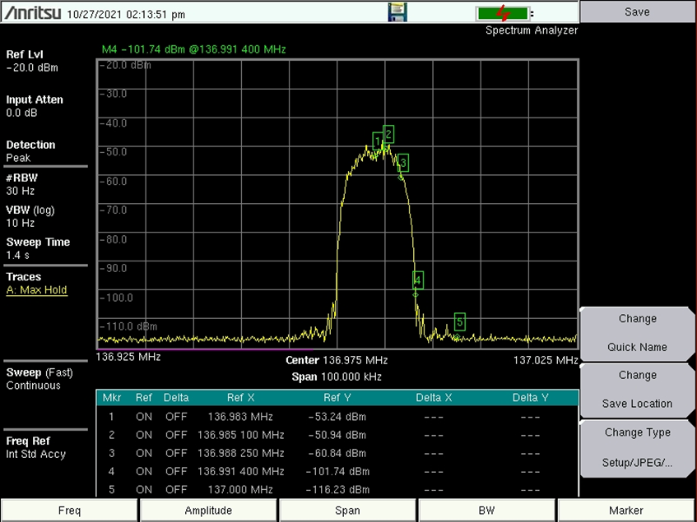

Figure 3-1: Example of VHF data link mode 2 modulation spectral roll-off. D8PSK modulation with 10.5 ksymbols/s rate (Example of VHF Radio)

Assessment of the operation of space-based VHF system into the adjacent channel in the out-of-band domain
The recommendation ITU-R SM.1541 provides the unwanted emission mask in the out-of-band domain. Such emission is defined within the 50 % and 150 % of the bandwidth and it would apply for a channel separation of 25 kHz. The out-of-band attenuation from the carrier power is defined as 25 dBc. However, as shown in Figure 3-1, the space-based VHF spectral roll-off has an attenuation higher than 60 dBc, which is more stringent than the ITU-R SM.1541.

Table 3-3: Assessment of the signal received by the ground VDL mode 2 station from an aeronautical mobile satellite (route) system operating in channel with 25 kHz frequency separation
Satellite to ground station transmission
Frequency | MHz | 136.975 | 136.975 | 136.975 | 136.975 | 136.975 | 136.975 | 136.975 | 136.975 | 136.975 | 136.975
Re (earth radius) | km | 6378 | 6378 | 6378 | 6378 | 6378 | 6378 | 6378 | 6378 | 6378 | 6378
Altitude (satellite) | km | 600 | 600 | 600 | 600 | 600 | 600 | 600 | 600 | 600 | 600
Elevation | ° | 90 | 80 | 70 | 60 | 50 | 40 | 30 | 20 | 10 | 0
Range | km | 600 | 608 | 635 | 683 | 761 | 882 | 1075 | 1392 | 1932 | 2831
Transmitter (satellite)
RF power | W | 85 | 85 | 85 | 85 | 85 | 85 | 85 | 85 | 85 | 85
Tx antenna gain | dBi | -5.5 | -2.2 | 0.7 | 3.6 | 5.5 | 6.9 | 7.8 | 8 | 8 | 8
Feeder losses | dB | 1 | 1 | 1 | 1 | 1 | 1 | 1 | 1 | 1 | 1
EIPR | dBW | 12.8 | 16.1 | 19.0 | 21.9 | 23.8 | 25.2 | 26.1 | 26.3 | 26.3 | 26.3
Spectral roll-off | dBc | 60 | 60 | 60 | 60 | 60 | 60 | 60 | 60 | 60 | 60
Out-of-band emission | dBW/ 25 kHz | -47.2 | -43.9 | -41 | -38.1 | -36.2 | -34.8 | -33.9 | -33.7 | -33.7 | -33.7
Signal propagation
Free space losses | dB | 130.7 | 130.8 | 131.2 | 131.8 | 132.8 | 134.0 | 135.8 | 138.0 | 140.9 | 144.2
Additional loss | dB | 1 | 1 | 1 | 1 | 1 | 1 | 1 | 1 | 1 | 1
Receiver (ground station)
Rx signal | dBm | -148.9 | -145.7 | -143.2 | -140.9 | -140.0 | -139.9 | -140.7 | -142.7 | -145.6 | -148.9
Rx requirement | dBm | -93 | -93 | -93 | -93 | -93 | -93 | -93 | -93 | -93 | -93
Required D/U | dB | 20 | 20 | 20 | 20 | 20 | 20 | 20 | 20 | 20 | 20
D/U margin | dB | 35.9 | 32.7 | 30.2 | 27.9 | 27.0 | 26.9 | 27.7 | 29.7 | 32.6 | 35.9

Table 3-3 provides the impact of the space-based VHF system into the ground station operating in the adjacent band. From the ICAO Handbook of RF requirements (Doc. 9718), a D/U protection ratio of more than 20 dB is specified. The outcome of this studies shows that the D/U ratio is, even for a worst case of maximum RF transmitter power, higher than the required one. The space-based VHF system could therefore operate without affecting the ground station in the first adjacent channel. In addition, the result would be similar for the other adjacent channels.

Impact of the operation of the space-based VHF system with a frequency shift of 3.2 kHz in the system operating in the adjacent channel
The space-based VHF system will have a mechanism to compensate the Doppler effect. Depending on the aircraft location and its flight route, the centre frequency of the radio will be shifted by +/-3.2 kHz at maximum.
As explained in section 5, the signal transmitted by the spacecraft radio will be shifted to compensate the Doppler effect.
Considering the use of the CSC (136.975 MHz), a Doppler effect of +/- 3.2 kHz and an effective bandwidth of 14 kHz, to keep the signal in the 25 kHz channel, the maximum Doppler compensation value is less than 2.7 kHz. However, it is worthwhile that the CSC channel in the upper part has a guard band of 12.5 kHz below 137 MHz, and the channel just below it is defined as a guard channel not used, not limiting the pre-compensation.

Outcome of the sharing studies
The operation of the space-based VHF system will not have any harmful interference impact on the AM(R)S. By applying a frequency shift of maximum 2.7 kHz to the centre frequency and considering a Doppler effect of 3.2 kHz, the studies show that there is no impact on the ground VDLm2 radios operating on the ground.
It is assumed that AM(OR)S parameters are similar to the VDLm2 RF parameters, consequently the same sharing outcome could be applied to the AM(OR)S. The space-based VHF system would not create any harmful interference to the AM(OR)S operating in the adjacent channel to the spacecraft channel. Nevertheless, the channel assigned to the space-based VHF radio should not be the same as AM(OR)S.

ANALYSIS OF THE DOPPLER EFFECT AND COMPATIBILITY WITH CURRENT AVIONICS
In the Space-based VHF communications system, the satellites play the role of the ground VDR (“VHF Data Radio”) of the VHF Voice or VDLm2 system. In this scenario, due to the fast satellites movement in their orbit, the signals transmitted by aircraft and satellites experiment a Doppler effect which results in a frequency shift (and probably a Doppler rate) considerably higher compared to the one experimented on the ground scenario which is only impacted by the aircraft movement.
The Space-based VHF system intends to support VHF voice and datalink to the aircrafts without any modification to the airborne equipment. As a result, the airborne radios have the same frequency capture range as specified for the terrestrial VHF scenarios. It is expected that the Doppler effect impacts with more severity the VDLm2 system than the voice.
This section presents the analysis carried out to evaluate whether the Doppler effect produced by the LEO satellite movement impacts the airborne receiver and provides possible solutions supported by the satellite radios to guarantee that both VHF voice and data (VDLm2) airborne radios can operate transparently.

VDLm2 Doppler effect analysis

VDLm2 Frequency Specifications
[RD-04] EUROCAE ED-92C. Minimum Operational Performance Standard (MOPS) for an Airborne VDL Mode-2 System Operating in the Frequency Range 118-136.975 MHz provides the following requirements related to the carrier frequency generation and detection:
- Frequency capture range: ± 967 Hz (± 685 Hz (Tx frequency error) + ± 282 Hz (Doppler Shift)) (section 2.2.1.2.7)
- Frequency stability of the RF carrier: ± 5 ppm (assumed for both transmitter and receiver) (section 2.2.1.3.10):
- Demodulate peak phase accelerations: 1000 Hz/s (section 2.2.1.2.8)
It has to be guaranteed that the frequency transmitted by the satellite radio could accommodate with those specified limits so that the existing aircraft equipment can receive the satellite transmissions as it would be operating in a terrestrial scenario.

Frequency Error Computation
By using space-based VHF services, the signal received by the aircraft will have a certain deviation from the central frequency mainly due to the following reasons:
- Offset applied to the transmitted frequency (i.e. carrier offset);
- Frequency stability of the transmitting clock;
- Doppler frequency shift due to the relative velocity between transmitter and receiver.
The frequency shift due to the Doppler effect is deterministic and, if needed, it would be possible to compensate it up to a certain point. Due to uncertainties, the Doppler compensation cannot be perfect, and some errors are introduced in the compensation process itself.
The following paragraphs detail the different contributions to the frequency error. The VHF frequency assumed for the estimation of the error is 137 MHz.
- Satellite oscillator
The instability of the onboard clock may introduce an error on the frequency to be transmitted.
As an order of magnitude, a frequency stability of ± 1ppm is achievable for the onboard clock. This would result on a frequency error of 137 Hz.
- Relative velocity Satellite-Aircraft
The relative velocities of the satellite and the aircraft induces a Doppler shift to the signal transmitted which affects the frequency of the carrier and the symbol rate. Assuming spacecraft orbit height around 600 km and field of view of the antenna is 62 degrees, the expected Doppler effect is provided in the Table 4-1:

 | ΔV [m/s] | Δf [Hz] | Delta wrt stationary [Hz]
SC with stationary AC | 6653 | 3040 | 0
SC with AC at 300 m/s | 6944 | 3173 | 133
SC with AC at 778 m/s | 7409 | 3385 | 345
Table 4-1: Computation of expected Aircraft – Satellite Doppler shifts
For a spacecraft flying directly over the aircraft, the evolution of the Doppler shift and Doppler shift rate over time is provided in Figure 4-1:
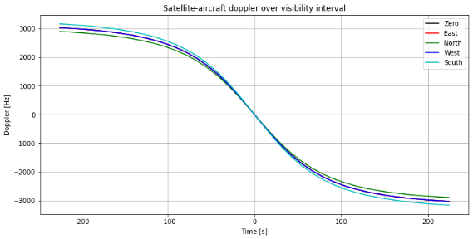
Figure 4-1: Aircraft – Satellite Doppler shifts time evolution over visibility interval

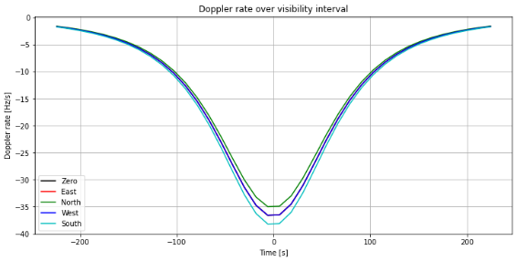
Figure 4-2: Aircraft – Satellite Doppler rate time evolution over visibility interval
It can be observed that the maximum Doppler shift is experimented at the edge of the satellite coverage, which means that in case the field of view of the VHF antenna is reduced (more satellites in the constellation) the maximum Doppler shift is reduced. On the other hand, the maximum rate on Doppler shift is experimented when the satellite is at the vertical of the aircraft.
The following plot shows the Doppler effect experimented by an aircraft within the satellite footprint. Note that the satellite is traveling North for this example:
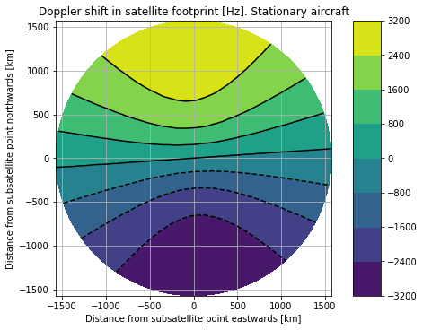
Figure 4-3: Satellite - Aircraft Doppler shift expected over satellite footprint
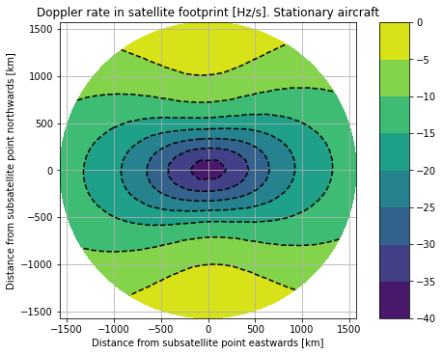
Figure 4-4:: Satellite - Aircraft Doppler rate expected over satellite footprint

Doppler compensation uncertainties
In principle, the Doppler effect can be compensated by shifting the center frequency of the VHF spacecraft radio as such that the frequency reaching the aircraft is within the airborne radio specifications. However, the compensation cannot be perfect, so the following potential residual errors are estimated.
- Effect off the delay to apply the compensation
As a worst case, the delay between the moment when the computation of the Doppler compensation to apply and the moment when the signal arrives to the aircraft will introduce some error in frequency due to the change in relative position/velocity over this time. The main source of the delay will be the processing delay, i.e. the time it takes for the signal to be transmitted since the moment when the computation of the Doppler shift is performed. In this case, a shift of up to 40 Hz per second of delay can be expected.
- Position knowledge error
The relative position and velocity of the satellite and the aircraft is known with a certain accuracy. Depending on the source of information used for the determination of the position/velocity of satellite and aircraft, the magnitude of the error might be different. Typical total errors are below 6 Hz.
Summary
Table 4-2 summarizes the different contributions to the global frequency error.

Source of Frequency error | VHF (Hz)
Satellite oscillator | 137
Satellite-aircraft velocity | 3158.65
Transmission delay (per second) | 40
Aircraft / satellite position error | 6
Total | 3295
Table 4-2: Frequency error budget

Example of VDLm2 Operation
According to the standards, the maximum frequency error allowed for the airborne radios to receive the message is ± 967 Hz. Therefore, it is not enough to absorb the expected frequency error due to Doppler shift of the satellite of about ± 3.3 kHz. A pre-compensation mechanism must be therefore implemented.
An example of pre-compensation mechanism can be based on the type of communications to be supported, that is, messages directed to a single aircraft (unicast) or messages directed to all aircraft (broadcast):
- Unicast
For unicast operations whose messages are dedicated to a single aircraft, the frequency transmitted by the spacecraft can be pre-compensated with a frequency offset based on the known spacecraft – aircraft position.
- Broadcast
For broadcast operations whose messages is directed to all aircraft, it is assumed that an aircraft can handle the reception of the same message twice, as it is the case for Ground Station Information Frames (GSIF).
The concept to compensate the Doppler effect is to transmit the same message several times to guarantee that the frequency received by the aircraft is within the frequency capture range. This can be done for example by transmitting with four frequency offsets: f0 – 2700 Hz, f0 – 900 Hz, f0 + 900 Hz, f0 + 2700 Hz where f0 being the assigned centre frequency. The traffic generated by such approach would remain low so it should not affect the channel occupation.
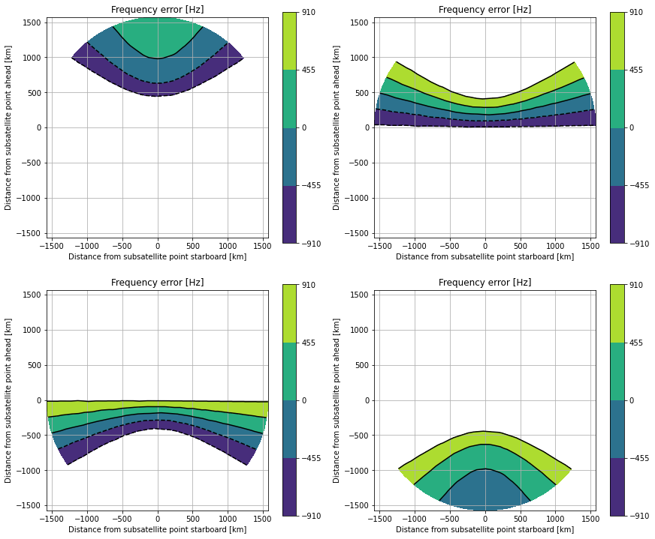
Figure 4-5: Example of Broadcast pre-compensation: areas with Aircraft Frequency Error below specification for each frequency offset intrioduced
Other solutions may be based on satellite antennas able to conform beams directed to sectors affected by a similar Doppler offset. Using beam forming or directional antenna to create an oblique footprint with radiation that is adapted to the Doppler effect observed by the aircraft. i.e, the satellite could radiate only in forward or rear direction with a negative or positive pre-compensated shift in frequency as shown in the figure below.
Figure 4-6: Example of Doppler pre-compensation using directional antennas

Considerations of the CSMA mechanism and the pre-compensation Doppler approach
The VDLm2 system is based on a CSMA (Carrier Sense Multiple Access) scheme that consists basically in sensing whether the channel for transmission is busy or not, and transmission occurs in the event the channel is idle. As it has been explained in previous sections, the Doppler shift caused by the satellite movement can introduce an offset in the carrier that is higher than the VDR frequency capture range. As the Doppler shift depends on specific aircraft location, a Doppler pre-compensation approach will be able to guarantee the correct reception by the airborne radio from the satellite transmissions (see Figure 4-5). On the other hand, an aircraft far away in other region may not be able to receive the pre-compensated satellite transmission correctly. For those aircraft at other regions, even if their CSMA cannot detect the channel as busy and decided to transmit, their transmissions are unlikely to affect the reception in the aircrafts in the region receiving with the correct pre-compensation due to the long distance.
Note in terrestrial networks the situation is equivalent, aircrafts located in places that are far from each other will not listen among them due to terrestrial coverage limits.

VHF Voice Doppler effect analysis

VHF Voice Frequency Specifications
According to RD-01] ICAO Annex 10, Vol III, Part 2, the capabilities of the airborne radios at reception of VHF Voice signals are:
- Voice 25 kHz:
  - Effective acceptance bandwidth with offset carrier: ± 8000 Hz
  - Effective acceptance bandwidth without offset carrier: ± 50 ppm (± 6850 Hz)
It has to be guaranteed that the frequency received by the airborne radio is within those specified limits in order for the system to work with existing aircraft equipment.
The case of VHF Voice channels of 8.33 kHz is not addressed in this document and left for future studies.

Voice Frequency Error Computation
The results presented in section 4.1.2 for VDLm2 are fully applicable for the VHF Voice system, being the maximum frequency offset expected, including the satellite to aircraft Doppler of ± 3.3 kHz.
As presented in section 4.1.2, the specification of the VHF Voice with 25 kHz bandwidth is well above the maximum expected frequency shift including satellite Doppler.

Example of VHF Voice Operation
In contrast with VDLm2 communications, the Voice service establishes a ground-aircraft communication for a longer period, typically on the order of seconds but with no upper limit. Due to the high velocity of the spacecraft, the selection of the best spacecraft signal to be used for the communications with an aircraft is highly dynamic. However, it cannot be guaranteed that one single spacecraft is in visibility of the aircraft for the whole duration of the call. In this case, in addition to the frequency shift, the system will handle communications handover from one spacecraft to the next one.
Satellite Coverage Overlap
The space-based VHF constellation provides a global coverage with areas being covered by a single satellite and others covered by two or more spacecraft simultaneously as observed in the following pictures. As the latitude increases, the overlap between satellites of adjacent orbital planes increases.
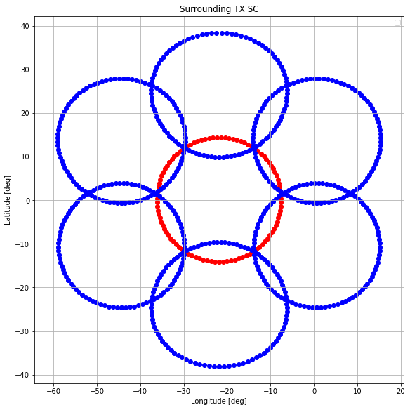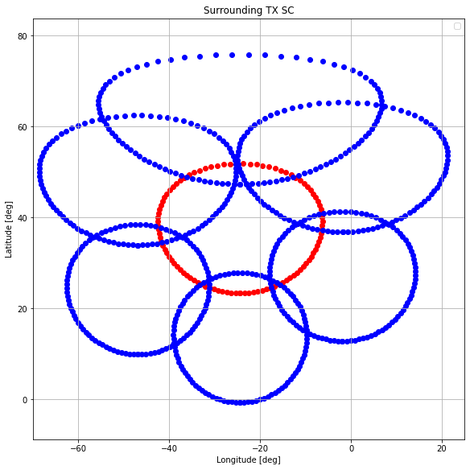
Figure 4-7: Example of Satellite Transmission Coverage Overlapp
Overlapping regions of satellites in the same orbital plane receive the VHF signal with a difference in frequency of about 6 kHz when both satellites transmit in the same frequency. Overlapping regions of satellites in adjacent orbital planes receive the VHF signal with a difference in frequency of less than 4 kHz when both satellites transmit in the same frequency. This fact could create an audible signal in the voice call in case both satellites are transmitting the same message.
Communications handover
To guarantee that a voice message is received by any aircraft inside a FIR, a smooth transition between satellites happens. As a result, there shall be a period of time during which two satellites transmit the same voice signal and it is up to each aircraft to choose the spacecraft with the best signal quality, always ensuring enough VHF voice signals spectral separation, that is, that signals received from different satellites does not overlap in frequency due to their different Doppler shift.
25 kHz Voice operations
It has been identified that the 25 kHz Voice service does not require any onboard pre-compensation mechanism to cope with the Doppler shift for a single communication spacecraft-aircraft.
To perform a smooth spacecraft handover within an ongoing call using CLIMAX, enough frequency separation between the signals from the two spacecraft must be guaranteed. This is the case for the spacecraft transition in the same orbital plane, but the handover between different orbital planes, needs to apply a different offset to ensure there are no interferences on the audio signal, which can be achieved by transmitting with a frequency offset of about 5 kHz positive for one orbital plane and negative for the adjacent orbital planes.
Figure 4-8 shows the difference in frequency received by an aircraft when it receives an audio signal from two satellites applying the mentioned strategy. It can be observed that the difference is always higher that 6 kHz guaranteeing that there is not spectral overlap when using the mechanism analysed.
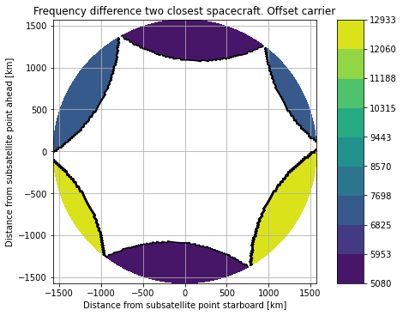
Figure 4-8: Frequency difference between VHF Voice Transmissions from two satellites at the aircraft receiver using offset carrier in Hz

Main Outcome from the Analysis
It is recognized that the Doppler effect between satellite and aircraft constitutes one of the main differences in the satellite to/from aircraft links with respect to the terrestrial scenario. In particular, the Doppler shift introduced by the satellite movement can have a value from -3.2 kHz to + 3.2 kHz depending on the aircraft to satellite position and direction of movement. This section has presented analysis of the impact for VHF Analog Voice and for VHF Data VDLm2 links of the Doppler shift of the satellite transmissions in the aircraft receivers. The analysis is focussed on the approach needed to guarantee that the aircrafts radios can detect the satellite transmissions without any modification.
For VHF Voice using 25 kHz channels and DSB AM modulation, the following key outcomes can be stated:
- The frequency capture range specified in the standards [RD-01] is well above the maximum Doppler shift of ± 3.2 kHz
  - Effective acceptance bandwidth with offset carrier: ± 8000 Hz
  - Effective acceptance bandwidth without offset carrier: ± 6850 Hz
- The aircraft voice radios can then receive correctly the satellite transmissions without any pre-compensation.
A more complex scenario has also been presented, scenarios in which an aircraft is located under the coverage of more than one satellite, it is expected that during the handover of the voice connection between satellites, several satellites may transmit the same voice frequency. Due to the different Doppler shift from different satellites, the VHF voice signals may overlap, producing interference. A possible solution presented is based on the use of the already in use CLIMAX approach, consisting in transmitting with a positive offset carrier in the plane and a negative one in adjacent planes. The offset is selected to guarantee that the separation between both transmissions is such that no overlap is produced.
For VDLm2 links, the impact of the Doppler in satellite transmission at the aircraft radio reception is expected to be more severe than for voice, due to the frequency capture range specified in the standards [RD-04] of ± 967 Hz is well below the Doppler shift of ± 3.2 kHz. From the analysis, the following key outcomes can be stated:
- A Doppler pre-compensation mechanism needs to be implemented in the satellite transmission to guarantee that the satellite transmission are received in the aircrafts VDL radios with an offset not higher than the specification.
- Several mechanism are possible to implement the pre-compensation mechanism. The example presented in previous sections consists basically in:
  - For unicast messages, compute the Doppler from the knowledge of aircraft and satellite positions, and introduced the resulted offset.
  - For broadcast messages, repeat the transmission several times to guarantee that all aircrafts will detect it. The increment in load derived from this approach is expected to be low as most of messages are unicast.
It is noted that the analysis has been focussed in the satellite to aircraft direction, as it is the key one to guarantee that the aircraft receiver will not be affected in any case. For the aircraft transmissions to the satellite, it is considered that the satellite radio will be designed to cope with the Doppler shift expected, avoiding any change in the aircraft radio transmitters.

OPERATION OF THE SPACE-BASED VHF SYSTEM – DATA SERVICE

Terrestrial and satellite coverage
The Space Based VHF is agnostic to the protocols running on top of the Aviation VHF Link Control (“AVLC”) layer. It will use the same AVLC protocol as on the ground-based VDLm2 radio. The protocols that will be used on top of this are transparent (just as they are for the ground-based VDLm2 radio). The Ground Station Information Frames (“GSIF”) will indicate the available services (AOA and/or ATN) over space-based VDL station.
The VDLm2 system is based on a CSMA (Carrier Sense Multiple Access) protocol which senses or listens whether the channel for transmission is busy or not and, transmits in the event the channel is idle. Nevertheless, when deploying a ground network based on this CSMA protocol, there is a well-known problem which is caused by the fact that the ground stations are not able to detect the transmissions done by the other stations as they are not in line-of-sight and they cover the sky. This issue can produce collisions due to simultaneous transmission and potentially degrading the performance. However, in the case of the space-based VDLm2 station which will cover a very wide area on the ground, the issue of the hidden transmitter would not happen, simply because the space-based VHF system would be in line-of-sight with the ground station. In the event, the ground-based VDL station transmits, the space-based VHF station would not transmit unless the signal received is below the detection threshold.
The airborne system only receives and processes VDL frames and it cannot tell the difference between VDL frames originating from a ground-based VDL station and a space-based VDL station. Handoff between a ground-based VDL station and a space-based VDL station is identical to a handoff between two ground-based VDL stations. In the CVME, the space-based VDL station is simply just another station that it is managing, albeit with a much larger coverage map.
Ground-based and space-based VDL services can be provided using the same or different DSP ID. However, it is highly suggested to use the “same DSP ID” as it does not require any changes in avionics configuration (no software modifications would ever be needed in the avionics). It should be noted that in case the space-based VDL service is required to operate with its own DSP ID that is different from the existing DSP IDs then the transfer from space-based to ground-based station would happen exactly in the same way as it is done currently on the ground. When an aircraft configured to be allowed to access the VDL service of different service providers for example Collins and SITA, loses datalink service when it flies outside the coverage area of one service provider but, it then detects the availability of VDL service from the other service provider and it will switch to that service provider. Such mechanism is already actively being used on the current aircraft fleet.
As currently done on the ground, an overlap between the ground and satellite coverage should be ensured to guarantee the continuity of service and to avoid any loss of connection.
The space-based VHF system will work exactly in the same manner as the ground-based system and it should be seen as a complementary component to the ground-based network, allowing to cover remoter or oceanic area.

Channel allocation and handoff management
These peer Link Management Entities (LME’s) will use the information provided by the received XIDs (e.g. lat/long position parameter, airport destination, acceptable alternate ground stations, etc.) and other information sources (e.g. transceiver’s signal quality/strength of received frames) to establish and maintain reliable links between the aircraft and the VDL Mode 2 ground system. In general, the aircraft LME will monitor the signal quality parameter (SQP) values of all transmissions from ground stations. When it determines that a ground station change is needed, it will send an XID to the selected (new) ground station. The aircraft LME may include a list of alternate (acceptable) ground stations. The ground service provider may, at its discretion, reply from another ground station (usually in the alternate list). This allows, among other functions, a means of load-balancing the ground stations. Several scenarios could be envisaged for the operation of the space-based VHF system:
- The use of the CSC
The airborne system is connected to the ground Common Signalling Channel. The aircraft flies from the continental to the oceanic area. The airborne system will remain connected to the ground CSC until that the receiver signal or the quality of signal reach a certain threshold and at that point, the airborne system could decide on its own to switch on the space-based VHF station. In general, the aircraft LME (Link Management Entity) will monitor the signal quality parameter values of all transmissions from ground stations. When it determines that a ground station change is needed based on the signal quality, policy based (e.g. depending on the flight direction), etc, it will send an XID to the selected (new) ground station. The same logic will be used for the space-based VHF system. It should be noted that the use of CSC is subject to the compatibility with the services operating above 137 MHz. Such constraints would not apply or will be less by using an alternate frequency, although that the outcome of the studies is not finalised yet, some technical constraints may be imposed on the operation of the CSC.
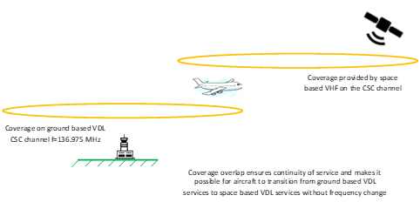
Figure 5-1:Operation using the CSC

- The use of an alternate frequency
The principle is similar to the ground
- The airborne system is connected to the ground CSC frequency. The aircraft flies from the continental area to the oceanic one. At one point, the Central VHF Management Entity (“CVME”) will indicate that an alternate frequency is available, and it will send a Ground-based requested aircraft-initiated handoff (“GRAHIO”) command to indicate to the airborne system to switch to the alternate frequency (either the same as on the ground allocated to the CSP or a dedicated channel for the space operation). The CVME will have the information related to the satellite coverage and it can be decided to limit the coverage close to the coastline.
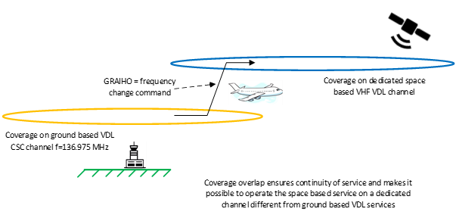

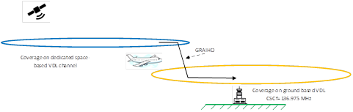
Figure 5-2:Operation using an alternative frequency

- The airborne system is connected to an alternate frequency
The Central VHF Management Entity (“CVME”) will send a GIHO command to the airborne system to indicate to switch to the channel allocated to the space-based VHF system (either a specific channel or a channel belonging to the CSP)

Only satellite coverage
The space-based VHF service is the only service available in remote and oceanic areas due to the fact the ground VHF system could not be deployed. In this context, it is obvious that there will be no impact on the ground VHF station. The aircraft LME will monitor the signal quality parameter (SQP) values of the transmission from the space-based stations. When it is required, the aircraft radio will perform an hand-off with another spacecraft radio.

Flight User Case
For the purpose of illustration of how Space Based VHF systems can be seamlessly integrated into the current Data Link systems, this section describes the various protocol and system elements implied in the provision of a continuous data link service for a transatlantic flight over the Atlantic Ocean for an aircraft not equipped with traditional satellite avionics.
For the purpose of this example, it is supposed that the Space Based VHF system operates on a dedicated frequency that is the same over all its coverage area. It is also supposed that the overlap between the terrestrial systems and the satellite system is limited to a geographical area in which handover from one system to another can take place, the satellite system being able to limit the geographical area of its transmissions to oceanic regions with limited overlap of the continental transmitters located on the coast.
A flight initiating at an airport in the South American continent and ending at an Airport located on the European continent will be considered. The purpose of this section are limited to highlighting the system elements necessary to establish a data link connection between the aircraft avionic systems and the ground VHF station. It is understood that, once this link is established, it can be used for performing data exchanges for many applications such as CPDLC or other FANS supported applications by using the foundation provided by the lower layer protocols. Nevertheless, only the lower layer protocol exchanges and system elements involved in these exchanges will be described hereafter.
Data Link connection is established by the aircraft avionics at the departure airport, prior to departure from the gate. This connection is established using a terrestrial VHF network with no deviation from the way it is done today. The exact same protocol exchanges take place between the time the aircraft departs from the gate and the time where the flight reaches a point where, in the absence of a Space Based VHF system, it loses terrestrial VHF coverage. During this time, the terrestrial VHF system performs a tracking of the terrestrial station to which the aircraft is connected by monitoring the transmissions it receives from the aircraft, using this information to determine the station to use to reach the aircraft in the event of an uplink transmission being sent to onboard systems.
Given its monitoring of the aircraft progression among terrestrial stations, the terrestrial system is able to determine that the aircraft is likely to go out of a given station coverage at a given time. This mechanism is also present in the case of terrestrial systems, even in the absence of a Space Based component. At this time, the terrestrial system being aware of the existence of a Satellite System providing VHF data link services and covering the region in which the aircraft will be flying, it issues a command to the onboard avionics to tune to a different frequency. This command is received by the onboard avionics and these initiate a connection to the system on the indicated frequency. In the case of a VDL mode 2 system, this exchange would be performed by the Central VHF Management Entity (“CVME”) indicating that an alternate frequency is available, and it sending a Ground-based requested aircraft-initiated handoff (“GRAHIO”) command to indicate to the airborne system to switch to the satellite system operating frequency. Although this report deals mainly with VDL mode 2 operations and systems, similar mechanisms exists for MODEA (ACARS) systems.
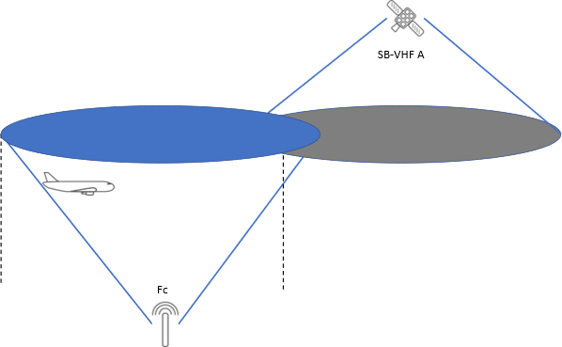
Figure 5-3: Overlap of Satellite and Terrestrial VHF systems coverage to allow for seamless transition to take place
The onboard avionics start using the satellite system for their data link exchanges. As the constellation provides a continuous coverage over the Atlantic Ocean, a data link connection remains available at all times, enabling the use of data link systems and application at any time during the flight. Within the satellite coverage, the frequency shift required on the SB-VHF radio is calculated and adjusted to cope with the Doppler effect.
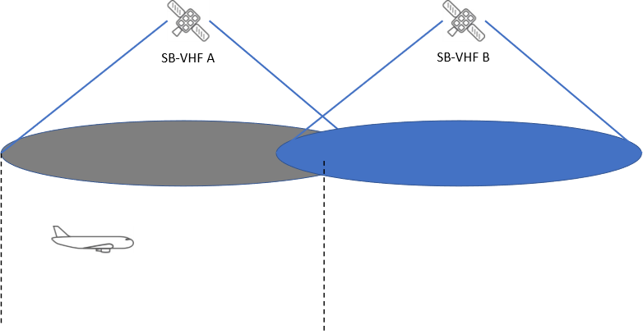
Figure 5-4: Illustration of the aircraft progression under the coverage of the satellite system
In a similar way to what the terrestrial systems perform, the satellite system is composed of multiple satellites and each of these satellites cover a given region of the earth a given time (unlike the terrestrial system, that correspondence varies with time as the constellation is not fixed but satellites evolve on their orbit). The data link system to which the satellite component is connected can thus monitor the evolution of the aircraft under its coverage and determine the moment at which it will be back in an area that is covered by a terrestrial VHF system. At that time, the same process as the one used when leaving terrestrial coverage is used to issue a command to the onboard avionics to tune to the terrestrial system frequency.
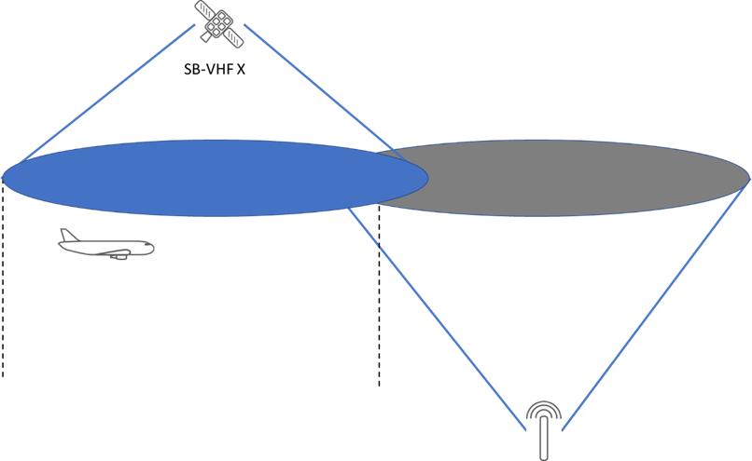
Figure 5-5: Overlap of Satellite and Terrestrial VHF systems coverage to allow for seamless transition to take place
The remainder of the flight continues using the terrestrial VHF systems in a way that is undifferentiated from the current VHF data link systems operation.
The whole process described above being transparent to the crew onboard the aircraft just as a change of terrestrial VHF station is transparent to them today with terrestrial systems.

OPERATION OF THE SPACE BASED VHF SYSTEM – VOICE SERVICE
Due to factors such as the power of the aircraft's VHF transmitter, propagation loss, noise level, etc, there is a limit to the distance at which reliable communications can be effected between an aeronautical station and a terrestrial station. This limiting distance, based on the weakest path, is the service range which is typically around 250NM. However, the limiting distance can be overcome through the Space-Based VHF Voice system.
The concept of the operation of the Space-based VHF Voice system is intended to provide VHF Voice services globally whilst preserving the current VHF Voice operational procedures. As it is well known, the airspace is divided in several areas called FIR (Flight Information Region) in order to divide the total air traffic volume. The FIRs may be split in ATC sectors under the control of one ATCO. For the purpose of this section, the term FIR and ATC sector are used indistinguishable. This sense, each satellite will be able to provide VHF Voice services to the FIR’s under its coverage area following an appropriate frequency coordination.
.

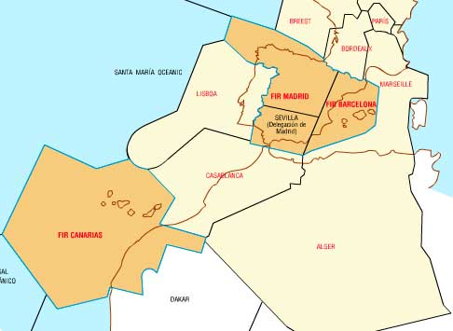
Figure 6-1: FIRS and sectors
Each area is assigned to specific ATCOs who can communicate with all aircraft located within its geographical area using the same frequency. Adjacent FIRs or sectors cannot reuse channels. The use of Space-based VHF voice service will not affect current procedures nor aircraft radios, which means the following Space based VHF system considerations:
- Currently used VHF Voice operational procedures are based on using different frequencies in different geographical areas. Hence, the new satellite-based system is designed to maximize service coverage to the geographical areas using different frequencies, i.e. satellites will dynamically adapt to the frequencies used in their coverage area.
- Minimization of the number of frequencies needed to provide coverage.
- Adjacent FIRs cannot operate in the same frequency due to the interferences.
- Each FIR will be covered using the smallest number of satellites.
- A specific frequency is assigned for each FIR where service is to be provided as in current operation.

STANDARS AND RECOMMENDATIONS APPLICABLE FOR AN AMS(R)S/ AM(R)S/ AM(OR)S COORDINATION

Reference document

ITU – Radio Regulations
The key setting the regulatory procedures to be applicable is the Radio Regulations (RR) document body. The RR establishes the definition of services, the allotment of frequencies, the protection criteria and special provisions in our case, for the aeronautical mobile services.
It is very important to bring here the difference between allocation, allotment and assignment as defined on RR 1.16 - 1.17 and 1.18. ITU R RR is currently studying the feasibility of new allocation to AMS(R)S while the allotments and assignments will be conducted by ICAO and national administrations, likely at later stages once the conditions to use the new allocation would be defined by the future WRC-23.
It is also important to bring here the definition provided by RR for the aeronautical mobile services, AMS (RR 1.32), AM(R)S (RR 1.33), AM(OR)S (RR 1.34) and AMS(R)S (RR 1.36).
In this point it is important to note that RR defines rules for the assignment and use of the frequencies in its article 4. It introduces the fundamental principle that individual administrations can use the spectrum in any way they wish, provided interference is not caused to services operating in conformity with the agreements in the RR and which are registered in the Master International Frequency Register (MIFR). Additionally, the RR also establishes that the safety services require special measures to ensure their freedom from harmful interference; it is necessary therefore to take this factor into account in the assignment and use of frequencies (RR 4.10).
The more important chapter of the RR related with Aeronautical Services is Chapter VIII (Articles 35 to 45) – Aeronautical Services that deals exclusively with aeronautical matters and addresses licensing and regulatory aspects of allocations as well as service operational matters. These matters are applicable to all aircraft operations, whether for civil, national governmental purposes. Special note to article 43 (Special rules relating to the use of frequencies).
One of last revised elements incorporated to RR related with aeronautical services is the Appendix 27, Frequency allotment Plan for the aeronautical mobile (R) service and related information. This appendix lays down a Frequency allotment Plan worldwide for AM(R)S in HF (2850-22000 kHz) that could be a reference to help ICAO to define and approve a Frequency allotment Plan for AMS(R)S operating in the VHF frequency band 117.975-137MHz.
As Appendix 27 establishes, technical and operational principles for the establishment of the Plan of allotment of frequencies and the definitions of the boundaries of the major world air routes areas (WMARAs) and definitions of the regional and domestic air routes areas (RDARAs) combined with a footprint space systems characteristics definition could be used as a reference to establish a frequency allotment plan to help the Nationals Administration for the assignment of frequencies in an international coordination context for AMS(R)S.
Specific tools or upgraded versions of SAFIRE/MANIF or Frequency Finder tools could be developed to help the coordination procedures between Administrations combining the current AM(R)S global allotment and national assigned frequencies with the new AMS(R)S allotment and assignment frequencies.

ICAO – SARPS
ICAO has developed a set of documents related to the procedures to use by the aeronautical services in the allocated frequency bands.
Those documents address both, the technical requirements, the frequency allotment and assignment and the operational coordination.
The following documents are a key references on this matter:
- Annex 10 – Volume V - Aeronautical Radio Frequency Spectrum Utilization.
- ICAO Handbook on Radio Frequency Spectrum Requirements for Civil Aviation including statement of approved ICAO policies (Doc 9718).
- Annex 10 – Volume III – Communications Systems
- ICAO Doc. 9776 – Manual on VHF Data Link (VDL) Mode 2
- Manual on the Aeronautical Mobile Satellite (Route) Service (Doc 9925)
- Global Operational Data Link (GOLD) Manual (Doc 10037)

In the following sections of this chapter, an extract is made of the most significant sections of above documents related to the objective of this section, which is to provide material to provide evidence that the coordination between AMS(R)S, AM(R) and AM(OR) is feasible and that there is already a documentary and procedural basis that makes possible such coordination or that can be used as a basis for developing the procedures that would be developed once the allocation of the AMS(R)S service in the band is obtained. 117.975-137MHz.
Emphasis is made on the fact that ITU-R defines the conditions for use of a new allocation to the AMS(R)S without concluding on any allotment or assignment of the frequencies. The ITU R process to agree on a new allocation are mostly based on compatibility with other services using adjacent bands. Once the new allocation is defined by ITU-R, ICAO will conduct the subsequent stages on allotment or assignment of frequencies consistently with the conditions specified by ITU R for the use of the new allocation. Before ITU R decides on the new allocation, ICAO can certainly conduct examples of exercises on frequency planning just to evidence that there would be tools to ensure the subsequent studies on allotment and/or assignments while protecting other aeronautical mobile services.

ICAO Annex 10, Volume V Aeronautical Radio Frequency Spectrum Utilization
The main reference for the Aeronautical radio spectrum utilization is the ICAO Annex 10, Volume V “Aeronautical Radio Frequency Spectrum Utilization”. In its introduction section on “Action by contracting States” and section 4.1 of this document where deals with Standards and Recommended Practices (SARPs) relating to the use of the frequency band 117.975 –137.000 MHz and includes matters pertaining to the selection of particular frequencies for various aeronautical purposes. These SARPs are introduced by the following preface, which sets out the principles upon which the utilization of this frequency band on a worldwide basis with due regard to economy is being planned.
Preface
The utilization of the frequency band 117.975 – 137.000 MHz on a worldwide basis with due regard to economy and practicability requires a plan that will take into account:
…..
c) the need to provide for coordination between international and national utilization so as to ensure mutual protection from interference;
d) the need for providing a global framework for the coordinated development of Regional Plans;
……..
It could be concluded from the above references and the content of this ICAO document, that the utilization of this frequency band is on a worldwide basis and that all National Administrations (Members States) should coordinate in a global framework the frequencies assigned in order to preserve the Aeronautical Safety.
The table 4.1 from Annex 10 Volume 5 provides an allotment table for using this frequency band.
Section 4.1.4 provides the protection criteria concerning the deployment of VHF frequencies and the avoidance of harmful interference, as a summary:
4.1.4.1 “…the protected service volume of one facility is separated from the protected service volume of another facility by a distance not less than that required to provide a desired to undesired signal ratio of 20 dB…”
4.1.4.2 “For areas where frequency assignment congestion is severe or is anticipated to become severe …. the protected service volume of one facility is separated from the protected service volume of another facility by a distance not less than that required to provide a desired to undesired signal ratio of 14 dB…”
It could be concluded that the most restricted protection criteria for the aeronautical mobile services operating in same channel is 20 dB of desired to undesired signal ratio.
- For Voice services (DSB-AM modulation signals), the minimum field strength of signals (Annex 10, Vol III, Part II, section 2.3.2.2.1) should be not less than a power flux density of −116.2 dBW/m², therefore, the criteria protection for AM(R) Voice Services operating in the 117.975-137MHz frequency band is: -136.2 dBW/m2.
- For VDL-Mode 2 application services, the minimum field strength of signals (Annex 10, Vol III, Part I, section 6.3.5.2) should be not less than a power flux density of −120 dBW/m², therefore, the criteria protection for AM(R) VDL-Mode 2 Applications services operating in the 117.975-137MHz frequency band is: -140 dBW/m2.
Section 4.1.4.3 for systems operating on adjacent channels only address to ensure operations free from harmful interference but does not define a level of protection.
Section 4.1.6 designates “… the list of frequencies available for assignment, together with provision for the use by the aeronautical mobile (R) service of all frequencies with a channel spacing of 25 kHz, and of all frequencies with a channel width and spacing of 8.33 kHz.
The plan provides that the total number of frequencies required in any region would be determined regionally.
In many regions particular frequencies have already been allotted for particular functions such as, for instance, aerodrome or approach control. The plan does not make such allotments (except as provided for in 4.1.1.1), such action being taken regionally if considered desirable…”
Following the 4.1.6 section, so far, the coordination process to assign VHF radio frequencies for use in the international aeronautical mobile service is done by national determination but in a regional basic coordination. Therefore, the process to use AMS(R)S in a coordinated way with the current AM(R)S could be done at international level in a regional basis but with a final licensing for operation assigned by a national administration.

ICAO Handbook on Radio Frequency Spectrum Requirements for Civil Aviation (Doc. 9718)
Other important reference document is the ICAO Doc. 9718 with two volumes.
In Volume I (ICAO spectrum strategy, policy statements and related information) it can be extracted for reference the sections that should be taken into account in the approval process of the WRC-23 Agenda Item 1.7 and in the studies of compatibility of the new allocations of AMS(R)S in the VHF 117.975-137MHz frequency band with the services operating in-band and the adjacent bands. Some references to take into count are sections 4, 5 and 6.
It is possible to conclude from these sections that there is in place a procedure to coordinate the assignment of frequencies for the aeronautical services. This procedure could be enhanced by improving some topics as:
- The reporting to the frequency assignment in the Master International Frequency Register (MIFR) as it was encouraged by the World Radiocommunication Conference, Geneva, 2012 (WRC-12).
- The coordination through the ICAO Regional Offices frequencies registration. Such coordination and registration need to take place through the radio regulator authority in each country.
- Improving and integrating the current tools to coordinate the assignment of frequencies as SAFIRE and Frequency Finder.
The outcome of these sections normally results in material being incorporated in the ITU Radio Regulations or in ITU-R Recommendations and subsequently being applied through national regulation by national telecommunication authorities but with ICAO playing a role at the worldwide level through the work of the Air Navigation Commission but also at the regional level by the ICAO Regional Offices through coordination of frequency assignment plans with States.
Allocations may be worldwide, as is the case with the majority of aeronautical services or made to one or two of the three ITU regions. Countries may make specific requests for sub-regional or country allocations, usually coordinated in advance with their neighbours. Examples of such worldwide coordination is in ITU documents Appendix 27 to the RR containing a frequency allotment plan for the AM(R)S in HF bands.
In the aeronautical services ICAO performs a central coordinating function, providing the international forum for the review of needs for spectrum, the development of technical planning standards and the registration of global use. Nevertheless, for the space services, Article 9 of the Radio Regulations could be also an additional coordination procedure operated by the Radiocommunication Bureau.
Additional information about the role of ICAO and the relationship with ITU to participate in different process to regulate the use of spectrum is summarized in Volume I, section 7-III of this Handbook. There is also in this section the summary of the relevant of safety service as aeronautical mobile communication service and the recommendation to avoid that aviation services should not accept the re-designation of the present AMS(R)S bands to the generic allocation of MSS or other mobile-satellite services. Service merging of aeronautical mobile service allocations with other services is not possible due to the radically different operational requirements.
Chapter 9 (Interference Protection Considerations) lays down the general considerations for the aviation safety services protection criteria. In general this framework is laid down in the RR for the observance by ITU members when cross-border cases of interference arise. RR define a set of principles and actions which are designed to provide administrations with agreed understandings for use with other administrations and internally within their own countries. This activity is international in character and is centred on the ITU in the first instance. ITU Regulations are treaty obligations and in respect of interference clearance are conscientiously followed. Where normal negotiation fails to resolve an issue, there is scope for reference of problems to the ITU Radio Regulations Board. Nevertheless some aspects are interesting to bring here to this document:
9.2.14 point to RR Appendix 3 as reference to the power supplied to the antenna transmission line form the transmitter and are “never to be exceeded values”. …. For system performance reasons, ICAO SARPs often specify more stringent levels, in effect, meeting the spirit of the “special agreement” requirements of the Regulations.
9.2.19 Non-safety-of-life services, willing to share a safety-of-life band, have to comply with the aviation safety requirements applicable in that band including certification of radio equipment, software and radio operators, as well as assumption of liability.
9.2.21 … As mentioned above, the application of sharing criteria, whether covered by an ITU-R Recommendation or not, cannot negate the right to claim protection from harmful interference. ….
9.2.22 Multiple interference inputs. ….. An extra margin of at least 3 dB is recommended in general, with higher values in particular cases where a number of interference sources are known to exist (for example, see ITU-R Recommendation M.1343).
9.2.23 Aviation safety factor. ….. Until established on the basis of further study on a case-by-case basis, an aviation safety margin of not less than 6 dB should be applied.
9.2.28 … If a request is not in accordance with the Regulations, an entry may still be made, provided it does not interfere with a registered service, but the assignment will enjoy no protection from later registrations meeting the requirements. This is the so-called “non-interference basis”.
9.4.6 … For radio transmitters, close control of unwanted emissions is essential, and the use of only necessary transmitting power to meet the requirements stated in RR 15.2 is also a discipline for operators of stations.
Table 9-1 provide a general guidance for the general protection limits for the aeronautical radio. These limits can only be applied to assess intra-system interference and cannot be used to assess compatibility between systems with different RF spectral characteristics. For the case of VHF Communications in the Frequency Band of 118-137MHz:
Minimum signal dB (uv/m): 37
Intra-system planning protection ratio DB: 14

Attachment D. Review and Update lays down the time and procedures to update this document the between ITU World Radiocommunication Conferences.
Attachment E (Approach for Establishing and promoting the ICAO position for future ITU World Radiocommunication Conferences) lays down the process to establish the ICAO position for each WRC.
2.2 The long-term implementation strategy contained in the Global Air Navigation Plan (Doc 9750) forms the basis for the spectrum requirements.
2.3 The ICAO policy on radio frequency spectrum requirements, as approved by the Council, is contained in this handbook.
3.4 The draft ICAO Position developed by the FSMP is reviewed by the ANC and sent to States and relevant international organizations for comment. The comments are reviewed by the ANC, and a consolidated ICAO Position is submitted by the ANC to the Council for approval.
3.5 After approval by the Council, the ICAO Position is sent to States for use in the coordination process leading to the development of national positions. The ICAO Position is also submitted as an information paper to the WRC.
3.7 Any subsequent developments arising from ICAO and ITU activities in preparation for the WRC are considered by the Council with a view to updating the ICAO Position as necessary.
4.4 Close coordination and cooperation with other aviation organizations participating in the conference, such as IATA, need to be maintained. Also, coordination with other specialized agencies of the UN on issues of common interest is required to broaden the support for specific elements of the ICAO Position.

Attachment F. ICAO position for the International Telecommunication Union (ITU) World Radiocommunication Conference 2023 (WRC-23). WRC-23 Agenda Item 1.7, ICAO Position approved by ICAO Assembly Resolution A38-6:
Agenda Item Title:
to consider a new aeronautical mobile-satellite (R) service (AMS(R)S) allocation in accordance with Resolution 428 (WRC-19) for both the Earth-to-space and space-to-Earth directions of aeronautical VHF communications in all or part of the frequency band 117.975-137 MHz, while preventing any undue constraints on existing VHF systems operating in the AM(R)S, the ARNS, and in adjacent frequency bands.
Discussion:
In the past the level of aircraft traffic and separation in oceanic and remote areas has been limited due to either the geographical impracticality and/or prohibitive costs of providing and maintaining suitable terrestrial communication, navigation and surveillance (CNS) systems. However, with the existing availability of global navigation satellite systems and the implementation at WRC-15 of a satellite based surveillance broadcast systems in the frequency band 1 087.7-1 092.3 MHz, there has been progress in the areas of navigation and surveillance. However, in certain regions of the world there remains insufficient communications capability to complement these satellite navigation and surveillance functions.
One proposal currently being studied uses low-Earth orbiting satellites to relay regional air traffic control messages between the pilot and controller. Were the system to be operated in the frequency band 117.975-137 MHz, currently allocated to the aeronautical mobile (Route) service (AM(R)S), then it would be possible to avoid carrying out a prohibitively expensive aircraft retrofit program as the system would utilize existing on-board radios. Availability of VHF satellite communications in oceanic and remote areas, as noted above where terrestrial infrastructure is non-existent or impractical, would also enhance the efficiency and capacity of aircraft operations as well as supporting communications to RPAS (Remotely Piloted Aircraft Systems) flight operations. The primary intention of the VHF satellite concept is to provide bi-directional communications from ATC to aircraft, and aircraft to ATC. The satellite concept is not designed or intended to be a replacement for existing VHF terrestrial infrastructure due to limitations with the satellite payload.
Aeronautical VHF channel assignments are planned in accordance with the principles contained in ICAO Annex 10 to the Convention on International Civil Aviation Volume V and detailed in the Handbook on Radio Frequency Spectrum Requirements for Civil Aviation Volume II. These criteria have been designed to ensure that communications are free from harmful interference. Co-ordination is then undertaken prior to deployment, in line with ITU procedures, between the relevant aeronautical authorities including ICAO to ensure there are no objections to the proposed assignment with a master list of approved assignments normally being published regularly by the relevant ICAO regional office. The satellite VHF relay concept would be subject to the same scrutiny with planning criteria needing to be developed within ICAO to ensure that both the terrestrial and satellite aeronautical VHF frequencies are free from harmful interference and co-ordination procedures are established to ensure that all relevant entities are consulted before any frequency is used. Particular consideration should be given to the high current utilization and future development of the terrestrial VHF band for voice and data communications in certain areas and the reduced channel bandwidth that is utilized in Europe.
The satellite system allocation to AMS(R)S shall operate in accordance with international standards, practices and procedures in accordance with the Convention on International Civil Aviation and not adversely impact or limit the operation of existing AM(R)S terrestrial VHF systems in the frequency band 117.975-137 MHz, nor require any changes to aircraft equipage or existing installations which do not participate in the provision of the link or service area provided by the satellite link.
Current ICAO Position:
To support ITU-R studies and the definition of relevant technical characteristics as called for by Resolution 428 (WRC-19).
To support a global allocation to the aeronautical mobile satellite (route) service for both the Earth-to-space and space-to-Earth directions in the frequency band 117.975- 137 MHz and that the use of the allocation be limited to the relaying of aeronautical VHF air traffic management communications.
To support that those systems shall operate in accordance with international Standards and Recommended Practices and procedures established in accordance with the Convention on International Civil Aviation.
To ensure that any change to the regulatory provisions and spectrum allocation resulting from this agenda item do not adversely impact the operation of existing VHF systems in the band 117.975-137 MHz operating in the AM(R)S, including regional usage of terrestrial VHF, nor require any changes to aircraft equipage or to existing installations.

Attachment G. Technical Information and Frequency-sharing Criteria. This attachment contains a repository of technical information for the various frequency bands relevant to aviation. This includes relevant references to other technical documentation, interference scenarios and frequency-sharing criteria.
Band: 117.975–137 MHz
Technical Information:
Service: AM(R)S
Aviation use: Air-ground and air-air communication (VHF voice and data)
Annex 10:
SARPs: Annex 10, Volume III, Part II, Chapter 2, 2.1, 2.2 and 2.3
Frequency plan: Annex 10, Volume V, Chapter 4, 4.1
Channelization: 25 kHz/8.33 kHz
Planning criteria: Doc 9718, Volume II
RTCA:
• DO-186A, MOPS for airborne radio communications equipment operating within the radio frequency range 117.975–137 MHz (1995), Change 1 (1998), Change 2 (2002)
• DO-207, MOPS for Devices that Prevent Blocked Channels Used in Two- Way Radio Communications Due to Unintentional Transmissions (1991)
• DO-209, MOPS for Devices that Prevent Blocked Channels Used in Two- Way Radio Communications Due to Simultaneous Transmissions (1992), Errata (1992)
• DO-219, MOPS for ATC Two-Way Data Link Communications (1993)
• DO-267A, MASPS for Flight Information Services Broadcast (FIS-B) Data Link (2004)
• DO-271B, Minimum Operational Performance Standards for Aircraft VDL Mode 3 Transceiver Operating in the Frequency Range 117.975–137.000 MHz (2003)
• DO-281, Minimum Operational Performance Standards for Aircraft VDL Mode 2 Physical, Link and Network Layer (2002)
Eurocae:
• ED-23B, MOPS for Airborne VHF Rx-Tx Operating in 117.975–136.975 (1995), Amendment #3 (1997)
• ED-67, MOPS for Devices That Prevent Unintentional or Continuous Transmissions
• ED-92A, MOPS for Airborne VDL Mode 2 Transceiver Operating in the Frequency Range 118–136.975 MHz (2003)
ARINC characteristic:
566A-9, Mark 3 VHF Communications Transceiver
622-4, ATS Data Link Applications Over ACARS Air-Ground Network
631-3, VHF Digital Link Implementation Provisions Functional Description
716-11, Airborne VHF Communications Transceiver 724-9, Mark 2 Aircraft Communications Addressing and Reporting System
(ACARS)
750-4, VHF Data Radio
ITU Res./Rec.:
ITU-R: Rec. SM.1009-1: Compatibility between the sound broadcasting service in
the band 87–108 MHz and the aeronautical services in the band 108–137 MHz
Other material:
• RTCA DO-165, Initial Report on Civil Aviation Frequency Spectrum
Requirements 1980–2000 (1976)
• RTCA DO-169, VHF Air-Ground Communication Technology and Spectrum Utilization (1979)
• RTCA DO-176, FM Broadcast Interference Related to Airborne ILS, VOR and VHF Communications (1981)
• RTCA DO-224B, Signal-in-space MASPS for Advanced VHF Digital Data Communications Including Compatibility with Digital Voice Techniques (2000), Change 1 (2001), Change 2 (2002)
• RTCA DO-225, VHF Air-Ground Communications System Improvements Alternatives Study and Selection of Proposals for Future Action (1994)
• RTCA DO-264, Guidelines for Approval of the Provision and Use of Air Traffic Services Supported by Data Communications (2000)
• RTCA DO-284, Next Generation Air/Ground Communication (NEXCOM) Safety and Performance Requirements (2003)
• RTCA DO-285, Next Generation Air/Ground Communication (NEXCOM) VDL Mode 3 Interoperability (2003)
• Eurocae ED-78A, Guidelines for the Approval of the Provision and Use of ATS Supported by Data Communications
• Eurocae ED-85A, Data Link Application System Document (DLASD) for the “Departure Clearance” Data Link Service
• Eurocae ED-89A, DLASD for the “ATIS” Data-link Service
• Eurocae ED-100A, Interoperability Requirements for ATS Applications Using ARINC 622 Data Communications
• Eurocae ED-106A, Data Link Application System Document for “Oceanic Clearance” (OCL) Datalink Service
• Eurocae ED-110A, Interoperability Requirements Standard for ATN Baseline 1 (Interop ATN B1)
• Eurocae ED-120, Safety and Performance Requirements Standard for Initial Air Traffic DLS in Continental Airspace.

In Volume II (Frequency assignment planning criteria for aeronautical radio communication and navigation systems), establishes in the section Background and purpose that:
This material was developed in response to requests from the ICAO Regions to provide updated frequency assignment planning criteria which can be implemented on a global basis to secure that aeronautical radio communication and navigation systems are protected from harmful interference on a uniform basis. The frequency assignment planning criteria were developed by the ICAO Aeronautical Communications Panel and the ICAO Frequency Spectrum Management Panel in cooperation with the ICAO Regional Offices.
This document is a clear example of how it is possible to develop an implementation criteria for a global basis solution for a frequency assignment to secure the aeronautical radio communication. This document is a supplement to the SARPS in Annex 10, Volume V.
In the same way that the last version of this document introduces new chapters as Chapters 3, 4, 5 and 6 for the principles and guidance material for frequency assignment planning for ILS, VOR, DME and GBAS VDB, an additional chapter for AMS(R)S principles and guidance material for frequency assignment planning for these services could be added.
Chapter 1. General methodology for compatibility analysis lays down elements to follow in the compatibility analysis, these elements could be applicable to the AMS(R)S compatibility studies. As an example is the laid down in section 1.2.2.1.3:
In cases where the interactions between the desired and the undesired signal have not been properly established (e.g. through actual measurements), protection of the desired (aeronautical) signal should be based on ensuring that the undesired signal is well below (6–10 dB) the noise floor of the aeronautical receiver.
In paragraph 1.1.2 of this volume II, point to ITU-R SM 1535 (The protection of safety services from unwanted emissions) for consideration of protection criteria and where the frequency band 118-137MHz is considered as “Aeronautical safety communications” used for safety services. Therefore, all protection criteria for safety-of-life along the RR shall apply to the safety aeronautical services operating in this band.
Section 1.2.5 (D/U ratio) lays down that:
D/U: protection ratio (dB) as required by Annex 10 or established through measurements.
Note.— If the compatibility analysis is for determining compatibility between an aeronautical system and a non-aeronautical system, then a safety margin in the order of 6–10 dB should be added to the required D/U ratio.
Section 1.2.6 (The effect of the adjacent channel rejection) lays down a reference to considerer the protection criteria for the adjacent channels:
The ACR is either the ACR as specified by ICAO (typically for intra-system compatibility) or the ACR obtained by measurements (typically for inter-system compatibility).
Nevertheless the current Chapter 2 (Aeronautical VHF air-ground radio communication systems operating in the band 117.975–137 MHz), contains technical and operational material on the assignment and use of frequencies in the this band and we can found some elements that could help to understand some coordination criteria, but observing that the calculations process are used for Earth-to-Earth communications, nevertheless, the protection criteria should be also valid.
Section 2.2.1.2 lays down that the protection of communications from harmful interference could be achieved by distance (co-frequency) and or frequency separation (adjacent frequency).
Section 2.2.2.5 ….
Note.— For both the desired signal and the undesired signal, the antenna gain and the feeder losses of the receiving station are the same when the frequency of both signals is the same (co-frequency) or when both transmitters operate on the (first) adjacent frequency (25 kHz). The ratio of the desired to the undesired signal at the antenna is therefore the same as at the receiver input.
Section 2.2.3.1 …..
For aeronautical VHF air-ground voice communication systems, ICAO SARPs specify that the D/U protection ratio for air-ground voice communication systems is 20 dB (signals-in-space). In areas with frequency congestion, a D/U protection ratio of 14 dB may be used.
Section 2.2.4.5.2 The minimum signal level method is recommended for use in particular when compatibility with dissimilar systems (e.g. VHF communications voice and VDL) has to be established.

Section 2.3 (Frequency assignment planning criteria) describes the frequency planning criteria for VHF air-ground voice communication systems. Summarizing Table 2-1 and Table 2-2 it could be conclude that:
- For DSB-AM emissions in adjacent channel:
  - Not specified in Annex 10
- For DSB-AM immunity in adjacent channel:
  - 1st adjacent channel: Not specified in Annex 10
  - 4th adjacent channel: -50dB
- For VLD-M2 emissions in adjacent channel:
  - 1st adjacent frequency (16 kHz bandwidth): >57dB
  - 2nd adjacent frequency (25 kHz bandwidth): >67dB
  - 4th adjacent frequency (25 kHz bandwidth): >77 dB
  - 8th adjacent frequency (25 kHz bandwidth): >82 dB
  - 16th adjacent frequency (25 kHz bandwidth): >87 dB
- For VDL-M2 immunity in adjacent channel:
  - 1st adjacent channel: -40 dB
  - 4th adjacent channel: -60dB

Section 2.4 (Allotment of the frequency band 117.975-137 MHz),
2.4.1.1 Annex 10, Volume V, Chapter 4 contains a general allotment of the frequency band 117.975–137 MHz. The main subdivisions of this band are the frequency bands allocated to both international and national services and frequency bands solely allocated to national services. Specific allotments to services are to be determined regionally. Appendices B and C contain these regionally agreed allotment plans. In practice, not much consideration is given to the allotments for national/international use (see Figure 2-7).
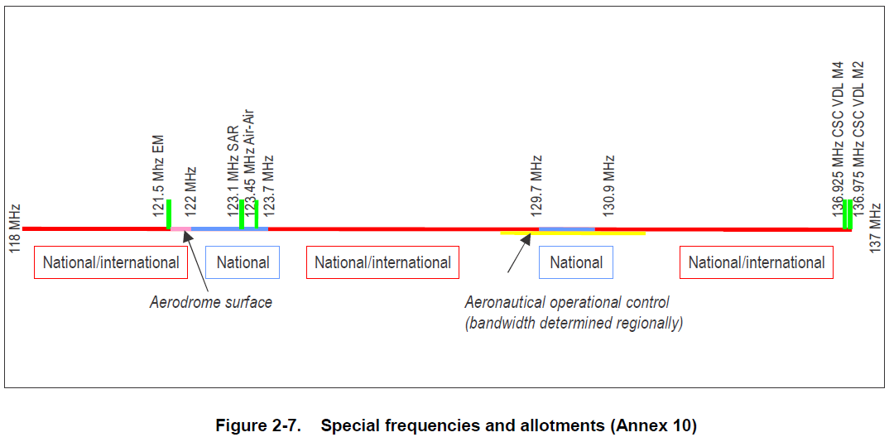
Figure 7-1: Special frequencies and allotments (Annex10)

2.4.1.3 Regional allotment plans provide for the use of the frequency band 136–137 MHz by VDL (VDL Mode 2 and VDL Mode 4).
2.4.2.1 In addition to the general allotment plan in Annex 10, all regions have developed more detailed allotment plans through which operational services are allotted to certain frequency bands and are included in relevant ICAO Regional Air Navigation Plans. The prime goal of these allotment plans is to accommodate new frequency assignments in the sub-bands allotted to a particular service. Appendix B and the supplement (published separately) to this Handbook contain a detailed overview of these allotment plans. The supplement can be downloaded at: http://www.icao.int/safety/fsmp/documents/doc9718.
2.4.2.3 Regional allotment plans provide the use of the frequency band 136–137 MHz by VDL (VDL Mode 2 and VDL Mode 4). In Europe, the frequency band 136.700–137.000 MHz is reserved for VDL (see Appendices B and C).
Section 2.5 (Frequency separation and channeling), lays down:
2.5.1.2 Currently, 8.33 kHz frequency separation has only been introduced in the EUR region. All other regions have agreed to base frequency assignment planning on 25 kHz frequency separation. This implies that radio equipment designed for 50 kHz or 100 kHz frequency separation, which may be still in operational use, may not always be protected from harmful interference that can be caused by stations operating on adjacent 25 kHz or 8.33 kHz frequencies.
Section 2.6 (Services and designated operational coverage (DOC)), lays down:
2.6.7 Coordination of frequency assignments. Frequency coordination must take place with all States that may be affected by a proposal for a new frequency assignment or where the characteristics of an existing assignment are modified. Normally, such coordination is effected through the ICAO Regional Offices which have a central and coordinating role in frequency assignment planning.
Section 2.9 (Separation distances for VDL (VDL Mode 2 and VDL Mode 4) lays down:
2.9.1.1 The same planning criteria as those used between VHF voice systems (20 dB protection ratio) should be used. The separation criteria are calculated as described in 2.7.2. The DOC for VDL Mode 2 and VDL Mode 4 facilities needs to be separated from the DOC of a co-frequency VHF communications voice (DSB-AM) system by at least the sum of the distance to the radio horizon of each service.
Note.— This applies also to frequency assignments between VDL facilities not operating in the same network.
2.9.2.1 The first frequency adjacent (25 kHz) to either a DSB-AM frequency or a VDL frequency should not be used in the same airspace.
Note.— The numbers in Table 2-10 are guard bands (channels). The next frequency that can be used without a frequency planning constraint is one channel higher (e.g. a desired DSB-AM station that is interfered by a VDL Mode 2 aircraft station requires one 25 kHz guard band). The next frequency, 50 kHz away, can be used in the same DOC without any frequency assignment planning constraint.

Annex 10 – Volume III – Communications Systems
This Part of Annex 10 includes Standards and Recommended Practices for certain forms of equipment for communication systems. While the Contracting State will determine the necessity for specific installations in accordance with the conditions prescribed in the relevant Standard or Recommended Practice, review of the need for specific installation and the formulation of ICAO opinion and recommendations to Contracting States concerned, is carried out periodically by Council, ordinarily on the basis of recommendations of Regional Air Navigation Meetings (Doc 8144, Directives to Regional Air Navigation Meetings and Rules of Procedure for their Conduct).
Part I – Digital Data Communication Systems lays down in their Chapter 6 (VHF Air-Ground Digital Link (VDL)) significant elements to taken in to account for these studies:
Mode 2. A data-only VDL mode that uses D8PSK modulation and a carrier sense multiple access (CSMA) control scheme.
6.1.2.1 Aircraft station radio frequency range. An aircraft station shall be capable of tuning to any of the channels in the range specified in Section 6.1.4.1 within 100 milliseconds after the receipt of an autotune command. In addition, for VDL Mode 3, an aircraft station shall be able to tune to any channel in the range specified in Section 6.1.4.1 within 100 milliseconds after the receipt of any tuning command.
6.1.2.3 Common signalling channel. Frequency 136.975MHz shall be reserved as a worldwide common signaling channel (CSC) for VDL Mode 2.

6.2 SYSTEM CHARACTERISTICS OF THE GROUND INSTALLATION
6.2.2 Power. Recommendation.— The effective radiated power should be such as to provide a field strength of at least 75 microvolts per metre (minus 109 dBW/m2) within the defined operational coverage of the facility, on the basis of free-space propagation.
6.2.3.1 Spurious emissions shall be kept at the lowest value which the state of the technique and the nature of the service permit.
Note.— Appendix S3 to the Radio Regulations specifies the levels of spurious emissions to which transmitters must conform.
6.2.4 Adjacent channel emissions
6.2.4.3.1 After 1 January 2002, the amount of power from all new installations of a VDL ground transmitter under all operating conditions when measured over a 16 kHz channel bandwidth centred on the first adjacent channel shall not exceed minus 18 dBm.

6.3 SYSTEM CHARACTERISTICS OF THE AIRCRAFT INSTALLATION
6.3.2 Power. The effective radiated power shall be such as to provide a field strength of at least 20 microvolts per metre (minus 120 dBW/m2) on the basis of free-space propagation, at ranges and altitudes appropriate to the operational conditions pertaining to the areas over which the aircraft is operated.
6.3.3 Spurious emissions
6.3.3.1 Spurious emissions shall be kept at the lowest value which the state of the technique and the nature of the service permit.
Note.— Appendix S3 to the Radio Regulations specifies the levels of spurious emissions to which transmitters must conform.
6.3.4 Adjacent channel emissions
6.3.4.3.1 After 1 January 2002, the amount of power from all new installations of a VDL aircraft transmitter under all operating conditions when measured over a 16 kHz channel bandwidth centred on the first adjacent channel shall not exceed minus 18 dBm.
6.3.5 Receiving function
6.3.5.2 Sensitivity. The receiving function shall satisfy the specified error rate with a desired signal strength of not more than 20 microvolts per metre (minus 120 dBW/m2).
Note.— The required signal strength at the edge of the service volume takes into account the requirements of the system and signal losses within the system, and considers environmental noise sources.
6.3.5.3 Out-of-band immunity performance. The receiving function shall satisfy the specified error rate with a desired signal field strength of not more than 40 microvolts per metre (minus 114 dBW/m2) and with an undesired DSB-AM D8PSK or GFSK signal on the adjacent or any other assignable channel being at least 40 dB higher than the desired signal.
6.3.5.3.1 After 1 January 2002, the receiving function of all new installations of VDL shall satisfy the specified error rate with a desired signal field strength of not more than 40 microvolts per metre (minus 114 dBW/m2) and with an undesired VHF DSB-AM, D8PSK or GFSK signal at least 60 dB higher than the desired signal on any assignable channel 100 kHz or more away from the assigned channel of the desired signal.
Note.— This level of interference immunity performance provides a receiver performance consistent with the influence of the VDL RF spectrum mask as specified in 6.3.4 with an effective isolation transmitter/receiver isolation of 69 dB. Better transmitter and receiver performance could result in less isolation required. Guidance material on the measurement technique is included in the Handbook on Radio Frequency Spectrum Requirements for Civil Aviation including statement of approved ICAO policies (Doc 9718).
6.4.2.2 Modulation rate. The symbol rate shall be 10 500 symbols/second, resulting in a nominal bit rate of 31500 bits/s. The modulation stability requirements for Modes 2 and 3 are provided in Table 6-2.

6.5 LINK LAYER PROTOCOLS AND SERVICES
6.5.1 General information
6.5.1.1 Functionality. The VDL link layer shall provide the following sublayer functions:
a) media access control (MAC) sublayer, which requires the use of the carrier sense multiple access (CSMA) algorithm for Mode 2 or TDMA for Mode 3;
b) a data link service (DLS) sublayer:
1) for Mode 2, the DLS sublayer provides connection-oriented point-to-point links using data link entities (DLE) and connectionless broadcast link over the MAC sublayer; and
2) for Mode 3, the DLS sublayer provides acknowledged connectionless point-to-point and point-to-multipoint links over a MAC sublayer that guarantees sequencing; and
c) a VDL management entity (VME), which establishes and maintains DLEs between the aircraft and the ground-based systems using link management entities (LME).

CHAPTER 10. POINT-TO-MULTIPOINT COMMUNICATIONS
10.1 SERVICE VIA SATELLITE FOR THE DISSEMINATION OF AERONAUTICAL INFORMATION
10.1.1 Point-to-multipoint telecommunication service via satellite to support the dissemination of aeronautical information shall be based on full-time, non pre-emptible, protected services as defined in the relevant CCITT Recommendations.

Part II – Voice Communication Systems lays down significant elements to taken in to account for these studies:
2.1.1 The characteristics of the air-ground VHF communication system used in the International Aeronautical Mobile Service shall be in conformity with the following specifications:
2.1.1.1 Radiotelephone emissions shall be double sideband (DSB) amplitude modulated (AM) carriers. The designation of emission is A3E, as specified in the ITU Radio Regulations.
2.1.1.2 Spurious emissions shall be kept at the lowest value which the state of technique and the nature of the service permit.
Note.— Appendix S3 to the ITU Radio Regulations specifies the levels of spurious emissions to which transmitters must conform.
2.1.1.3 The radio frequencies used shall be selected from the radio frequencies in the band 117.975 – 137 MHz. The separation between assignable frequencies (channel spacing) and frequency tolerances applicable to elements of the system shall be as specified in Volume V.
Note.— The band 117.975 – 132 MHz was allocated to the Aeronautical Mobile (R) Service in the ITU Radio Regulations (1947). By subsequent revisions at ITU World Administrative Radio Conferences the bands 132 – 136 MHz and 136 – 137 MHz were added under conditions which differ for ITU Regions, or for specified countries or combinations of countries (see RRs S5.203, S5.203A and S5.203B for additional allocations in the band 136 – 137 MHz, and S5.201 for the band 132 – 136 MHz).

2.2 SYSTEM CHARACTERISTICS OF THE GROUND INSTALLATION
2.2.1 Transmitting function
2.2.1.1.1 Offset carrier systems in 8.33 kHz, 25 kHz, 50 kHz and 100 kHz channel spaced environments. The stability of individual carriers of an offset carrier system shall be such as to prevent first-order heterodyne frequencies of less than 4 kHz and, additionally, the maximum frequency excursion of the outer carrier frequencies from the assigned carrier frequency shall not exceed 8 kHz. Offset carrier systems for 8.33 kHz channel spacing shall be limited to two-carrier systems using a carrier offset of plus and minus 2.5 kHz.
2.2.1.2 POWER
Recommendation.— On a high percentage of occasions, the effective radiated power should be such as to provide a field strength of a least 75 microvolts per metre (minus 109 dBW/m2) within the defined operational coverage of the facility, on the basis of free-space propagation.
2.2.2 Receiving function
2.2.2.2 Sensitivity. After due allowance has been made for feeder loss and antenna polar diagram variation, the sensitivity of the receiving function shall be such as to provide on a high percentage of occasions an audio output signal with a wanted/unwanted ratio of 15 dB, with a 50 per cent amplitude modulated (A3E) radio signal having a field strength of 20 microvolts per metre (minus 120 dBW/m2) or more.
2.2.2.4 Adjacent channel rejection. The receiving system shall ensure an effective rejection of 60 dB or more at the next assignable channel.

2.3 SYSTEM CHARACTERISTICS OF THE AIRBORNE INSTALLATION
2.3.1 Transmitting function
2.3.1.2 Power. On a high percentage of occasions, the effective radiated power shall be such as to provide a field strength of at least 20 microvolts per metre (minus 120 dBW/m2) on the basis of free space propagation, at ranges and altitudes appropriate to the operational conditions pertaining to the areas over which the aircraft is operated.
2.3.1.3 Adjacent channel power. The amount of power from a 8.33 kHz airborne transmitter under all operating conditions when measured over a 7 kHz channel bandwidth centred on the first 8.33 kHz adjacent channel shall not exceed -45 dB below the transmitter carrier power. The above adjacent channel power shall take into account the typical voice spectrum.
Note.— The voice spectrum is assumed to be a constant level between 300 and 800 Hz and attenuated by 10 dB per octave above 800 Hz.
2.3.2 Receiving function
2.3.2.1 Frequency stability. Where 8.33 kHz channel spacing is introduced in accordance with Volume V, the radio frequency of operation shall not vary more than plus or minus 0.0005 per cent from the assigned frequency.
2.3.2.2 SENSITIVITY
2.3.2.2.1 Recommendation.— After due allowance has been made for aircraft feeder mismatch, attenuation loss and antenna polar diagram variation, the sensitivity of the receiving function should be such as to provide on a high percentage of occasions an audio output signal with a wanted/unwanted ratio of 15 dB, with a 50 per cent amplitude modulated (A3E) radio signal having a field strength of 75 microvolts per metre (minus 109 dBW/m2).
Note.— For planning extended range VHF facilities, an airborne receiving function sensitivity of 30 microvolts per metre may be assumed.

2.3.2.5 Adjacent channel rejection. The receiving function shall ensure an effective adjacent channel rejection as follows:
a) 8.33 kHz channels: 60 dB or more at plus or minus 8.33 kHz with respect to the assigned frequency, and 40 dB or more at plus or minus 6.5 kHz;
Note.— The receiver local oscillator phase noise should be sufficiently low to avoid any degradation of the receiver capability to reject off carrier signals. A phase noise level better than minus 99 dBc/Hz 8.33 kHz away from the carrier is necessary to comply with 45 dB adjacent channel rejection under all operating conditions.
b) 25 kHz channel spacing environment: 50 dB or more at plus or minus 25 kHz with respect to the assigned frequency and 40 dB or more at plus or minus 17 kHz;
c) 50 kHz channel spacing environment: 50 dB or more at plus or minus 50 kHz with respect to the assigned frequency and 40 dB or more at plus or minus 35 kHz;
d) 100 kHz channel spacing environment: 50 dB or more at plus or minus 100 kHz with respect to the assigned frequency.
2.3.2.6 Recommendation.— Whenever practicable, the receiving system should ensure an effective adjacent channel rejection characteristic of 60 dB or more at plus or minus 25 kHz, 50 kHz and 100 kHz from the assigned frequency for receiving systems intended to operate in channel spacing environments of 25 kHz, 50 kHz and 100 kHz, respectively.
Note.— Frequency planning is normally based on an assumption of 60 dB effective adjacent channel rejection at plus or minus 25 kHz, 50 kHz or 100 kHz from the assigned frequency as appropriate to the channel spacing environment.

2.3.2.8 VDL—INTERFERENCE IMMUNITY PERFORMANCE
2.3.2.8.1 For equipment intended to be used in independent operations of services applying DSB-AM and VDL technology on board the same aircraft, the receiving function shall provide an adequate and intelligible audio output with a desired signal field strength of not more than 150 microvolts per metre (minus 102 dBW/m2) and with an undesired VDL signal field strength of at least 50 dB above the desired field strength on any assignable channel 100 kHz or more away from the assigned channel of the desired signal.
Note.— This level of VDL interference immunity performance provides a receiver performance consistent with the influence of the VDL RF spectrum mask as specified in Volume III, Part I, 6.3.4 with an effective transmitter/receiver isolation of 68 dB. Better transmitter and receiver performance could result in less isolation required.
ATTACHMENT TO PART I. GUIDANCE MATERIAL FOR THE VHF DIGITAL LINK (VDL),,
3.1.4 VDL virtual circuits may be cleared when the aircraft or ground IS identifies a policy situation where the virtual circuit to the ground DTE is no longer necessary but this shall only happen if another VDL virtual circuit remains established. A policy situation is a situation where considerations other than coverage influence the decision to establish a connection. This could be, for example, a situation where an aircraft is within the designated operational coverage area of ground stations operated by different operators and a decision must be made with which operator to establish a connection. The case where an aircraft crosses a border between two States needs special attention. An aircraft has to establish a virtual circuit to the DTE in the IS of the State entered before clearing the virtual circuit with the DTE in the IS of the State left.
3.1.5 The scenarios for subnetwork connection maintenance are shown in Figure ATT I-1*. If the ground stations on each side of a State border do not offer ISO 8208 connectivity to the DTEs of the IS in both States, aircraft crossing the border will have to set up a link connection to a ground station in the State entered before being able to establish a virtual circuit to the IS of that State. Only after establishment of the new link connection and virtual circuit, the aircraft will clear the virtual circuit with the DTE of the IS of the country left over the link which gave access to that IS. If the VDL aeronautical stations on both sides of the State border offer connectivity to the IS in both States, the changeover of the virtual circuits has to take place over the same link connection.
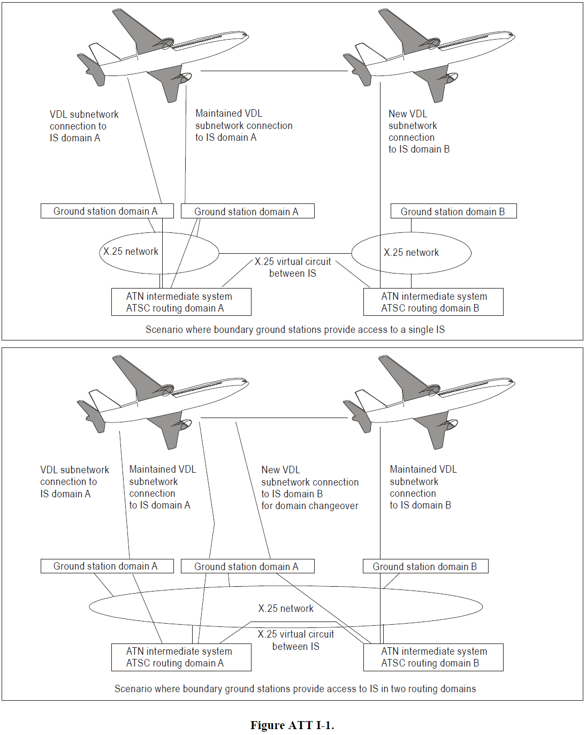
Figure 7-2: Figure ATT I-1 from Annex 10 – Volume III – Communications Systems

3.2 VDL quality of service for ATN routing
3.2.1 The use of the VDL system for air-ground communications will depend on the routing decisions of aircraft and ground-based ATN IS. These ISs will decide on the path to be used for air-ground communications based on quality of service values requested by transmitting ESs.
3.2.2 The IS at each end of the air-ground connections must interpret the requested QOS value and decide which of the available connections can best be met. It is important that the level of QOS which a VDL connection is perceived as providing is set at a level which corresponds to its true performance.
3.2.3 In cases where the VDL is the only data link with which an aircraft has been equipped, all communications must be routed via a VDL connection and the value set for QOS to be provided by the connection must not block the communication.
3.2.4 In other cases where aircraft are equipped with other air-ground data links (such as AMSS and SSR Mode S) there may be simultaneous parallel connections over multiple subnetworks. In these cases, the values for QOS provided by each subnetwork must be set so as to ensure that the VDL connection will be used where appropriate.
3.2.5 It is necessary that coordination take place between aircraft operators, ground station operators and ground system operators to ensure that the right balance is achieved between different subnetworks.

4.2 Institutional issues concerning VDL ground station network operators
4.2.1 An ATS provider wishing to use VDL for air traffic service (ATS) communications needs to ensure that the VDL service is available. The ATS provider can either operate the VDL ground station network itself or arrange for the operation of the VDL stations (or VDL network) by a telecommunications service provider. It seems likely that individual States will make different arrangements for the provision of VDL service to aircraft. Operation and implementation of VDL need to be coordinated at a regional level in order to ensure acceptable service on international routes.
4.2.2 The use of a VDL ground station network by entities external to the ATS provider will be subject to service agreements between the ATS provider and the telecommunications service provider. These agreements set out the obligations of the two parties and need, in particular, to be specific on the quality of service provided as well as the characteristics of the user interface.
4.2.3 It seems likely that some VDL ground station network operators will levy user charges. These are expected to be levied either on the aircraft operators and/or on the ATS providers. It is necessary to ensure that the use of VDL is feasible for those aircraft operators intended to use VDL for ATS/AOC communications.

4.3 VDL ground station equipment
4.3.1 A VDL ground station will consist of a VHF radio and a computer which may be separate or integrated with the radio. The VDL functionality of the VHF radio equipment will be similar to that installed in aircraft.
4.3.2 The provision of network status monitoring is an important element in the maintenance of the highest availability possible.

4.4 Ground station siting
4.4.1 The line of sight limitations of VHF propagation is an important factor in the siting of ground stations. It is necessary to ensure that the ground stations are installed in a manner which provides coverage throughout the designated operational coverage area (DOC).
4.4.2 The coverage requirements for VDL depend on the applications that are intended to operate over the VDL. These applications may function, for example, when an aircraft is at en-route altitude, in a terminal area or on the ground at an airport.
4.4.3 En-route coverage can be provided using a small number of ground stations with a large DOC (for example, the range of a VHF signal from a station at sea level and an aircraft at 37 000 ft is approximately 200 NM). Hence, it is in fact desirable that the smallest number of ground stations possible be used to provide en-route coverage in order to minimize the possibility of simultaneous uplink transmissions from ground stations which may cause message collisions on the VHF channel. The factors limiting en-route coverage will be availability of landmass and the availability of a communications link from a ground station to other ground systems.

4.5 Ground station frequency engineering
4.5.1 The choice of the VHF channel on which a ground station will operate depends on the coverage that the ground station will be required to provide. Coverage on a particular channel is provided by a collection of ground stations operating on that channel and the communications on that channel will occupy the channel for all the ground stations in a coverage area.
4.5.2 As with VHF voice communications, VDL communications cannot be limited to propagating only within States, and frequency coordination between States will be required in the allocation of VDL frequencies. The nature of the protocol does, however, allow for frequency re-use by several ground stations within the same coverage area and hence the rules for the assignment of frequencies are not the same as for voice communications.
4.5.3 The carrier sense multiple access (CSMA) media access control protocol (MAC) layer used in VDL cannot exclude message collisions if some stations using a frequency channel cannot receive the transmissions of other stations, a situation known as a hidden transmitter situation. Hidden transmitters lead to simultaneous transmissions which can cause the intended receiver of one or both transmissions to be unable to decode the received signal.
4.5.4 A frequency will be assigned to providing en-route coverage and all the en-route stations will be set to operate on this frequency. In order to minimize the probability of simultaneous transmissions on the channel by hidden transmitters in a CSMA environment, this channel may not be used for terminal area or aerodrome surface communications except in areas of very low channel loading.
4.5.5 The VDL SARPs call for the provision of a common signalling channel (CSC) on which access to VDL service will be guaranteed in all areas where VDL Mode 2 service is available. This is especially important at airports and on the edge of VDL en-route coverage zones where aircraft are likely to establish initial VDL connectivity. Since the characteristics of Mode 1 and Mode 2 radio frequency transmissions are not compatible, the CSC cannot be used for Mode 1 communications. There is no requirement for a CSC for VDL Mode 1.

Manual on VHF Data Link (VDL) Mode 2 (Doc 9776)
The Manual on VHF Data Link (VDL) Mode 2 establishes interesting details to take into account to understand the operational coordination for AMS(R)S applications over VDL Mode 2 with AM(R)S applications over VDL Mode 2.
It is not intended to summarize the document in this section, but to bring main elements to understand how Common Signalling Channel (CSC) works and how an aircraft could scan for another VDL Mode 2 channels when the aircraft doesn’t detect the CSC 136.975MHz carrier.
In “Part I. Implementation aspects, Chapter 3. Link layer protocols and services” we can find the follows paragraphs:
3.4.1.2 Common signalling channel. The common signalling channel (CSC) (136.975 MHz) is used wherever service providers want to annunciate the VDL availability of CNS services over VHF carriers using the VDL Mode 2 physical and MAC layers (i.e. D8PSK and CSMA). By guaranteeing one common frequency, the problem of the aircraft in trying to locate a valid frequency is minimized. Also, aircraft tuned to frequencies other than the CSC do not need the frequency list XID parameter to be aware of an alternate frequency to use in the frequency recovery function.
3.4.1.2.1 Invocation. The LME should use the CSC to establish a link level connection when commanded startup or other search algorithms have failed and an aircraft is equipped for VDL Mode 2 and is in a service area that offers VDL Mode 2. The aircraft LME tunes the radio to the CSC and attempts to establish a link. After a link is established, the ground station may send an autotune command to the aircraft to have it switch to a different frequency.
3.4.1.2.2 Failure. If no link can be established using the CSC, then the LME may optionally use the frequency search function. Otherwise, the CSC function remains active.
3.4.1.3 Frequency search. The frequency search function attempts to establish a data link connection with any station on any frequency. Frequencies known a priori to be available for data service are scanned, and upon detection of an appropriate/usable signal, a link is established.
3.4.1.3.1 Invocation. The LME should perform the frequency search function upon commanded startup or failure of other search algorithms, and either the aircraft cannot use VDL Mode 2 or is not in a service area that offers VDL Mode 2 service.
3.4.1.3.2 Failure. If the frequency search function fails, the LME may use the CSC or remain in the frequency search function.
3.4.1.3.3 Timer TG1 (maximum frequency dwell time). This timer is implementation-dependent and is included as an example of what parameter(s) an implementation may include in the frequency search table. The frequency search table is a static table located in the aircraft LME that lists possible frequencies on which to attempt to make a link, the provider(s) available on that frequency, and whatever other pertinent information is required by the specific LME implementation in the selection of an optimal frequency.

In section “Part II – Detailed Technical specifications” we can find also the follows paragraphs:
5.4.4.1 Frequency management procedures. The aircraft LME shall use the following procedures to acquire a frequency on which reliable VDL services are available.
5.4.4.1.1 Frequency search. The aircraft LME shall initiate the frequency search procedure on system initialization or after link disconnection, if it can no longer detect uplink VDL frames on the current frequency. It shall attempt to identify a frequency on which VDL service is available by tuning the radio to the CSC and to other frequencies on which it knows a priori that VDL service is available. It shall scan until it detects a valid uplink VDL frame with an acceptable source address or until Timer TG1 expires, in which case it shall tune the radio to another frequency and continue to scan.
5.4.4.1.2 Frequency recovery. The aircraft LME shall initiate the frequency recovery procedure if it can no longer establish a link on the current frequency or if the MAC entity indicates that the current frequency is congested. When airborne, it shall tune the radio to an alternate frequency using the data in the air frequency support list previously received on the current link.

As a summary of previous requirements, it can be concluded that the VDL Mode 2 nominally works with the CSC in a first instance but the standard also permits to work with other carriers if the CSC is not available. This feature of the CSC is very important as some confusion has arisen when addressing the mandatory need of using the CSC just in one single frequency assignment or the CSC can effectively work in any frequency assignment, so decided, within the full range 136-137 MHz.
This is very well known by the Communication Services Providers and by the Aircraft Operator when they are setting the options to link in the CMF of the aircraft. In the below figure there is an example where the Aircraft is configured for an automatic sharing operation in function of region and establishing the precedence criteria to connect using POA or AOA services and the VHF frequencies channels to use in combination with the previous parameters.

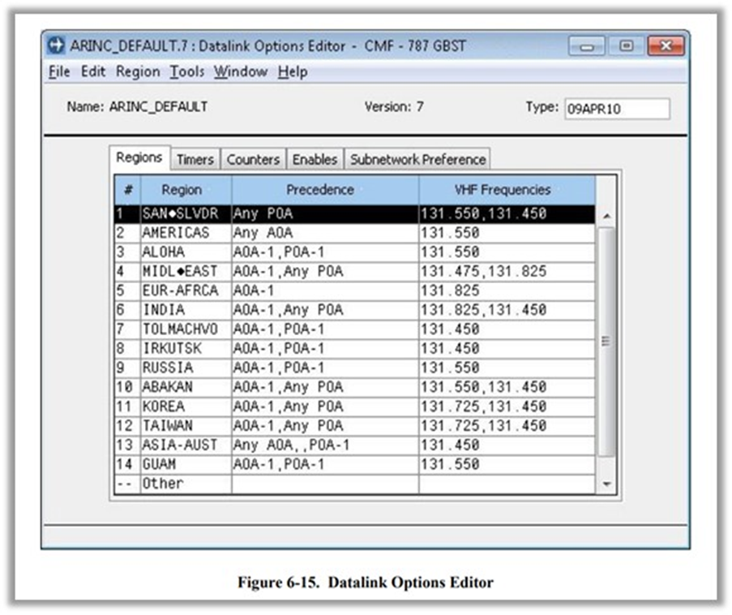
Figure 7-3: Example of CMF setting for VHF frecuencies use

Manual on the Aeronautical Mobile Satellite (Route) Service (Doc 9925)
This document lays down in its Part I general information on AMS(R)S including information on applications, user requirements, potential operational benefits, and information on standardization activities undertaken by ICAO and aviation industry bodies. The Manual does not enter to specify a technology to provide the service, that is, is agnostic to the technology. It should be noted that this document signals to satellite communication as crucial element for future air traffic management.
FOREWORD
Satellite technology has a unique potential to satisfy many present and future communication, navigation and
surveillance (CNS) needs. A key part of system improvement in the future is the introduction of air-ground digital
communication services which could provide substantial benefits in air traffic services (ATS) efficiency and capacity, satisfying the needs of air traffic safety as well. Important system considerations include: worldwide interoperability; access by all classes of aeronautical users; the need to accommodate evolutionary system growth in terms of functional capability and capacity in an adaptive manner, considering different requirements in different areas; and the potential for taking advantage of satellite service capability from different service providers.

The Aeronautical Communications Panel (ACP) of the Air Navigation Commission has carried forward future air navigation systems planning that designated basic architectural concepts for using satellite communications, initially in oceanic and remote environments, and eventually in continental airspace. Progress in the development of satellite communications for aeronautical safety is made through the revision of Standards and Recommended Practices (SARPs) and guidance material by ICAO for the aeronautical mobile satellite (route) service (AMS(R)S) and through the interactions of ICAO with other international bodies to assure that resources are coordinated and available.

Accepting to largely replace voice communications with the application of data links to support ATS requires assurance that all relevant elements of data link network(s) and subnetworks (such as a satellite subnetwork) are properly coordinated and interoperable. AMS(R)S is considered a global satellite subnetwork of the aeronautical telecommunication network (ATN) that provides end-to-end voice and data connectivity among end-users, such as air traffic controllers, pilots and aircraft operators. Interoperability with the ATN is assured by means of a standardized architecture for all elements of the ATN, based on ICAO SARPs and guidance material.

The objective of this manual is to provide an overview of systems operating in the AMS(R)S and offer guidance on the consideration of satellite networks as a platform for AMS(R)S communications for the safety and regularity of flight. The AMS(R)S serves the safety, regularity and efficiency of flight by providing communications between the aircraft earth stations (AES) (on-board an aircraft) and ground earth stations (GES) through a satellite link.

Part I - Chapter 2
Costs and benefits
2.2.30 The initial cost of AES equipment varies widely depending on the class of service provided, e.g. core
capability, data rate and voice capability. Moreover, aircraft operators have an interest in keeping the cost and quantity of onboard equipment to a minimum. Any onboard equipment requirements should appropriately weigh costs and benefits ensuring that the minimum communications service standards are met and taking into account the desire for minimizing cost.

2.3.1 The application of AMS(R)S in oceanic and remote areas should provide improved communications,
surveillance and procedures. This will lead to improved safety, increased airspace efficiency including a potential for reduced separation, improved meteorological information, and reduced flight time, based on the use of more efficient flight profiles.
2.3.2 A reduction of longitudinal and lateral separation between aircraft requires enhanced CNS capabilities in
air traffic systems and on board those aircraft. Enhanced CNS systems provide controllers with automated tools such as conflict prediction and reporting to assist in separation assurance and with tools to better monitor flight plan conformance. Enhanced communication and surveillance systems also enable controllers and pilots to better communicate and manage weather deviations and contingency situations such as aircraft turn-backs and diversions.

2.3.3 Flight planning plays an important role in operations over oceanic airspace. Theoretically, the flight path
from departure aerodrome to destination, along a great circle, would give the minimum distance track. However, wind speeds and directions and other meteorological aspects such as temperature, areas of clear air turbulence, etc., affect flight times and therefore the optimum flight paths vary considerably from day to day. Additionally, the free choice of the desired flight path may be restricted by the need to maintain a particular flight level, MACH number or a specific track in an organized track system.
2.3.4 Fuel cost is a dominant part of the total cost of flight operations and is especially significant for longdistance
flights. ATC can assist in fuel conservation and gas emissions reduction by accepting a pilot’s request for a
change of the current flight plan (if the traffic situation permits) which is normally a result of a change in the operational factors affecting the efficiency of the flight.

2.3.9 The AMS(R)S in oceanic areas with high air traffic density will provide capability for rapid access
communications between the ground and the aircraft for both data and voice. This system will be able to accommodate ADS.
2.3.10 The evolution of ATM resulting from AMS(R)S (data and voice communications environment) is characterized by the improvement of traffic monitoring (surveillance accuracy), trajectory prediction, and conflict search and resolution, including short-term conflict alert, and will in addition permit improvement of existing flight planning procedures.
2.3.11 Consequently, a reduction of longitudinal and lateral separation, an increase of tactical conflict resolution
and better accommodation of optimal routes are expected.

Although in part I of this document the limitations of the current VDL ground service are considered, the implementation of this service in the future AMS(R)S via VHF space stations in orbit may require a new section of this document to collect the characteristics of the new Space Based VHF Services which incorporate all the benefits described in this document for AMS(R)S but with the huge benefit that the aircrafts do not need change its avionics and airworthiness certifications.

All the institutional arrangements laid down in chapter 4, section 4.1 referring to the guidelines stressed by ICAO’s Tenth Air Navigation Conference could be used to support the new allocation of AMS(R)S in the VHF aeronautical band.

Global Operational Data Link (GOLD) Manual (Doc 10037)
The GOLD Manual provides guidance and information concerning data link operations and is intended to facilitate the uniform application of Standards and Recommended Practices contained in Annex 2 — Rules of the Air, Annex 10 — Aeronautical Telecommunications and Annex 11 — Air Traffic Services, the provisions in the Procedures for Air Navigation Services — Air Traffic Management (PANS-ATM, Doc 4444) and, when applicable, the Regional Supplementary Procedures (Doc 7030).
This guidance material is intended to improve safety and maximize operational benefits by promoting seamless and interoperable data link operations throughout the world. This edition applies to DLIC, ADS-C, and CPDLC using FANS 1/A and ATN B1 technologies. Additional guidance is provided that applies to CPDLC for automatic dependent surveillance – broadcast (ADS-B) in-trail procedure (ITP).
This document is brought here to emphasize the importance of data link to the aviation industry.
1.1.1 Data link benefits
1.1.1.1 Data link services, such as CPDLC and ADS-C, provide communications that are intended to support safer and more efficient air traffic management and increase airspace capacity.
1.1.1.2 In addition, in airspace where procedural separation is being applied, the data link services improve communications, surveillance and route conformance monitoring.
1.1.1.3 CPDLC improves communication capabilities by reducing voice channel congestion and enabling the use of CPDLC-related automation (such as automatically composing proposed text for a clearance upon completion of a conflict probe).
1.1.1.4 Depending on the specific implementation, other advantages associated with CPDLC include:
a) providing direct controller-pilot communications (DCPC) in airspace where it was not previously available;
b) allowing the flight crew to print messages;
c) allowing messages to be stored and reviewed as needed;
d) reducing flight crew-input errors by allowing the loading of information from specific uplink messages, such as route clearances or frequency change instructions, into other aircraft systems, such as the FMS or radios;
e) allowing the flight crew to request complex route clearances, which the controller can respond to without having to manually enter a long string of coordinates;
f) reducing flight crew workload by supporting automatically transmitted reports when a specific event occurs, such as crossing a waypoint and the loading of clearance information directly into the flight management system; and
g) reducing controller workload by providing automatic flight plan updates when specific downlink messages (and responses to some uplink messages) are received.

1.1.2.1 “Data link” is a generic term that encompasses different types of data link systems and subnetworks. Figure 1-1 provides an overview of a data link system, including subnetworks. While all data link capable aircraft have access to VHF data link, not all aircraft have access to additional satellite, and/or HF data link capability. Similarly, not all communication service providers (CSPs) have HF data link capability. Some ANSPs do not operationally require, nor allow use of, some of the subnetworks (e.g. SATCOM).

1.1.4.2.2 The data link services improve communications, surveillance and route conformance monitoring to support operational capabilities that enable:
a) reduced separations, for example:
1) 50 NM (93 km) longitudinal separation;
2) 30 NM (55.5 km) longitudinal separation; and
3) 23 NM (42.6 km) lateral separation.
b) user preferred route (UPR);
c) re-route in some airspace; dynamic airborne re-route procedure (DARP);
d) weather deviation management in reduced separation environments;
e) more efficient air traffic management and increases in airspace capacity. For example, ADS-C provides automatic surveillance capability that an ANSP may use to replace CPDLC and/or voice position reporting; and
f) reduced flight crew workload through, for example, automatic position reporting and the ability to load clearance information directly into the flight management system.

1.2.1.1.3. The ACARS network consists mainly of VHF (VDL M0/A and VDL M2) and satellite subnetworks, but also includes the HFDL subnetwork. The performance characteristics of each subnetwork varies and its use for ATS communications will depend on the performance required for the intended operation (refer paragraph 1.1.3).

1.2.1.2.3. The ATN relies only on VHF (VDL M2) to meet the performance required for the intended operations (refer paragraph 1.1.3.2).

Summary of ICAO Referred document
In summary, Doc. 10037 that provides information on the importance and benefits of data link operations, with an important aspect showing tthat is that the most advanced networks for the digitalization of air traffic management (ATN) rely on VHF (VDL M2) (section 1.2.1.2.3).
Doc. 9925 brings the importance of digital communications, by providing coverage of aeronautical services in remote and oceanic areas, and the need to accommodate i the growth of systems, in an evolutionary way, in terms of functional capacity and ability to adapt to different needs and the potential of the advantage provided by the service capacity of different providers.
Doc. 9776 details the protocols and technical specifications of the VDL Mode 2 application; it also explains the process of searching for the frequency to establish the service, where it can be noteden that the aircraft can tune to another channel different from the specific frequency assignment initially assigned to CSC, giving full flexibility for the operation of to establish the service if the CSC signal, which can be located in several frequency assignments when the original assigned frequency to CSC is not found.
The most technical document related to VHF voice and data communications is Volume III of ICAO Annex 10. Part I contains the technical specifications of the data link, type of modulation, basic parameters to be taken into account both in the transmitting and receiving parts. Part II sets out the technical specifications for voice communications. In the Attachment to Part I, it establishes criteria for the location of VDL stations, it is established in sections 4.5.1-4.5.2 that coverage of a particular channel can be provided by a collection of stations operating on that channel, that is, that the same frequency can be assigned to an entire area of ​​operation for multiple VDL stations.
Doc 9718 is addresses specifically spectrum use and compatibility studies. In this document, based largely on the ITU RR, it can be found the spectrum use strategy established by ICAO and details on both the coordination procedures to be followed for the allotment and assignment of frequencies, both globally and regionally, while respecting the sovereignty of the States, such as the protection criteria and the procedures to be followed. i
Finally, the highest-ranking document in this regard, Volume V of ICAO Annex 10, develops the Standards and Recommended Practices related to the use of of the frequency band 117.975 –137.000 MHz and includes matters pertaining to the selection of specific frequencies for various aeronautical purposes.
In summary, it can be noted that there is already in place a set of documents on Standards, Procedures and Tools to help the management of new AMS(R)S, specifically suitable to undertake the necessary coordination with other services operating in the 117.975-137 MHz,

Current planning and tools for frequency assignment coordination

Global, regional and national planning
Some regions as ICAO-EUR have in place already developed regional planning which connect with the ICAO Global Plan and with National Plan, as an example, the European (EUR) Air Navigation Plan (Doc 7754), in Volume I, Part I, section 5, shows a figure summarizing this relationship between global, regional and national planning
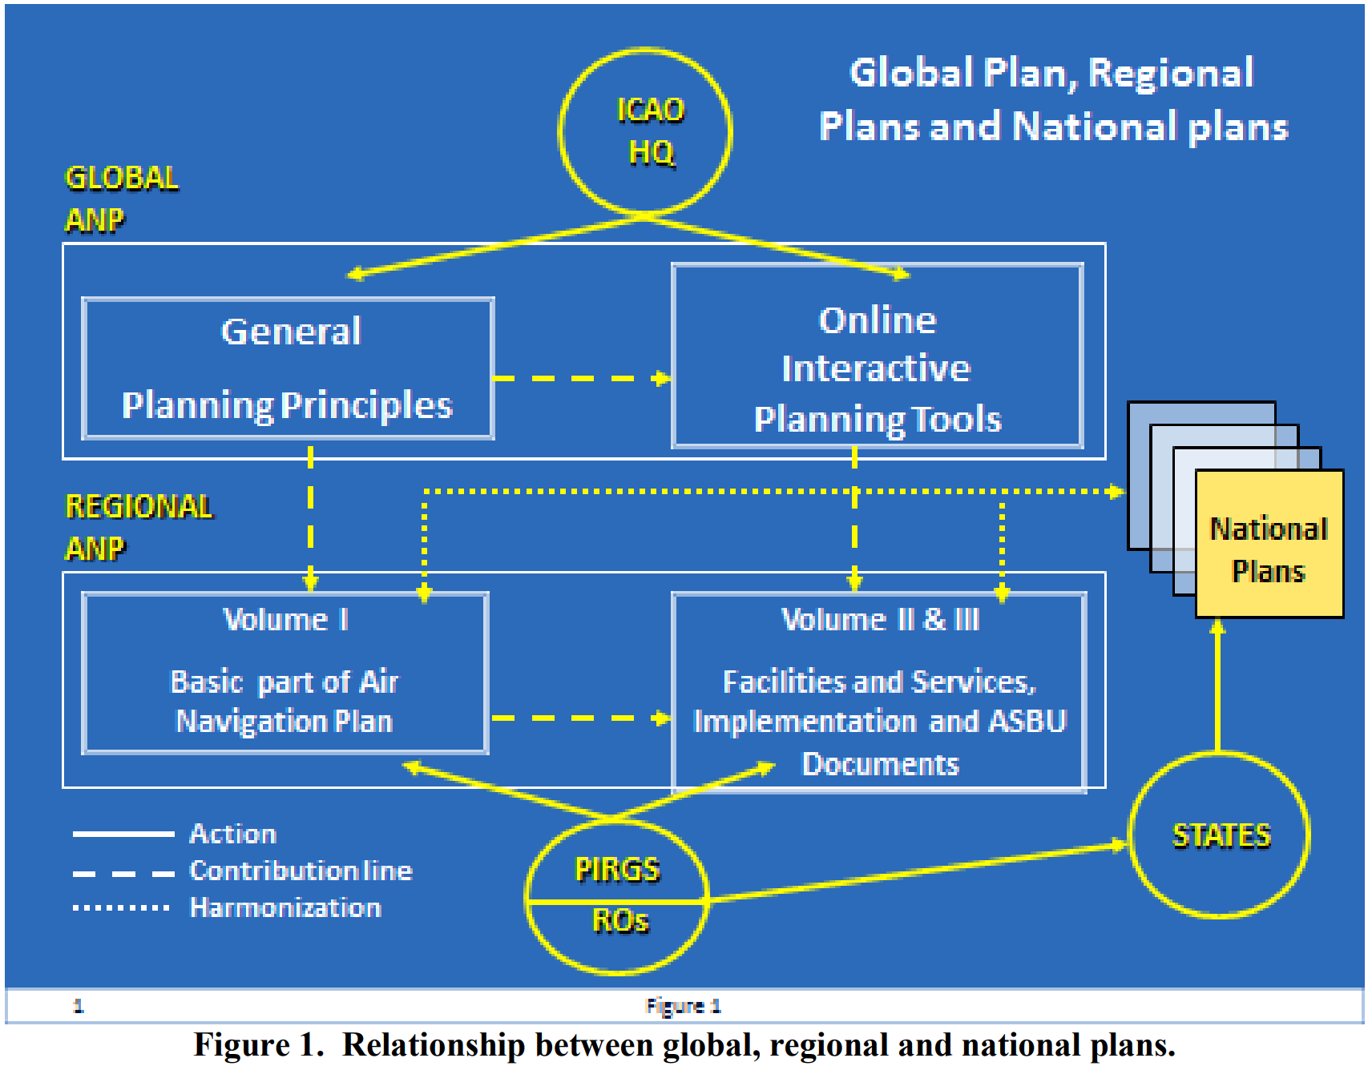
Figure 7-4: Relationship between global, regional and national plans (ICAO-EUR)
“ 5.1 Planning takes place at global, regional and national levels. Planning is accomplished with the help of planning tools and methodologies that are used primarily at the regional and national levels, conditioned by guidance from the global level. The basis for effective planning is the GANP (Doc 9750), which should guide the development of regional and national implementation plans that will support system architectures.”
The Regional Air Navigation Plans (ANPs) set forth in detail the facilities, services and procedures required for international air navigation within a specified geographical area.
The development of these regional plans is undertaken by ICAO’s six planning and implementation regional groups (PIRGs) in coordination with States and supported by ICAO’s Regional Offices and the Air Navigation Bureau.

Additional to the European Air Navigation Plan, some working groups have been defined specific to undertaking the frequency coordination activities as The Frequency Management Group (FMG) established by EANPG who has approved (formally endorsed by EASPG) the EUR Frequency Management Manual – ICAO EUR Doc 011.
This Manual (Doc 011) lays down:
PART I 2.2 The main tasks of the FMG are:
a) to establish co-ordinated frequency assignment plans for the EUR aeronautical mobile services and the EUR radio navigation aids service, and to make recommendations, as necessary, concerning frequency aspects of their implementation;
b) to co-ordinate the frequency aspects of new requirements, as necessary;
c) to give advice to States on questions of frequency assignment, rated coverage, etc., as necessary;
d) to undertake specific tasks assigned to it by the EASPG;
e) to advise the EASPG on frequency spectrum issues covering all aeronautical radio services, including satellite based facilities; and
f) to work in liaison with relevant international organisations.

PART I 3.3 “… The EASPG has mandated the use of the Spectrum and Frequency Information (SAFIRE) web based tool to carry out coordination and registration of frequency assignments in the EUR Region. …”

PART I 3.6 Co-ordination must be made with all States that in some way may be affected by the proposed assignment. Additionally some States may have an interest in being informed about changes, although not directly affecting them, in order to update national databases or for other purposes.

PART I 3.7 After successful co-ordination of a new or modified assignment, the assignment is registered in SAFIRE database. All States and ICAO are informed about the registration of assignments through SAFIRE. The registered assignments are published in the appropriate frequency assignment table of the ICAO EUR Air Navigation Plan.

PART II 1.3.1 Protection by distance separation has in the past been achieved by making sure that any other transmitter (on the ground or airborne) is below the radio horizon. Alternatively, a recently introduced change to Annex 10 allows the Regional use of a desired to undesired signal ratio of 14 dB, equivalent to a 5 to 1 distance ratio, if this separation distance is shorter than the distance to the radio horizon.

PART II 1.3.2 Risk of conflict normally only occurs between two aircraft, one in each service area, while the location of the ground transmitter is of less importance. For practical planning special software made available through EUROCONTROL or a table may be used, listing the required distance between combinations of services on the same channel. Also the adjacent channel is considered.

PART II 1.5 Co-ordination must at least be made with States which may be affected by the proposal. Special care is required for assignments with a very large co-ordination distance (e.g. VOLMET) which may exist on almost any frequency in the band.

PART II 2.1 The table ….
-131.400 – 131.975 MHz reserved for operational control (OPC) communications*
-131.525, 131.725 and 131.825 reserved for ACARS data link
- Aeronautical Mobile Services 136.900 - 136.975 MHz reserved for air-ground data link communications on a worldwide basis.
- *OPC: Assignments used for OPC purposes shall not be co-ordinated on protected standard channels. 8.33 kHz channel spacing to be used wherever possible, between 131.405 – 131.980 except for the ACARS channels 131.525, 131.725 and 131.825. The use of voice at the first adjacent 8,33 kHz channel to ACARS is not possible. Care should be taken when considering the use of the second adjacent channel at 16,67 kHz from the ACARS.
Unprotected assignments within this band can accommodate services other than OPC, where local planning conditions permit.
Concerning the use for ATS purposes of the lower adjacent frequencies to 131.400 and the upper adjacent frequencies to 131.975, care should be exercised for the observance of adjacent channel compatibility requirements.

PART II 2.2 The table below contains the VHF data link channel plan in the sub-band 136.700 – 136.975 MHz
Note 2: Services in all VDL Mode 2-allotted channels can be delivered by using dual DSP ID (dual squitter) technology.
PART II 4.1.2.2 Unprotected frequency assignment: A frequency assignment for which compatibility of reception is not assessed in the planning of aeronautical frequency assignments. Stations operating in accordance with such an assignment may expect interference from other aeronautical assignments.

PART II 4.2.2.1 The reception and the transmission of a protected frequency assignment are considered compatible with those of another protected frequency assignment, when sufficient distance or frequency separation exists to ensure the protection of the reception of both assignments.

PART II 4.3.1 A proposed assignment can be objected when it is incompatible with an existing assignment.
Note 1: A proposed assignment is incompatible with the reception of an existing protected assignment when harmful interference is expected to the reception of the existing protected assignment caused by transmissions of the proposed assignment. A proposed protected assignment is incompatible with the transmission of an existing assignment when harmful interference is expected to the reception of the proposed protected assignment caused by transmissions of the existing assignment.
Note 2: In the case of a bilateral arrangement regarding two incompatible assignments, one proposed and the other existing, it is recommended that the content of the arrangement be recorded in a repository accessible to the Registration Office.

PART II 6 Adjacent channel separation distances between services
DSM-AM to DSB-AM
The following planning criteria should be used for the deployment of DSB AM RTF services on adjacent channels:
6.1 Services with equal channel spacing (either 8.33 or 25 kHz) and frequency separation of one (1) channel or with different channel spacing and frequency separation of 25 kHz:
a) These services may have overlapping service areas provided that a separation distance of at least 10 NM is maintained between a ground receiver of one service and a ground transmitter of the other service, except when both services under consideration are on 8.33 kHz channels and at least one utilises offset carrier systems.
b) In the case of two 8.33 kHz services where one or both utilises an offset carrier system, the separation distance between services should be determined on the basis of co-channel separation criteria.
Note: For international co-ordination purposes, the only requirement for States in this case is to notify to a neighbouring State the location of ground receivers and ground transmitters that are located within 10NM of the land mass of the neighbouring State except when they are sited at the centre of a circular service. Notwithstanding, States are urged to ensure compliance with the constraint in a) within their own territories.

PART II 6 Adjacent channel separation distances between services
VDL to VDL & Other Services
6.4 Adjacent channel separation between VDL and DSB-AM systems operating in the same geographical area shall be in accordance with the following table.
Note 1: The numbers in the table represent the guard channels (25 kHz). The next frequency that can be used without any frequency assignment planning constraint is 1 (one) higher (e.g. a desired DSB-AM station that is interfered by a VDL mode 2 aircraft station requires one 25 kHz guard band channel. The next frequency, 50 kHz separated from the VDL Mode 2 assigned frequency, can be used in the same designated operational coverage area without any frequency assignment planning constraint.

PART II 7 Operational Control
7.1 Dedicated frequencies for operational control purposes should be assigned to those aircraft operators who are required to maintain a system of Operational Control under the provisions of Annex 6, Part I.
7.3 The Annex 10 provisions for frequency protection should not apply to OPC frequencies used in the EUR region.

PART IV 1.1 Co-ordination and registration procedures for frequency assignments are usually agreed between States under the rules of the ITU. These procedures are agreed between States in order to assure mutual acknowledgement of (the status of) each other's frequency assignments and the corresponding rights and obligations under ITU rules. Within the aeronautical ICAO community in Europe, the FMG has established co-ordination procedures between States, which can be regarded as mirror procedures to the formal ITU versions. Although these procedures do not have the same formal status as the original ITU-ones, in practice they are treated by States concerned in much the same way. This document highlights the main parties involved in these procedures and their mutual relationship/responsibility.

Supplement C-4.2 The 5:1 distance ratio equates to a D/U of at least 14dB as described in ICAO Annex 10 Volume V Attachment A. In cases where the undesired ray path is intersected by terrain, the D/U ratio will be preserved. Thus compatibility will be achieved, providing the undesired-to-desired distance ratio is not less than 2.5:1.
Supplement C-5.2 The use of the RLOS distance as the compatibility criterion is based on the requirements of ICAO Annex 10 Volume V, which states: "The geographical separation between facilities operating on the same frequency shall, except where there is an operational requirement for the use of common frequencies for groups of facilities, be such that the protected service volume of each facility is separated from the protected service volume of the other facility by a distance not less than that required to provide a desired to undesired signal ratio of 20 dB or by a separation distance not less than the sum of the distances to associated radio horizon of each service volume, whichever is smaller."

Supplement G-1.3. Non co-site operations
1.3.1. VDL Mode 2 operations can co-exist with other ACARS (AM with MSK modulation), VDL Mode 2 data, and voice services if the proper frequency and channel separations are observed. Based on a transmitter power of 25 watts and omni-directional antennas:
1.3.1.1. A VDL Mode 2 station can be expected to operate satisfactorily within 50 kHz of another VDL Mode 2, AM Voice, or ACARS station if the antennas are separated by a distance in the order of 2 kilometres.

Supplement G-1.4. Co-site operation of active VDL channels
1.4.1. For co-site installations a combination of frequency and distance separation should be applied based on the principles set out below.
1.4.2. It is expected that the VDL service will require three active VDL channels in an airport, co-site environment (e.g., the Common Signaling Channel (CSC), Alternate #1, and Alternate #2). Therefore, it is expected that each VDL transceiver will require two or three cavity filters with the notch tuned to the other two frequencies that are being rejected.

Supplement G-2.2.2. Undesired Frequency: For calculation purposes, the undesired frequency can generally be taken as 136.975 MHz; i.e. the frequency of the VDL Mode 2 Common Signalling Channel (CSC).
2.2.3. Antenna Characteristics: The antenna systems are assumed to be omni-directional with a net gain of 0 dBi (antenna gain minus feeder/coupling losses).
2.2.4. Desired Signal: The minimum desired signal to be protected is taken to be -90dBm, measured at the input to the filter/receiver.
Note 1: ICAO Annex 10 Volume III SARPs require a minimum desired field strength of 20μV/m at the ground station which corresponds to a desired level of -94 dBm for an assumed antenna system gain of 0 dB at the input to the filter/receiver. However, in order to avoid greater complexity in the system design (e.g. additional filtering) and/or excessive separation distances, it is recommended that the ground station system is designed to support the higher value given above.
Note 2: Weaker desired signals (down to -94 dBm) may need to be protected in particular for the provision of en route coverage. While in this case the present method can be applied, the final formula (equation 3) should be adjusted to account for the level of the desired signal.
2.2.5. S/I Ratio: The minimum signal-to-interference value shall be 20 dB, measured at the input to the receiver. Thus the maximum tolerable level of the interfering signal is -110 dBm.

Tools for frequency assignment coordination
There is no a unique tool to coordinate the frequencies assignment. Some ICAO regions use the Frequency Finder tool while other uses SAFIRE or their own solution. This is not the ideal context to coordinate the frequency assignments on a worldwide basis, nevertheless, it could be a starting point to define one or several tools to be used at worldwide level. These tools are usual mechanisms both for frequency planning exercise as well as for assisting on the sharing studies. As an example, SAFIRE is intensively used in Europe due to the congestion of frequencies and necessary reuse of frequencies, the coordination process is already defined and known by the ICAO European Administration using the tool on a daily basis. The following figure summarizes the coordination process.

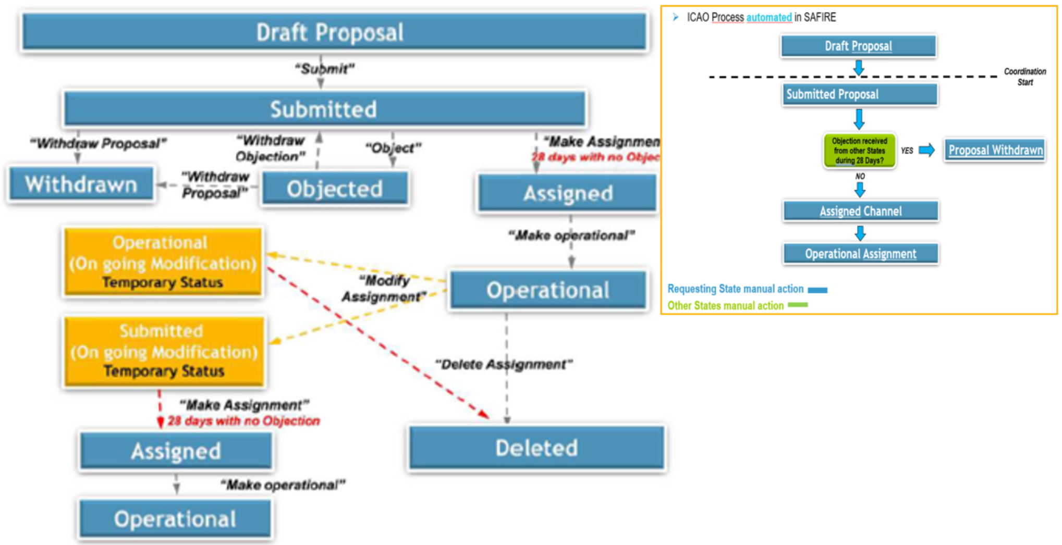
Figure 7-5: Example of frequency coordination process in EUR region

The coordination inside ICAO EUR area is efficient but the coordination with other ICAO Regional neighbours is not processed in an automated way and, so far, an Administration-to-Administration coordination process could be more practical process than a regular coordination between ICAO Regionals Offices.

Current global statistic of VHF assignments
This section provides statistical analysis on the usage of the frequency assignments to preliminary identify possible saturation of the available spectrum or whether there may be heterogeneous or unbalanced usage of certain frequency assignments.
To understand the current VHF assignments it is important to analyse the current use of VHF 117.975-137MHz channels worldwide.
Several statistical analyses were performed in order to study potential scenarios that could help to develop a worldwide coordination process for frequency assignments.
The outcome of this first analysis indicates that defining a coordination process on a Regional basis could be an easy and practical way to establish the frequency assignment criteria for the AMS(R)S.
The next graphical figures, processed from SAFIRE and Frequency Finder Data Bases, show the worldwide use of VHF channels and with different sub-bands details, it can be found that:
- 5 channels are no used worldwide.
- There are more than 35 channels used lest than 10 times worldwide.
- The more saturated sub-bands are:
  - 129-132MHz due to the AOC ground stations worldwide
  - 136-137MHz due to the VDL-Mode 2 ground stations in Europe.
- Less usage is done for the sub-band is 117.975-129MHz.

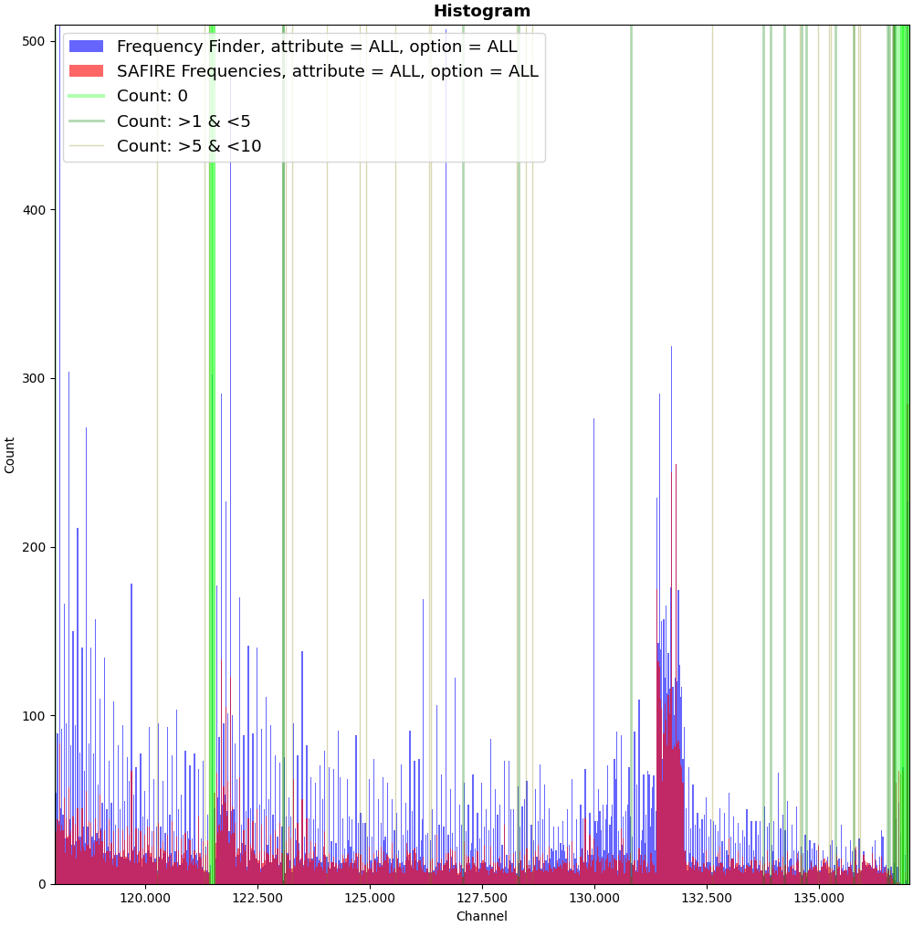 | 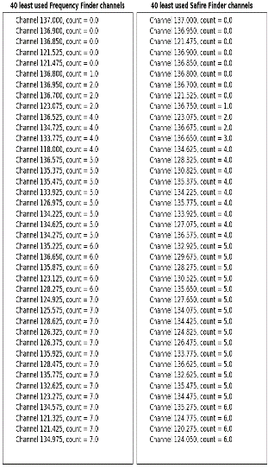

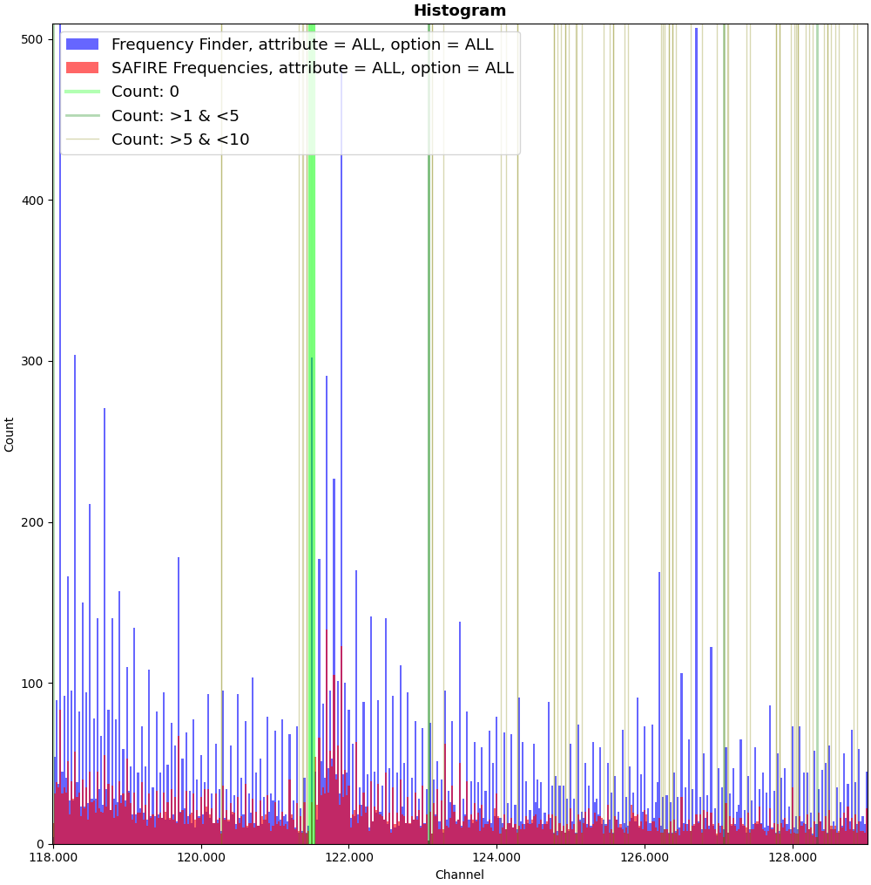 | 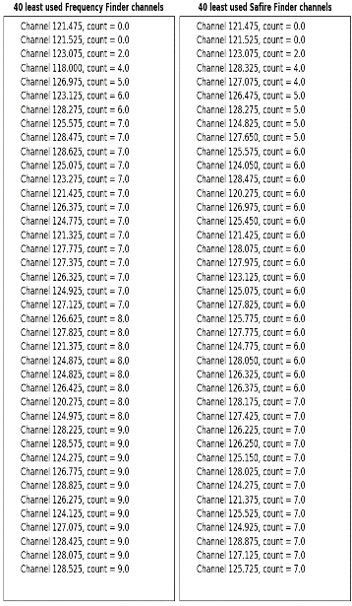

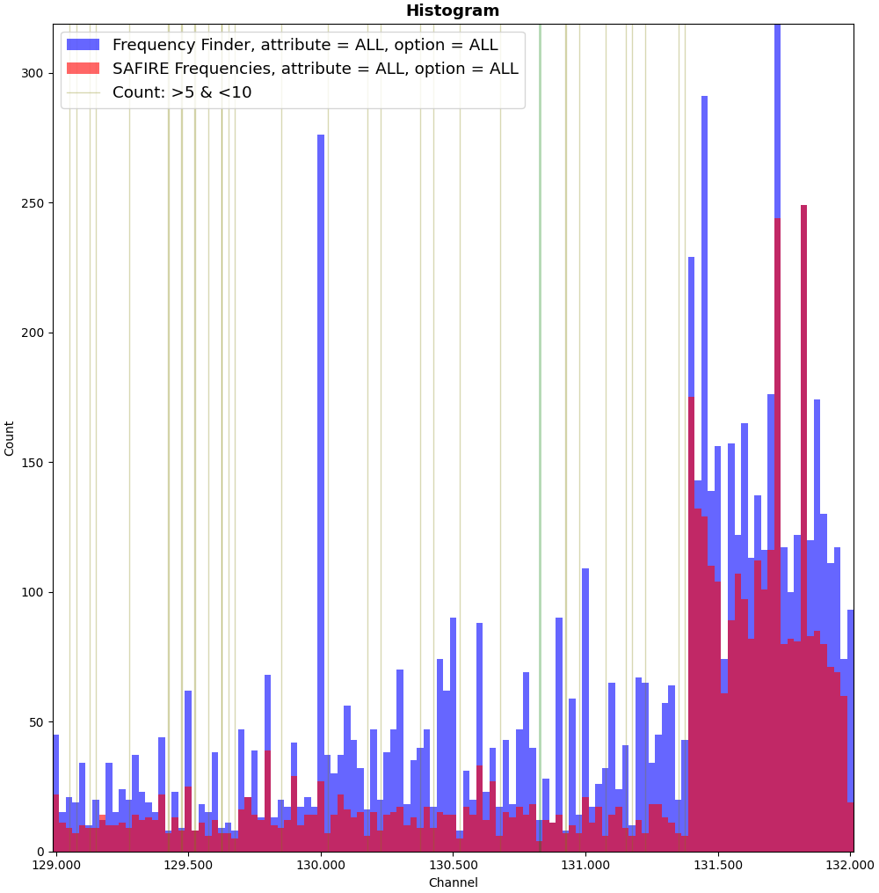 | 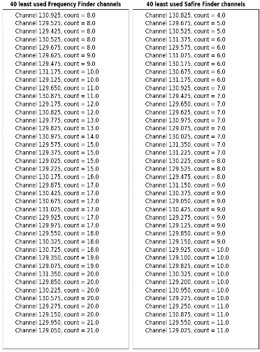

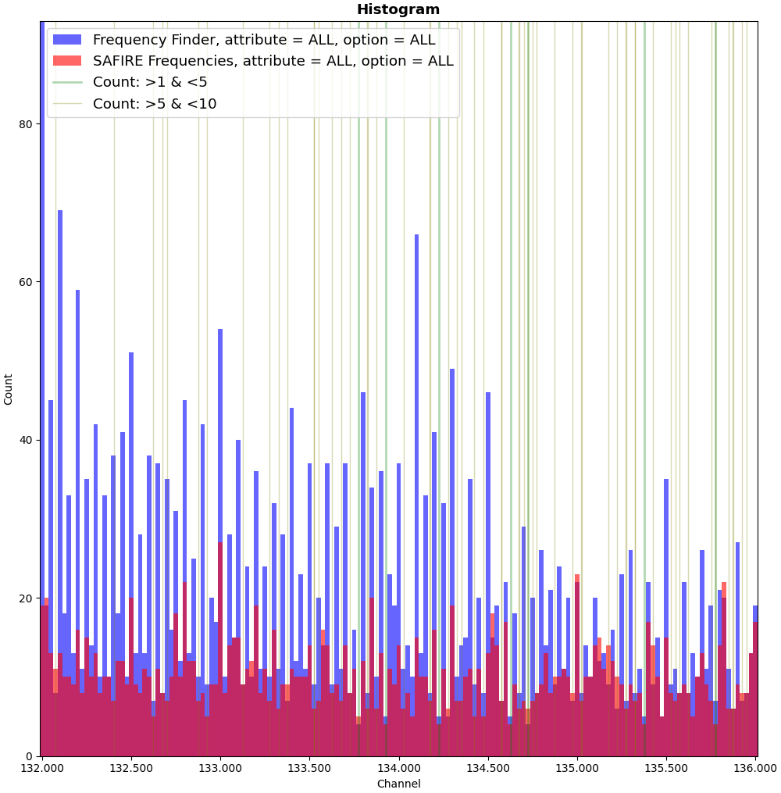 | 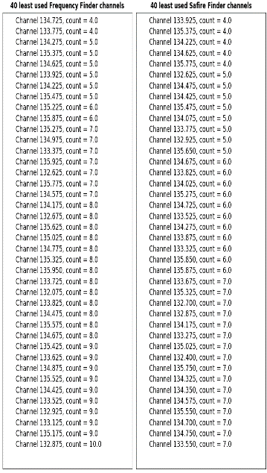

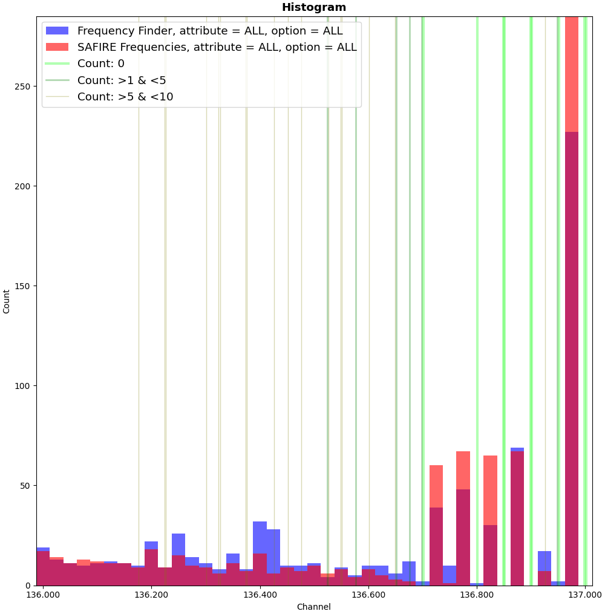 | 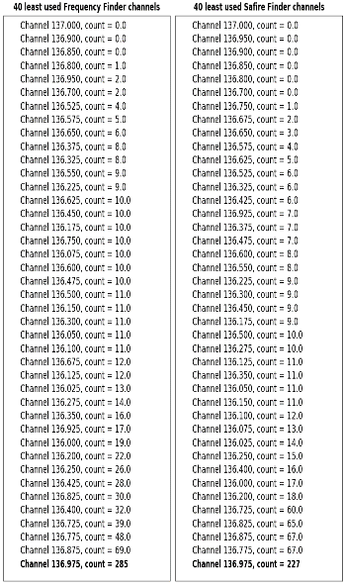

The next graphical figures show the statistical analysis for each ICAO region except for North America (USA and Canada) as their frequencies do not appear in the Frequency Finder tool, it is easy to conclude that:
- It could be easier and more practical to define a coordination process on a Regional basis.
- The more complex area to define a frequency coordination process will be EUR region.
- Despite that no information is available for some countries in the North of America, it could be concluded that there will be a similar complex case than for EUR region, although some singularities may be present in some regions of North of Canada.

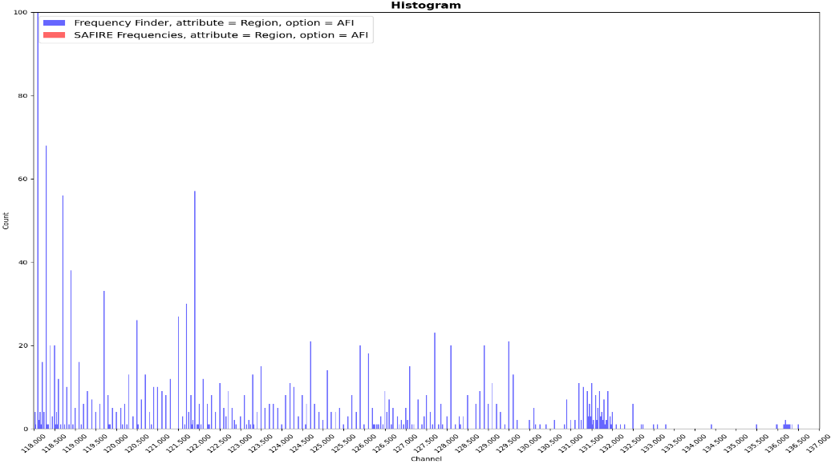 | 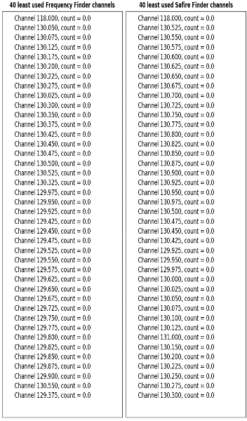
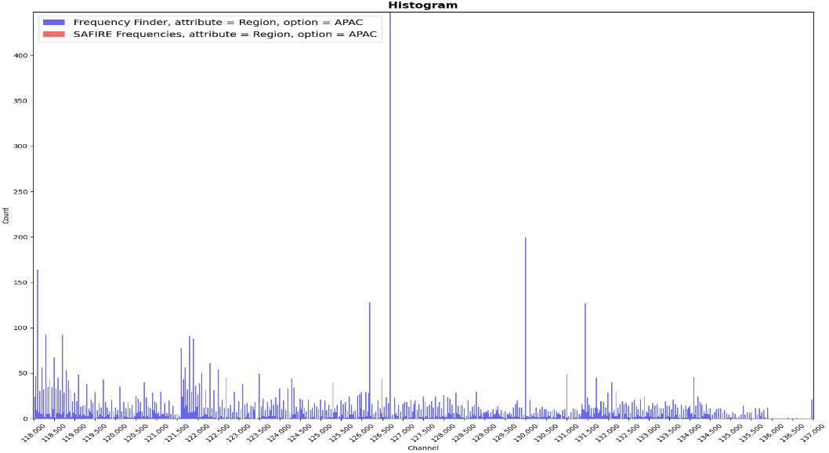 | 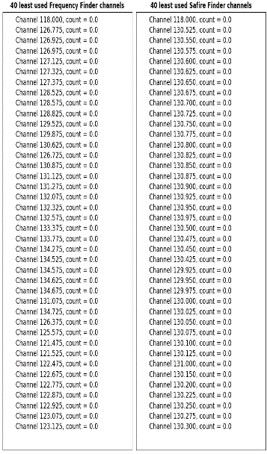

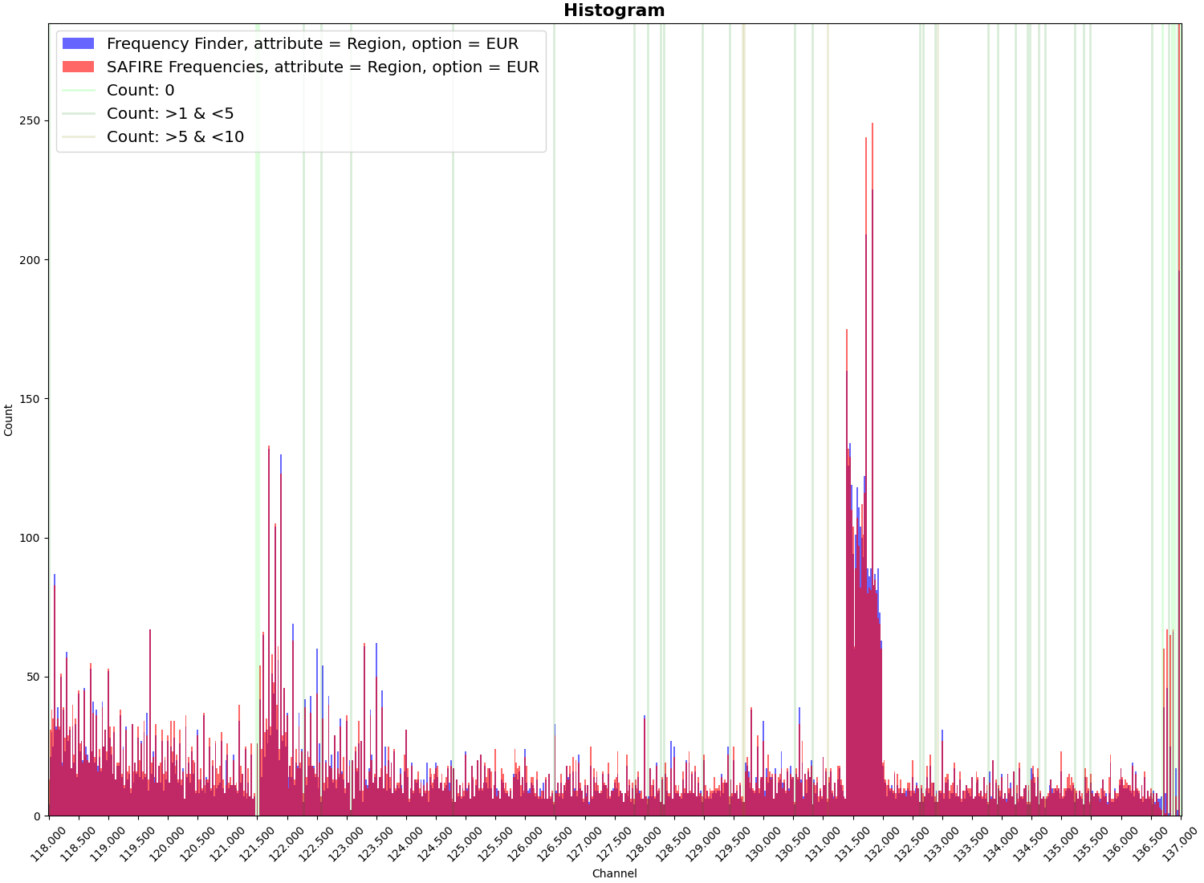 | 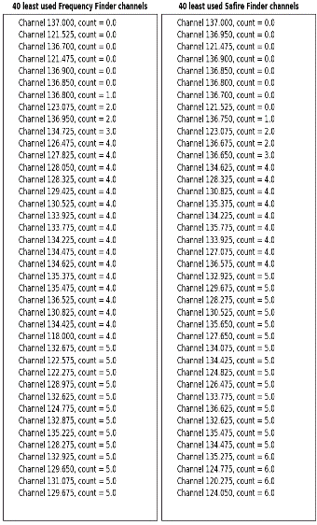

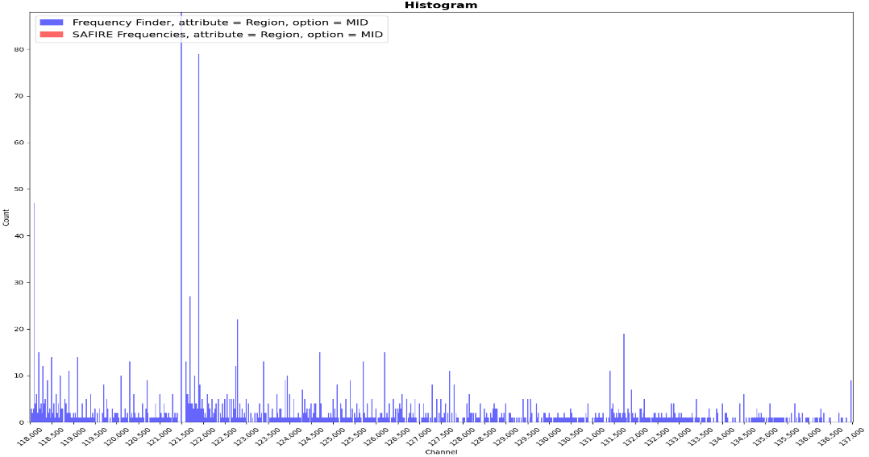 | 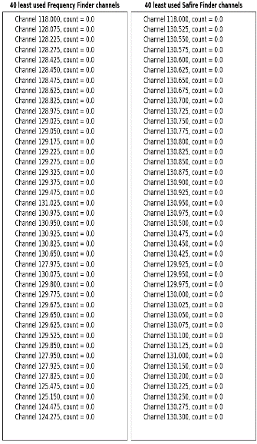

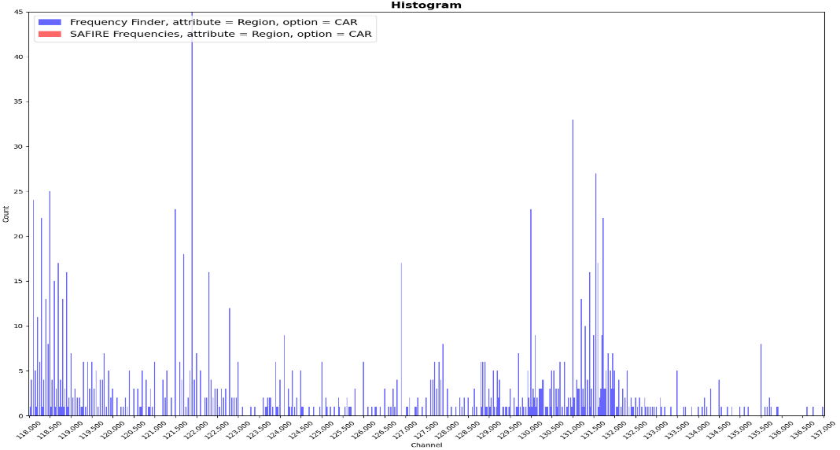 | 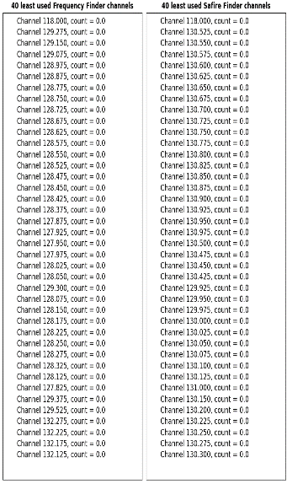

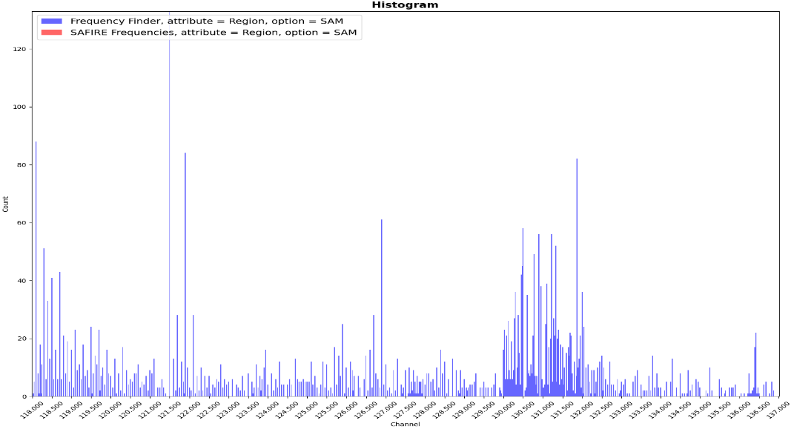 | 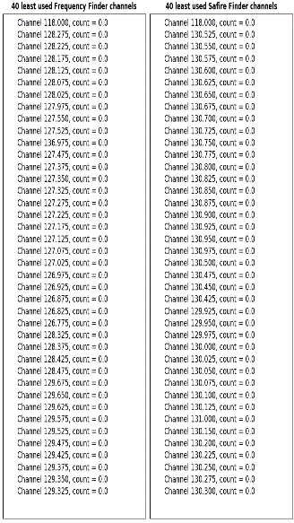

Analysing the current global frequencies assignment, it could be found that
- It could be easier and more practical to define a frequency coordination process on a Regional basis.
- There are more than 35 channels used less than 10 times worldwide.
- There are also more than 40 channels not used so far in a global basis with the exception of Europe and North of America.

Global AM(R)S VHF coverage
The following figures show, as an example, a draft drawing of the worldwide CSC 136.975 MHz ground stations. It could be understood that the Communication Service Providers (CSPs) have to take in to account the overlapping of coverage between different stations to manage the VHF Data link service with the aircrafts receiving signals from different ground stations.
Special case is the European region where the massive overlapping could increase the complexity to manage the coordination network to establish and maintain the link between the aircraft and the ground operator.
In this situation it could be understood that an additional overlapping for VDL-Mode 2 service could be considered while not increasing the management complexity. Even if the strategy to provide VDL-Mode 2 coverage would take in to account an Space Based VHF station, maybe some rationalization to the ground infrastructure could be applied and even, maybe some hidden problems or ping-pong jumping problems could be avoided. This is a serious concept to consider that a Space Based VHF VDL-Mode 2 service could be a real benefits for the European cases.
Different considerations should take in to account for the Space Based VHF Voice services in airspace as congested as central Europe.
In addition, in other airspaces, a planning for VDL-Mode 2 coverage could be done taken in to account a potential Space Based VHF system.

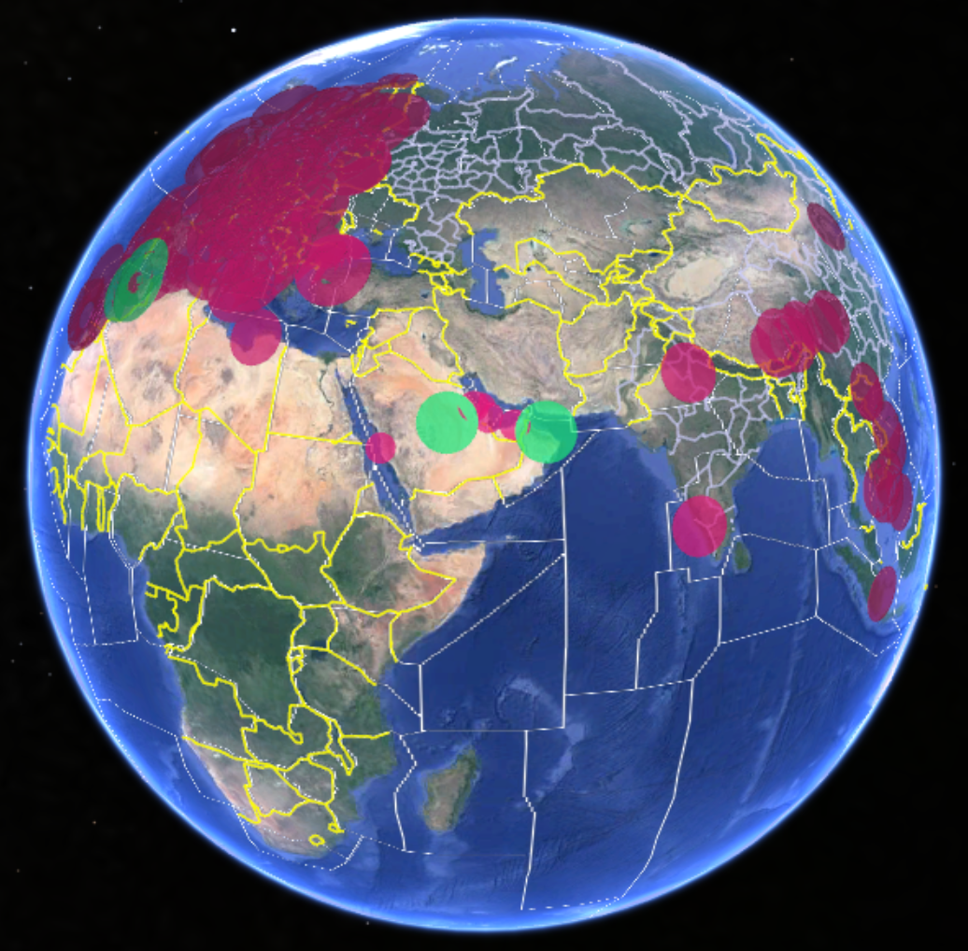
Figure 7-6: Extract of CSC (136.975 MHz) ground stations worldwide
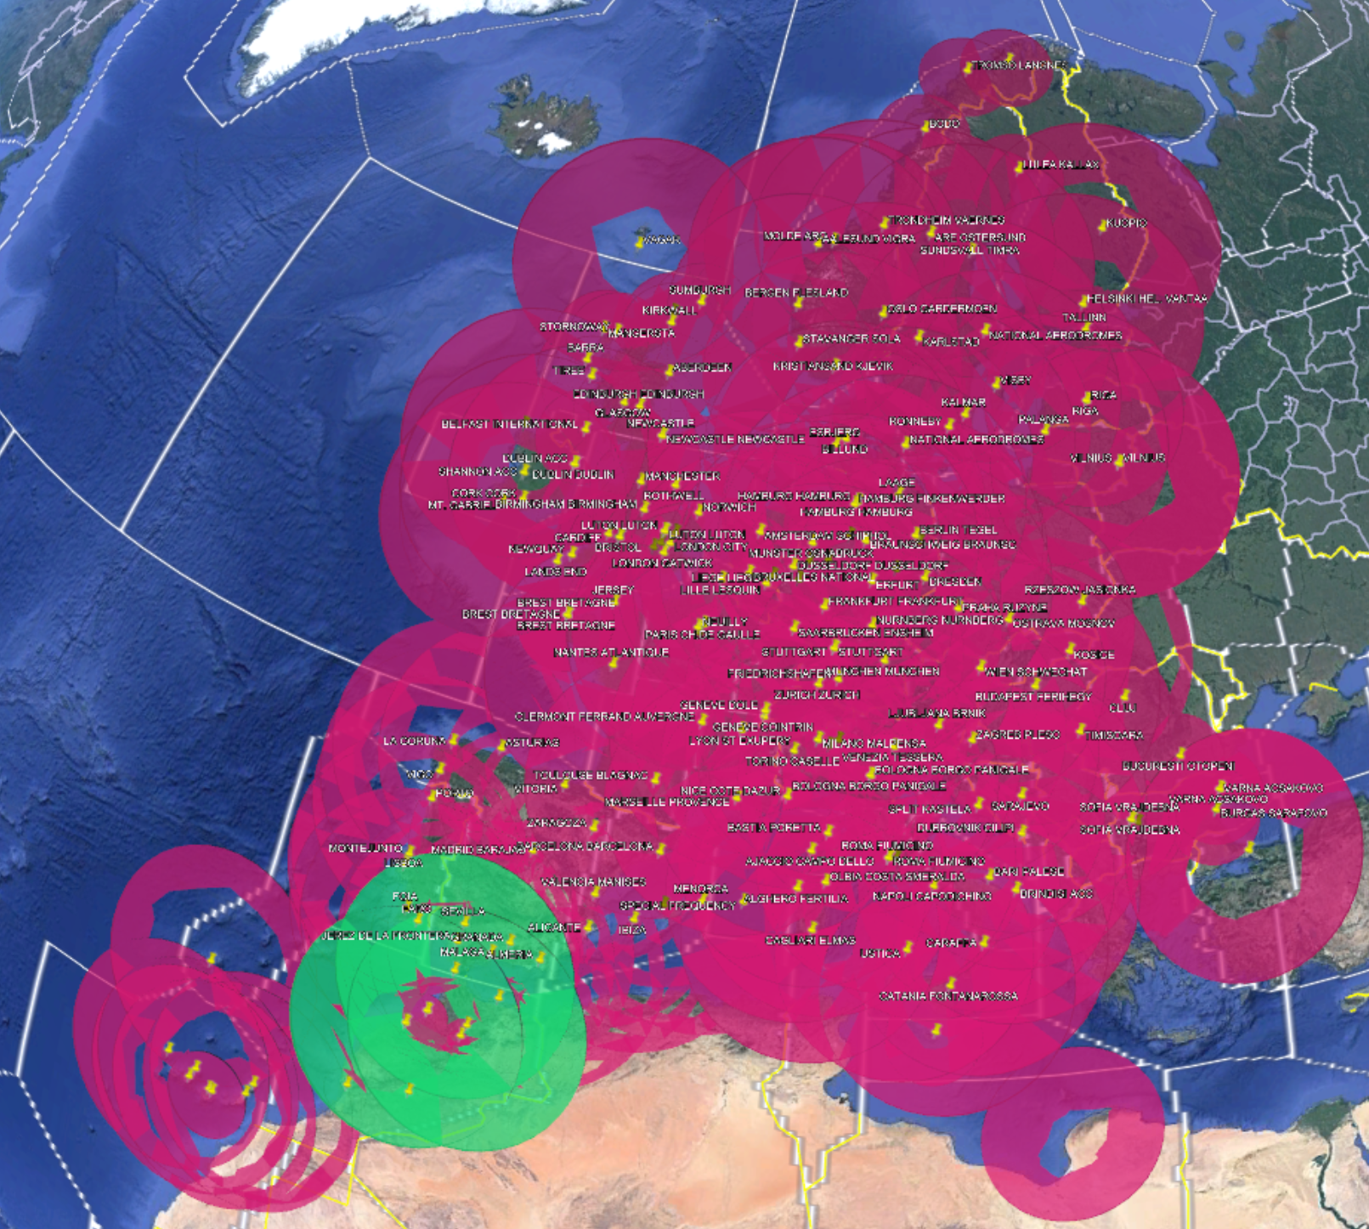
Figure 7-7: Details of masive overlaping of CSC (136.975 MHz) ground stations in EUR region
The following figure shows, as an example, the systems in EUR region operating in the frequency channel 133.500 MHz, this frequency has been choose in and random process and it is only to understand how is the locations of VHF ground stations that operate in the same frequency channel. The information have been extracted from the SAFIRE and/or Frequency Finder data base. It could be concluded that, in certain cases, even in a region as saturated as EUR region, still there is room to incorporate additional VHF ground stations.
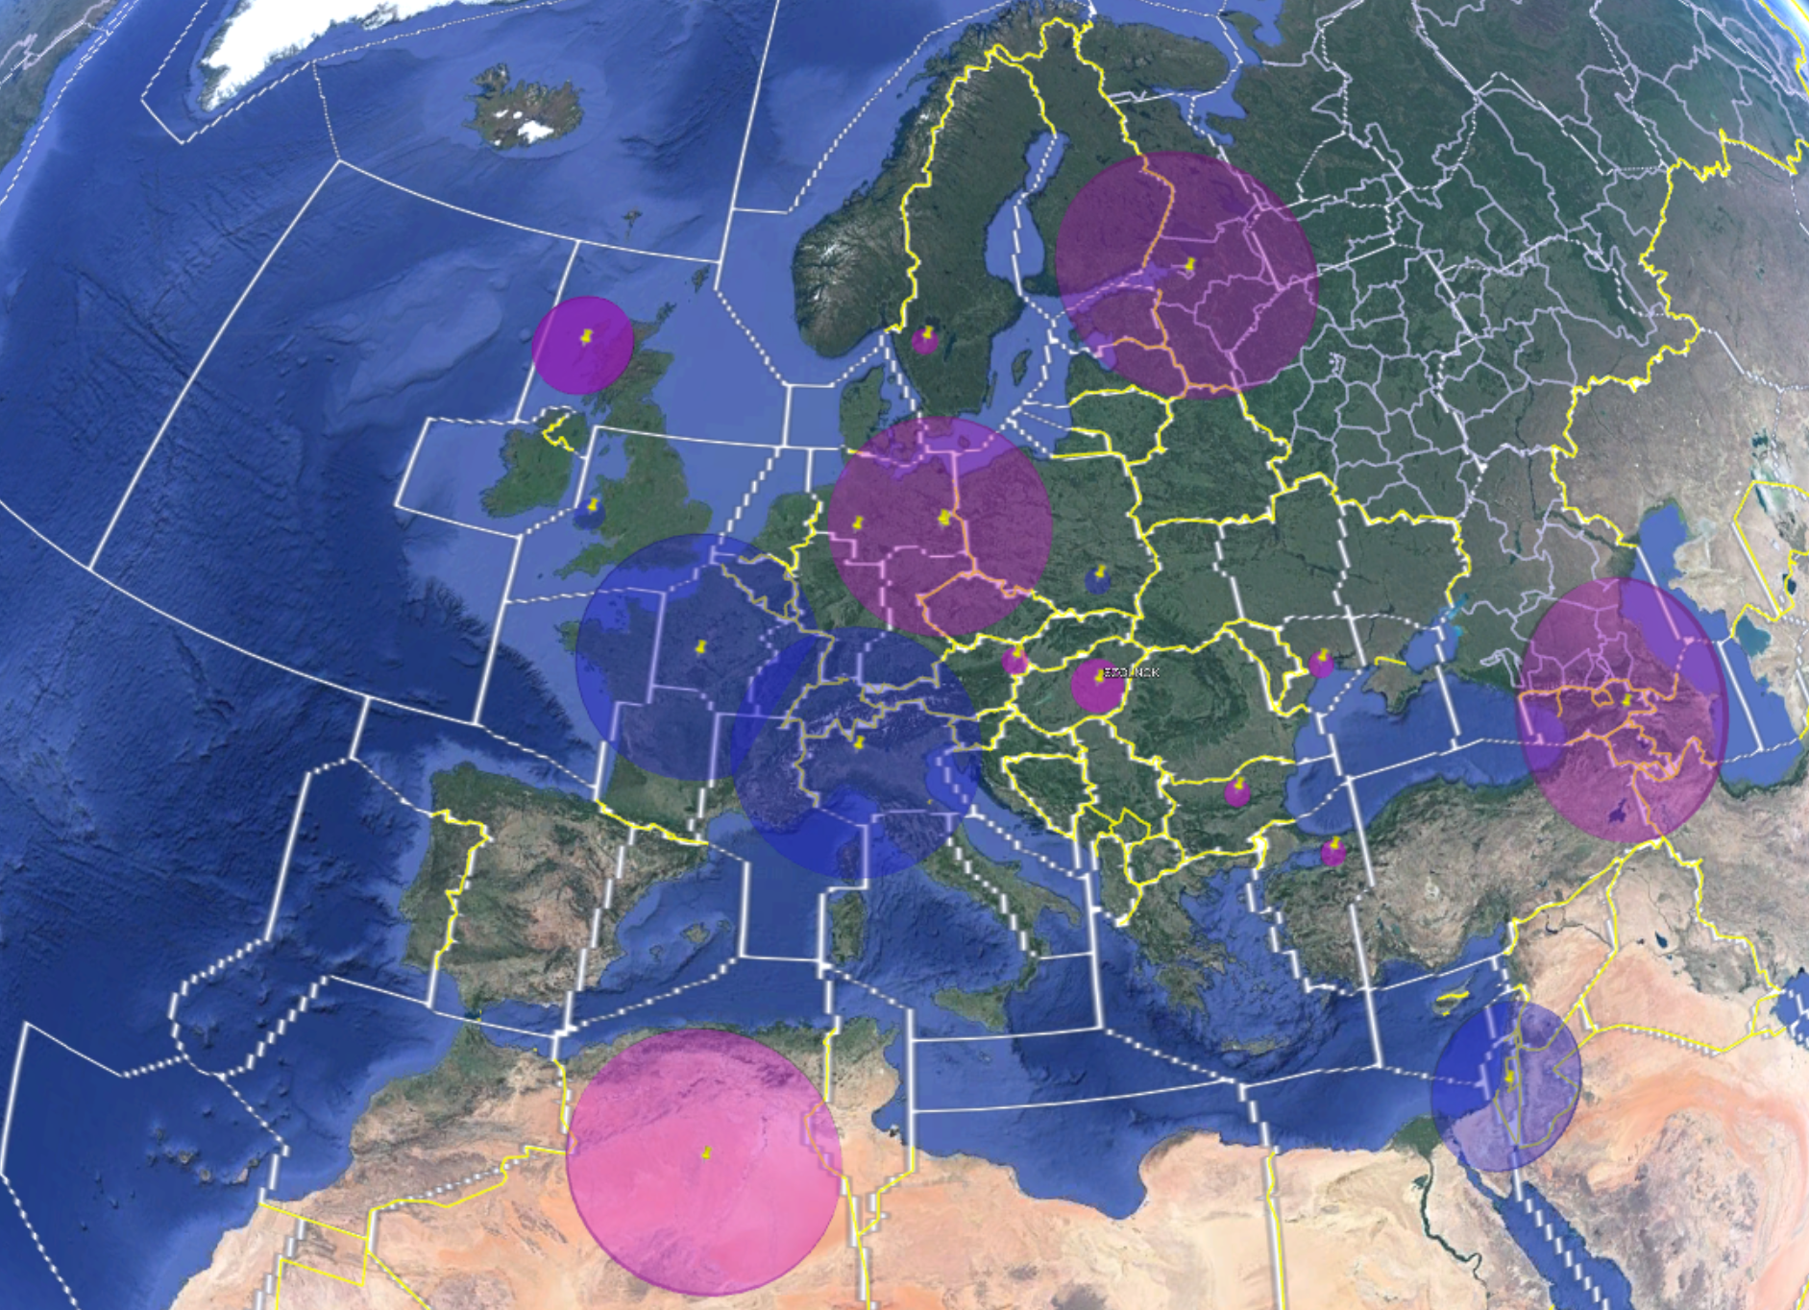
Figure 7-8: VHF ground stations operating in 133.500 MHz in EUR region (SAFIRE/Frequency Finder)

Regulatory considerations
Assuming that a new AMS(R)S allocation is adopted by the ITU-R WRC-23, and that ICAO will develop the associated standards, there is a huge potential benefit for the aeronautical sector exploiting this potential new allocation.
Emphasis is made on the fact that ITU-R defines the conditions for use of a new allocation to the AMS(R)S without concluding/constraining on any future allotment or assignment of the frequencies. The ITU R process to agree on a new allocation is mostly based on compatibility with other services using adjacent bands. Once the new allocation is defined by ITU-R, ICAO will conduct the subsequent stages on allotment or assignment of frequencies consistently with the conditions specified by ITU R for the use of the new allocation. Before ITU R decides on the new allocation, ICAO can certainly conduct examples of exercises on frequency planning just to evidence that there would be tools to ensure the subsequent studies on allotment and/or assignments while protecting other aeronautical mobile services.
Consequently, ICAO can start its internal studies and considerations related to AMS(R)S by developing the relevant Standards and Recommended Practices (SARPs) in the whole VHF aeronautical frequency band 117.975-137 MHz with the aim to make them available after the WRC-23 and continue/complete the studies on frequency assignment planning and coordination once the conditions of use of the new AMS(R )S allocation are defined by ITU R WRC23.

Timeline for ITU-R and ICAO developments on new allocation to AMS(R)S
It is important to clarify the different timelines of ICAO and ITU. Each Organization has different responsibilities and competences and carry out their work under different rules and timelines.

The following picture provides a summary of the typical timeline:
Figure 7-9: : Typical time line ICAO / ITU-R regarding WRC-23 AI 1.7

Current status
ITU are addressing the compatibility studies following the WRC-23 AI 1.7 “to consider a new aeronautical mobile-satellite (R) service (AMS(R)S) allocation in accordance with Resolution 428 (WRC-19) for both the Earth-to-space and space-to-Earth directions of aeronautical VHF communications in all or part of the frequency band 117.975-137 MHz, while preventing any undue constraints on existing VHF systems operating in the AM(R)S, the ARNS, and in adjacent frequency bands”
Two main documents are the vehicles to record all activities of the scope of this agenda item. One is a Preliminary Draft New Report (PDNR) which is elaborated by the competent ITU-R Working Party 5B who has the responsibility to conduct the technical compatibility studies. Another document is the Conference Preparatory Meeting (CPM) Text. This document includes the regulatory conditions and summary of studies to help WRC23 to take decisions. The resulting decisions of the WRC23 would require modifications to the Table of frequency Allocations included in the Article 5 of the Radio Regulations. The CPM includes methods to satisfy the mandate of the agenda item. The draft CPM text regarding agenda item 1.7 has been already elaborated by the Working Party 5B and will be discussed at the CPM meeting early 2023.

Summary for the ITU-R activities related with WRC-23 AI 1.7 and current status.
- Regarding PDNR and the compatibility studies ongoing some paragraph can be extract to summarize:
This report provides studies on the use of low-Earth orbiting satellites to relay air traffic control messages between the pilot and the controller. Operation of the space-based VHF system within the frequency band 117.975-137 MHz, currently allocated to the aeronautical mobile (Route) service (AM(R)S), aims to utilize existing on-board VHF radios used for provision of terrestrial-based VHF communications, thus being compliant with ITU-R Resolution 428.
A new allocation to the aeronautical mobile satellite (Route) service (AMS(R)S) within this frequency band 117.975-137 MHz is being considered under the agenda item 1.7 of the WRC-23.
AMS(R)S links between aircraft and satellite (shown as “Satellite VHF COM” in Figure 1) will operate within the frequency band 117.975-137 MHz and are the subject of considerations contained in this Report. Feeder links of AMS(R)S systems between earth station and satellite are not implemented within the VHF frequency band and may be accommodated in the fixed-satellite service, therefore consideration of feeder links are out of the scope of this Report.
ITU-R carried out sharing and compatibility studies for the co-existence between potential new AMS(R)S systems operating in the frequency band 117.975-137 MHz (Earth-to-space and space-to-Earth), providing voice and data applications as mentioned above, and existing primary in-band and adjacent band services. Based on the outcome of the studies, technical and regulatory proposals are provided towards a possible new AMS(R)S allocation within the frequency band 117.975 137 MHz.
In the framework of the consideration of a possible new allocation to the AMS(R)S within the aeronautical frequency band 117.975-137 MHz, this report defines the relevant technical characteristics of a reference satellite system that would relay VHF voice communications operating today under the Aeronautical Mobile (Route) Service (AM(R)S), and complement terrestrial communications infrastructures for the coverage of oceanic and remote areas. This report also reviews existing primary services in-band and in adjacent bands, and studies compatibility between systems operated under these services and the reference AMS(R)S system.
Main conclusions are as follows:
• Protection of in-band systems operating under AM(R)S and AM(OR)S, and of adjacent band systems below 117.975 MHz under ARNS would be resolved through conventional frequency planning exercise, involving the relevant aeronautical authorities including ICAO, and assigning frequencies to the satellite system over interested regions in a manner that ensures compatibility between ground and satellite facilities.
• For an AMS(R)S system operating in the band 117.975-136 MHz, studies conducted on the basis of voice application show that protection of adjacent-band systems operating above 137 MHz in the Mobile satellite service (space-to-Earth), Space operation service (space-to-Earth), Space research service (space-to-Earth), and Meteorological satellite service (space-to-Earth) is ensured with minimum 0.5 dB margin, by a 1 MHz guard band in 136-137 MHz and RR Appendix 3 limits for AMS(R)S spurious emissions falling above 137 MHz.
• For an AMS(R)S system operating in the band 136-137 MHz, and using VDL Mode 2 application, sharing and compatibility studies show that the protection of adjacent-band systems operating above 137 MHz in the Mobile satellite service (space-to-Earth), Space operation service (space-to-Earth), Space research service (space-to-Earth), and Meteorological satellite service (space-to-Earth) is ensured by limiting the maximum PFD level of unwanted emissions above 137 MHz to -166.6 dB(W/(m²/ . 14 kHz)).

- Regarding the CPM text:
  - As a summary, two Methods have been defined, Method B complemented by Method B1 or Method B complemented by Method B2 as follows from the CPM Text:
2/1.7/4.2 Method B: New allocation to the aeronautical mobile satellite (route) service within the frequency band 117.975-137 MHz
This Method is not an independent and standalone Method as such and thus should be considered together with Methods B1 or B2.
Create a new co-primary allocation for the AMS(R)S in the Earth-to-space and space-to-Earth directions in the frequency band 117.975-137 MHz, or part thereof, under following conditions:
– the use of frequency band 117.975-137 MHz is limited to non-geostationary satellite systems only;
– limiting the use of the new AMS(R)S allocation to internationally standardised aeronautical systems;
2/1.7/4.2.1 Method B1: Method B with the following additions
– ensuring protection of AM(OR)S service in the frequency band 132-137 MHz, noting that the characteristics of AM(OR)S are not available. Nevertheless, AM(OR)S systems are understood to operate on channels within national assignments of AM(R)S, and coexistence between AM(R)S, AMS(R)S and AM(OR)S might therefore be envisioned through frequency planning and coordination;
– ensuring protection of services in adjacent bands and not constraining these services.
In-band coexistence between AM(R)S and AMS(R)S and adjacent-band coexistence between ARNS and AMS(R)S around 117.975 MHz needs to be ensured through frequency planning and coordination work.
The protection of adjacent band services operating above 137 MHz from AMS(R)S space stations unwanted emissions falling above 137 MHz is ensured:
– through the 1 MHz guard band in 136-137 MHz, as RR Appendix 3 provides appropriate limits for spurious emissions for AMS(R)S systems operating in 117.95-136 MHz;
– through a limit of satellite pfd of -166.6 dB(W/(m² . 14 kHz)) on the level of unwanted emissions above 137 MHz for AMS(R)S emissions from systems operating in 136-137 MHz.
2/1.7/4.2.2 Method B2: Method B with the following additions
– applying RR No. 9.11A coordination procedures (including RR No. 9.14) for AMS(R)S systems, e.g. extending scope of RR No. 5.208 to AMS(R)S in 117.975-137 MHz;
– applying coordination threshold (-140 dB(W/(m2 at 4 kHz)) at the Earth's surface for AMS(R)S space stations during coordination under RR No. 9.14, by including AMS(R)S in the band 117.975-137 MHz in Annex 1 to Appendix 5 of the RR
– ensuring protection of services in adjacent bands and not constraining these services by adopting restrictions on unwanted emissions from AMS(R)S space stations. Such limits should not be worse than those specified in ICAO SARPs for AM(R)S aircraft transmitting stations in adjacent channels (see Section 6.3.4, Annex 10 to the Convention on International Civil Aviation — Aeronautical Telecommunications, Volume III — Communication Systems, ICAO).
– AMS(R)S systems in the frequency band 117.975-137 MHz should not claim protection from interference from AM(R)S and AM(OR)S systems operating in the common frequency band, as well as from ARNS, MSS (space- Earth), SOS (space-to-Earth), SRS (space-to-Earth) and MetSat (space-to-Earth) operating in adjacent frequency bands;
– applying RR No. 5.208A and RR No. 5.208B for the application of the conditions for new AMS(R)S allocations in the frequency band 117.975-137 MHz.
Studies are on-going for the protection of adjacent band services operating above 137 MHz from AMS(R)S emissions. Subject to confirmation, this protection might be ensured through a limit [XXX] on the level of unwanted emissions above 137 MHz for AMS(R)S emissions from systems operating in 117.95-137 MHz.

ICAO ongoing activities
ICAO has created two main working groups to collect and discuss the contributions related to this agenda item and to study the necessary review of the current ICAO SARPS, these groups are the FVSG (Future VHF Sub Group) reporting to ICAO-PT-T and collecting all the activities and studies to review the ICAO SARPS provisions, such as Annex 10, and provide necessary technical inputs and materials to support the implementation of new aeronautical satellite VHF communication technologies and the CG-SV (Coordination Group – Satellite VHF) reporting to ICAO-FSMP and tasked to develop and to collect all the Questions and Answers related to the Space-Based VHF and related to the future AMS(R)S operating in the VHF frequency band.
Summarizing as lays down in WP06 DCIWG5 Appendix B:
A development and standardization of emerging aeronautical communications technologies and systems operating in VHF frequency band will be carried out.
Change Requests (CRs) to GANP will be submitted to formulate or modify existing threads for VHF technologies that includes enhancement of existing VHF technology. This may include Advanced VHF Data Link (AVDL) and use of VHF technology with Satellite communication technology to relay VHF communication over satellite (space-based aeronautical VHF). Document affected or actions needed are at least the following:
- Technical studies and Concept of Operations. Conduct necessary studies on interference analysis and spectrum compatibility and develop overall concept of operations for selected future VHF technologies.
- Annex 10 - Vol III. Review and, as necessary, update SARPs to support medium-term future VHF technologies.
- Annex 10 - Vol V. Review and, as necessary, update SARPs to support medium-term future VHF technologies.
- Manual on Space based VHF (Doc xxx). Provide guidance on the new Space VHF system that assist future ICAO activities in support of the implementation.
- Actions. Identify any consequential amendments to any other ICAO Documents.

Independently of next periodic FSMP meeting by August-September 2022, by February-March 2023 and by August-September 2023, there are two keys important meetings at ICAO to set the ICAO position for the WRC-23, one is the at Air Navigation Commission level by March-April 2023 and at Council level by May-June 2023.

Others considerations
At it is mentioned in section 5.3 of Attachment E, Volume II of ICAO Handbook on Radio Frequency Spectrum Requirements for Civil Aviation including statement of approved ICAO policies (Doc 9718), the economic value of spectrum allocated to certain applications can exceed by far the economic value of aeronautical applications of the same spectrum. This has recently been demonstrated by the results of the “spectrum auctions” conducted in several countries to support future commercial mobile multimedia systems. This situation requires aviation to identify clearly the need and economic value of required spectrum in certain bands and to consider innovative approaches to guarantee the required level of safety-service availability.
That is, in order to prevent the ICAO safety communications needs in the future, any opportunity to allocate aeronautical services in any band of spectrum should be used by ICAO to provide the aeronautical community with alternative solutions in the short term or at least to preserve and maintain the rights to use the spectrum in the long term.
Note should be taken that ITU R allocations are decided only at WRC. WRCs are held every 4 years. Including agenda items for possible new allocations is not a fast process and require many years of studies. ICAO should not dismiss the opportunity offered by WRC23 to obtain a new allocation for aeronautical mobile satellite (on route) service which would be available for ICAO during decades. ICAO can develop the standards for use of the new ASM(R)S allocation when convenient for ICAO as well as conduct the necessary frequency planning exercises at it own pace, provide ITU would have concluded on the new allocation to AMS(R)S.

Conclusions
Considering the different timelines of ICAO and ITU where each Organization has different responsibilities and carry out their work under different rules and timelines and considering the current process status at ITU and ICAO related with the WRC-23 AI 1.7, ICAO should continue supporting the efforts of the ITU-R WP 5B to help deciding on a new allocation to AMS(R)S in the band 117.975-137 MHz. Similarly, ICAO can conduct its own preliminary internal studies to analyze the operational compatibility of AMS(R)S with AM(R)S, the necessary update of SARPs if needed and preliminary exercises on frequency planning and coordination options.

AMS(R)S, AM(R)S and AM(OR)S Coordination
Although the final exercises on frequency planning and coordination among AMS(R)S, AM(R)S and AM(OR)S should be completed once the ITU R would have decided on the conditions for use of new allocation to AMS(R)S, initial considerations can be made:
- AM(OR)S defined in RR 1.34 is not appropriate for safety-of-life operations.
- AMS(R)S and AM(R)S as defined in RR 1.36 and RR 1.33 respectively are considered for safety-of-life.
- The RR 44 gives the order of priority of communications and RR 43.1 “§ 1: Frequencies in any band allocated to the aeronautical mobile (R) service and the aeronautical mobile-satellite (R) service are reserved for communications relating to safety and regularity of flight between any aircraft and those aeronautical stations and aeronautical earth stations primarily concerned with flight along national or international civil air routes.
- The RR foot notes 5.201 and 5.202 provide additional allocation to AM(OR)S in the band 132-137MHz for certain countries, these footnotes state that “In assigning frequencies to stations of the aeronautical mobile (OR) service, the administration shall take account of the frequencies assigned to stations in the aeronautical mobile (R) service” and therefore, the current AM(OR)S services operating in this band have to be also protected to the same level they are protected versus AM(R )S.
- The RR 4.10 Member States recognize that the safety aspects of radionavigation and other safety services require special measures to ensure their freedom from harmful interference; it is necessary therefore to take this factor into account in the assignment and use of frequencies.
- Under RR 6.3 Member States may, under the provisions for special arrangements in the Constitution, conclude, on a worldwide basis, and as a result of a conference to which all Member States have been invited, special agreements concerning the assignment of frequencies to those of their stations participating in a specific service, on condition that such assignments are within the frequency bands allocated exclusively to that service in Article 5.
- The RR 9 for Procedure of effecting coordination with or obtaining agreement of other administrations.
- That the protection criteria defined for AM(R)S in co-frequency and adjacent-frequency defined in section 7.1.2.1 in this document shall apply in the AMS(R)S and AM(R)S planning assignment coordination but also same criteria can be applied for AMS(R)S and AM(OR)S planning assignment coordination. However, AM(OR)S systems operate in channels within national assignments, which themselves are managed by one of the followings ICAO, regional organizations and national regulators. Therefore, the compatibility between AMS(R)S and AM(OR)S assignments should be resolved through their conventional frequency planning exercise. In the event that a new allocation is made to AMS(R)S in this band, the corresponding responsible organization will develop a corresponding channel plan for use of AMS(R)S frequencies to ensure compatibility between the satellite and terrestrial uses of the band. By protecting existing terrestrial assignments, this plan should protect any existing assignments to AM(OR)S.
Regarding protection of AMS(R)S space station, some countries are proposing the regulatory provision that AMS(R )S space station would not be entitled to claim protection. While the interference risks from other adjacent band satellite services into AMS(R)S space station are minimal, it is understood that a safety related service should be able to be protected from harmful interference generated by other services operating in the adjacent band above 137 MHz. In a first review of satellite networks operating above 137 MHz, it can be noted that the frequency assignments associated to those other networks are generally narrow band with assigned bandwidths of 25 kHz, 50 kHz and few other larger bandwidths, which means that the large majority of emissions from those networks will fall under the category of spurious emissions and consequently AMS(R)S space station would be protected under Appendix 3 provisions. However, there are some theoretical assignments of those networks operating in the edge of the band, at 137.0-137.050 kHz which would fall under out of band emissions.
The interference path from other adjacent band services into AMS(R)S space station is when the interfering satellite network operate at higher altitudes than the space station of AMS(R)S. In this case, the interference will be related to the dynamics of move of the interfering space station into the interfered with AMS(R )S space station, thus, being subject to a very short term interference domain. While further detailed dynamic studies will be required to confirm the acceptable levels of harmful interference, a preliminary analysis could show that the ephemerides cases of alignment of interfering space station into the space station of AMS(R)S space station will of extremely short time. In addition, the possibility of application of Art 9 and Art 11 of RR would also allow detailed coordination when specific cases of interference between satellite networks operating in the adjacent band above 137 MHz and AMS(R)S space stations are identified by the involved administrations.
Based on the above considerations, it can be preliminary concluded that the coordination between AMS(R)S, AM(R)S and AM(OR)S is feasible.

Understanding of ITU Allocation and ICAO Allotment and Administration Assignment
It is necessary to understand the correct order of international procedures to use a frequency assignment, that is, a portion of frequency spectrum for a service.
The first step is the allocation of this service in the Table of frequency Allocation in Article 5 of the Radio Regulations. If there is not a service allocation, there is not possible any use by that service.
Therefore, the first step is to adopt the new allocation to the aeronautical mobile-satellite (R) service in the frequency band 117.975-137 MHz in order to support aeronautical VHF communications in the Earth-to-space and space-to-Earth directions. This first crucial stage is currently in elaboration in the ITU domain producing the first Preliminary Version of CPM for the Agenda Item 1.7 for the WRC23.
Once the allocation is in place, the second step is to define an allotment and/or assignment of frequencies and the procedures for coordination, which could be implemented at a worldwide and/or on a regional basis. This Coordination Plan and Procedure could be defined by a worldwide entity as ICAO in coordination with the ICAO Regional Offices. The plan or criteria for frequency assignment and coordination procedures should be established once the allocation is decided by ITU-R and conditions associated to the usage of such allocation be identified by ITU-R, likely on the basis of requirements to ensure technical compatibility with other adjacent band services.
The possibilities to undertake the frequency planning exercise and the subsequent coordination procedures are preliminary evidence showing that it would be feasible to carry out such exercises and the necessary the coordination procedures even using tools currently in place regularly used by ICAO and ICAO Regionals while observing the technical requirements, the conditions identified so far in the feasibility studies, and the operational compatibility studies provided by this document and further documented in the PDNR of the ITU-R WP5B. This document provides also evidences that there is room for several mechanisms to undertake the frequency planning exercises and procedures for international and national coordination of the frequency assignments.

SUMMARY and CONCLUSIONS
Regarding section 2 ‘RELEVANT OPERATIONAL REQUIREMENTS IDENTIFIED’, it can be summarized that the major operational ATM benefits from the SB-VHF concept are:
- The use of the same operational procedures for ATCOs in continental and oceanic and remote continental areas..
- Added value in safety for the aircraft operation in oceanic and remote continental areas since now full CNS services are provided to the aircraft.
- Significant increase of capacity in oceanic and remote continental areas.
- No additional training for ATCOs, as operation is the same as in continental areas.
- Significant reduction in fuel burnt and therefore CO₂ emissions thank to the use of optimal and efficient routes (e.g. i4D and TBO).
- Increase of situational awareness for ATCOs that have more accurate information about the position of the aircrafts and their flight intent.
In the longer term, SB-VHF can facilitate the implementation of the PBCS concept in oceanic and remote continental areas airspace by allowing aircraft to receive the same ATS service as if they were flying over continental areas. This shift from procedural to ATC service provides obvious advantages over the current situation for certain airspace operating close to capacity.
The complementary use of VHF voice and VHF data (CPDLC and ADS-C) with surveillance information through ADS-B will facilitate the introduction of functionalities such as Trajectory Based Operations (TBO), Free Route Airspace (FRA) and 4D Trajectory Datalink (4DTRAD) in oceanic and remote continental airspace, in regions where this can be shown to bring productivity benefits.).
Today, all these concepts are applicable to the continental areas by virtue of the communication systems available (datalink using CPDLC and ADS-C) that support them. These concepts are however also applicable to remote and oceanic areas when the enabling technology, as SB-VHF, is available.
The availability of SB-VHF service will enable the realisation of safety benefits made possible by the introduction of full ATC service in oceanic regions having busy and complex traffic, for which procedural service is reaching its capacity limits. Additionally, VHF voice and VHF data (CPDLC and ADS-C) will offer the potential for increased airspace productivity and seamless operations between busy oceanic and continental areas.
SB-VHF services allows the possibility of extending current ATCOs continental operational procedures to oceanic and remote continental areas without changes respecting current continental ones. The voice and data communications between ATCOs and pilots would remain exactly the same. These communications are completely transparent for ATCOs and pilots and they are not aware about the underlying technology that supports these communications.
This important advantage together with the fact that there is no change required either in the avionics on board means that ATCOs and pilots will continue using the operational procedures they use today implying no need for additional training or further certification for the ATCOs.
The major expected operational airline benefits from the SB-VHF concept are:
- Reduce flight crew workload using the same communication system (VHF) is all airspace, regardless of whether it is continental or oceanic/remote. This would contribute to simplify/standardize communication procedures and reduce potential communication errors and/or issues.
- No additional training for pilots/aircrew, as operation is the same as in continental areas.
- Simplify the airborne equipment needed to comply with the requirement to have two independent systems along the route. Availability of VHF space-based would contribute to reduce the communication equipment, in special HF equipment. This means a reduction in costs. Also, a reduction in weight, thus diminishing fuel consumption and emissions.
- No need of additional equipment onboard the aircraft. No impact at all on the current avionics system.
- Added value in safety for the aircraft operation in oceanic and remote continental areas since now full CNS services are provided to the aircraft.
- Significant increase of capacity in oceanic and remote continental areas.
- Significant reduction in fuel burnt and therefore CO2 emissions thank to the use of optimal and efficient routes (e.g. i4D and TBO).
- Increase of situational awareness for pilots that have more accurate information about the position of the aircrafts and their flight intent.
Based on the technical requirements met by SB-VHF in terms of latency, continuity, availability and integrity (mainly coming from users requirements, i.e. ED-137 for VoIP and ED-228 for datalink B2), SB-VHF could be ideally placed to support AOC communications in remote and oceanic areas providing the same performance as over continental areas, which definitely represents a significant advantage for the “connected aircraft”.
In summary, ANSPs and airlines are requiring more and more datalink communications for an increased ATC and AOC automation, allowing extra capacity while improving safety. This requirement will be accusingly more intensive in the years to come.
Current and future ANSPs and airlines operational concepts mandate the provision of datalink services. In this way, it is mandatory to exploit the potential for the Agenda Item 1.7 at WRC 23 to ensure ITU R decides on a new allocation to AMS(R)S in the whole aeronautical band 117.975-137 MHz., including 136-137 MHz sub band where datalink services are provided.

Regarding section 3 ‘INCUMBENT SERVICES IN THE BAND 117.975-137 MHZ’.
The detailed analysis (in section 3 of the attachment) provides the assessment of the operation of space-based VHF system into the adjacent channel in the out-of-band domain with and without Doppler shift caused by the spacecraft. The goal is to evaluate the impact of the space-based VHF system into the ground station operating in the adjacent band.
The analysis carried out focusses in the Space based VHF data services, based on VDLm2 characterized by an effective bandwidth of the transmitter of 14 kHz and a spectral roll-off that has an attenuation higher than 60 dB in the out of band domain.
The recommendation ITU-R SM.1541 provides the unwanted emission mask in the out-of-band domain. The detailed evaluation outcomes shows that the D/U is higher than the required one in the recommendation. The space-based VHF system could therefore operate without affecting the ground station in the first adjacent channel. In addition, the result would be similar for the other adjacent channels.
The space-based VHF system will have a mechanism to compensate the Doppler effect. Depending on the aircraft location and its flight route, the centre frequency of the radio will be shifted by +/-3.2 kHz at maximum. The Space-based system, as it will be detailed below, can transmit with a frequency shift to pre-compensate the spacecraft Doppler,
The studies has shown that by applying a frequency shift of maximum 2.7 kHz to the centre frequency and considering a Doppler effect of 3.2 kHz, it is anticipated that there is no impact on the ground VDLm2 radios operating on the ground in an adjacent band at 25 kHz and that the frequency shift would have no limit for adjacent bands at 50 kHz or above. Consequently, the theoretical studies carried out so far have shown that the operation of the space-based VHF system would have no impact on the terrestrial system operating at the adjacent band.
It is assumed that AM(OR)S parameters are similar to the VDLm2 RF parameters, consequently the same sharing outcome could be applied to the AM(OR)S system. The space-based VHF system would not create any harmful interference to the AM(OR)S operating in the adjacent channel to the spacecraft channel. Nevertheless, the channel assigned to the space-based VHF radio should not be the same as AM(OR)S.

Regarding section 4 ‘ANALYSIS OF THE DOPPLER EFFECT AND COMPATIBILITY WITH CURRENT AVIONICS’.
In the Space-based VHF communications system, the satellites play the role of the ground VDR (“VHF Data Radio”) of the VHF Voice or VDLm2 system. The Doppler effect between satellite and aircraft constitutes one of the main differences in the satellite to/from aircraft links with respect to the terrestrial scenario. The Doppler shift introduced by the satellite movement can have a value from -3.2 kHz to +3.2 kHz depending on the aircraft to satellite position and direction of movement.
These theoretical studies and analysis detailed in section 4 present the impact for VHF Analog Voice and for VHF Data VDLm2 links of the Doppler shift of the satellite transmissions in the aircraft receivers. The analysis is focused on the approach needed to guarantee that the aircrafts radios can detect the satellite transmissions without any modification.
For VHF Voice system using 25 kHz channels and DSB AM modulation, the following key outcomes can be stated:
- The frequency capture range specified in the standards is well above the maximum Doppler shift of ± 3.2 kHz
  - Effective acceptance bandwidth with offset carrier: ± 8000 Hz
  - Effective acceptance bandwidth without offset carrier: ± 6850 Hz
- The aircraft voice radios can then receive correctly the satellite transmissions without any pre-compensation.
For a scenarios in which an aircraft would be located under the coverage of more than one satellite, a possible solution based on the already in use CLIMAX approach could be implemented, consisting in transmitting with different offset carrier from satellites at different orbital planes. The offset would be selected to guarantee that the separation between both transmissions is such that no overlap would be produced. Not any modification would be required in the aircraft voice radios.
For VDLm2 links, the impact of the Doppler in satellite transmission at the aircraft radio reception is expected to be more severe than for voice, due to the frequency capture range specified in the standards of ± 967 Hz is well below the Doppler shift of ± 3.2 kHz.
From the theoretical analysis, it can be stated that a Doppler pre-compensation mechanism needs to be implemented in the satellite transmission to guarantee that the satellite transmission are received in the aircrafts VDL radios with an offset not higher than the aircraft radio capture range. Several mechanism would be feasible to be implemented as pre-compensation mechanism.
Examples of pre-compensation mechanism are described in section 4.1.3. One could consists in the computation of the Doppler shift from the aircraft and satellite positions that can be known by the Space-Based VHF system. For messages to be broadcasted, the transmission could be repeated several times to guarantee that all aircrafts will detect it.
It is noted that the analysis has been focused in the satellite to aircraft direction, as it is the key one to guarantee that the aircraft receiver will not be affected in any case. For the aircraft transmissions to the satellite, it is considered that the satellite radio will be designed to cope with the Doppler shift expected, avoiding any change in the aircraft radio transmitters.
Measurements of the mechanism analyzed for compensation of the Doppler effect will be carried out in the trials foreseen during the on going and future projects.

Regarding section 5 ‘OPERATION OF THE SPACE-BASED VHF SYSTEM – DATA SERVICE’,
In light of the elements identified in paragraphs 2.1 and 2.2, various operational scenarios can be considered, they are highlighted and summarized below:
- Operation of a Space Based VHF service using a dedicated frequency limited to areas where no terrestrial coverage currently exists.
- Operation of a Space Based VHF service using a dedicated frequency limited to areas where no terrestrial coverage currently exists with enough geographical overlap to enable for users to seamlessly transition from Terrestrial to Satellite Based VHF systems
- Operation of a Space Based VHF service using a specific frequency in areas where limited terrestrial coverage currently exists. It is implied that the selection of the frequency to be used by the Space Based VHF system will be such that it provides the necessary frequency offset from terrestrial stations so as to not cause them any interference, in the worst case conditions of physical signal impairments (e.g. Doppler, Attenuation, …).
- Operation of a Space Based VHF service using a dedicated frequency in areas overlapping terrestrial coverage. For this operational scenario, a frequency that provides the necessary frequency offset from all terrestrial stations in the coverage area will need to be selected/identified so as to limit interference.
- Operation of a Space Based VHF service using a dedicated frequency worldwide, overlapping terrestrial coverage when available. For this operational scenario, a frequency that provides the necessary frequency offset from all terrestrial stations worldwide will need to be selected/identified so as to limit interference.
- Operation of a Space Based VHF service using the VDL Common Signaling Channel (CSC) in areas where no terrestrial coverage currently exists
- Operation of a Space Based VHF service using the VDL Common Signaling Channel (CSC) areas where no terrestrial coverage currently exists with enough geographical overlap to enable for users to seamlessly initiate connection from the Terrestrial to Satellite Based VHF systems
- Operation of a Space Based VHF service using the VDL Common Signaling Channel (CSC), overlapping terrestrial coverage when available.

It is clear that the most conservative approaches lie in the operation of a Space Based VHF service using a dedicated frequency limited to areas where no terrestrial coverage currently exists, from a protection of systems and services point of view as the absence of interference is obtained “by design” in such a case; however, the following operational limitations that arise from this scenario need to be highlighted:
- Users of the existing terrestrial VHF Data Link systems will not be able to benefit from the existence of a Space Based VHF Data Link service in a seamless fashion; indeed, aircraft avionics will need to be reconfigured in order to include the specific elements for the Space Based VHF system (e.g. operating frequency, operating geographical area, etc..).
- The shaping of the satellite spotbeams to avoid causing any overlap to existing terrestrial systems is likely to be based on an approach that need further analysis and may be costly, and as such it is in principle not considered.
Given all the elements exposed above, it is proposed that, at present, operation of Space Based VHF systems be initially performed using the approach as follows:
- Operation of a Space Based VHF service using a dedicated frequency limited to areas where no terrestrial coverage currently exists with enough geographical overlap to enable for users to seamlessly transition from Terrestrial to Satellite Based VHF systems.

Regarding section 7 ‘STANDARS AND RECOMMENDATIONS APPLICABLE FOR AN AMS(R)S/AM(R)S/AM(OR)S COORDINATION’.
From the analysis of the ITU regulation and the current standards developed by ICAO, it can be concluded that there is already a documentary body in force that would allow establishing or developing the procedures, rules and tools for a coordination between the new AMS(R)S with the current AM(R)S, AM(OR)S and the services in the adjacent bands while ensuring protection of the allocated services in the same and the adjacent bands and not constraining these services.
Considering the different timelines of ICAO and ITU where each Organization has different responsibilities and carry out their work under different rules and timelines and considering the current process status at ITU and ICAO related with the WRC-23 AI 1.7, ICAO should continue supporting the efforts of the ITU-R WP 5B to help deciding on a new allocation to AMS(R)S in the band 117.975-137 MHz. Similarly, ICAO can conduct its own preliminary internal studies to analyze the operational compatibility of AMS(R)S with AM(R)S, the necessary update of SARPs if needed and preliminary exercises on frequency planning and coordination options.
It is necessary to understand the correct order of international procedures to use a frequency assignment, that is, a portion of frequency spectrum for a service.
The first step is the allocation of this service in the Table of frequency Allocation in Article 5 of the Radio Regulations. If there is not a service allocation, there is not possible any use by that service.
Therefore, the first step is to adopt the new allocation to the aeronautical mobile-satellite (R) service in the frequency band 117.975-137 MHz in order to support aeronautical VHF communications in the Earth-to-space and space-to-Earth directions. This first crucial stage is currently in elaboration in the ITU domain producing the first Preliminary Version of CPM for the Agenda Item 1.7 for the WRC23.

differentially encoded 8 phase shift keying (D8PSK)
CLIMAX in Eurocae ED-137: Due to environmental or infrastructure constraints, some control sector coverage cannot be achieved by only one ground station. In response to such operational constraints it is necessary to use simultaneously several independent ground stations operating with the same frequency. In the ground-to-air direction (controller to pilot), the same audio signal is transmitted by all the ground stations involved. To prevent heterodyne interference in the overlapping coverage area of the transmitters, the associated carriers must be offset while staying within the channel width (25 kHz).
double-side band amplitude modulation (DSB-AM)
Out-of-band immunity performance of receiver as per Annex 10, Volume III, Part I, 6.3.5.3 (VDL) and Volume III, Part II, 2.3.2.8 (DSB-AM).
Adjacent frequency emissions (transmitter) for VDL specified in Annex 10, Volume III, Part I, 6.3.4.
ATN end systems (ES)
ATN intermediate systems (IS)
ISO 8208 data terminal equipment (DTE)
CMF: Central Maintenance Function
POA: Plain Old ACARS (Aircraft Communications Addressing and Reporting System).
AOA: ACARS over AVLC; AVLC: Aviation VHF Link Control.
AES — Aircraft Earth System
The European Air Navigation Planning Group (EANPG) is composed of the 52 ICAO Contracting States that provide air navigation services in the ICAO European Region. (EANPG predecessor of the EASPG).
European Aviation System Planning Group (EASPG)
Radio Line Of Sight (RLOS)

