FREQUENCY SPECTRUM MANAGEMENT PANEL (FSMP)

Seventeenth Working Group Meeting

Cairo, Egypt – 30 August – 7 September 2023

Agenda Item 6 : Interference from Non-Aeronautical Sources – FSMP.

INTERFERENCE ON THE SADC VSAT AND NAFISAT VSAT NETWORKS

(Presented by Lisa Tele, ATNS – South Africa)

SUMMARY
This paper provides information about the recent interference reported on the SADC and NAFISAT VSAT networks.

- INTRODUCTION
  - ATNS has received reports from the VSAT network users and states about the interference experienced from external sources. These cases are recent and are still being investigated. This is shared to inform the aviation community as we are preparing for the WRC-23.
- DISCUSSION
  - ATNS operates the SADC VSAT and NAFISAT VSAT networks in order for the countries in Africa to receive Air Traffic Services (ATS) and Flight plans using this communication network. Most countries in the African region are primarily dependent on these networks for the service provision.
  - The Resolution 154 (WRC-12) invited the ITU-R to study possible technical and regulatory measures in some countries in Region 1 to support the existing and future FSS earth stations in the 3 400-4 200 MHz frequency band used for satellite communications related to safe operations of aircraft and reliable distribution of meteorological information, considering that where an adequate terrestrial communication infrastructure is not available, FSS earth stations are the only viable option to augment the communication infrastructure in order to satisfy the overall communications infrastructure requirement of the International Civil Aviation Organization (ICAO.
  - The efficient provision of air navigation services requires the implementation and operation of ground communications infrastructure with high availability, reliability and integrity. In some countries in Africa, the difficulty of fulfilling these requirements, given the extent of the airspace and weakness in terrestrial communication infrastructure, has led to the extensive deployment of an aeronautical communication infrastructure based on very small aperture terminal (VSAT) systems operating in the FSS. The frequency band of operation is 3 400-4 200 MHz (with the standard C-band frequency range being 3 700-4 200 MHz and the extended C-band frequency range being 3 400-3 700 MHz).
  - Report ITU-R M.2109 contains sharing studies between IMT-Advanced systems and geostationary-satellite orbit (GSO) networks in the FSS in the 3 400-4 200 and 4 500-4 800 MHz frequency bands. Report ITU-R S.2199 contains studies on compatibility of broadband wireless access systems and FSS networks in the 3 400-4 200 MHz frequency band.
  - These studies show a potential for interference from IMT and broadband wireless access stations into FSS earth stations at distances of up to several hundred kilometers. Such large separation distances would impose substantial constraints on deployments of both mobile and earth stations. The studies also show that interference can occur when IMT systems are operated in the adjacent frequency band.
  - The Resolution 154 Rev (WRC-15) considered that in Region 1 the allocation to the mobile, except aeronautical mobile, service in the band 3 400-3 600 MHz is subject to the technical and regulatory limitations listed in No. 5.430A, aimed at ensuring compatibility with co-primary services of neighbouring countries. That a number of developing countries rely, to a great extent, on FSS systems using very small aperture terminals (VSAT) in the band 3 400-4 200 MHz for provision of communications related to safe operation of aircraft and reliable distribution of meteorological information.
  - Post WRC-19, the implementation of IMT systems as resolutions seem to be imposing threat to these frequency bands.
  - Towards the WRC-23, Agenda Item 1.2 seeks for the identification of the frequency bands 3 300-3 400 MHz, 3 600-3 800 MHz, 6 425-7 025 MHz, 7 025-7 125 MHz and 10.0-10.5 GHz for International Mobile Telecommunications (IMT), Agenda item 1.3 seeks for possible primary allocation of the frequency band 3 600-3 800 MHz to the mobile service in Region 1.

- CONCLUSION
  - This is a recent issue that was brought up and still being under investigation, however the past and the possible future allocations of this band has been seen to causing harmful interferences to the VSAT networks which are operating in the C-Band FSS band. This is a serious concern for aviation community in the African region especially towards the WRC-23.

— END —

APPENDIX 1
VSAT NETWORKS IN AFRICA

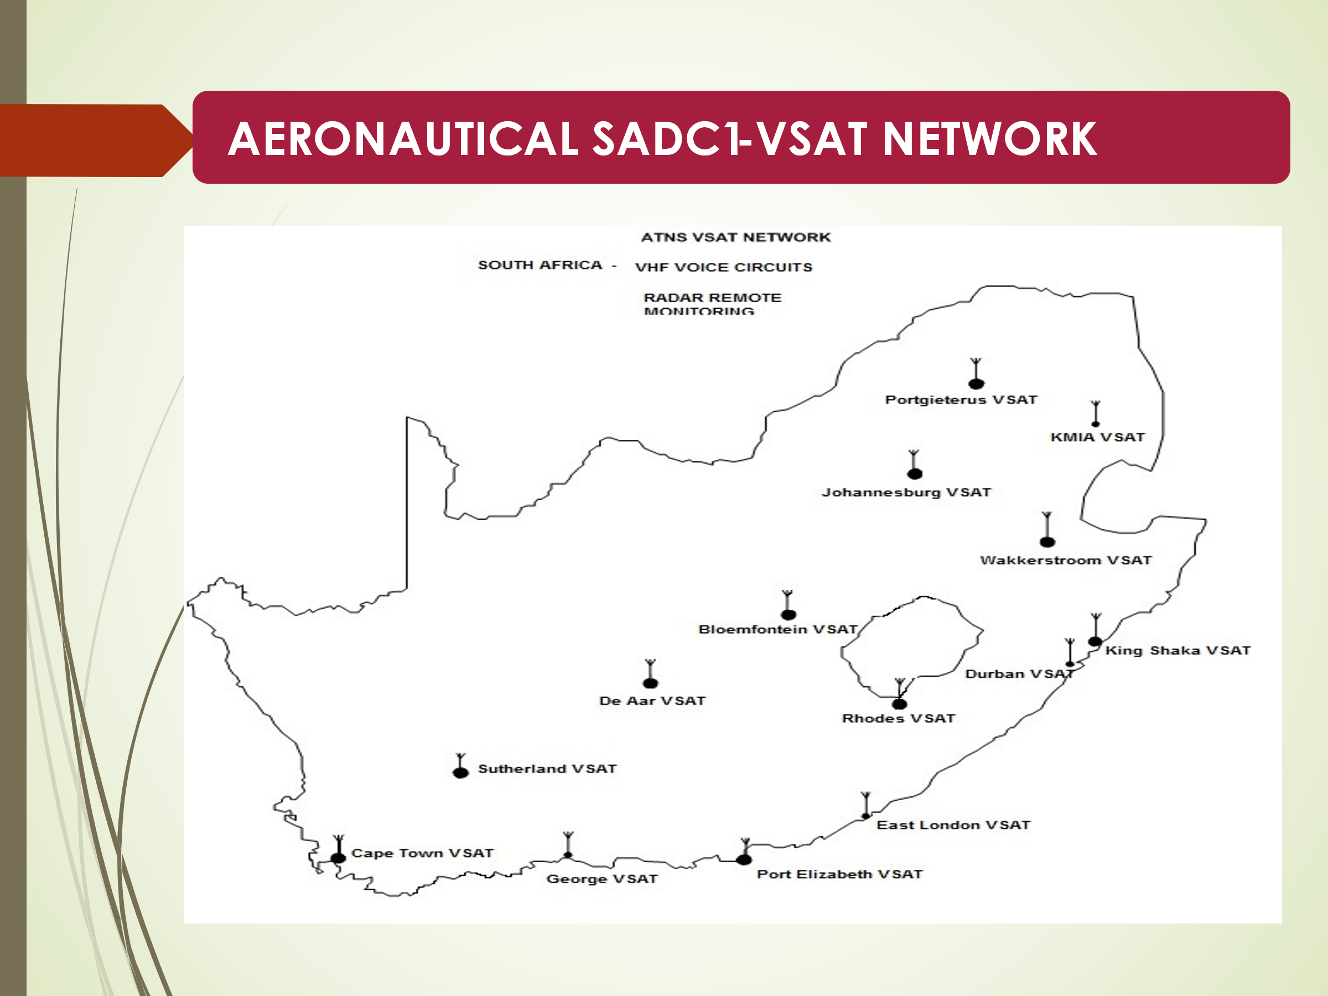
Figure 1: VSAT earth stations in South Africa
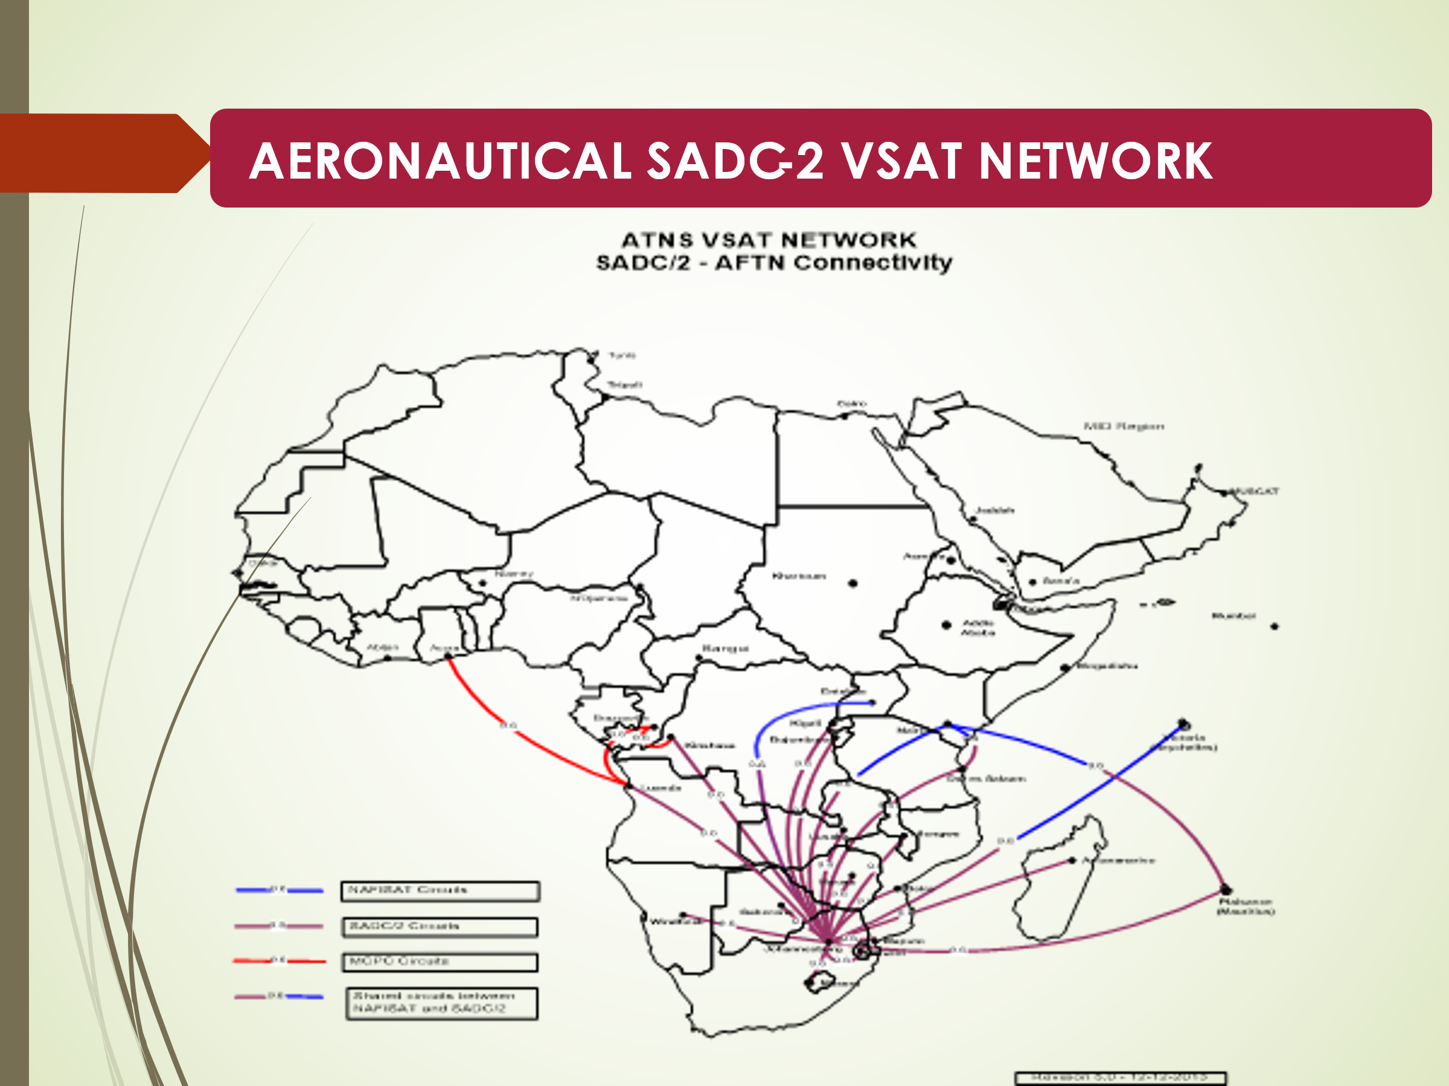
Figure 2: VSAT network in the SADC region

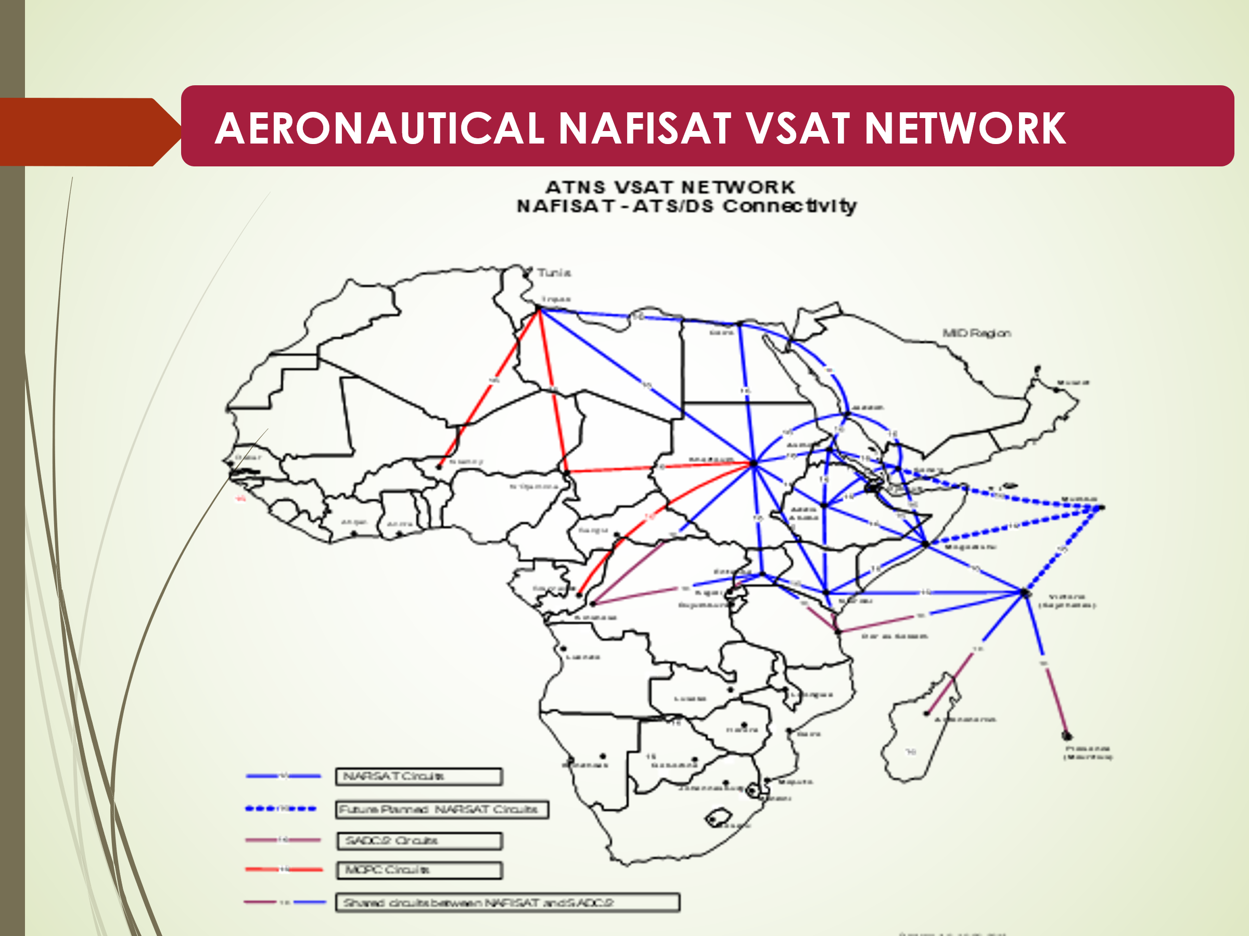
Figure 3: VSAT network in the East African region

