NAVIGATION SYSTEMS PANEL (NSP)

JOINT WORKING GROUPS – EIGHTH MEETING

8 - 19 November 2021
(VIRTUAL MEETING)

Agenda Item 6 b) Signal and compatibility issues in the band 960 to 1215 MHz

Draft
Revised LDACS (L-band Digital Aeronautical Communications System)
versus DME/TACAN Compatibility Testing Plan

Presented by: SWG rapporteur, Felix Butsch

SUMMARY
This paper provides a draft of a revised ‘LDACS/DME compatibility plan’ to be used for further compatibility testing to be finally discussed an agreed by ICAO NSP.
The new material is based on the insights from ‘LDACS/DME compatibility tests’ carried out during 2019 under contract from Eurocontrol in the frame of the SESAR2020 solution PJ.14-02-01 on LDACS.
Comments on the final test report collected by SWG between June and November 2020 as well as discussion in 12 virtual meetings of SWG between 16th December 2020 and 15th June 2021 were taken into account.
Rev. 2 of this paper takes into account discussions and agreement of the joint sessions of SWG and CNTWG at the JWGs/8 meeting in November 2021.
Action for the NSP members:
• Review the draft of the proposed revised testing plan
• Revise, as necessary
• Agree on the final testing plan

Editorial Notes:
Yellow text identifies either editorial notes or text that needs to be further discussed
Revision marks mark changes at the latest Webex or earlier changes which could not yet be finally agreed.
Comments represent either comments, which could not be resolved at the last virtual meeting, or comments by the SWG rapporteur which provide guidance for the further discussion.

0 Background of the paper 5
1 Introduction 6
1.1 LDACS frequency usage 7
1.2 DME/TACAN frequency usage 8
1.3 Overlap of LDACS with DME TACAN channels 9
1.3.1 LDACS Forward Link, initial deployment 9
1.3.2 LDACS Reverse Link, initial deployment 9
1.4 DME/TACAN selectivity and potential impact of image frequencies 9
1.5 Other systems in the same frequency band 16
1.5.1 JTIDS 16
1.5.2 UAT 16
1.5.3 1030 and 1 090 MHz systems 17
2 LDACS characteristics 18
2.1 LDACS signal 18
2.1.1 LDACS Ground Transmitter 21
2.1.2 LDACS Airborne Transmitter 21
2.1.3 DME/TACAN-background 23
2.1.4 JTIDS/Background 27
2.1.5 LDACS background 30
2.1.6 UAT-background 31
3 Compatibility Testing 35
3.1 General testing approach 35
3.2 Test-Bench 36
4 Test Configurations 38
4.1 DME/TACAN Interrogator Tests 38
4.1.1 DME/TACAN Interrogator Setup Parameters 38
4.1.2 Relevant DME/TACAN Interrogator performance characteristics 42
4.1.3 Evaluation of the DME/TACAN Interrogator performance characteristics 43
4.1.4 Compatibility threshold determination for DME/TACAN Interrogators 44
4.2 DME/TACAN Transponder Tests 45
4.2.1 DME/TACAN Transponder Setup Parameters 45
4.2.2 Relevant DME/TACAN Transponder performance characteristics 46
4.2.3 Compatibility threshold determination for DME/TACAN Transponders 47
5 Interference Scenarios and Test-Cases 49
5.1 Pre-tests of Non-interfered DME/TACAN equipment 49
5.2 Interference scenarios 50
5.3 Compatibility test-cases 55
6 DME/TACAN equipment types to be tested 59
7 Appendix – Currently used, or earlier tested DME/TACAN Equipment 59
7.1 Information provided by Collins Aerospace, US 59
7.2 Information provided by DSNA, France 60
7.3 Information provided by FAA 60
7.3.1 TACAN/DME Interrogators used in JTIDS compatibility tests in the US 60
7.3.2 TACAN/DME Beacons used in JTIDS compatibility tests in the US 61
7.3.3 Information provided by NEC 62
7.3.4 Information provided by CAA UK 62
8 References 63
9 Abbreviations and Glossary 67

Background of the paper
During 2019 LDACS versus DME/TACAN compatibility tests were conducted under contract from Eurocontrol in the frame of the SESAR2020 solution PJ.14-02-01 on LDACS.
These tests were based on an “LDACS/DME compatibility testing plan” [LDACS EMC Testing Plan 2018] agreed by ICAO NSP in November 2018. At the ICAO NSP/JWGs/5 meeting in October 2019, initial results of LDACS compatibility tests were presented [LDACS EMC Initial results 2019]. At that meeting a slight revision of the testing plan was agreed (JWGs/5 flimsy 23). In particular the specification of the JTIDS-background was updated (JWGs/5-flimsy 11).
Afterwards the compatibility testing continued in its second phase, final results of the ‘LDACS versus DME/TACAN compatibility tests’ [LDACS EMC Final results 2020] of the SESAR2020-project were then presented in the frame of the virtual meeting of the ICAO NSP JWGs/6 a joint meeting of meeting of the SWG CNTWG on 8th of June.
However, the ICAO NSP meeting could not finally conclude discussions of the presented test report. Therefore, the report was further reviewed and commented by correspondence during summer 2020.
Then, on 5th of October 2020 virtual meeting of the SWG took place to further consider the results of the LDACS versus DME/TACAN compatibility tests. The test report was discussed in conjunction with numerous written comments provided by US-experts, who were involved in compatibility tests of JTIDS with DME/TACAN in past decades. The conclusions of that meeting were (SWG meeting report contained in NSP/6-flimsy 21, rev.2):
- The presented study used overly conservative DME and JTIDS interference backgrounds.
- More state-of-the art DME and TACAN equipment types should be tested.
- The testing results cannot not be directly used for the derivation of compatibility and frequency assignment planning criteria.
For this reason, it was decided that an update of the “LDACS/DME compatibility testing plan” (NSP/5-WP38) is necessary before it can be used as basis for further compatibility testing.
In November an update of US comments on the LDACS compatibility test report as well as proposals to revise the existing “LDACS/DME compatibility testing plan” (NSP/5-WP38) was circulated.
During the ICAO NSP/6 meeting in November 2020 it was decided that virtual meetings of the SWG should be conducted to further discuss the US comments in detail and to develop a revised LDACS compatibility testing plan (SWG report, NSP/6-flimsy 21, rev.2).
This paper contains the latest version of the ‘draft revised LDACS/DME compatibility testing plan’. For the derivation of this document comments on the final test report collected by SWG between June and November 2020, as well as discussion in 12 virtual meetings of SWG between 16th December 2020 and 15th June 2021 were taken into account. Revision 1 of this paper contains the changes agreed at the JWG/8 meeting in November 2021.

Introduction
The future aeronautical terrestrial datalink ‘L-band Digital Aeronautical Communications System’, LDACS will be accommodated in parts of the band 960 to 1164 MHz (Figure 1, [L-Band Compendium]).
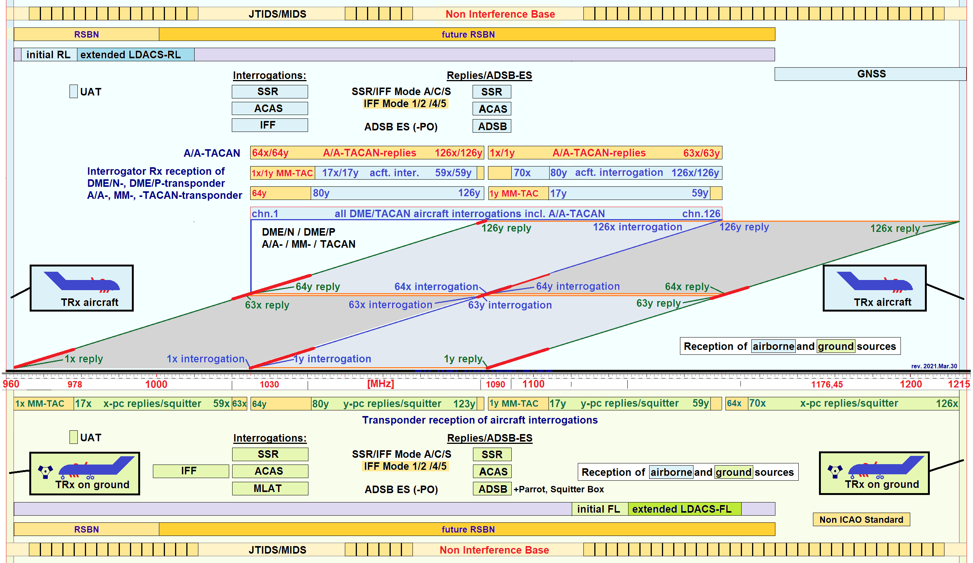
Figure 1: Systems in the band 960 to 1215 MHz
The band 960 to 1215 MHz is used for the aeronautical radionavigation systems DME and TACAN, Secondary Surveillance Radar (SSR) and Mode-S-based Systems (e.g., ACAS, MLAT ADS-B) as well as for other non-ICAO systems, like the Joint Tactical Information Distribution System JTIDS (aka ‘Multifunctional Information Distribution System, MIDS or Link-16).
Since DME and the ICAO-compliant ranging function of TACAN is in the purview of the ICAO Navigation Systems Panel, this paper specifies necessary measurements in order to obtain electromagnetic compatibility criteria, between LDACS and DME/TACAN.
Once an agreement on the compatibility criteria has been achieved, these criteria can then be considered as a basis for the derivation of the frequency coordination criteria. For this purpose, it is foreseen to apply a suitable propagation model in order to calculate necessary frequency separation distances depending on the frequency-offset between a given LDACS-channel and a given DME TACAN-channel. The compatibility criteria resulting from the LDACS laboratory testing can then also be applied for LDACS frequency cell planning.
Having available the compatibility criteria, the next step is to use them to develop frequency assignment planning criteria and submit them to ICAO FSMP for adoption. This whole process shall be finalized in a timeframe supporting the planned time-plan for LDACS standardization which is currently being carried-out within the Project Team Terrestrial Data Link (PT-T) of the ICAO Communications Panel (CP). According to the ICAO CP job card on LDACS standardization, the time-plan foresees applicability of the LDACS standardization in 2024. This implies to have all standardization documentation to be ready by the third Quarter of 2022.

LDACS frequency usage
LDACS is the envisage future terrestrial data link for aviation covering both voice and data exchange. It is based on the Orthogonal Frequency-Division Multiplexing (OFDM) technology and uses adaptive coding and modulation, like the current state-of-the-art commercial mobile radio standards. The nominal transmission bandwidth of a single LDACS channel is 498.05 kHz (more than 96 % of the signal power shall lie within this bandwidth) for each link direction, i.e., forward link (FL) and reverse link (RL). The spacing between LDACS channels is 500 kHz. LDACS enables overall (FL and RL) net data rates of 591 to 2590 kbps depending on the used coding and modulation scheme.
LDACS uses a cellular deployment concept and communication is centralized via the ground station of an LDACS cell. LDACS supports seamless handovers between ground stations.
The revision of ‘ITU-R Resolution 417’ during the World Radio Conferences, WRC2012 and WRC2015 ITU conferences addressed further the use of the frequency band 960-1164 MHz by the aeronautical mobile (R) service [ITU-R Res.417]. The revised resolution requires that any new communications systems shall not cause harmful interference to RNSS (e.g., GPS L5, GALILEO E5, GLONASS L3, Beidou B2) operating in the frequency band 1164-1215 MHz. To achieve this, the Resolution specifies maximum EIRP values for ground and aircraft emissions (as a function of their carrier frequency) and sets limits on emissions in the band below 1164 MHz (i.e., precisely one of the bands where LDACS was aiming to operate) as well as to spurious emissions in the band above 1164 MHz. These power limitations in the upper part of the band 960 to 1164 MHz stipulated by ITU resolution 417 significantly reduce the flexibility of LDACS deployment and make it practically impossible for LDACS to operate above 1125 MHz.
The imposed power limitations of the ITU Resolution 417, requires shifting the LDACS forward link below 1125 MHz. Therefore, the proposed LDACS frequency bands for an initial deployment are:
- Forward Link (Ground-to-Air): 1110–1125 MHz
- Reverse Link (Air-to-Ground): 964–979 MHz
Figure 2: LDACS frequency bands for forward link (FL) and Reverse link (RL); dark green initial deployment, light green foreseen extension for full deployment.

For full deployment at a later stage extended frequency bands may be considered in the future:
- Forward Link 1110-1156 MHz
- Reverse Link 964-1010 MHz
However, at this point in time, compatibility testing should be performed for the frequency bands of the initial deployment only! Before deploying the extended frequency bands additional compatibility testing might be required. The frequency bands for Forward and Reverse Link of LDACS are visualized in Figure 1 and Figure 2.

The above-mentioned plan for the initial deployment is considering 15 MHz of spectrum for each the Forward and Reverse Link aiming to provide frequencies for LDACS frequency planning and at the same time minimise impact to DME. The Reverse Link frequency band is chosen in the lower part of the L-band, where DME Ground Transponders are not receiving. This way, it is ensured that DME ground stations are not interfered by transmissions from LDACS airborne stations.

LDACS applies as basic modulation scheme an Orthogonal Frequency-Division Multiplexing (OFDM) [LDACS Draft SARPs]. The OFDM subcarrier spacing and with that the OFDM subcarrier bandwidth is 9.765625 kHz. The OFDM symbol duration is 120 µs including a cyclic prefix of length 17.6 µs. LDACS, utilizes uses 51 OFDM subcarriers including the zero Hertz subcarrier. Therefore, it occupies a transmit bandwidth of 498.05 kHz (51x 9.765625 kHz).
The LDACS Forward Link transmits on all 50 subcarriers while the Reverse Link may transmit on 25 or 50 subcarriers according to tile assignments. For Reverse Link compatibility testing, all 50 subcarriers shall be used.
Note: The aircraft-specific dedicated channel in the control part of the Reverse Link only uses 25 subcarriers [LDACS Specification].
The LDACS framing structure for FL and RL is based on super-frames (SF) of duration 240 ms.
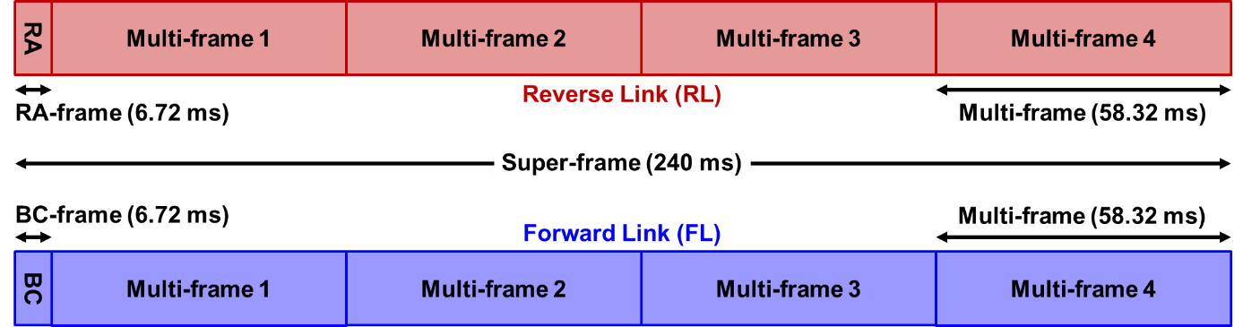
Figure 3: LDACS framing structure based on super-frames subdivided into a Random Access (RA) segment and four multi-frames in RL, a Broad Cast (BC) frame and four multi-frames in FL [LDACS Draft SARPs]

DME/TACAN frequency usage
DME is an ICAO-standardized radionavigation system. It measures the slant range between an aircraft and a ground station by determining the propagation delay of signals in the frequency band between 960 and 1215 MHz. An airborne Interrogator initiates an exchange by transmitting a gaussian-shape pulse pair to a Ground Transponder. After a known delay, the Transponder replies by transmitting a pulse pair on a frequency that is offset from the interrogation frequency by 63 MHz.
The ICAO DME channel plan defines 352 different channels in the frequency band 960 to 1215 MHz [ICAO DME chan]. A channel is defined by an interrogation/reply frequency pair separated by 63 MHz and a pulse code. The pulse code is determined by the spacing between the pulses of an interrogation or reply and is designated by X or Y. The spacing is 12 microseconds for X channels and 30 microseconds spacing for Y channels. A channel is designated by a number from 1 to 126 followed by a letter (i.e., 63X).
TACAN is a navigation system used by military aircraft that provides users with bearing and slant-range distance to a ground or mobile station (ships or refuelling aircraft). The distance-measuring component of TACAN is functionally identical to and has the same specifications of DME. TACAN operates in the same frequency band as DME and is bound to the ICAO channel plan.
The DME/ channels 1X/Y (962 MHz) to 16X/Y (977 MHz) of ‘military mobile TACAN (MM-TACAN’) are used for replies by TACAN Transponders on ships [NATO study].
Note: There is a concern that Military use of channels 1 to 16 may be impacted by the LDACS RL use of 964 to 979 MHz. If the EMC test data indicates that a frequency separation or a standoff distance is required between LDACS RL equipped aircraft and TACAN/DME interrogator receivers it may be difficult to ensure that the restrictions are implemented. It is expected that Military use of channels 1 to 16 is largely uncoordinated with civilian users because the frequency bands do not overlap and therefore prior coordination has not been required. Also due to operations security (OPSEC) it is expected that the precise military location at any given time would be very sensitive.
Military operations are dynamic and can therefore occur without any prior coordination so the actual frequencies and the location of the military receivers may not be known at any point in time. Without prior coordination it is may not be possible to ensure that LDACS will not interfere with future military operations. The problem is compounded due to the uncertainty of military aircraft that can be 300 miles from naval ships. So, it is possible for the military aircraft to be hundreds of miles over land.
It is important that this issue be solved before LDACS operations commence.

Overlap of LDACS with DME TACAN channels

LDACS Forward Link, initial deployment
The LDACS Forward Link (Ground-to-Air) of the initial deployment 1110–1125 MHz overlaps with the following DME-channels:
- 76X/Y (1110 MHz) to 101X/Y (1125 MHz), DME Airborne Interrogation
- 23Y (1110 MHz) to 38Y (1125 MHz), DME Ground Transponder Reply

LDACS Reverse Link, initial deployment
The LDACS Reverse Link (Air-to-Ground) of the initial deployment 964–979 MHz overlaps with the following DME-channels used by civil aviation:
- 17X (978 MHz) to 18X (979 MHz), DME/TACAN Ground Transponder Reply
Moreover, the LDACS Reverse Link overlaps with the following DME-channels used by MM-TACAN:
- 3X (964 MHz) to 16X (977 MHz), TACAN Maritime Mobile, Transponder Reply

DME/TACAN selectivity and potential impact of image frequencies
DME/TACAN equipment uses an Intermediate Frequency of 63 MHz. DME/TACAN equipment with pure front-end filter selectivity may show a certain susceptibility at the Image Frequency with a 126 MHz offset from the channel of the desired frequency (Figure 4). Manufacturers of state-of-the art DME Ground Transponders indicate Image Frequency Rejections between 75 and 85 dB. In particular Mobile TACAN Transponders may have pure Image Frequency Rejection (e.g., TRN-26).
Note 1:[ICAO Annex10-I], section 3.5.4.2.6.5 states for the case of DME transponders “Signals greater than 900 kHz removed from the desired channel nominal frequency and having power densities up to the values specified in 3.5.4.2.3.3 for DME/N and 3.5.4.2.3.4 for DME/P shall not trigger the transponder. Signals arriving at the intermediate frequency shall be suppressed at least 80 dB. All other spurious response or signals within the 960 MHz to 1 215 MHz band and image frequencies shall be suppressed at least 75 dB.”
Note 2: This requirement specifies a rejection of DME signals received at the Image Frequency. The RF- rejection of signals with other characteristics, e.g., LDACS may not reach the same magnitude.
Note 3: [ICAO Annex10-I] does however not specify the required Image Rejection for DME aircraft interrogators, even though the input material from EMC research between DMET/TACAN IFF/SSR assumed the necessity of an Image Rejection of ≥ 60 dB [SGM-100-60].
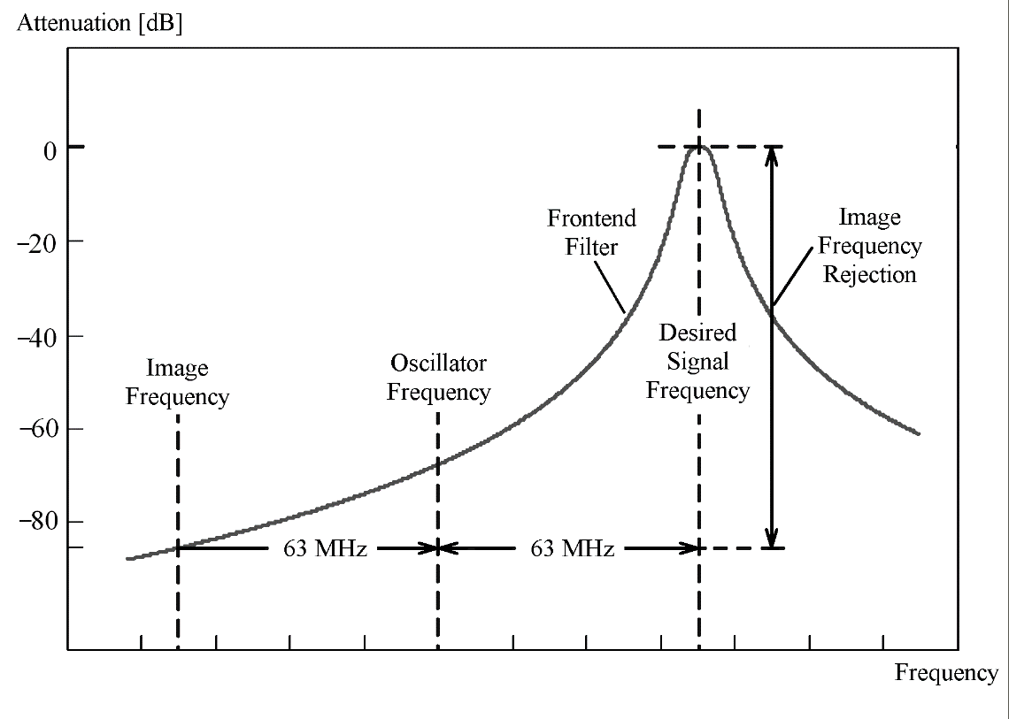
Figure 4: Principle of Image Frequency Rejection with an Intermediate Frequency of 63 MHz

In order to find out, whether a DME/TACAN Interrogator or Transponder receiver is susceptible against interference near the image frequency, the span of the selectivity measurements shall include the Image Frequency and 5 MHz beyond the Image Frequency.

Note: DME Interrogators ‘Sperry DME-1077B’ and ‘KN 64’ and ‘KN 63’ and ‘NARCO DME-890’ are known to have no ‘Image Frequency Rejection’. Approximately ‘one third’ of General Aviation Interrogators do not have ‘Image Frequency Rejection’
For LDACS FL frequencies a frequency offset of +126 MHz and -126 MHz could affect DME receiver operating in the frequency band between and 984 – 999 MHz.
For LDACS RL frequencies, a frequency offsets of +126 MHz could affect DME receiver operating in the frequency band between 1090 – 1105 MHz.

Figure 5 illustrates the principle of DME/TACAN receiver selectivity measurement.
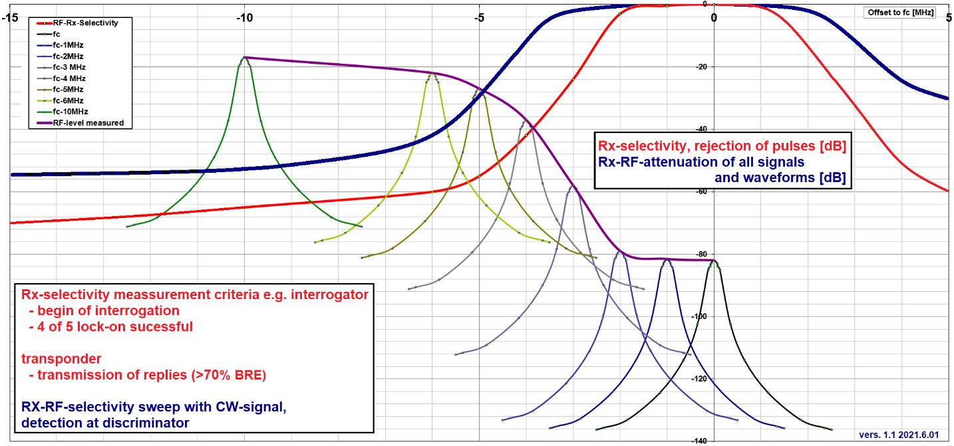
Figure 5: Example of DME/TACAN receiver selectivity measurements near receiver passband (centered on 1094 MHz for test signal spectrum level above MTL of -92 dBm and Receiver selectivity in dB versus frequency)

Note: Receiver selectivity is specified in ICAO SARPs and MOPS to be measured with the Desired signal only. The increase in signal strength needed, to achieve stable operation is plotted for different offsets from the centre frequency as shown below [L-Band Compendium].
This measurement procedure only identifies the receiver selectivity curves for the suppression of the waveform the receiver was designed to process (i.e., gaussian-shaped Pulses Pairs) and is therefore not necessarily identical to a receiver’s frontend selectivity, which identifies the suppression of any waveform.
DME and TACAN receiver designs often contain dedicated pulse discriminator to improve the suppression of DME or TACAN pulses in adjacent in excess of 60 dB, even though the Rx-RF-selectivity is much lower. This discriminator consists of a ‘wide signal path’ covering the operating channel and a ‘narrow signal path’ covering the channel in operation as shown in the figures below. In literature attributed to McKinley for DME (1949) and Ferris for TACAN (1955). Newer designs in Transponder employ two separate receiver paths, -one wide for the operating channel and the adjacent channel, and a narrow one for the operating channel to perform the same function. Actual measured receiver selectivity curves are often asymmetrical in reference to the centre frequency.

Receiver RF-selectivity measurement of DME/TACAN interrogators:
A desired DME signal on the right channel modulated with the correct pulse code is fed into the antenna port of the DME/TACAN interrogator under test. The weakest signal level (sensitivity) for a reply of the interrogator signal is determined and used as reference level for the Rx-selectivity.
Then, injected CW-signal is injected, and its frequency is moved away from the nominal centre frequency (on-channel) in steps of 0.5 MHz. At each frequency the level of the test signal is increased until lock-on is successful (i.e., end of search is reached), four out of five searching cycles. The resulting signal level is plotted versus the frequency.
Note: FAA TSO C66a, section 2.1.4 contains a specification of spurious response and intermodulation requirements for image frequencies.
Figure 6: Excerpt from TSO C66a specifying the spurious responses and intermodulation test method

Note: ARINC Characteristic 568, section 4.17 provides a specification of the interrogator selectivity

Figure 7: Excerpt from ARINC 568 specifying the interrogator selectivity
Note: DME/TACAN Interrogators usually have an Automatics Gain Control (AGC) adjusting the gain to varying signal levels from changing distance wrt. DME Ground transponders. This AGC may respond to the interference signal and change sensitivity depending on the interference signal level.

Receiver RF-selectivity measurement of DME/TACAN transponders:
A desired DME signal on the right channel modulated with the correct pulse code is fed into the antenna port of the DME/TACAN transponder under test. The weakest signal level (sensitivity) for a reply of the interrogator signal is determined and used as reference level for the Rx-selectivity.
Then a CW-signal is fed into the antenna port of the DME/TACAN transponder under test. The frequency of the CW signal is moved away from the nominal centre frequency (on-channel) in steps of 0.5 MHz. At each frequency the level of the test signal is increased until the Beacon Reply Efficiency reaches 75 % (value significantly above the ICAO limit for BRE of 70 %). The resulting signal level is plotted versus the frequency.
Note: ‘Receiver Selectivity’ defines only the rejection of pulses and pulse pair having pulse characteristics specified for use for DME/N, DME/P and TACAN in [ICAO Annex10-I] and related documents, when the pulse pairs used for measurement are not centered on the nominal channel center frequency but moved in fixed steps of 0.5 MHz above and below the nominal channel center frequency selected by the receiver. The ‘Receiver Selectivity does not allow to conclude on the actual Receiver-RF-Selectivity which defines the suppression of any signal or waveform in dB, since rejection of DME pulses on adjacent channels of >60 dB can also be achieved with dedicated circuits (e.g., McKinley or Ferris Discriminator) without requiring a Receiver RF-selectivity in the same magnitude of >60 dB.

Selectivity requirements and selectivity measurement procedure for DME interrogators are defined in DME MOPS (e.g., EUROCAE ED54, sections 3.13, 6.4.12 and 6.7.14). It is a requirement that a DME interrogator will achieve lock-on to the ‘DME transponder of interest’ in 4 out of 5 times. An alternative method is to measure the transponder signal level for an interrogator to start interrogations when squitter pulses of the correct pulse code have been successfully processed.
Note: While this is the fastest method of measuring the receiver selectivity, it cannot be applied to interrogator which interrogate consistently, independent if valid squitter pulse pairs are received or not (e.g., Bendix KDM-706 or Bendix KTU-709).
Consequently, a DME or TACAN receiver may have a lower rejection of pulses received from the receiver’s image frequency compare to the ‘adjacent channel rejection’ if the ‘adjacent channel rejection’ is achieved with dedicated circuits for the suppression of adjacent channels, and not with Receiver-RF-selectivity of ≥ 60 dB. Selectivity requirements and selectivity measurement procedure for DME transponders are defined in DME MOPS (e.g., EUROCAE 57, sections 3.3.3.2, 6.4.12 and 6.7.14)
This is evident in the need to ascertain the image frequency rejection for aircraft interrogators since image rejection is only defined for transponder by ICAO and some interrogator designs have been measured to have image of less than 60 dB rejection. While an image rejection of ≥60 dB was initially assumed for aircraft interrogator in the EMC studies on DMET/TACAN vs. SSR/IFF [SGM-100-60] in 2.a for Ground to Air Interference for SSR/IFF interrogators into airborne DMET/TACAN, which is basis for DME/N in [ICAO Annex10-I] today.
It is important to note that the Rx-Selectivity does not allow to conclude that it is identical to RF-selectivity of the measured receiver which identifies the attenuation of any signal or waveform in the measured frequency offset to the nominal center frequency.
The measured Rx-Selectivity and Rx-RF-Selectivity may be not centered on the nominal channels center frequency and/or may be asymmetrical.
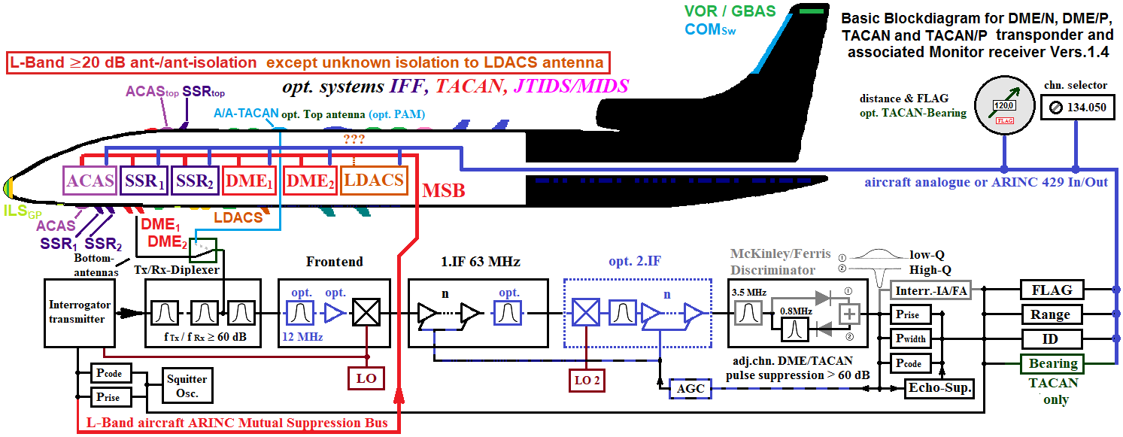
Figure 8: Block diagram of a DME/N, DME/P, TACAN interrogator

A block diagram of a DME transponder containing information on signal filtering components is depicted in Figure 9.

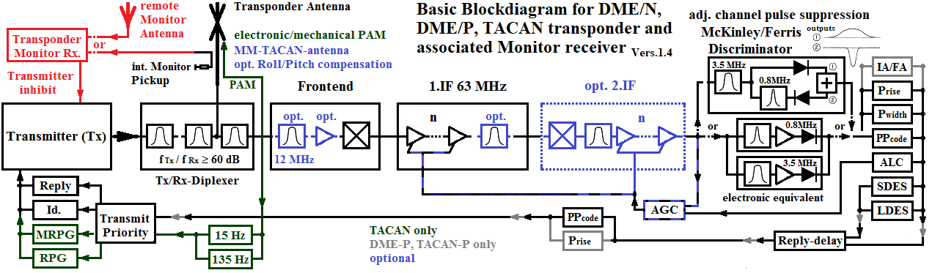
Figure 9: Block diagram of a DME/N, DME/P, TACAN transponder

Figure 12 shows an example of measured selectivity exhibiting a high susceptibility at the Receiver Passband and a lower susceptibility near the Image Frequency.

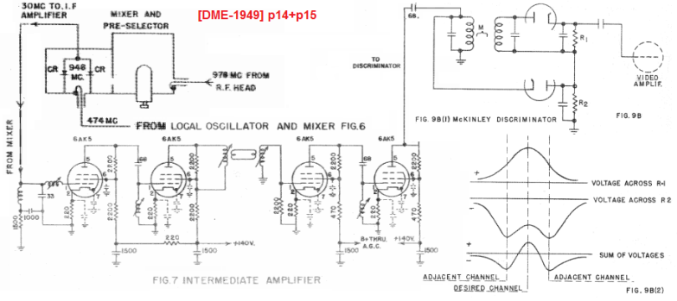  Figure 10: DME frontend, 4 stage IF-amplifier [~23 dB selectivity) and McKinley discriminator providing 60 dB suppression of adjacent channel DME pulses | 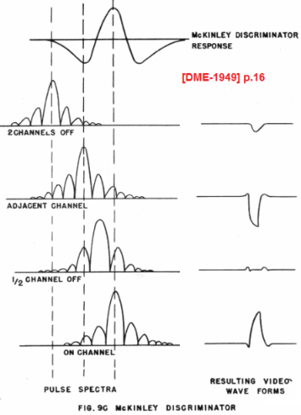  Figure 11: McKinley-Discriminator-off channel-response
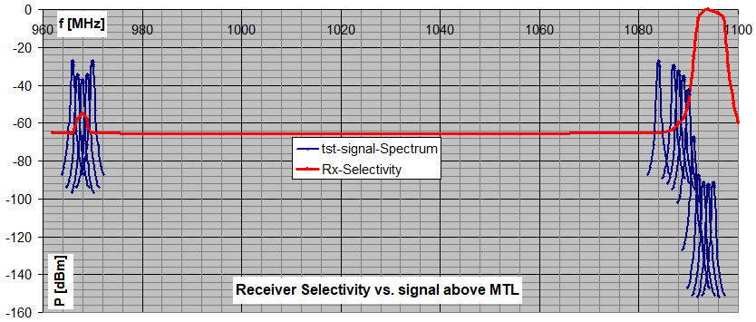
Figure 12: Example of measured selectivity with Receiver Passband and susceptibility near Image Frequency (Measured with DME signal. Power of test signal spectrum is indicated above Minimum Trigger Level of -92 dBm)

Any discoveries of spurious responses during such a sweep should also be examined, i.e., the interference threshold of undesired LDACS signals on such a frequency needs to be established.

Other systems in the same frequency band
This chapter provides further information on other systems in the band, like JTIDS, UAT and 1030/1090 MHz systems (Figure 13, [L-Band Compendium]).
Figure 13: L-Band usage frequency overview with JTIDS, UAT and 1030/1090 MHz systems

JTIDS
JTIDS is a network radio system used by armed force of the United States and other NATO countries. Since JTIDS has no ITU-Allocation it operates under national bilateral Frequency Clearance Agreements (FCA) between the Civil Aviation Authorities (CAA) and the Ministries of Defence (MoD). JTIDS uses a ‘Spread Spectrum Direct Sequence` modulation with Frequency Hopping over 51 channels with 3 MHz spacing in the following sub-bands (Figure 13):
- 969 to 1008 MHz (14 channels),
- 1053 to 1065 MHz (5 Channels) and
- 1113 to 1206 MHz (32 channels)
In the context of compatibility testing between LDACS and DME/TACAN one of the test-cases to be considered is the additional interference background of JTIDS (section 2.1.4).

UAT
Universal Access Transceiver (UAT) is a bi-directional aeronautical data link system. It is applied for broadcasting a traffic information and weather data and for Automatic Dependent Surveillance. UAT operates at 978 MHz ([ICAO UAT SARPS], [ICAO Doc 9861]). To date (2021) UAT is only used in North America. Deployment in other world regions is currently also considered. The UAT channel is identical to the DME channel 17X.
The LDACS reverse link frequency band also surrounds the UAT frequency at 978 MHz. For regions where UAT is deployed parts of the LDACS reverse link frequency band cannot be used and frequency coordination criteria must be defined to allow a parallel operation of LDACS and UAT.
“Ensuring compatibility between LDACS and UAT will be pursued between ICAO FSMP, ICAO CP DCIWG PT-T. This task is not in the purview of ICAO NSP and therefore is outside the scope of this document.”

1030 and 1 090 MHz systems
Ensuring compatibility between LDACS and Secondary Surveillance Radar (SSR) and Mode-S-based Systems using the channels 1030 and 1090 MHz, Airborne Collision Avoidance System (ACAS), Multi Lateration (MLAT), 1090ES, etc. will be pursued between ICAO FSMP, ICAO CP DCIWG PT-T and ICAO SP. This task is not in the purview of ICAO NSP and therefore outside the scope of this document.

LDACS characteristics

LDACS signal
Compatibility of a single interferer is to be tested. Hence, the definition of a single interference source is to be specified here. In the context of an interference consideration, it has to be distinguished between reverse link transmissions of the airborne transmitter and the forward link transmissions of the ground station transmitter.
The ‘maximum LDACS ground station EIRP’ is +52 dBm and the ‘maximum LDACS airborne station EIRP’ is 41 dBm).

Note: In addition, [LDACS Draft SARPS] specify an ‘Extended Range LDACS Ground station’ with an EIRP of +58 dBm below 1120 MHz, in this way ensuring compliance with ITU-R Resolution 417. This higher EIRP would be reached by means of an 18 dBi gain antenna. Such a LDACS stations would not be co-located with a DME/TACAN ground beacon, nor close to runways or taxiways.

The LDACS signals used for the compatibility tests shall comply with the spectrum mask in the LDACS Draft SARPs [LDACS Draft SARPS]. Among other things the LDACS signal needs to comply with the LDACS transmit spectral mask in the [LDACS Draft SARPs], depicted in Figure 14.
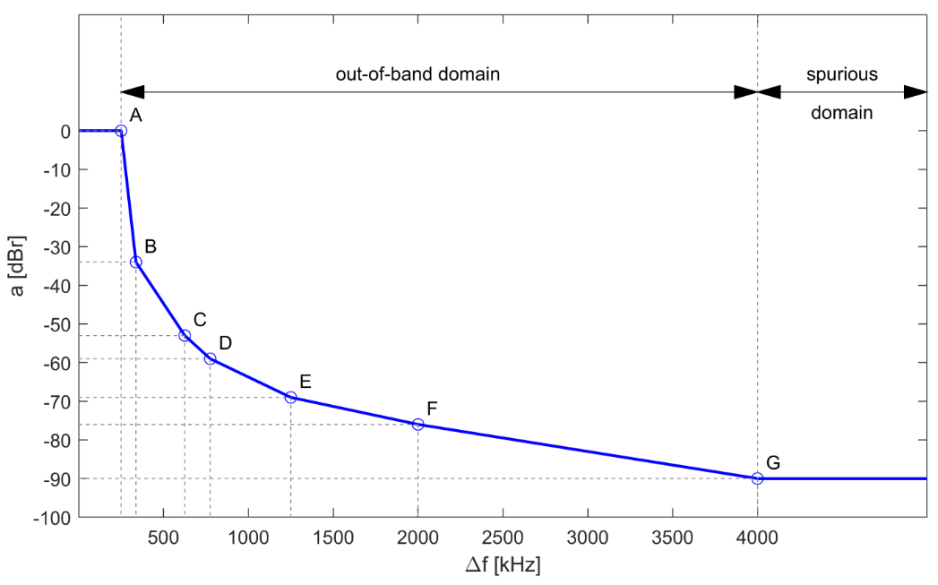
Figure 14: LDACS transmit spectral mask

Note: Utilization of subcarriers (e.g., reduced number of subcarriers during synchronisation is described in paragraph 7.5.1 of [LDACS Specification].

The LDACS signals has a Peak Power Ratio (PAPR) of 11 dB [LDACS Draft SARPs]. It is important that worst-case peaks, which are 11 dB higher than the average signal really appear during the measurement interval. It was demonstrated that for measurement times longer than 10 s, the probability that a LDACS Symbol with a PAPR of 11 dB occurs is higher than 99.9 %.

LDACS signals applied for the measurements shall have same PAPR characteristics than an operationally used LDACS transmitter. Before carrying out the compatibility tests the applied LDACS-source (LDACS transmitter or signal generator shall) be checked by determining the ‘Complementary Cumulative Distribution Function, CCDF and comparing it with its theoretical values given below:

Table 1: Table of calculated probability for given PAPR of LDACS
PAPR [dB] | 14 | 13 | 11 | 10 | 9
CDF – Symbol | 1.0000000 | 1.0000000 | 0.9998 | 0.9977 | 0.9824
CCDF – Symbol | 6.17E-10 | 1.08E-07 | 1.70E-04 | 2.27E-03 | 1.76E-02
Number of Samples for 99 % probability | 1.38E+12 | 7.87E+09 | 4.99E+06 | 3.75E+05 | 4.83E+04
Measurement Time for 99 % probability [sec] | 2205700.0000 | 12586.0000 | 7.9808 | 0.5998 | 0.0773
PAPR [dB] | 8 | 7 | 6 | 5 | 4
CDF – Symbol | 0.9130 | 0.7160 | 0.3898 | 0.1150 | 0.0146
CCDF – Symbol | 0.0870 | 0.2840 | 0.6102 | 0.8850 | 0.9854
Number of Samples for 99 % probability | 9.77E+03 | 2.99E+03 | 1.39E+03 | 9.60E+02 | 8.63E+02
Measurement Time for 99 % probability [sec] | 0.0156 | 0.0048 | 0.0022 | 0.0015 | 0.0014
With:
CDF: Cumulative Distribution Function
CCDF: Complementary cumulative distribution function
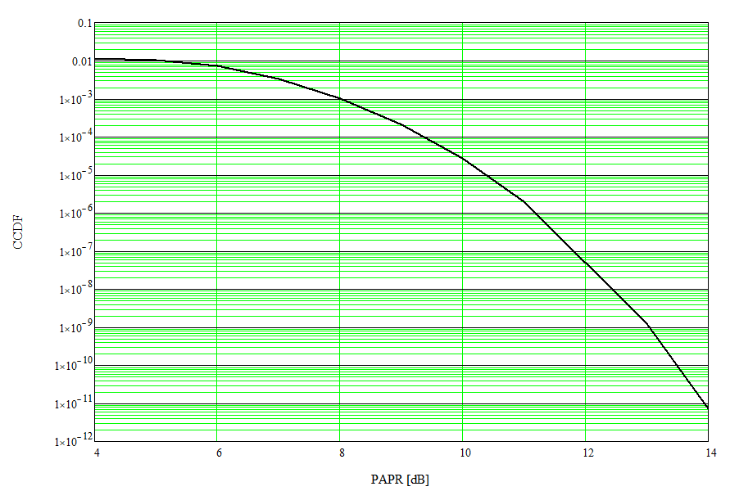
Figure 15: CCDF versus PAPR for LDACS

It is recommended to validate the PAPR of an LDACS signal by using the provided CCDF functions of a modern RF Power Meter or a Real-Time Spectrum Analyser with a resolution bandwidth of at least 5 MHz.

Note: To measure the PAPR of a signal, two values are necessary. The ‘average power’ and the ‘peak power’. In general, the former is easy to determine. When measuring the peak power, the bandwidth and rise time are important.
Peak power meters perform power measurements in a manner that provides both ‘peak power’ and ‘average power’ readings for all types of modulated carriers. The most important issue is that the sensor must be able to accurately track the envelope fluctuations of the signal at all times i.e., at least 5 MHz.
Many modern communication signals fall into the category of ‘noise-like modulated signals’, which are using digitally modulated data formats, like OFDM or CDMA within bursts or packets. For these signals, statistical power analysis often makes more sense than time-domain analysis. When statistical analysis is performed, power samples are acquired and analysed by ‘how frequently each power value occurs’ rather than ‘when it occurs’.
Statistical Power Analysis is best for signals like LDACS when probability information is helpful in analysing the signal and to validate ‘peak probability’, ‘peak to average power ratio’ (PARR) and ‘crest factor’.
The CCDF, or ‘Complementary Cumulative Distribution Function’ representing the probability that the power is at or above that point. Most of the modern power meters or spectrum analysers are providing a CCDF measurement function.

Note: References for PAPR measurements:
- Application Note, “Peak Power Meters for Crest Factor and Scalar Measurements Using Broadband OFDM Sign” by Vitali Penso, Boonton
- RF Globalnet, “Basic Power Measurement” by Russel Lindsay, Anritsu, https://dl.cdn-anritsu.com/en-us/test-measurement/files/Brochures-Datasheets-Catalogs/Articles/11410-00929A.pdf
- Application Note, “Power Measurement on Pulsed Signals with Spectrum Analyzers” Rohde&Schwarz, https://cdn.rohde-schwarz.com/pws/dl_downloads/dl_application/application_notes/1ef48/1EF48_2E.pdf

LDACS Ground Transmitter

Frequency as parameter
The LDACS transmitter frequencies should be indicated as frequency-offset with respect to the centre frequency of the DME/TACAN channel. The frequency-offset values need to be specified individually in the various test-cases.
Since the LDACS channel spacing is 500 kHz, frequency-offset shall be a multiple of 500 kHz with respect to the centre Frequency of the DME/TACAN channel. This also includes the on-channel scenario with zero frequency-offset.
A fixed list of offset frequencies may be specified in a test-case.

Duty Cycle as Parameter
A duty cycle of 100 % shall be used for the signals of the LDACS Ground Transmitter.

LDACS signal level at DME/TACAN Equipment Under Test
The transmitted interference signal level of LDACS is defined as average signal level at the input of the at Equipment Under Test, EUT.
During the compatibility measurements the undesired LDACS signal level is step-wise increased in order to establish the highest acceptable signal level which just allows compliance with all performance characteristics of the DME/TACAN Equipment Under Test (specified in section 4.1.2 for Interrogators and in section 4.2.2 for Transponders.

LDACS Airborne Transmitter

Frequency as Parameter
The LDACS transmitter frequencies should be indicated as offset frequency with respect to the centre frequency of the DME/TACAN channel. The frequency-offset values should be specified individually for the various test-cases.
The LDACS channel spacing is 500 kHz. The LDACS channel shall be set to the channel, which is on-channel compared to the DME/TACAN channel (LDACS has same centre frequency as the DME), as well as multiples of 500 kHz (including centre frequency of LDACS on DME channel boundaries). A fixed list of DME offset frequencies needs to be specified in a test-case (e.g., frequency-offsets of 0, 0.5, 1.5, 2, 2.5, 5, 7, 9 and, 11 MHz).

Duty Cycle as Parameter
In contrast to the LDACS forward link signal transmitted by a ground station, the Reverse Link signal transmitted from airborne stations can have varying duty cycles.
The RL duty cycle shall be varied in the range of values 2.4 %, 4.8 %, 9.2 % per second. The ‘Maximum allowed RL duty cycle’ shall be established by means of the compatibility tests.
The transmission of the Reverse Link is subdivided into tiles in terms of time and in terms of frequency. Transmission patterns specify the used tile distribution and subsequently the duty cycle. Various patterns result in the same duty cycle.
In addition, to simulate the impact of transmissions from multiple, other airborne stations. i.e., the LDACS-Background, a duty cycle of 100 % shall be used for compatibility tests involving the LDACS Airborne Transmitter (Reverse Link).
Note: The duration of a signal transmission by an LDACS on-board transmitter will never exceed 58.32 ms and therefore is expected to always pass the 95% per 40 seconds sliding window, a technique, which is used to evaluate DME ranging error evaluation, used according ICAO DOC 8071, Vol. I.

LDACS signal level at DME/TACAN Equipment Under Test
The signal level of the undesired LDACS signal which will be fed into input of the EUT is defined as ‘average signal power level’.
During the measurement test-cases, the LDACS signal level is varied to identify the highest acceptable interference level (chapter 5). Background interference signals
For some test-cases “Background interference signals” are to be fed into the Equipment Under Test in addition to the Desired DME or TACAN signal and the Undesired LDACS signal. The purpose of the “Background interference signals” is to mimic also other signals e.g., in the same frequency band as: DME/TACAN signals from equipment using a different pulse-code, JTIDS signals, LDACS signals from other cells. For the test-cases, where background interference signals need to be fed-in, the signal characteristics described in this chapter apply.
The characteristics of the applied background signals of JTIDS, LDACS and DME/TACAN should be regularly monitored and documented in the test-report.

DME/TACAN-background
Pre-tests:
DME/TACAN Interrogator background
In addition to the desired DME/TACAN signal itself, additional 6000 single pulses (half pulse pair, with equal pulse width as DME) at the receiver input port shall be used in pre-tests of DME/TACAN Interrogators.
The signal level of the 6000 single pulses to be applied is contained TSO C66a, C66b, C66c (referring to RTCA DO-189), ARINC 568, ARINC 709.
The ID Tone should be “on” for the sensitivity-test in the frame of pre-test with 6000 pps, otherwise, it should be “off”).
Note: The purpose of 6000 single pulse background is to mimic the signals from other systems in the air: other DME Interrogators interrogating other Ground Transponders as, IFF-signals from other aircraft. In the compatibility test, the background (EPE) will substitute this background. -76 dBm is the value specified in TSO C66a. TSO C66b & TSO C66c refer to RTCA DO-189, where: a value of 30 dB above desired level is mentioned.

Table 2: Excerpt from FAA TSO C66a:
2.1 Accuracy. At distances from the transponder from zero to that for which the equipment is designed, the total error of the airborne equipment, as presented to the pilot, shall be such that when combined by root sum square with a 0.1 nautical mile error attributed to the ground facility, the total error does not exceed:
a. ± 0.5 nautical mile or 3% of the distance, whichever is greater. When such equipment is designed for distance indication beyond 100 nautical miles, the total error at distances of 100 nautical miles or greater shall not exceed 3 nautical miles.
b. This accuracy shall be met under all combinations of the following conditions:
(1) A variation in fruit from zero to 6,000 random pulses per second, or 3,000 pairs of pulses per second with a spacing of 17.5 microseconds or greater, at a level of 10 dB above the level of the random pulse pairs of a single TACAN station.
(2) Variation in input signal level from -10 dBm to the weakest signal on which the equipment will lock-on.
(3) Variation in received pulse repetition rate within the range of 700 to 2,700 ±3.3% pulse pairs per second.
Note that it is not necessary that equipment be subjected to all combinations of the above variable conditions simultaneously to determine compliance with this standard. The over-all error may be determined by adding algebraically the errors due to the separate variables.

DME/TACAN Transponder background
There is no need to apply such a background for DME/TACAN Ground Transponders.

Compatibility test:
DME/TACAN Interrogator background
In the compatibility tests of DME/TACAN Interrogators with LDACS a representative DME Background (aka Extraneous Pulse Environment, EPE) similar to the one used during the US JTIDS EMC test program for the Interrogator testing shall be used.

Table 3: Interrogator background used in US JTIDS EMC test program (*modified)
Frequency relative to the tuned Interrogator  (MHz) | Pulse Spacing (µs) |  | Pulse Rate  (ppps) | Signal Level  (dBm)
Frequency relative to the tuned Interrogator  (MHz) | X Mode | Y Mode | Pulse Rate  (ppps) | Signal Level  (dBm)
+1  +1  +3  +3 | 12  12  12  12 | 30  30  30  30 | 1373  700  1373  1373 | -75  -78  -90  -97

*Note: Column on ‘pulse type’ was removed in order to allow DME/P to be replaced by DME/N. This environment (with all positive frequency-offsets) was derived from the environment of the Los-Angeles Basin in [1984].
Until a new European DME/TACAN background is derived, the modified version of the DME/TACAN background used in US JTIDS EMC test program can be used. In this context also an ‘on-channel off-code DME signal’ should be considered.

DME/TACAN Transponder background
The tested DME/TACAN Transponder should be loaded with a same-pulse-code signal with a signal power level of -80 dBm and an interrogation rate of 2174 ppps.
If the tested transponder does not work satisfactorily with an interrogation rate of 2174 ppps for X- and Y-code, the maximum interrogation rate shall be established, documented, and used in the compatibility tests. Note: Explanation of a load of 2174 ppps: It was assumed that a transponder would service 100 aircraft transmitting at 27 per second using the beacon independently. Based on simulation, 2174 was determined in the US-test (by means of a Poisson Distribution, taking into account overlapping and Transponder response delay time) as the number of ppps received as a load for testing since due to practicality only a single interrogator simulator can be used (i.e., without overlapping of signals from different aircraft which would occur in practice). In this way 2565 ppps are assumed (27 x 95 =2565). In this model 95% of Interrogators are in track mode (27 ppps) while 5% will be in acquisition mode i.e., 5x150 ppps=750 ppps (2565 ppps +750 ppps =3315 ppps). Figure 20provides an example of BRE versus Desired signal level for various Interrogation Rates.
As a background information the following description of the DME transponder load used in the US JTIDS versus DME/TACAN is provided:
A beacon load represents interrogation pulses from TACAN/DME interrogators obtaining service from a beacon. To produce the beacon load, two TACAN/DME beacon simulators are used. One simulator is used for the desired signal (as described previously) and the other is used to generate the remaining load signal. Once the load rate is selected, the interrogation rate of the load signal generator must be reduced to compensate for the interrogations produced by the desired signal generator and for the fact that only one signal source is used to model the many independent interrogations that occur in a real environment.
The beacon simulator generates pulse pairs that are Poisson distributed in time, but the minimum pulse pair spacing produced is 60 microseconds (This is a characteristic of the applied simulator and may be different for other types of simulators). Therefore, the beacon will decode almost every pulse pair generated by the beacon simulator. In an actual environment, some interrogations from independent sources could overlap, and the pulse pair spacings would not be limited to a minimum of 60 microseconds. However, the beacon would, by design, not decode any pulse pairs that arrive less than 60 microseconds after the most recent valid decode. This is called the beacon dead time. In order to compensate for this 60 microsecond minimum pulse pair spacing in the beacon simulator, the beacon load is reduced by the number of pulse pairs that would normally fall within the beacon dead time.
The equation that determines the load signal rate that will be produced by the load simulator is:
N_{r} = (N_{i} -N_{d}) / (1 +τ_{D}(N_{i}-N_{d}))
Where:
N_{r} = load signal rate produced by the load simulator, in ppps
N_{i} = load interrogation rate from aircraft obtaining service from the beacon, in ppps
N_{d} = interrogation rate produced by the desired signal generator (200 ppps), and
τ_{D} = beacon dead time (60 microseconds).
For the EMC Demonstration Tests, three different Load interrogation rates were used. The total equivalent Load rates, the number of aircraft represented by these rates, the desired signal generator pulse rates, and the corresponding Load signal generator pulse rates are summarized in the table below. The Load signal level for all of the EMC Demonstration Tests was –80 dBm.
Equivalent Total Load  Interrogation Rate (N_{i}) | Approximate Number of  Aircraft Represented¹ | Desired Signal  Interrogation Rate (N_{d}) | Load Signal Generator  Interrogator Rate (N_{r})
2700 ppps | 100 | 200 ppps | 2174 ppps
1970 ppps | 73 | 200 ppps | 1600 ppps
1264 ppps | 47 | 200 ppps | 1000 ppps
¹Assumes each aircraft transmits an average of 27 pulse pairs per second.

An example of typical load curved where the behaviour of the tested transponder near 2174 ppps is visible is contained in contained in Figure 20 .

In the compatibility tests of DME/TACAN Interrogators with LDACS a representative DME Background (aka Extraneous Pulse Environment) similar to the one used during the ‘US JTIDS EMC test program’ for the Interrogator testing shall be used (Table 4).

Table 4: DME/TACAN Ground Transponder background used in US JTIDS EMC test program (*modified)
Independent  Signal Source Leg # | Freq  (MHz) | Frequency  Relative to the tuned Transponder | Pulse Coding  Relative to Transponder | Pulse Pair Spacing  (uSec) | Number  of Pulse Pairs/Sec | Power Level  (dBm)
1 | 1147 | +1 MHz | ON Code | 12 | 176 | -101
 |  |  |  |  | 112 | -104
2 | 1147 | +1 MHz | OFF Code | 36 | 96 | -61
 |  |  |  |  | 32 | -64
 |  |  |  |  | 64 | -67
 |  |  |  |  | 96 | -70
 |  |  |  |  | 240 | -73
 |  |  |  |  | 272 | -76
 |  |  |  |  | 368 | -80
 |  |  |  |  | 288 | -83
 |  |  |  |  | 608 | -86
 |  |  |  |  | 256 | -92
3 | 1148 | +2 MHz | OFF Code | 36 | 120 | -73
 |  |  |  |  | 240 | -76
 |  |  |  |  | 120 | -80
 |  |  |  |  | 180 | -83
 |  |  |  |  | 420 | -86
 |  |  |  |  | 180 | -92
4 | 1149 | +3 MHz | OFF Code | 36 | 80 | -49
 |  |  |  |  | 64 | -56
 |  |  |  |  | 31 | -58
 |  |  |  |  | 64 | -61
 |  |  |  |  | 31 | -64
 |  |  |  |  | 160 | -67
 |  |  |  |  | 208 | -70
 |  |  |  |  | 272 | -73
 |  |  |  |  | 336 | -76
 |  |  |  |  | 240 | -80
 |  |  |  |  | 352 | -83
 |  |  |  |  | 416 | -86
 |  |  |  |  | 64 | -92
5 | 1149 | +3 MHz | ON Code | 12 | 32 | -52
 |  |  |  |  | 32 | -56
 |  |  |  |  | 176 | -64
 |  |  |  |  | 128 | -67
 |  |  |  |  | 96 | -70
 |  |  |  |  | 144 | -73
 |  |  |  |  | 272 | -76
 |  |  |  |  | 32 | -80
 |  |  |  |  | 416 | -83
 |  |  |  |  | 160 | -86
 |  |  |  |  | 128 | -92
*Note: Column on ‘pulse type’ was removed in order to allow DME/P to be replaced by DME/N. Signals at -95 dBm and lower at frequency-offsets of more than 1 MHz were discarded.

Note: Until a new DME/TACAN background is derived, a modified version of the DME/TACAN background used in US JTIDS EMC test program can be used. In this context also an ‘on-channel off-code DME signal’ should be considered. The UK test program used such an environment. The Italian program utilized an EPE that consisted of on-code off-channel pulse pairs. The Japan program used both off-code on channel and on-code off-channel pulse pairs.

JTIDS/Background
JTIDS/MIDS employs a TDMA transmission system architecture with a time slot (TS) duration of 7.8125 ms. Each terminal transmission within a time slot consists of a sequence of either 72, 258, or 444 pulses. Individual pulses last 6.4 μs and the carrier is modulated by a continuous phase-shift modulation (CPSM) using 200 ns chips at a rate of 5 Mb/s to produce a 32-bit message per symbol. Adjacent pulses are spaced by 6.6 μs. Pulse rise and fall times are approximately 800 ns.
Each pulse is transmitted on a carrier frequency that is selected every 13 microseconds pseudorandom on one of between 37 to 51 carrier frequencies in a uniform manner. The selection of a carrier frequency is made such that there is a 30 MHz frequency separation for adjacent pulses. Minimizing the number of pulses received is accomplished by limiting the aggregate number of pulses transmitted in the RF environment or the by limiting the pulse density. JTIDS/MIDS maintains 45 MHz and 48 MHz notches over the 1030 MHz and 1090 MHz bands respectively.
A key parameter associated with JTIDS/MIDS networks is the Time Slot Duty Factor (TSDF), which is a measure of pulse density. Compatibility with TACAN and DME is promoted by controlling this pulse density. The 100% TSDF is defined as 396288 pulses transmitted in a 12 second interval or 33024 pulses in one second. Typically, it is expressed in a notation with two parameters. (e.g., 100/50) which is not to be interpreted as a fraction:
• The first (100%) indicates the percent of pulses that are allocated to the entire JTIDS/MIDS network or the aggregate of all JTIDS users in a defined geographic area;
• The second parameter indicates the maximum percent of pulses that are allocated to an individual terminal or single user in that network.
Therefore, 100/50 represents a network with 100% total TSDF for all the users with the maximum single user in the network assigned to 50%. The 100/50 could also apply to the aggregate TSDF of all users in a defined geographic area with the maximum single user in that geographic area of 50%.
The Geographic Area of LINK 16 Operations can be defined in two different ways,
1. Any Point in Space (APIS)
2. Platform Centric (PC).
Individual administrations have definitions in their respective frequency clearance.
The PC Geographic Area definition is defined as a cylinder of X Nautical Miles (NM) radius around each LINK 16 platform covering the total airspace between the highest airborne LINK 16 platform and the ground.
APIS Geographic Area definition is defined as a cylinder with a radius of X nm drawn around any point in space.
Common definitions are 100% TSDF in 100 NM radius around every platform for PC and 50 NM radius around any point in space (’50 NM Any Point In Space’ is predominant in Europe).

The TSDF is also typically used to describe Link-16 EMC test conditions used for laboratory bench test to describe point sources that transmit specific blocks with different assigned TSDF percent levels which are maintained at specified signal levels during the test (i.e., point sources with an assigned TSDF and a prescribed signal level). These scenarios are created to model how a local JTIDS operation would appear as a JTIDS EPE to a unit under test (such as TACAN or DME) which is operating in that scenario and within the geographic area.

The TSDF is relative to the total number of pulses in a 12-s frame which is the time used for the network design.: 258 pulses/TS × 128 TS/s × 12 s = 396,288 pulses

The JTIDS signals to be applied for the compatibility tests should comply with the following
specifications for the pulse-shape and spectrum mask from DoD Regulation 4650.1-R1 [DOD 4650.1]:
.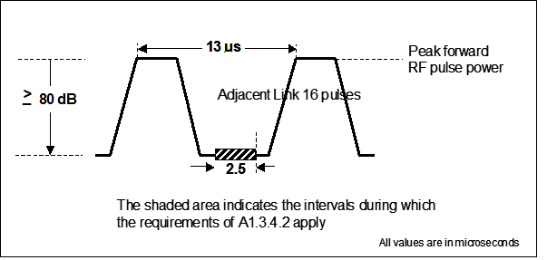
Figure 16: JTIDS Pulse specification
The characteristics of the TDMA waveform which is applied for the JTIDS background should be documented in the measurement report.
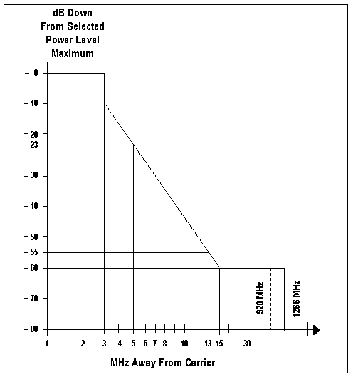
Figure 17: JTIDS Spectrum mask
Note: The Spectrum will actually be better, than the mask in Figure 17 with typically -67 dBc at 15 MHz frequency-offset.
It is necessary that the JTIDS signals which are used as background are verified to be using correct JTIDS pulses (pulse specification in Figure 16).

Real JTIDS terminal signals, or accurate 51 carrier frequency transmission simulators will be suitable for the tests.
Using 11 out of 51 JTIDS channels, i.e., 5 below, one co-channel and 5 above the victim DME channel under consideration may also be adequate.
If the DME/TACAN channel under test have a susceptibility at the image frequency, 11 JTIDS channels need to be applied centered about the image frequency.
However, accuracy in both time and frequency domain for covering inband and image frequencies (or any other spurious response frequencies) will require careful study.
The German ‘Link 16 TACAN EMC test environment specification’ for the DME Beacons described in Table 5 (expressed as ’50 NM Any Point In Space’, APIS specification) is regarded as the most representative test case environment for LDACS operating in Europe. It is a conservative test model which is used as an overbound case to the operational environment ([German FCA], [NATO in SE7]). This test model was determined to be sufficient for evaluating the MIDS/JTIDS and TACAN and DME transponder equipment. The transponder beacon test environment is shown in the first half of Table 4 and shows representative foreground signal sources and a complex background model for the environment (see Figure [5] below for this background environment).

Table 5: Modified ‘German Link 16 TACAN EMC test environment’ (Transponder and Interrogator)
JTIDS Point Source | Time Slot Duty Factor | Signal Level
For TACAN and DME Ground Transponders
FG-1 | 10% | -21 dBm
FG-2 | 40% | -33 dBm
FG-3 | 50% | -50 dBm
BG | 366% | -78 dBm to -71 dBm*
For TACAN and DME Interrogators
FG-1 | 50% | -36 dBm
FG-2 | 50% | -58 dBm

Acronyms: FG = JTIDS Foreground, BG = JTIDS Background
*Note: Different point sources with signal levels between -78 and – 71 dBm are shown in Table 6
Note: Table 5 is adapted from German Armed Forces Technical Test Centre for Information Technology and Electronics WTD 81 Document entitled, “German Frequency Clearance for MIDS/JTIDS Peacetime Operations and Its Geographical Area” dated 14 June 2005([German FCA], [NATO in SE7]

Table 6: Complex Effective Background Load for JTIDS/MIDS and DME/TACAN Transponder EMC Testing
Signal Level (dBm) | TSDF (%)
-71 | 38
-72 | 19
-73 | 29
-74 | 52
-75 | 51
-76 | 60
-77 | 58
-78 | 58
Total | 366
Note: For the DME interrogators, the environment is shown in the bottom half of Table 4. For this environment, only FG sources are modelled. This is because the test data showed that effects to the interrogator only occurred from stronger FG signal level point sources so that the background environment specified for the DME transponders was not deemed to be necessary.

LDACS background
The LDACS RL is not overlapping with the DME/TACAN ground transponders receive band. Therefore, any interference of DME/TACAN ground can occur only due to LDACS Forward Link transmissions. The emissions of a single LDCAS ground station will dominate over any conceivable background caused by other LDACS ground stations.
Therefore, an analysis of the impact of an LDACS background is only required for the airborne co-site cases of LDACS RL transmissions. In the airborne co-site case, the strongest LDCAS interference comes from the LDACS transmitter on-board the same aircraft. In addition, there is a background environment representing all other aircraft in the vicinity.
Two LDACS signal generators shall be used, one with ‘maximum RL duty cycle’ with the maximum expected on-board co-site signal level and one with ( (100 % - ‘Maximum RL duty cycle’) with a signal level representing emissions the closest aircraft i.e. aircraft separated 1000 ft in altitude (going into different direction), slightly offset in order to be in an elevation angle with maximum receive antenna gain (antenna pattern of bottom mounted antenna has maximum gain at 30° down => worst case slant range 1500 ft).

Note: The LDACS background interference emulates the LDACS RL transmissions of other aircraft and was generated in past compatibility test using another LDACS RL transmitter with a certain power level and duty cycle [LDACS EMC Final results 2020].
‘Maximum LDACS RL duty cycle’ is a parameter which needs to be optimised during the compatibility test campaign.
If the impact of a LDACS reverse-link signal with (100 % - ‘Maximum RL duty cycle’ as a background signal causes problems, it may be necessary to realistically aggregate environments with multiple LDACS aircraft in the area.
Note: The duration of the Random Access (RA) frame of the Revers Link is’6.7 ms per superframe’ resulting in a duty cycle reduction of 2.8 %.

UAT-background
UAT signal characteristics are specified in the [ICAO UAT SARPs]. According to section 12.4 of [ICAO UAT SARPs] UAT uses a binary continuous phase frequency shift keying with a modulation index of not less than 0.6. A binary ONE (1) is indicated by a shift up in frequency from the nominal carrier frequency and a binary ZERO (0) by a shift down from the nominal carrier. The frequency modulation rate is 1.041667 Mbps.
UAT spectrum mask is contained in Table 2 and Figure 1 of [ICAO UAT SARPs]. According to section 12.1.2.3.2 of [ICAO UAT SARPs] the maximum EIRP for a UAT aircraft station is +58 dBm , assuming a nominal transmit power of 54 dBm and an antenna gain of 4 dBi section 12.1.2.3.2 of [ICAO UAT SARPS].

UAT is only using a channel centered to 978 MHz. Since ground-to-air transmissions of DME TACAN occur near, or on 978 MHz the only DME/TACAN equipment trying to receive those signals are aircraft DME/TACAN interrogators. Therefore, the analysis of the impact of LDACS only an UAT background needs to be taken into account for the scenarios where the DME/TACAN Interrogator is the victim, since only the DME Interrogator is in a sub-band, where UAT is operating.

Concerning the impact of UAT on DME interrogators in the presence of LDACS signals, it needs to be distinguished between the following cases:

On-board co-site case:
The maximum transmission rate of an on-board UAT is a single transmission of up-to approximately 400 usec per second, i.e., with a duty cycle of about 0.04 % [UAT EMC Certification]. Due this
short transmission on-board UAT, even if the signal would exceed the DME interrogator receiver threshold, it would be for such a short time that the impact is negligible.

Off-board case:
A combination of several UAT signals from ground and several UAT signals from multiple aircraft in the vicinity of the considered DME-interrogator needs to be taken into account. (+)

ICAO Doc 9861, Figure II-2-2 defines the time frame for UAT transmissions from ground (Ground segment) and air (ADS-B segment) as follows:
Figure 18: UAT frame
Notes: This figure corresponds to UAT MOPS RTCA (DO-282B), section 1.3.1 Figure 1.1
The figure is further explained in ICAO Doc 9861, Ed.2 as follows:
2.3.1.2 Figure II-2-2 illustrates the message timing structure called a UAT frame. A UAT frame is one second long
and begins at the start of each Coordinated Universal Time (UTC) second. Each UAT frame is divided into two segments:
- the ground segment in which UAT ground uplink messages are broadcast in one or more time slots; and
- the ADS-B segment in which UAT ADS-B messages are broadcast.

2.3.1.3 Guard times are incorporated between the segments to allow for signal propagation and timing drift. The UAT frame contains 3 952 message start opportunities (MSOs) that are spaced at 250 μs intervals. This spacing represents the smallest time increment used by UAT for scheduling message transmissions, and each transmission must start only at a valid MSO.
ICAO Doc 9861, Ed.2, Appendix E, ‘ DME OPERATION IN THE PRESENCE OF UAT SIGNALS’ paragraph 12, provides the following UAT/DME environment description:
The UAT/DME environments that must be considered span different time frames. In the near term, over approximately a ten-year time interval, DMEs operating at 978 MHz are expected to be moved. However, over
this time span, there will be DMEs operating at 978-MHz co-channel with UAT in a number of European locations. In the longer term after these DMEs are moved, the closest DME will be 1 MHz away from the UAT 978-MHz frequency. Upon examining the bench-test results, the consistent behaviour of the DMEs at a given UAT interference level down to reply efficiency of 30 per cent, can be utilized to make conclusions of the UAT effect on DME in the projected environments. If one analyses the Core Europe 2015 scenario to determine the probability of overlapping a DME pulse pair at or above the UAT interference level that would cause loss of operation, it can be determined that the DME will operate without any measurable degradation in that environment.
For example, taking the co-channel Honeywell KD-7000 DME unit results with a desired signal level of –83 dBm, UAT signals at or above –96 dBm could potentially impair DME operation if the reply efficiency reduced to 30 per cent or below. Taking the Core Europe 2015 scenario and looking at the number of UAT messages at a level of -96 dBm or above, on average, less than 900 messages per second would be received if a DME receiver is positioned over Brussels at 40 000 feet. This is the same aircraft location used in the high-density Core Europe 2015 analysis in Appendix J. The probability of overlap is significantly less than the minimum probability that would cause probability of reception to be reduced to the level that would impact DME operation. Since the co-channel case would not occur at the aircraft densities produced by the Core Europe 2015 scenario, the operation of DMEs on 978 MHz can be safely achieved. Since the co-channel DME case is validated for Core Europe 2015, the DME channels 1 MHz or more from the UAT occupied frequency will not be impacted given there is on average 10 dB additional protection shown by the bench-test results when the DME is 1 MHz away from UAT signals.
ICAO Doc 9861, Ed.2, Figure II-E-16 provides the ‘JTIDS/MIDS and UAT combined interference analysis’

Editorial note: The generation of such an UAT interference environment needs to be further discussed!

Note: Recommended signal generator: Cobham ATC-5000NG NextGen Transponder/ DME Test Set and ADS-B Target Generator, alternative a generic vector signal generator may be used.
Note: UAT meeting the SARPS OOB mask has little/no effect on DME at or beyond 2 MHz from the UAT channel 978 MHz.

The impact of an UAT background needs only to be tested on DME operation on the first adjacent channels of the UAT at 978 MHz

The assumption the following UAT background specifipation hall be used to test the impact of LDACS on DME/TACAN:

UAT compatibility with DME was assessed using a signal environment denoted CE2015. That scenario included 2091 aircraft (both airborne and ground) within a circle of 300nm radius centered on Brussels, Belgium. The victim aircraft DME receiver was assumed to be at 37000 ft altitude at the center of the circle.
UAT bursts were formed using the long transmission format and random data. 500 UAT bursts were equally distributed over a 1 second superframe with the power levels and numbers as shown in Table xx. The identical 1 second UAT superframe burst distribution is then repeated one a second, and the time jitter of the DME signal with respect to the UAT interference providing sufficient statistics.

Table xx: UAT Signal Rates and Powers
*Reference:WP6 of ICAO NSP, May 2004
Power level in dBm | Number of UAT signals
-60 | 1
-66 | 8
-72 | 21
-78 | 43
-84 | 116
-90 | 311
Total Signals | 500

Note: References which are relevant for the UAT background specification:
- UAT Manual, ICAO Doc 9861, 2nd Ed.,
- Chapter 7, ‘UAT FREQUENCY PLANNING CRITERIA’
- Appendix B, ‘STANDARD INTERFERENCE ENVIRONMENTS’ of => section B.4.7.2.1, ‘TIS-B hot-spot analysis’ provides information on UAT TIS-B up-link transmission characteristics, other UP-Link transmissions (e.g., weather) need also to be specified.
- App E, ‘DME OPERATION IN PRESENCE OF UAT_
- UAT MOPS published as RTCA (DO-282B)
- ADS-B Technical Link Assessment Team (TLAT) Technical Link Assessment Report, March 2001

Note: Compatibility between UAT and LDACS will be treated by the ICAO Communications Panel and its working group (DCIW PT-T).

Compatibility Testing

General testing approach

General testing approach:
- For each of the ‘Interference scenarios’ (section 5.2) determine the ‘minimum expected separation distance’ between LDACS-transmitter and DME receiver. From this, derive the ‘minimum expected path loss’. From this, determine, the ‘maximum expected signal levels of the Undesired LDACS FL or RL signals’ at the receiver input of the DME/TACAN interrogator or transponder receiver.
- For the compatibility test, establish a bi-directional DME link, with the ‘minimum desired DME/TACAN signal level’ at the receiver input of the DME/TACAN interrogator or transponder receiver to be tested.
- In addition to the ‘Desired DME signal’ to be protected (and the applicable background signals) feed in an ‘Undesired LDACS FL or RL signal’.
- Starting at a zero frequency-offset (co-channel) increase the frequency-offset of the Undesired LDACS signal in steps (0.5 or 1 MHz). The variation of the frequency-offset between LDACS in DME shall be done in steps. The step size is 0.5 MHz, if the variation of the LDACS frequency is within in the LDACS tuning range. If frequency-offsets outside the LDACS tuning range need to be used, the DME frequency shall be changed in 1 MHz steps.
- Exclude frequencies of the Undesired LDACS signal which are outside the intended frequency FL or RL frequency sub-bands, unless in the case the impact of LDACS signals on or adjacent to DME image frequencies need to be tested!
- For every frequency-offset und every undesired signal level to be tested, it is important to start the compatibility test with switching on the Undesired LDACS signal, 3 seconds before the Desired signal is switch on. In this way it is ensured that blocking of the DME’s pulse detector by the Undesired signal is taken into account.
From here on, a distinction between testing of Interrogators and Transponders needs to be made:
- Interrogator testing:
  - For every frequency-offset increase the Undesired LDACS signal level until Break-lock is reached (BSOP).
  - At the given frequency-offset start again to increase the Undesired LDACS signal level from a level 10 dB below Break-lock in steps of 1 dB as long as the DME interrogator’s performance characteristics (ASOP, ID-Tone, range accuracy see section 4.1.3) are still met. In this way determine a curve describing the ‘maximum tolerable undesired LDACS signal level as a function of the frequency-offset’ (compatibility criterion, which can also be expressed as Desired-to-Undesired signal ratio, taking into account the applied ‘minimum desired DME/TACAN signal level’).
  - For the test of DME/TACAN interrogators, it needs to be ensured that at every frequency offset and every tested undesired LDACS signal level the break-lock needs to be enforced by ‘re-channelling’ the desired signal frequency before the maximum tolerable LDACS signal is established (this also clears the range memory) .
- Transponder testing:
  - For every frequency-offset increase the Undesired LDACS signal level from 10 dB below the Minimum Triggering Level (MTL) in steps of 1 dB as long as the DME transponder’s performance characteristics (BRE, Monitor Alert, Ranging Error, see section 4.2.3) are still met. In this way determine a curve describing the 'maximum tolerable undesired LDACS signal level as a function of the frequency-offset' (compatibility criterion, which can also be expressed as Desired-to-Undesired signal ratio, taking into account the applied 'minimum desired DME/TACAN signal level').

- If, for a given frequency the targeted DME performance characteristics cannot be met with the maximum expected Undesired signal level, increase the frequency-offset until it can be met. If this is not possible, frequency compatibility cannot be achieved with a frequency offset. In this case other mitigation measures (e.g., siting restrictions for LDACS ground transmitters or suppression of simultaneous on-board transmission by means of, or minimum separation distance between on-board antennas and/or use the Mutual Suppression Bus) need to be developed.

- This test shall be repeated also with desired signal levels above and below the minimum Desired signal level in steps of -3 dB, -2 dB, 0 dB, -1 dB, +1 dB, +2 dB, + 3 dB, + 6 dB in order to establish the sensitivity of this test. This helps to determine the impact of fading, cliff-effect and the “no-effect” level.

Test-Bench
In a test-bench DME/TACAN on-board and ground equipment (either the equipment itself or a simulator) needs to be connected allowing simulating the propagation of signals between a DME/TACAN Interrogator and a DME/TACAN Ground Transponder, as well as the sources of the Undesired LDACS signal and the Background signals. A simplified block schematic diagram of the test-bench is shown in the figure below:

Port 2
DME/TACAN Equipment Under Test (EUT)
DME/TACAN Simulator
LDACS Transmitter
Test Bed Network
Background Simulator(s)
Figure 19: Block Diagram of the test-bench

Description of the various blocks in the figure above:
- Equipment Under Test – A ‘DME/TACAN aircraft Interrogator receiver’ or a ‘DME/TACAN Ground Transponder receiver’, depending on the test scenario. Additional input ports like the aircraft Mutual Suppression Bus (MSB) for aircraft EUT is to be connected for test-cases using the MSB.
- DME/TACAN Simulator– This is a laboratory test equipment designed to provide the DME/TACAN EUT with realistic signals from its paired DME/TACAN entity.
- LDACS transmitter –This is a LDACS transmitter, or LDACS simulator, generating LDACS signals which have characteristics compliant to the LDACS Draft SARPs [LDACS Draft SARPs]
- Background Simulator(s) –This is one or more a signal generator(s) or transmitter(s), which provide(s) additional signals, i.e., the DME-background (different pulse code DME pulses on a DME channel or on adjacent channels) and/or the JTIDS-background
- Test Bed Network – This is a network to route the signals to the required destinations and provide the necessary isolation between output and input ports of the equipment. This includes simultaneously providing the EUT with the desired DME Simulator signal and undesired LDACS signal. It also provides the DME Simulator receiver with the interrogation or reply signals transmitted by the DME/TACAN EUT.

Test Configurations
Since the test configurations described here have limited details, a description of the detailed test-configuration is developed and provided for review by ICAO NSP SWG together with ‘example test-data’ before start of the test campaign.

DME/TACAN Interrogator Tests

DME/TACAN Interrogator Setup Parameters
The setup parameters described in this chapter concern the ‘Interrogator EUT’ as well as the ‘Transponder Simulator’ which establish a bi-directional signal link for the DME/TACAN interrogation and response signals. Configuration parameters of the DME/TACAN EUT as well as the ‘DME/TACAN Simulator’ need to set up an operational communication. The applicable parameters are specified in the following sections.

Channels
Based on the considerations of overlaps between the frequency ranges of LDACS and DME/TACAN in section 1.3, the following DME-channels are identified as possible “co-channel channels”
- LDACS ground transmitter: All Interrogator receive channels between 23Y (1110 MHz) and 38Y (1125 MHz), i.e., only Y-channels
- LDACS airborne transmitter: Only Channels 17X (978 MHz) and 18X (979 MHz) used for DME/TACAN by civil aviation are relevant for the LDACS reverse-link. Moreover, the DME channels 3X (964 MHz) to 16X (977 MHz) which are received by ‘MM-TACAN’ Interrogators.

Simulated Range Value
The nominal range value of the ‘DME/TACAN Ground Transponder simulator’ shall be set to a target 60 NM for all test-cases, if not otherwise specified.
Note: The DME/TACAN signal power level to be used in the test is specified independent from this range value. The range value of 60 NM is the target value, which is only specified for the evaluation of a potential range variation due to the impact of interference. There is no need to adjust the DME/TACAN signal power levels to the expected receive power at the target range!

Mutual Suppression Bus (MSB)
The role of the Mutual Suppression Bus (MSB) in the context of compatibility of LDACS and DME/ TACAN is described in [HELIOS MSB] as follows: The MSB is used in aircraft for L-Band systems such as Secondary Surveillance Radar (SSR) Transponders, TCAS/ACAS and DMEs. These L-Band avionics systems physically connect to the common bus. The L-Band systems that are connected to the bus drive the bus to announce to other systems that a transmission is taking place throughout the interval that the bus is activated.
The systems that are connected to the bus can react in a variety of ways to the presence of a suppression pulse. In most cases, they desensitize their receivers for the duration of the pulse. The connected systems may also monitor the bus to react to other L-Band transmissions on the aircraft by delaying their own transmissions so as not to simultaneously transmit while another L-Band system is transmitting.
The MSB effectively limits the access of systems to the aircraft’s RF resources in order to avoid mutual interference. Therefore, a major consideration of systems connecting to and driving the MSB is to minimize as much as possible the duration of the suppression period.
For the compatibility test it is essential to apply a representative load of the MSB.
Apart from the impact of LDACS, a total load of 9.3 % (= 8.4 % + 0.9 %) to the Mutual Suppression Bus port of the EUT is assumed.
Note: With an assumed duty cycle of LDACS Reverse Link 9.6 % the total load would increase to approximately 18.9 %. Collision of suppression pulses from various sources would reduce this number.
The number of transmissions of on-board transmitter vary-with/depend-on, ESE meaning number interrogations replied received from SSR-, IFF-ground and ACAS-Interrogators, and for DME-, TACAN- and ACAS-interrogations and ACAS-squitter transmitted. The load is specified as:
- SSR-Load:
    - 2000 Mode A & C replies per second for SSR, with a length of 33 µs ([ICAO Annex-10-IV] )
    - 16 Extended Length Messages (ELM) per second, with a length of 140 µs each ([ICAO Annex-10-IV], section 3.1.2.10.3.7)
    - 50 Mode S long replies per second, with a length of 140 µs ([ICAO Annex-10-IV], section 3.1.2.10.3.7)
    - 6 ADSB squitters per second, with a length of 140 µs ([ICAOAnnex-10-IV], section 3.1.2.10.3.7)
    - 83 ACAS Whisper/Shout events per second, with a length of 91 µs ([ICAO Doc 9863], section 3.7.3.6.1)
    - 57 Mode S interrogations per second ([ICAO Doc 9863], section 3.7.3.6.2), OR
    - Maximum overall interrogation rate (Mode A/C and Mode S, v and vi) is not more than 1 % of the time ([ICAO Doc 9863], section 3.7.3.4) based on these assumptions, the total load for Mode A, C and S is 8.4 %.
Table 2-3: Cosite Environment [UAT EMC Certification]
Event | Event Blanking Interval (usec) |  | Events per Second
Event | Event Duration | Additional Blanking due to Rx Recovery | Events per Second
DME Interrogations | 19 | 15 usec | 70
ATCRBS Replies | 20 | 15 usec | 200
Mode S Replies | 64 | 15 usec | 4.5
Mode S Interrogations | 20 | 15 usec | 5
Whisper Shout Interrogations | 25 | 15 usec | 80

Note: In the US the consideration of impact of UAT on the MSB load was not deemed to be necessary. However, UICAO Doc 9861, ‘UAT Manual’, section 5.2 stipulates “all UAT equipment classes shall provide an output suitable to sending suppression signals. The duration is 5 usec before and after the transmission of 430 usec, once per second, which adds up to 0.043 % MSB load. Therefore, there is no need to consider the impact of UAT as additional load in the context of compatibility measurements between LDACS and DME/TACAN!

- DME-Load:
60 µs length ([ARINC-709A], attachment 6, section 2), 1 additional Interrogator in aircraft 150 interrogations with a fraction of 0.9 % of the total load ([ICAOAnnex10-I], section 3.5.3.4.2).
The number of blanking signals and its length of blanking is to be defined as “<number of blankings for one second> at <blanking duration>”. If not otherwise stated in a test-case, the blanking is set to “2000 at 33µs | 72 at 140 µs | 89 at 91 µs | 150 at 60 µs”.

Note 1: The above provided values are based on the minimum transmission rate that equipment transmitting on 1030 MHz and 1090 MHz has to provide. The 1090 MHz channel load alone in the area between Frankfurt and Munich (Germany) is today 20%, while the peak Transponder occupancy measured in 1995 was already above 85% at 15 000 ft (Reference [CT-TN96/20]). Due to increased use of Mode S capable Interrogators, high equipage rate of ACAS and addition of MLAT sensors the load has increased significantly.

Note 2: MSB characteristics are defined ARINC and RTCA documents and vary with document and version e.g. [DO-144], [ARINC-709] and [ARINC-735]. The number of interrogations replies and Squitters to be transmitted are defined in [ICAO Annex-10-I], [ICAOAnnex-10-IV] and related documents.

Note 3: For comparison, the following SSR-load characteristics were obtained during test flight recordings carried out in the core area of Europe in April 2017:
- 500 Mode A & C replies per second max, with a length of 33 µs
ii) Peak of 49 Extended Length Messages (ELM) per second, with a length of 140 µs each
iii) Peak 100 Mode S short replies per second, with a length of 70 µs
iv) 6.2 ADSB squitters per second, with a length of 140 µs
v) 83 ACAS Whisper/Shout events per second, with a length of 91 µs
vi) 10 ACAS events (interrogations) per second, with a length of 91 µs
For one test-case, it is to be assumed that a LDACS onboard Reverse Link transmitter can block transmissions of other L-band systems (DME/TACAN interrogator and SSR transponder) by means of the MSB with the ‘Maximum RL duty cycle’ in addition to the blocking of the total load by other on-board systems of 9.3 %. The impact of such a suppression on the ‘DME/TACAN interrogator under test’ shall be analysed.

Beacon Reply Efficiency (BRE)
The Beacon Reply Efficiency of the ‘DME/TACAN Ground Transponder simulator’ is to be set to ≥ 70 % for all measurements. This value shall not be varied. This value for BRE is specified for DME/N operation in [FAA-E-2996] and [ICAO Annex10-I], Vol. 1, Chapter 3, section 3.5.4.6.

ID Morse Code
Some measurements require the absence of the ID Morse Code. In such cases, it will be individually described that Morse Code will not be transmitted for a certain test. In all other cases, Morse Code will be transmitted with the following parameters:
- Code Repetition rate shall be 1 per 40 seconds (According to [ICAO Annex10-I], Vol. 1, Chapter 3, Section 3.5.3.6.3)
- ID Code to be used is ‘MJQY’ (Note: Rational: Note that the Morse code pulse length of the “J”, “Q” and “Y” characters are identical)
- Dots and dashes durations shall be set as specified in [FAA-E-2996] and [ICAO Annex10-I], Vol. 1, Chapter 3, Section 3.5.3.6.3.
- As specified in [ICAO Annex 10-I] all ground transponders shall transmit reply pulses between key down times (references [ICAO Annex10-I], sections ‡3.5.3.6.2.1 and 3.5.3.6.2.3.)

Note: FAA order 6750.16E provides detailed description of the Morse Code).
Note: DME/TACAN Ground transponders fill in equalising pulse pairs if there would otherwise occur gaps in the transmission during ID tone transmission. It is not expected that these equalising pulse pair increase the squitter rate during the ID tone transmission .

Squitter Rate
The ‘DME/TACAN simulator’ simulating the ‘DME/TACAN Ground Transponder’ shall be set to the following Squitter Rates:
- DME squitter rate = 2700 ppps and 1000 ppps
- TACAN squitter rate = 3600 ppps

TACAN Pulse Amplitude Modulation, PAM
In order to operate as a TACAN Ground Transponder the ‘DME/TACAN Ground Transponder simulator’ shall be set to ‘TACAN mode’ which allows generation of the reference pulse groups and a pulse amplitude modulation (PAM).
The modulation index of the pulse peak amplitude shall be 20 % for each of the 15 Hz and 135 Hz signal components.
Note: MilStandard 291C specifies a limit of 21 % +/-9 % for each for 15 Hz and 135 Hz signal.

Tests of ‘Scanning DME Interrogators’
So-called ‘scanning DME Interrogators’ are interrogating several DME Ground Transponders sequentially. There are two scanning modes:
- In “Direct Scanning Mode” (DSM), several fixed DME channels are set.
- In “Free Scanning Mode” (FSM) is an extension of the (DSM). In addition to the setting of all directed channels of the DSM, the Interrogator scans also all other channels which are not set in the DSM.

Direct Scanning Mode – “OFF”
In this test-case the impact to a DME Interrogator with deactivated Scanning Mode is tested. Only a single channel is selected for the DME Interrogator.

Direct Scanning Mode – “ON”
To test the impact to a DME Interrogator the Scanning Mode is switched on. The same frequency is being used for all directed frequencies (generated by the same DME beacon simulator). All channels have to lock within the allotted time frame (at least 5 seconds). Valid position output shall be possible.

Relevant DME/TACAN Interrogator performance characteristics
For the tests of DME/TACAN Interrogators, the following performance characteristics need to be evaluated:

Search time
The condition which exists when the DME interrogator is attempting to acquire and track from the selected transponder, the response to its own interrogations [ED-54].
Note: [ICAO Annex 10-I] does not limit the ‘maximum search time:
3.5.3.4.3 DME/N. Recommendation.— After 15 000 pairs of pulses have been transmitted without acquiring indication of distance, the PRF should not exceed 60 pairs of pulses per second thereafter, until a change in operating channel is made or successful search is completed.
‡3.5.3.4.4 DME/N. When, after a time period of 30 seconds, tracking has not been established, the pulse pair repetition frequency shall not exceed 30 pulse pairs per second thereafter

Warning Flag
The warning flag shall not be raised due to interference at any time during the evaluation of the flag.

Time-To-Acquire (TTA)
TTA or acquisition time is the time an Interrogator needs to acquire a stable track.
The condition which exists when the DME interrogator has locked onto replies in response to its own interrogations and is continually providing the distance to the ground station or a point to which distance is referenced by adjustment of the transponder delay. Track includes a predefined memory period which begins upon loss of the reply signals. ·At the end of this period the interrogator returns to search. [ED-54]
Note:
[ICAO Annex10-I] specifies that an aircraft is in ‘track mode’ when the IRF is reduced to ≤ 30 ppps. RTCA DO-189, DME Airborne MOPS [RTCA DO-189], section 2.3.11.1 specifies that transition from search mode to track mode needs to occur below 2 s as defined as Acquisition time (TTA).

Ranging Error
After the successful acquisition and an additional pause of 1 second, the range is measured in time intervals of 500 ms as often as possible, averaging all measurements recorded in that time frame. Range deviation is measured 50 times sequentially. The range deviation is specified as a 95 % quantile of the absolute deviation of the measured range relative to the given range of 60 NM”.
There shall be no change range deviation by more than the manufacturer specified ranging accuracy within a timespan of at least 20 seconds due to the undesired LDACS signal. The obtained ranging error shall be analysed to identify the potential occurrence of a fixed error, i.e., Range Bias Errors.

Tracking of Signal
No loss of range tracking (or for TACAN range and bearing) is acceptable. The weakest Desired signal level where the Interrogator maintains tracking for 60 seconds shall be established.
BSOP shall be measured in presence of transmissions of ID Morse code from the Transponder simulator.
Note: Many DME/TACAN Interrogators indicate ‘loss of tracking’ by raising a ‘memory mode’-flag.

ICAO ID Code
ICAO ID code shall correspond to the transmitted ‘ICAO ID code’ for 3 consecutive ‘ID Morse code transmissions’ and 4 letters when paired to an ILS and/or MLS from the Transponder simulator without flag sign raised.
For Interrogators with no automatic ID evaluation the acceptability of the ID-code shall be judged by a human listener. One listener is sufficient to judge the acceptability. No Morse Code training is required.
For Interrogators with automatic ID evaluation the acceptability of the ID-code can be evaluated by software.
Note: The ID tone is probably the most susceptible parameter.

Bearing Distortion (only for TACAN)
The nominal TACAN azimuth to be used for the compatibility tests shall be 90° or 270° to ensure checking the worst-case (whatever angle causing the north reference burst are at the bottom of the envelope).

The bearing shall be evaluated withing a timespan of at least 20 seconds. The bearing error caused by the undesired signal shall not be higher than the bearing error without the undesired LDACS signal present.
The obtained bearing shall be analysed to identify the potential occurrence of a fixed error (aka bias error) of the TACAN bearing. Such a bias-error is not acceptable.

Note: Suitable simulator types are Aeroflex and Republic. Base models of the Aeroflex do not provide 90 or 270 degrees. Aeroflex units only put out 0 degrees. However, Aeroflex can provide alternate bearing with purchase of ADD-ON equipment sold by the manufacturer. Republic natively supports 0 to 360-degree selection using front panel controls.
Note: A threshold for the Bearing error of ± 3 degrees (95 percent probability) is specified in Appendix 2 of [FAA AC-00-31].

Evaluation of the DME/TACAN Interrogator performance characteristics

Acquire Stable Operation Point (ASOP)
ASOP represents the Undesired signal threshold, which allows the Interrogator to still acquire and display correct range values. The IRF has to be reduced to ≤30 ppps for non-scanning interrogators.
A success rate of 80% for acquisition is equivalent to the statement “successful end of search four out of five searching Cycles” in [ED54] part 37, section 2.9. A suitable acquisition time limit for this test needs to be established during the pre-test.
ASOP is to be measured in absence of transmissions of ICAO ID Morse code transmissions from the Transponder to avoid acquisition effects based on the reply rate of the DME/TACAN simulator.
The ASOP test fails, if one or more of the following criteria fail:
- Absence of the Flag
- The IRF is ≤30 ppps
- Time-To-Acquire (TTA)
- Correct Range within tolerances
- Correct Bearing within tolerances (for TACAN interrogators)

Break Stable Operation Point (BSOP)
BSOP represents the Undesired signal threshold at which ‘loss of track’ or ‘loss of ID Code readability’ first occurs and/or the Interrogation Repetition Frequency (IRF) is increased to ≥30 ppps.
BSOP is to be measured in with transmissions of ICAO ID Morse code transmissions from the Transponder.
The BSOP-test fails if the following criterion fails:
- Signal stays tracked (see section 4.1.2.5)

Threshold for ID Code (IID)
IID represents the Undesired signal threshold at which the indicated ICAO ID code corresponds to the given ICAO ID code.
The IID-test fails if the following criterion fails:
- ICAO ID code corresponds to the given ICAO ID (see section 4.1.2.6.)

Threshold for TACAN Bearing (IBearing)
For the test of TACAN Interrogators, in addition to the tests of ASOP, BSOP, ID Code described for DME Interrogators tests in section 4.1.3 a test establishing the Threshold for ‘TACAN Bearing’ is necessary.
- IBearing represents the Undesired signal threshold at which the Bearing information acquisition time is below the given specification of the EUT.
- The IBearing-test fails if the following criterion fails:
- Bearing distortion (see section 4.1.2.7)

Compatibility threshold determination for DME/TACAN Interrogators
In order to determine the compatibility threshold of an Interrogator the interference thresholds the following performance parameters have to be evaluated for various frequency-offsets and signal power levels of the Undesired LDACS signal:
- Acquire Stable Operation Point, ASOP
- Break Stable Operation Point, BSOP
- Interference threshold for ID Code
- Bearing distortion (only for TACAN Interrogators)

The applicable compatibility threshold for a given frequency-offset between the Undesired LDACS signal and the desired DME/TACAN signal is the lowest interference threshold obtained by evaluating the above-mentioned performance parameters. It is expressed as the ‘Desired-to-Undesired signal power level’ (D/U) as a function of the frequency-offset.

DME/TACAN Transponder Tests

DME/TACAN Transponder Setup Parameters
The setup parameters described in this chapter concern the ‘Transponder EUT’ as well as the ‘Interrogator Simulator ‘which establish a bi-directional signal link for the DME/TACAN interrogation and response signals.

Channels
The channels should be specified individually for the various Test-cases. However, the following channels are identified as possible on-channel cases, based on the specifications in section 1.3:
- LDACS ground transmitter (FL): DME/TACAN Transponder receive channels
between 76X/Y (1110 MHz) and 101X/Y (1125 MHz); i.e., both, X and Y-Channels
- LDACS airborne transmitter (RL): No on-channel case exists with civil-aviation use of DME/TACAN.

Monitor setup
The Transponder MONITOR must be configured to be Operational (ON) during test data collection on the beacon
Note: There is a large list of settings provided by the manufacturer that indicates the appropriate ranges used in these settings. A transponder monitor is required to be operational (by law) whenever a transponder becomes operational.

Echo Suppression of DME/TACAN Transponders
There are two types of Echo Suppression implemented in DME/TACAN Transponders:
- Short Distance Echo Suppression (SDES) is a circuit that allows mitigating the effect the impact of multipath received between interrogation pulse pairs.
- Long Distance Echo Suppression (LDES) is a circuit that allows mitigating the effect the impact of multipath received after the initial interrogation pulse pairs.
Note: Echo Suppression tests are defined in [FAA-E-2996] section 4.5.2.2.5. [FAA-E-2996] section 3.2.2.5.2 of provides a description of LDES.
Since LDES is rarely used, ICAO NSP SWG decided that it is sufficient to test the impact of SDES switched “ON” or “OFF”. Therefore, in the test-cases, set the parameters to:
- SDES: ON
- LDES: OFF
If SDES is “on”, interference may cause dead time. This should be investigated. SDES desensitizes the receiver for e.g., for 12 us for X-code and 36 us for Y-code.
Note: ICAO Annex 10, Vol. I, section 3.5.4.2.9 and ICAO NSP JWGs/2-IP/1 as well as the report of ICAO NSP SWG June 2017 provide additional information on SDES.

Relevant DME/TACAN Transponder performance characteristics
The following performance characteristics need to be evaluated for the test of DME/TACAN Ground Transponders:

Beacon Reply Efficiency (BRE)
The BRE shall be measured externally i.e., the BRE-information provided by the Transponder’s internal monitor shall not be used.

Ranging Error
To evaluate the ranging error the Morse Code Ident should be switched off. The range deviation is measured with an interrogation rate of 200 ppps.
To establish range values, the time delay of a reply initiated by an interrogation is measured. The distance is calculated assuming speed of light and taking the channel specific ground transponder delay into account. The additional delay due to the ‘test bench’ has to be taken into account.
The resulting time delay is calculated in distance applying the speed of light for the velocity. The range deviation is the Standard Deviation of 50 individual readings.
If the ID cannot be switched off, an additional guard window of 2 seconds before the ID transmission starts and 5 seconds after the ID transmission has ended in order to securely avoid measurements which are influenced by the ID.
Pre-test:
For the testing of the DME/TACAN Ground Transponder performance, at first the Ranging Error. Without an undesired signal present, shall be evaluated.

Compatibility test:
There shall be no increase of the range deviation due to the undesired LDACS signal.
‘Range Lock flag’, ‘Memory Mode Flag’ and ‘Bearing Log Flag’ should be evaluated, before evaluating range and bearing.
The obtained ranging error shall be analysed to identify the potential occurrence of a fixed error, i.e., Range Bias Errors.
Note: According to [ICAO Annex10-I], section 3.5.4.5. a DME Ground Transponder associated with a landing aid shall not contribute more than ±75 m (95%) to the overall system error of the range. This requirement represents the most demanding Transponder requirement. However, similar to the Interrogator, it only applies to a pulsed extraneous signal environment. Measurement accuracies of ±0.1 microseconds i.e., 30 m (95%), measured as a variation of reply delay, are considered achievable (ICAO DOC 8071, Vol. I, section 3.2.16, Table I-3-2).

Monitor Alerts
The Monitor system of a DME/TACAN Ground Transponders shall not show any of its alerts (specified in its operations manual). The absence of monitor alerts is assumed, if within 30 seconds no alert is displayed.
The actual Monitor trigger level (close to the required sensitivity) may depend on the type of equipment i.e., Terminal of En-route DME transponder. Therefore, the set Monitor trigger level need to be provided in the test-report.
It needs also to be checked, whether excessive noise produced by LDACS interference cause transmission of “Ghost replies”. Further information can be found in section 3.3.4. of [ED73E].

Compatibility threshold determination for DME/TACAN Transponders
In order to determine the compatibility threshold of a DME/TACAN Transponder, the interference thresholds the following performance parameters have to be evaluated for various frequency-offsets and signal power levels of the Undesired LDACS signal:
- Beacon Reply Efficiency (BRE)
- Ranging Error
- Monitor alerts*

Beacon Reply Efficiency (BRE):
The target BRE is 70 % for all measurements.
Note: The BRE is specified in [ICAO Annex10-I] Chapter 3 for various sensitivities
3.5.4.6 Efficiency
3.5.4.6.1 The transponder reply efficiency shall be at least 70 per cent for DME/N and DME/P (IA mode) and 80 per cent for DME/P (FA mode) at all values of transponder loading up to the loading corresponding to 3.5.3.5 and at the minimum sensitivity level specified in 3.5.4.2.3.1 and 3.5.4.2.3.5.

3.5.4.2.3 Transponder sensitivity
3.5.4.2.3.1 In the absence of all interrogation pulse pairs, with the exception of those necessary to perform the sensitivity measurement, interrogation pulse pairs with the correct spacing and nominal frequency shall trigger the transponder if the peak power density at the transponder antenna is at least:
a) minus 103 dBW/m² for DME/N with coverage range greater than 56 km (30 NM);
b) minus 93 dBW/m² for DME/N with coverage range not greater than 56 km (30 NM);
c) minus 86 dBW/m² for DME/P IA mode;
d) minus 75 dBW/m² for DME/P FA mode.
3.5.4.2.3.2 The minimum power densities specified in 3.5.4.2.3.1 shall cause the transponder to reply with an efficiency of at least:
a) 70 per cent for DME/N;
b) 70 per cent for DME/P IA mode;
c) 80 per cent for DME/P FA mode.

3.5.4.2.3.5 The transponder sensitivity level shall not vary by more than 1 dB for transponder loadings between 0 and 90 per cent of its maximum transmission rate.
Note: According to ICAO Annex 10, Vol. I, Att. C, table C-9 and section 7.2.2 ‘CTOL Ground to air power budget’:
Conversion from PFD to power at antenna port (i.e., NOT at receiver input):
@1087.5 MHz | dBW | dBW/m² | dBm
dBW | n.a. | +22 | +30
dBW/m² | +22 | n.a. | +8
dBm | -30 | -8 | n.a.
Examples: At the mid-band frequency (1087.5 MHz) -103 dBW/m² corresponds to -95 dBm and
-93 dBW/m² corresponds to -85 dBm.

Note: -103 dBW/m² correspond to -95 dBm and -93 dBW/m² correspond to - 85 dBm.

Ranging Error:
The ranging error of the DME transponder is specified in [ICAO Annex10-I] Chapter 3, section 3.5.4.5:
3.5.4.5 Accuracy
3.5.4.5.1 DME/N. The transponder shall not contribute more than plus or minus 1 microsecond (150 m (500 ft)) to the overall system error.

3.5.4.5.1.1 DME/N. Recommendation.— The contribution to the total system error due to the combination of the transponder errors, transponder location coordinate errors, propagation effects and random pulse interference effects should be not greater than plus or minus 340 m (0.183 NM) plus 1.25 per cent of distance measure.
Note.— This error contribution limit includes errors from all causes except the airborne equipment and assumes that the airborne equipment measures time delay based on the first constituent pulse of a pulse pair.
‡3.5.4.5.1.2 DME/N. The combination of the transponder errors, transponder location coordinate errors, propagation effects and random pulse interference effects shall not contribute more than plus or minus 185 m (0.1 NM) to the overall system error.
Note.— This error contribution limit includes errors from all causes except the airborne equipment and assumes that the airborne equipment measures time delay based on the first constituent pulse of a pulse pair.
‡3.5.4.5.2 DME/N. A transponder associated with a landing aid shall not contribute more than plus or minus0.5 microsecond (75 m (250 ft)) to the overall system error.

Monitor Alerts:
*ALL of the settings of the Transponder Monitor selected to be in operation during the compatibility test needs to be reported in a Table with each of the data sets that are collected. These include CW sensitivity, Short and Long Echo Suppression Gate Settings, Reply Efficiency Monitor Thresholds etc.
Note: [ICAO Annex10-I] Chapter 3 section 3.5.4.7.2 specifies the DME/N monitoring action
Note: It must be kept in mind that the DME Ground Transponder is extremely sensitive to CW-like signals. Example 1: Once at Frankfurt airport (Germany) a flawed UHF radio used by the pilots on approach at the airport in question sent out a burst of CW signal whenever the Pilot Keyed OFF of the UHF radio. This CW signal burst (very short in time) was found to routinely shut down the beacon. The shutdown was caused by the Transponder Monitor.
Example 2: A DME-721 French Beacon which was tested at the Joint Spectrum Centre (JSC) also reacted to detected CW by changing the sensitivity of the Beacon in steps of +10 d.
CW-Like Signals are a very serious EMC problem and issue for Ground Based DME/TACAN Beacon Transponder Receivers. Each manufacturer selects the action the Beacon Monitor will perform and the thresholds at which the action is performed is controlled by the Beacon Monitor Settings.

The applicable compatibility threshold for a given frequency-offset between the Undesired LDACS signal and the desired DME/TACAN signal is the Undesired LDACS signal level for a given Desired signal, where there is NO impact on Beacon Reply Efficiency (BRE), Ranging Error, Monitor alert!

Interference Scenarios and Test-Cases

Pre-tests of Non-interfered DME/TACAN equipment
Before compatibility tests with LDACS are performed, the correctness of the measurement set-up and compliance of the un-interfered DME/TACAN equipment with applicable standards has to be performed.
Non-interfered test-cases are due to verify correct performance of the DME/TACAN equipment before compatibility tests are performed.

Table 7: Test-case for the pre-tests
DME/TACAN Airborne Interrogator: | DME/TACAN Ground Transponder:
Desired signal only (references below) | Desired signal (reference below)
Desired signal  + DME Interrogator-background of 6000 single pulses (on channel) (see section 2.1.3) | n/a

Note: References for Interrogator pre-tests: ED54, TSO C66, + “Manufacturer’s check-out requirements”
References for Transponder pre-tests: ED57, FAA-E-2296, + “Manufacturer’s check-out requirements”

Pre-test of DME/TACAN ground transponders:
For each ‘DME/TACAN Transponder under test’ a curve representing the Beacon Reply Efficiency versus Desired signal level shall be established (example below).
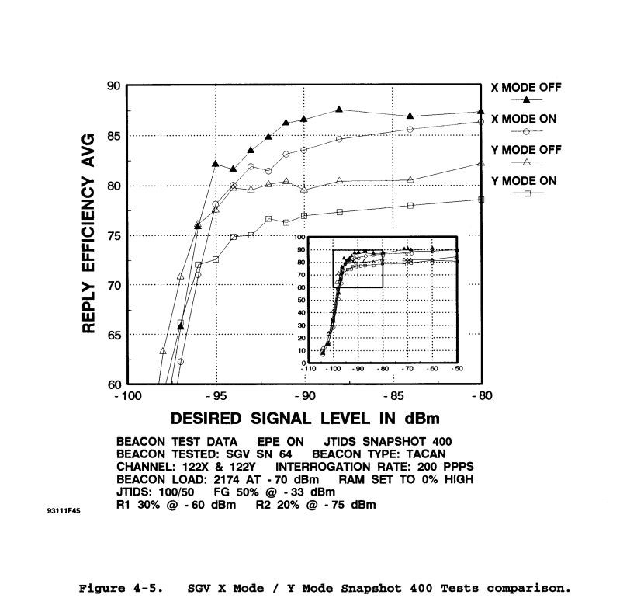
Figure 20: Example of Beacon Reply Efficiency versus Desired signal level

Interference scenarios
Interference scenarios define, which type of signal (e.g., LDACS ground, or airborne transmission) has to be tested against which type of equipment (e.g., DME/TACAN ground, or airborne equipment) under which conditions (e.g., minimum separation distances between LDACS transmitter and DME/TACAN receiver; maximum expected undesired signal power level).
The SESAR Project P15.2.4 study [LDACS EMC Scenarios] identified twelve potential generic interference scenarios considering the potential interference between two systems as shown in the figure below. In each scenario, there are two systems under consideration, A and B.

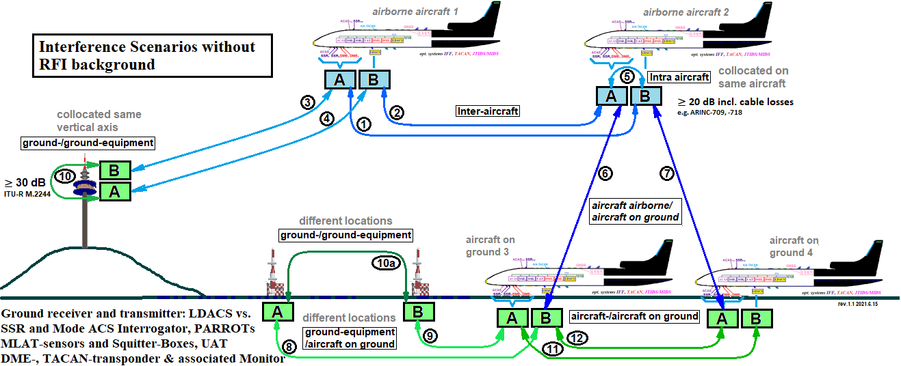
Figure 21: Interference Scenarios between systems A and B

The twelve identified Interference Scenarios can be described as follows:
- Scenario 1 and 2: Airborne Aircraft to Airborne Aircraft
- Scenario 3: Airborne Aircraft to Ground Station
- Scenario 4: Ground Station to Airborne Aircraft (reverse path of Scenario 3)
- Scenario 5: Co-located, same Aircraft
- Scenario 6 and 7: Airborne Aircraft to Aircraft on Ground
- Scenario 8: Aircraft on the Ground-to-Ground Station
- Scenario 9: Ground Station to Aircraft on Ground (reverse path of Scenario 8)
- Scenario 10: Ground Station to Ground Station: cases: on same mast (10) and at different sites (10a)
- Scenario 11 and 12: Aircraft on the Ground to Aircraft on Ground
The [HELIOS Interference Scenario Study] provided a more detailed analysis of geometries and coupling losses for these scenarios. The coupling losses were derived with the following methods:
- Measured results in situations where antennas are in very close proximity (i.e., on the same structure);
- Free space path loss equation where the first Fresnel zone of the link is not obstructed;
- The propagation curves of ITU-R P.528 at distances beyond this.

Note: The indicate attenuations are measured from antenna to antenna.

Scenario 1 (and 2): Airborne Aircraft to Airborne Aircraft
In this scenario, the minimum distance likely to be encountered between the two ends of the link is as one aircraft passes above another. In RVSM airspace, this represents a distance of 1000 ft (or 305 m). At this distance, the free space path loss equation applies. The minimum loss is therefore 82 dB.

Scenario 3 (and 4): Airborne Aircraft to Ground Station
In this scenario, the minimum distance likely to be encountered between the two ends of the link is during the approach or take-off phase of flight when the aircraft is close to the runway. On occasion, radio equipment is mounted just to the side of the runway and thus it is possible that (for a fleeting moment), the closest distance between the two could be as low as 50 metres, indicating a path loss of 66 dB.

Scenario 4 is the reverse path of scenario 3 which, in terms of analysis, will have different parameters, however in terms of the path loss will be the same.

Scenario 5: Co-located, same Aircraft
For this scenario, measurements of the coupling between various antennas are by far the best mechanism to arrive at possible ranges of losses. These have been shown to be around 30 dB in a typical installation. In contrast to this, [ARINC 709], specifies only 20 dB minimum isolation:

Table 8: Excerpt from [ARINC 709]
6.2.3 Antenna Isolation. The antenna should be installed on the aircraft in such a manner as to provide at least 20 dB of isolation from other L-Band systems such as ATC transponder and other DMEs, as well as from TACAN and IFF for special cases where commercial and military equipment are combined. The 20 dB figure includes antenna isolation plus the combined attenuation of the transmission lines of any two L-Band systems being co-isolated.”

Scenario 6 (and 7): Airborne Aircraft to Aircraft on the Ground
In this scenario, the minimum distance likely to be encountered between the two ends of the link is when aircraft in the take-off run have just become airborne. This is only a temporary situation given the speed of the departing aircraft but in large airports, the time of exposure while the departing aircraft is still in low altitude could last up to a minute. While still above the airport, departing aircraft could be in the region of 500 ft (150 metres) above the airport surface, representing a minimum loss of 76 dB.

Scenario 8 (and 9): Aircraft on the Ground-to-Ground Station
In this scenario, the minimum distance likely to be encountered between the two ends of the link is when the aircraft is parked in the apron area or taxiing in the vicinity of the runway. The distance will therefore depend upon the location of the ground station relative to the aircraft. At large airports such as Frankfurt, this may be up to 2,500 m from the aircraft’s location. In other places, the aircraft may be expected to come within 50 metres of a ground station. The range of losses applicable in this scenario is therefore 66 to 100 dB.

Scenario 10: Ground Station to Ground Station
In this scenario, the minimum distance likely to be encountered between the two ends of the link is when both ground stations are co-located (i.e., at the same physical site) and loss will be at a minimum when the antennas for the two ground stations are mounted on the same mast. In such situations, the loss between two systems can be as low as 30 dB.
Note: The Ground Station to Ground Station with assumption that both transmitters on the same mast is very challenging. [ITU-R M.2244] provides guidance on how ground-to-ground isolation is determined.

Scenario 11 (and 12): Aircraft on the Ground to Aircraft on the Ground
In this scenario, the minimum distance likely to be encountered between the two ends of the link is when both aircraft are parked next to each other. However, in this case, the aircraft is largely inactive in terms of operational and ATC data exchanges and any transmissions in this instance will be limited. The most operationally relevant scenario for aircraft on the ground is when aircraft are operating in the vicinity of the active runway when preparing for take-off, or just after landing. In many busy airports the separation between aircraft is at a minimum while queuing for their take-off slot. This will, potentially, be slightly closer for small aircraft than for large aircraft. Typical minimum separation distances between aircraft could be as low as 50 metres.

Table 9: Minimum path losses for various scenarios
Scenario | Minimum Loss
1 (and 2): Airborne Aircraft to Airborne Aircraft | 82 dB
3 (and 4): Airborne Aircraft to Ground Station | 66 dB
5: Co-located, same Aircraft | 20 dB*
6 (and 7): Airborne Aircraft to Aircraft on the Ground | 76 dB
8 (and 9): Aircraft on the Ground-to-Ground Station | 66 dB
10: Ground Station to Ground Station | 30 dB
11 (and 12): Aircraft on the Ground to Aircraft on the Ground | 66 dB
Note*: According to [ARINC 709], section 6.2.3

Because LDACS ground Transmitters have a higher EIRP than LDACS airborne transmitters, scenarios 3 and 4 as well as 8 and 9 are not identical as stated in the Helios-study. Therefore, these cannot be combined.
With the aforementioned LDACS EIRP values and the path losses in Table 9, one obtains the following ‘maximum received LDACS signal’ at the DME antenna port for the various scenarios:

Table 10: Maximum received LDACS signal for various scenarios
Scenario | Min. Loss | Calculation | Max. LDACS Received Power
1 (and 2): Airborne Aircraft to Airborne Aircraft* | 82 dB | 41 dBm -82 dB | - 41 dBm
3: Airborne Aircraft to Ground Station | 66 dB | 41 dBm – 66 dB | - 25 dBm
4: Ground Station to Airborne Aircraft | 66 dB | 52 dBm – 66 dB | - 14 dBm
5: Co-located, same Aircraft** | 20 dB | 41 dBm – 20 dB | 21 dBm
6 (and 7): Airborne Aircraft to Aircraft on the Ground | 76 dB | 41 dBm – 76 dB | -35 Bm
8 Aircraft on the Ground-to-Ground Station | 66 dB | 41 dBm – 66 dB | -25 dBm
9: Ground Station to Aircraft on the Ground | 66 dB | 52 dBm – 66 dB | -14 dBm
10: Ground Station to Ground Station | 30 dB | 52 dBm – 30 dB | 22 dBm
11 (and 12): Aircraft on the Ground to Aircraft on the Ground | 66 dB | 41 dBm – 66 dB | -25 dBm

Note*: Two aircraft separated 1000 ft in altitude (going into different directions), slightly offset in order to be in an elevation angle with maximum receive antenna gain (antenna pattern of bottom mounted antenna has maximum gain at 30° down => worst case slant range 1500 ft)

Note**: In contrast to the Helios Study, [ARINC 709] specifies minimum coupling loss of 20 dB

Note: [LDACS Draft SARPS] also specify an ‘Extended Range LDACS Ground station’ with an EIRP of +58 dBm below 1120 MHz (ensuring compliance with ITU-R Resolution 417). This would be implemented by means of an 18 dBi gain antenna. Such a LDACS stations would not be co-located with a DME/TACAN ground beacon, nor close to runways or taxiways.

The most challenging scenarios are Scenario 5 (Co-located, same Aircraft) and Scenario 10 (Ground Station to Ground Station).

Compatibility test-cases
Based on the considerations above, the following test cases shall be carried out:

Table 11: Test-cases
Scenario
1 (and 2) | ‘Airborne LDACS Tx’ to ‘Airborne DME/TACAN Interrogator’
1a | DME desired signal according to section 4.1  + LDACS (single undesired LDACS signal from a adjacent aircraft)
1b | DME desired signal according to section 4.1  + DME Interrogator-background according to section 2.1.3, Table 4  + LDACS background, interrogator-case with a duty cycle according to section 2.1.5
1c | DME desired signal according to section 4.1  + DME Interrogator-background according to section 2.1.3, Table 4  + LDACS background, interrogator-case  + JTIDS background, interrogator case, according to section 2.1.4, Table 5
1d | DME desired signal according to section 4.1  + DME Interrogator-background according to section 2.1.3, Table 4  + LDACS background, interrogator-case with a duty cycle according to section 2.1.5  + JTIDS background, interrogator case, according to section 2.1.4, Table 5  + UAT background, interrogator-case, tbd, according to section 1.5.2
3 | ‘Airborne LDACS Tx’ to ‘DME/TACAN Ground Transponder’
3a | DME desired signal, according to section 4.2  + DME Transponder-background, according to section 2.1.3, Table 5
3b | DME desired signal, according to section 4.2  + DME Transponder-background,  + LDACS (single undesired LDACS signal) + JTIDS background, transponder-case, according to section 2.1.4 Table 5
 | Note: There is no UAT background, DME transponder-case
3c | DME desired signal, according to section 4.2  + DME Transponder-background,  + JTIDS background, transponder-case, according to section 2.1.4 Table 5  + LDACS (single undesired LDACS signal)  + Impact of SDES according to section 4.2.1.3
4 | ‘Ground LDACS TX’ to ‘Airborne DME/TACAN Interrogator’
4a | DME desired signal according to section 4.1  + DME Interrogator-background, according to section 2.1.3, Table 4  + LDACS (single undesired LDACS signal, ground TX)
4b | DME desired signal according to section 4.1  + DME Interrogator-background, according to section 2.1.3, Table 4  + LDACS (single undesired LDACS, ground TX signal)  + JTIDS background, interrogator-case, according to section 2.1.4, Table 5
4c | DME desired signal according to section 4.1  + DME Interrogator-background, according to section 2.1.3, Table 4  + LDACS (single undesired LDACS ground TX signal)  + JTIDS background, interrogator-case, according to section 2.1.4, Table 5  + UAT background, interrogator-case, tbd, according to section 1.5.2
4d | DME desired signal according to section 4.1  + DME Interrogator-background, according to section 2.1.3, Table 4  + LDACS (single undesired LDACS, ground TX signal)  + JTIDS background, interrogator-case, according to section 2.1.4, Table 5  + Impact of Mutual Suppression Bus (MSB), according to section 4.1.1.3)
5 | ‘Airborne LDACS Tx’ to ‘Co-site Airborne DME/TACAN Interrogator’
5a | DME desired signal according to section 4.1
5b | DME desired signal according to section 4.1  + LDACS (single undesired LDACS signal)
5c | DME desired signal according to section 4.1  + LDACS (single undesired LDACS signal)  + Impact of Mutual Suppression Bus (MSB) according to section 4.1.1.3
5d | DME desired signal according to section 4.1  + DME Interrogator-background according to section 2.1.3, Table 4  + LDACS (single undesired LDACS signal)  + JTIDS background-interrogator case, according to section 2.1.4, Table 5  + UAT background, interrogator-case, tbd, according to section 1.5.2
5e | DME desired signal according to section 4.1  + DME Interrogator-background according to section 2.1.3, Table 4  + LDACS (single undesired LDACS signal)  + JTIDS background, interrogator-case, according to section 2.1.4, Table 5  + UAT background, interrogator-case, tbd, according to section 1.5.2  + Impact of Mutual Suppression Bus (MSB) according to section 4.1.1.3)
6 (and 7): | ‘Airborne LDACS Tx’ to ‘DME/TACAN Interrogator in Aircraft on the Ground’
8 | ‘LDACS TX on Aircraft on the Ground’ to ‘DME/TACAN Ground Transponder’
9 | ‘LDACS Ground Tx’ to ‘DME/TACAN interrogator on Aircraft on the Ground’
10 | Ground LDACS Tx to DME/TACAN Ground Transponder
10a | DME desired signal, according to section 4.2  + LDACS (single undesired LDACS signal)  Note: Test case without any background
10b | DME desired signal, according to section 4.2  + LDACS (single undesired LDACS signal)  + Impact of SDES, according to section 4.2.1.3
10c | DME desired signal, according to section 4.2  + DME Transponder-background according to section 2.1.3, Table 4  + JTIDS background, transponder-case according to section 2.1.4 Table 5  Note: Test case with only with DME and JTIDS background
10d | DME desired signal, according to section 4.2  + DME Transponder-background according to section 2.1.3, Table 4  + JTIDS background, transponder-case according to section 2.1.4 Table 5  + Impact of SDES, according to section 4.2.1.3
10e | DME desired signal, according to section 4.2  + DME Transponder-background according to section 2.1.3, Table 4  + JTIDS background, transponder-case according to section 2.1.4, Table 5  + LDACS (single undesired LDACS signal)
10f | DME desired signal, according to section 4.2  + DME Transponder-background, according to section 2.1.3, Table 4  + JTIDS background, transponder-case, according to section 2.1.4, Table 5  + LDACS (single undesired LDACS signal)  + Impact of SDES, according to section 4.2.1.3
11 (and 12): | ‘LDACS TX on aircraft on the ground’ to ‘DME/TACAN interrogator on Aircraft on the Ground’

For the testing it is important to pursue the general testing approach described in chapter 3.1. Among other things, this approach foresees that every test case shall be repeated also with desired signal levels above and below the minimum Desired signal level in steps of -3 dB, -2 dB, 0 dB, -1 dB, +1 dB, +2 dB, + 3 dB, + 6 dB in order to establish the sensitivity of this test. This helps to determine the impact of fading, cliff-effect and the “no-effect” level.

DME/TACAN equipment types to be tested

The minimum list of DME/TACAN equipment types to be tested is:
  - Ground side:
    - Three DME transponder types from different manufacturers (e.g., INDRA, SELEX, Thales, NEC)
    - Three TACAN transponder types from different manufacturers (e.g., Moog, Thales)
  - Airborne side:
    - GA category DME interrogators:
      - without pre-selector* (e.g. ‘Sperry DME-1077B’, ‘KN 64’, ‘KN 63’ and ‘NARCO DME-890’)
      - with pre-selector
    - air transport category DME/TACAN interrogators (e.g., Collins, Honeywell)
    - business jet category DMETACAN interrogators (e.g., Collins, Honeywell)
Note: GA interrogators without a pre-selector are typically very old. The feasibility of testing these types needs to be confirmed.
The Appendix (chapter 7) provides lists of currently used DME/TACAN equipment types, which are candidates for a representative compatibility test. Equipment that has similar design does not require testing.

Appendix – Currently used, or earlier tested DME/TACAN Equipment

Information provided by Collins Aerospace, US

DME-900:
Target Market: Commercial Air Transport
Standards: TSO-C66a, RTCA DO-151A, DME ARINC Characteristic document is 709-8. Also complies with the ARINC structural and data transfer characteristic documents 429, 600, and 602.

Multi-Channel Unit (5 channels)
DME-2100:
Target Market: Commercial Air Transport
Standards: TSO-C66c, RTCA DO-189, DME ARINC Characteristic document is 709-8.
Also complies with the ARINC structural and data transfer characteristic documents 429,
600, and 602.

Multi-Channel Unit (3 channels)
DME-4000:
Target Market: Business and Regional Aircraft
Standards: TSO-C66c, RTCA DO-189, DME ARINC Characteristic document is 709-8.
Multi-Channel Unit (3 channels)

Collins also recommends testing for LDACS compatibility with Collins TACAN products
ARN-118 and ARN-153.

Information provided by DSNA, France
The most frequently installed on Airbus aircraft is the DME 2100 from Collins Aerospace.
Other types of DME Interrogators from Collins Aerospace (DME 700, 900 series) and
Honeywell (DMA 37A, DMA 37B) are also used.

Information provided by FAA

TACAN/DME Interrogators used in JTIDS compatibility tests in the US
The total number of Interrogators tested to date is approximately 39. The following list shows the airborne TACAN and DME Interrogators that have been tested. The three types of testing that is identified is WT=waveform test, BT= bench test, FT= flight test. The waveform tests occurred prior to 1980 and were used to determine the final Link 16 waveform design. Link 16 was tested against 11 different Interrogator receivers before the waveform design was finalized. Also identified are the Interrogators that were used during flight tests and were intended to verify compatibility under actual operational conditions.

TACAN Interrogators Tested:
- Sierra Test Set
- Marconi AD 2700
- King KTU 709 BT
- MITAC BT
- AN/ARN-21 WT
- AN/ARN-21C WT & BT
- AN/ARN-52 WT
- AN/ARN-84 WT & BT
- AN/ARN-91 FT
- AN/ARN-118 FT & BT
- AN/ARN-136 BT
- AN/ARN-153 BT
- AN/ARN-154 BT – Foster Air

DME Interrogators Tested:
- UDI-4 WT, FT & BT
- DMS 44A BT
- DME 190 WT, FT & BT
- DMA 37A BT & JA/BT
- DME 195 FT & BT
- DME-40 BT
- DME 890 BT
- DME-42 BT
- KN 60 WT
- DME-451 BT
- KN 60C FT & BT
- DME-700 BT
- KN 62A BT
- DME-860E-2 WT, FT & BT, BT
- KN 63 BT
- DME-860E-3 FT & BT
- KN 65 BT
- DME-860E-5 FT & BT
- KN 65A FT & BT
- AVQ-75 WT, FT & BT
- KDM 705 BT
- AVQ-170 BT
- KDM 705A BT
- AVQ-870 WT
- KDM 7000 WT, FT & BT
- DME 1077B BT
- KDM 7000A BT
- TDM 709 BT
- KDM 7000B FT & BT
- ALCATEL FDT-90 BT

TACAN/DME Beacons used in JTIDS compatibility tests in the US
Link 16 was originally tested against 4 different beacon receivers before the waveform design was finalized. Approximately 22 different TACAN/DME beacon Transponder types have been tested to some degree.
TACAN Beacons previously tested:
- FSD-2 BT
- FSD-5 BT
- AN/GRN-9 WT & BT
- AN/GRN-9A FT & BT
- AN/GRN-9B BT
- AN/GRN-9C BT
- AN/GRN-9D BT
- AN/GRN-20B FT & BT
- N/LRN-16 FT & BT
- RTB-2 WT, FT & BT
- SGV BT
- AN/TRN-41 FT & BT
- AN/URN-20 BT
- AN/URN-25 BT
- Thales AN 453 TACAN BT
The following Thales beacon Transponders were determined to be of similar design to the Thales AN 453 TACAN:
- FSD–2
- FSD–5
- FSD–10
- FSD–15
- FSD–30
- FSD–40
- FSD–45
- FTA–10
- FTA–43

DME Beacon Transponders Previously Tested
- Aerocom 5350A FT & BT
- Butler 1020 FT & BT
- Cardion 8974 FT & BT
- Cardion 9783 BT
- NEC DME-90A FT & BT
- NEC DME-91A FT & BT
- Thomson DME-721 BT
- Thomson DME-740 BT
- Wilcox 596B FT & BT
- Fernau 2020 DME BT
- Fernau 1117 DME BT
- Thales DME 415 BT

Information provided by NEC
Note: NEC manufacturing DME and TACAN transponder under contract of JCAB and JSDF according to their specification. NEC's DME and TACAN transponder has no Equipment type number but customer's specification number. NEC has an experience of compatibility test of DME and JTIDS with JCAB and JSDF.

Information provided by CAA UK
At present (2021) the most numerous existing DME beacon type used in the UK is the Fernau 2020. The Fernau 2020 beacon is used for UK JTIDS/DME compatibility testing and to determine UK Lnk16 FCA conditions.
The UK Fernau 2020 beacons are being replaced by the Indra Navia NORMARC LDB 103 DME beacon, (https://www.indracompany.com/en/indra-air-navigation ), and will therefore become the most widely used beacon type in the UK. It would be appreciated if the Indra Navia NORMAC LDB 103 DME beacon is added as a candidate for LDACS/DME testing.

References
[ARINC-521] | ARINC Characteristic 521B, Airborne Distance Measuring Equipment TACAN (DMET), 1957, Mar. 25
[ARINC-521B] | ARINC Characteristic 521B, Airborne Distance Measuring Equipment (DME), 1962, Jun. 28
[ARINC-532] | ARINC- Characteristic 532, Air Traffic Control Transponder, 1955; 532B 1957; 532-C 1965-1-01, 532-D incl. suppl. 1 -5, Air Traffic Control Transponder, 1965101
[ARINC 568] | ARINC Characteristic 568, Mark 3, Airborne Distance Measuring Equipment (DME), April 15, 1987
[ARINC-709] | ARINC Characteristic-709-1 Mark 5, Airborne Distance Measuring Equipment, 1979-Mar-23
[ARINC-709A] | ARINC Characteristic 709A, Precision Airborne Distance Measuring Equipment (DME/P), 1987 Oct. 01 & Revision; 1994 Aug. 17
[ARINC-718A] | ARINC Characteristic 718A, Mark 4 Air Traffic Control Transponder (ATCRBS/ Mode S), ARINC-718A-4, 2011
[ARINC-735] | ARINC Characteristic 735, Traffic Alert and Collision Avoidance System (TCAS), 1989309, ARINC 735A
[CT-TN96/20] | “1030/1090-Megahertz Signal Analysis at Frankfurt, Germany”, DOT/FAA Technical Note DOT/FAA/CT-TN96/20, 1030/1090-MEGAHERTZ SIGNAL ANALYSIS, FRANKFURT, GERMANY, Leo Wapelhorst, Thomas Pagano, 1996
[DME-1949] | Distance Measuring Equipment, US Department of Commerce Civil Aeronautics Administration, 1949 May 1
[DO-144] | RTCA DO-144, Minimum Operational Characteristics For Airborne ATC Transponder Systems, RTCA, 1970, March.12
[DO-150] | RTCA DO-150, Minimum Performance Standards – Airborne ATC Transponder Equipment, RTCA, 1972, March.17
[DO-151B] | DO-151B, Minimum Performance Standards Airborne Distance Measuring Equipment (DME) Operating Within the Radio-Frequency Range of 960-1215 Megahertz, RTCA, 1997
[DO-181E] | DO-181E, Minimum Operational Performance Standards for Air Traffic Control Radar Beacon System/ Mode S Select (ATCRBS/Mode S) Airborne Equipment
[DO-185B] | DO-185B, Minimum Operational Performance Standards for Traffic Alert Collision Avoidance System (TCAS II) Airborne Equipment, RTCA
[DO-189] | RTCA DO-189, Minimum Operational Performance Standards for Airborne Distance Measuring Equipment (DME) Operation Within the Radio Frequency Range of 960-1215 Megahertz, RTCA, Sept 1985
[DO-300] | DO-300(A), Minimum Operational Performance Standards (MOPS) for Traffic Alert and Collision Avoidance System II (TCASII) Hybrid Surveillance, RTCA
[DO-358] | DO-358, Minimum Operational Performance Standards (MOPS) for Flight Information Services Broadcast (FIS-B)
[DOD 4650.1] | US Department of Defence (DOD) Regulation 4650.1-R1, “Link 16 Electromagnetic Compatibility (EMC) Features Certification Process and Requirements”, 26 April 2005
[ED143] | ED 143 (incl. Change 2) Minimum Operational Performance Standards for Traffic Alert Collision Avoidance System (TCAS II), EUROCAE
[ED221A] | ED-221A, Minimum Operational Performance Standards (MOPS) for Traffic Alert and Collision Avoidance System II (TCASII) Hybrid Surveillance
[ED54] | EUROCAE ED54, MINIMUM OPERATIONAL PERFORMANCE REQUIREMENTS FOR DISTANCE MEASURING EQUIPMENT INTERROGATOR (DME/N AND DME/P) OPERATING WITHIN THE RADIO FREQUENCY RANGE 960 TO 1215 MHz, Jan. 1984
[ED57] | EUROCAE ED57, MINIMUM OPERATIONAL PERFORMANCE SPECIFICATION FOR DISTANCE MEASUREMENT EQUIPMENT (DME/N and DME/P) GROUND EQUIPMENT, Dec. 1986
[ED73E] | EUROCAE ED 73E, Minimum Operational Performance Standards for Secondary Surveillance Radar Mode S Transponders, EUROCAE
[FAA AC-00-31A] | FAA-AC-00-31, United States (U.S.) National Aviation Standard for the Very High Frequency Omnidirectional Radio Range (VOR)/Distance Measuring Equipment (DME)/Tactical Air Navigation (TACAN) Systems, September 20, 1982
[FAA TSO C66a] | Technical Standard Order, Federal Aviation Regulations Part 37 Airborne Distance Measuring Equipment, (Air Carrier Aircraft) Minimum Performance Standards For Airborne Distance Measuring Equipment Operating Within The Radio-Frequency Range Of 960-1215 Megacycles, FAA, 1965215 (See Note* on TSO C66a below)
[FAA-E-2996] | FAA PERFORMANCE SPECIFICATION FOR DISTANCE MEASURING EQUIPMENT (DME)
[German FCA] | German Frequency Clearance for MIDS/JTIDS Peacetime Operations and Its Geographical Area” German Armed Forces Technical Test Centre for Information Technology and Electronics WTD 81, 14 June 2005
[HELIOS Interference Scenario Study] | EUROCONTROL-Study on “FCI Technology Investigations: L band Compatibility Criteria and Interference Scenarios Study, Deliverables S1-S7: L-Band Interference Scenarios”, John Micallef, Richard Womersley, Simon Dunkley, Ian Casewell, Helios, August 2009
[HELIOS MSB] | EUROCONTROL-Study on “FCI Technology Investigations: L band Compatibility Criteria and Interference Scenarios Study Deliverable C7: Assessment on the potential use of the onboard suppression bus for L-DACS operation”, John Micallef, Richard Womersley, Helios, May 2009
[ICAO Annex10-I] | International Standards and Recommended Practices, Aeronautical Telecommunications, Annex10 to the convention on international civil aviation, Volume I (Radio Navigation Aids), Amd. 90, “Aeronautical Telecommunications – Radio Navigation Aids”
[ICAO Annex10-IV] | ICAO, International Standards and Recommended Practices, Aeronautical Telecommunications, Annex10 to the convention on international civil aviation, Volume IV, Surveillance Radar and Collision Avoidance Systems, 1st Ed. 1995, Mar; 2nd Ed. 1998 Jul; 3rd Ed. 2002Jul, 5th Ed
[ICAO DME chan] | ICAO Annex 10, Vol. I, Table A, “DME/MLS angle, DME/VOR and DME/ILS/MLS channelling and pairing”
[ICAO Doc 8071-I] | ICAO Manual on testing of Radio Navigation Aids Volume I, 4th Ed. 2000
[ICAO Doc 8071–III] | ICAO Manual on testing of Radio Navigation Aids Volume III, Testing of Surveillance Radar Systems, 2nd Ed. 2020
[ICAO Doc 9684] | ICAO Doc 9684, Manual on the Secondary Surveillance Radar (SSR) Systems, 1. Ed., 1997 (withdrawn, superseded by Doc 9924 Aeronautical Surveillance Manual)
[ICAO Doc 9688] | ICAO Doc 9688, Manual on Mode S Specific Services, 1st Ed., 1997 (withdrawn, superseded by Doc 9871)
[ICAO Doc 9861] | Guidance on definition of UAT equipment classes will be provided in Part II of the Manual on the Universal Access Transceiver (UAT)
[ICAO Doc 9863] | ICAO Doc9863, Airborne Collision Avoidance System (ACAS) Manual, 1Ed. 2006
[ICAO Doc 9871] | ICAO Doc 9871, Technical Provisions for Mode S Services and Extended Squitter, 1. Ed. 2008, 2. Ed., 2017
[ICAO Doc 9924] | ICAO Doc 9924, Aeronautical Surveillance Manual, 3rd Ed., 2020
[ICAO UAT SARPS] | ICAO Annex 10, Volume III, Chapter 12, Universal Access Transceiver (UAT)
[ITU-R Res.417] | RESOLUTION 417 (REV. WRC-15), Use of the frequency band 960-1 164 MHz by the aeronautical mobile (R) service, International Telecommunication Union, 2015
[ITU-R M.2244] | ITU-R report M.2244, Isolation between antennas of IMT base stations in the land mobile service, International Telecommunication Union, November 2011
[JTIDS SPS WG-1 TR-96-001] | JTIDS SPECTRUM SUPPORTABILITY DOCUMENTATION TACAN/DME BEACONS, SPS WG-1 TR-96-001, NTIA SPECTRUM PLANNING SUBCOMMITTEE, WORKING GROUP ONE, Sept. 1996
[L-Band Compendium] | “Compendium of systems and equipment in the band 960 MHz to 1215 MHz”, Doc. SE7(17)092, ECC SE7 meeting, Hannover, October 2017, Joachim Wollweber, DFS
[LDACS Draft SARPS] | Finalization of LDACS Draft SARPs, ICAO CP DCIWG/2-WP05, October 2018
[LDACS EMC Final results 2020] | LDACS (L-band Digital Aeronautical Communications System) versus DME/TACAN Compatibility, ICAO NSP JWGs/6-WP/28, June 2020:  -Attachment A: Deliverable D1.2, ‘Test Bench Technical Description’, Project EU-2019-004 PJ.14-02-01  -Attachment B: Deliverable D4, ‘Final Test Report, ‘Compatibility testing of LDACS with DME/TACAN in the SESAR2020 solution PJ.14-02-0”
[LDACS EMC Initial results 2019] | LDACS (L-band Digital Aeronautical Communications System) versus DME/TACAN Compatibility Testing – Initial Results, ICAO NSP JWGs5-WP49, Montreal, October 2019
[LDACS EMC Scenarios] | SESAR Project P15.2.4 Early Task, Early Working Activity EWA04-2 Task 1b, “Updated Interference Scenarios for Existing L-band Systems”, Edition 00.02.00, August 2011
[LDACS Specification] | LDACS A/G Specification, D3.1.210, SESAR2020 PJ14-W2-60, December 2020 (available at: https://www.ldacs.com/publications-and-links/#post-Specifications)
[LDACS EMC Testing Plan 2018] | ‘LDACS (L-band Digital Aeronautical Communications System) versus DME/TACAN Compatibility Testing Plan”, ICAO NSP/5-WP/38, Montreal, November 2018
[NATO in SE7] | “PMSE Equipment EMC Evaluation Requirements”,  - Appendix A: “Comparison of National Link 16 (JTIDS/MIDS) Frequency Clearance Agreement Geographic Area Limits and EMC Test Program Equipment Environments”, Doc SE7(17)083, presented by NATO Spectrum Capability Panel (CaP3), ECC SE7 meeting, Hannover, October 2017
[NATO study] | “COMPATIBILITY STUDY: POTENTIAL INTERFERENCE BETWEEN TWO CANDIDATE AM(R)S SYSTEMS AND DME/TACAN”, NATO C3 Agency, Technical Note 1435, The Hague, August 2010
[SGM-100-60] | DMET/TACAN SSR/IFF Interference Potentials, 17 February 1960, declassified public disclosure IMSM-0431-99

Note*: Since there is no mandate for retrofit of any equipment built under TSO-C66A, TSO-C66B, these TSOs still apply to the existing equipment built prior to the date ranges listed above. The TSO-66x define the applicability by publication date as follows:
  - TSO C66a is applicable for equipment built before 03. Aug. 1981
  - TSO C66b is applicable for equipment built before after 03. Aug.1981 and before 18. Jan.1991
  - TSO C66c is only applicable to equipment built after 18. Jan. 1991

Abbreviations and Glossary

ARINC | Aeronautical Radio, Incorporated,
ALC | Automatic Load Control (DME/TACAN transponder)
ASOP | Acquire Stable Operation Point
BRE | Beacon Reply Efficiency
BSOP | Break Stable Operation Point
D/U | Desired-to-Undesired signal power level
dBr | dB in relation to maximum of Emission Mask
DME | Distance Measurement Equipment
DMET | DME-TACAN based, today’s DME/N
ED | EUROCAE Document
EUROCAE | European Organisation for Civil Aviation Equipment
EUT | Equipment Under Test
FAA | Federal Aviation Administration
FA | Final Approach mode (DME/P)
ICAO | International Civil Aviation Organization
ICAO NSP | Navigation Systems Panel of the International Civil Aviation Organisation
ICAO NSP SWG | Spectrum Working Group of the ICAO NSP
IA | Initial Approach mode (DME/P)
IRF | Interrogation Repetition Frequency
JTIDS/MIDS | Joint Tactical Information Distribution System / Multifunctional Information Distribution System
kc | kilo cycles
LDACS | L-Band Digital Aeronautical Communication System
MOPS | Minimum Operational performance Standard
MSB | Mutual Suppression Bus
MTL | Minimum Triggering Level
MRPG | Main Reference Pulse Group (TACAN)
mc | Mega Cycles
ppps | pulse pairs per second
PPCode | Pulse Pair Code (DME/TACAN)
pps | pulses per second
ppt | pulses per timeslot
RX | Receiver
Squitter | Unsolicited replies
TACAN | Tactical Air Navigation
TBN | Test Bed Network
TSDF | time slot duty factor
TSO | Technical Standards Order
TTA | Time to acquire
TX | Transmitter
UAT | Universal Access Transceiver

— END —

