FREQUENCY SPECTRUM MANAGEMENT PANEL (FSMP)

Fourteenth Working Group meeting

Web Meeting, 25 29 April 2022

Agenda Item 5b) : WRC-23 AI1.7 VHF AMS(R)S

PROPOSAL

(Presented by Fleury Christian, French Civil Aviation)

SUMMARY
During the last FSMP WG13 and ITU WP5B, several States expressed concern about ICAO's ability to coordinate AMS(R)S and AM(R)S assignments, and therefore also AMS(R)S and AM(OR)S allocations. This document aims to describe the method currently used on the European continent for coordination in the band 117.975-137 MHz and invite other ICAO region to share the same information.

- INTRODUCTION

The development of WRC-23 Agenda Item 1.7 has raised multiple questions for existing VHF operators and users about how VHF SATCOM systems will interface with terrestrial VHF services.

But first, it seems fundamental that we should have a global view of the methodology used in each of ICAO regional offices to carry out coordination and registration of frequency assignments in all or part of the 117.975-137 MHz frequency band.
- DISCUSSION
  - The European General Rules for Co-ordination of Frequency Assignments

There is an arrangement for coordination between Civil Aviation representatives in the EUR region. The coordination processes are designed to ensure that Europeans States have an opportunity to assess compatibility with the planning rules contained in the EUR FREQUENCY MANAGEMENT MANUAL (EUR Doc 011) prior to a frequency being assigned for operational use. The EASPG has mandated the use of the Spectrum and Frequency Information (SAFIRE) web-based tool to carry out coordination and registration of frequency assignments in the EUR Region. The basic aeronautical coordination procedure is depicted below

ICAO Process (EUR DOC011) automated in SAFIRE

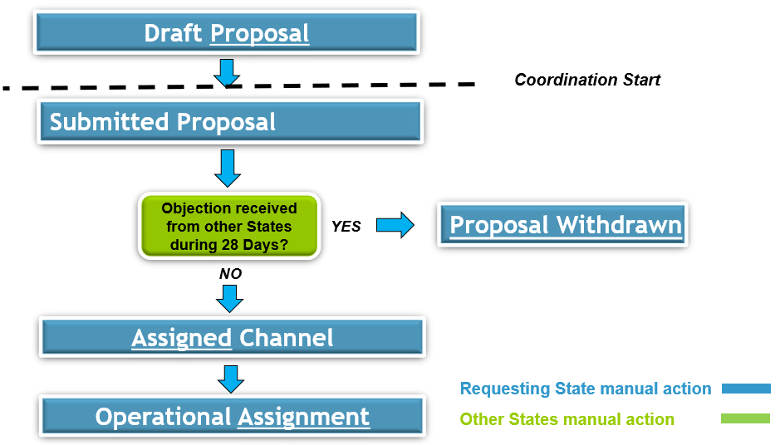
Co-ordination is deemed to have been completed and the assignment is considered to be granted when either:
i. All concerned States have registered their acceptance, or
ii. A 4 week period has elapsed without an objection having been registered

Frequency Coordination Process

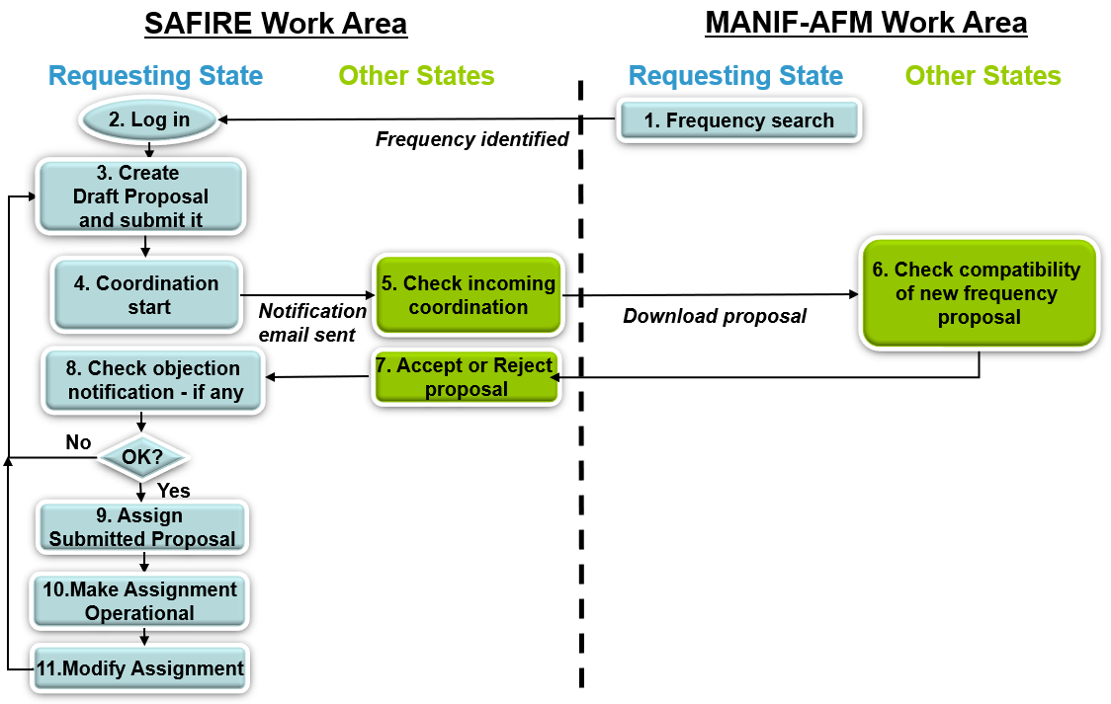

For the VHF communications band 117.975 - 137 MHz special procedures are applied due to the congestion problems in this band. Block Planning Exercises are organised, as required, based on the mutual arrangements agreed between the States involved. These exercises are organized for those requirements for which an available channel can only be identified through shifting of one or more existing assignments to some other channel. The normal coordination procedure can be used if no shifts are involved.

Co-ordination must be made with all European States that in some way may be affected by the proposed assignment. Additionally, some States may have an interest in being informed about changes, although not directly affecting them, in order to update national databases or for other purposes

After successful co-ordination of a new or modified assignment, the assignment is registered in SAFIRE database. All States and ICAO are informed about the registration of assignments through SAFIRE. The registered assignments are published in the appropriate frequency assignment table of the ICAO EUR Air Navigation Plan.

MANIF AFM is software provide by Eurocontrol that provides a capability for conducting the compatibility assessment (such as Frequency Finder).

  - AM(OR)S Assignments
Due to the lack of time between the end of the previous ITU WP5B and the submission deadline for FSMP WG14, it was not possible to gather information on how AM(OR)S assignments (referring to footnote ITU-R 5.201 & 5.202) are coordinated with AMS(R)S assignments, nor even if the countries identified in footnotes 5.201 and 5.202 have AM(OR)S European assignments in the band 132-137Mhz. The only information we have obtained is that these assignments are not recorded in the SAFIRE database.
It is expected that ICAO Regions share
- how AM(R)S assignments are coordinated in their respective area.
- how AM(OR)S assignments (if any) are coordinated with AM(R)S in their respective area.

- ACTION BY THE MEETING
  - The meeting is invited to:
- Note and review this Working paper
- invite other ICAO region to share how
  - AM(R)S Assignments, in the 117.975-137Mhz frequency band, are coordinated
  - AM(R)S and AM(OR)S Assignments (if any), in the 132-137Mhz frequency band, are coordinated together

— END —

European Region Aviation System Planning Group ( EASPG)

