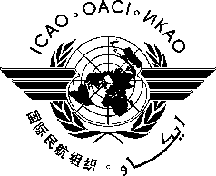
INTERNATIONAL CIVIL AVIATION ORGANIZATION

thirteeth working Group Meeting of the
Frequency Spectrum Management Panel
(FSMP-WG/13)

(Virtual, 21-25 February, 2022)

DRAFT AGENDA

Agenda Item 1 Opening and Working Arrangements

Agenda Item 2 ICAO WRC-23 Position
a) Identified conflicts between administration preliminary proposals and ICAO Position
b) Discussion of possible future agenda item proposals from administrations
c) Modifications/Updates to the ICAO WRC-23 Position

Agenda Item 3 Development of (planned) Material for ITU-R Studies on:
a) WRC-23 AI1.6 Suborbital Vehicles
b) WRC-23 AI1.7 VHF AMS(R)S
c) WRC-23 AI1.8 FSS for UAS
d) WRC-23 AI1.9 Wideband HF
e) WRC-23 AI1.10 Non-safety AMS
f) WRC-23 AI9.2 Radio Regulations clean-up
g) Other

Agenda Item 4 Radio Altimeter issues
b) Report from correspondence group on radio altimeters (CG-RA)
a) National efforts to implement broadband mobile near 4200-4400 MHz
- Mitigation measures
- Safety Cases/Compatibility Analyses

Agenda Item 5 Any Other Business

