FREQUENCY SPECTRUM MANAGEMENT PANEL (FSMP)

Nineteenth Working Group Meeting

Montréal, Canada, 15 to 26 July 2024

Agenda Item 3: Development of Material for ITU-R Studies on:
- Non-WRC material for the ITU

Liaison statement from ITU-T SG17
(LS on security work for UAM/AAM service in SG17)

(Presented by Secretary)

SUMMARY
Attached is the Liaison Statement from ITU-T Study Group 17 regarding security work for UAM/AAM service.

Action: FSMP WG/19 is invited to note the attached copy of the liaison statement and prepare inputs if required.

(The copy was also provided to the Secretary of the AAM Study Group)

______________

 | INTERNATIONAL TELECOMMUNICATION UNION  TELECOMMUNICATION  STANDARDIZATION SECTOR  STUDY PERIOD 2022-2024 |  |  | SG17-LS116
 |  |  |  | STUDY GROUP 17
 |  |  |  | Original: English
Question(s): |  | 13/17 |  | Geneva, 20 February - 1 March 2024
(Ref.: SG17-TD1931)
Source: |  | ITU-T Study Group 17
Title: |  | LS on security work for UAM/AAM service in SG17
LIAISON STATEMENT
For action to: |  |  | -
For information to: |  |  | ISO TC20 SC16 and ICAO AAM SG
Approval: |  |  | ITU-T Study Group 17 meeting (Geneva, 1 March 2023)
Deadline: |  |  | -
Contact: |  |  | Heung Youl Youm  Chair, SG17  Korea (Republic of) |  | Tel: +82-41-530-1328  E-mail: hyyoum@sch.ac.kr
Contact: |  |  | Sang-Woo Lee  ETRI  Korea (Republic of) |  | Tel: +82-42-860-1097  E-mail: ttomlee@etri.re.kr
Contact: |  |  | Seungwook Park  Hyundai Motor  Korea (Republic of) |  | Tel: +82-31-5172-6885  E-mail: seungwook.park@hyundai.com
Contact: |  |  | Yi Zhang  Beijing Qihu Keji Co., Ltd. P.R.China |  | E-mail: zhangyi1-s@360.cn
Contact: |  |  | Takamasa Isohara  KDDI Corporation  Japan |  | Tel: +81 80 6828 8638  E-mail: ta-isohara@kddi.com

ITU-T Study Group 17 is pleased to inform you of our recent activities on telecommunication/ICT security aspects of UAM/AAM service as follows:

New work item agreed:
- ITU-T X.aamd-sec, Security guidelines for categorized data in advanced air mobility

Draft Recommendation under development:
- ITU-T X.evtol-sec, Security requirements and guidelines for telecommunications in an urban air mobility (UAM) environment

SG17 would appreciate it if ISO TC20 SC16 and ICAO AAM SG could collaborate with SG17 through its Question 13 on UAM/AAM security.

Attachment (2):
- Scope and Summary of new work item: X.aamd-sec
- Draft Recommendation under development: X.evtol-sec
Attachment 1Draft Recommendation ITU-T X.aamd-sec
Security guidelines for categorized data in advanced air mobility

Scope
This Recommendation categorizes the data used in advanced air mobility (AAM) environments into several types and defines the security level for each categorized data type. Based on these categorized data types in each security level, this Recommendation identifies the security threats and provides security requirements and implementation guidance for categorized data in AAM.
Summary
Advanced Air Mobility (AAM) relies heavily on data for navigation, communication, and overall system functionality. In contrast to ground vehicles, AAM vehicles operate within three-dimensional airspace. Thus, safe and efficient navigation requires accurate and secure data including real-time updates on airspace conditions, weather, and the positions of other aerial vehicles. Therefore, ensuring data security in AAM is crucial due to its distinctive challenges and characteristics.
To address these security problems, this Recommendation provides a security threat analysis and specifies security requirements for categorized data in AAM environment. Furthermore, this Recommendation provides how to implement the mitigation methods to fulfill the security requirements.

Attachement 2
Draft Recommendation ITU-T X.evtol-sec
Security requirements and guidelines for telecommunications in an urban air mobility (UAM) environment

1 Scope
This Recommendation provides security requirements and guidelines for telecommunications in an urban air mobility (UAM) environment. This Recommendation includes an overview of connectivity utilized for an urban air mobility. In addition, this Recommendation provides analysis of security threats, security requirements and implementation guidelines.

2 References
The following ITU-T Recommendations and other references contain provisions, which, through reference in this text, constitute provisions of this Recommendation. At the time of publication, the editions indicated were valid. All Recommendations and other references are subject to revision; users of this Recommendation are therefore encouraged to investigate the possibility of applying the most recent edition of the Recommendations and other references listed below. A list of the currently valid ITU-T Recommendations is regularly published. The reference to a document within this Recommendation does not give it, as a stand-alone document, the status of a Recommendation.
None.

3 Definitions

3.1 Terms defined elsewhere
This Recommendation uses the following terms defined elsewhere:
3.1.1 authentication [b-ITU-T X.1252]: Formalized process of verification that, if successful, results in an authenticated identity for an entity.
3.1.2 authorization [b-ITU-T X.800]: The granting of rights, which includes the granting of access based on access rights.
3.1.3 availability [b-ITU-T X.800]: The property of being accessible and useable upon demand by an authorized entity.
3.1.4 authenticity [b-ITU-T X.641]: Protection for mutual authentication and data origin authentication.
3.1.5 accountability [b-ITU-T X.800]: The property that ensures that the actions of an entity may be traced uniquely to the entity.
3.1.6 confidentiality [b-ITU-T X.800]: The property that information is not made available or disclosed to unauthorized individuals, entities, or processes.
3.1.7 integrity [b-ISO/IEC 27000]: Property of accuracy and completeness.
3.1.8 jamming [b-NIST SP 800-98]: A deliberate communications disruption meant to degrade the operational performance of the RF subsystem. Jamming is achieved by interjecting electromagnetic waves on the same frequency that the reader to tag uses for communication.
3.1.9 non-repudiation [b-ITU-T X.800]: The recipient/sender of data is provided with proof of the origin/delivery of data. This will protect against any attempt by the sender/recipient to falsely deny sending/receiving the data or its contents.
3.1.10 threat [b-ISO/IEC 27000]: Potential cause of an unwanted incident, which can result in harm to a system or organization.
3.1.11 cryptomaterial [b-ISO 21177]: Cryptomaterial refers to either a secret key for a symmetric algorithm, or a private key for an asymmetric algorithm and the associated public key or certificate.
3.1.12 remote pilot [b-ISO 23665]: Person charged by the operator with duties essential to the operation of an unmanned aircraft and who manipulates the flight controls, as appropriate, during flight time.
3.1.13 pilot-in-command (PIC) [b-ICAO Annex 1]: The pilot designated by the operator, or in the case of general aviation, the owner, as being in command and charged with the safe conduct of a flight.
3.1.14 second-in-command (SIC) [b-NASA]: A human onboard the aircraft with secondary and tertiary operational responsibility behind aircraft automated systems and the PIC. In instances where an onboard SIC exists, it is assumed that the PIC is operating in a remote capacity. The SIC has more responsibility than an aircraft steward and is fully trained and qualified for the assigned roles and responsibilities. A SIC does not require the same qualifications as a PIC. The SIC is a necessary role to build the safety case for a single PIC with operational control for more than one aircraft at a time.

3.2 Terms defined in this Recommendation
This Recommendation defines the following terms:

3.2.1 safety manager: Refers to SIC who can manage the passengers and safely land the aircraft in case of an emergency4 Abbreviations and acronyms
This Recommendation uses the following abbreviations and acronyms:
AAM Advanced Air Mobility
ADS-B Automatic Dependent Surveillance-Broadcast
ATC Air Traffic Control
BRLOS Beyond Radio line-of-sight
BVLOS Beyond VLOS
C2 Command and Control
CAN Controller Area Network
CTOL Conventional Take-Off and Landing
EEPROM Electrically Erasable Programmable Rom
EVLOS Extended VLOS
eVTOL Electric Vertical Take-Off and Landing
FCS Flight Control System
GCS Ground Control System
GNSS Global Navigation Satellite System
IDS Intrusion Detection System
IFR Instrument Flight Rule
MCU Microcontroller Unit
OTA Over-The-Air update
PQC Post-Quantum Cryptography
RLOS Radio line-of-sight
RPA Remotely Piloted Aircraft
RPAS Remote Piloted Aircraft Systems
RPS Remotely Piloted Station
STOL Short Take-Off and Landing
UAM Urban Air Mobility
UAS Unmanned Aircraft System
UTM UAM Traffic Management
VFR Visual Flight Rules
VHF Very High Frequency
VLOS Visual line-of-sight
VTOL Vertical Take-Off and Landing
WAP Wireless Access Point

5 Conventions
This Recommendation uses the following conventions:
The keywords “is required to” indicate a requirement which must be strictly followed and from which no deviation is permitted if conformance to this document is to be claimed.
The keywords “is recommended” indicate a requirement which is recommended but which is not absolutely required. Thus, this requirement need not be present to claim conformance.
The keywords “can optionally” indicate an optional requirement which is permissible, without implying any sense of being recommended. This term is not intended to imply that the vendor’s implementation must provide the option and the feature can be optionally enabled by the network operator/service provider.
In the body of this Recommendation, the verbal form “can” sometimes appears, in which case it is to be interpreted as “is able to”.

6 Overview of telecommunications for an urban air mobility

6.1 Connectivity in an UAM/AAM environment
In order to provide safe and exact aviation as well as broadband services in a cabin, aerial vehicle in an UAM/AAM environment communicates with Vertiport, GCS, UTM, ATC, OTA server, satellite and other airplanes as depicted in Figure 1 (refer to Appendix I).
Figure 1 – Connectivity in an UAM/AAM environment

’’6.2 Communication interfaces
The datalink system is a key component for providing communication capability in the vehicle. It consists of internal and external communications sub-systems, as shown in Figure 2.
For internal communications, CAN and Ethernet can be used. For stable and low speed communication a CAN network is used to transfer flight control data and vehicle status with the FCS. On the other hand, Ethernet is used for communications with the infotainment system to transfer high bandwidth data.
For external communications, it consists of gateway and various modems such as a cellular modem, C2 modem and SatCom modem, GNSS data receiver, air traffic transceiver and a maintenance port for diagnosing internal systems of the vehicle.

Figure 2 – Datalink system for internal/external communications

7 Security threats

7.1 Factors related to threats
In this clause, the data flow between the vehicle and its external entities and security assets are defined to analyse security threats of the vehicle.

7.1.1 Data flow
Based on the connectivity and communication interfaces, the data flow is able to be derived as depicted in Figure 3.

Figure 3 – Data flow diagram

7.1.2 Security assets
Security assets to be protected from cyber-attacks are defined in Table 1.

Table 1 – Security assets
Security assets | Description
Software | Software running on the systems such as Datalink, infotainment and FCS including firmware, parameter data item, configuration data, and IDS/Firewall rules for detecting and preventing malicious messages
Cryptomaterial | Cryptomaterial refers to either a secret key for a symmetric algorithm, or a private key for an asymmetric algorithm and the associated public key or certificate
Communications with GCS/vertiport/ATC | Communications with GCS, vertiport, ATC in order to control the vehicle and share flight and traffic information
Communications with passengers | Communication data with the Wi-Fi antenna inside the vehicle for the passenger’s Internet connection
Communications for diagnostics | Diagnostic communication between the vehicle and diagnostic tools in order to inquire on the status of the vehicle and control the vehicle by force
OTA update  package | Data package that holds update instructions, e.g. binaries, scripts, and configuration data
Log data | The proof of any information on communications and events

7.2 Identified threats
This clause identifies security threats that can optionally compromise each of the security assets defined in clause 7.1.2.

7.2.1 Threats to confidentiality
Unauthorized exposure of communication data
An attacker is able to eavesdrop on communication messages between the vehicle and external entities, and expose vehicle control commands, status information, update package, and so on. Figure 4 shows that an attacker is able to obtain the private data or use it for a further attack.
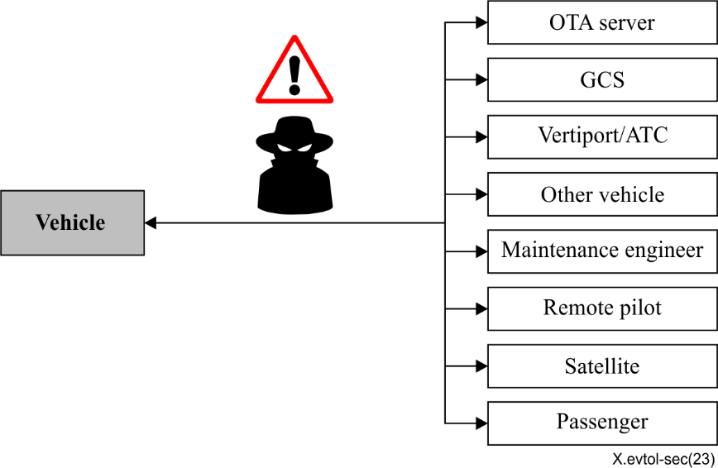
Figure 4 –Threat to the confidentiality of communication data

Unauthorized exposure of update package
As shown in Figure 5, an attacker is able to obtain update packages by:
- Accessing the electrically erasable programmable ROM (EEPROM) of each system in the vehicle
- Eavesdropping on the communication data between the vehicle and the OTA server.
Attackers is able to analyse update packages to identify control flow, version information and so on, and use them for further attacks. In addition, an attacker is able to send the update package of lower versions and attack using known vulnerabilities.
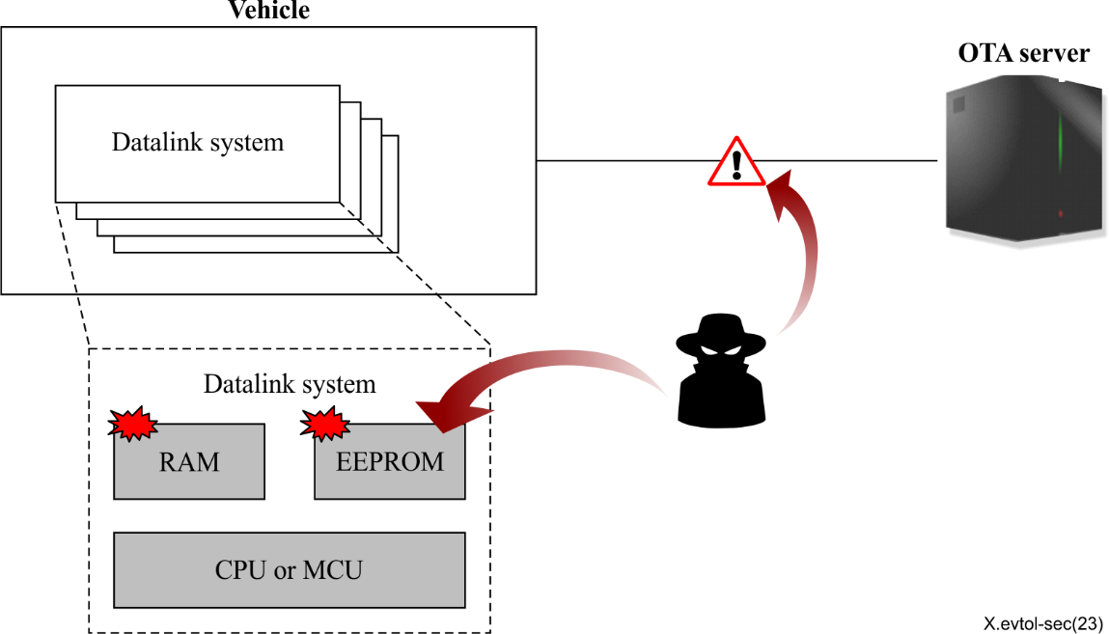
Figure 5 – Threat to the confidentiality of update packages

Unauthorized exposure of cryptomaterial
As illustrated in Figure 6, an attacker is able to sniff cryptomaterial by
- physically opening the casing of the storage.
- reading the cryptomaterial from the memory of each component where the cryptomaterial is used.
- modifying the firmware and altering the control flow to expose the cryptomaterial.
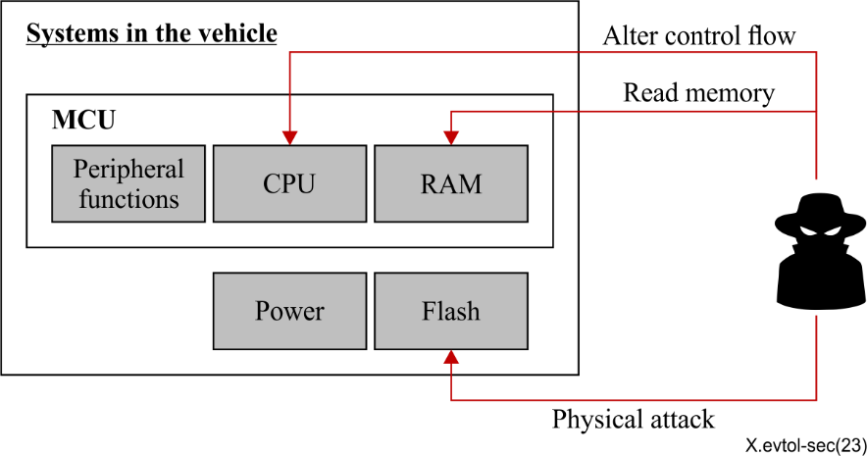
Figure 6 – Threats to the confidentiality of cryptomaterial

7.2.2 Threats to integrity
Software manipulation
An attacker is able to modify the software such as firmware, scripts, calibration data, log data and so on.

IDS/firewall rules manipulation
An attacker is able to manipulate rules of the firewall and the intrusion detection system (IDS) to make them ignore anomaly messages.

Communication data manipulation
An attacker is able to change communication messages between the vehicle and external entities, as depicted in Figure 7. For example, attackers is able to create fake vehicles around the target vehicle by tampering with ADS-B communication data. In another example, GNSS or similar satellite-based positioning information, being violated intentionally by threat actor(s) through spoofing/local replacement of the legitimate positioning signal is able to lead to incorrect positioning information being sent to and consumed by one or more eVTOL(s), which is able to in turn cause physical crashing and/or collision of the eVTOL(s) among themselves or other (flying or not) objects.
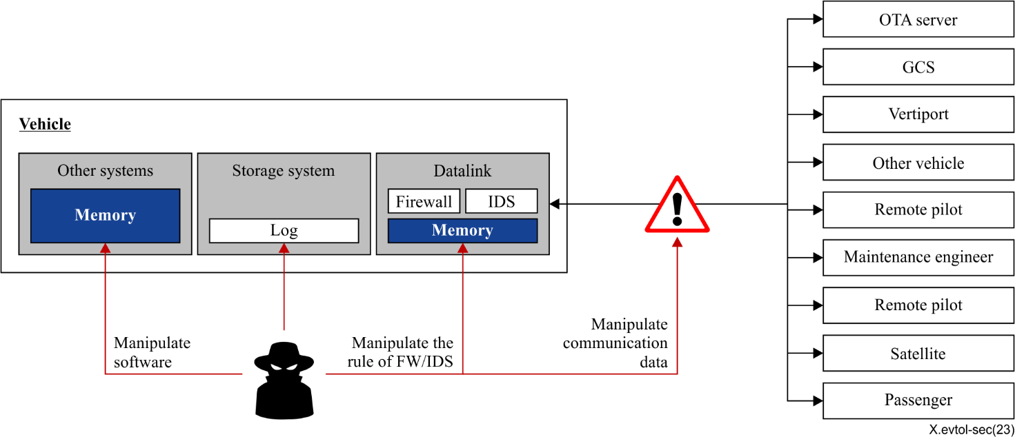
Figure 7 – Threats to integrity

7.2.3 Threats to authenticity
Impersonation
An attacker is able to impersonate other entities such as GCS/vertiport/ATC and maintenance engineers to control the vehicle. In addition, an attacker is able to impersonate an OTA server to distribute malicious or lower versions of update packages, as shown in Figure 8.
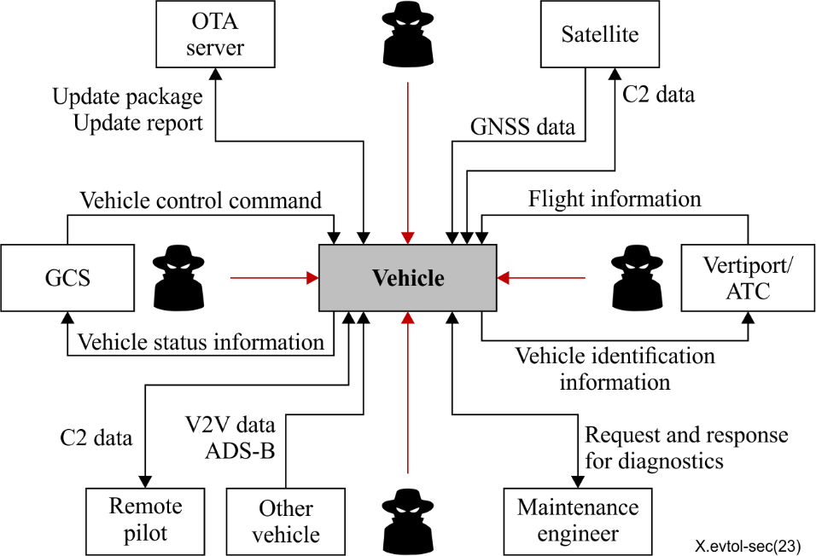
Figure 8 – Threats to authenticity

7.2.4 Threats to availability
Denial-of-service (DoS) to communication interfaces
The attacker is able to perform jamming attacks on the vehicle or send a large amount of radio signals to the vehicle so that it is unable to process them normally. Consequently the vehicle is not able to receive control commands from the GCS or transmit the vehicle's current state to the ground control system (GCS), as illustrated in Figure 9. In addition, an attacker is able to cause unintended malfunctions of the datalink system so that it is not able to t communicate with other entities. In addition, an attacker is able to exploit TCP/IP packets to generate DoS attacks in communication channels using cellular and Wi-Fi.
Figure 9 – Threats to availability

7.2.5 Threats to accountability
Log data manipulation
An attacker is able to delete or modify log data and especially audit logs of security events from the intrusion detection system, firewall, and over-the-air system, as depicted in Figure 7.

7.2.6 Threats to authorization
Unauthorized access
An attacker is able to gain access to the data bus inside the vehicle after gaining privileges higher than their own through privilege escalation, as shown in Figure 10.
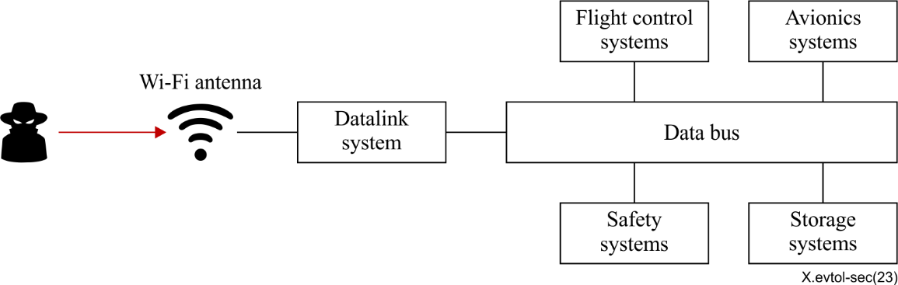
Figure 10 – Threats to authorization

7.2.7 Threats to non-repudiation
Denial of sending and receiving messages
A fake pilot is able to deny the fact of sending/receiving commands and data from GCS/vertiport/ATC/ vehicles, or vice versa (e.g., a fake engineer in a vertiport), as illustrated in Figure 11.
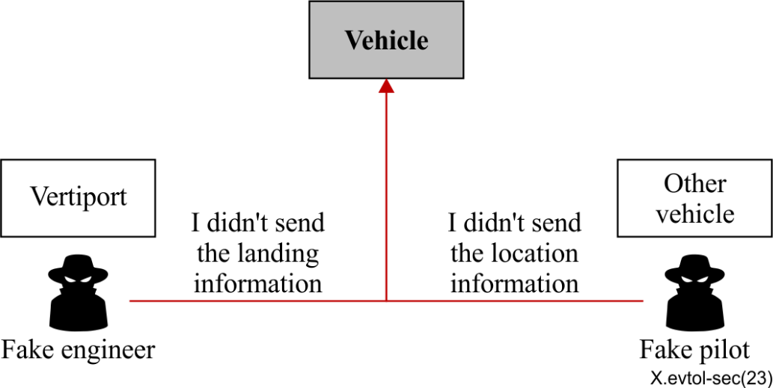
Figure 11 – Threat to non-repudiation

8 Security requirements
This clause describes security requirements to address the identified threats of eVTOL vehicles in the UAM environment.

8.1 Confidentiality
[SR-01] The confidentiality of communications data with the external entities (GCS/vertiport/ATC/remote pilot/other vehicles) is required to be protected against unauthorized exposure.
[SR-02] The vehicle is recommended to apply communication data encryption measures provided by the communication protocol of each system.
[SR-03] The configuration data used in communication protocols can optionally no longer be secure over time. Therefore, it is recommended to be checked periodically.
[SR-04] The confidentiality of the OTA update package is required to be protected from unauthorized disclosure during the update procedure.
[SR-05] The confidentiality of the OTA update package is recommended to be protected using a symmetric key or an asymmetric key-based encryption mechanism.
[SR-06] The confidentiality of cryptomaterial is required to be protected against unauthorized exposure.

8.2 Integrity
[SR-07] The integrity of software is required to be protected against manipulation.
[SR-08] The software manipulation is recommended to be detected at the software start-up phase.
[SR-09] The software manipulation is recommended to be detected during software runtime.
[SR-10] The integrity of IDS/firewall rules is required to be protected against manipulation.
[SR-11] The integrity guarantee mechanism is recommended to be applied to part or all of the IDS/firewall rules.
[SR-12] The integrity of any communications with the external entities (GCS/vertiport/ATC/remote pilot/other vehicles) is required to be protected against manipulation.
[SR-13] In order to ensure the integrity of communication data, an algorithm, well known and acceptable in the industry, is recommended to be used.
[SR-14] Strong GNSS message authentication whenever and wherever available is recommended to be used. In cases where it is not available, other satellite constellations' signals can optionally be repurposed, using these for positioning, to balance for the risk of GNSS spoofing.

8.3 Authenticity
[SR-15] All communications with the external entities (GCS/vertiport/ATC/remote pilot/other vehicles) is required to be received from a trusted source.

8.4 Availability
[SR-16] The availability of any communications with the external entities (GCS, vertiport, ATC, remote pilot, and other vehicles) is required to be protected against denial-of-service.
[SR-17] When designing a system, functional redundancy is recommended to be considered
[SR-18] The vehicle is recommended to be able to operate safely, even when any communications with the external entities are not operating.

8.5 Accountability
[SR-19] For audits, the accountability of log data is required to be guaranteed.
[SR-20] Log data in the vehicle is required to be protected against manipulation.

8.6 Authorization
[SR-21] Appropriate access authorities for in-flight passengers is required to prevent actions that grant higher authority than the configured authority of an account.

8.7 Non-repudiation
[SR-22] To prevent message sending/receiving repudiation, an digital signature for messages is able to be used.
NOTE – In the future, the use of post-quantum cryptography (PQC) is required to be considered in case of the existing cryptosystem (e.g., an asymmetric key-based system) that is threatened by the development of quantum computer technology.
Table 2 shows the mapping relation between security requirements and security threats.
Table 2 – Mapping of security requirements and threats
Security  objectives | Security requirements |  | Related  threats
Confidentiality | [SR-01] | The confidentiality of communications data with the external entities (GCS/vertiport/ATC/remote pilot/other vehicles) is required to be protected against unauthorized exposure. | Unauthorized exposure of communication data
Confidentiality | [SR-02] | The vehicle is recommended to apply communication data encryption measures provided by the communication protocol of each system. | Unauthorized exposure of communication data
Confidentiality | [SR-03] | The configuration data used in communication protocols can optionally no longer be secure over time. Therefore, it is recommended to be checked periodically. | Unauthorized exposure of communication data
Confidentiality | [SR-04] | The confidentiality of the OTA update package is required to be protected from unauthorized disclosure during the update procedure. | Unauthorized exposure of update package
Confidentiality | [SR-05] | The confidentiality of the OTA update package is recommended to be protected using a symmetric key or asymmetric key-based encryption mechanism. | Unauthorized exposure of update package
Confidentiality | [SR-06] | The confidentiality of cryptomaterial is required to be protected against unauthorized exposure. | Unauthorized exposure of crypto material
Integrity | [SR-07] | The integrity of software is required to be protected against manipulation. | Software manipulation
Integrity | [SR-08] | The software manipulation is recommended to be detected at the software start-up phase. | Software manipulation
Integrity | [SR-09] | The software manipulation is recommended to be detected during software runtime. | Software manipulation
Integrity | [SR-10] | The integrity of IDS/firewall rules is required to be protected against manipulation. | IDS/Firewall Rules manipulation
Integrity | [SR-11] | The integrity guarantee mechanism is recommended to be applied to part or all of the IDS/firewall rules. | IDS/Firewall Rules manipulation
Integrity | [SR-12] | The integrity of any communications with the external entities (GCS/vertiport/ATC/remote pilot/other vehicles) is required to be protected against manipulation. | Communication data manipulation
Integrity | [SR-13] | In order to ensure the integrity of communication data, an algorithm well known and acceptable in the industry is recommended to be used. | Communication data manipulation
 | [SR-14] | Strong GNSS message authentication whenever and wherever available is recommended to be used. In cases where it is not available, other satellite constellations' signals can optionally be repurposed, using these for positioning, to balance for the risk of GNSS spoofing.
Authenticity | [SR-15] | All communications with the external entities (GCS/vertiport/ATC/remote pilot/other vehicles) is required to be received from a trusted source. | Impersonation
Availability | [SR-16] | The availability of any communications with the external entities (GCS/vertiport/ATC/remote pilot/other vehicles) is required to be protected against denial-of-service. | Denial-of-service to communication interfaces
Availability | [SR-17] | When designing a system, functional redundancy is recommended to be considered. | Denial-of-service to communication interfaces
Availability | [SR-18] | The vehicle is recommended to be able to operate safely, even when any communications with the external entities are not operating. | Denial-of-service to communication interfaces
Accountability | [SR-19] | For audit, the accountability of log data is required to be guaranteed. | Log data manipulation
Accountability | [SR-20] | Log data in the vehicle is required to be protected against manipulation. | Log data manipulation
Authorization | [SR-21] | Appropriate access authority for in-flight passengers is required to prevent actions that grant higher authority than the configured authority of an account. | Unauthorized access
Non-repudiation | [SR-22] | To prevent message sending/receiving repudiation, an asymmetric key-based digital signature for messages is required to be used. | Denial of sending and receiving messages

9 Implementation guidelines for improving security of eVTOL vehicle

9.1 Verification of the source and the received data between vehicle and external entities
When eVTOL receives an update package or various information from external entities such as GCS, vertiport, ATC, a remote pilot, or other vehicles, it is recommended to check whether the source and the received data are trusted or not. To do this, the communication party is recommended to be authenticated through cryptographic methods such as a digital signature using asymmetric cryptographic algorithms. In addition, since the attack for the periodically transmitted communication data is able to be easily detected just by checking consistency compared with the previous data or by comparing its hash value with a hash value of the same data from other vehicles driving nearby. Every communication data is recommended to verify the consistency. The security requirements [SR-12], [SR-13], and [SR-f14] are closely related to these items.

9.2 Establishment of secure communication channel between the remote pilot and the safety manager
Communication between the remote pilot and the safety manager is recommended to be secured in order to ensure a safe flight. An attacker is able to impersonate legitimate pilots and then transmit malicious information to the safety manager. This could be a serious threat to the safety of vehicles and passengers. Therefore, all communications between the remote pilot and the safety manager are recommended to be verified as a trusted source, (see [SR-12] and [SR-14]).
For example, the remote pilot and the safety manager is able to be authenticated by ATC using token-based authentication. When the authentication is successfully completed, the session key for en/decryption and the MAC generation/verification key to be used for data transmission are exchanged through a method such as hybrid encryption. Thereafter, all communication data makes a transmission frame of encrypted data through the exchanged session key and MAC generated from the freshness value and the encrypted data, to provide confidentiality, integrity of data and authentication of messages and data sources.

9.3 Consistency verification of regular status data
For flight safety, ATC is recommended to constantly check information such as the location and condition of vehicles. Each vehicle is recommended to periodically transmit its information to ATC to meet this requirement. In this case, incoming messages are recommended to be verified because an attacker is able to transmit false information to ATC to cause confusion or to prevent the vehicle from noticing the problem as described in [SR-14].
A simple method to check whether the transmitted data is false or not, is to verify the location and time information as follows. After ATC receives data from vehicles, previous received data from the same vehicle in the database is utilized to calculate the differences (delta) with the current received data. If the delta value bounces abnormally, it is highly probable for the current data to be false information, because those data are recommended to be changed slowly. So this delta value is able to be an indicator that the vehicle is moving at a normal speed and path.
If the verification is failed, this clearly indicates that the attack is underway. In this case, the vehicle is recommended to activate the emergence process, and ATC is recommended to communicate with the pilot (including the remote pilot) or safety manager through a separate channel to recover safe states.

9.4 Verification of V2V messages and misbehaviour report
As UAM/AAM technology and service evolves, corridors will become increasingly complex. Some corridors will overlap or intersect, and there can optionally be a possibility of collision between vehicles. In addition, since eVTOL will fly only a few hundred metres off the ground, it is necessary to communicate with terrestrial vehicles. Thus, a vehicle to vehicle (V2V) system is recommended to avoid severe accidents such as crashes, as described in [b-RFC 9365]. It has already begun to standardize V2X system in the UAM/AAM environment [b-RTCA V2V]. Vehicles are recommended to communicate with each other to avoid severe accidents such as crashes.
Attackers is able to impersonate normal vehicles and send malicious data to other vehicles to make them misunderstand the flight environment. If an attacker transmits data as if a fast-approaching vehicle is far away from an intersection of corridors, serious collisions is able to occur in IFR situations.
Therefore, according to [SR-14], vehicles are recommended to check all data from other vehicles and report it when the receiving data is suspicious (which is a misbehaviour report), as shown in Figure 12.
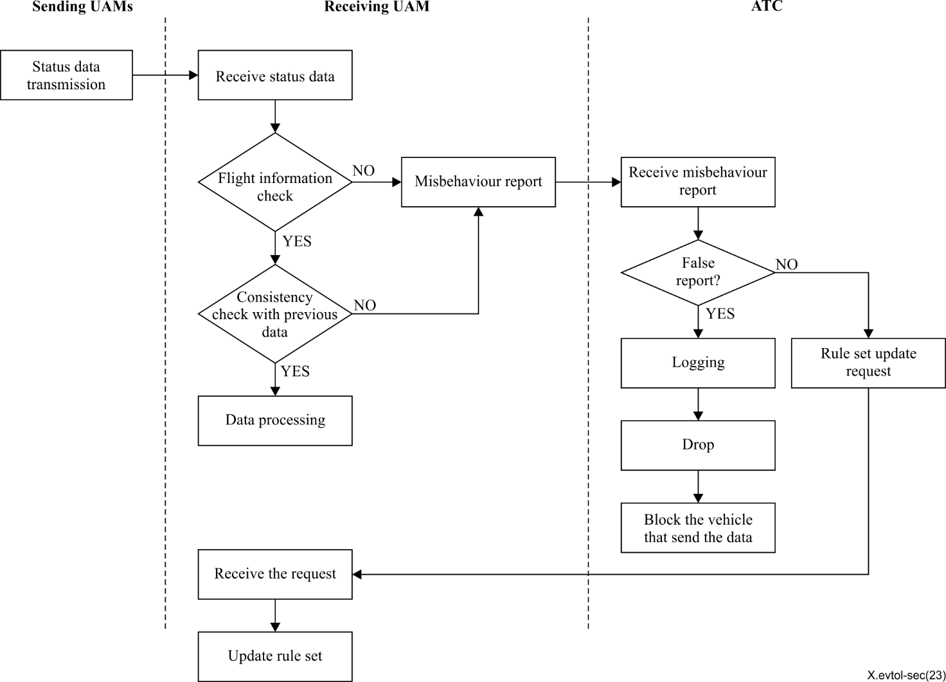
Figure 12 – Verification process of V2V communication and report

When ATC receives the misbehaviour report from vehicles, the report should be verified as to whether it is false or not as a global misbehaviour detection described in [b-C2C].

Appendix I

Overview of connected aerial vehicles for an UAM/AAM

I.1 Overview of connectivity and system structure
According to the length of runways required for taking-off and landing, aerial vehicles can be categorized as conventional take-off and landing (CTOL), short take-off and landing (STOL) and vertical take-off and landing (VTOL) vehicles. CTOL is a conventional type of aerial vehicle which needs a long runway to take off and land, while STOL and VTOL need respectively a shorter runway or none at all. The electric vertical take-off and landing eVTOL vehicle is a new type of aerial vehicle used for urban air mobility (UAM) or advanced air mobility (AAM) services in urban areas which are characterized by severe road traffic congestion, noise-sensitive environments, and crowded and cramped spaces with high-rise buildings and residential houses. The eVTOL can be described as a vehicle positioned in between drones and conventional airplanes and that features vertical take-off and landing capability, electrification of lift and rotating rotor power, and auto/semi-auto/remote controls. Passenger transportation including air taxis, emergency purposing (e.g. rescue, police and first-aid), and leisure activities as well as freight delivery services would be envisioned applications for UAM/AAM services. An unmanned and/or remotely controlled aerial vehicle intended for specific purposes such as delivering freight, filming scenes, atmospheric research or surveillance can be categorized as an unmanned aircraft system (UAS) vehicle.
In order to provide safe and exact aviation as well as broadband services in a cabin, eVTOL uses various communication link types as follows (refer to Figure I.1 and Table I.1)
- Air traffic control (ATC) service: This type of network is used for preventing collisions between aircraft and on the manoeuvring area between aircraft and obstructions, and expediting and maintaining an orderly flow of air traffic. [b-ATS]
- ADS-B: This type of communication is used for air traffic control for broadcasting position information to other aircraft and air traffic control (ATC) using VHF bandwidth. [b-ADS-B]
- V2V: This type of communication is used for aircraft-to-aircraft communication to share information and prevent collision between aircraft. [b-V2V]
- GNSS: Refers collectively to the worldwide positioning, navigation, and timing determination capability available from one or more satellite constellations. A GNSS constellation may be augmented by ground stations and/or geostationary satellites to improve integrity and position accuracy. [b-GNSS]
- SatCom: This system is used for providing broadband services in the cabin of aircraft by using a satellite communication channel (e.g., satellite-based Internet service). [b-ITU-R S.1782-1]
- Cellular connectivity: This type of communication is used for providing broadband services in the cabin of aircraft and command and control (C2) communication by using mobile network channels. [b-ETSI TS 122 125]
- Wi-Fi: This type of communication is used for providing broadband services in a cabin through SatCom or mobile network.
- C2 (Command and control): This type of communication is used as data link between the remotely-piloted aircraft and the remote pilot station for the purposes of managing the flight. [b-C2]
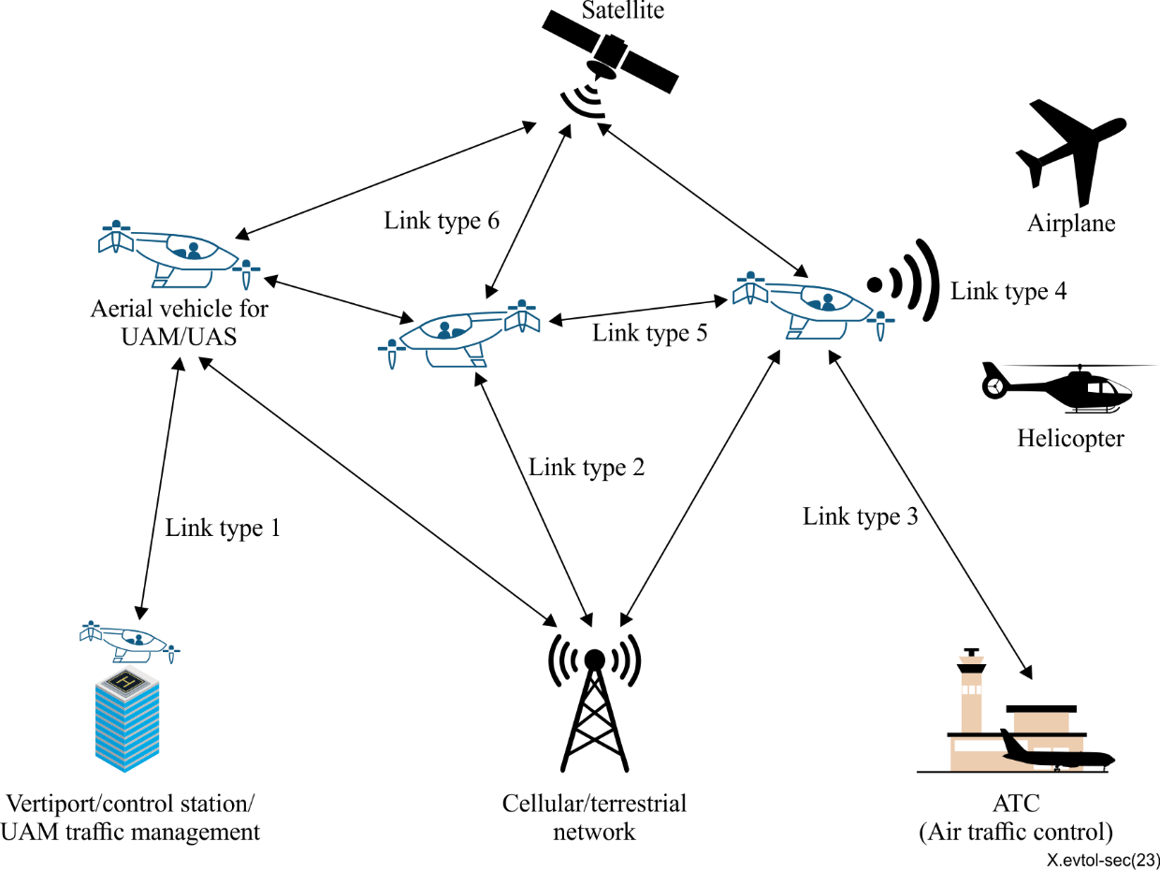
Figure I.1 – Communication link types for UAM/AAM service

Table I.1 – Communication link types and use cases
Link type | Use case | Communication  technology
1 | Control station/vertiport/UAM traffic management (UTM) to vehicle  - Command and control signal  - Flight information  - etc. | - C2  - Cellular connectivity
2 | Mobile/Terrestrial network to vehicle  - Command and control signal  - Broadband data (e.g., Multimedia data) | - Cellular conectivity
3 | ATC to vehicle  - Flight information | - Air traffic communication
4 | Vehicle to conventional aircraft  - Flight information | - ADS-B
5 | Vehicle to vehicle  - Flight information | - V2V  - ADS-B
6 | Satellite to vehicle  - Time and positional data  - Command and control signal  - Broadband data | - GNSS  - C2  - SatCom

The in-flight network and system structure of a vehicle is depicted in Figure I.2 showing various types of antennas for communication with outer entities on the surface of the vehicle, and an in-flight system structure connected with a data bus:
- Datalink systems: These systems are used for providing communication capability inside and outside of the vehicle.
- Infotainment Systems: This system is used for providing entertainment services in a cabin of vehicle.
- Flight Control Systems (FCS): This system is a collection of mechanical and electronic equipment that allows an aircraft to be flown with exceptional precision and reliability (b-ITU-T F.749).

Figure I.2 – Overall network and system structure of vehicle

I.2 Use cases from a service perspective
In this clause, the following UAM/AAM use cases [b-EASA usecases] are explained:
- Shuttle service using a fixed corridor
- Freight transportation
- Air ambulance

I.2.1 Shuttle service using a fixed corridor
Due to issues regarding safety and interference with other air services, service with take-off and landing at fixed locations along fixed routes will be provided in phase 1 (refer to Table I.2). In other words, a shuttle service is provided so that passengers can quickly move from an outlying area requiring connection with other transportation systems such as an airport to the city.
In this use case, the aircraft travels in a fixed corridor, as illustrated in Figure I.3. The impact on existing air traffic management and operation can be minimized by using a fixed corridor. The fixed corridor may be connected in a straight line to the destination or may be bent depending on the restrictions under the aviation laws, tall buildings, and relationships with other air services. Each corridor is defined without interfering with other corridors initially. However, as experiences and skills are met, each corridor can overlap to form a network. In this case, sharing of operation safety and traffic flow management information should be needed more imperatively.
eVTOL vehicles take off and land at the designated location such as a vertiport. Take-off and landing at any location may pose a safety hazard, so special facilities with safety and communication infrastructure must be used. Charging vehicles, maintenance (after its landing on vertiport), passenger boarding and disembarking, and passenger-related convenience functions can be provided through these facilities.
For take-off and landing in the city, the vehicle is limited to vertical take-off and landing aircraft. This restriction allows for flexible selection of vertiport locations, operation without significant changes to existing urban environments and related regulations, and compatibility with other low-altitude air services.
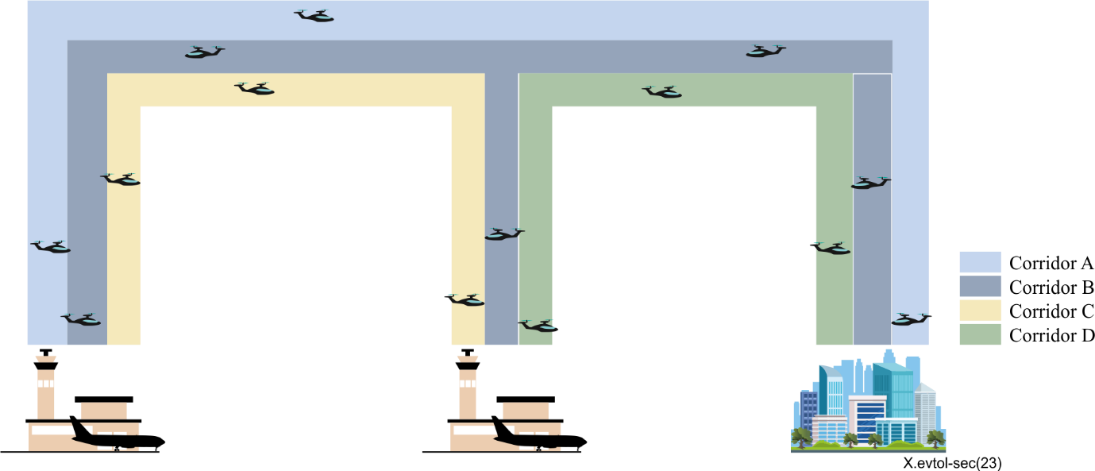
Figure I.3 – Example of the UAM/AAM corridor

I.2.2 Freight transportation
Another promising use case for UAM/AAM is freight transportation. Its advantages are shown in two areas. From an environmental aspect, since eVTOL uses electric powered propulsion systems, carbon footprint and the noise pollution can be reduced when compared to conventional transportation using combustion engine systems. From a performance aspect, the UAM/AAM service enables quick and remote deliveries in congested and hard-to-reach locations. For air cargo service, eVTOL can deliver relatively heavy payloads of more than hundreds of Kg from the main hub to a local hub. This offers a better solution than road transportation in areas with vast land areas, lack of road infrastructure, and security issues related to ground transportation.

I.2.3 Air ambulance
An air ambulance is utilized to transport injured or sick patients efficiently and quickly over long distances. Usually a helicopter has been used for this use case but eVTOL could be utilised to replace helicopters in the near future. eVTOL as an air ambulance can be used to transport patients from the accident site to hospitals or to transport urgent patients between hospitals or to deliver human organs to the hospital for cases of emergency surgery. Generally medical staffs, patients and medical equipment would be carried and communication with the existing transportation system (including V2X) should be considered since the flight route would be a non-fixed free route.

I.3 Use cases from an operational perspective
In this clause, the following use cases from an operational perspective are described:
- Onboard pilot
- Remote piloted aircraft systems (RPAS)
- Autonomous operation

I.3.1 Onboard pilot
UAM/AAM is expected to develop in three phases as outlined in Table I.2.

Table I.2 – UAM/AAM development phase [b-UAM roadmap]
Phase | Pilot | Autonomy | Corridor
Phase 1 | On board | Limited | Fixed corridor
Phase 2 | Remote pilot | Partial | Fixed corridor network
Phase 3 | No pilot | Full | Dynamic corridor network

According to the UAM/AAM development phase outlined in Table I.2, a pilot who has obtained appropriate qualifications boards the vehicle and complies with the overall rules and regulations as well as taking responsibility for the safety of the vehicle and passengers in the early stage. The pilot operates a vehicle while receiving various information essential for safe flight from ATC in addition to visual flight rules (VFR). In other words, when the weather conditions are not clear enough to allow VFR flight, it is necessary to receive various information from ATC and convert the flight mode to instrument flight rule (IFR) flight. In addition, ATC should monitor in real time whether the vehicle deviates from the predetermined route to prevent intrusion into the no-fly zones, and in the case of a problem, immediately informs the pilot to determine whether a safe flight is possible.
In the process of receiving flight information or transmitting a vehicle's information to ATC in order to monitor the route, trust in the source of information between the vehicle and ATC and the authenticity of the communication message itself is essential.

I.3.2 Remote piloted aircraft systems (RPAS)
As outlined in Table I.2, the pilot operates the vehicle remotely through wireless communication in phase 2. That is, a remotely piloted station (RPS) controls a remotely piloted aircraft (RPA) through a command and control (C2) link. Currently RPAS-related regulations stipulate for vehicles with non-people on board, but as UAM/AAM develops, RPAS is expected to be applied to shuttle services. Strictly trained and licensed pilots operate the certified vehicle, and safety managers can board the vehicle to ensure safety and manage passengers.
RPAS must consider both radio line-of-sight (RLOS) and beyond radio line-of-sight (BRLOS) situations as shown in Figure I.4.

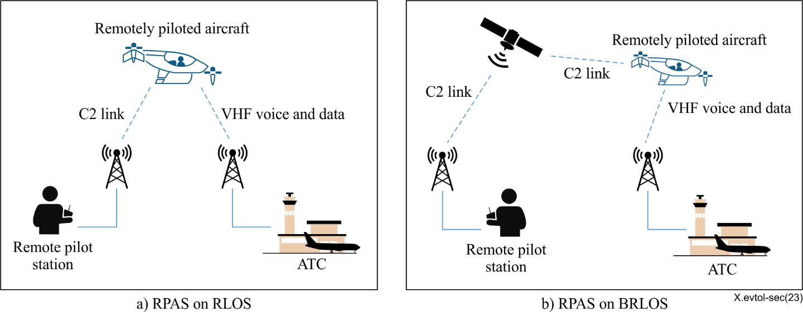
Figure I.4 – RPAS on RLOS and BRLOS situation

In the RLOS situation, RPAS communicates with the vehicle directly and the state of the vehicle can be checked with the naked eye. As compared with RLOS, in the BRLOS situation, communication is relayed, and since it cannot be confirmed with the pilot's sight and a communication delays may occur, the attack surface may increase.
The operation of RPAS considers the following three situations:
Visual line-of-sight (VLOS)
This is the case when the remote pilot maintains visual contact with the RPA without external assistance. In this case, the pilot can directly monitor the entire flight and maintain a fixed distance from other objects. According to [b-ICAO 2015], the following restrictions apply in a VLOS situation:
- Maximum distance between the pilot and the vehicle: 500m
- Maximum altitude of the vehicle: 500 feet (150m) above the ground
Extended VLOS (EVLOS)
This is the case when remote pilots rely on remote observers to keep the vehicle in sight at all times. In this case, the pilot also can directly monitor the entire flight and maintain a fixed distance from other objects as in the case of VLOS.
Beyond VLOS (BVLOS)
This is the case when the pilot does not maintain VLOS with RPA. In order for the vehicle to travel long distances, BVLOS operation is essential. Currently, BVLOS is not permitted in most countries due to concerns about uncontrolled flights that endanger lives and critical infrastructure.
One of the most important threats in RPAS is the disconnection of the C2 link. If the C2 link is disconnected, the remote pilot can no longer control the vehicle, and accidents such as collisions or falls may occur. Therefore, it is necessary to have partial autonomous flying functions and a safety manager to board the vehicle in preparation for the disconnection of the C2 link.

I.3.3 Autonomous operation
When UAM/AAM services attain autonomous operation in phase 3, in addition to the business advantages of carrying more passengers and cargo, operational safety can be improved in the same way as autonomous road vehicles can reduce traffic accidents caused by human error. Since the difficulties in autonomy are relatively low compared to a self-driving car, rapid development of autonomous technology may be possible. Autonomous operation communicates with ATC and other vehicles more frequently than in phase 1 and 2 to download flight data and recognize the situation circumstances. This means that it can be exposed to vulnerabilities such as virus infection or unauthorized access due to the increase of the attack surface. If the attacker manipulates the data as if there were other aircraft around the target vehicle, the pilot could visually check it in the VFR flight, but this cannot be done in IFR-based autonomous operation. Therefore, in the case of autonomous operation, higher cybersecurity criteria should be applied than in other cases.

Bibliography
[b-ITU-T X.641] Recommendation ITU-T X.641 (1997), Information technology – Quality of service: framework.
[b-ITU-T X.800] Recommendation ITU-T X.800 (1991), Security architecture for Open Systems Interconnection for CCITT applications.
[b-ITU-T X.1252] Recommendation ITU-T X.1252 (2021), Baseline identity management terms and definitions.
[b-ITU-T X.1373] Recommendation ITU-T X.1373 (2017), Secure software update capability for intelligent transportation system communication devices.
[b-ITU-R S.1782-1] Recommendation ITU-R S.1782-1 (2019), Guidelines on global broadband Internet access by fixed-satellite service systems.
[b-ETSI TS 122 125] ETSI TS 122 125 V17.6.0 (2022), Unmanned Aerial System (UAS) support in 3GPP.
[b-ISO/IEC 27000] ISO/IEC 27000:2018, Information technology – Security techniques – Information security management systems – Overview and vocabulary.
[b-RFC 9365] IETF RFC 9365 (2023), IPv6 Wireless Access in Vehicular Environments (IPWAVE): Problem Statement and Use cases.
[b-ATS] ICAO annex 11. http://cir2cus.free.fr/documentation/ATS_R2_and_ATS_no.5_signalling_protocol_specifications.pdf
[b-ADS-B] RTCS SC-186, Automatic Dependent Surveillance-Broadcast (ADS-B). https://www.rtca.org/sc-186/
[b-GNSS] Glossary in Federal Aviation Administration (FAA) https://www.faa.gov/air_traffic/publications/atpubs/pcg_html/glossary-g.html
[b-V2V] Vehicle-to-Vehicle (V2V) Communications Use Case. https://nari.arc.nasa.gov/aam-portal/airspace/
[b-C2] RTCA DO-362, Command and Control (C2) Data Link Minimum Operational Performance Standards (MOPS) (Terrestrial). https://global.ihs.com/doc_detail.cfm?document_name=RTCA%20DO%2D362&item_s_key=00694348
[b-C2C] Car 2 Car Communication Consortium (2021), White Paper on Misbehaviour Detection and Reporting to Misbehaviour Authority.
[b-ICAO 2015] International Civil Aviation Organization (2015), Manual on Remotely Piloted Aircraft Systems (RPAS).
[b-NIST SP 800-98] National Institute of Standards and Technology (2007), Guidelines for Securing Radio Frequency Identification (RFID) Systems.
[b-RTCA V2V] RTCA (2022), Status of Advanced Air Mobility Vehicle-Vehicle Recommendations to RTCA.
[b-ITU-T F.749] ITU-T F.749.10 (05/2019), Requirements for communication services of civilian unmanned aerial vehicles
[b-UAM roadmap] UAM Team Korea (2020), K-UAM Concept of Operations 1.0.
https://www.kdu.ac.kr/flightmobil/sub.do?mncd=1570&mode=view&no=404437252
[b- ISO 21177] ISO 21177:2023(en), Intelligent transport systems
[b-EASA usecases] EASA, “WHAT ARE THE BENEFITS FOR THE EU?”
https://www.easa.europa.eu/en/what-is-uam
[b-ISO 23665] ISO 23665:2023, Unmanned aircraft systems.
[b-ITU-T F.749] ICAO Annex 1, Personnel Licensing
[b-NASA] NASA Vision CoP UML 4, UAM Vision Concept of Operations (ConOps) UAM Maturity Level (UML) 4

________________

