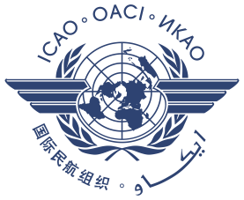
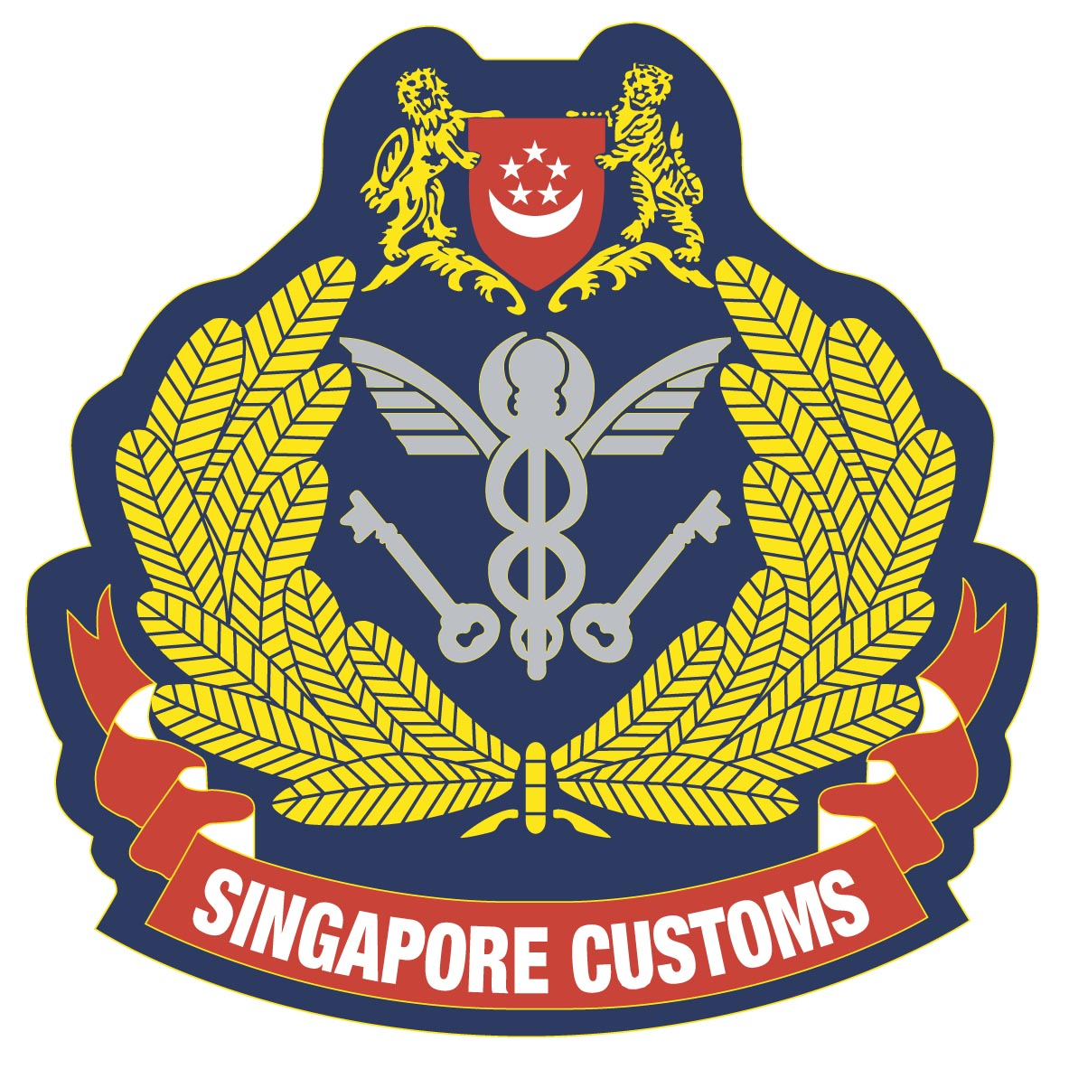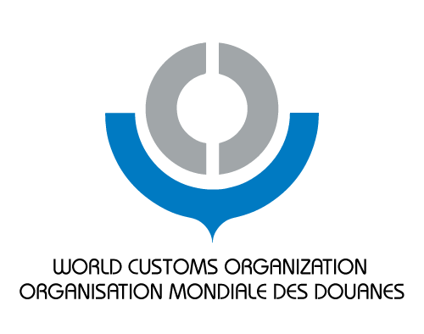

INTERNATIONAL CIVIL AVIATION ORGANISATION – WORLD CUSTOMS ORGANISATION – SINGAPOREJOINT CONFERENCE ON ENHANCING AIR CARGO SECURITY AND FACILITATIONSYNERGY THROUGH COOPERATION
Conference Registration Form
(Please fill up the form in CAPITAL LETTERS)
PERSONAL INFORMATION
Attached Photo Here
* Preferably taken against a plain/white background
*Photo size: 45mm(H) x 35mm(W)
*File size: 100KB or less & in .jpg or .gif format
Country |  | 
Salutation (Mr/Ms/Mrs/Dr)
Family Name (as in passport)
Given Name (as in passport)
Name to appear on ID Badge
Gender
Date of Birth (DD/MM/YY)
ORGANIZATION INFORMATION
Organization
Division / Department
Designation
Office Address
Office Phone No. |  |  | Office Fax |  | Mobile No.
Email Address
PASSPORT INFORMATION
Passport No. |  | Citizenship
Date of Expiry (DD/MM/YY) |  | Date of Issue
Passport Type: | Diplomatic / Official / Regular
Please complete the form and email to MOT_Secretariat@mot.gov.sg by 07 JUNE 2012.
Alternatively, you may fax it to:
Attn: Mr Dennis LIU / Mr Ignatius NG
Ministry of Transport, Singapore
International Relations and Security Division
Fax: +65 6375 7734
Tel: +65 6375 7063 / +65 6375 2505
REGISTRATION DEADLINE: 07 JUNE 2012

