Doc. 9718
ICAO Handbook on radio frequency spectrum requirements for
Civil Aviation

Volume II
Frequency assignment planning criteria for aeronautical radio communication and navigation systems

FOREWORD
Background and purpose
Volume II of the Handbook on radio frequency spectrum requirements for civil aviation (Doc 9718) presents frequency assignment planning criteria for aeronautical radio communication and navigation systems.
This material was developed in response to requests from the ICAO Regions to provide updated frequency assignment planning criteria which can be implemented on a global basis to secure that aeronautical radio communication and navigation systems are protected from harmful interference on a uniform basis. The frequency assignment planning criteria were developed by the ICAO Aeronautical Communications Panel and in cooperation with the ICAO Regional Offices.
Status of the Handbook (Volume II)
This Volume contains detailed frequency assignment planning criteria for VHF air/ground communication systems (voice and data) operating in the frequency band 117.975 – 137 MHz supplementing the relevant Standards and Recommended Practices (SARPs) in Annex 10 to the Convention on International Civil Aviation – Aeronautical Telecommunications, in particular Volume V – Aeronautical Radio Frequency Spectrum Utilization, and provides guidance to the application of these SARPs. In addition, it also provides the relevant background that led to the development of the detailed frequency assignment planning criteria.
In developing the frequency assignment planning criteria, careful attention was given to the material already available and used in the ICAO Regions and published through the relevant Regional Air Navigation Plans.
Future revisions will include material on frequency assignment planning for aeronautical HF air/ground communication systems (voice and data) and for radio navigation systems (NDB, ILS, VOR, GBAS, DME and MLS).
Implementation of frequency assignment panning criteria
The material contained in this Volume is general in nature and should be applicable in all ICAO Regions. However, implementation in the Regions has to take place through relevant decisions by the Regional Planning and Implementation Groups (PIRGs) which are responsible for amending and updating provisions of the Regional Air Navigation Plans. Specific Regional requirements on the use of radio frequencies have been accommodated as much as practicable. Future specific regional requirements can be implemented through relevant Regional Air Navigation agreements and/or incorporated in future revisions to this Handbook.
It should be noted that the coordination of frequency assignments as well as the development of the regional frequency assignment plans rests with the ICAO Regional Offices and that these Offices should be consulted when amendment to these plans are being considered by ICAO contracting States.
Note: In some Regions, for administrative and practical purposes, different coordination mechanisms may be implemented.
Global Plan
The frequency assignment planning criteria as contained herein support the development of globally harmonized frequency assignment plans as an element of the Global Air Navigation Plan and the application of these criteria secures protection of frequency assignments on a globally harmonized and uniform basis.
Organization of the Handbook (Volume II)
Chapter 1 provides general principles and other material to be used in compatibility analysis of aeronautical radio communication and navigation systems. This material forms the technical basis for the frequency assignment planning criteria and can also be used when assessing compatibility of new systems planned to operate in frequency bands already used for aeronautical purposes.
Chapter 2 contains the background that was used when developing frequency assignment planning criteria for VHF air/ground communication systems (voice and data). This Chapter gives due account to Regional differences in using the VHF band while maintaining the basic principles for the protection of radio frequencies from harmful interference on the basis of globally accepted principles.

Table of Contents
Chapter 1. General Methodology for Compatibility Analysis 5
1.1 Introduction 5
1.2 Compatibility model 5
1.2.1 Compatibility assessment 5
1.2.2 Protection of the desired signal 5
1.2.3 Determination of the desired signal at the victim receiver antenna 7
1.2.4 Calculation of the undesired signal at the victim receiver antenna 8
1.2.5 D/U ratio. 9
1.2.6 The effect of the adjacent channel rejection 9
1.2.7 D/U ratio at the receiver input 9
1.3 Propagation modeling 9
1.3.1 Introduction 9
1.3.2 Free – Space Propagation Model 9
1.3.3 Aeronautical propagation curves 11
1.3.4 Calculation of basic transmission loss when both the undesired transmitter and desired receiver are on the ground 13
1.4 Net filter discrimination (placeholder) 14
Chapter 2. Aeronautical VHF air-ground radio communication systems operating in the band 117.975 – 137 MHz 15
2.1 Introduction 15
2.1.1 ICAO documents relevant to frequency assignment planning in the band 117.975-137 MHz 15
2.2 Interference model 15
2.2.1 General 15
2.2.2 Interference model for aeronautical frequency assignment planning 16
2.2.3 Separation-distance ratio method (co-frequency) 17
2.2.4 Minimum signal level method 19
2.2.5 The effect of the radio horizon 23
2.2.6 Protection based on line-of sight separation 23
2.3 Frequency assignment planning criteria 24
2.3.1 General planning criteria 24
2.3.2 Typical signal parameters 25
2.4 Allotment of the frequency band 117.975 – 137 MHz 26
2.4.1 Special frequencies 26
2.4.2 Regional allotment plans 27
2.5 Frequency separation and channeling 28
2.5.1 Frequency separation between VHF COM channels 28
2.5.2 Protection of 25 kHz frequency assignments from 8.33 kHz assignments 28
2.5.3 Channeling 28
2.6 Services and designated operational coverage 29
2.6.1 Services 29
2.6.2 Coordination of special frequencies 29
2.6.3 Table of uniform values for designated operational coverage (DOC) 29
2.6.4 Coverage at very low angles from ground transmitter 31
2.6.5 Interference from FM broadcasting stations 32
2.6.6 Co-location of facilities 32
2.6.7 Coordination of frequency assignments 32
2.7 Calculation of separation distances (methodology) 32
2.7.1 Frequency and/or distance separation 32
2.7.2 Co-frequency separation distances 33
2.7.3 Adjacent frequency separation distances 39
2.7.4 Co – and adjacent frequency consideration in a mixed environment where 8.33 kHz and 25 kHz frequency separation is being used 41
2.8 Separation distances (air ground communication services and ground based broadcasting services) 42
2.8.1 Calculation of distances to the radio horizon 42
2.8.2 Table of separation distances 43
2.9 Separation distances for VDL (VDL Mode 2 and VDL Mode 4) 45
2.9.1 VDL operating co-frequency with other VDL or VHF COM voice systems 45
2.9.2 VDL operating on adjacent frequencies with other VDL or VHF COM voice systems 45
2.9.3 Operation of VDL on the surface of an airport 46
Appendix A 48
Appendix B 53
Appendix C 54
Appendix D 60

List of tables
Table ‎2-1 Typical values for various parameters for VHF communication systems (transmitter) 25
Table ‎2-2 Typical values for various parameters for VHF communication systems (receiver) 26
Table ‎2-3 Frequency allotment and special frequencies 27
Table ‎2-4 Channeling / frequency pairing for frequencies with 25 kHz and 8.33 kHz separation 28
Table ‎2-5 Table of uniform designated operational coverage 30
Table ‎2-6 Distance as function of angle above horizon 31
Table ‎2-7 Adjacent frequency separation distances for a mixed 25 kHz/8.33 kHz environ 42
Table ‎2-8 Distance to radio horizon with aircraft at maximum altitude 43
Table ‎2-9 Minimum geographical co-frequency separation distances between stations 44
Table ‎2-10 25 kHz guard band (channels) between DSB-AM, VDL mode 2 and VDL mode 4 (air-air) 45
Table ‎2-11 25 kHz guard band (channels) between DSB-AM and VDL (modes 2 and 4) on the surface of an airport 46

List of figures
Figure 1-1 Schematic diagram of the complete scenario to be analyzed 6
Figure 1-2 Schematic diagram of the minimum signal scenario 7
Figure 1-3 Schematic diagram of the desired signal path to the receiving antenna 7
Figure 1-4 Desired signal path when minimum field strength is specified 8
Figure 1-5 Schematic diagram of the undesired signal path 8
Figure 1-6 Radio Horizon versus physical horizon 10
Figure 1-7 Propagation through ducting 11
Figure 2-1 Model for establishing separation distances 16
Figure 2-2 Desired signal and undesired signal path to desired (victim) receiver 17
Figure 2-3 Model for establishing separation distances when minimum field strength is specified 20
Figure 2-4 Vertical polar diagram of antenna 30 m above ground level 21
Figure 2-5 Minimum desired signal at antenna and undesired signal path to desired (victim) receiver antenna 21
Figure 2-6 Propagation path greater than radio line of sight 23
Figure 2-7 Reduction in distance to the transmitter when receiving above the horizontal plane through the ground antenna 32
Figure 2-8 Separation based on radio line-of-sight 33
Figure 2-9 Separation distance based on the 5 to 1 distance ratio 34
Figure 2-10 Interference mechanism between broadcast services 36
Figure 2-11 Interference mechanism between broadcast services and air/ground services 36
Figure 2-12 Geometry for calculating separation distances for AS communication services 37
Figure 2-13 Adjacent frequency separation for air-ground services 39
Figure 2-14 Adjacent frequency separation between broadcast services 40

Figure A - 1 Curve sets for basic transmission loss at 125 MHz for 50% of the time for values of h1 49
Figure A - 2 Curve sets for basic transmission loss at 300 MHz for 50% of the time for values of h1 50
Figure A - 3 Curve sets for basic transmission loss at 1 200 MHz for 50% of the time for values of h1 51
Figure A - 4 Curve sets for basic transmission loss at 5 100 MHz for 50% of the time for values of h1 52

General Methodology for Compatibility Analysis

Introduction
This chapter describes a general methodology that can be used in the analysis of interference between similar and dissimilar radio systems and provides the procedures for calculating the distance and frequency separation required to prevent harmful interference to systems used by aviation for communication and (radio) navigation purposes.

For a more detailed analysis, taking into account the aeronautical compatibility requirements, the method as described in ITU-R Recommendation SM.337 on “Frequency and distance separation” may be used in some cases. Also relevant are the provisions of ITU-R Recommendation SM.1535 on “The protection of safety services from unwanted emissions”.

Compatibility model

Compatibility assessment
The electromagnetic compatibility of radio equipment should be calculated by the following method:
Step 1: determine the desired signal level (and spectral distribution) at the desired (victim) receiver input;
Step 2: determine the undesired (interfering) signal level (and spectral distribution, including noise) at the desired (victim) receiver input, taking into account the total receiving system performance requirements as per Annex 10;
Step 3: determine the interactive effects among the desired and undesired signals for various frequency separations, while meeting the total receiving system performance requirements. These effects can be determined through actual measurements or through analysis.
Step 4: determine from the data obtained in step 3, the degree of frequency and/or distance separation required to provide the required level of service to ensure that any interference received by the victim receiver is not harmful;
Step 5: determine, for establishing frequency/distance separation requirements, the appropriate propagation model.

Note: In all cases, the co-frequency protection requirements have to be assessed, preferably through measurements. The procedures described in Recommendation ITU-R SM.337 would allow, under specific conditions, to develop the frequency/distance separation when the interfering signal is not co-frequency with the desired signal while meeting the system performance requirements.

Protection of the desired signal

Protection of the desired signal can be considered along two principles.

The first principle calculates the actual field strength of both the desired and the undesired signal at the receiver antenna, taking into account the distance to the (desired) transmitter. On the basis of the established D/U ratio, the maximum signal level of the undesired (interfering) signal determines in turn the maximum level of the interfering signal, before the interference becomes harmful as shown in formula (4) in paragraph 1.2.5.. This principle is illustrated in Figure 1-1.

Figure ‎1-1 Schematic diagram of the complete scenario to be analyzed
where:-
F_{d}: feeder loss for the desired transmitter (dB)
F_{r}: feeder loss of the receiver (dB)
F_{u}: feeder loss for the undesired transmitter (dB)
G_{d}: gain of the antenna of the desired transmitting system (dBi)
G_{r}: gain of the (desired) receiver antenna (dBi)
G_{u}: gain of the antenna of the undesired transmitting system(dBi)
L_{d}: propagation loss for the desired signal (dB)
L_{u}: propagation loss for the undesired signal (dB)
PT_{d}: output power of the desired transmitter (dBm)
PT_{u}: output power of the undesired transmitter (dBm)
P_{d} power at the antenna of the desired receiver
P_{u} power at the antenna of the desired receiver
RP_{d} power at the input of the desired receiver
RP_{u} power at the input of the desired receiver

The second principle uses the minimum field strength at the receiver antenna (signal in space) as is specified by ICAO for all communication and navigation systems. This minimum field strength has to be assured throughout the designated operational coverage of the facility. Similar to the first principle described in paragraph 1.2.2.1.1, on the basis of the established D/U ratio, the maximum signal level of the undesired (interfering) signal can be determined, before the interference becomes harmful. This approach is more appropriate to establish protection throughout the designated operational coverage compared to the method in paragraph 1.2.2.1.1. This principle is shown in Figure 1-2.

In cases where the interactions between the desired and the undesired signal have not been properly established (e.g. through actual measurements) protection of the desired (aeronautical) signal should be based on securing that the undesired signal is well (6 – 10 dB) below the receiver noise power of the aeronautical receiver.

Figure ‎1-2 Schematic diagram of the minimum signal scenario

Determination of the desired signal at the victim receiver antenna
The following diagram illustrates the scenario to be analyzed.
Figure ‎1-3 Schematic diagram of the desired signal path to the receiving antenna

The received power at the antenna of the receiver can be calculated by summing the transmitter power, antenna gains and feeder losses as shown in formula (1)

$P_{d}= {PT}_{d}-F_{d}+G_{d}-L_{d}$ ( 1 )
where:
PT_{d} output power of the desired transmitter (dBm)
F_{d}: feeder loss for the desired transmitter (dB)
G_{d}: gain of the desired transmitter antenna (dBi)
L_{d}: propagation loss for the desired signal (dB)
P_{d}: power of the desired signal at the antenna of the receiver (dBm)

The propagation loss L_{d} is calculated in accordance with the appropriate propagation model as developed by the ITU. See section 1.3 on propagation modeling and using the propagation the model to calculate the path loss.

When the minimum desired signal level at the receiver antenna is specified and used in compatibility calculations, the scenario as shown in Figure 1-4 applies. In this case, P_{d} at the antenna of the receiver is as is specified in the relevant provisions of Annex 10.

Figure ‎1-4 Desired signal path when minimum field strength is specified
This modifies formula (1) into formula (2).

$P_{d}= xx dBm$ ( 2 ) (xx is as specified by ICAO; for the conversion from µV/m to dBm see paragraph 2.3.2)

Calculation of the undesired signal at the victim receiver antenna
The Figure 1-4 illustrates the undesired signal path to be analyzed.

Note: the need for calculating the signal level of the undesired signal applies to both principles as identified in paragraphs 1.2.2.1.1 and 1.2.2.1.2 and further clarified in paragraphs 1.2.2. and 1.2.3 respectively.

Figure ‎1-5 Schematic diagram of the undesired signal path
The received power at the input of the receiver antenna can be calculated by summing the various transmitter power, antenna gains and feeder losses as indicated in formula (3).

$P_{u}= {PT}_{u}-F_{u}+G_{u}-L_{u}$ ( 3 )
where:-
F_{u}: feeder loss for the undesired transmitter (dB)
G_{u}: gain of the undesired antenna (dBi)
L_{u}: propagation loss for the undesired signal (dB)
PT_{u}: output power of the undesired transmitter (dBW)
P_{u}: power of the undesired signal at the isotropic receiver antenna (dBm)

The propagation loss is calculated in accordance with the appropriate propagation model developed by the ITU. See section 1.3 on propagation modeling and using the propagation the model to calculate the path loss.

D/U ratio.
After having calculated (or used the relevant ICAO standard value) the values for the desired signal and the undesired signals at the receiver antenna, these signal levels, in order to protect the desired signal from harmful interference from the undesired signal need to comply with formula (4):

$P_{d}-P_{u}=\frac{D}{U}$ ( 4 )
where:
P_{u =} power of the undesired signal at the receiver [detector] (dBW)
P_{d}= power of the desired signal at the receiver [detector] (dBW)
D/U: Protection ratio (dB) as required by Annex 10 or established through measurements

Note: if the compatibility analysis is for determining compatibility between an aeronautical system and a non-aeronautical system then a safety margin in the order of 6 – 10 dB should be added to the required D/U ratio.

The effect of the adjacent channel rejection
When the frequencies are offset (i.e. the frequency of the desired signal differs from that of the undesired signal) the adjacent channel characteristics of the desired receiver will attenuate the desired signal before it is being processed in the receiver. The factor with which these signals are attenuated is the Adjacent Channel Rejection (ACR). The ACR is either the ACR as specified by ICAO (typically for intra system compatibility) or the ACR obtained by measurements (typically for inter system compatibility).

The power Pu at the antenna, as calculated with formula (3) becomes for adjacent frequencies

$P_{u}= {PT}_{u}-F_{u}+G_{u}-L_{u}-ACR$ ( 5 )

D/U ratio at the receiver input
For both the desired signal and the undesired signal at the receiver antenna gain G_{r} and receiver feeder losses F_{r} are the same. Therefore the D/U ratio at the receiver antenna is the same as the D/U ratio at the receiver input.

Interference immunity performance for digital systems

Receiving function — interference immunity performance.
The standard measurement technique for digital systems provides that the desired signal field strength be doubled, and that the undesired signal be applied in increasing levels until the channel performance, that is the specified error rate, degrades to a value equal to the value found at the specified receiver sensitivity.

Propagation modeling

Introduction
The ITU has developed a number of propagation models some of which are applicable to the study of the planning criteria for aeronautical systems and the protection of those systems from interference from other radio systems that are either sharing the frequency band or operating in adjacent frequency band.
The common propagation models used in aeronautical spectrum studies are described in sections 1.3.2-1.3.4 below and their applicability including the advantages and disadvantages are described in section 1.3.5.

Free – Space Propagation Model
The free space propagation model as defined in Recommendation ITU-R P.525 assumes an ideal propagation path where the transmitter and receiver antennas are considered isotropic antennas located in a perfectly dielectric, homogeneous, isotropic and unlimited environment with no obstructions. The free space attenuation or propagation loss can be calculated with formula (5)

$L_{bf}=20\log{\frac{4πd}{λ}}$ ( 6 )
where:
L_{bf} : free-space basic transmission loss (dB)
d : distance
λ : wavelength
Note that d and λ are expressed in the same unit.

The same formula can be re-written using the frequency instead of the wavelength:

$L_{bf}=32.4+20\log{f}+20\log{d}$ ( 7 )
where:
f : frequency (MHz)
d : distance (km).
or
$L_{bf}=37.8+20\log{f}+20\log{d}$ ( 8 )
where:
f : frequency (MHz)
d : distance (NM)

It should be noted that the propagation of radio waves, typical of VHF and UHF frequencies, is subject to a number of additional conditions, compared to the free space propagation. Refraction and ducting as described below as described below can extend the range over which this propagation model is applicable:

Refraction – Gradual changes in the refractive index of the [standard] atmosphere with altitude causes the bending of radio waves slightly towards (or in some cases away from) the Earth. The effect is that radio waves can propagate beyond the physical horizon to and can be received up to a distance which is commonly referred to as the radio horizon as shown in Figure 1-6. Along this path no other (significant) losses than the free space propagation loss between the transmitter and the receiver has to be considered. Variations in the refractive index of the atmosphere however cause the radio horizon to vary as well. The bending effect of refraction is corrected in radio propagation by calculation the distance to the radio horizon using a 4/3 Earth radius. The 4/3 Earth radius approximation has been derived based on a standard atmosphere at sea level and is therefore not universally applicable. However, it is very widely used and provides a good approximation to describe the effect of radio path propagation globally.

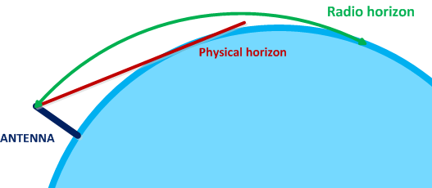
Figure ‎1-6 Radio Horizon versus physical horizon

Ducting – The change in refractive index is normally gradual, but under certain atmospheric conditions a layer, of warm air may be trapped above cooler air, often over the surface of water. The result is that the refractive index will decrease far more rapidly with height than is usual. The rapid reduction in refractive index (and therefore dielectric constant) may cause complete bending down, as illustrated in the Figure 1-7. The unusual atmospheric condition traps the radio waves in a duct. Extreme bending of the radio waves between the top of the atmospheric duct and reflection of the radio waves from the surface of the Earth may propagate the radio waves over extreme long distances (e.g. more than 500 NM). Other phenomena such as sand storm may also cause ducting of radio waves.
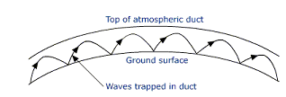
Figure ‎1-7 Propagation through ducting

In aeronautical frequency assignment planning neither variations in the refractive index of the atmosphere (which causes variations in the distance to the radio horizon and effectively modify the 4/3 factor)) nor the effect of ducting is taken into account. In cases where these phenomena cause serious problems, consideration can be given to accommodate different criteria.

In the aeronautical standard propagation model free space propagation conditions are assumed when the transmitter and the receiver are within the distance to the radio horizon (line of (radio) sight).

The distance to the radio horizon (4/3 Earth radius) can be calculated using equation (9).

$d_{RH}=1.23\left(\sqrt{h_{TX}}\right)$ ( 9 )
where
d_{RH}: the distance of the station to the radio horizon (NM)
h_{Tx}: the height of the transmitter above the Earth’s surface (feet)

Note: The same formula can be used to calculate the radio horizon of the receiver by substituting the height of the transmitter with the height of the receiver.

Applying this formula to both the transmitter and the receiver (e.g. between an airborne transmitter and an airborne receiver) formula (10) can be used for the calculation of the distance to the radio horizon between the transmitter and receiver.

$d_{RH}=1.23\left(\sqrt{h_{TX}}+\sqrt{h_{RX}}\right)$ ( 10 )
where
d_{RH}: the radio horizon separation distance between the transmitter and receiver (NM)
h_{Tx}: the height of the transmitter above the Earth’s surface (feet)
h_{Rx}: the height of the receiver above the Earth’s surface (feet)

Aeronautical propagation curves
Recommendation ITU-R P.528 “Propagation curves for aeronautical mobile and radionavigation services using the VHF, UHF and SHF bands” contains a method for predicting the transmission loss in the frequency range 125-15 500 MHz for aeronautical and satellite services. The method uses an interpolation method on basic transmission loss data from sets of curves. These sets of curves are valid for ground-air, ground-satellite, air-air, air-satellite, and satellite-satellite links. The only data needed for this method are the distance between antennas, the heights of the antennas above mean sea level, the frequency, and the time percentage. The curves of Recommendation ITU-R P.528 are contained in Appendix A. These curves are also available in a tabular format (spread sheet).
This Recommendation, also, gives the calculations for the expected protection ratio or wanted-to-unwanted signal ratio exceeded at the receiver for at least 95% of the time, R (0.95). This calculation requires the following additional data for both the wanted and unwanted signals: the transmitted power, the gain of transmitting antenna, and the gain of receiving antenna.

These propagation curves are based on empirical data of actual propagation losses for 5%, 50% and 95% time availability. Within the radio horizon these curves are consistent with free-space path loss and allows for an offset to account for the various time availability percentages. These curves were derived from the IF-77 model. The curves are also valid when the propagation path extends beyond the radio horizon and were used to determine the attenuation of radio signals beyond the radio horizon.

Aeronautical frequency assignment planning is based on the curves for 50% of the time. These give a good approximation of the free space propagation (until the radio horizon, beyond which the path losses as in paragraph 1.3.3.1 apply.

For propagation over the horizon and based on Recommendation ITU-R P.528 curves for 125 MHz, 1 200 MHz and 5 100MHz the following path losses expressed in dB per nautical mile (a) were established:
  - in the band 108 – 137 MHz a is 0.5 dB/NM
  - in the band 960 – 1215 MHz a is 1.6 dB/NM
  - in the band 5030 – 5091 MHz a is 2.7 dB/NM

If the actual distance d between the transmitter and the receiver is less than the distance to the radio horizon, the free space transmission loss can be calculated with formula (8).

If the actual distance d between the transmitter and the receiver is greater than the distance to the radio horizon, (i.e. the receiver is beyond direct radio line of sight of the transmitter), the total transmission loss is the sum of the free space transmission loss for the distance to the radio horizon and the transmission loss for propagation beyond the radio horizon (e.g. 0.5 dB/NM for VHF frequencies as shown above. The total transmission loss can be calculated with formula (11).

$L_{bf}=37.8+20\log\left(d_{RH}\right)+20\log\left(f\right)+a.\left(d-d_{RH}\right)$ ( 11 )
A Windows version of the IF 77 model is contained in the ICAO frequency assignment planning program FREQUENCY FINDER and can be used for assessing more precise signal parameters. Normally, for radio paths up to the radio horizon, aeronautical frequency assignment planning is based on free space propagation loss. For the path beyond the radio horizon, as in formula (11) the transmission loss is calculated, depending on the frequency range, as shown above in paragraph 1.3.3.1. Applying the IF-77 model may result in a more accurate prediction of the actual radio wave propagation characteristics.

Calculation of basic transmission loss when both the undesired transmitter and desired receiver are on the ground

In certain situations, both the undesired transmitter and the desired (victim) receiver can be located on the ground (e.g. the aircraft is on the surface of the airport and may interfere with a ground receiver station or a ground transmitter may interfere with an aircraft receiver). Applying in this case free space propagation loss will result in unrealistic low transmission losses when free space propagation is applied. More realistic models that may be applied in these cases is either the two-ray (or flat Earth model) or the Egli model.

Two ray or flat Earth model
To calculate the received power taking into account the effect of the ground, the two ray ground reflection model or flat Earth model can be applied by the use of formula (12) and gives a more accurate prediction of the received power compared to the free space model:

$P_{u}={eirp}_{U}+G_{R}-L_{R}-L_{pol}-40\log{d}+20\log{H_{T}}+20\log{H_{R}}$ ( 12 )
In this formula is:
P_{U} = Received power (dBm) at the receiver input
eirp_{U}= e.i.r.p. of the undesired (interfering) transmitter, including antenna gain and cable losses
d = distance (m) between (undesired) antenna and (desired) receiver
H_{T}= transmitter antenna height (m)
H_{R}= receiver antenna height (m)
G_{R}= receiver antenna gain (dB)
L_{R}= receiver cable losses (dB)
L_{pol} = polarization discrimination (dB) (assumed to be 10 dB if direction of polarization differs 90°)

Note: this formula is an approximation of propagation loss at low angles and over a short distance (e.g. on the surface of an airport)

Egli model
The Egli model can be used to predict propagation losses taking into account the effect of the terrain, when both the transmitting and the receiving antenna are located relatively close to the ground. The Egli model offers a more accurate prediction of path loss compared to the free space model. The Egli model is based on measured path losses and converted into the following mathematical model and provides an alternative generic method to predict propagation losses when the antennas are close to the ground and includes an empirical frequency dependent correction for frequencies greater than 30 MHz:
The received power from an undesired (interfering) transmitter can be calculated with the formula (13):
$P_{u}={eirp}_{U}+G_{R}-L_{R}-L_{pol}-40\log{d}+20\log{H_{T}}+20\log{H_{R}+20}\log{40}-20\log{f}$ ( 13 )
In this formula is:

P_{U} = Received power (dBm) at the receiver input
eirp_{U}= e.i.r.p. of the undesired (interfering) transmitter, including antenna gain and cable losses
d = distance (m) between (undesired) antenna and (desired) receiver
H_{T}= transmitter antenna height (m)
H_{R}= receiver antenna height (m)
G_{R}= receiver antenna gain (dB)
L_{R}= receiver cable losses (dB)
L_{pol} = polarization discrimination (dB) (assumed to be 10 dB if direction of polarization differs 90°)
f = frequency (MHz)
Note: this formula is an approximation of propagation loss at low angles and over a short distance (e.g. on the surface of an airport)

Aeronautical VHF air-ground radio communication systems operating in the band 117.975 – 137 MHz

Introduction
The frequency band 108 – 137 MHz is allocated by the International Telecommunication Union (ITU) to the Aeronautical Mobile (Route) Service (AM(R)S) and used for air-ground voice and for air-ground and air-air data link communications. The use of this band is regulated by the ITU through the ITU Radio Regulations and relevant ITU-R Recommendations and Reports. Details on these Regulations can be found in Volume I of this Handbook. Specific provisions pertaining to the aeronautical use of this band is in the relevant ICAO SARPs in Annex 10, Volumes III and V. This chapter contains technical and operational material on the assignment and use of frequencies in the band 117.975 – 137 MHz. Material on the use of the band 108 – 117.975 MHz by the aeronautical mobile (R) service (GBAS/VDB and VDL Mode 4) is in Chapter 3 of this Handbook on VHF/UHF navigation systems (ILS, VOR, GBAS/VDB, VDL Mode 4, DME; in preparation).
Note: The use of the allocation to the aeronautical mobile (R) service in the band 108 – 117.975 by aviation is subject to the conditions as contained in ITU Resolution 413 (WRC-12).

ICAO documents relevant to frequency assignment planning in the band 117.975-137 MHz
- Annex 10 Volume III (Communication systems),
  - Part I (Digital data communication systems) – Chapter 6 – VHF air-ground digital link
  - Part II (Voice communication systems) – Chapter 2 – Aeronautical Mobile Service
- Annex 10 Volume V, Chapter 4 – Utilization of frequencies above 30 MHz and Attachment A - Considerations affecting the deployment of VHF communication frequencies
- ICAO Regional Air Navigation Plans and relevant ICAO Regional Air Navigation Agreements

Interference model

General

An aircraft can be subject to interference caused by transmissions from other (nearby) aircraft and from ground stations. These interfering transmissions can be generated on the desired (operational) frequency (co-frequency interference) or on frequencies adjacent to the desired frequency (adjacent frequency interference).The general model (as described in Chapter 1) which is used to establish separation distances between co-frequency and adjacent frequency assignments is illustrated in Figures 2-1 and 2-2.

The protection of communications from harmful interference requires that, in general, a signal from a desired RF source that is received will not receive simultaneously a signal from another (undesired) RF source that can cause harmful interference to the proper reception and processing of the desired signal. This is achieved by securing that in the frequency assignment planning process the undesired RF source is separated in distance (in case both sources operate on the same frequency) from the (desired) receiver or, when operating on adjacent frequencies, is sufficiently separated in frequency and distance. The distance separation (or the frequency/distance separation) needs to be sufficient to bring the undesired signal level at the desired receiver to a value below which the interference, if any, is no longer harmful and the receiving system performance requirements are met..

Interference model for aeronautical frequency assignment planning

The model used for establishing (co-frequency) separation distances in aeronautical frequency assignment planning for systems used in the band 117.975 – 137 MHz for VHF air-ground communications, based on the general method in Chapter 1 and is illustrated in Figures 2-1 and 2-2. This model assesses interference at the antenna input (signals in space). Specifications for aeronautical systems as established by ICAO also refer to signals in space.

RF emissions that are co-frequency (or adjacent frequency) to the actual operating frequency of facility A in Figure 2-1 (e.g. emissions from aircraft “b” in Figure 1-2) may interfere with communications within the designated operational coverage of the desired station/service (area A in Figure 2-1). Frequency assignment planning for both the facilities A and B in Figure 2-1 needs to secure that no harmful interference is caused between the stations operating within the designated operational coverage of facility A and of facility B. This is achieved by securing sufficient geographical separation between the facilities.

Note: Within the designated operational coverage of a single frequency, all aircraft (and the ground station) operate as a “party line” or “simplex net” where multiple users are using the same frequency.

Figure ‎2-1 Model for establishing separation distances

For air/ground communications, the protection of the desired aircraft receiver (which is communicating with a ground station) from harmful interference caused by transmissions on another aircraft (operating on the same of an adjacent frequency) is normally the most constraining factor in securing the use of these frequencies free from harmful interference. This model is illustrated in Figure 2-1; the schematic diagram of this model is in Figure 2-2.

In Figure 2-1, aircraft station “a” that is receiving signals from the (desired) ground station “A” can be interfered by transmissions from aircraft station “b” (or any other undesired RF source). The separation distance between aircraft station “a” and aircraft station “b” needs to secure that level the (undesired) signals received by aircraft “a” from aircraft “b” are sufficiently below the level of the signals received from ground station “A” to prevent harmful interference. The signal ratio necessary to protect the desired signal from harmful interference from the undesired signal is the protection ratio (D/U).
Note: in case ground station “B” (or both ground stations “A” and “B”) is an aeronautical broadcast station (e.g. VOLMET) a different geometry from that shown in Figure 2-1 applies. This is further described in paragraphs 2.7.2.2 and 2.7.2.3.

The signal level of the desired and the undesired signal at the aircraft antenna can be calculated with the method as illustrated in Figure 2-2.
The level of the desired and of the undesired signal at the (desired) antenna input can be calculated with formulas (14) and (15) as shown in Chapter 1, paragraphs 1.2.3 and 1.2.4.
The level of the desired signal at the antenna is:
$P_{d}= {PT}_{d}-F_{d}+G_{d}-L_{d}$ ( 14 )
The level of the undesired signal at the antenna input is:
$P_{u}= {PT}_{u}-F_{u}+G_{u}-L_{u}$ ( 15 )
Formula (4) in Chapter 1, paragraph 1.2.5 shows that $P_{d}-P_{u}=\frac{D}{U}$
Note: for both the desired signal and the undesired signal, the antenna gain and the feeder losses of the receiving station are the same when the frequency of both signals is the same (co-frequency) or when both transmitters operate on the (first) adjacent frequency (25 kHz). The ratio of the desired to the undesired signal at the antenna is therefore the same as at the receiver input.

Figure ‎2-2 Desired signal and undesired signal path to desired (victim) receiver
In formula (14) L_{d} is the free space propagation loss for the designated operational range (DOR) of the desired facility (A in Figure 2-1) and can be calculated with formula (8) in Chapter 1, paragraph 1.3.2:
$$L_{d}=37.8+20\log{f}+20\log{d_{DOR}}$$
In formula (15) L_{u} is the separation distance between the undesired RF source (aircraft “b” in Figure 2-1 and the desired receiver (aircraft “a” in Figure 2-1) and can be calculated as follows:
$$L_{u}=37.8+20\log{f}+20\log{d_{SEPDIST}}$$
$\frac{D}{U}=P_{d}-P_{u}=e.i.r.p D- L_{d}-\left(e.i.r.p U-L_{u}\right)=e.i.r.p. D-e.i.r.p U-20\log{d_{DOR}+20\log{d_{SEPDIST}}}$ .
From this formula, the free space separation distance between the desired receiver and the undesired transmitter can be calculated. This separation distance presents the minimum free space separation between the desired receiver and the undesired transmitter.

Separation-distance ratio method (co-frequency)
In case the e.i.r.p of both the desired transmitter (A in Figure 2-1) and the undesired RF source (“b” in Figure 2-1) are the same, the (required) D/U can be expressed as the ratio between d_{SEPDIST} and d_{DOR} in the formula above
For the desired signal at the receiver antenna: $P_{d}= e.i.r.p-L_{d}$
For the undesired signal at the receiver antenna: $P_{u}= e.i.r.p-L_{u}$
Note: equal e.i.r.p. for ground and aircraft transmitter is normally assumed in frequency assignment planning for aeronautical air/ground communication systems. The e.i.r.p includes the transmitter output power and the effect of cable losses and antenna gain. Tables 2-1 and 2-2 in paragraph 2.3.2 provide typical values normally used in compatibility analyses)
The desired to undesired signal ratio (D/U) equals $P_{d}-P_{u}$ (formula (4) in Chapter 1); P_{d} and P_{u} are expressed in dBm).
$\frac{D}{U}= e.i.r.p-L_{d}+G_{r}-F_{r}-\left( e.i.r.p-L_{u}+G_{r}-F_{r}\right)= L_{u}-L_{d}$
L_{d} and L_{u} are respectively the propagation losses along the radio path from the desired transmitter and from the undesired transmitter to the receiver and is based on free space propagation conditions. L_{d} (dB) is calculated based on the designated operational range (DOR) of the desired facility. The free space propagation model is documented in paragraph 1.3.2 in Chapter 1. In case the separation between the desired receiver and the undesired transmitter is larger than the radio horizon of each station, the effect of the propagation beyond the radio horizon needs to be considered. The effect of beyond-the-radio horizon propagation is described in paragraph 1.3.3 in Chapter 1 and paragraph 2.2.5 in this Chapter. The free space propagation loss is calculated using formula (8) in Chapter 1, paragraph 1.3.2 as follows:
$L_{d}=37.8+20\log{f}+20\log{d_{d}}$
and
$L_{u}=37.8+20\log{f}+20\log{d_{u}}$
which brings
${\frac{D}{U}=L}_{u}-L_{d}=37.8+20\log{f}+20\log{d_{u}}- \left(37.8+20\log{f}+20\log{d_{d}}\right)=20\log{d_{u}}- 20\log{d_{d}}=20\log{\frac{d_{u}}{d_{d}}}$ ( 16 )
Formula (16) demonstrates that the desired to undesired (D/U) signal ratio can be expressed as the ratio between the distance from the receiver to the undesired transmitter and the distance to the desired transmitter under free space propagation conditions.

For aeronautical VHF air/ground voice communication systems, ICAO SARPs specify that the D/U protection ratio for air/ground voice communication systems is 20 dB (signals in space). In areas with frequency congestion, a D/U protection ratio of 14 dB may be used.
Substituting in formula (16) D/U = 20 gives a separation distance ratio (d_{u}/d_{d}) of 10. In case (in free space) the distance from the receiver to the undesired transmitter is 10 times larger than the distance to the desired transmitter (when both the desired and the undesired transmitter radiate with the same e.i.r.p.), the signal ratio of the desired signal to the undesired signal is 20 dB.
Substituting in formula (16) D/U = 14, gives a separation distance ratio (d_{u}/d_{d})of 5. In case (in free space) the distance from the receiver to the undesired transmitter is 5 times larger than the distance to the desired transmitter (when both the desired and the undesired transmitter radiate with the same e.i.r.p.), the signal ratio of the desired signal to the undesired signal is 14 dB.
Note: free space propagation conditions only apply when the transmitter and the receiver are within radio line-of-sight of each other (within the radio horizon).The separation distance ratio (d_{u}/d_{d}) assumes equal e.i.r.p. of both the desired and the undesired transmitter station. See section 2.3.1 for the application of the D/U ratio of 20 dB or of 14 dB.

The interference model described paragraph 2.2.2 and the distance ratio method in paragraph 2.2.3 calculate (directly or indirectly) the desired signal level at the receiver antenna (or the receiver input). This model takes into account that when the distance between the desired transmitter and receiver is decreased, the actual signal strength at the receiver increases and, while meeting the required D/U criteria, the distance from the undesired (interfering) transmitter to the receiver may be decreased.
Note: The minimum signal level method, described in paragraph 2.2.4, is based on the protection of the minimum field strength throughout the designated operational coverage of the desired service. The frequency assignment planning constraints in this case are more restrictive.

Adjacent channel separation distance ratios can also be calculated using this method. When calculation the adjacent channel separation, formula 21 calculates:
$$\frac{D}{U}=L_{u}-L_{d}$$
For adjacent channel calculations, taking into account the adjacent channel rejection ACR, this formula can be re-written into $$\frac{D}{U}=(L_{u}^{'}+ACR)-L_{d}$$

$$\frac{D}{U}=L_{u}-L_{d}=(L_{u}^{'}+ACR)-L_{d}=(20\log{d_{u}^{'}}+ACR)- 20\log{d_{d}}$$

$$\frac{D}{U}-ACR=20\log{d_{u}^{'}}- 20\log{d_{d}=20\log{\frac{d_{u}^{'}}{d_{d}}}; }$$
$$\frac{d_{u}^{'}}{d_{d}}={10}^{(\frac{D}{U}-ACR)/20}$$
Note: $d_{u}^{'}$ is the distance from the undesired transmitter to the receiver.
The D/U ratio to be used in (normally 20 dB) depends on the regionally agreed frequency assignment planning criteria.
The minimum geographical separation distance between facilities operating on the first adjacent channel (either 25 kHz or 8.33 kHz) is normally 10 NM. This implies that designated operational coverage areas where adjacent channels are in use need to be separated by at least 10 NM.
For a mixed environment where both 8.33 kHz and 25 kHz channels are being used, different adjacent channel criteria apply (see paragraph 2.7.4). The method in paragraph 2.2.3 below is recommended for determining adjacent channel separation.
The distance-ratio method cannot be used for determining geographical separation distances for area services (e.g. ACC, FIR) or for cases where the transmitter is located well outside the center of (or even outside) a circular service area.

Minimum signal level method

Annex 10 (Volume III) has established minimum field strength levels (signal in space) for the air/ground communication systems that can operate in the frequency band 112 – 137 MHz. Protection of aeronautical VHF air/ground communication systems is typically based on the principle that the minimum desired signal is not subject to harmful interference when the interfering (undesired) signal is 20 dB or more (or 14 dB, as required) below the specified minimum field strength (of the desired signal), in accordance with the provisions in Annex 10. ICAO has specified in Annex 10 (Volume II) that the minimum field strength for VHF COM air/ground voice communication systems should be 75 μV/m throughout the designated operational coverage. (Re. Annex 10, Volume III, Part II, paragraph 2.2.1.2); the desired to undesired (D/U) ratio is either 20 dB or, where applicable, 14 dB
Note: These field strength levels, together with other relevant data such as typical values for ground and airborne transmitter power, are reproduced in Tables 2 – 1 and 2 – 2 (see paragraph 2.3.2 below).
When protecting only the minimum specified field strength level (which, from the frequency assignment protection point of view is the safest method), the method used for establishing co-frequency separation distances does not take into account the radiated energy of the desired transmitter but requires that the minimum specified RF signal throughout the designated operational coverage area is protected. Generally, this method provides for better protection compared to the distance-ratio method described in paragraph 2.2.2. See also paragraph 2.2.4.3 below.

The minimum signal level method is described in paragraph 1.2.2.1.2 in Chapter 1, Figure 1-2. This method is illustrated in Figures 2-3 and 2-5. In this method, protection of the desired signal from harmful interference requires that a signal from an undesired source (e.g. aircraft “b” in Figure 2-3) at the desired receiver is sufficiently below the minimum signal level (75 µV/m) of the desired signal (and NOT the actual signal level as calculated in paragraph 2.2.2 and 2.2.3).
Figure ‎2-3 Model for establishing separation distances when minimum field strength is specified
This model also applies to calculating separation distances when the desired receiver and the undesired transmitter are operating on adjacent frequencies. Due to the effect of RF selectivity of the desired receiver, the minimum separation distance in this case is smaller than when they are operating on the same frequency. The undesired (interfering) station can be an aircraft station or a ground station.

Effect of the vertical polar diagram of VHF COM antennas

The minimum signal method assumes that the VHF COM facility radiates in all directions just enough power to achieve at the edge of coverage the minimum signal level as specified in Annex 10.

In the system design for VHF COM systems it should be secured that for the ground station the conditions of Annex 10 (which specify the minimum field strength) are met. Since the alternative (or simplified) model does not take into account the actual e.i.r.p. of the desired ground station (transmitter), no separation distance ratio criterion as described in paragraph 2.2.2.4 can be developed.

The minimum signal level method is recommended for use in particular when compatibility with dissimilar systems (e.g. VHF COM voice and VDL) has to be established.

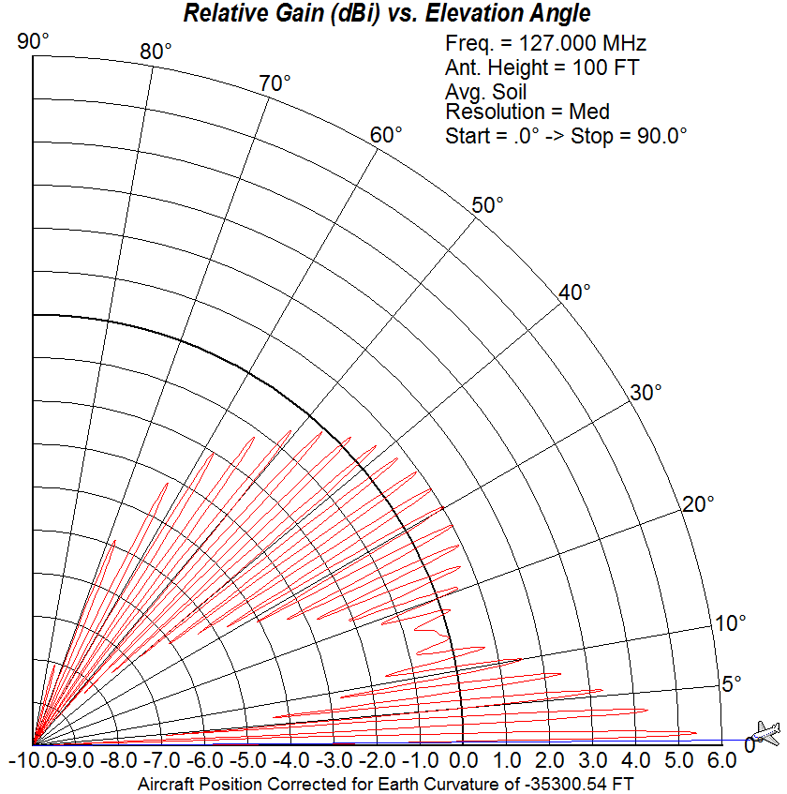

Figure ‎2-4 Vertical polar diagram of antenna 30 m above ground level

The minimum signal level method requires that the signal level of the undesired (interfering) signal be calculated at the antenna of the receiver. The desired signal level is 75 µV/m. The D/U ratio( P_{d} – Pu (dBm)) is 20 (14) dB. The analysis below describes this method which is illustrated in the schematic diagram in Figure 2-5.
Figure ‎2-5 Minimum desired signal at antenna and undesired signal path to desired (victim) receiver antenna

The (desired) signal level (P_{d}) at the antenna is 75 µV/m (-82 dBm). The level of the undesired signal (P_{u}) (from aircraft “b” in Figure 2-3) is calculated formula 21 in paragraph 2.2.2.3.
$P_{d}= 75 μV/m = -82 dBm$ (at the receiver antenna)
$P_{u}= {PT}_{u}-F_{u}+G_{u}-L_{u}$ (at the receiver antenna; P_{Ttu} is for most transmitters typical 25 W)
For P_{Tu} = 25 W (44 dBm), F_{u} = 3dB and G_{u} = 0 dB,
$$P_{u}= 44-3+0-L_{u}=(41-L_{u})dBm$$
$$\frac{D}{U}=20 dB=P_{d}-P_{u}=-82 dBm-41 dBm+L_{u}=-123 dBm+L_{u}$$
$$L_{u}=143 dB$$

In this scenario (D/U = 20 dB), and assuming a typical transmitter power for the undesired aircraft transmitter of 25 W, the minimum separation distance between the desired receiver and the undesired (aircraft) transmitter needs to secure that the transmission losses over the radio path are 143 dB.
Formula (8) in Chapter 1, paragraph 1.3.2 calculates that for a free space transmission loss of 143 dB (f = 127 MHz) a (free space) distance of 1428 NM is required. This distance is far greater than the double the distance to the radio horizon for aircraft at an altitude of 45000 ft. The effect of the radio horizon is described in paragraph 2.2.5. Calculations for establishing the minimum separation distance between facilities are in section 2.7.

In case the protection ration is 14 dB (see Section 2.3.1), the required free space transmission loss is calculated as follows:
$$\frac{D}{U}=14 dB=P_{d}-P_{u}=-82 dBm-41 dBm+L_{u}=-123 dBm+L_{u}$$

$$L_{u}=137 dB$$
Formula (8) in Chapter 1, paragraph 1.3.2 calculates that for a free space transmission loss (f = 127 MHz) a (free space) separation distance of 718 NM is required. This distance is greater than the distance to the radio horizon for aircraft at a maximum altitude of 45000 ft. The effect of the radio horizon is described in paragraph 2.2.5. Calculations for establishing the minimum separation distance between facilities are in section 2.7.
Note: When applying the minimum signal level method as described in this section, the application of a D/U of 14 dB or 20 dB has no (or a limited) effect on the minimum separation distance with a co-frequency interfering station since in both cases the free space separation distance that is required to secure protection of the desired signal from harmful interference is more than the sum of the distances to the radio horizon of the respective facilities.

The minimum signal level method as described in paragraph 2.2.4.5 can also be used to calculate the adjacent channel separation distance as follows:
$P_{d}= 75 μV/m = -82 dBm$ (at the receiver antenna)
$P_{u}= {PT}_{u}-F_{u}+G_{u}-(L_{u}^{'}+ACR)$ (at the receiver antenna)
Where the total transmission loss for the undesired signal $L_{u}=L_{u}^{'}+ACR$
(ACR is +60 dB for the first adjacent channel)
For P_{Tu} = 25 W (44 dBm), F_{u} = 3dB and G_{u} = 0 dB,
$$P_{u}= 44-3+0-L_{u}^{'}-ACR=41-L_{u}^{'}-ACR (dBm)$$
$$\frac{D}{U}=20 dB=P_{d}-P_{u}=-82 dBm-41 dBm+L_{u}^{'}+ACR=-123+L_{u}^{'}+ACR (dB)$$
$L_{u}^{'}=123+\frac{D}{U}-ACR$ (for the values of P_{d} and P_{u} above)
If ACR =60 dB (first adjacent channel rejection), $L_{u}=63+\frac{D}{U}$
$$L_{u}^{'}=37.8+20\log{f}+20\log{d_{u}=83} (dB)$$
For f=127 MHz and D/U=20 DB $L_{u}^{'}=1.4 NM$
Using the same methodology, for an ACR=50 dB and D/U=20dB, the minimum separation distance
$$L_{u}^{'}=4.5 NM$$
Note: To protect the receiver to the muting threshold (5 μV/m or P_{d}= -105.6 dBm) a minimum separation distance of 21 NM would be required.
The minimum geographical separation distance between facilities operating on the first adjacent channel (either 25 kHz or 8.33 kHz) is normally 10 NM. This implies that designated operational coverage areas where adjacent channels are in use need to be separated by at least 10 NM.
For a mixed environment where both 8.33 kHz and 25 kHz channels are being used, different adjacent channel criteria apply (see paragraph 2.7.4).
Editorial note: The EUR FMG has developed provisions for the calculation of adjacent channel geographical separation for 8.33 kHz and 25 kHz facilities operating in a mixed environment. Additional material will be inserted in this paragraph clarifying these provisions. Temporary, the adjacent channel criteria developed by the EUR FMG have been inserted in paragraph 2.8

The effect of the radio horizon

The effect of the radio horizon on the (radio) path loss is shown in Figure 2-6
Figure ‎2-6 Propagation path greater than radio line of sight
In cases where minimum required free space separation distance between the receiver and the undesired (interfering) transmitter, as calculated with the methods in paragraph 2.2.3 or 2.2.4, is greater than the sum of the distance to the radio horizon, the calculation of the total separation distance needs to include the conditions applicable to the “over the horizon” propagation. The radio signals over the horizon are attenuated at a much faster rate per nautical mile compared to free space propagation. This is shown in the ITU propagation curves in Appendix A. For VHF frequencies, the attenuation beyond the radio horizon is 0.5 dB/NM. (See Chapter 1, paragraph 1.3.3.1).
In the example given in Figure 2-6, the total free space loss (propagation loss) between aircraft stations “a” and “b” is equal to sum of the free space attenuation of the path (RH_{A} + RH_{B}) to which the attenuation d_{BLOS} needs to be added.
With formula 11 in Chapter 1, the total path loss between aircraft stations “a” and ‘b’ as shown in Figure 2-3 can be calculated as follows:
$$L_{bf}=37.8+20\log\left({RH}_{A}+{RH}_{B}\right)+20\log\left(f\right)+0.5\left(d_{BLOS}\right)$$
In this formula RH_{A}, RH_{B} and d_{BLOS} are expressed in NM; f is expressed in MHz. RH_{A} and RH_{B} can be calculated with formula (9) in Chapter 1.

Protection based on line-of sight separation

When the minimum required separation between the designated operational coverage of facilities operating on the same frequency is larger than the sum of the distance to the radio horizon of each facility (to obtain the required D/U ratio (20 dB or 14 dB)) at the edge of coverage (maximum range and maximum height), the frequency assignment planning criteria for co-frequency assignment planning as contained in Annex 10 Volume V requires that the designated operational coverage areas for each facility are separated by no more than the sum of the distances to the radio horizon (see paragraph 2.3.1.2 and Appendix E)

This implies that when the separation distance is indeed determined by the sum of the distance to the radio horizon of the respective facilities, the required D/U protection ratio is not met in a small area at the closest points between the two designated operational coverage areas. It is however recognized that it is highly unlikely that two aircraft will be at the closest point at edge of each designated operational coverage area at the same time. The size of the small area depends on the dimensions of the designated operational coverage of the two facilities.

In some specific cases however, as described in paragraph 2.7, the effect of propagation beyond the radio horizon has to be considered when establishing geographical separation distances.
Note: The calculation of minimum separation distances for various air/ground communication services is described in paragraphs 2.7 and 2.8.

Frequency assignment planning criteria
Note: This section describes the frequency assignment planning criteria for VHF air/ground voice communication systems. Frequency assignment planning criteria for the VHF air/ground data link (VDL Mode 2 and VDL Mode 4) are in section 2.9

General planning criteria

Provisions concerning the deployment of VHF frequencies and the avoidance of harmful interference are contained in Annex 10, Volume V, Chapter 4, section 4.1.5. (Amendment 86) For the ease of reference, these provisions are reproduced in Appendix E. The latest amendments to Annex 10 should be consulted in case additional amendments were introduced.

For co-frequency assignments the minimum geographical separation between facilities shall be such that the designated operational coverage of each facility is separated by a distance not less than:

required to provide a D/U ratio of 20 dB;

or

the sum of the distance to the radio horizon of the designated operational coverage area of each facility.
Alternatively, in areas where the frequency congestion is severe, a protection ratio of 14 dB can be used on the basis of a Regional air navigation agreement
Notes:
- facilities using a common frequency do not require frequency protection between each other (e.g. Extended Range facilities)
- the distance to the radio horizon is calculated as shown in Chapter 1, paragraph 1.3.2 with the formula
$d_{RH}=1.23\left(\sqrt{h}\right)$
where
d_{RH} = the distance of the station to the radio horizon (NM)
h = the height of the transmitter or receiver above the Earth’s surface (feet)

- the application of the minimum separation distance based on the sum of the radio horizon distance of each facility assumes that it is highly unlikely that two aircraft will be at the closest points between and at the maximum altitude of the frequency protected service volume of each facility
- details on the calculation of separation distances are in paragraph 2.7. Paragraph 2.8 contains separation distances for the uniform designated operational coverage for aeronautical services as identified in paragraph 2.6.
- the separation distance is calculated for aircraft operating at the maximum range and maximum height of the designated operational coverage.
- in cases where broadcast services (VOLMET) are involved, the minimum geographical separation distance required to obtain a protection ratio D/U of 20 dB is established relative to the ground broadcast transmitter.

For adjacent frequency assignments, the minimum geographical separation between facilities shall be such that points at the edge of the designated operational coverage of each facility are separated by a distance sufficient to ensure operations free from harmful interference.
Notes:
- the edge of the designated operational coverage is at the maximum range and maximum height.
- for facilities operating with 25 kHz or 8.33 kHz channel spacing, the adjacent channel separation of 10 NM has been established.
- protection is based on an Adjacent Channel Rejection (ACR) of 60 dB with the first assignable 25 kHz or 8.33 kHz channel.
- In a mixed environment, where both 25 kHz and 8.33 kHz channel spacing is deployed, the adjacent channel separation as shown in Table 2-6 is to be applied when making frequency assignments

Typical signal parameters

Table 2 – 1 contains typical values for ground and airborne transmitter power that can be used in a detailed compatibility assessment.
Parameter | DSB-AM | DSB-AM | VDL-M2 | VDL-M2 | VDL-M3 | VDL-M3 | VDL-M4 | VDL-M4
TRANSMITTER | Airborne | Ground | Airborne | Ground | Airborne | Ground | Airborne | Ground
Output power transmitter (typical ground station output power is 25 or 50 W (44 or 47 dBm) | 44 dBm  (25 W) | 50 dBm  (100 W) | 42 dBm  (16 W) | 44 dBm  (25 W) | 44 dBm  (25 W) | 44 dBm  (25 W) | 42 dBm  (15 W) | 45 dBm  (32 W)
Feeder loss (assumed) | -3 dB | -3 dB | -3 dB | -3 dB | -3 dB | -3 dB | -3 dB | -3 dB
Antenna gain (assumed) | 0 dB | 2 dB | 0 dB | 2 dB | 0 dB | 2 dB | 0 dB | 2 dB
EIRP | 41 dBm  (12.5 W) | 49 dBm  (80 W) | 39 dBm  (8W) | 43 dBm  (20 W) | 41 dBm  (12.5 W) | 43 dBm  (20 W) | 40 dBm  (10 W) | 44 dBm  (25 W)
Adjacent frequency emission (Transmitter) for VDL specified in Annex 10, Vol. III, Part I, paragraph 6.3.4
1st adj fr. (16 kHz bandwidth) | Not specified in Annex 10 |  | -18 dBm | -18 dBm | -18 dBm | -18 dBm | -18 dBm | -18 dBm
2nd adj fr. (25 kHz bandwidth) | Not specified in Annex 10 |  | -28 dBm | -28 dBm | -28 dBm | -28 dBm | -28 dBm | -28 dBm
4th adj fr. (25 kHz bandwidth) | Not specified in Annex 10 |  | -38 dBm | -38 dBm | -38 dBm | -38 dBm | -38 dBm | -38 dBm
8th adj fr. (25 kHz bandwidth) | Not specified in Annex 10 |  | -43 dBm | -43 dBm | -43 dBm | -43 dBm | -43 dBm | -43 dBm
16th adj fr. (25 kHz bandwidth) | Not specified in Annex 10 |  | -48 dBm | -48 dBm | -48 dBm | -48 dBm | -48 dBm | -48 dBm
32nd adj fr. (25 kHz bandwidth) | Not specified in Annex 10 |  | -53.dBm | -53.dBm | -53.dBm | -53.dBm | -53.dBm | -53.dBm
Table ‎2-1 Typical values for various parameters for VHF communication systems (transmitter)
Parameter | DSB-AM | DSB-AM | VDL-M2 | VDL-M2 | VDL-M3 | VDL-M3 | VDL-M4 | VDL-M4
RECEIVER | Airborne | Ground | Airborne | Ground | Airborne | Ground | Airborne | Ground
Min signal at receiver antenna  Annex 10, Vol. III | 75 μV/m  (-82 dBm)  part II  2.2.1.2 | 20 μV/m  (-93 dBm)  part II  2.3.1.2 | 75 μV/m  (-82 dBm)  part I  6.2.2. | 20 μV/m  (-93 dBm)  part I  6.3.2 | 75 μV/m  (-82 dBm)  part I  6.2.2. | 20 μV/m  (-93 dBm)  part I  6.3.2 | 75 μV/m  (-82 dBm)  part I  6.9.5.1.1.2 | 35 μV/m  (-88 dBm)  part I  6.9.5.1.1.1
Feeder loss | -3 dB | -3 dB | -3 dB | -3 dB | -3 dB | -3 dB | -3 dB | -3 dB
Antenna gain | 0 dB | 2 dB | 0 dB | 2 dB | 0 dB | 2 dB | 0 dB | 2 dB
Min. signal at receiver input | -85 dBm | -94 dBm | -85 dBm | -94 dBm | -85 dBm | -94 dBm | -85 dBm | -89 dBm
Out-of-band immunity performance of receiver as per Annex 10, Volume III, Part I, paragraph 6.3.5.3.(VDL) and Volume III, Part II, paragraph 2.3.2.8 (DSB-AM).
1st adj. Ch |  |  | -40 dB | -40 dB | -40 dB | -40 dB | -40 dB | -40 dB
4th adj. Ch | -50 dB | -50 dB | -60 dB | -60 dB | -60 dB | -60 dB | -60 dB | -60 dB
Table ‎2-2 Typical values for various parameters for VHF communication systems (receiver)

Conversion from input power (dBm) to field strength (μV/m and vice versa.) was with the following formula:
$P_{r}=E-20\log{f-167.2}$ ( 17 )
where:
Pr is isotropically received power (dB(W))
E is the electric field strength (dB(μV/m) and
f is the frequency (GHz) (ITU-R Recommendation P.525-2 refers).

This formula can be re-written into:
$10\log{P_{r}=20\log{E}-}20\log{f}-77.2$ ( 18 )
where:
P_{r} is the signal at receiver antenna (in space) in mW,
E is the field strength at the antenna in µV/m
F is the frequency f in MHz.
[dB(µV/m) = 20log(µV/m)]

$10\log{P_{r}}$ is expressed in dBm (power relative to 1 milliwatt)

Note: the typical transmitter power of ground stations can vary from 10 – 100 W.

Allotment of the frequency band 117.975 – 137 MHz

Special frequencies

Annex 10, Volume V, Chapter 4, paragraph 4.1.1 and Table 4 – 1 has established a general allotment of the frequency band 117.975 – 137 MHz. The main sub-divisions of this band are the frequency bands allocated to both international and national services and frequency bands solely allocated to national services. Specific allotments to services are to be determined regionally. Appendices C and D contain these regionally agreed allotment plans. In practice, not much consideration is given to the allotments for national / international use.

Note:

Frequency assignments for international use are those that are required as per regional Air Navigation Plan. These frequencies are identified with “ICAO” in the frequency assignment plan. Other frequencies are for national use and are identified as “NAT” in the frequency assignment plan.

Annex 10, Volume V includes provisions for the use of specific frequencies as follows:

Frequency (MHz) | Usage | Comments | Annex 10, Volume V
121.500 | Aeronautical emergency frequency | Guard band* 121.450 – 121.550 MHz | 4.1.3.1
121.550 – 122.917 | Aerodrome surface communications |  | -
123.100 | Auxiliary frequency (SAR) | Guard band* 123.050 – 123.150 MHz | 4.1.4.3
123.450 | Air-to-air communications | Outside range of VHF stations | 4.1.4.2
128.825 – 132.025 | Aeronautical Operational Control | Range to be determined Regionally** | (Rec.) 4.1.8.1.3
136.925 | Common signaling channel | Reserved for VDL Mode 4 | 4.1.3.3.2
136.975 | Common signaling channel | Reserved for VDL Mode 2 | 4.1.3.3.1
136.500 – 136.975 | Only for frequency assignments with 25 kHz channel spacing |  | 4.1.8.8.1, Note 1
* the frequencies 121.450 MHz, 121.550 MHz, 123.050 MHz and 123.150 MHz are assignable frequencies
** regional allotment plans have determined the actual band for aeronautical operational control communications
Table ‎2-3 Frequency allotment and special frequencies

Regional allotment plans provide for the use of the frequency band 136 – 137 MHz by VDL (VDL Mode 2 and VDL Mode 4). In Europe the frequency band 136.700 – 137.000 MHz is reserved for VDL. (Re. Appendices C and D)

Regional allotment plans

In addition to the general allotment plan in Annex 10, all Regions have developed a more detailed allotment plan through which operational services are allotted to certain frequency bands and included these in the relevant ICAO Air Navigation Plans (ANP). The prime goal of these allotment plans is to accommodate new frequency assignments in the sub-bands allotted to a particular service. Appendices C and D contain a detailed overview of these allotment plans.

Frequency assignments should preferably be made in accordance with the provisions of the Regional allotment table. However, in case a particular requirement for a frequency assignment cannot be made from within the sub-band that is allotted to the relevant service, other sub-bands can be considered to satisfy the requirement. The Regional frequency allotment plans also include provisions for sub-bands for aeronautical operational control (AOC) communications.

Regional allotment plans provide for the use of the frequency band 136 – 137 MHz by VDL (VDL Mode 2 and VDL Mode 4). In Europe the frequency band 136.700 – 137.000 MHz is reserved for VDL.

Frequency separation and channeling

Frequency separation between VHF COM channels

Annex 10 stipulates that the minimum separation between assignable frequencies in the aeronautical mobile (R) service shall be 8.33 kHz. (Annex 10, Volume V, paragraph 4.1.2.2.) This provision recognizes that in Regions or areas where 25 KHz channel spacing provides for an adequate number of frequency assignments to meet national and international requirements equipment designed for 25 kHz channel spacing will continue to be used and continue to be protected. The introduction of 8.33 kHz channel spacing in Regions or areas requires a Regional air navigation agreement for the mandatory carriage of equipment designed for 8.33 kHz channel spacing.

Currently, 8.33 kHz frequency separation has only been introduced in the EUR Region. All other Regions have agreed to base frequency assignment planning on 25 kHz frequency separation. This implies that radio equipment designed for 50 kHz or 100 kHz frequency separation that may be still in operational use may not always be protected from harmful interference that can be caused by stations operating on adjacent 25 kHz or 8.33 kHz frequencies.

Protection of 25 kHz frequency assignments from 8.33 kHz assignments

In Regions that continue operation of communication equipment designed for a frequency separation of 25 kHz, frequency assignments are protected from harmful interference from the use of frequencies operating on multiples of 8.33 kHz, both within the same Region as well as in adjacent Regions (see Annex 10, Volume V, paragraph 4.1.2.3, note and 4.1.8.1, note 2).

Channeling

Normally, in aviation (e.g. in radio telephony) the frequency in use is identified by the actual frequency. For the use of 8.33 kHz frequencies, the frequency identification for 8.33 kHz frequencies is replaced with a channel identification that is using a number (similar to the identification of a frequency) which is mapped to the actual frequency in use. The channel/frequency identification to be used for identifying frequencies with a channel spacing of 8.33 kHz is as shown in Table 2 – 4.
Frequency (MHz) | Frequency separation (kHz) | Channel #
118.0000 | 25 | 118.000
118.0000 | 8.33 | 118.005
118.0083 | 8.33 | 118.010
118.0167 | 8.33 | 118.015
118.0250 | 25 | 118.025
118.0250 | 8.33 | 118.030
118.0333 | 8.33 | 118.035
118.0417 | 8.33 | 118.040
118.0500 | 25 | 118.050
118.0500 | 8.33 | 118.055
118.0583 | 8.33 | 118.060
118.0667 | 8.33 | 118.065
118.0750 | 25 | 118.075
118.0750 | 8.33 | 118.080
118.0833 | 8.33 | 118.085
118.0917 | 8.33 | 118.090
118.1000 | 25 | 118.100
etc.
Table ‎2-4 Channeling / frequency pairing for frequencies with 25 kHz and 8.33 kHz separation

Services and designated operational coverage

Services

Frequency assignments are made to implement specific aeronautical services as follows:
Aerodrome
TWR Aerodrome control service
AS Aerodrome surface communications
AFIS Aerodrome flight information service

Approach
APP Approach control service
ATIS Automatic terminal information service

En route
FIS Flight information service
ACC Area control service

Other functions
A/A Air-to-air
A/G Air-to-ground
AOC Aeronautical operational control
VOLMET Meteorological broadcast for aircraft in flight
GPS VHF En-Route General Purpose System
EM Emergency
SAR Search and rescue

Coordination of special frequencies

No frequency coordination of frequency assignment planning is necessary for the emergency frequency (121.500 MHz) and the SAR frequency (123.100 MHz) as these services are available globally at each station where this service is required. The provisions in Annex 10 include a guard band for these frequencies to prevent adjacent channel interference. Also, no specific frequency assignment planning is required for the air-to-air communication channel 123.450 MHz as this channel is to be used only in remote and oceanic areas when the aircraft is out of the coverage of VHF ground stations.

Table of uniform values for designated operational coverage (DOC)

Frequencies for aeronautical radio communication services are (normally) implemented to satisfy the operational need for specific services. These services, and their uniform designated operational coverage areas, are as in Table 2 – 4.
Service | Designated Operational Coverage (DOC) |  |  | Mode
Service | Range (NM) | Height (ft) | Comments
Aerodrome
TWR | 25 | 4000 | Height above ground | A/G
TWR/L | 16 | 3000 | Height above ground; only in EUR
PAR | 25 | 4000 | Height above ground | A/G
AFIS | 25  EUR: 15 | 4000  EUR: 3000 | Height above ground | A/G
AS | Limits of aerodrome | Surface |  | A/G
Approach
APP–L | 50  EUR: 25 | 12000  10000 |  | A/G
APP–I | 75  EUR: 40 | 25000  EUR: 15000 |  | A/G
APP–U | 150  EUR: 50 | 45000  EUR: 25000 |  | A/G
En-Route
ACC–L | Area | 25000 | Within specified area; max range155 NM** | A/G
ACC-LL | EUR: Area | 15000 | Within specified area; max range120 NM**
ACC-I | Area | 25000  EUR: 35000 | Within specified area; max range 130 NM**  Within specified area; max range 185 NM** | A/G
ACC–U | Area | 45000 | Within specified area; max range 200 NM** | A/G
FIS-L | Area | 25000 | Within specified area; max range 155 NM** | A/G
FIS or FIS-U | Area | 45000  EUR: 23000 | Within specified area; max range 200 NM**  Within specified area; max range 120 NM** | A/G
VOLMET | 200 | 45000 | Maximum range 200 NM* | BC
Other functions
ATIS | 200  EUR: 60 | 45000  EUR: 20000 |  | BC
A-A | 200 | 45000 | Maximum range 200 NM** | A/G
A-G | 200 | 45000 | Maximum range 200 NM** | A/G
AOC | 100 | 250 | Not protected; max. range 100 NM | A/G
EM | N/A | N/A | No frequency coordination required | A/G
SAR | N/A | N/A | No frequency coordination required | A/G
GPS | 200 | 45000 | Maximum range 200 NM** | A/G
Table ‎2-5 Table of uniform designated operational coverage
Notes:
    - Designated operational coverage marked with ** are reduced to 80% of the distance to the radio horizon in case no maximum range is provided. (see also paragraph 2.6.4)
    - Different DOC areas may be specified by States
    - DOC for AOC only provided to enable compatibility assessment when frequencies for AOC are shared with ATC services; different DOC may be specified.
    - For area services, no frequency protection is provides outside the specified area.
    - Unless specified by States, the DOC for A-A and A-G is assumed at 45000 ft. / 200 NM
    - Mode: A/G: air/ground communications; BC: (ground) broadcast communications

Additional functionality concerning the use of these services in the column “comments” may be added to the services as follows:
CD Clearance delivery
CTA Control area
DF Direction finding
ER Extended range
PAR Precision Approach Radar
RCAG Remote controlled air-ground communications
SR Surveillance Radar

These additions do not alter the basic service or the DOC for which the frequency is required and should be included as a remark to the frequency assignment in the COM list in the global table of frequency assignments.

Certain services may not require protection because they are not in operation to provide safety-of-life service (e.g. for Gliders, Balloons). However, when these services are shared with ATC services, a compatibility analysis is required (see also paragraph 2.7.2.5.3).

Non-standard DOC (Range and Height) may be implemented as and when required. Reduced DOC, where operationally acceptable, may alleviate frequency congestion.

The use of common frequencies, preferably Region wide, to satisfy requirements for specific non-protected applications such as light aviation, gliding and balloon activities is recommended as such use increases the efficiency in frequency assignment planning.

Frequencies for aeronautical operational control are not protected through frequency planning. These frequencies are normally assigned on the basis of the traffic loading that is expected. (E.g. within the same area, smaller airlines can share the same frequency for operational control purposes).

Coverage at very low angles from ground transmitter

Due to the vertical polar diagram of the antenna of the ground station, at very low angles the radiation of the transmitted energy is too low to provide coverage over a large area Also, the distance to the aircraft decreases if the angle of the radio path with the horizontal plane through the ground antenna increases. As an example, for an aircraft operating at 45000 ft., the distance to the ground transmitter decreases as shown in Table 2-6.(4/3 Earth radius).

Angle (degree) | Distance (NM)  Height: 45000 ft | Distance (NM)  25000 ft | Distance (NM) 4000 ft
0  (radio horizon) | 261 | 195 | 78
.1 | 252 | 186 | 70
.2 | 245 | 178 | 63
.3 | 237 | 171 | 57
.4 | 230 | 164 | 52
.5 | 223 | 158 | 74
.6 | 217 | 152 | 43
.7 | 210 | 146 | 40
.8 | 204 | 140 | 37
.9 | 198 | 135 | 34
1 | 192 | 130 | 32
Table ‎2-6 Distance as function of angle above horizon

The geometry used in these calculations is shown in Figure 2-7
Figure ‎2-7 Reduction in distance to the transmitter when receiving above the horizontal plane through the ground antenna
On the basis of the principles in 2.6.4.1, in case for certain services no actual maximum Designated Operational Range has been specified, the maximum operational range within which frequency protection is provided can be about 80% of the distance to the radio horizon. For certain of these services, a maximum operational range has been incorporated in table 2-5.
It is recognized that States may require different values for the designated operational coverage from the uniform values in Table 2-5 for certain services.
Note: Application is to be decided on a Regional level

Interference from FM broadcasting stations

The risk of interference from FM broadcasting stations operating in the band 87 – 108 MHz is generally not considered for frequency assignments in the band 117.975 – 137 MHz.

Co-location of facilities

ICAO frequency assignment planning does not include protection against interference that may be caused in case facilities are co-located (e.g. interference due to intermodulation products). During the installation of COM systems the COM service provider needs to prevent such cases of interference (e.g. by using cavity filters).

Coordination of frequency assignments

Frequency coordination must take place with all States which may be affected by a proposal for a new frequency assignment or where the characteristics of an existing assignment are modified. Normally, such coordination is effected through the ICAO Regional Offices which have a central and coordinating role in frequency assignment planning.

Calculation of separation distances (methodology)
Note: The material in this section can be used in cases where frequency assignment planning needs to consider systems with only 25 kHz or 8.33 kHz frequency separation to secure co- and adjacent frequency compatibility. Paragraph 2.7.4 contains material that can be used when there is a need to establish separation distances to secure compatibility between systems operating with 25 kHz and 8.33 kHz characteristics..

Frequency and/or distance separation

Protection of frequency assignments from harmful interference is achieved through frequency and/or distance separation. Normally, the determining factor in frequency assignment planning is the risk of interference between two aircraft, operating within different DOC areas at the closest point. As normally the ground station is located well within the DOC area, the ground station is protected when the aircraft (receiver) is protected from harmful interference.

The separation distances provided in this paragraph are the minimum distances that need to be maintained between the ground stations that provide the relevant service. The separation distances have been established using the method and provisions in paragraphs 2.2 and 2.3 and comply with the frequency assignment planning criteria as specified in Annex 10, Volume V. Practical values for the separation of co-frequency facilities are in section 2.8.

Co-frequency separation distances

Air/ground communication services.

Protection of co-frequency assignments for air/ground communication services (involving aircraft transmissions) is obtained by securing that the D/U ratio is in accordance with the regionally agreed value. The D/U ratio can be either 14 dB or 20 dB (see paragraph 2.3).

Circular service areas
(i) Separation distance is based on D/U = 20 dB or radio line-of-sight distance
As described in paragraph 2.3 and as per the requirements of Annex 10 the minimum required separation distance from the edge of the DOC (of the desired) ground station A to another (undesired) aircraft, operating on the same frequency (and outside the desired DOC), should be not greater than the sum of the distance to the radio horizon from each aircraft station.

As shown in Figure 2-8, the minimum distance between the DOC of the service areas is equal to

RH_{A} + RH_{B}
The distance to the radio horizon can be calculated with formulas (8) or (9) in Chapter 1, paragraph 1.3.2. In these formula, the factor h_{TX} and or h_{RX} is the designated operational height of the respective DOC areas.

As shown in Figure 2 – 8, when the ground stations (with circular coverage and the ground stations are located approximately at the center of this coverage area) have a designated operational range of R_{A} and R_{B} respectively and RH_{A} and R_{B} is the distance from the respective aircraft to the radio horizon, the minimum separation distance between the ground stations is:

R_{A} + RH_{A} + RH_{B} +R_{B.}

Figure ‎2-8 Separation based on radio line-of-sight

Separation distance is based on D/U = 14 dB (1 : 5 separation distance ratio) or radio line-of-sight.

As described in paragraph 2.2.2 and as per the requirements of Annex 10 the minimum required geographical separation distance between the edges of the designated operational coverage areas can be calculated with the separation distance ratio method as follows. This method has been implemented in Europe [and North America].

To meet the 14 dB protection requirement, the distance between the (desired) aircraft receiver and the (interfering) aircraft transmitter needs to be at least 5 times the distance between the (desired) aircraft receiver and the desired ground station.
Figure ‎2-9 Separation distance based on the 5 to 1 distance ratio
In Figure 2 – 9 the designated operational range for ground station A is R_{A} and for ground station B is R_{B}. Aircraft stations a and b operate at the closest point and at the edge of the respective DOC areas. If the (minimum) separation distance from aircraft station a to aircraft station b is at least 5 times the distance from aircraft station a to ground station A (5*R_{A}) aircraft station a is protected (14 dB) from interference from aircraft station b. Vice versa, if the distance from aircraft station b to aircraft station a is at least 5 times the distance from aircraft station b to ground station B (5*R_{B}) aircraft station b is protected from interference from aircraft station a. The minimum required separation distance between the two DOC areas A and B is the largest of

(Max) [5*R_{A} or 5*R_{B}]

The minimum separation between the ground stations (circular coverage for A and B and the ground stations are located in the approximate center of the DOC) is the larger value of

(Max) [ (R_{A} + 5R_{A} + R_{B}) or ( R_{A} + 5R_{B} + R_{B})]

In cases where the value (Max) [5*R_{A} or 5*R_{B}] is larger than the sum of the distances to the radio horizon of each facility (RH_{A} + RH_{B}) as described in 2.2.5 and 2.3.3.1 above, the radio line-of-sight criterion should be used. The minimum total required separation distance between closest points at the edges of the respective coverage areas is therefore:

(Min) {[RH_{A}+RH_{B}] or (Max) [5R_{A} or 5R_{B}]}

Note 1: In both cases above, the edge of the DOC area is the point where the aircraft can operate at maximum designated operational range and height. Application of the 5 to 1 distance ratio assumes that the e.i.r.p of both the [desired] station and the [undesired; interfering] station are the same. Where the e.i.r.p of the transmitters is different, adjustments to the 5 to 1 distance ratio are necessary (see paragraph 1.3.4).
Note 2: The application of the 5:1 distance ratio in frequency assignment planning is not recommended for area services or for services with circular DOC when the ground station is located well outside the center of the circular service since in these cases the worst case where the 5.1 distance ratio needs to be met is not always the closest point between the DOC areas considered. In addition, it should be recognized that the benefits for efficient frequency assignment planning using the 5:1 distance ratio are marginal. Only in areas where frequency congestion is becoming desperate, the use of the 5:1 distance ratio for frequency assignment planning should be considered.
Note 3: in both cases above, once protection of the aircraft receiver “a” is secured, also the ground station is protected from harmful interference (from aircraft station “b” since the ground station is well beyond the radio horizon of aircraft station “b”.

Area services – co-frequency separation distances

The minimum separation between the designated operational coverage of two area services is equal to the sum of the radio line-of-sight for each area service at the limit of the DOC (coverage). This method provides frequency protection throughout the DOC of the area service and establishes for each of the area services a buffer zone equal to the distance to the radio horizon for an aircraft at maximum altitude of the relevant DOC. The minimum separation to protect the two area services from harmful interference is established at the closest point between the service areas.

In many cases, for large designated operational coverage areas of area services, a single ground station cannot provide coverage throughout the service area. In these cases, where required, additional coverage is provided through installing extended range stations (forward relay). These stations can operate on the same frequency (using the off-set carrier system as specified in Annex 10, Volume III) or on a discrete frequency. Not in all cases full VHF coverage is provided, in particular for lower flight levels.

When the same frequency used by an area service is also used by a broadcasting service (which is a circular service), the minimum separation is the larger value of the following:
- to protect the aircraft receiver at the edge of the area coverage, the minimum distance to the ground broadcast transmitter should be at least the distance to the radio horizon + 15 NM from the limit of the DOC of the area service. Note: Annex 10 (2012) mentions a distance of 30 NM).
- the minimum distance from the aircraft broadcast receiver to the airborne transmitter at the edge of the area service should be at least the sum of the distance to the radio horizon (radio line-of-sight) for each aircraft. The minimum distance from the edge of the DOC of the area service to the broadcast transmitter should be at least the sum of the distance to the radio horizon for each aircraft plus the range of the broadcast station.

The methodology for establishing the minimum separation distances is the same as provided in paragraphs 2.7.3 and 2.7.4. However, in order to secure protection of area services throughout the DOC, separation distances are measured from the limit of the DOC rather than from the ground station(s) providing the area service.
As pointed out in Note 2 to paragraph 2.7.2.1.1, the use of the 5:1 distance ratio for co-frequency assignment planning for area services is not recommended.

Broadcast services (ATIS and VOLMET)

Broadcast services such as ATIS and VOLMET are characterized by ground-to-air transmissions only and do not involve airborne transmissions. As a consequence, only interference from the (undesired) ground broadcast station needs to be considered. Because to the continuing nature of the broadcast transmissions, protection of the (desired) signal) down to the muting level of the receiver is necessary.
A VOLMET (ATIS) broadcast station normally has a maximum designated operational range is 200 NM and a maximum designated operational height of 45000 ft. see paragraph 2.6.4 and Table 2-4). For an (undesired) VOLMET transmitter with an e.i.r.p. of 100 W, the field strength at the (desired) aircraft, when the VOLMET station is 15 NM beyond the radio horizon of the (desired) aircraft) will be approximately at the receiver muting level of 5 μV/m (-105.6 dBm).

The designated operational coverage for these broadcast stations is normally the maximum that can be achieved (200 NM at flight level 450). The interference mechanism is shown in Figure 2 – 10.
Figure ‎2-10 Interference mechanism between broadcast services

The minimum separation distance between two (ground) broadcast stations is

R_{A}+RH_{A}+15 (NM)

To secure compatibility when station B is the wanted broadcast station and aircraft B is the desired receiving aircraft station, the minimum separation distance between the (ground) broadcast stations A and B is

R_{B}+RH_{B}+15 (NM)

To secure compatibility between the two broadcast stations the minimum separation distance to be maintained between the ground broadcast stations A and B respectively is the larger value of:

(Max) RH_{A} + R_{A} + 15 or RH_{B} + R_{B} + 15

Where: R_{A} is the designated operational range for ground broadcasting station “A”
R_{B} is the designated operational range for ground broadcasting station “B”
RH_{A} is the distance to the radio horizon of aircraft A
RH_{B} is the distance to the radio horizon of aircraft B
(Distances in NM)

The minimum separation distances between the edges of the designated operational coverage of each facility is 15 NM.

Broadcast and air-ground services

To protect an aircraft station receiving broadcasts from a ground station from another station providing air/ground communications the mechanism as shown in Figure 2 - 11 applies

Figure ‎2-11 Interference mechanism between broadcast services and air/ground services
In order to protect aircraft B, which is receiving (only) broadcast information from ground broadcast station B (e.g. VOLMET or ATIS), from interference that can be caused by transmissions from aircraft station A, the same methodology as described in paragraph 2.7.2.1.1 applies (separation distances in case both the undesired and the desired station provide air/ground communication services.

To protect aircraft station A from interference that can be caused by (ground) broadcast station B, the minimum separation between the two ground stations needs to be (see paragraph 2.7.2.2):

R_{A}+RH_{A}+15 NM

However, the distance to protect aircraft station B from interference from transmissions from aircraft station A is always greater than the distance to protect aircraft station A from interference that can be caused by broadcasting station B. Geographical separation between the facilities should be based on the method as described in paragraph 2.7.2.1.

Aerodrome surface communications (AS)
Aerodrome Surface communications provide an essential safety service. In case the separation distance is not sufficient, clearances or other instructions that are intended to be used solely on a nearby (“undesired”) aerodrome can be understood as a valid instruction on the desired aerodrome. For AS communications, the actual difference in height (above MSL) with a nearby airport or the effect of anomalous propagation may need to be considered. A height difference of 100 m with the nearby aerodrome would result in the radio horizon (of the nearby aerodrome) being increased to about 25 NM. The resulting (D/U) would be 15.5 dB. (See the Appendix to this paper)

Along the same principles as for aircraft in flight, as described in paragraph 2.7.2.1.1, the minimum separation distance can be calculated with the formula RH_{A} + RH_{B} as illustrated in Figure 2-12.
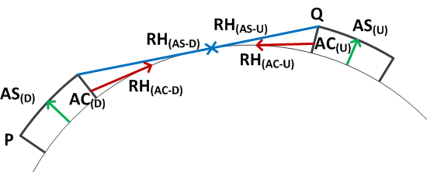
Figure ‎2-12 Geometry for calculating separation distances for AS communication services

In Figure 2-12, the parameters are:

AS_{(D)} and AS_{(U)}: Designated operational coverage for aerodrome surface communications (5 NM/100 ft.)
AC_{(D)}: Desired aircraft (antenna height 30 ft.)
AC_{(U)}: Undesired aircraft (antenna height 30 ft.)
AS_{(D)}: Desired AS ground [base] station (antenna height 100 ft.)
AS_{(U)}: Undesired AS ground [base] station (antenna height 100 ft.)
RH _{(AS-D)} and RH_{(AS-U)}: Distance to the radio horizon from the edge of coverage (12.3 NM)
RH_{(AC-D)} and RH_{(AC-U)}: Distance to the radio horizon from the aircraft at maximum range (6.7 NM for 30 ft.)

Using formulas (1) and (3) in Chapter 1 the required transmission loss can be calculated as
$$\frac{D}{U}=L_{u}-L_{d}$$
In this formula$L_{d}=20\log{d_{d}}=13.9 dB$ (d_{d}=5 NM)
and $L_{u}=20\log{d_{u}}+A=13.9 dB$ (d_{u} is the distance to the radio horizon between the two ground stations which is for stations at a height of 100 ft. (30 m) above the terrain 2*12.3 NM. A is the required transmission loss beyond the radio horizon)

$$\frac{D}{U}=L_{u}-L_{d}=20log⁡({{RH}_{\left(AS-d\right)}+{RH}_{AS-u}})+A-13.9=20$$

For ${RH}_{\left(AS-d\right)}+{RH}_{AS-u}$=24.6, the factor A (transmission loss beyond the radio horizon) equals 6dB. This corresponds to a distance of 12 NM. As a result, the total minimum separation between the edges of the DOC of the two ground stations should be 36.3 NM (37 NM). Since the antenna height above the terrain of the ground station (30) is higher than that of the aircraft station, this separation distance will protect the communications with an aircraft (on the surface of an airport) as well as vehicles using AS frequencies.

Note: when using the two-ray propagation model (see Chapter 1, paragraph 1.3.4), the minimum separation distance between the two ground stations would be slightly more than 25 NM.

In frequency assignment planning, the DOC for AS services is circular with a designated operational coverage of 5 NM / 100 ft. The minimum separation distance between the DOC of two (co-frequency) AS services is equal to the sum of the distance to the radio horizon of each station. This would provide for a co-frequency separation distance between the ground stations of 35 NM.

If so desired, on the basis of regional agreements, the separation distances to be applied can be amended. In addition, consideration could be given to increase the minimum separation distance to a value that would reduce the undesired signal to below a squelch level of 5 μV/m at the [airborne and ground ] receiver antenna. However, when considering that more realistic propagation models for ground-ground propagation as in Chapter 1, paragraph 1.3.2 will result in better protection, the separation distance of 35 NM between AS ground stations may provide sufficient protection.

Adjacent channel protection for AS services needs to be provided by securing that the DOC of the undesired (interfering) station is separated by at least 10 NM from the DOC of the desired station.

Editorial note: if so desired, this paragraph can be simplified. Note that in the case of AS services, protection if offered to the ground station as the antenna height of the ground station is greater than that of the aircraft station on the surface of the airport.

Unprotected services

Certain services are not protected from interference and in many cases, no coverage has been determined for these services. An example is the use of frequencies for aeronautical operational control or for special uses such as for gliders and balloons.

Assignment of frequencies to stations is in these cases normally determined on the basis of the traffic loading that can be expected by the users of these -unprotected- frequencies. As long as these frequencies are in operation exclusively for unprotected use, these assignments should not be subject to interference calculations.

When these frequencies are shared with protected services, consideration needs to be given whether the use of the unprotected frequencies may cause interference to frequencies (co- and adjacent frequency) which do require protection from harmful interference and an assessment of potential interference should be undertaken. This may result in a situation that while the protected service is to be protected from interference from the unprotected service, the unprotected service is in turn also protected from interference from the protected service. In these cases, establishing a DOC for the un-protected service is necessary.

In the interest of efficient frequency assignment planning it is important to realize that when frequency assignments to unprotected services are being made, these should preferably be concentrated in one (or more) sub-bands solely reserved for unprotected services. Where feasible, such sub-bands should be established.

Adjacent frequency separation distances

Air/ground communication services (25 kHz or 8.33 kHz frequency separation).

The minimum separation between aircraft operating on the first adjacent (25 kHz or 8.33 kHz) frequency used in frequency assignment planning is 10 NM as illustrated in Figure 2-13. In paragraph 2.2.2.6 and 2.2.3.8 calculations for adjacent channel separation are provided. This separation distance applies to frequency assignment for use by equipment designed for 25 kHz frequencies (channels) or for 8.33 kHz frequencies (channels). The separation distance in cases where equipment designed for 8.33 kHz bandwidth is used in the same area where equipment designed for 25 kHz bandwidth channels is used is described in paragraph 2.7.4.
Figure ‎2-13 Adjacent frequency separation for air-ground services

The minimum separation between two ground stations operating on the first adjacent 25 kHz frequency is:

R_{A} +10 NM +R_{B}

This minimum separation distance prevents adjacent frequency interference between two aircraft and applies when one (or both) aircraft stations provides air/ground communications.

Adjacent frequency geographical separation for area services

The minimum separation distance between the designated operational coverage of two area services are to be separated (at the edge of coverage) by at least 10 NM when in each of the two areas the first adjacent frequencies is being used. (In this case, a buffer zone around the area service of 10 NM is required.)

The same condition applies when one of the services is a circular service. In this case, the minimum separation between the edge of the designated operational coverage of the area service and the ground station of the circular service is the range of the circular service + 10 NM

When the adjacent frequency used by an area service is used by a broadcasting service (which is a circular service), the minimum separation is the larger value of the following:
- to protect the aircraft receiver at the edge of coverage, the minimum distance to the ground broadcast transmitter from the edge of coverage should be at least 13 NM.
- the minimum distance from the aircraft broadcast receiving to the airborne transmitter at the edge of the area service should be at least the sum of the distance to the radio horizon (radio line-of-sight) for each aircraft plus 13 NM. The minimum distance from the edge of the DOC of the area service to the broadcast transmitter should be at least 13 NM plus the range of the broadcast station.

Adjacent frequency separation distances between broadcast services (ATIS, VOLMET).

In case both ground stations are broadcast (VOLMET, ATIS) stations, the minimum adjacent frequency separation distance between the aircraft and an unwanted (interfering) ground broadcasting station is 13 NM as shown in Figure 2 – 11.
Figure ‎2-14 Adjacent frequency separation between broadcast services

The minimum separation between two ground broadcast stations, operating on adjacent frequency, is

R_{A} + 13 NM
where:
R_{A} is the designated operational range for ground broadcast station A

Similarly, for broadcast station B, the minimum separation distance between the two ground stations is
R_{B} + 13 NM
where:
R_{B} is the designated operational range for ground broadcast station B (not shown in Figure 2 – 14)

The minimum separation distance that needs to be secured between the broadcast stations A and B is the larger value of:
(Max) R_{A} + 13 NM or RB + 13 NM

In this case, the DOC for adjacent channels may overlap with each other.

Adjacent frequency separation distances – broadcast and air-ground services

In this case, two different interference mechanisms need to be analyzed as illustrated in Figures 2-13 and 2-14. The minimum separation distance can be calculated as follows:

Aircraft a is involved in air/ground communications with ground station A (Range R_{A})
Aircraft b is receiving broadcast messages only from ground station B (Range R_{B})

A - the minimum separation distance between the two ground stations to protect the aircraft station a from interference from the (broadcasting) ground station b, as described in paragraph 2.7.4.2, is
R_{A} +13 NM
where

R_{A} is the designated operational range of the station providing air/ground communications.

A – the minimum separation distance between the two ground stations to protect the broadcast receiver (aircraft station b) from interference from aircraft station a. With the method as described in paragraph 2.7.4.1, the minimum distance between the aircraft stations is 10 NM. The minimum distance between the ground stations is

R_{A} +10 + R_{B}
where:
R_{A} is the designated operational range of the air-ground communication service and
R_{B} is the designated operational range of the broadcast service

To secure protection of both services, the minimum separation between the ground stations is the larger value of:
(Max) R_{A} +13 NM or R_{A} +10 + R_{B}

Co – and adjacent frequency consideration in a mixed environment where 8.33 kHz and 25 kHz frequency separation is being used

Note: The following criteria have been developed by the EUR Frequency Management Group and may require further consideration, in particular with regard to the protection of frequencies using off-set carrier (CLIMAX) systems.

Co-frequency separation criteria should be used when the 8.33 kHz frequency and the 25 kHz frequency are the same (e.g. channel 119.000 and 119.005 operate both on the frequency 119.000 MHz). Co-frequency separation criteria should also be applied between an 8.33 kHz frequency and a 25 kHz frequency which are separated by 8.33 kHz MHz. (e.g. channels 119.010 and 118.990, using frequencies 119.0083 MHz and 118.9917 MHz respectively) are considered both co-frequency to the [25 kHz] frequency 119.000 (119.000 MHz))

At least [33] NM should be the separation distance between the edges of the DOC’s when the 8.33 kHz and a 25 kHz frequencies are separated by 16.67 MHz (e.g. channels 119.015 and 118.985, using frequencies 119.0167 MHz and 118.9833 MHz).

Note: These frequencies are considered co-frequency to the next 25 kHz frequency (e.g. co-frequency to 119.025 MHz and 118.975 MHz respectively.

At least 10 NM should be the separation between the edges of the DOC’s when the 8.33 KHz frequency and the 25 kHz frequency are separated by 20 kHz (i.e. the same criteria as for a 25 kHz adjacent frequency.

At least 4 NM should be the separation distance between an 8.33 kHz frequency and a 25 kHz frequency which are separated by 25 kHz (e.g. channel 118.000 (25 kHz) and 118.030 (8.33 kHz) which use the frequency 118.000 MHz and the frequency 118.025 MHz respectively)

Table 2 – 7 gives an overview of the separation distances to be maintained in a mixed 25 / 8.33 kHz environment. The values for the adjacent frequency separation are in NM. “C” indicates that the co-frequency separation criteria (line-of-sight or the 1 to 5 distance ratio needs to be applied.

 | 118.0000  118.000 | 118.0000  118.005 | 118.0083  118.010 | 118.0167  118.015 | 118.0250  118.025 | 118.0250  118.030 | 118.0333  118.035 | 118.0417  118.040 | 118.0500  118.050 | 118.0500  118.055 | 118.0583  118.060 | 118.0667  118.065 | 118.0750  118.075 | 118.0750  118.080 | 118.0833  118.085 | 118.0917  118.090 | 118.1000  118.100 | 118.1000  118.105 | 118.0000 | 118.0000 | 118.0000
118.0000  118.000 | C | C | C | 33 | 10 | 4
118.0000  118.005 | C | C | 10 |  | 4
118.0083  118.010 | C | 10 | C | 10 | 33
118.0167  118.015 | 33 |  | 10 | C | C | 10 |  |  | 4
118.0250  118.025 | 10 | 4 | 33 | C | C | C | C | 33 | 10
118.0250  118.030 | 4 |  |  | 10 | C | C | 10 |  | 4
118.0333  118.035 |  |  |  |  | C | 10 | C | 10 | 33
118.0417  118.040 |  |  |  |  | 33 |  | 10 | C | C | 10 |  |  | 4
118.0500  118.050 |  |  |  | 4 | 10 | 4 | 33 | C | C | C | C | 33 | 10
118.0500  118.055 |  |  |  |  | 4 |  |  | 10 | C | C | 10 |  | 4
118.0583  118.060 |  |  |  |  |  |  |  |  | C | 10 | C | 10 | 33
118.0667  118.065 |  |  |  |  |  |  |  |  | 33 |  | 10 | C | C | 10
118.0750  118.075 |  |  |  |  |  |  |  |  | 10 | 4 | 33 | C | C | C | C | 33 | 10
118.0750  118.080 |  |  |  |  |  |  |  |  | 4 |  |  | 10 | C | C | 10 |  | 4
118.0833  118.085 |  |  |  |  |  |  |  |  |  |  |  |  | C | 10 | C | 10 | 33
118.0917  118.090 |  |  |  |  |  |  |  |  |  |  |  |  | 33 |  | 10 | C | C | 10
118.1000  118.100 |  |  |  |  |  |  |  |  |  |  |  |  | 10 | 4 | 33 | C | C | C | C
118.1000  118.105 |  |  |  |  |  |  |  |  |  |  |  |  | 4 |  |  | 10 | C | C
Table ‎2-7 Adjacent frequency separation distances for a mixed 25 kHz/8.33 kHz environ

Separation distances (air ground communication services and ground based broadcasting services)

Calculation of distances to the radio horizon

Applying the methodology as described in paragraph 2.7.2, separation distances between the edges of the designated operational coverage areas have been calculated using the distance to the radio horizon (R_{LOS}) as below:
Symbol | Service range (NM) | Service height | Radio horizon
TWR | 25 NM | 4000 ft. | 78 NM
AFIS | 25 NM | 4000 ft. | 78 NM
AS | Limits of aerodrome | Surface | N/A
APP-U | 150 NM | 45000 ft. | 260 NM
APP-I | 75 NM | 25000 ft. | 195 NM
APP-L | 50 NM | 12000 ft. | 134 NM
ACC-U | Specified area | 45000 ft. | 260 NM
ACC-L | Specified area | 25000 ft. | 195 NM
FIS-U | Specified area | 45000 ft. | 260 NM
FIS-L | Specified area | 25000 ft. | 195 NM
VOLMET | 260 NM | 45000 ft. | 260 NM
ATIS | 260 NM | 45000 ft. | 260 NM
Table ‎2-8 Distance to radio horizon with aircraft at maximum altitude

The minimum separation distance between the closest point of the designated operational coverage area of each service are summarized in Table 2 – 9 and are in accordance with the methods described in paragraph 2.7.2. Separation distances involving air/ground communication services have been calculated as shown in paragraph 2.7.2.1.1 and are limited to the sum of the radio horizon of each facility. When using non-uniform values for the designated operational coverage of the services in Table 2-5, the minimum geographical separation between the can be calculated as shown in paragraph 2.7.2.1.1 (separation distance based on radio line-of-sight distance).

The minimum separation distance between broadcast services (VOLMET, ATIS) assumes a designated operational coverage for these services of 260 NM / 45000 ft. See also paragraph 2.7.2.2.

Table of separation distances

Separation distances between the edges of the designated coverage areas
 |  | VICTIM
 | Service | TWR  25/4000 | AFIS  25/4000 | AS  Surface | APP-U  150/450 | APP- I  75/250 | APP-L  50/120 | ACC-U  Area/450 | ACC-L  Area/250 | FIS-U  Area/450 | FIS- L  Area/250 | VOLMET  260/450 | ATIS  200/450
INTERFER | TWR | 156 | 156 |  | 338 | 273 | 212 | 338 | 273 | 338 | 273 | 338 | 338
INTERFER | AFIS | 156 | 156 |  | 338 | 273 | 212 | 338 | 273 | 338 | 273 | 338 | 338
INTERFER | AS  (Note 2) |  |  | 25
INTERFER | APP-U | 338 | 338 |  | 520 | 455 | 394 | 520 | 455 | 520 | 455 | 520 | 520
INTERFER | APP-I | 273 | 273 |  | 455 | 390 | 329 | 325 | 390 | 455 | 390 | 455 | 455
INTERFER | APP-L | 212 | 212 |  | 394 | 329 | 268 | 394 | 329 | 394 | 329 | 394 | 394
INTERFER | ACC-U  (Note 1) | 338 | 338 |  | 520 | 455 | 394 | 520 | 455 | 520 | 455 | 520 | 520
INTERFER | ACC-L  (Note 1) | 273 | 273 |  | 455 | 390 | 329 | 455 | 390 | 455 | 390 | 455 | 455
INTERFER | FIS-U  (Note 1) | 338 | 338 |  | 520 | 455 | 394 | 520 | 455 | 520 | 455 | 520 | 520
INTERFER | FIS-L  (Note 1) | 273 | 273 |  | 455 | 390 | 329 | 455 | 390 | 455 | 390 | 455 | 455
INTERFER | VOLMET | 338 | 338 |  | 520 | 455 | 394 | 520 | 455 | 520 | 455 | 15 | 15
INTERFER | ATIS | 338 | 338 |  | 520 | 455 | 394 | 520 | 455 | 520 | 455 | 15 | 15

Table ‎2-9 Minimum geographical co-frequency separation distances between the edges of the designated coverage areas

Note 1: All distances are in NM.
Note 2: Frequencies for aerodrome surface communications should be selected from the band 121.600 – 121.975 MHz. This band is reserved exclusively for aerodrome surface communications. No separation distances with other services are provided. Should it be necessary to share frequencies for AS with air/ground communication services, the minimum geographical separation distance can be calculated as shown in paragraph 2.7.2.1.1 and assuming a designated operational coverage for aerodrome surface communications of 5 NM/100 ft.

In the EUR Region, the table of separation distances has been developed, taking into account
- Different values for the uniform designated operational coverage (see paragraph 2.8.3.1 and Table 2-5.
- Application of the separation-distance ratio method (5:1) using the D/U protection ratio of 14 dB.
For information purposes, this table is reproduced below.

EUR Table of separation distances
Service | AFIS/TWR  16/3000 | TWR  25/4000 | APP-U  50/250 | APP- I  40/150 | APP-L  25/100 | ACC-U  Area/450 | ACC-I  Area/350 | ACC-L  Area/250 | ACC/LL  Area/150 | VOLMET  271/450 | ATIS  60/02050
AFIS/TWR | 80 | 125 | 250 | 200 | 125 | 328 | 297 | 261 | 218 | 328 | 241
TWR | 125 | 125 | 250 | 200 | 125 | 339 | 308 | 272 | 229 | 339 | 252
APP-U | 250 | 250 | 250 | 250 | 250 | 455 | 424 | 388 | 345 | 455 | 300
APP-I | 200 | 200 | 250 | 200 | 200 | 412 | 381 | 345 | 302 | 412 | 300
APP-L | 125 | 125 | 250 | 200 | 125 | 384 | 353 | 317 | 274 | 384 | 297
ACC-U  (Note 1) | 328 | 339 | 455 | 412 | 384 | 522 | 491 | 455 | 412 | 522 | 300
ACC-I  (Note 1) | 297 | 308 | 424 | 381 | 353 | 491 | 460 | 424 | 381 | 491 | 300
ACC-L  (Note 1) | 261 | 272 | 388 | 345 | 317 | 455 | 424 | 388 | 345 | 455 | 300
ACC-LL | 218 | 229 | 345 | 302 | 274 | 412 | 381 | 345 | 302 | 412 | 300
VOLMET | 328 | 339 | 455 | 412 | 384 | 522 | 491 | 455 | 412 | 10 | 211
ATIS | 241 | 252 | 300 | 300 | 297 | 300 | 300 | 300 | 300 | 211 | 124
Notes:
- Separation distances in NM.
- All distances in red/italics have been calculated using the 5:1 distance ratio. Other separation distances are limited to the radio horizon.
- Separation distances between VOLMET and ATIS were calculated assuming an antenna height of the VOLMET/ATIS transmitter of 65 ft. (20m)

Separation distances for VDL (VDL Mode 2 and VDL Mode 4)

VDL operating co-frequency with other VDL or VHF COM voice systems

The same planning criteria as used between VHF voice systems (20 dB protection ratio) should be used. The separation criteria are those as described in paragraph 2.7.2. The designated operational coverage for VDL Mode 2 and VDL Mode 4 facilities need to be separated from the designated operational coverage of a co-frequency VHF-COM voice (DSB-AM) system with at least the distance to the radio horizon of each service. .
Note: This applies also to frequency assignments between VDL facilities.

VDL operating on adjacent frequencies with other VDL or VHF COM voice systems
The 1st frequency, adjacent (25 kHz) to either a DSB-AM frequency or a VDL frequency should not be used in the same airspace.

The 2nd frequency, adjacent (25 kHz) to a DSB-AM frequency should not be used in the same airspace for VDL Mode 4.

 |  | Interference source
 |  | DSB-AM | VDL 2 | VDL 4
Victim | DSB-AM |  | 1 | 2
Victim | VDL 2 | 1 | 1 | 1
Victim | VDL 4 | 2 | 1 | 1
Table ‎2-10 25 kHz guard band (channels) between DSB-AM, VDL mode 2 and VDL mode 4 (air-air)

Note: The numbers in Table 4 are guard-bands (channels). The next frequency that can be used without frequency planning constrain is 1 channel higher (e.g. a desired DSB-AM station that is interfered by a VDL Mode 2 aircraft station requires one 25 kHz guard band.. The next frequency, 50 kHz away, can be used in the same designated operational coverage without any frequency assignment planning constraint.

Operation of VDL on the surface of an airport

Attention is drawn to the possibility of interference between DSB-AM and VDL Mode 2/4 when these systems are used on the surface of an airport. The following adjacent channel constraints have been developed under the assumption that the minimum separation between an aircraft on the surface of an airport and the ground station (transmitter/receiver) is at least 210 m. This is considered a realistic scenario at most airports. However, aircraft at the surface of an airport can be separated at closer ranges. Protection has been considered at the minimum required field strength and calculations have been made assuming free space propagation conditions. Measurements at a number of representative airports showed that in many cases the minimum fields strength is about 10 – 12 dB higher than the minimum required.

On the basis of an analysis performed by the Aeronautical Communications Panel, the following frequency assignment planning constraints have been developed for VDL Mode 2 and VDL Mode 4, when operating with aircraft on the surface of an airport.
 |  | Interference source
 |  | DSB-AM | VDL 2 | VDL 4
Victim | DSB-AM | - | 4 | 4
Victim | VDL 2 | 4 | 1 | 1
Victim | VDL 4 | 4 | 1 | 1
Table ‎2-11 25 kHz guard band (channels) between DSB-AM and VDL (modes 2 and 4) on the surface of an airport

Interference can occur if the frequency separation between a VDL frequency assignment (guard band) is four channels (25 kHz) or less. In this case interference between aircraft stations can be prevented through securing that the minimum field strength of these systems is at least 70 dBm at the antenna. Any interference that may be caused in ground based receiving stations (i.e. not aircraft stations) can be mitigated through using cavity filters that block in these receivers the reception of unwanted signals from transmissions from aircraft operating on the surface of an airport.

Note: Detailed information is available in the documents VDL Frequency Assignment Planning Criteria (117.975 – 137 MHz) and VDL Mode 4 and VOR compatibility (112 – 117.975 MHz) which can be downloaded from the ACP Website (http://legacy.icao.int/anb/panels/acp/repository.cfm ) in the Repository section.
---------------------------

Appendices
‎Appendix A Aeronautical propagation curves for 125 MHz, 300 MHz, 1200 MHz and 5100 MHz (Source: Recommendation ITU-R P.528)
‎Appendix B Terms and definitions
‎Appendix C Regional frequency allotment plans
‎Appendix D Regional frequency utilization table

Appendix A contains the propagation curves as per ITU-R Recommendation P.528-3

The following points are to be noted:

1 Figures A-1 to A-4 show median values of the basic transmission loss at the frequencies 125, 300, 1 200 and 5 100 MHz for the time availability of 50%.

2 Each figure consists of three curve sets where the upper, middle and lower sets provide h₂ values of 1000, 10 000, and 20 000 m, respectively.

3 Additional curves and further details on their application are contained in ITU-R Recommendation P.528-3. This Recommendation also includes the curves in a tabular format (spreadsheet).
Figure A - 1 Curve sets for basic transmission loss at 125 MHz for 50% of the time for values of h1

Figure A - 2 Curve sets for basic transmission loss at 300 MHz for 50% of the time for values of h1
Figure A - 3 Curve sets for basic transmission loss at 1 200 MHz for 50% of the time for values of h1

Figure A - 4 Curve sets for basic transmission loss at 5 100 MHz for 50% of the time for values of h1

Terms and definitions

Designated operational range or height (DOR or DOH) – The range or height to which an aid is needed operationally in order to provide a particular service and within which the facility is afforded frequency protection.

Note 1 – The designated value for range or height is determined in accordance with the criteria for the deployment of the aid in question.

Note 2 – The designated value for range or height forms the basis for the technical planning of aids.

Designated operational coverage (DOC) – The combination of the designated operational range and the designated operational height (e.g. 200NM/FL500 is the designated operational coverage for an aid with a designated operational range of 500 NM and a designated operational height of 50.000 ft (Flight Level 500).

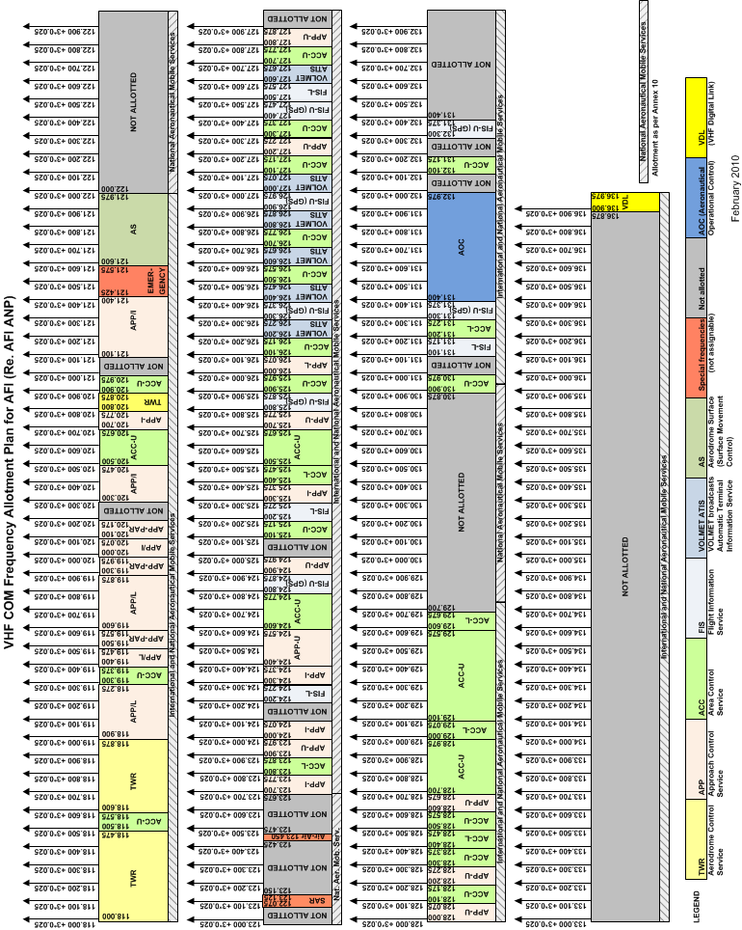
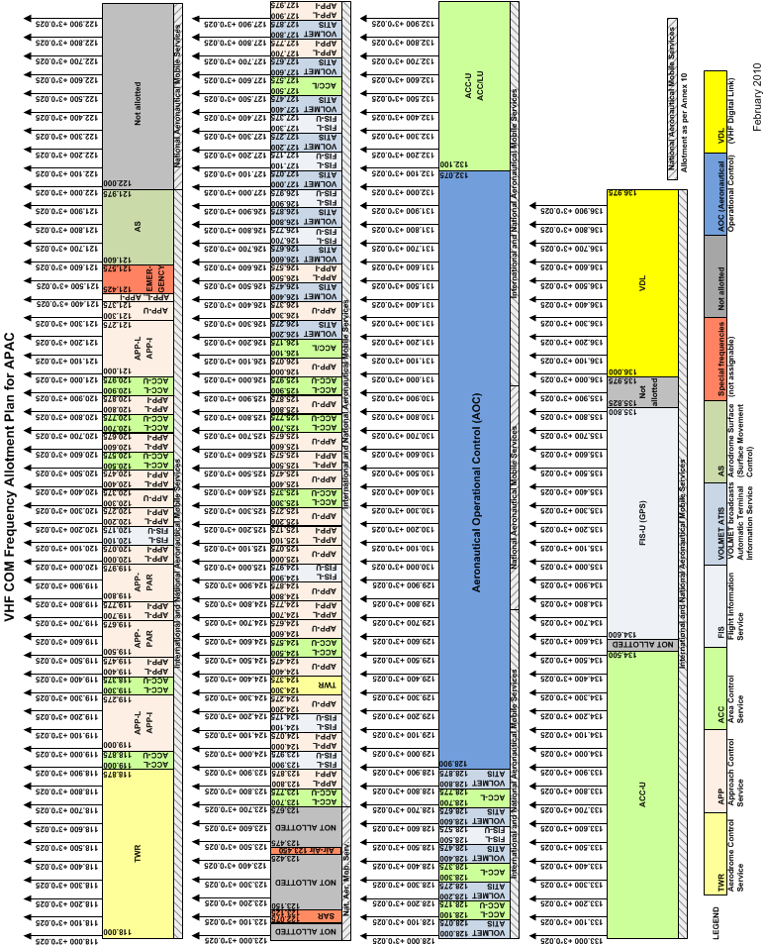
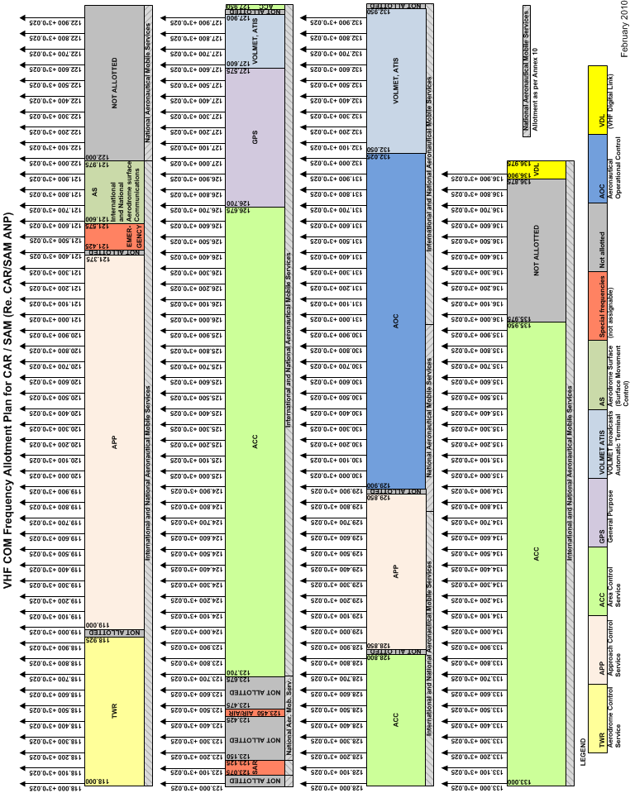
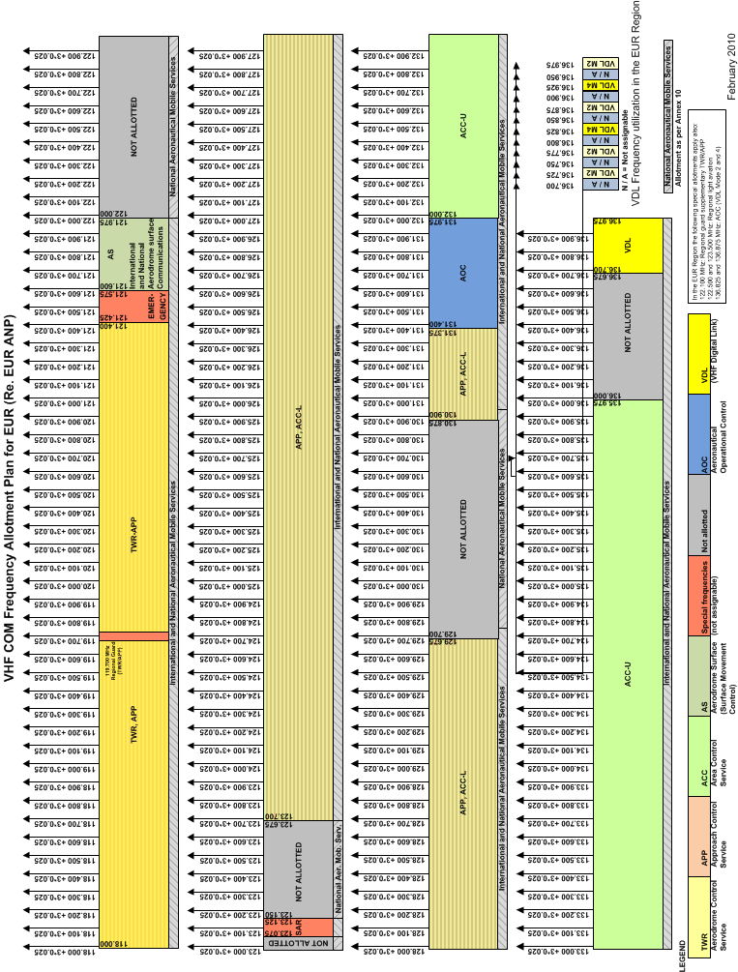

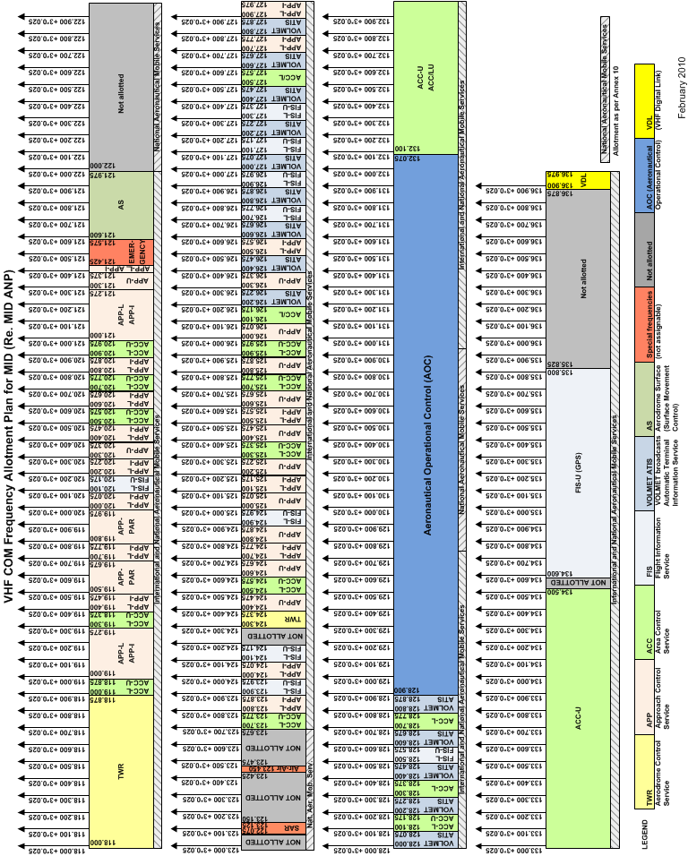

Regional frequency utilization table
The Regional frequency allocation tables referenced in the Handbook Volume II can be downloaded from the website of the Aeronautical Communications Panel at [insert link]
ICAO Regional Offices are encouraged to refer to these allotment tables in the Regional Air Navigation Plans when implementing in the Regional Air Navigation Plans the frequency assignment planning criteria as contained in this Handbook (Vol. II)

----------END----------

APPENDIX E ANNEX 10 VOL V
- END -

