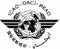 | International Civil Aviation Organization ECCAIRSIII-NI01  South American Office 02/02/2023  ECCAIRS Recurrent Workshop - Phase III (English)  (Lima, Peru, 19 to 23 june 2023)

GENERAL INFORMATION
(Presented by the Secretariat)

- Place and date of the event

The ECCAIRS workshop - Phase III- “Customization”, will be held at the ICAO SAM Regional Office premises at Víctor Andrés Belaunde 147, Centro Empresarial Real, 4th tower, floors 3 and 4, San Isidro, from 24 to 28 November 2014.

- Coordinator

Sr. Daniel Barafani
Experto AIG
Oficina Regional SAM de la OACI
Tel: +511 611-8686
E-mail: icaosam@icao.int
dbarafani@icao.int

- Registration of participants

Participants are required to register in advance with the SAM Regional Office, sending the registration form. A subsequent face-to-face registration will be made from 08:30 to 09:00 a.m. the first day of the event. *Participants must bring their personal computers to perform the exercises.

- About the SAM Office

At the ICAO SAM Regional Office main web page it can be found the “General Information”, “Climate” and “Hotels” sections, please follow this link: https://www.icao.int/SAM/About-SAM/Pages/default.aspx

- Passport, visa and vaccination requirements

It is recommended to contact the Peruvian Embassy or Consulate in your country, to enquire on this requirement well before your departure.

- Money exchange and credit cards

The Peruvian currency is the Nuevo Sol Peruano (S/.). Please follow this link: https://www.gob.pe/13493-consultar-tipo-de-cambio to find out about the current currency exchange rate. Credit cards as American Express, Master Card, VISA, Diners Club, etc., are usually welcomed in hotels, shopping centres and restaurants.

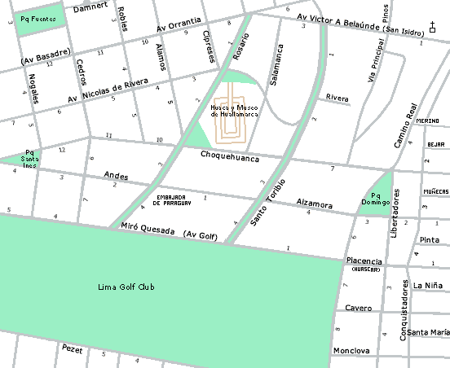
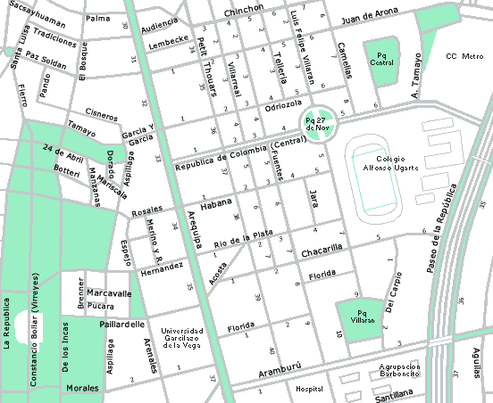
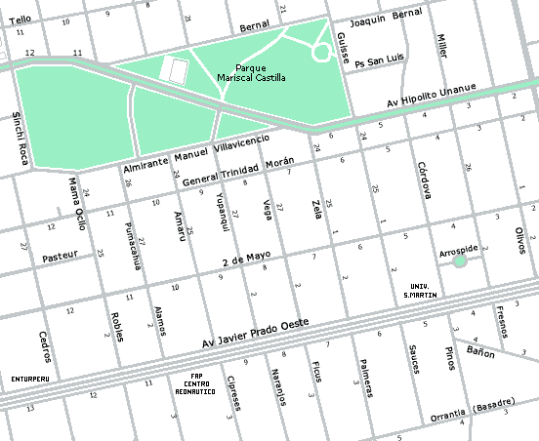
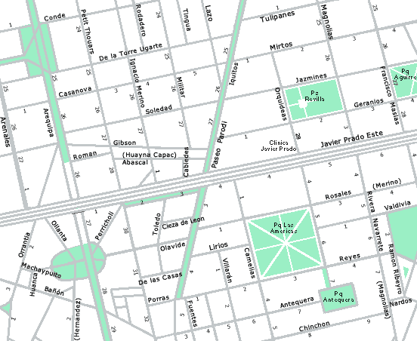
ICAO SOUTH AMERICAN REGIONAL OFFICE LOCATION MAP IN LIMA, PERU
Av. Víctor Andrés Belaúnde 147 - Edificio 4, cuarto piso, San Isidro

