
APPENDIX B
INTERNATIONAL CIVIL AVIATION ORGANIZATION
SOUTH AMERICAN (SAM) REGION

Unmanned Aircraft System Traffic Management (UTM) Concept of Operations

Disclaimer
This document is an unedited version of the unmanned aircraft system concept of operations and has not yet been approved in final form. As content may still be supplemented, removed, or modified during the editing process, the authors shall not be responsible whatsoever for any costs incurred as a result of its use.

Table of Contents
1 Introduction 10
1.1 Need for UTM 11
1.2 UTM Evolution 12
1.3 Scope of the CONOPS 13
1.4 UTM Principles 13
1.5 Purpose of the CONOPS 14
2 UTM Concept of Operations 15
2.1 General 15
2.2 Civil/Military Coordination 17
2.3 Benefits 17
2.4 Architecture 20
2.5 Operations 25
2.6 Roles and Responsibilities 34
2.7 Remote Identification (RID) 34
2.8 Airspace Management 36
3 Operational Scenarios 48
3.1 Scenario Overview 48
3.2 Summary of Scenarios 48
4 UTM Implementation 54
4.1 General 54
4.2 Transition to UTM Implementation 54
4.3 Latin American Initiatives 56
5 Bibliography 60

Tables
TablE 1 - ROLES AND RESPONSIBILITIES 34
TablE 2 - SUMMARY OF SCENARIOS 48

Figures
FIGURE 1 - UTM SYSTEM ARCHITECTURE 20
FIGURE 2 - UTM IN THE CONTEXT OF ATM OPERATIONS. 26
FIGURE 3 - fundamental NEED FOR INTEGRATION OF UTM DATABASES 28
FIGURE 4 - MULTIPLE AREAS OF OPERATION AUTHORISED FOR A UAS OPERATOR 29
FIGURE 5 - IDENTITY AND NETWORK CYBERSECURITY POLICIES APPLICABLE TO UTM 43
FIGURE 6 - SARPAS 57
FIGURE 7 - SISANT 57
FIGURE 8 - airspace ACCESS REQUESTS 58
FIGURE 9 - new structure of the SARPAS system 59

Glossary
Abbreviations and Acronyms
ADS-B | Automatic dependent surveillance - broadcast
AGL | Above ground level
ANAC | Agencia Nacional de Aviación Civil
ANSP | Air navigation service provider
API | Application programming interface
APP | Application
ASBU | Aviation system block upgrades
ATC | Air traffic control
ATS | Air traffic services
ASM | Airspace management
ATM | Air traffic management
BR-UTM | Brazilian UTM
BVLOS | Beyond visual line-of-sight
CA | Certification authority
CAA | Civil aviation authority
CNS | Communications, navigation and surveillance
CONOPS | Concept of operations
CORUS | Concept of operations for European UTM systems
C2 | Command and control link
DAA | Detect and avoid
DECEA | Department of Airspace Control
ERP | Emergency response plan
FAA | Federal Aviation Administration
FT | Foot
FUA | Flexible use of airspace
GPS | Global positioning system
GRAIN | Global resilient aviation information network
HITL | Human in the loop
IATF | International aviation trust framework
IFR | Instrument flight rules
KPI | Key performance indicator
NFZ | No-fly zone
NM | Nautical mile
NOTAM | Notice to airmen
OACI | International Civil Aviation Organization
PBA | Performance-based approach
ANSP | Air navigation service provider
PVR | Priority volume reservation
RA | Registration authority
RID | Remote identification
RID USS | Remote identification service provider
RPA | Remotely piloted aircraft
RPAS | Remotely piloted aircraft system
RPIC | Remote pilot-in-command
RPS | Remote pilot station
SARPS | Standards and recommended practices
SARPAS | Request for access to airspace to use RPAS
SISANT | System for unmanned aircraft
SDSP | Supplemental data service provider
SMS | Safety management system
SORA | Specific operations risk assessment
SSR | Secondary surveillance radar
UA | Unmanned aircraft
UAS | Unmanned aircraft system
UAS-ID | UAS identification
UREP | Unmanned aircraft report
USS | UAS service supplier
UTM | Unmanned aircraft system traffic management
UVR | UAS volume reservation
V2V | Vehicle to vehicle
VFR | Visual flight rules
VLOS | Visual line-of-sight
VLL | Very low level
VMC | Visual meteorological conditions

___________________________________

Definitions
The following definitions apply in this document:
Aircraft - Any machine that can derive support in the atmosphere from the reactions of the air other than the reactions of the air against the earth´s surface.
Unmanned aircraft (UA) - An aircraft which is operated with no pilot on board.
Remotely piloted aircraft (RPA) - An unmanned aircraft which is piloted from a remote pilot station.
Certification authority (CA) - An authority responsible for the digital signature and disclosure of the public key linked to a given entity, with a view to compliance with the identity cybersecurity policies applicable to UTM.
Responsible authority - (i) For flights over the high seas: the appropriate authority of the State of registry. (ii) For flights other than over the high seas: the appropriate authority of the State having sovereignty over the territory overflown.
Registration authority (RA) - An authority responsible for verifying the identity of entities applying for certificates to be stored by the CA.
Data link communications- A means of communication for the exchange of messages using data link.
Detect and avoid (DAA) - The capability to see, sense or detect conflicting traffic or other hazards and take the appropriate action with a view to complying with the applicable flight rules.
Command and control link (C2) - The data link between the remotely piloted aircraft and the remote pilot station for the purpose of managing flight.
Remote pilot station (RPS) - The component of the remote pilot aircraft system containing the equipment used to pilot the remotely piloted aircraft.
Air traffic management (ATM) - The dynamic, integrated management of air traffic and airspace (including air traffic services, airspace management and air traffic flow management) - safely, economically and efficiently - through the provision of facilities and seamless services in collaboration with all parties and involving airborne and ground-based functions.
Unmanned aircraft system traffic management (UTM) - A specific aspect of air traffic management which manages UA operations safely, economically and efficiently through the provision of facilities and a seamless set of services in collaboration with all parties and involving airborne and ground-based functions.
Remote identification (RID) - Is the ability of a drone in flight to provide identification and location information that can be received by other parties.
UA identification - A unique data element that can be traced back to a UA and its operator.
Beyond visual line-of-sight (BVLOS) - An operation in which the remote pilot or UA observer does not use visual reference to the remotely piloted aircraft in the conduct of flight.
Very low level (VLL) - Portion of airspace below that in which VFR is normally used.
Standards and recommended practices (SARPS) - Technical specifications adopted by the ICAO Council in accordance with Article 37 of the Convention on International Civil Aviation in order to achieve the highest practicable degree of uniformity in regulations, standards, procedures and organisation in relation to aircraft, personnel, airways and auxiliary services in all matters in which such uniformity will facilitate and improve air navigation.
NOTAM - A notice distributed by means of telecommunication containing information concerning the establishment, condition or change in any aeronautical facility, service, procedure or hazard, the timely knowledge of which is essential to personnel concerned with flight operations.
RPA observer - A trained and competent person designated by the operator who, by visual observation of the remotely piloted aircraft, assists the remote pilot in the safe conduct of the flight.
Operator - A person, organisation or enterprise engaged in or offering to engage in an aircraft operation.
Remote pilot - A person charged by the operator with duties essential to the operation of a remotely piloted aircraft and who manipulates the flight controls, as appropriate, during flight time.
Remote pilot-in-command (RPIC) - The remote pilot designated by the operator as being in command and charged with the safe conduct of a flight.
Air navigation service provider (ANSP) - An organisation that provides the service of managing the aircraft in flight or on the manoeuvring area of an aerodrome and which is the legitimate holder of that responsibility.
UAS service supplier (USS) - An entity that assists UAS operators with meeting UTM operational requirements that enable safe and efficient use of airspace.
Supplemental data service provider (SDSP) - An entity responsible for the provision of essential or enhanced services, including data such as: (a) terrain and obstacles, (b) specialised weather, (c) surveillance, and (d) constraint information.
Global resilient aviation information network (GRAIN) - Considered as the network of networks interconnecting aviation stakeholders for all information exchanges.
Priority volume reservation (PVR) - Procedure to establish a portion of airspace for the purpose of supporting emergency ground and air operations (air ambulance, search and rescue, disasters) and/or public safety operations, generally of short duration (hours rather than days or weeks), with specified airspace boundaries, as well as established start and end times, by notifying UTM operators of the airspace blocks in which these activities occur.
Note: The definition of priority volume reservation (PVR) is based on the UAS volume reservation (UVR) concept defined by the FAA [1] and does not imply that the volume established is for the exclusive use of unmanned aviation.
Unmanned aircraft system traffic management - A system that provides UTM through the collaborative integration of humans, information, technology, facilities and services, supported by air, ground or space-based communications, navigation and surveillance.
Unmanned aircraft system (UAS) - An aircraft and its associated elements which are operated with no pilot on board.
Remotely piloted aircraft system (RPAS) - A remotely piloted aircraft, its associated remote pilot station(s), the required C2 links and any other components as specified in the type design.
Air traffic management system - A system that provides ATM through the collaborative integration of humans, information, technology, facilities and services, supported by air, ground and/or space-based communications, navigation and surveillance.
Flight termination system - A system that provides the ability to intentionally end the flight in a controlled manner in the event of an emergency.
Note: Flight termination systems are designed to minimise the possibility of injury or damage to people, property or other aircraft on the ground and in the air.
Air traffic control service – A service provided for the purpose of:
- preventing collisions:
- between aircraft, and
- on the manoeuvring area between aircraft and obstructions; and
- expediting and maintaining an orderly flow of air traffic.
Air traffic service - A generic term meaning variously, flight information service, alerting service, air traffic advisory service, air traffic control service (area control service, approach control service or aerodrome control service).
Air traffic - All aircraft in flight or operating on the manoeuvring area of an aerodrome.
Automatic dependent surveillance - broadcast (ADS-B) - A means by which aircraft, aerodrome vehicles and other objects can automatically transmit and/or receive data such as identification, position and additional data, as appropriate, in broadcast mode by means of data link.
Visual line-of-sight (VLOS) - An operation in which the remote pilot or RPA observer maintains direct unaided visual contact with the remotely piloted aircraft.
Restricted area - An airspace of defined dimensions, above the land areas or territorial waters of a State, within which the flight of aircraft is restricted in accordance with certain specified conditions.
No-fly zone (NFZ) - A territory or established area over which flights are not permitted.

Introduction
Unmanned aviation has evolved rapidly and, consequently, the capabilities of so-called drones continue to improve, based on technological evolution. The promising market in this new era of aviation has shown diversified potential, which can be applied in critical infrastructure inspection and monitoring, surveying and mapping, filming and photography, precision agriculture, search and rescue, disaster relief and public safety, among other uses. This accelerated development has led to a boom in the use of this type of aircraft, whether for commercial or recreational purposes.
To exploit this technology to its full capacity, it cannot be limited to visual line-of-sight (VLOS) operations, and a mechanism to allow beyond visual line-of-sight (BVLOS) flight is needed. Furthermore, the air traffic management (ATM) system, as conceived, does not meet the needs of the sector in a cost-effective manner. The concept of an unmanned aircraft traffic management (UTM) system emerges as an effective alternative.
According to the definition adopted by the International Civil Aviation Organization (ICAO) in the document Unmanned Aircraft Systems Traffic Management (UTM) – A Common Framework with Core Principles for Global Harmonization, 3rd [2] UTM is defined as an ATM subsystem whose objective is to manage unmanned aircraft system (UAS) operations safely, economically and efficiently through the provision of facilities and a seamless set of services in collaboration with all parties and involving airborne and ground-based functions. The system will provide a management model through the collaborative integration of humans, information, technology, facilities and services, supported by air, ground or space-based communications, navigation and surveillance.
ATM is a system with more than 75 years of history, whose function is to manage airspace and aircraft operations safety and efficiently, based on airspace design principles and systems operated in cooperation between pilots and air traffic controllers, who have clearly-defined roles and responsibilities. The emerging unmanned aircraft sector offers many opportunities, but to integrate seamlessly into the current system, unmanned aircraft will need to co-exist with the existing aviation systems.
The insertion of new entrants into this well-regulated environment must be done on the basis of risk assessments and proposed mitigation actions, ensuring the safety of other airspace users, people and property on the ground. Privacy, safety, reliability and the environment are additional factors of public interest and must be taken into account by the authorities when implementing and operating the UTM system.
For the development of this concept of operations (CONOPS), the experience of other countries was taken into account, as embodied in documents, mainly the aforementioned Unmanned Aircraft Systems Traffic Management (UTM) – A Common Framework with Core Principles for Global Harmonization, 3rd edition [2], U-space Concept of Operations (CORUS) [3] and FAA Concept of Operations v2.0 [1]. It is important to note that this is a constantly evolving subject, and it is hoped that, like in other countries, the CONOPS will be considered a living and evolving document.
While this document is not prescriptive, it can serve as a basis for States to address, inter alia, issues related to interoperability between UTM and ATM systems, UAS certification and the integration of UAS operations into the ATM environment.

Need for UTM
Integration of UAS in very low-level (VLL) airspace, an environment where operational procedures are based on human ability to maintain safety levels consistent with aeronautical activity, presents a variety of issues and challenges. The volume of UAS operations in this environment can be on a scale comparable, if not greater, to that of manned air traffic, presenting a significant challenge to authorities in the airspace management process.
The VLL environment is defined as the airspace below that used by aircraft under visual flight rules (VFR), as set out in chapter 4, paragraph 4.6 of Annex 2 [4] of the Chicago Convention, as transcribed below:
“Except when necessary for take-off or landing, or except by permission from the appropriate authority, a VFR flight shall not be flown:
a)...
- elsewhere than as specified in 4.6 a), at a height less than 150 m (500 ft) above the ground or water.”
However, to increase the level of safety for manned aircraft, a 100ft buffer zone was established between UAS operations in the UTM environment and aircraft operating VFR above 500ft, limiting the VLL environment to 400ft. Although there are many reasons why manned aircraft may fly in VLL airspace, this does not affect its definition.
Currently, States have authorised, based on Art. 8 of the Chicago Convention, UAS operations, commercial or recreational, by accommodating the described technology. Accommodating, according to ICAO, means restricting the operation to specific conditions (e.g., VLOS, 400 ft, etc.) or to low-risk airspaces (segregated, away from densely populated areas, etc.).
On the other hand, some operators have obtained authorisation from the civil aviation authorities to operate BVLOS or above 400 ft AGL, following a case-by-case assessment. However, this case-by-case approach does not allow the market to be explored to its full potential, preventing operations on a wider scale.
Given the number, type and duration of planned UAS operations, the existing air traffic management system infrastructure and associated resources cannot be economically scaled to provide services to UAS. In addition, the nature of most of these operations does not require direct interaction with the ATM system.
In order to safely manage the expected rapid increase of UAS operations in the airspace, solutions are needed that go beyond the current ATM infrastructure and air traffic control (ATC) personnel resources. Solutions are needed that change the current paradigm of manned aircraft operations, moving towards one that promotes shared situational awareness among operators.
Therefore, the ATM system, as conceived, does not fully meet the requirements of unmanned aviation, calling for the creation of this new management model, whose main function is to provide a cooperative environment that allows for the increase of UAS operations, more specifically BVLOS, in VLL airspace.

UTM Evolution
In Latin America, as in the rest of the world, over the last seven years the UAS sector has undergone a dizzying evolution from military applications to professional and commercial developments in the civil sector.
Day after day, numerous applications for these aircraft are discovered in different economic sectors; creativity and innovation have been the permanent driving force of this industry that has gained great relevance in areas such as agriculture, mining, security and surveillance, topography, fire prevention, cinema and television, energy, construction, transport, search and rescue and recreation, among many others.
The unmanned aviation sector has a huge potential for expansion, which points to great growth in the medium term in the region, where continuous technological development makes available better aircraft to realise the extraordinary prospects for development of the global industry, where drones become fundamental tools in the production and service sectors. Thus, new applications and uses emerge every day which, with their versatility and efficiency, offer clear advantages (economic, ecological and in terms of execution time) over traditional solutions.
In Latin America, the aeronautical authorities of each country have analysed the development of this new technology, and have adopted the provisions of ICAO and other aeronautical authorities. These authorities issued the first regulations for UAS operations. Thus, the first general airworthiness and operational requirements for UAS became known in 2009. This was the first regulatory framework for administrative and operational control of UAS and their safe insertion in the airspace.
The new regulatory framework set forth the administrative procedure to register companies, persons, pilots and equipment before the aeronautical authority. Following this registration and after receiving a document authorising them as UAS operators, they could start their professional or commercial air operation.
The information for registration as an individual or a corporation consisted of the documents of the company or individual, the certificate of the basic UAS pilot course given by an aeronautical training centre authorised by the aeronautical authority, the technical and operational information of the UAS to be used, and the safety management system (SMS) [5].
Following the issuance of these first standards, the process of updating the regulations began, with the aim of adapting the regulations to the technological development of these aircraft and to the demands of the industry. This is achieved by creating direct communication channels with the industry to listen to their demands and by actively participating in the different events related to the UAS sector.
These channels, which involve the use of technological tools (Internet and APP) that allow companies to register, request an operation and obtain subsequent approval by the aeronautical authority, can be considered the first phase of implementation of the UTM system in Latin America.

Scope of the CONOPS
This CONOPS will apply to both VLOS and BVLOS operations conducted in VLL environment, up to 400 feet above ground level (AGL) within controlled and uncontrolled airspace.
This CONOPS is not intended to propose or endorse any specific UTM system design or technical solutions to meet the UTM challenge. Its main objective is to provide a comprehensive framework for such a system. Accordingly, the information contained herein proposes a common set of guiding principles and enabling actions.
With respect to classes of airspace, unmanned aircraft operations may take place in controlled airspace, uncontrolled airspace or in transit across them.
Uncontrolled airspace is the portion of the airspace where no air traffic control service is provided and is therefore classified as Class G airspace. As there is no provision of air traffic control service, manned operations are managed in a cooperative manner and mainly by visual means, based on well-defined principles and rules of operation (Rules of the Air) and applicable to air traffic management (ATM). In order to ensure fair access to airspace, UTM seeks to provide a similar means of cooperative traffic management for unmanned aircraft and other aircraft participating in uncontrolled airspace.
Unmanned aircraft operating in UTM environment in controlled airspace will be subject to authorisation and will not be provided with air traffic control services.
Any UTM system must be able to interact with the air traffic management (ATM) system in the short term and integrate with the ATM system in the long term. The introduction and management of unmanned traffic, as well as the development of the associated UTM infrastructure, should not adversely affect the safety or efficiency of the existing ATM system.
In this respect, a common framework would facilitate global harmonisation of UTM systems and provide a step-by-step approach for integration into the ATM system. This would allow the industry, including manufacturers, service providers and end users to evolve safely and efficiently without disrupting the existing manned aviation system.
For the purpose of this guidance material, in the short and medium term, UTM will be considered as a separate system but interoperable with the ATM environment, while in the long term, integration and potential convergence with ATM is considered as a realistic solution.

UTM Principles
Controlled airspace includes airspace designated as Class A, B, C, D and E, and is characterised by the provision of air traffic control service. This service is based on "pilot x air traffic controller" human interaction (human in the loop - HITL), which is a fundamental characteristic of the ATM system in these environments.
Therefore, for safe and efficient operations, UTM systems must be interoperable and consistent with the ATM environment. While requirements have not yet been developed, some basic principles can be established to guide their development. In addition, the principles currently used in the existing ATM structure are still valid for services provided in the UTM environment. Accordingly, it is proposed that the following principles be taken into account:
- The regulator is ultimately responsible for system oversight, whether UTM or ATM;
- Existing rules for prioritisation of aircraft, such as emergency and support to public safety operations, must remain applicable in the UTM system, and practices unique to that environment must be compatible with those procedures;
- Access to airspace should remain equitable, provided that each aircraft is capable of meeting the requirements of the airspace in which it intends to operate; and
- The UAS operator must be duly qualified to perform the normal and contingency operational procedures established for the airspace in which it intends to operate.
In order to fulfil their oversight and safety responsibilities, the responsible authorities must have unrestricted access, upon demand to UAS operators, to the position, speed, planned path and performance capabilities of each UA in the airspace, through the UTM system.

Purpose of the CONOPS
The purpose of the CONOPS is to describe the conceptual elements associated with UAS operations in VLL airspace that will guide the adoption of solutions by the various parties involved in implementation.
Likewise, the CONOPS seeks to establish a phased implementation approach, through field demonstrations and in a controlled environment, providing the data collection necessary for system maturation. Based on this premise, CONOPS will be updated as necessary to reflect the progress of research and the continued maturation of concepts resulting from collaboration among all stakeholders.
It is possible, and indeed desirable, that additional features, although not considered essential for the safety of operations, are available in the UTM environment. However, once implemented, these services must comply with the principles described above.
In order to describe the requirements associated with the development of the system, the following elements will be addressed:
- UTM concept of operations, which provides the foundational principles around which the system is based, as well as a description of a conceptual architecture and the systemic relationship among all stakeholders;
- Roles and responsibilities of each participant in the UTM environment; and
- Timeline of actions inherent to the development of hypothetical cases in the UTM environment.

UTM Concept of Operations

General
The road towards UTM should run parallel to the guidelines developed in the Global Air Traffic Management Operational Concept (Doc 9854) [7] so that they converge almost seamlessly towards the expected transition. Differences or inconsistencies will appear between the two concepts, accepting UTM as an ATM subsystem, but the threads should be consistent, facilitating their assimilation through the identification and recognition of the same instruments, tools and designs towards a quality end product that incorporates flexibility, ensures equity, promotes collective participation, enables the exchange of reliable information and data, allows interconnectivity to make these available and to jointly choose a more efficient, convenient, environmentally-friendly and cost-effective operation, without departing from the highest safety standards.

UTM System
Considered an ATM subsystem, the UTM system is cooperative in nature, where all participants have a direct impact, and entails a comprehensive use of all its components (technology, facilities, information, data and communication, navigation and surveillance), in which human participation (from the regulator, the oversight entity, the service provider, the manufacturer, external suppliers, to the user) permits a dynamic and seamless interconnection and interaction.

Commitment of the Sectors Involved

UAS Industry
UAS manufacturers and developers must understand the UTM approach and identify its guiding principles in order to focus their attention on incorporating capabilities, navigation, communication, identification systems, with a view not only to VLL, but also thinking ahead to integration beyond this first phase of the CONOPS.
This will permit an initial alignment with the ATM platform, through a non-invasive integration consistent with its requirements and capabilities, and will provide sustainable alternatives towards a common benefit.

Regulatory Bodies
Regional standardisation is urgently needed in terms of the regulatory framework, classification and registration of UAS, certifications and ratings for both unmanned aircraft and their remote pilots, observers and support personnel, certified workshops, risk management, operator certification, DAA and command and control (C2) link, thus enabling the standardisation of these documents (ideally in digital form), the adoption of the use of geo-barriers, mapping and design of airspace structures, identification and oversight of restricted or prohibited areas of operation, agreements with security forces or institutions for the control of documentation and operators. In short, such standardisation would provide added value by allowing equitable, orderly and seamless access to UAS operations across neighbouring States and, at a later stage, at the regional level, as the UTM system evolves.

Operators
The aviation industry as we know it has more than 75 years of evolution, together with standards and recommended practices, which have enabled an efficient, smooth and safe organisation and development.
The so-called drones have emerged thanks to accelerated technological development in recent years, and their applications seem endless. Their easy access brings with it a community of users with little or no aeronautical background. UTM must establish training and eligibility requirements to bridge this gap. Users must be consciously involved in the environment where they intend to carry out their operations, developing situational awareness, identifying hazards, mitigating risks, becoming part of the system, in all its components and in a participatory manner.

External USS Service Providers
The USS service provider is an element that enables operators to meet the operational requirements of the UTM system, providing safe and efficient use of airspace. The USS is an important element in the management of this system and must perform functions such as:
- acting as a communication bridge between UTM system users, in order to support operators' ability to meet the regulatory and operational requirements of UAS operations;
- providing operators with information on planned operations in and around a volume of airspace to enable them to verify their ability to carry out the mission safely and efficiently; and
- archiving, in historical databases, information related to operations for analytical and regulatory purposes.
In general, these basic functions enable a USS network to provide cooperative management of low-altitude operations without the direct involvement of the authorities. The services provided by the USS give UAS operators the ability to plan operations, share flight intentions, resolve strategic and tactical conflicts, monitor operational compliance, provide remote identification, request airspace access authorisation, manage airspace of interest, and consider off-nominal situations.
The USS can provide UAS operators with the following services:
- discovery: allows system-authorised users to identify active USS, as well as services available on the USS network;
- registration: enables operators to register data related to their aircraft; and
- message security: provides data protection, as well as the assurance that data is exchanged only with authorised users.
With the growth of the sector, other needs will emerge, prompting the USS to provide new services.
At present, such applications are under development, but they depend on a cooperative user who voluntarily initiates a communication by launching an "intent-to-fly". In other words, it depends solely on the user's discretion to initiate a link.

Interconnection between Stakeholders
An agile interconnection platform, allowing for real-time exchange of information, protected from malicious interference, capable of transmitting reliable data, that is sustainable, continuous, allowing for different levels of access based on user credentials, could be an investment that the States of the region should consider based on a cost-benefit analysis. However, it would not necessarily be too far away from similar projects within the ATM framework. It depends exclusively on the reality of each State and its projects or investment plans. The UTM system would recommend obtaining such a platform or extending the existing one.

Civil/Military Coordination
The use of UAS in reconnaissance and defence tasks is growing at an accelerated pace. The States of the Latin American region have adopted or are in the process of concluding agreements between these institutions, the ANSP and the aeronautical authority in order to define procedures, based on the type of mission or objective pursued with the use of UAS.
Several types of actions can be identified:
- Defence;
- Surveillance;
- Training;
- Demonstrations; and
- Joint military operation exercises.
In general, it is common to use restricted areas that are included in the national aeronautical information publication, except in defence missions where the procedures defined in agreements take precedence.

Benefits
The harmonised implementation of the UTM system in the Latin American region will create synergies among the States, enabling solutions for the establishment of short-, medium- and long-term strategies.
This approach will allow States to promote, in a harmonised manner, the scalability of safe UAS operations while preserving the safety of other airspace users, people and property on the ground.
Accordingly, efforts are being made to develop operational procedures and requirements for ATM automation systems, with a view to identifying potential conflicts in UAS integration. These concepts, once validated, will ensure seamless interoperability between the two systems (ATM - UTM) and the parties will be sufficiently prepared to coexist, allowing the aircraft to move seamlessly between these two environments in a safe and orderly manner.

For all Stakeholders
The UTM system provides an innovative approach to meeting operational requirements, leveraging the fact that its needs greatly accelerate the commitment to provide services due to market forces and incentives to meet operator demand, while placing a much smaller infrastructure and manpower burden (cost) on the States to implement.
Thus, full implementation of the UTM system will bring common benefits to all stakeholders, including:
- A flexible and extensible structure that can adapt and evolve as the commercial spectrum changes and matures; and
- A structure that allows the responsible authority to maintain its authority over the airspace, while allowing industry to manage operations in areas authorised for low-altitude UAS flight.

For the State
- It provides an integrated approach within the safety framework that brings together most UAS operations (without unduly hampering innovation);
- It gradually expands existing regulations for small UAS operations, initially focusing on less complex operations;
- It provides, in harmonious collaboration with the Region, guidance to enable future, more complex operations;
- It provides, together with an advisory group, risk mitigation expertise through mechanisms for collaboration among stakeholders, both from the industry and the State, to guide safety developments involving new regulations and/or amendment of existing ones;
- It encourages suitable regional assistance for data collection and analysis, and involvement of members of the industry, strengthening the RPAS community's commitment to adopting and implementing safety improvements;
- It matures its regulations based on lessons learnt;
- It integrates, in a participatory manner, the development of new UAS technologies in cooperation between the State and the industry to achieve viable solutions enabling:
- routine UAS operations in VLL airspace;
- coordination and prioritisation of the technical, procedural, regulatory and policy solutions needed for capacity building;
- development of a plan to assist the community concerned in facing new or unprecedented situations when so required; and
- resolution of conflicts between different types of operations.
- It addresses new challenges, developing recommendations for UAS requirements and policies, in response to issues raised, such as:
- unexpected risks to public safety and national security due to the extent of UA operations;
- the need for a robust system that is immune to cyber-attacks, allowing for reliable information sharing; and
- development of a regulatory framework that addresses the right to privacy, accountability and transparency for commercial and private use of UAS.

For the Industry
It allows industry, through cooperation with regulatory authorities, to play a key role in the process of identifying the operational needs of UAS, developing technological solutions that enable scalable operations of this new technology, at very low altitudes, in a safe and efficient manner.

For UAS Operators
One of the main objectives of the UTM system is to create a business environment that allows for scalability of UAS operations, provided the market is fully explored, without impairing the safety of other airspace users, people and property on the ground. UTM will enable many companies to operate, innovate, compete and deliver services in a cost-effective manner.
In addition to managing complex operations at very low altitudes, the UTM system contributes to public acceptance by balancing commercial pressures resulting from the growth of these activities with issues such as:
- nature preservation;
- the health and privacy of individuals; and
- security.

For other Airspace Users
Airspace at very low altitudes may be used by other types of airspace users, such as:
- military aircraft;
- rotary-wing aircraft;
- balloons;
- hang-gliders; and
- parachutists.
Therefore, the UTM system enables safe interaction among all these users, ensuring enhanced situational awareness of all who thrive in, and interact with, this system.

Civil Community
In the absence of a UTM system, UAS operations related to humanitarian aid and emergency response require pre-planning and careful coordination, and it is not possible to use these capabilities in unforeseen situations to assist victims of natural or man-made disasters. Humanitarian missions as a result of a catastrophic event (e.g., a natural disaster causing great urgency) require swift approval to operate and a lengthy CAA filing and review process would be inappropriate and even ineffective.
With the implementation of the UTM system, the operator, in possession of an authorisation to operate, will be able to request, through its USS, the establishment of priority volumes, which will be instantly communicated via the USS network, ensuring that the operations are known to other users participating in this collaborative environment. In this way, civil society will have at its disposal a range of services whose main objective is to safeguard human life.

Architecture
Within the UTM environment, the responsible authority maintains its regulatory and operational authority for airspace and manned and unmanned aircraft operations; however, the operations are not managed by ATC. Rather, they are organised, coordinated and managed by a set of authorised actors in a distributed network of highly automated systems via application programming interfaces (APIs).
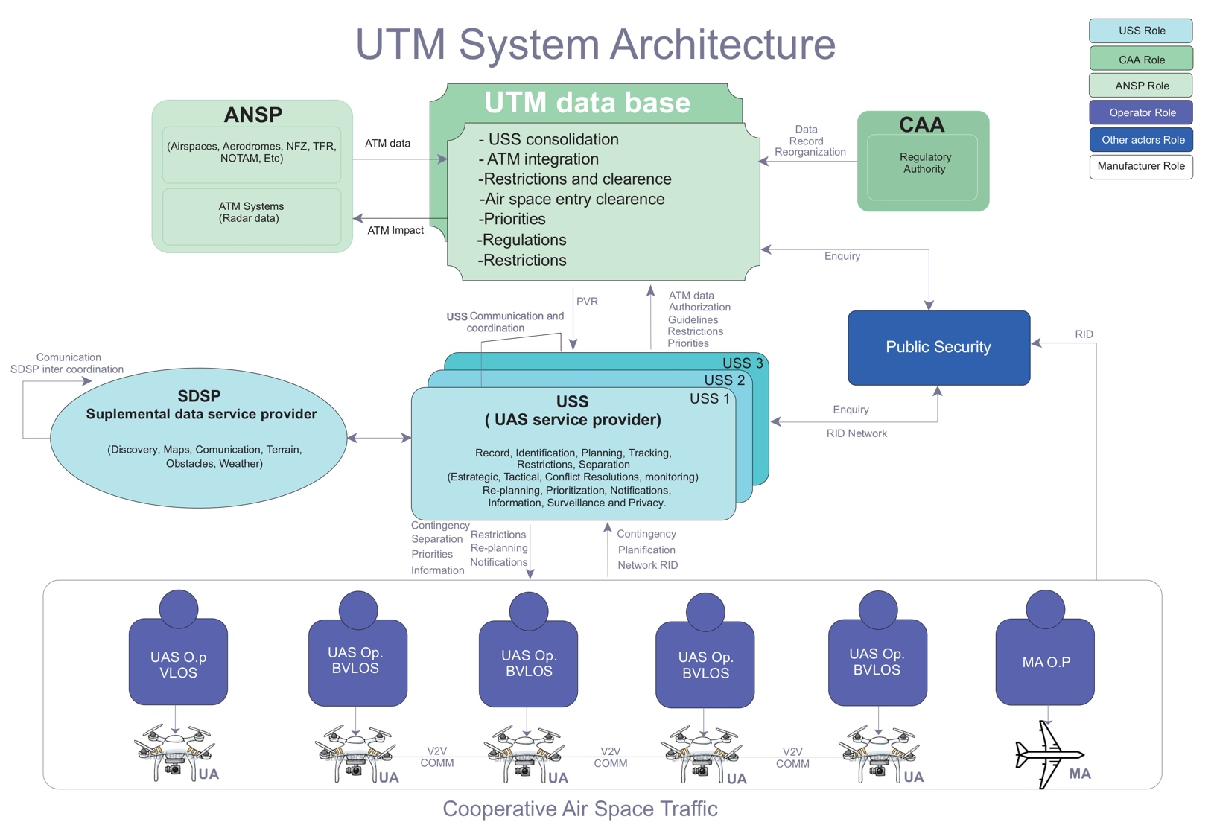
Figure 1 depicts a notional UTM architecture that provides a high-level, graphical identification of the various actors and components, their contextual relationships, as well as high-level functions and information flows.
Figure 1 - UTM system architecture

As shown, UTM comprises a sophisticated relationship between the authority, the operator and the various entities providing services and/or demonstrating a demand for services within the UTM environment. The illustration highlights a model, which heavily leverages utilisation of third-party entities to support the authority and the operator in their respective roles and responsibilities. Sections 2.4.1 and 2.4.2 describe elements of this notional architecture.

Participants and Roles
The UTM environment is seen as a cooperative and digitised ecosystem, in which all actors are expected to interact with each other through a robust and reliable network for information/data exchange, and whose main objective is to provide high situational awareness to all stakeholders. In addition, the responsible authority, when deemed necessary, is expected to interact with the UTM system for regulatory oversight, ensuring that airspace users have access to the necessary resources for safe operation in this complex environment.

Civil Aviation Authority (CAA)
In the context of UTM, the civil aviation authority will be responsible for:
- providing a regulatory framework for the efficient, orderly and safe operation of UAS;
- registering, rating, inspecting and auditing both remote pilots and UAS, certified workshops and training centres;
- issuing proficiency certificates, registration documentation, ratings and limitations to unmanned aircraft, pilots and unmanned aircraft systems;
- defining scope and exceptions;
- defining the requirements to be met by service providers (USS and SDSP), in accordance with the regulatory basis, operational ratings, data transmission security, information accuracy, link requirements, CNS integration, meteorological information, density, capacity, etc.;
- auditing and certifying ANSP processes in UTM; and
- validating ATM-UTM integration processes.

Air Navigation Service Providers (ANSPs)
- provide USS and SDSPs with the operational requirements to be met within the airspace under its management (ASM), such as: airspace constraints, no-fly zone (NFZ), special activity airspace, operational layers or ceilings, geo-barriers, type and quality of data to be provided, additional relevant information, communication channels, etc.
- establish airspace management processes and channels for UAS operations beyond the UTM environment;
- design airspace structures tailored to the operational needs of the sector;
- harness CNS capabilities for efficient and secure exchange of relevant data;
- manage the integration between ATM and UTM systems; and
- participate with the State in awareness-raising programmes, information campaigns, social participation, in aspects of safety, quality, management and transparency.

Operator
The operator is the person or entity responsible for the overall management of their operation. Its role is to meet regulatory and operational responsibilities, plan operations, share flight intent information, and conduct operations in a mindful and safe manner using all available information. Use of the term "operator" in this document is inclusive of airspace users electing to participate in UTM, including manned aircraft operators, except when specifically referred to as one or the other separately.

Remote Pilot-in-Command (RPIC)
The remote pilot-in-command (RPIC) is the person responsible for the safe conduct of each UAS flight. An individual may serve as both the operator and the RPIC. The RPIC adheres to operational rules of the airspace in which the unmanned aircraft is flying; avoids other aircraft, terrain and obstacles; assesses and respects airspace constraints and flight restrictions; avoids incompatible weather conditions and environments; and monitors the flight performance and location of the aircraft. If flight safety is compromised, due to system/equipment degradation or environmental vulnerabilities, the RPIC will be aware of these factors and may intervene appropriately. More than one RPIC may take control of the aircraft during the flight, provided that one person is responsible for the operation at any given time and is identified.

Other Stakeholders - Public Safety and General Public
Other stakeholders can also access information and/or utilise UTM services via the USS network. Stakeholders include public safety entities and the general public. Public safety entities, when authorised, can access UTM operations data as a means to ensure safety of the airspace and people and property on the ground, security of airports and critical infrastructure, and privacy of the general public. Data can be accessed through dedicated portals or can be routed directly to public safety entities upon request. Data in the public domain can be accessed by the general public.

Services and Supporting Infrastructure
UTM services are modular and discrete, allowing for increased flexibility in the design and implementation of new services. This modular approach allows the authority to provide tailored oversight of services in order to strike a balance between providing State oversight and spurring industry innovation.
At the most basic level, services may be characterised in one of the following ways:
- services that are required to be used by operators due to regulations issued by the responsible authority and/or have a direct connection to their systems. These services must be qualified by the responsible authority against a specified set of performance rules;
- services that may be used by an operator to meet all or part of a regulatory or operational requirement. These services must comply with specific policies and must be individually approved by the responsible authority; and
- services that provide additional assistance to an operator, but are not used for regulatory or operational compliance. These services may meet industry standards, but will not necessarily be qualified by the authority. The format of these additional services must have a standard structure to achieve uniformity in their presentation by each and every provider.

UAS Service Supplier (USS)
A USS is an entity that assists UAS operators with meeting UTM operational requirements that enable safe and efficient use of airspace in accordance with the regulatory framework.
The USS is an important link in the management of this system and must perform functions such as:
- acting as a communication bridge between the associated UTM actors to support operators’ abilities to meet the regulatory and operational requirements for UAS operations;
- providing information about planned operations in and around a volume of airspace, so that operators can ascertain the ability to safely and efficiently conduct the mission; and
- archiving operations data in historical databases for analytics, statistics, accountability assessment, or others purposes of interest to users, companies or manufacturers.
In general, these key functions allow for a USS network to provide cooperative management of low-altitude operations without direct authority involvement. However, they may be available to the authority for research purposes.
USS services support operations planning, intent sharing, strategic and tactical de-confliction, conformance monitoring, remote identification (RID), airspace authorisation, airspace management functions, and management of off-nominal situations. Likewise, these services exchange information with one another over the Internet or other compatible and certified platform to enable UTM services (e.g. exchange of flight intent information, notification of airspace changes, etc.).
The USS may provide UAS operators the following services:
- services that enable authorised UTM stakeholders to discover active USSs and their available services within the USS network;
- services enabling vehicle owners to register data related to their UAS;
- services for USS registration; and
- message authentication to ensure data is secured and exchanged only with authorised users.
The USS may also provide other additional services to support UTM participants as market forces create opportunity to meet business needs.

USS Network
The term "USS network" is the amalgamation of USSs connected to each other, exchanging information on behalf of subscribed operators. The USS network shares operational intent data, airspace constraint information, and other relevant details across the network to ensure shared situational awareness for UTM participants. In the UTM structure, multiple USSs can operate in the same geographical area.
The USS network must implement a shared model, with industry agreed-upon methods for de-confliction and/or negotiation, and standards for the efficient and effective transmission of intent and changes to intent. This reduces risk to operators and improves overall capacity and efficiency in the shared space.
The USS network is also expected to facilitate the ready availability of data to the authority and other entities as required to ensure safe operation in the airspace, and any other collective information sharing functions, including security and identification.

Supplemental Data Service Providers (SDSP)
Operators and USSs can access supplemental data service providers (SDSPs) for essential or enhanced services, including terrain and obstacle data, specialised weather data, surveillance, and constraint information. SDSPs may connect to the USS network or directly to operators through other means (e.g., public/private internet sites).

UTM Database
The UTM database has the function of establishing an interface between UTM system users and the various governmental agencies with the objective of sharing data necessary for the safety of operations. Through the UTM database, authorities share airspace constraint data as well as interact with the UTM system, accessing on request information related to the status of operations. The UTM database also provides a means for public or private entities, through an access policy established by the responsible authority, to query and receive data for purposes of incident or accident investigation and compliance audits.

Airspace System Data Sources
Airspace data provided by the responsible authority is connected to the UTM environment through a UTM database. This allows for flow of essential and discrete data across the UTM community. Furthermore, access to shared data is only allowed for authorised users. The database interface between the authority and UTM stakeholders external to the authority acts as a gateway such that external entities do not have direct access to authority systems and databases. Access to this database is restricted, that is, it can only be used under licence of the owner, being permeable the data voluntarily made available to meet the needs of the UTM system.
The data sources that may be connected to the UTM database for information exchange purposes include UAS registrations, airspace authorisations, operational waivers, and constraints.

Operations
One of the main premises of the UTM system is that users will cooperate and operate in accordance with the appropriate operating rules and procedures for their operations. The various services provided in this ecosystem are mainly aimed at allowing, through information exchanges, operations to be conducted safely and in accordance with the safety levels established for manned aviation.
The UTM system supports the management and safe conduct of operations through:
- the issuance of operating authorisations in accordance with the operational requirements of the intended airspace;
- the issuance of flight permit categories, depending on whether it is for controlled or uncontrolled airspace;
- facilitating operations planning (strategic phase), based on flight intent data made available to the users;
- notifying and disseminating airspace constraint information, identifying active priority volumes (PVR);
- versatile information in the face of unforeseen restructuring of the priority volumes established under special conditions or circumstances arising from unforeseeable events (e.g., intervention of public forces or emergency response); and
- de-conflicting capability.

Participation
A robust UTM system ensures equitable, safe and efficient interaction at all times, provides data, information, maps, operational limits, quality and availability of priority volumes that allow operators to self-manage their flight needs, helping them to identify their environment, generating, in a broad sense, situational awareness that enables them to detect and evade other UAS and manned aircraft, understanding that this is an unavoidable and primary responsibility during the operator's tactical phase.
Therefore, all UAS operators not receiving ATC separation services are required to participate in the UTM system at some level, using applicable services to meet the performance requirements of their operations. The number and type of services required vary based on the type and location of the intended operation and the associated communication, navigation, and surveillance (CNS), and other operational needs.

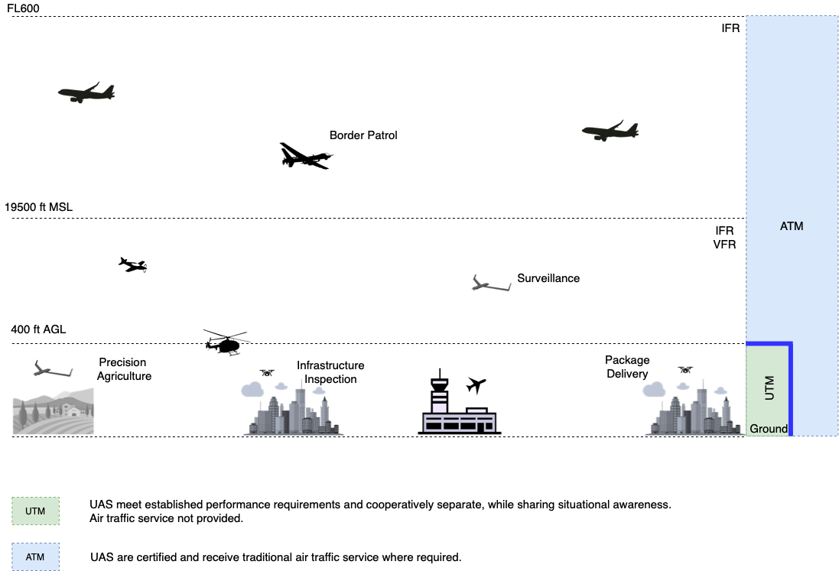

Figure 2 - UTM in the context of ATM operations

BVLOS UAS Operators
To date, most BVLOS operations are not able to identify and visual separate from other UAS and manned aircraft. It is expected that UAS manufacturers and service developers will adopt tools compatible with the corresponding communication, navigation and surveillance (CNS) capabilities and with those adopted for the ATM environment. However, this document refers to very low-level (VLL) operations, and thus, an approach outside of this block should be envisaged exclusively for the ATM environment, requiring management based on those principles, involving airspace reservation or segregation and the respective NOTAM publication. In a first stage, the UTM system can only provide information regarding the channel and the way to request authorisation for that type of operation.
Therefore, BVLOS operators must use UTM services to enable their operations, including, inter alia:
- UA registration data;
- remote identification (RID) transmission;
- priority volumes;
- identification of other UAS operators involved in each priority volume established;
- strategic de-confliction through the sharing of flight intent and negotiation;
- monitoring of flights and their conformance to flight intent;
- notification/alerts of in-flight conflicts;
- in-flight rerouting options;
- weather; and
- navigation and surveillance.

VLOS UAS Operators
Unlike BVLOS operation, VLOS flights allow the UAS operator to visually manage conflicts. Given that the ability to safely operate VLOS is not predicated upon data exchanges with other UTM system participants, the use of UTM services will be directly related to meeting existing requirements and legislation. Recreational or non-recreational operators performing VLOS flights must meet requirements related to aircraft registration, remote identification, and obtaining airspace authorisation for flight in controlled airspace. The operators satisfy such requirements through use of the services provided by the responsible authority, or through a USS that has been qualified to provide said services.

Manned Aircraft Operators
Manned aircraft operators are not required to participate in UTM, but may, and are encouraged to voluntarily do so to obtain the safety benefits that are gained from shared awareness among airspace users. Manned aircraft operators have access to information regarding the conduct of UTM operations and can voluntarily participate at different levels:
- Passive participation - Manned aircraft operators use information from the USS network (flight intent of UAS operators) to gain situational awareness of nearby operations and plan their activities, but do not make available their flight intent information to UAS operators; and
- Active participation - Manned aircraft operators make their flight intent available to other UTM participants via the USS network, fostering situational awareness for other participants with active operations near their own.
Furthermore, manned aircraft operators may actively participate in the UTM system, without the need to connect to the USS network, by simply equipping their aircraft with features that will make them detectable by other airspace users, such as:
- ADS-B; and
- remote identification.

Performance Authorisation

Fundamentals
The advent of unmanned aircraft has turned us towards a different approach to airspace management than we have had for 75 years. Flight rules, separation techniques, communication, navigation, performance and surveillance requirements together make for a robust and safe manned air traffic management system. Today, this know-how and processes, while a starting point, do not allow for the full integration of UAS operations.
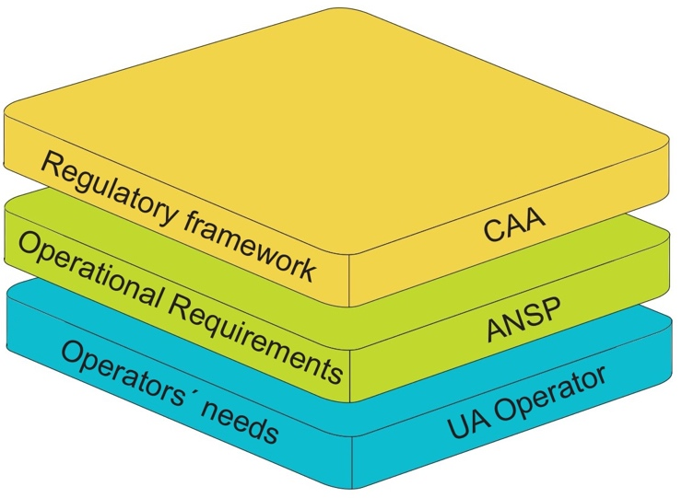
Successful operations in a UTM environment will depend on a correct initial identification of the needs of three key parties, as shown in Figure 3: the UAS users or operators, the air navigation service provider (ANSP) and the civil aviation authority (CAA) or regulator. The product that responds to these needs will become a "performance authorisation", which cannot be managed in the traditional way or through the channels we currently use to conduct manned aircraft operations. It becomes essential to incorporate new players to effectively manage this product, using new platforms for communication, identification and data exchange. Thus, related third parties emerge to consolidate rules, processes, essential information, requirements, limitations or restrictions and make them available to the UTM system. These are the USSs and SDSPs. The next step is to non-invasively integrate the ATM and UTM systems as far as their compatibility allows, taking advantage of the benefits of CNS management. USSs shall take into account variability, while preserving safety and equity in the airspace.

Figure 3 - Fundamental needs for integration into UTM database

In UTM, the ANSP, the CAA and the USS are jointly responsible for ensuring interoperability of the system actors. Interoperability in UTM focuses on how data is exchanged and interpreted. A common understanding of CNS requirements among actors is critical to the overall safety case. Depending on the overall risk of the underlying operation, substantiating data may be required of the applicant.

Obtaining a Performance Authorisation
The performance authorisation concept provides operational criteria for the assessment of different and emerging technologies, geared to the evolution of operations. Once the criteria have been established and accepted, the operation, including technical and human performance, and even its feasibility, can be assessed against these operational parameters.
Operations in the UTM environment will take a similar approach, requiring the issuance of performance authorisations related to communications, navigation and surveillance (CNS). UAS operations present a wide range of CNS performances, considering the many types of aircraft and operations envisaged. The expectation is that this variation will be managed by the USS, through the provision of differentiated services. The USS will need to take into account the different CNS performances, ensuring equitable access to airspace, without impairing the safety of other users, people and property on the ground.
Operators are required to obtain a performance authorisation from the responsible authority prior to conducting a class or type of UTM operation. The performance authorisation will be granted to operators that substantiate to the authority their ability to meet the requirements established for the intended airspace. Performance authorisations are envisioned to provide credibility, stability, uniformity and accountability to operators participating in the UTM environment.
Each performance authorisation request must demonstrate compliance of the overall system, including air and ground assets, USS/SDSP services, personnel, suitability, procedures and capabilities associated with the applicable performance requirements, as well as the ability of the system to maintain the aircraft within a specific operating volume, notify deviations or adverse conditions and de-conflicting.
The aggregation of performance authorisations leads to the creation of authorised areas of operation, with defined geographical boundaries. It is possible to have access to more than one authorised area of operation under a single performance authorisation. Different levels of performance may be required based on the underlying airspace infrastructure.
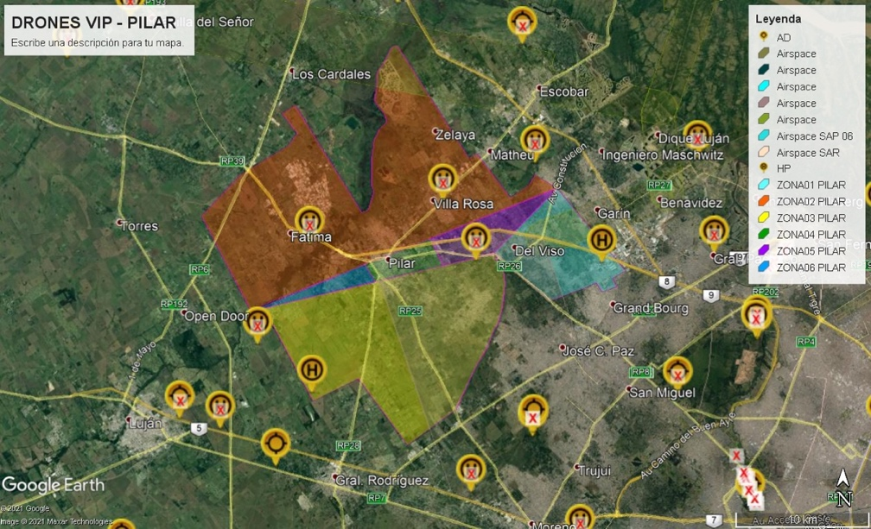
The universe of operators is expected to obtain from the USS network the data that will lead to an efficient and safe operation, with authorisations being issued based on variables of capacity, proximity, detect and avoid (DAA) resources, obstacle or hazard identification, proximity to predefined airspaces containing and conducting manned flights.

Figure 4 - Multiple areas of operation authorised for a UAS operator
The authorised areas of operation will vary in complexity and access requirements based on the airspace involved, geographical location, demographic density, accessibility to USS networks, availability and reach of USS and SDSP servers, communication and data exchange effectiveness, demand and capacity. All this information must be provided to the UTM system by the USS and SDSP. It will also depend on a prior analysis of probability data on the likelihood of a conflict or incident occurring, supported by risk analysis data. This criterion incorporates questions such as: How likely is it to occur; how often is it likely to occur; what would be the severity of the conflict or incident; and what would be the likelihood of a conflict or incident occurring?
The "static" information available in the UTM system can be provided by the CAA and the ANSP, based on the design of existing airspace structures. These structures are subject to continuous updating and may be modified as a result of redesign or new requirements. The UTM system must provide for this possibility and articulate a process for reporting and updating the information.

Airspace Authorisation
All UAS operators conducting UTM operations must obtain ANSP authorisation when operating within the bounds of controlled airspace. This authorisation is referred to as an airspace authorisation and is separate from a performance authorisation.
The performance authorisation substantiates an operator’s ability to meet flight performance capabilities in the intended area of operation, while the airspace authorisation grants access to operate in controlled airspace and provides the air traffic facility with jurisdiction over the airspace and access to information about operations being conducted. An airspace authorisation grants an operator access to controlled airspace for a limited period of time, typically short term.
UTM operators can apply for airspace authorisations directly through ANSP systems or they can use a CAA-qualified USS to provide automated authorisation services.
USSs qualified to provide airspace authorisation services identify operations that require airspace authorisation (i.e. identify any portion of operation intent that lies in controlled airspace). USSs notify operators of the need for ATC authorisation and support.

Operation Planning
With UTM, flight intent is submitted and shared among operators for situational awareness in the form of an operation plan. In this regard, it differs from a “flight plan” that is propagated through ATC automation systems for aircraft operations managed by the air traffic control service.
The operation plan is developed prior to the operation and indicates the four-dimensional volume of airspace within which the operation is expected to occur, the times and locations of the key events associated with the operation, including launch, recovery, and any other information deemed important (e.g. segmentation of the operation trajectory by time). While a single volume can be used, segmentation of that four-dimensional volume promotes the efficient use of airspace and reduces the likelihood of overlapping operations.
The operation plan as proposed may be impacted by other planned operations (e.g., overlapping airspace volumes), airspace constraints (e.g., airspace restrictions, special use airspace, NOTAMs, UAS volume reservations), or ground constraints (e.g., public gatherings, sensitive areas, obstacles), therefore the operator must assess all appropriate information affecting the planned operation and make amendments to the plan as applicable. The operator identifies operational conflicts and strategically “de-conflicts”, potentially via the capabilities provided by the service providers (USS) (e.g., operator collaboration and de-confliction algorithms) designed to provide fair access to the airspace.

Following this sharing of intent to the USS network, the operator’s USS continues to offer de-confliction support up to the start of the operation.

Constraint Information and Advisories
UAS operators are responsible for identifying unexpected operational conditions or flight hazards that may affect their operation. This information is dynamic and constantly updated, collected and assessed both prior to and during the operation in order to ensure the safe conduct of the operation. The USS must support this operator responsibility by supplying airspace constraint and advisory information, weather and other relevant data.
Near real-time advisories are provided through the USS network, and are made available to affected users regarding:
- traffic (e.g., aircraft known and unknown that may represent a hazard for the operation, as well as non-conforming operations);
- weather and winds (gusts that could exceed the operating capacity of the aircraft); and
- other hazards pertinent to low altitude (e.g., unexpected obstacles such as a crane or power-line NOTAM, bird activity or migratory information, local UAS restrictions, or other specific hazard information.
The static and dynamic information made available on the network comes mainly from the USS and/or the SDSP. UA operators may participate in the distribution of information through a report, advising of specific phenomena or conditions experienced or encountered first-hand. The FAA [1] has termed these reports as "unmanned aircraft reports (UREPs)", comparable to “manned aircraft pilot reports (PIREPs)". These reports, as well as the type of information to be reported, should be in a standard format, achieving a harmonised and clear criterion for the handling of this type of information.
UAS priority volume reservations (PVRs) may be established when activities on the ground, or in the air, present a potential risk to UTM safety interests. PVRs are designed to support safety of transient flights (e.g., police activity, emergency response, public safety) by notifying UTM operators about blocks of airspace in which these activities occur. PVRs are generally short in duration, have specified airspace boundaries, and have an established start and end times. A USS that has been qualified to provide PVR services creates and routes PVR data through the USS network to notify affected operators and stakeholders.

Separation
UTM operators are directly responsible for maintaining separation from other aircraft, airspace, weather, terrain, and hazards, and avoiding unsafe conditions throughout an operation.
Separation is achieved through efficient management aimed at sharing flight intent, creating collective situational awareness, strategic de-confliction of airspace volumes (planning and negotiation), aircraft trajectory tracking and conformance monitoring, tactical de-confliction, and establishing rules of the road (e.g., right-of-way rules).

Operators/RPICs (if separate entity) are responsible for remaining within the bounds of their flight volume(s) and tracking the aircraft location during all phases of flight, while meeting required performance criteria for the operation performed. Operators monitor for vehicle non-conformance and/or on board equipment failures or degradation (e.g., lost link, engine failure).
For situations where corrections cannot be made, operators are responsible for notifying affected airspace users as soon as practical and executing a predictable response.
The USS can assist the operator in providing path tracking and conformance monitoring capabilities and notifying affected airspace users when a particular off-nominal event occurs causing a deviation from the original flight intent. Such events, when they jeopardise the operation of manned aircraft or require ATC intervention, must be immediately communicated by the USS to the ANSP for action to be taken to protect manned air traffic. This link should be channelled through the UTM database.
The operator is responsible for in-flight coordination with other operators, and can use services of a USS to facilitate this coordination. The operator’s performance authorisation may require on-board communications, navigation, and detect and avoid (DAA) equipment to maintain separation tactically. In the event intent needs to be updated in-flight, USSs will accommodate operator updates.
USSs and/or SDSPs support the operator by supplying weather, terrain, and obstacle clearance data specific to the area of operation during the pre-flight planning phase to ensure strategic management of the UTM operation, as well as in-flight updates ensuring separation provision. The USS maintains and provides near real-time and forecast weather information for the region. Operators monitor weather and winds throughout flight. In the event their aircraft performance is inadequate for flight in current or forecast weather, operators take appropriate action to safely land as soon as practical and possible.
Using in-flight connection capabilities, operators also monitor terrain and obstacle data to ensure the aircraft does not collide with the ground, wires, terrain, mountains, or other obstacles. Data providers maintain and provide the most current terrain/obstacle databases in order to develop accurate avoidance information for UTM operators.

Contingency
Contingencies may be related to UTM and UA failures. While it is possible that a UTM contingency procedure may affect UA operations, a UA contingency or emergency should not trigger a specific contingency procedure for the UTM system.

Contingency Plan

For UTM Services
UTM providers must define and implement contingency plans in the event of disruption, or potential disruption of the UTM system or related supporting services. The objective of contingency planning is to assist in providing for the safe and orderly flow of UA traffic in the event of disruptions of the UTM system and related supporting services. Contingency planning is an important means to mitigate risks.
A contingency plan goes into effect if the service shows poor behaviour or if the service plausibility check detects that input data from external sources is missing (incorrect or with high latencies). As a precondition, the service itself must be stable, under control and capable of detecting such occurrences.
An example would be where the monitoring service detects inconsistent data from the tracking service, so it gives the respective warning to impacted users through the USS network.

For UAS Operators
A contingency plan for the operator is a backup plan (Plan B), which describes the procedures to follow in a possible incident. It aims to maintain the safety levels of the operation in the event of possible degradation of the systems involved (UTM and UAS).
An example would be a failure of the GPS navigation system, requiring the remote pilot to switch to manual navigation mode and take control of the aircraft. For operators that have developed an operations manual, contingency planning for off-nominal situations must be part of the standard operating procedures.

Emergency

For UTM Services
A UTM service emergency comes into force if the service is out of control or is completely lost.

For UAS Operators
An emergency for the UA operator is an incident or accident that causes the UA to be out of control.
An example would a failure of the GPS navigation system, causing the UA to be out of control, so the pilot deploys the parachute (flight termination).
For operators that have developed an operation manual, an emergency procedure for such an off-nominal situation must be part of the standard operating procedures. The operations manual may include the Emergency Response Plan (ERP) to minimise the escalating effects of an out-of-control operation.

Roles and Responsibilities
The table summarises the roles and responsibilities of the UA operator, USS and responsible authority associated with a UTM operation.
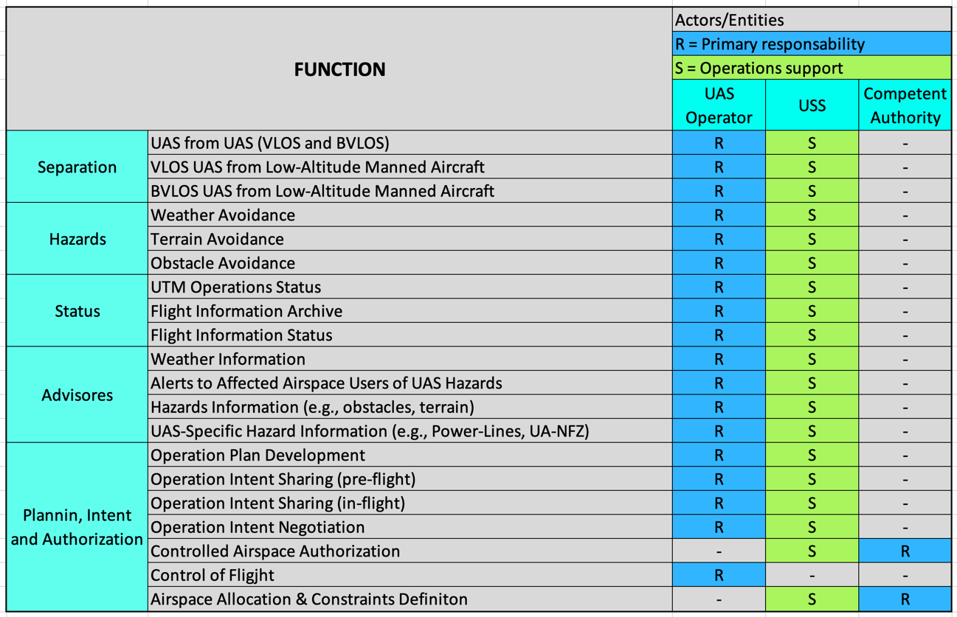

Table 1 - Roles and responsibilities

Remote Identification (RID)
Remote identification provides a means to address public concerns and protect for public safety vulnerabilities associated with low-altitude UA operations, including privacy and security threats. RID allows electronic identification of a UA/operator through use of a unique identifier (similar in concept to an automobile licence plate), eliminating anonymity and preserving the operational privacy of remote pilots, companies and their customers.
RID enables accountability and traceability, particularly for BVLOS operations, where an operator and aircraft are not co-located. USSs that provide RID services process and distribute RID data to the general public, law enforcement, the authority, and other public officials according to protocols established by the responsible authority.
Public officials, with a need to know, have credentials that give them access to an expanded set of data compared to the general public.
RID uses a combination of technology and services to identify UAs and associated operators who may pose safety, security, and /or privacy concerns to the public. As a member of the independent service provider system exchanging information across a common network, the UTM architecture supports RID through various means, including:
- providing the architecture, infrastructure, and services by which operators transmit RID information through network publishing; and
- providing services by which authorised persons may obtain information relevant to public safety concerns.
RID is predicated upon transmission of a set of information that enables a recipient to determine location and establish traceability back to a UAS operator/RPIC responsible for a specific aircraft. It is assumed that there is a minimum set of information that operators transmit that is publicly accessible, termed an RID message.
For the purposes of this document, it is assumed that the RID message elements include, at a minimum:
- a unique identification number - UA ID;
- UA location; and
- a timestamp.
The information in the publicly accessible RID message may be used by authorised entities to obtain additional information relevant to public safety. While rules regarding RID for UA are still under development, two methods are recommended for UA to transmit RID and tracking information:
- Direct broadcast [8]: transmission of radio signals directly from the UA to recipients in the vicinity of the UA. Data can be received by anyone within broadcast range;
- Network publishing [8]: transmission via the Internet or a remote identification service provider that interacts directly or indirectly with the UA or with other sources in the case of non-equipped network participants. Customers can access the published data to obtain UA identification and tracking information.
An operator transmitting via the public network sends an RID message to a USS that has been qualified by the authority to provide RID services - termed RID USS. The RID USS makes the RID message available to all other RID USSs, and vice versa, such that the complete set of messages held by the various USSs comprises a distributed database. The general public may utilise services provided by RID USSs. An example of a potential service would be a cell phone application supporting queries to publicly-accessible data.
Any query through a single RID USS results in a return of all transmitted RID messages that conform to the bounds of the query, regardless of the original RID USS that received each transmission. Additionally, the authority is able to query RID USSs via the USS network for relevant RID messages when such information is needed.
Authorised public safety entities that need to obtain information beyond the publicly-accessible RID message elements are able to query the USS network. A USS that has been qualified by the authority to provide public safety services may have increased access-to-information privileges within the USS network, compared to USSs not providing public safety services. For example, an authorised law enforcement officer may subscribe to a public safety USS, which could support queries to the USS network for information relating to a submitted UAS ID. USSs that have or provide services to the operator tied to the UAS ID will provide information back to the public safety USS commensurate with the level of information access associated with the requesting law enforcement officer, which could include operator name and contact information.

Airspace Management
UTM is designed to ensure UA operations are authorised, safe, secure, and equitable in terms of airspace access. UTM imposes requirements on operations and performance commensurate with operator, aircraft, services, operational environment, and airspace class considerations. Airspace management is predicated on a layered approach to safety, security, and equity of airspace access through the following:
- performance authorisations and certifications that ensure operators, equipment, and USSs meet the appropriate capability and performance requirements for the operations planned;
- airspace authorisations that provide situational awareness to air traffic management stakeholders of UTM operations in controlled airspace;
- strategic traffic management of operations through interactive pre-flight planning;
- separation provision through de-confliction services and in-flight conflict alerts to UTM participants, including aircraft intent, airspace constraints, and hazards using DAA for appropriate guidance;
- contingency management through operation planning, coordinated procedures and response protocols, and pre-programmed system or aircraft responses to flight anomalies;
- near real-time notifications of airspace constraints and advisories that safeguard the safety of the airspace;
- obstacle and aircraft avoidance through the use of appropriate ground-based or on-board equipment, including collision detect and avoid (DAA); and
- identification of aircraft operators and UAS/RPICs through RID information exchanges.
In addition, security of the airspace is ensured through airspace data and system protection, as well as through the collection, maintenance, and provision of identity information for UTM operations, aircraft and operators through RID, aircraft registration, operator logs, USS services, and appropriate aircraft identification mechanisms. Finally, equity of airspace access for UTM operations is fostered through operation orchestration and operator negotiation to optimise airspace use among the participants.

Safety
Safety refers to the safety of people and property on the ground, as well as in the air. UTM has multiple layers of separation assurance to ensure the safe conduct of operations, from strategic flight planning and management tools to tactical aircraft and obstacle avoidance capabilities.

Strategic Management of Operations
UTM operations can be strategically managed through interactive planning and orchestration of intent information as well as relevant environmental considerations that enable strategic de-confliction for multiple UAS operations. Operation intent sharing, strategic de-confliction, airspace constraint evaluation, weather reporting and forecasting capabilities, and other key supporting features of UTM reduce the need for tactical separation management and reduce the likelihood of in-flight intent changes due to weather or airspace restrictions.

Operators planning to fly beyond visual line-of-sight (BVLOS) are required to share operation intent with other operators/airspace users via the USS network. Intent data predominantly consists of the spatial and temporal elements of an operation. At a minimum, operation intent includes operation volume segments that make up the intended flight path. Operation volumes are four-dimensional blocks of airspace that have specified entry and exit times for the operator’s UA. These volumes may be stacked in sequence such that one volume’s exit time coincides with the entry time of an adjacent volume along the flight path. The result is that each operation volume in the sequence comprises a segment of the overall flight profile.
Operation volumes are contained within the operator’s authorised areas of operation, as defined in their flight intent. UAS performance capabilities will typically determine the size of operation volume segments, with UAS of higher navigational performance being able to maintain flight within smaller navigation volumes as compared to lower-performance UAS. Navigational performance requirements may be more stringent in certain airspace during periods when traffic density/operational tempo is high. UASs assist in managing and minimising overlap of operation volume segments when necessary, with the goal of maintaining separation through strategic de-confliction.
Intent information is made available by operators to UTM participants and other airspace users via the USS network to promote situational awareness and support cooperative interactions.
Operator data submitted during the planning stage does not need to be pre-verified with records for compliance at the time of submission (e.g., compliance with provisions for authorised areas of operation, pilot certifications, use of specified equipment/technologies).
Tactical de-confliction methods--the next layer of separation--are necessary when strategic de-confliction alone is not adequate to support the safety of operations (e.g., operations in areas with dense air traffic) or people/property on the ground.
Intent data serves several primary functions:
- it informs other operators, manned and unmanned, of nearby operations to promote safety and shared awareness;
- it enables de-confliction of operating volumes (i.e., strategic separation); and
- it supports monitoring and tracking.
USSs can also utilise elements of operation intent (e.g., operation volume location and entry/exit times) to enable automatic distribution of spatially and temporally relevant advisories.
Constraints, weather, and the exchange of supplemental data assist operators in determining whether environmental conditions or other factors encountered are suitable for the flight at the planned location at the specific date and time (e.g., weather and wind forecasts, expected obstacles). This data assists operators with determining whether they can meet their responsibilities for safe flight or successfully complete their mission given the predicted conditions.
Strategic management services alone may be sufficient to ensure the safety of low-risk, low-complexity UAS operations. For example, a BVLOS operator conducting a flight in a rural/remote area (where UAS/manned activity at low altitudes is sparce) shares intent via the USS network, providing others the information necessary to maintain separation. Due to the low density of operations at these low altitudes, those who become aware of this operation via a USS, plan around that operation, or when objectives result in a potential overlap, spatial or temporal adjustments are made to ensure strategic separation.
Conversely, higher risk, higher complexity operations, such as over densely populated areas with manned aircraft activity, would likely require additional separation beyond strategic management.

Separation/Conflict Management
UTM services/capabilities support a range of UAS operations from rural areas with minimal manned aircraft activity and no people or property on the ground, to urban vicinities with considerable manned traffic, terrain, and surface obstructions. The corresponding requirements for separation provision--in terms of data exchange, tracking and conformance monitoring, equipage, and operator responsibilities--are commensurate with the risks to people and property. Aircraft/capability requirements are addressed in the performance authorisation obtained by the operator prior to the operation.
UAS operators share separation responsibility with other UAS operators (BVLOS and VLOS) and other traffic. UAS operators desiring to operate in areas with high density or heterogeneous traffic may be required to equip with DAA technologies to meet these responsibilities.
Low-altitude manned aircraft operating in both uncontrolled and controlled airspace have access to, and are encouraged to, utilise UTM operation planning services to de-conflict their operations. Low-altitude manned aircraft pilots share some responsibility with BVLOS UAS operators for maintaining separation from each other (though they do not share responsibility for separation from VLOS UAS operators).
Because UASs can be difficult to identify when small in size, certain UASs may be required to comply with visibility requirements specifically designed to achieve visual identification.
During flight, the operator is responsible for complying with all rules and regulations associated with the operation, including avoiding other aircraft, complying with airspace restrictions, and avoiding terrain and obstacles. Commercial services, or third-party providers, can provide assistance to operators in meeting responsibilities. For operations in areas with minimal air traffic, advisories regarding known or uncooperative traffic (e.g., USS alerts on non-conforming aircraft, unmanned reports (UREPs)) may assist operators with maintaining separation.
The operator maintains a connection with the USS to support data exchange pertaining to aircraft tracking and monitoring, terrain and obstacle clearance data, weather, and/or notifications and advisories regarding airspace constraints, traffic, or other hazards that could affect the flight. In the case of a notification or advisory, the RPIC is responsible por safety and acts accordingly.
Manned and unmanned operators that are not required to share intent, but operate near or below 400 feet AGL, are encouraged to, at minimum, utilise services to identify operations that could impact their route of flight as part of their pre-flight responsibilities.
When UAS operate in areas where manned aircraft are more prevalent, operators are responsible for maintaining separation from all aircraft, including UTM participants and non-participants.
This may be done using USS in-flight de-confliction services designed to identify and alert operators of airborne traffic or through ground-based or airborne technological solutions (e.g., position sharing, vehicle-to-vehicle (V2V) equipment, ground-based surveillance data, airborne surveillance data, and DAA capabilities). USSs can further assist with in-flight separation responsibilities by providing services that assist operators with staying within the bounds of their volume (for example, aircraft tracking and monitoring services), disseminating information that facilitates avoidance of flight hazards (e.g., weather/wind information, terrain and obstacle data, UREPs) and coordinating with affected airspace users to facilitate effective airspace management responses in the event of a contingency.
All low-altitude aircraft sharing airspace do so with a clear understanding of responsibilities, rules, and procedures, regardless of whether they are participating in/receiving services from UTM or ATC. Right-of-way rules, established procedures, and safe operating rules enable harmonised interaction when aircraft encounter one another. Though low-altitude manned aircraft and VLOS unmanned aircraft are not required to share intent, they are encouraged to, at minimum, utilise UTM services that enable them to identify UAS operations that may affect their route of flight to increase the likelihood they identify UAS.
BVLOS UTM operators must be capable of tracking their vehicle and remaining within the bounds of their shared intent volumes. USSs can assist operators in meeting this requirement through aircraft tracking and conformance monitoring services whereby UAS transmit near-real time tracking data to the USS, so the USS can provide services that enable operators to monitor the UA’s position and conformance to applicable system-based operation volume boundaries during BVLOS portions of flight. USSs may also use conformance monitoring to track operator conformance to the geographical boundaries specified in the performance authorisation.
The responsible authority makes real-time airspace constraint data available to the USS through the UTM database to support airspace management services, but it does not receive intent or other data from the USS during nominal operations. During off-nominal operations, the USS notifies the authority of an event via the UTM database (per established USS policy) only if the situation meets the criteria for ATC authority attention that take into account the ability of ATC to take action in a timely manner.
If a PVR goes into effect, an automatic notification is sent to the USS network so that affected UTM participants can be identified and informed of the PVR. If impacted by a PVR, operators exercise discretion when deciding to take action, understanding they are responsible for the overall safety of the flight.

The operator /RPIC can:
- proceed with the operation if confident it is safe to continue;
- avoid or exit the airspace; or
- land.
The authority also receives information pertaining to PVRs through the UTM database and publishes the data to a public portal for airspace user access, sends prescribed data to internal authority stakeholders, and archives records according to policy and procedures.
Operators receive data for weather, wind, terrain, obstacles, and other supplemental service-provided data pertinent to flight to assist them in meeting their responsibilities. Weather services provide the operator with information regarding winds, temperatures, pressure, precipitation, and visibility. Operators are encouraged to submit UREPs on observed weather phenomena and other aviation information (e.g., uncooperative traffic) so that this information can be shared across the USS network with other affected operators.
Operators are responsible for ensuring endurance and/or fuel levels are adequately maintained to remain compliant with rules or regulations, or to support safe operations. Endurance/fuel levels (actual or reserves) may be provided to the USS to enable monitoring and alerts for endurance level checks and/or enable estimates of endurance levels in the event of a contingency (e.g., estimation of fuel/endurance levels when aircraft is not expected to return to conformance).

Contingency Management
In the event of a contingency, the operator is responsible for notifying affected airspace users. A USS can assist the operator in meeting this obligation by establishing and maintaining communications with affected UAS operators, authority entities (as required), and other airspace users as appropriate, via the USS network.
If an operator/RPIC determines that safety is compromised, the USS must be notified as soon as practical of the compromised condition, and relevant operational information provided to the USS.
If an active flight is: (a) experiencing a critical on-board equipment failure or degradation (e.g., lost link, engine failure); (b) not tracking, or vehicle position is unknown for some period of time, or (c) not conforming to flight intent and/or conformance is not expected to be restored, USS-assisted response protocols are in place to support the operator/RPIC in mitigating potential for damage or injury.
Contingency procedures or protocols, such as pre-programmed aircraft loss of command-and-control link responses, shared with the USS during the operation planning process, or updated in-flight, facilitate network-wide de-confliction of affected flights. USSs actively work to contain their support operations within operation volumes despite uncertain conditions (e.g., USSs update the operation intent of the compromised operation by modifying or creating operation volumes that reflect a new route; if RPIC has limited/no control of the UA, USSs generate new operation volumes based on the UA’s projected path).

USS supporting compromised operations notify (and update) the USS network of potentially hazardous situations according to established UTM guidelines, notification standards, and messaging protocols. Impacted operators are notified/alerted and respond accordingly.
USSs also notify potentially impacted, connected non-UTM users of off-nominal or potentially hazardous situations, providing relevant data to assist with managing the situation effectively (e.g., position data, contact information). Non-UTM users could include public/private/commercial entities.
Aircraft capabilities also support notification to impacted airspace users during contingencies. If a UA is equipped with V2V communication capability (e.g., V2V broadcast capability), it broadcasts relevant information (e.g., position) to nearby aircraft with cooperative equipment, allowing for affected stakeholders (e.g., nearby operators in four-dimensional proximity to the compromised aircraft) to gain awareness of the situation and respond accordingly.
In the event an off-nominal event poses a threat to the ATM system (e.g., accidental or non-conforming “rogue” aircraft), UTM participants must be able to notify the authority with timely and actionable information.
ATC’s role is to provide safety mitigations to aircraft receiving ATC services from a hazardous UAS operation that poses a credible safety risk. The UTM database provides a connection through which the USS network can send pertinent UTM operations data, including flight status, aircraft location (if known), and intent information until the hazard no longer poses a risk.
USSs or operators acting as their own USS send notification of errant flights, along with required data, to the UTM database for routing to the appropriate ATC facilities/entities.
During a contingency event, impacted operators act in accordance with rules and regulations to avoid the UA. Once a contingency event is over, the USS provides notice of recovery to affected entities, including the USS network, for distribution to airspace users. The USS network also notifies the authority via the UTM database, providing data required to restore nominal ATM operations and comply with archiving requirements, reporting requirements, and procedures. The UTM database routes the data according to established protocols. Operators, USSs, and other stakeholders are encouraged to track and share performance and operational issues with the UTM community to identify and improve aircraft, systems, procedures, and services associated with the operational environment.

Aircraft and Obstacle Avoidance
BVLOS and VLOS UA operators are responsible for separating from and remaining well clear of all other aircraft.
Because risks associated with different areas of operation can vary, the requirements for on-board DAA systems for UAS also vary. In airspace where risk to life in the air and on the ground is low, a relatively higher risk of UAS-to-UAS collision may be accepted, and thus the authority may not require DAA technologies.

Conversely, operations in more heterogeneous environments (e.g., mix of manned and unmanned aircraft, controlled airspace) could imply higher risk to manned aircraft due to the higher risk of collision, therefore, increased performance requirements may be imposed (e.g., on-board systems, real-time avoidance equipment, network-based solutions).
The geographical area, proposed DAA means, both air- and ground-based, and other criteria must be taken into account during the performance authorisation process.
Data communications between UAS and manned aircraft could allow the exchange of position information from the manned aircraft to support the DAA at intervals appropriate to the operation according to the performance authorisation and relevant regulatory requirements.

Security
In addition to ensuring safety of operations, security is a priority of UTM, and is an expectation of the public. Security refers to the protection against threats that stem from intentional acts (e.g., terrorism) or unintentional acts (e.g., human error), affecting people and/or property in the air or on the ground. UTM contributes to security, while UTM systems and information are protected from external and internal security threats.
Security risk management goals include balancing the needs of the members of the UTM community that require access to the airspace with the need to protect stakeholder interests and assets, including the authority, public safety entities, airspace participants, and the general public. In the event of threats to aircraft or threats using aircraft, UTM provides relevant information and assistance to responsible authorities.
A key component of security is the integrity of the information being exchanged among actors. An example of an information integrity concept that could be applied to UTM is the effort currently being made by an International Civil Aviation Organization (ICAO) study group, that is working to ensure integrity in a uniform way across all aspects of aviation. To this end, the aviation community, industry, and States are collaborating with ICAO to define a cybersecurity network and identity policies for the International Aviation Trust Framework (IATF). The purpose of the IATF is to create an international operational network and identity policy framework creating a Global Resilient Aviation Information Network (GRAIN). GRAIN is a network of networks interconnecting aviation stakeholders for all information exchanges.
Figure 5 depicts the cybersecurity and network policy relationship with reference to UTM stakeholders. Not all networks that operate under the IATF network policies are necessarily interconnected. Some network connections use the IATF network policies without being “connected” to GRAIN; other network connections use the identity policies without the network policies.
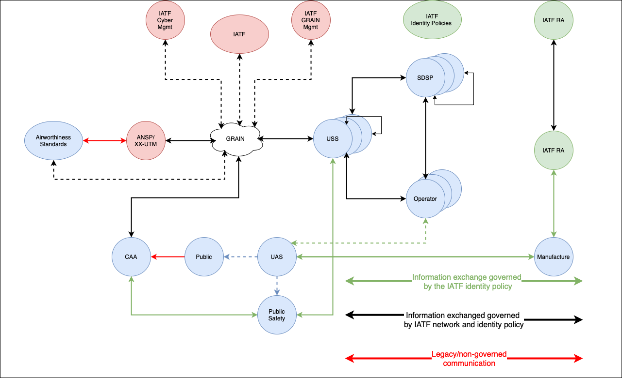

Figure 5 - Identity and network cybersecurity policies applicable to UTM

All UTM stakeholders using IATF policies use an IATF-compliant registration authority (RA) to perform the vetting and proofing of the identities. In addition, all UTM stakeholders using the IATF policies use an IATF-compliant certificate authority (CA). The RA and the CA can be implemented by commercial entities.
Identities issued by different CAs under IATF policies are interoperable and can trust each other. The trust relations between identities can be managed by stakeholders and by application domain.
UTM supports the required security and accountability functions. The UAS operating community meets security requirements that are levied by the responsible authorities and designed to guard airspace systems and architectures against security threats.
UTM meets applicable security requirements through data collection, archival, and provision protocols within the IATF, ensuring operations data is available to support stakeholder needs.

The Authority
The authority establishes requirements and response protocols to guard airspace systems and the public against associated security threats. It uses UTM data (e.g., intent, RID messages) as a means of traceability to:
- ensure operators are complying and conforming to regulatory standards;
- identify and hold accountable those who are responsible during accident/incident investigations; and
- inform other airspace users, if needed, of UAS activity in the vicinity of the airspace in which they are operating.
The authority can use near-real time data from UTM to address security needs with respect to operations conducted under ATM, including managing off-nominal and exigent circumstances. They use archived data as a means to analyse UTM operations and ensure airspace needs and security objectives are being met. The authority can also use UTM data to notify federal entities of security threats. It leverages the GRAIN and IATF policies to ensure the integrity and authenticity of the information received from all UTM stakeholders.

Public Stakeholders
Municipal, state, and federal entities (e.g., state police, etc.) require access to UTM data to inform responses to local or federal complaints and safety/security incidents, and the conduct of investigations. Data access limitations are set by the authority for individual federal and public safety/security entities (e.g., public information, classified information). Depending on the nature of the safety or security situation, historical or near-real time information may be needed.
Data deemed publicly-accessible (e.g., RID messages) may be obtained by the general public through third-party services/applications and/or the government. UTM data that is not publicly accessible (e.g., operator contact information) is managed and provided based on the need to know, the credentials, and the level of access to information authorised for the requestor using identities issued in accordance with IATF policies.

Data Management and Access
Operators must satisfy archiving and sharing requirements stipulated by the authority, to support safety and security. Stakeholders may need information on active UTM operations for the purposes of aircraft separation and identification of UAS affecting air/ground activities, among other things, such that operators respond to requests from authorised entities in near-real time. An example of such information is RID messages. Operators are required to archive certain data to support post-flight requests by authorised entities (e.g., the authority, public entities), as previously noted; examples of such data may include:
- operation intent;
- 4D position tracks;
- reroute changes to intent; and
- off-nominal event records (e.g., rogue UAS).
USSs providing services to operators satisfy applicable data management requirements set by the authority, such as responding to authorised requests for operator data that must be provided in near-real time.
USSs may also support authorised historical information requests of an operator when providing data archiving services. USSs use IATF-compliant network communications and identities to communicate.
The authority retains information obtained from operators and USSs relevant to regulatory and policy needs, such as operator registration information, airspace authorisation records, and operational waivers.
In some cases, information may be requested by the authority to address a specific need, but not a situational need, but is not retained after the need has passed. A theoretical example is the authority requesting network-published RID messages in real time to assist authorised public safety personnel in identifying a UAS operator.
From the messages obtained from the USS network, the operator identity is determined. The set of RID messages, however, is not retained as the situational need was satisfied. The IATF-compliant operator and UA identities are used to ensure the integrity and authenticity of the RID messages in transit and archived.
The authority provides services to certain federal public entities in support of public safety and security needs; services may include provision of portals designed to facilitate automated information exchanges and queries to the USS network for authorised data. Local, state public entities may have dedicated portals external to the authority by which they can request and receive authorised information. USSs meet applicable security requirements and protocols when collecting and provisioning data to such entities.
Authorisation and authentication between entities, using IATF-compliant identities, ensure data is provided to those permitted to obtain it. Authorised entities utilise USS network discovery services to identify individual USSs from which to request and receive data commensurate with access credentials.
Therefore, USSs must be:
- discoverable to the requesting entity;
- available and capable to comply with the request; and
- a trusted source, as mitigation/enforcement actions may be taken as a result of the information provided.

Networked Systems
UTM introduces new security challenges due to UAS operator reliance on interconnectivity and integration. USS connections to other USSs, operators, public entities, general public, and government assets increase overall network complexity and provide opportunities for cyber incidents and attacks--including threats to system security and unintended or malicious degradation of system performance.
To protect for these system vulnerabilities, cybersecurity architectures, requirements, and structures are developed and implemented to mitigate the potential for malicious activities and prevent unlawful access to third-party and authority systems.
Protection methods include authentication/access control, data security, information protection processes and procedures, maintenance and protection technology.
Access control will be implemented at various levels of communication (application, system and network) by all key stakeholders, and these access controls must comply with industry requirements and best practices.
Two communicating parties will perform mutual authentication based on the exchange of their interoperable and globally trusted digital identities. The receiving party will verify the authenticity of the sending party to determine whether or at what level it is allowed access.

These cybersecurity architectures, requirements, and structures are defined by IATF network policies. USSs authenticate one another using IATF-compliant identities that ensure trust in their respective network capabilities when engaging in information exchanges, through compliance with the IATF network policies.

Aircraft Systems
UAS design architectures, which vary by manufacturer and/or model, can be manipulated in ways that impact the safety and security of people on the ground and in the air. Command and control link infrastructure, cellular communications, RPS security, and global positioning system signal vulnerabilities, create potential for misuse (intentional and unintentional) and malicious interference (e.g., hacking, hostile takeovers) of UAS technologies.
The authority considers security risks and requirements proposed for an operation during the performance authorisation process and evaluates the adequacy of proposed solutions (e.g., encrypted links). UAs are registered in accordance with authority rules and regulations prior to operating in the airspace. Although UTM assumes an operator’s registration is valid, operator records are subject to auditing by the authority at the latter’s discretion. Operators are required to certify, register, and obtain all appropriate authorisations and demonstrate compliance with performance and capacity requirements per regulatory policy prior to performing UTM operations.
Aircraft systems, including the aircraft and the RPS, are operated in accordance with applicable RID requirements, which may include transmission by the aircraft (via over-air broadcast) or network publication (via a USS qualified by the State to provide RID services). When required for the mission, the authority may require the RID to be cryptographically protected by an authentication message, ensuring the authentication, non-repudiation, and integrity using an IATF-compliant UAS identity.

Equity
UTM provides an operating environment that ensures airspace users have right of access to airspace needed to meet their specific operational requirements, and that the shared use of airspace by different users can be achieved safely. Within the cooperative rules and processes for the shared UTM initiative, there is no assumption of a priority scheme that would diminish equity of access for users that have received a performance authorisation to operate in an authorised area of operation. In airspace with moderate demand, equitable access is achieved through operator collaboration, efficient airspace design, and authority rules. As demand for a volume of airspace increases, the performance requirements for the performance authorisation may increase to ensure continued free access. If demand for a volume of airspace becomes too great to maintain safety of flight, or support all types of operations, the authority may be required to manage the demand for access.

Airspace Access
When contentions arise at points in UTM airspace, and operators have already planned and shared their intent with the network, USSs assist with resolving or minimising the issues via alteration of spatial or temporal elements of the operation intent and/or operator collaboration and negotiation. Operators adjust plans to de-conflict overlapping airspace according to personal preferences or with USS tools (e.g., operation planning service). USS collaborative flight planning capabilities (e.g., route planning functions, airspace configuration options) offer equitable solutions to competing users and/or enable operator negotiation using collaborative USS tools (e.g., real-time operator exchanges) to identify acceptable alternate plans that minimise volume overlap. Operators and USSs consider airspace volume efficiency during the intent sharing process to optimise UTM-wide airspace capacity. Operators ensure intent changes are accurate and up to date, pre-empting unnecessary de-confliction of airspace (e.g., an operator updates intent when a planned operation is cancelled). Business rules ensure that individual operators cannot optimise their own operations at the expense of sub-optimising other operators and the UTM ecosystem as a whole.

Priority Flights
Priority access demands for airspace may overlap with UTM operational volumes.
In the event of a public safety incident (e.g., emergency medical services or first responders must access airspace), authority-authorised entities (e.g., law enforcement, fire department) can request PVR to alert UTM participants of the public safety activity.
PVRs do not exclude UTM participants from the airspace; however, operators/RPICs are expected to exercise caution if they continue their operations, as they are responsible for the overall safety of their flight and are accountable for their actions.

Operational Scenarios

Scenario Overview
Operational scenarios will consist of commercial, scientific, security, defence, and recreational or sport operations, conducted in controlled, uncontrolled airspace, up to an upper limit of 400 ft AGL.
The scenarios, as proposed, emphasise aspects related to unmanned operation, as well as the interaction among the different participants in the system, with a view to promoting situational awareness among the different operators through the exchange of information such as: (a) flight intent; (b) aircraft position; (c) airspace constraints; and (d) traffic volumes.

Summary of Scenarios
SCENARIO | TITLE | DESCRIPTION
3.2.1 | BVLOS/VLOS operations in controlled and uncontrolled airspace | Conduct of BVLOS/VLOS operations in controlled and uncontrolled airspace, through the use of services such as: (a) flight planning; (b) airspace access authorisation; (c) strategic de-conflictions; and (d) user messaging.
3.2.2 | Establishment of a priority volume and its operational impact on the UTM environment | Allows an accredited operator involved in operations related to the safeguarding of human lives to request the priority volume through a UAS service supplier (USS) or directly through the means made available by the responsible authority, The information on the priority volume created must be shared with the other users of the system via the USS network. Those responsible for previously authorised volumes whose operations are impacted by the priority volume must take the necessary actions for the safety of operations, maintaining separation from the priority operation.
3.2.3 | Interaction between unmanned aircraft (BVLOS) and manned aircraft operating at very low level (VLL) | Enables unmanned aircraft to interact with manned aircraft, providing enhanced situational awareness through information sharing over the USS network, cooperative V2V communication, and detect and avoid technologies.
3.2.4 | Interaction between UAS operators and those responsible for restricted airspace for use of the FUA concept in the UTM environment | Enables interaction between UAS operators and those responsible for portions of restricted airspace. The outcome of the interactions between the stakeholders has as its main objective the implementation of the FUA concept in the UTM environment.
Table 2 - Summary of scenarios

BVOS/VLOS Operations in Controlled and Uncontrolled Airspace
This scenario takes into account BVLOS/VLOS operations in controlled and uncontrolled airspace, operating at very low level (VLL).

UAS operators intending to operate BVLOS must mandatorily participate in the UTM system and share their intention to operate through the USS network, thereby promoting situational awareness of other system participants.
BVLOS operations must be requested through a UAS service supplier (USS) accredited by the responsible authority, the choice of which will be at the discretion of the operators. VLOS flights and/or flights for recreational purposes may be requested directly through the means made available by the authority, which will contain all the information necessary for the conduct of the operation, such as: (a) airspace constraints; (b) operational volumes in force; (c) no-fly zones; and (d) NOTAMs.
Manned aviation operators may interact with the system through a dedicated USS network or directly through the means made available by the responsible authority, by sharing their flight intent and/or accessing information on previously authorised volumes that may conflict with the intended operation.
Note: Intentions to operate in controlled airspace must be subject to ATC clearance through the interface between ATM and UTM systems provided by the responsible authority.

Operation Planning – “Strategic Phase”
The operator transmits via its USS its intent to fly BVLOS, using an interface made available by the supplier. However, VLOS operations may be requested directly through the means made available by the responsible authority.
Thereby, the operator provides initial planning information to its USS, such as an area of operation, points of interest, and times (arrival, departure, occupancy, etc.). Through the discovery services, the USS identifies other USSs responsible for possible operations in the area of interest that may conflict with the planned operation, and requests flight intent information from other operators belonging to its network. As a result of these interactions, operational volumes already authorised and potentially conflicting with the intended operation will be obtained, provided that the operator plans the operation, thus avoiding operational volumes already in place.
If the volume or volume segment has no conflict with any operational volume previously authorised, no planning action will be required. If, however, there is a conflict between volumes, strategic de-confliction action will be required, such as: (a) adjustments to the lateral/vertical boundaries of the desired volume; (b) temporal adjustments; or (c) a combination of both.
If there is conflict, as mentioned above, operators will be able to strategically de-conflict by coordinating with other operators through the USS.
Once planning has been completed by the operators, the USS will make available, as soon as it is accepted, the planned operational volume through the USS network.

Execution of the Operation
Once ready to conduct the operation, the remote pilot will notify its respective USS, which will pass the status of the requested volume to “activated”, disseminating this information to its networked operators and other UTM system users via the USS network.
Upon receipt of the "activated" status confirmation, the remote pilot will start the operation and the volume will remain in this condition until the remote pilot notifies the end of the activity or the period reported during the planning phase comes to an end.
The remote pilot must conduct the operation in accordance with the activated volume, ensuring separation between their aircraft and other airspace users. The USS may assist the remote pilot in maintaining the authorised volume by providing the compliance monitoring service. To this end, the remote pilot must share, throughout the operation, the aircraft position with their USS.
Operations that are not in compliance with the previously shared flight intent will have their status changed to "non-conforming" by the respective USS and this information shall be made available to all system users via the USS network. If the non-conforming status affects manned operations, the USS shall alert the responsible authority. In addition, the USS shall alert the supervisory authority, which shall use resources to determine the causes of the deviation and if appropriate, apply the corresponding penalty.

End of the Operation
Upon being informed by the remote pilot of the end of the activity, the USS will change the status of the operation to "closed", sharing this information with other airspace users through the USS network. Also, the operation may be considered as completed upon reaching the end of the total planned duration of the flight reported in the plan. Likewise, the USS will change the status of the operation to "closed", sharing this information with other airspace users through the USS network.

Establishing a Priority Volume and its Operational Impact on the UTM Environment
This scenario addresses the request for a priority volume in order to respond to an emergency situation, as well as the operational impact on the UTM environment.
As a basic assumption, the scenario considers that the priority volume request will be made by a duly authorised user, taking into account the ability to approve the request, to establish the required volume, and to disseminate it to other users of the system through the USS network. The USS responsible for the priority volume will also notify the responsible authority through the available means.
The USS shares with the responsible authority the details of the emergency operation, as well as the constraints resulting from the establishment of the priority volume. Once in possession of the information, the responsible authority automatically shares it via other means with other airspace users. As a result of the information exchange, all USSs will be aware of the priority volume established, identifying the operations (VLOS and/or BVLOS) potentially affected within their respective networks.
Once notified of the activation of the priority volume, the impacted users and those already operating take the necessary de-confliction actions. Operations that have not yet started their activities make modifications based on the characteristics of the priority volume, such as flight intent and contingency responses that would violate the airspace associated to the priority volume.
Upon completion of the operation, the operator informs their USS, which, via the USS network, will disseminate the information to other system users, and operations that may have been interrupted can be restored to normal.

Interaction between (BVLOS) UAs and Manned Aircraft Operating at VLL
This scenario examines the different possibilities through which unmanned aircraft participating in the UTM system can interact with manned aircraft. The scenario is based on the assumption that BVLOS operations are cooperative and provide real-time electronic identification and positioning information. Manned aircraft operate in accordance with existing rules, procedures and regulations.

Unmanned Aircraft On-Board Detection Capability
The unmanned aircraft will use on-board capabilities, such as visual sensors, to search the environment for other airspace users that may pose a risk to the operation.
When an object is detected close to the aircraft, the on-board collision avoidance systems relay the information to the remote pilot station, alerting the pilot to the potential conflict. Depending on the characteristics of the detected object, such as: (a) distance; (b) speed, (c) trajectory; and (d) flight attitude, the remote pilot will take appropriate action to stay clear. Additionally, the on-board collision avoidance system can be pre-programmed to manoeuvre automatically when an object is detected, especially in situations of loss of command-and-control (C2) link.

Ground-Based Detection Capability
In this scenario, a provider uses a ground-based structure to detect and identify objects via sensors (radar) or to receive signals transmitted by cooperative aircraft (ADS-B/SSR). While individual operators can set up this equipment, the structure needed to support the scalability of BVLOS operations requires that the service be provided by a third party, either a USS or a supplemental data service provider (SDSP).
The ground system, managed by the SDSP, detects and identifies an airborne aircraft and thus the USSs belonging to the provider's network have automatic access to this information. With the information from the SDSP, the USSs can identify, in their network, the intentions and/or operations that are already in progress and that will need to know about the detected aircraft. Once the intentions and/or operations in progress are identified, the USSs send messages/alerts to their operators and/or the affected remote pilots, who are responsible for taking appropriate action to maintain safe operation.

Aircraft On-Board Cooperative Equipment
In this scenario, UAS operators use devices capable of interacting with the on-board equipment of manned aircraft, such as ADS-B. The equipment may transmit/receive data (ADS-B OUT/IN) or just receive information (ADS-B IN).
While in flight, on-board systems can obtain information about equipped aircraft in the vicinity of the volume used, relaying it to the remote pilot via the remote pilot station (RPS). With this information in hand, the remote pilot takes appropriate action to stay clear of the manned aircraft.
If the unmanned aircraft is actively interacting, capable of transmitting data (ADS-B OUT), the manned aircraft equipment (ADS-B IN) will capture this information and relay it to the pilot, allowing the pilot to stay clear of unmanned operations in accordance with current regulations.

Voluntary Passive Participation of Manned Aircraft in UTM
In this scenario, manned aircraft operators operating in the UTM environment voluntarily use the services provided by a USS or SDSP, gaining access, among other things, to data related to the planned operations, as well as to volumes that are active and in the area of interest. The information received will provide the pilot, during planning or in-flight, with a better situational awareness of the airspace involved, thus avoiding possible conflicts with other airspace users. As this is a passive participation, it is assumed that the pilot of the manned aircraft does not share any information with their USS.
NOTE: VLOS operations can participate in the UTM system passively and under the same conditions as manned aviation. The UAS operator could make use of the information available on the USS network but not share its own information with other users of the system.

Voluntary Active Participation of Manned Aircraft in UTM
Manned aircraft operators that do not have on-board equipment capable of interacting cooperatively with unmanned aircraft can opt to actively participate in UTM by providing their own operation intent to the USS network. Participation allows other UTM system users to be aware of the intent of the manned aircraft and understand the limitations of this aircraft in relation to coordination with other system users. The exchange of information during the planning phase is considered strategic and is similar to that proposed in scenario 1, paragraph 3.2.1.

Interaction Between UAS Operators and those Responsible for Restricted Areas
This scenario will address the flexible use of airspace through interaction among stakeholders, allowing the use of a restricted area without impairing the safety of operations.
UAS operators that need to use restricted airspace, which is either permanently or temporarily activated, shall request de-confliction of the activities involved through their USS.
Restricted areas that are not permanently activated will be available in the planning phase (strategic phase) and may be part of the planned route, provided that their unavailability is not previously registered by the party responsible for the area.
Once the unavailability of the restricted area is registered, the restricted airspace will be activated and this information will be passed through the USS network, not allowing it to be made available to the UAS operator in the flight planning phase.
Those responsible for airspaces that are permanently activated or whose activation has been requested shall first enter information on the use of the area (actual activity), which will be used as a basis for de-confliction.
The USS, in possession of this information and of the characteristics of the intended operation of its UAS operator, may authorise the use of restricted airspace and make the authorisation data available on the USS network.

UTM Implementation

General
The ATM system, conceived more than seven decades ago, is an extremely conservative environment, very well regulated, with well-defined roles and responsibilities. The introduction of a new entrant into this ecosystem requires, on the part of the authorities, a careful risk assessment and subsequent proposal of mitigation actions. Therefore, to enable full implementation of the UTM system and the subsequent interoperability with the ATM environment, a step-by-step approach involving all stakeholders is required. In this regard, cooperation between authorities, industry and the UAS community is necessary, with a view to the spiral development of the UTM system.
The spiral concept states that each cycle will generate a prototype slightly different from the previous one, consisting of a more sophisticated version of the system. From the perspective of UTM system implementation, it can be said that each cycle will generate a scenario that is more complex than the predecessor, either by increasing air traffic density and distribution, introducing new services or a combination of both. Initial tests and assessments are related to low-complexity operations, and more complex concepts and operational requirements are built upon the maturity attained throughout the process. Each new development cycle is designed to make the UTM system architecture evolve so as to accommodate a variety of UAS operations, ranging from remotely piloted aircraft to fully autonomous operations.
The spiral approach to UTM development provides several advantages. Firstly, the use of lower complexity environments, where current resource utilisation meets safety requirements and simplifies the implementation process. Secondly, the development of the UTM system according to a complexity scale allows for scalable, flexible and adaptable services that are sized to the specific characteristics, rather than applying a one size fits all approach. The UTM project must be able to adapt to new technologies, both ground-based and airborne, and allow for more advanced forms of interaction, through interoperable systems capable of digital information and data exchange. Ultimately, the UTM system must satisfy a diversified demand for operations, business models, applications and technologies, and support safe and efficient operations that coexist with manned aviation and without harming the ATM environment, ensuring fair and equitable access to airspace.

Transition to UTM Implementation
Doc 9854 [7] – Global Air Traffic Management Operational Concept - provides guidance particularly applicable to the UTM through the stated objectives and the identification of system needs. Implementation is an evolving and continuous process.
Its guiding principles coincide with the considerations of this UTM CONOPS:
- safety;
- human beings;
- technology;
- information;
- collaboration; and
- continuity.
Stakeholder expectations are the creative and evolutionary driving force towards a dynamic product, which accepts change as it matures, based on safety, commercial goals, cost/benefit analyses, and sustainability, and in a participatory manner within its community. The achievement of goals will be based on a successful exchange of experiences gained in the Regions, ensuring the sharing of data and timely information to avoid negative or low-impact experiences with a view to sustained progress. Therefore, the final outcome depends on a defined regional programme, with clear goals and constant reviews leading to a system aligned with the needs and opportunities.
To supplement this concept, Doc 9882 [9] – Manual on Air Traffic Management System Requirements, together with Doc 9883 [10] - Manual on Global Performance of the Air Navigation System, contribute to the implementation and transition to the UTM system, as the principles and concepts described therein provide an approach fully harmonised with the architecture proposed in this CONOPS.
Concepts such as the performance-based approach (PBA) and its principles offer:
- focus on desired or required results through the adoption of performance objectives and goals;
- informed decision-making, motivated by desired or required results; and
- decision-making based on facts and data.
These concepts lead to the methodical application of a series of well-defined steps such as: recording indicators (KPIs), using metrics to consistently support data, assessing progress in achieving objectives, setting performance goals, identifying gaps, selecting decisive factors to achieve target performance, identifying solutions to exploit opportunities and solve problems, and even implementing solutions. It is a cyclical and flexible process, allowing for numerous revisions towards the achievement of new or enhanced objectives.
Finally, Doc 9750 [11] - Global Air Navigation Plan, invites us to design UTM implementation using the Aviation System Block Upgrades (ASBU) methodology, based on which progress milestones, implementation dates and scope will be established, thus maintaining the dynamic and evolutionary principle of the system.
A new set of blocks for UTM must be considered in order to define the implementation phases. These phases must define specific milestones towards the achievement of goals. To this end, each State within the Region shall provide data and information in a participatory manner, including:
- identified technical and operational needs;
- demand/capacity measurements;
- cost-effectiveness assessment;
- quantification of UTM system efficiency;
- possible impact of the UTM system on the environment;
- levels of flexibility of the UTM environment;
- levels of harmonisation with globally consolidated practices;
- levels of participation of the UTM community;
- predictability levels;
- safety indicators; and
- security indicators.
The impact of the socio-economic and political reality of each State as part of the Region is unfailing. Identifying these gaps and agreeing on a selfless model for joint achievement of goals and objectives, through plans, support projects and mutual cooperation, emerge as a new challenge towards UTM harmonisation at regional and global level. It is therefore essential to share the experience gained by those States that have experienced a high demand for unmanned aircraft operations, prompting them to quickly evolve to meet the new challenges. Such experience offers an assertive path towards a product of excellence and in constant evolution. Regional standardisation of procedures, regulations, services, tools and technologies must be part of the agenda towards UTM implementation.

Latin American Initiatives
To meet the enormous challenge of the unmanned aircraft industry, Latin American authorities have been working to safely promote the full integration of this technology into traditional aviation. Some States in the Region already have initiatives in place that are implemented in isolation and seek to meet domestic demand.
An example is Brazil, a State that has been promoting the unmanned aviation sector since 2009. In this regard, the Brazilian authorities, mainly the National Civil Aviation Agency (ANAC) and the Department of Airspace Control (DECEA) have issued special authorisations, based on Art. 8 of the Chicago Convention [12], with a view to promoting the sector while preserving the safety of other airspace users, people and property on the ground.
Initially, access to Brazilian airspace by unmanned aircraft entailed a manual process, which could take weeks. The first step in the process was to obtain an authorisation to operate from ANAC. Once the documentation was received, the operator started the airspace access application process with DECEA, attaching the document issued by ANAC. Each application was analysed by experts from both Brazilian authorities, which made the process very time-consuming because of the regulations.
However, with the increase in demand, it was felt that the manual procedure would not meet airspace access requests by unmanned aircraft in a scalable manner. Thus, DECEA, the main Brazilian ANSP, started the development of a system, whose main objective was to streamline the airspace access authorisation process while preserving the safety of other users, people and property on the ground.
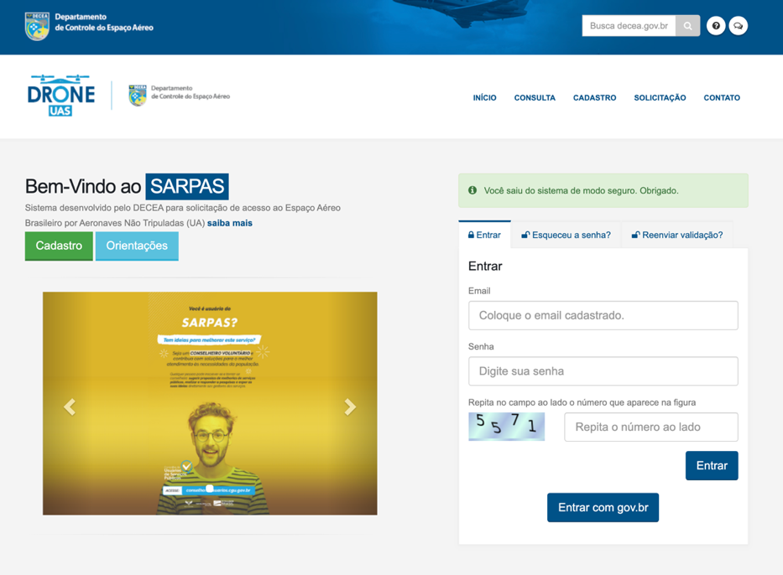
As a result, at the end of 2016, DECEA launched the SARPAS System [13], as part of its SIRIUS Strategic Programme. Considered the forerunner of the Brazilian UTM system (BR-UTM), SARPAS [13] is a web-based monolithic system that revolutionised the airspace access request process through services provided to the operator, such as: a) aircraft and pilot registration; b) flight planning interface; c) Brazilian airspace access rules; and d) prohibited flight zones.

Figure 6 - SARPAS [13]
Furthermore, in 2017 ANAC issued Brazilian Civil Aviation Regulation number 94 (RBAC-E94) [14], establishing the general requirements for unmanned aircraft for civil use. With the advent of RBAC-E94 [14], the Agency launched the Unmanned Aircraft System (SISANT) [15], which allows the operator to register online unmanned aircraft with a maximum take-off weight of 25 kg. intended for VLOS operations up to 400 ft AGL.
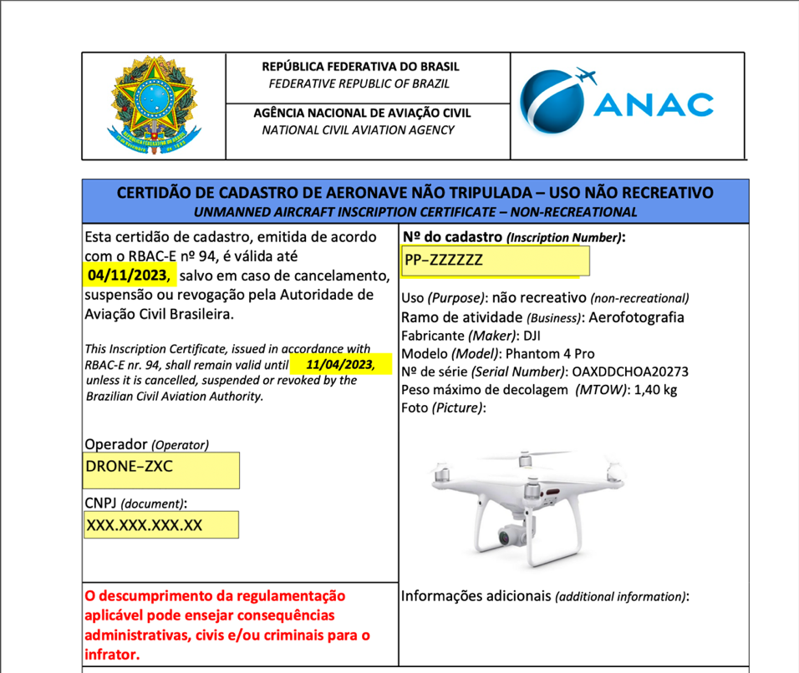

Figure 7 - SISANT [15]

After the Brazilian authorities implemented the systems, the airspace access process, which previously could take weeks, now takes 45 (forty-five) minutes to 18 (eighteen) days, depending on the characteristics of the operation, such as: a) type of flight - visual range (VLOS) or beyond visual range (BVLOS); b) intended flight altitude; and c) distance from aerodromes.
To this end, the SARPAS system [13] compares the information provided by the operator during flight planning with existing regulations and decides whether the authorisation will be issued automatically or needs to be issued by an airspace expert, through ATM analysis. If the request needs to be assessed by an airspace management specialist and a NOTAM is not required, the clearance can be issued within 2 (two) days, and within 18 (eighteen) days if the notice needs to be issued.
Immediately after the launch of SARPAS [13], the number of airspace access requests by unmanned aircraft increased significantly from just a few dozen to more than 19,000 (nineteen thousand) in 2017, as shown in Figure 8.

Figure 8 - Airspace access requests

After almost 5 (five) years and more than 600,000 (six hundred thousand) airspace access requests, SARPAS was updated and renamed SARPAS NG [16]. As shown in Figure 9, the main modification consisted in the division of the initially monolithic system into two subsystems: the backend, called ECO-UTM [17] and the frontend, called SARPAS NG [16], which is considered the first USS of the Brazilian UTM system. Unlike the previous SARPAS [13], the SARPAS NG [16] went on to allow potential USSs to connect to the ECO-UTM [17] through the application programming interface (API), under the rules established by DECEA.

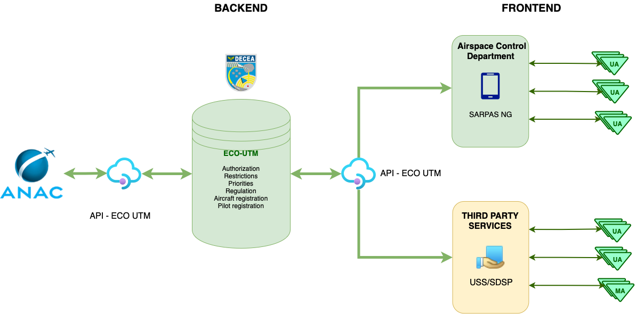

Figure 9 - New structure of the SARPAS system [16]

During 2021, DECEA made available the beta version of SARPAS NG [16], considered the first BR-UTM provider. The main objective of this strategy was to give the community the possibility to provide DECEA with feedback on the new functions available, including strategic de-confliction, which was not available in the previous version of the system.
For testing the new SARPAS NG functionalities [16], operators were invited to interact with the system, providing DECEA with feedback on the results obtained and obstacles encountered. To this end, DECEA provided a specific link through which stakeholders could give their opinions and/or suggestions on the new generation of the SARPAS system [13]. Based on the proposals submitted, events will be organised for integration with the industry and research will take place for consolidation of concepts, clarification of integration issues, and use testing.

______________________________________________

Bibliography

[1] | FAA, 2 March 2020. [Online]. Available: https://www.faa.gov/uas/research_development/traffic_management/media/UTM_ConOps_v2.pdf.
[2] | ICAO, "UTM FRAMEWORK," 2020. [Online]. Available: https://www.icao.int/safety/UA/Documents/UTM%20Framework%20Edition%203.pdf.
[3] | "SESAR," 2019. [Online]. Available: https://www.sesarju.eu/sites/default/files/documents/u-space/CORUS%20ConOps%20vol2.pdf.
[4] | ICAO, "ANNEX 2," July 2005. [Online]. Available: https://store.icao.int/en/annex-2-rules-of-the-air.
[5] | ICAO, "ANNEX 19," July 2016. [Online]. Available: https://store.icao.int/en/annex-19-safety-management.
[6] | JARUS, "SORA," 30 January 2019. [Online]. Available: http://jarus-rpas.org/content/jar-doc-06-sora-package.
[7] | ICAO, "DOC 9854," 2005. [Online]. Available: https://store.icao.int/en/global-air-traffic-management-operational-concept-doc-9854.
[8] | ASTM, 1 December 2019. [Online]. Available: https://global.ihs.com/doc_detail.cfm?document_name=ASTM%20F3411&item_s_key=00801293.
[9] | ICAO, "DOC 9882," 2008. [Online]. Available: https://www.icao.int/airnavigation/IMP/Documents/Doc%209882%20-%20Manual%20on%20ATM%20Requirements.pdf.
[10] | ICAO, "DOC 9883," 2009. [Online]. Available: https://store.icao.int/en/manual-on-global-performance-of-the-air-navigation-system-doc-9883.
[11] | ICAO, "DOC 9750," 2016. [Online]. Available: https://www.icao.int/airnavigation/documents/ganp-2016-interactive.pdf.
[12] | ICAO, "DOC 7300," 2006. [Online]. Available: https://store.icao.int/en/convention-on-international-civil-aviation-doc-7300.
[13] | DECEA, "SARPAS," [Online]. Available: https://servicos.decea.mil.br/sarpas/.
[14] | ANAC, "RBAC-E94," 02 May 2017. [Online]. Available: https://www.anac.gov.br/assuntos/legislacao/legislacao-1/rbha-e-rbac/rbac/rbac-e-94-emd-01.
[15] | ANAC, "SISANT," [Online]. Available: https://sistemas.anac.gov.br/sisant.
[16] | DECEA, "SARPAS NG," [Online]. Available: https://servicos.decea.mil.br/sarpas/#beta.
[17] | DECEA, "ECO-UTM," [Online]. Available: https://ajuda.decea.mil.br/base-de-conhecimento/o-que-e-o-eco-utm/.
[18] | ICAO, "DOC 10019," February 2015. [Online]. Available: https://store.icao.int/en/manual-on-remotely-piloted-aircraft-systems-rpas-doc-10019.
[19] | ICAO, "GRAIN_CONOPS_DRAFT," 2019. [Online]. Available: https://portal.icao.int/TFSG/Library/Global_resilient_aviation_network_conops_final_draft_conference.pdf.

