Performance Surveillance Assessment

Context and Goals
You are the safety analyst of the CAA of the Netherlands and you are in charge of monitoring the operations of Schiphol Airport, the main airport of the Netherlands. One of the elements you are monitoring is missed approaches which are executed on the airport. A missed approach is when an aircraft aborts landing and decides to overfly the airport and start the landing procedure again.
You have been monitoring the missed approaches for a few weeks and it appears that in average, 0.2% of the approaches end with a missed approach procedure. There are little variations on a weekly basis.
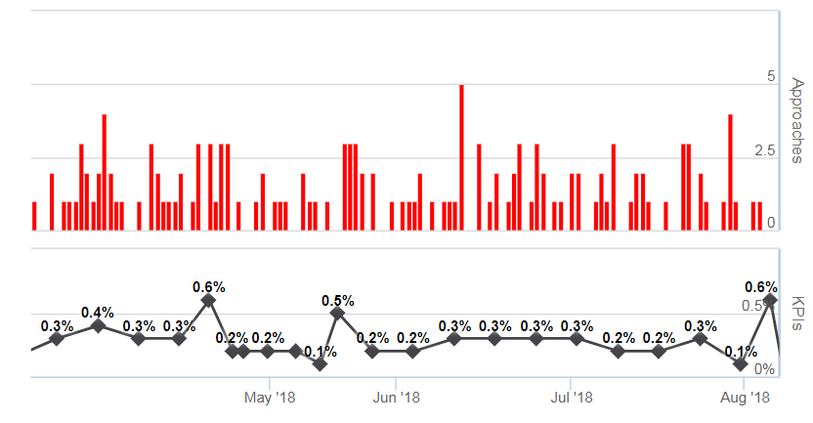
Each morning you are getting the data of the day before and every Monday you get in addition the average of the previous week.
In September and October you face a high level of missed approaches.
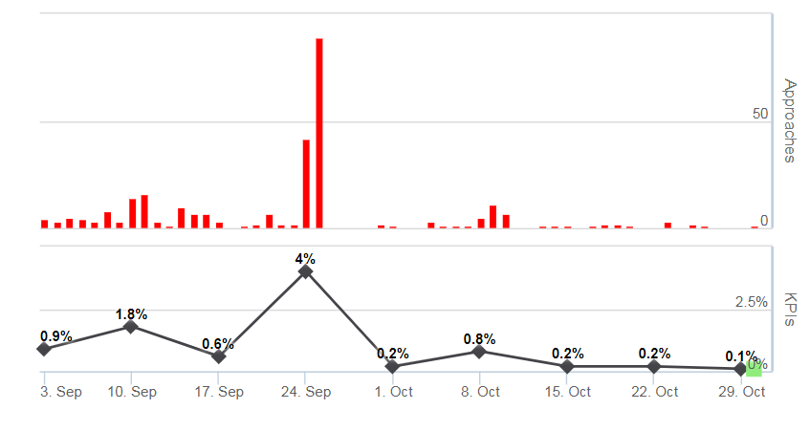
After this monitoring period of 1 year, you are asked to establish a procedure to monitor performance and take appropriate actions.

Instructions
The procedure should contain the following sections (use table 1 as a template):
- Context
Describe the context of what it being monitored, what are the safety elements. Explain why it is important to monitor missed approaches
- Indicator
Define the indicator which is going to be used for the monitoring. Define a key indicator and additional metrics if needed.
- Alert levels
Establish alert levels for the indicator. Define for each level, what are the triggers to enter the level, and what are the triggers to move down again. Establish also the minimum duration the level should be maintained.
- Actions
Establish for each alert level, the actions to be executed. Describe who does the action, what is the deliverable and when is the action closed.

Table 1: Monitoring Plan

The procedure should contain the following sections (use table 1 as a template):
Context

Indicator

Alert Levels
Level | Trigger In | Trigger Out | Min Duration | Action(s)
0
1
2
3
4

