SIMS Workshop

Hazard Identification Assignment

Context and Goals
The city of Pasadena, USA, has a heliport from which it operates a public security service using 2 helicopters. The current layout of the platform is shown in figure 1.

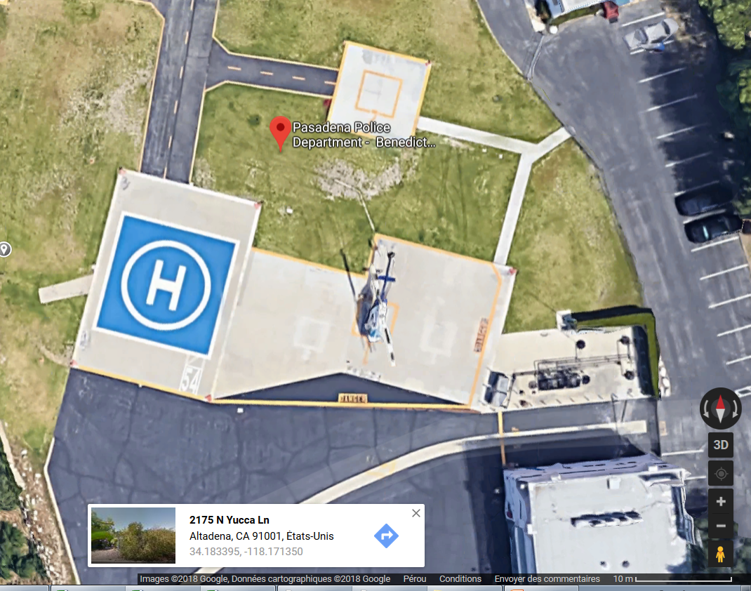
Figure 1: Pasadena Heliport Layout

A major accident on the platform in 2012 destroyed both helicopter during a collision on the ground. Appendix A contains the investigation report issued by the National Transportation Safety Board(NTSB). Changes were made on the platform to answer concerns raised by the NTSB.
This video shows the accident:
https://www.youtube.com/watch?v=qHMhsD8OFCs&t=69s

You have been appointed as new manager of that platform. Your team comprises data scientists provided by the local university with big data and machine learning knowledge. The data scientists are able to recognize patterns in video, images and voice.

The city council has asked you to establish indicators to monitor the safety situation on the platform on a daily basis in order to prevent a similar event than the one of 2012. Furthermore the city council has asked you to make use of available data and the data scientists as much as possible. The available data is listed in appendix B.

Instructions
The presentation should contain the following sections:
- Risk Registry
By looking at the accident report and the risk categories as defined by the CAST ICAO Common Taxonomy Team (CICTT), establish a list of risks in terms of occurrence categories which are most likely to occur at this operation. Use table 1 as a template.
- Mitigation action
For each of the risks, identify the main action which would reduce the risk.
- Monitoring
For each of the risks as well as for each mitigation action, define indicators which can be used to measure the importance of the risk and the efficiency/effectiveness of the actions. For the risk monitoring indicators, you should use the data listed in appendix B.

Appendix A

Pasadena Accident Investigation Report

NTSB Identification: WPR13GA044A
HISTORY OF FLIGHT
On November 17, 2012, at 1558 Pacific standard time, a Pasadena Police Department (PD) helicopter struck another stationary Pasadena PD helicopter while maneuvering to park at the Pasadena Police Benedict Heliport, Altadena, California. N911FA, a Bell OH-58, was attempting to park on Pad 2 at the Pasadena PD heliport, and N96BM, a Bell OH-58A, was on the ground adjacent to Pad 1 with its main rotor blades turning when the collision occurred. Pasadena PD operated both helicopters under the provision of 14 Code of Federal Regulations Part 91, as public-use flights. Both helicopters sustained substantial damage. The commercial pilot and two passengers of N911FA received minor injuries. The commercial pilot and tactical flight officer (TFO) of N96BM received minor injuries. Also, one person on the ground received minor injuries. Visual meteorological conditions prevailed, and no flight plans had been filed.
According to Pasadena PD, N911FA was providing traffic support for a college football game at the Rose Bowl in Pasadena, California. The flight departed at 1552, and flew toward the Rose Bowl; the intent was to be gone for a 1 hour flight. At the time of departure for N911FA, weather at the heliport was not a factor. At 1555, about 3 minutes later, N96BM was moved out of the hangar in response to an in-progress call, and placed on the outside edge of Pad 1, in between Pad 1 and Pad 2 facing to the south. The pilot of N96BM had started the engine, and begun the startup sequence.
At 1558, N911FA returned to the heliport due to diminishing weather. The pilot of N911FA made a normal approach from the north to the main pad. From the main pad, the pilot performed a left pedal turn turning the helicopter to the east, and hover-taxied toward pad 2. The pilot then made a right pedal turn, turning the helicopter to the south. As she lowered the collective to land on pad 2, the main rotor blades came into contact with N96BM's main rotor blades.
The air support Lieutenant (Lt.) was interviewed on November 18, 2012. He had observed that throughout the day prior to the accident, the weather had been spotty; clear one moment, cloudy and overcast the next. As N911FA took off, he observed from his office marginal weather conditions. A couple of minutes later, he looked out his window, and noted that the weather was closing in, and that N96BM was on Pad 1 preparing to take off. He walked out of his office toward N96BM, with the intent of telling the flight crew to stand down. He stated that he had been standing by the left door on the outside of N96BM. He observed N911FA returning to base, and thought that was a good thing. He recalled hearing a loud bang, getting knocked to the ground, and then running away from N96BM.
PERSONNEL INFORMATION
N911FA
The 49-year old pilot of N911FA held a commercial pilot certificate with a rating for rotorcraft-helicopter issued on January 17, 1991. The pilot held a second-class medical issued on June 6, 2012, with the limitation that the pilot must have available glasses for near vision. The pilot's estimated total time was 16,200 total hours with an estimated 8,000 hours in the accident make and model. The pilot had been assigned to the Pasadena PD Air Operations division since 1989; 22 years as a pilot and one year as a Tactical Flight Officer (TFO).
N96BM
The 40-year old pilot of N96BM held a commercial pilot certificate with a rating for rotorcraft-helicopter issued in August of 2010. The pilot held a second class medical issued on March 22, 2012, with no waivers or limitations. The pilot's estimated total time was 13,065 hours with an estimated 725 hours in the accident make and model. The pilot had been assigned to the Pasadena PD Air Operations Division since 2005; 2 years as a pilot and 5 years as a TFO.
WITNESS INFORMATION
Pilot N911FA
According to the pilot of N911FA, her day began at 0530. Throughout the day, she checked weather and noted precipitation/rain during the day. The first two flights of the day were for traffic evaluation with no problems encountered. The pilot reported marginal weather conditions, but made the decision to fly after conferring with her lieutenant that if the weather was not good, she would return to base. The pilot and two passengers departed about 1552; the pilot reported that they were airborne for only a few minutes before returning to the heliport to land due to weather.
While on the return back to the heliport, the pilot had broadcasted her position per protocol. Upon arrival at the heliport, the pilot performed a reconnaissance of the area to make sure there were no people in the area. When she looked at the landing pads, she saw the outline of N96BM on landing pad 1; the pilot was not sure if the main rotor blades were turning or not. The pilot continued the approach, and radioed her intention and location, but received no response from anyone. On short final, she heard a helicopter radio querying if there was "any Pasadena on 02?" She responded, but did not hear the response as her helicopter had gone below the mountains.
On final she observed N96BM on the ground and assumed it to be on pad 1; at the time there was no direct/established communications with the pilot of N96BM. The pilot hover-taxied to Pad 2, and was concentrating on keeping her helicopter in the box for Pad 2. She stated that she was getting on the radios to tell the passengers to stay put, and simultaneously lowered pitch; at that point the, "sky fell." The pilot stated that she had seen two helmets in the helicopter, but did not have eye contact with the pilot or TFO of the other helicopter.
The pilot stated that the windscreen and side windows were wet with water drops. She was looking forward to stay straight and utilizing the chin window and her periphery to land inside the box.
The pilot stated that at the time she did not realize that the parked helicopter (N96BM) was not in the box. Her state of mind was that the other helicopter was in the box, so pay attention to your box when you land, and you'll be fine.
In her experience, she had not observed a helicopter placed outside of the box.
Pilot N96BM
According to the pilot, he had arrived at the heliport for his duty shift at 1500. He had performed a maintenance flight check, and recalled that there were rain cells to the south with 4-5 miles visibility and a 2,000 foot ceiling. About 1530 he spoke to the pilot of N911FA, and that he had told the other pilot that there was weather and rain cells to the south.
He stated that he had been pushing out N96BM when a call for assistance was requested, as N911FA had already departed he moved N96BM to Pad 1. The pilot stated that he placed the helicopter on the outside of Pad 1; he knew they would be off the ground in a couple of minutes or he would be up on radios. The pilot stated that his thought process was that, when he was up on radios he would check the weather, and request the pilot of N911FA start toward the priority call.
The pilot stated that it was not uncommon to place the helicopter outside of the box, and he had witnessed other pilot's do the same. He opined that it was done due to poor water drainage when it rained as well as to keep clearance from the adjacent fuel farm.
Other Witnesses
The Tactical Flight Officer (TFO) for N96BM stated that he and the mechanic were being directed by the pilot as they pushed the helicopter outside, and that they did not place the helicopter inside the box for pad 1, instead it was parked to the west of the box.
The TFO recalled putting on his gear at the helicopter, climbing in and seat belting himself in. The lieutenant came to his side of the helicopter, and asked if they wanted to respond due to the weather. The TFO indicated that the traffic helicopter (N911FA) was still up; once they were airborne, if the weather was bad, they would come back to the heliport. The TFO stated he heard a loud bang and saw the lieutenant run toward a fire extinguisher. At the time, he had not been aware that another helicopter had landed. When he looked up he saw that the main rotor of the helicopter he was sitting in was gone.
The Director of Maintenance was the on duty mechanic on the day of the accident; his mission was to maintain the helicopters, and assist with helicopter movement. He recalled that he assisted with the movement of N96BM outside of the hangar to pad 1. He had not realized that N96BM had been placed outside of the pad 1 landing box until after he disconnected the auxiliary power unit (APU) and had started back to the hangar. The duty mechanic stated that, due to the fact that the helicopter was getting ready to depart, it should not have been an issue; he had observed N911FA on inbound to the heliport. He stated that he had been inside the hangar for about a minute when he heard a loud explosion.
METEOROLOGICAL CONDITIONS
Weather obtained at 1628 for the Bob Hope Airport (BUR), Burbank, California, 8 miles west of the accident site, indicated visibility as 3 statute miles, light rain showers, wind from 180-degrees at 6 knots, cloud conditions scattered at 1,100 feet, broken at 1,600 feet, and overcast at 3,100 feet. At 1553, BUR reported weather conditions as visibility 5 statute miles, rain showers, wind from 210-degrees at 6 knots, cloud conditions as scattered at 1,100 feet, broken at 1,900 feet, and overcast 2,600 feet.
Weather obtained at 1647 for El Monte Airport (EMT), El Monte, California, 8 miles southeast of the accident site, indicated visibility as 10 statute miles, calm wind, cloud conditions as few clouds at 1,800 feet, broken at 3,800 feet, and overcast at 4,500 feet. At 1547, EMT reported weather conditions as visibility 10 statute miles, wind from 180-degrees at 6 knots, clouds conditions, few at 4,200 feet, scattered at 4,800 feet, and overcast at 6,000 feet.
AIRPORT INFORMATION
The Pasadena PD–Benedict Heliport was established in 1972; it was situated on a mesa that overlooks the 210 freeway in Altadena, California. The heliport was not a certificated heliport as it was built prior to California Department of Transportation (DOT) Division of Aeronautics requirements; as such, it had received an exempt status.
According to a letter from the California DOT, dated July 13, 1979, in January of 1973, the heliport was designated under the classification of "public safety agencies," and will be exempted from the Department of Aeronautics heliport regulations. It was deemed that the heliport was exempt, and could continue to operate as such.
The OIC (Officer in Charge) of the air unit responded to the letter submitted by the DOT and the city chose not to pursue that.
WRECKAGE AND IMPACT INFORMATION
On-scene documentation was conducted. The accident had been recorded on video. The recorded video showed that N96BM was moved out of the hangar toward Pad 1. The helicopter was parked to the west and outside of the painted square that denoted Pad 1, which placed N96BM in-between Pad 1 and Pad 2 facing south.
The distance between the outside of Pad 1 to the outside of Pad 2 was 33 feet, as measured by a total station provided by the Pasadena Police Department.
After the impact, both helicopters came to rest upright, with minimal displacement/movement of each helicopter. N911FA came to rest facing toward the northeast, and mostly inside of Pad 2; a portion of the aft skid came to rest outside of the Pad 2 box. N96BM remained to the west of Pad 1.
The transmission and main rotor blades separated from N96BM, and came to rest adjacent to the helicopter. The main rotor blades of N911FA separated from the transmission, and came to rest about 10 feet forward and to the left of the helicopter; directly behind N96BM. The transmission for N911FA remained attached to and inside the helicopter in its relative normal position. One main rotor blade from each helicopter, where they initially contacted each other, came to rest near the hangar, forward of N96BM, and near a chain link fence, behind N96BM.
During the on-site examination, the distance between the two parking pads as well as the distance between Pad 1 and the fuel farm was noted. Measurement of the separation distance between Pad 1 and Pad 2 was measured as 33 feet. The distance between Pad 1 and the fuel farm was measured as 24 feet. According to AC 150/5930-2C Heliport Design section 214 titled Helicopter Parking, parking pads size depends on the number and specific size of the helicopter that will be accommodated at the facility. The minimum distance between parking pads should be one-third the diameter of the main rotor blades. Additionally, under subsection e. fueling (2) it stated not to locate fueling equipment in the TLOF (touchdown and liftoff area), FATO (final approach and takeoff area), or safety area, maintaining a distance of one-half rotor diameter clearance from objects, and if that was not practical at the existing field to install long fuel hoses.
TEST AND RESEARCH
There was not an established monitored UNICOM frequency. There was also no mechanism to alert ground personnel that a helicopter was arriving to the heliport other than by ground personnel "hearing" it approach. As a result of the accident, the air division established monitored UNICOM and radio procedures for arrival and departure of helicopters at the heliport.
Radio communications were established by the Pasadena PD, and identified in their standard operating procedures. Pilots were required to radio their intentions for departure and landing, along with the direction they were taking off from or direction they were landing. Start-up was identified as a critical time for radio communications as a parked helicopters' pilot had not yet powered up the helicopter and turned on the radios.
Pad 1 was 49x49 feet; the center of pad 1 to its outside edge was 25 feet. The edge of pad 1 to center of pad 2 was 12 feet. Thirty-seven feet separated the center of pad 1 from pad 2.
Pad 2's dimensions were 39 feet on the north side, 27 feet on the south side, with the west and east sides estimated to be about 25 feet.
The OH-58A main rotor blades are 35 feet in diameter, with 11 feet of clearance for this model of helicopter. The fuel pit was measured to be 29 feet from pad 1.
Heliport Evaluation
The Pasadena PD Heliport was evaluated by the California DOT - Division of Aeronautics as requested by the NTSB IIC on December 17, 2012. It was noted that the facility was exempt from state heliport permit requirements under applicable provisions of the California Code of Regulations, Title 21 that had been in effect in 1972, when the heliport was established.
As a result of the evaluation, the following actions were identified that would enhance heliport safety, and bring the facility into conformance with current heliport design standards (Advisory Circular Heliport Design AC 150/5390-2C dated April 24, 2012).
1. Recommend trimming of a 38-foot tall oak tree to a height below the transitional surface or remove the tree entirely. The tree was located 36 feet southwest of the Final Approach and Takeoff Area (FATO); it penetrated the heliport's Federal Aviation Regulation (FAR) Part 77, 2:1 Transitional Surface by approximately 20 feet.
2. Replace hooded light figures with flush green perimeter lights in accordance with Federal Aviation Administration (FAA) AC 150/5390-2C, Heliport Design, paragraph 216.
3. Mark the FATO in accordance with AC 150-5390-2C figures 2-22 and 2-23.
4. Remove all helicopter parking spot markings, and redesign the heliport parking plan in accordance with AC 150-5390-2C, paragraph 214, table 2-1, and figures 2-17 and 2-18.

Appendix B

Big Data sources
The following data sources are available for use
- Weather conditions on the platform including visibility, wind, precipitation and freezing conditions updated every 30 minutes (source: weather station)
- Flight information of both helicopters including position, altitude, speed and heading updated every second (source: ADSB network)
- Helicopter operations including time of departure, landing, flight hours updated after every flight (source: flight plan)
- Pilot logs including duty times and flight hours updated after every flight (source: pilot logs)
- Technical logs including defects and malfunctions detected during flight updated after every flight (source : techlogs)
- Physical condition of pilots including heart rate and body temperature updated every second (source: physical data)
- Video coverage of the entrance of the platform with feature detection (source: platform camera)
- Front and back camera on helicopter with feature detection (source: onboard camera)

Table 1: Risk Registry Template

Risk | Category | Risk monitoring indicators | Mitigation Action | Action Efficiency Indicator

