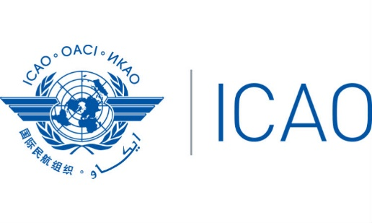
International Civil Aviation Organization
South American Office
PA-RAST/34— WP/01
12/11/18

Thirty Fourth Pan America — Regional Aviation Safety Team Meeting
(PA-RAST/34)
Miami, United States – 13 to 14 November 2018

Provisional Agenda

Agenda Item 1: Approval of the Provisional Agenda
The Meeting is expected to review and approve the provisional agenda for the meeting

Agenda Item 2: Review of PA-RAST Action Items and RASG-PA Valid Conclusions/Decisions
The Meeting will review the last PA-RAST meeting actions items and conclusions, as well as the latest activities of RASG-PA Meetings.

Agenda item 3: Results from the ESC/31 Meeting

- Project based approach/Communications Plan
- Collaborative Safety Teams
- AN13 Conclusions review
- RASG-PA activities regarding runway safety initiative

Agenda Item 4: Update from MAC DIP Champion
MAC DIP Champion will provide an update on the DIP implementation.

Agenda Item 5: PA-RAST work program planning
The Meeting will agree on the work program framework and milestones for the next 3 years, and potential dates for 2019 meetings.

Agenda Item 6: Presentation aviation safety data

- ASR 8th Edition
- ICAO Data
- IATA Data
- ASIAS Data
- BCAST Data
- NAV CANADA Presentation

Safety Analysis Ad-hoc Team creation

Agenda Item 8: Other Business

-- END --

