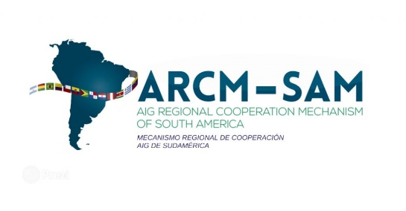
Code: | Revision: | Date:
Registration Form

ARCM Accidents Investigation Workshop
(Lima, Peru, 3 to 7 September 2018)

State - Organization: ……………………………………………………………………………………………… .

Name (the same to be included in the participation certificate): ………

…………………………………………………………………………………………………………………….

Official responsibilities in your State: ….……………………………………………………………………

Official address: …………………………………………………………………………………......

Telephone No.: ……………… Fax No.: …………………… E-mail: …………………………………………. ….

Hotel or Address in Lima: …………………………………………………………................................ .........

Arrival date, time and flight: ………………………………………………………................................ .........

Departure date, time and flight: ………………………………………………………...........................................…………

Signature: ………………………………………………… Date: ………………………………………… .

Kindly send this registration form before 3 August 2018 to the ICAO South American Office in Lima, by email to icaosam@icao.int and to the ARCM Secretariat to info@arcm-sam.org

