Alert levels calculation
The determination of the alert levels is associated to the trend of the indicator’s historical data. This is to ensure that the alert setting of an indicator takes into account its own recent historical behaviour. Historical data performance is specifically measured using two characteristics of the historical data group:

a) the average value; and

b) the standard deviation (SD) value

The alert levels for a new monitoring period (current year) are based on the preceding period's performance (preceding year), and are derived from these two values (average and SD), namely its data points average and the standard deviation (SD). The alerts levels are represented in the safety indicator graph by 3 alerts lines, as follows:

1) average + 1 SD;
2) average + 2 SD; and
3) average + 3 SD.

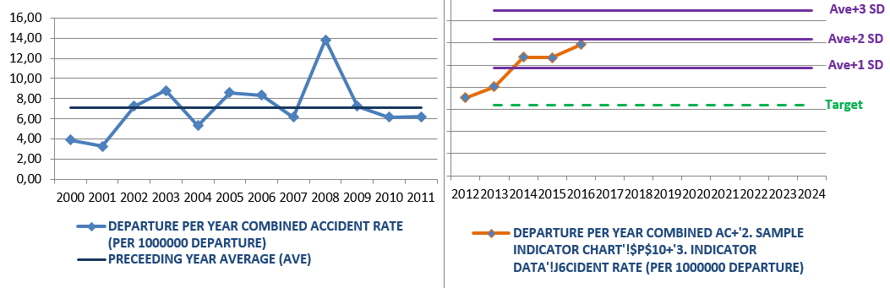
For manual calculation purposes, the formula for the standard deviation (SD) (population) is:
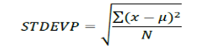
where:
∑: is the symbol for summation
X: is the value of each data point
µ: is the average value of all data points
N: is the value of the data points

Manual calculation is illustrated as follows through an example:

The average rates for years 2012, 2013, 2014 and 2015 are as follows:
2012: 3.5
2013: 2.5
2014: 3.5
2015: 2.5
The following equation is used for obtaining the average value:
Average (µ) = 3.5 + 2.5 + 3.5 + 2.5 = 3
4
To calculate standard deviation (SD) (population), first calculate the difference between each rate and the average, and we square each value (x- µ)².

(3.5 – 3.0)² = (0.5)² = 0.25
(2.5 – 3.0)² = (-0.5)² = 0.25
(3.5 – 3.0)² = (0.5)² = 0.25
(2.5 – 3.0)² = (-0.5)² = 0.25

Next, to obtain the SD, calculate the average of these values and obtain the square root of that value.

SD = √ (0.25 + 0.25 + 0.25 + 0.25) = 0.5
4
With the standard deviation (SD) and average thus obtained, calculate the alert levels with one, two and three standard deviations for 2016, using the following equations:

1) average + 1 SD;
2) average + 2 SD; and
3) average + 3 SD.

After replacing the data, the following is obtained:

1) 3 + 0.5 = 3.5
2) 3 + 0.5 + 0.5 = 4
3) 3 + 0.5 + 0.5 + 0.5 = 4.5

