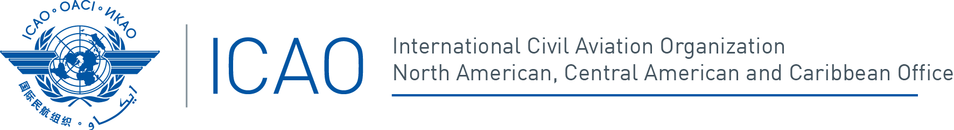

Third ICAO/IATA/CANSO Performance-Based Navigation (PBN) Harmonization, Modernization and Implementation Meeting for the North American, Caribbean and South American (NAM/CAR/SAM) Regions
(ICAO/IATA/CANSO/PBN/3)
Miami, Florida, United States, 10 - 14 July 2017

REGISTRATION FORM

1. | Position in your Delegation:  (Please select one option) | Chief Delegate |  |  |  |  |  |  | Delegate
1. | Position in your Delegation:  (Please select one option) | Adviser |  |  |  |  |  |  | Observer
2. | Country / Organization
3. | Salutation |  | Mr. |  |  |  |  | Mrs. |  |  |  | Miss
4. | Name
5. | Official Position or Title
6. | Official Telephone
7. | Mobile (to contact you in case of an emergency)
8. | Official E-mail
9. | Hotel and address where you will be staying during the event
10. | Please indicate if accompanied by your family |  | Yes |  |  |  |  |  |  | #
11. | Dates of total stay in the venue Country
12. | Please indicate if you have any medical condition or allergies
13. | Emergency contact information in your country of origin |  | Name
13. |  |  | Relationship
13. |  |  | Telephone

Please send this form to:
E-mail: icaosam@icao.int
icaonacc@icao.int

