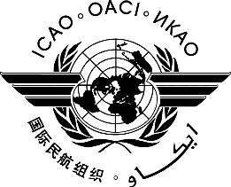 | International Civil Aviation Organization  WORKING PAPER
  A41-WP/xxxx
  P/xx
  ../../22
  (Information paper)
  English only
ASSEMBLY — 41ST SESSION

PLENARY

Agenda Item | ##: | Title of agenda item

TITLE

(Presented by ...)

EXECUTIVE SUMMARY
Start text here
Strategic Objectives: | This working paper relates to Strategic Objectives...
Financial implications:
References:

- INTRODUCTION
  - ...

