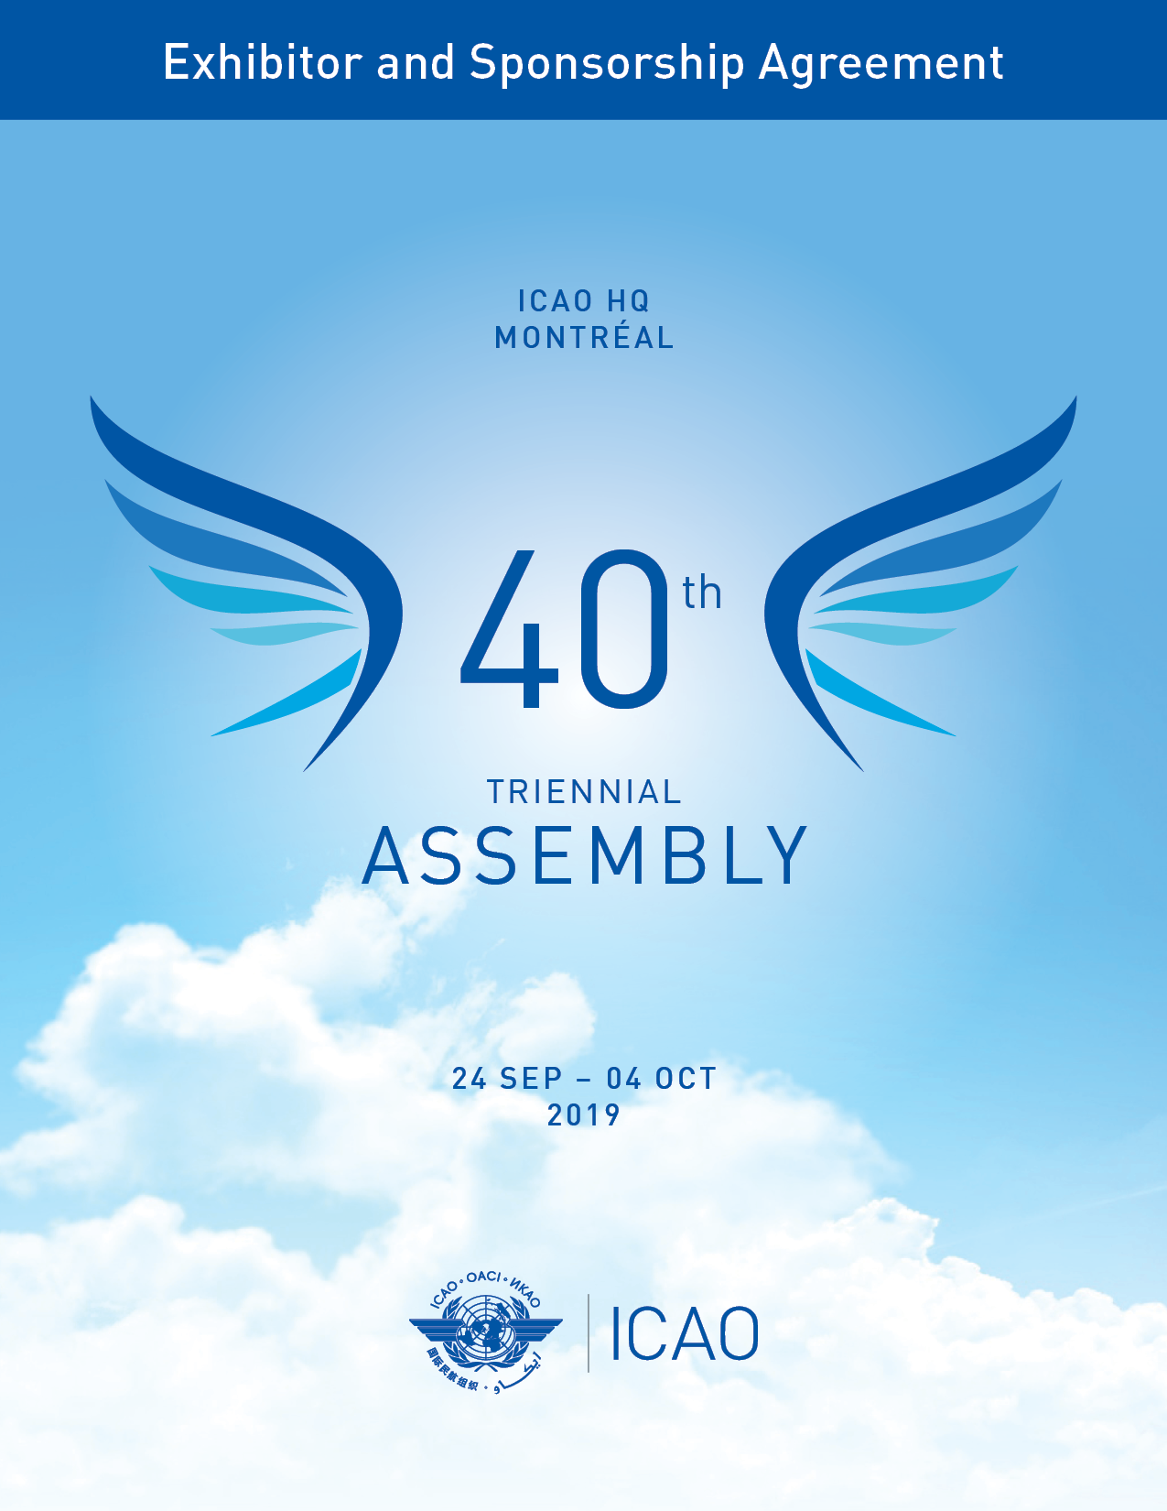

Important Information

- ICAO’s approval selection process of an exhibitor will be subject to the following criteria:
- Region and;
- Industry sector.

- The SkyTalks:
- Must address one of ICAO’s Strategic Objectives and/or the No Country Left Behind (NCLB) initiative;
- May not be commercially oriented;
- Presentation must be verified and approved by ICAO.

- The use of the ICAO brand/logo is strictly prohibited without formal approval.

- Exhibitors (company’s representatives and staff) may not enter into the Assembly Hall area during the 40th Assembly (September 24 – October 4), nor can they distribute promotional material in the assembly area, however they may engage in network activities within the “SkyTalks Industry Zone”.

Please note that all companies interested in participating as an exhibitor and/or presenting a SkyTalks must be approved by the Office of the Secretary General.

____________________________________________________________________________________

To participate as an exhibitor at this Assembly, please return pages 1-4.

- Company Information:

Company Name
Contact Person | Salutation Mr. Mrs. Ms. Dr.
First Name |  | Last Name
Title |  | Email Address
Address
City |  | Province
Postal / Zip Code |  | Country
Tel No. |  | Fax No.

- Booking an Exhibition Space

Please note that your booth number will be assigned and confirmed by your project manager.
To see a list of exhibition services and benefits, please see Appendix A.

To view the exhibition floor plan for A40, see Appendix B.
Date | Booth No | Select | Cost
Wave 1:  24 -26 September* | 21 - 32 |  | $12,000
Wave 2:  27-29 September* | 21 - 32 |  | $10,000
Wave 3:  30 Sept. to 2 October* | 21 - 32 |  | $7,500
Wave 4:  3-4 October* | 21 - 32 |  | $5,000
*Your company’s participation as an exhibitor during A40 is subject to approval by all ICAO bureaus.

- Exhibition Requirement

 | Booth Rental Space | Requirements
 | Any size | Exhibitor must use ICAO’s recommended exhibition service provider. ICAO will provide the basic booth structure and furtniture.

Restrictions:
- Display back panel walls must not exceed 8 feet (2.5 metres) in height.
- Side panels must not extend more than 10 feet (3 metres) from the back wall and cannot be more than 3 feet (1 metre) in height.

- SkyTalks Presentations

During A40, exhibitors will have an opportunity to present on a subject pertaining to one of the ICAO Strategic Objectives. These SkyTalks will be designated as ICAO SkyTalks, a unique venue that enables the sharing of knowledge from presenters and industry professionals. The aim is to stimulate discussions among manufacturers, member states and key stakeholders in the aviation industry.

In addition to a live audience, each presentation (30 minutes) will be lived stream and video tape. The presentations will be released to the public through our blog and social media platforms.

SkyTalks presentations will be allocated based on meeting selection criteria and approval from the Office of the Secretary General.
Only exhibitors can reserve a SkyTalks. Please note that the number of available Industry SkyTalks presentations is limited. See table below for the available dates.

A40 SkyTalks Presentation
Date | Day | Select | *Time | Cost
September 24 | Tuesday |  | TBD | $5,000
September 25 | Wednesday |  | TBD | $5,000
September 26 | Thursday |  | TBD | $5,000
September 27 | Friday |  | TBD | $5,000
September 30 | Monday |  | TBD | $5,000
October 1 | Tuesday |  | TBD | $5,000
October 2 | Wednesday |  | TBD | $5,000
October 3 | Thursday |  | TBD | $5,000
*Your project manager will assign your company a time slot.

- Program Directory

The information below and your corporate logo will appear in the program directory. Please complete the table below and send us a high resoluciotn logo via email to mcr@icao.int before September 2, 2019. Mininum resolution 300 dpi. Preferred formats: PNG, EPS, AI, BMP.

Company Name
First Name |  | Last Name
Website URL |  | Email Address
Company Description (Maximum 100 words)

- Invoicing and Payment

Total Payment USD

Following receipt of the duly completed agreement form and approval from ICAO, ICAO will email the customer a copy of the invoice in
pdf format and the original invoice will be mailed to the exhibitor.

Due Date: Invoice must be paid in full within 14 days upon receipt of the invoice.
Non Payment: Failure to make payment may result in the cancellation of the agreement and the reserved
space will be subject to resale.

Please select one of the following payments below. (ICAO’s preferred method of payment is by credit card)

 | Bank Transfer |  | Cheque |  | Credit Card

- Withdrawal Policy

The exhibition booking or SkyTalks may be withdrawn by the agreement signatory, in accordance with this provision.
Only a written withdrawal notice sent by email to mcr@icao.int or your project manager shall have effect.
The withdrawal notice shall be deemed to have been given on the date such notice is received by ICAO at the
mcr@icao.int inbox.

Withdrawal notices received in good order will be acknowledged in writing by ICAO.
In the event of withdrawal, refunds shall apply as follows:

If the cancellation request is: | Refund
More than 29 days before the start date of the event | Full refund
Between 22 to 28 days before the start date of the event | 75% refund
Between 14 to 21 days before the start date of the event | 50% refund
Less than 14 days before the start date of the event | No refund

- Transportation and Customs Clearance
International In bound shipment:
ICAO is not responsible for any transportation and customs clearance fee for the exhibition materials.
All materials shipping to ICAO should be prepaid in full with your carrier. ICAO will not accept COD shipments.

- Terms and Conditions

- By submitting this signed Exhibitor / Sponsor Agreement application form, the applicant whose information is completed at paragraph 1 (the “Applicant”) agrees with the International Civil Aviation Organization, headquartered at 999 Robert-Bourassa Boulevard, Montreal, Quebec, Canada, H3C 5H7 (“ICAO”), to abide by the Terms and Conditions set out herein. Applicants for exhibition space shall be referred to as “Exhibitors” and sponsorship Applicants shall be referred to as “Sponsors”.
- ICAO shall be under no obligation whatsoever in connection with any application, until written acknowledgement of ICAO’s acceptance of the application form. In particular, ICAO shall be under no obligation to accept an application form. For Exhibitors, the exhibition space is guaranteed only upon ICAO’s written acknowledgement and payment by the Exhibitor in accordance with paragraph 7 of this form.
- The person signing the Acceptance below represents and warrants that he or she is duly authorized to sign on behalf of the Applicant and that the Agreement shall be binding on the Applicant.
- All payments shall be made to ICAO in US Dollars only. If the invoice is not paid by the due date, ICAO may in its sole discretion, cancel the sponsorship and/or exhibition rental space.
- All materials shipping to ICAO should be prepaid in full with the carrier. COD shipments shall not be acceptable to ICAO.
- The rights and obligations of the Applicant under this Agreement shall be non-assignable and non-transferable, except with the express written consent of ICAO.
- Exhibitors and Sponsors shall confine all business, demonstrations, exhibitions, canvassing, and distribution of printed matter or other items exclusively to the assigned booth space. No overflow into the aisles shall be permitted, due to fire and safety regulations. Promotional materials shall not promote military applications or name or make any reference to territories not formally recognised by the United Nations as sovereign states.
- ICAO makes no representations or warranties with respect to the demographic nature and/or number of exhibitors and/or attendees that will attend the event.
- ICAO accepts no responsibility or liability for any loss, damage or personal injury, arising in connection with this Agreement and the associated event(s). The Exhibitor should therefore make its own insurance arrangements in accordance with its requirements, risks and expectations. The Exhibitor shall indemnify, save and hold harmless ICAO and its employees or agents, from and against any claims, actions, losses, damages, expenses and costs whatsoever arising from the Exhibitor’s acts or omissions.
- Nothing in or relating to this Agreement shall be deemed a waiver, express or implied, of any immunity from suit or legal process or any privilege, exemption or other immunity enjoyed or which may be enjoyed by ICAO, its Officials and staff, under international or national laws.
- The Applicant shall ensure compliance with the following: Non compliance may result in the termination of this agreement
  - Applicant’s products and services must not go against or perceived to go against ICAO’s 5 strategic objectives or the NCLB (No Country Left Behind) initiative.
  - The Applicant shall be in good financial standing with ICAO with no outstanding debts.
  - The Applicant shall not use the ICAO brand, logo or intellectual property, except with the express written approval of ICAO.
  - Exhibiting or sponsoring the event will not pose any conflict of interest.
  - The Applicant’s participation may not be perceived as being negative to Member States or regions.
  - The Applicant should contribute, provide value and share knowledge with Member States and the civil aviation industry.

- Return the Agreement Form

The character of the exhibitor and/or sponsor is subject to the approval of ICAO.
Confirmation of the allocated exhibition spaces(s) and/or sponsorship will be guaranteed by return of this duly completed and signed agreement form and full payment. Please return the agreement by email (scan or pdf format) to your project manager or mcr@icao.int.

- Acceptance

The information set forth in this exhibitor agreement is accurate.
I have read, understood and agree to abide to the terms and conditions as set forth in this agreement.

 | Signature: ____________________________________ |  | Date:
Appendix A: Exhibition Services
Services included |  | Comments
Exhbition booth space and booth construction |  | 4th Floor / Will be arranged through the ICAO recommended exhibition service providers. See sample below.
Complimentary exhibition pass. |  | 2 complimentary passes for each exhibitor.  Note: for the Assembly 39th Session: only Workshop Zone passes will be issued.
Carpet at the exhibition space(s). |  | Exhibition areas are carpeted. The ICAO building is air conditioned
Electricity supply (one outlet per single space) with an extension cable and a multi-socket power bar. |  | 110V for a maximum of 15 ampere.
Free wireless Internet connection.

24-hour security. |  | Special security measures will be in place. ICAO is not responsible for any loss or damage of property in the exhibition areas
Exhibitor’s logo, contact, url and description of the company’s products/services in the program directory.

Access into the assembly hall. |  | Photo ID Badge must be worn during the symposium.
Invitation to all hospitality events. (reception, coffee, lunch, workshops)

Daily cleaning of public areas.

Not Included |  | Comments
Materials handling, advance warehouse storage, rental of extra furniture, chairs, tables, graphic banners, electrical accessories, transformers. |  | Should be arranged through the ICAO recommended exhibition service providers.
Transportation and customs services. |  | Should be arranged through the ICAO recommended customs broker
Audio visual equipment, laptops, TV, DVD players. |  | Should be arranged through the ICAO recommended audio visual supplier

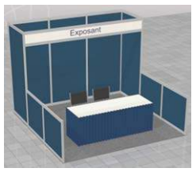
Standard Booth setup through the exhibition service provider.

Inlcudes: back and side walls, skirted table, 2 chairs, header sign, track ligh, wastebasket.

Appendix B: Floor Plan A40

