REPORT OF THE THIRD FACE-TO-FACE MEETING OF THE AIR TRAFFIC FLOW MANAGEMENT INFORMATION REQUIREMENT SMALL WORKING GROUP (ATFM/IR/SWG/F2F/3)

Tokyo Japan, 4-5 April, 2019
The views expressed in this Report should be taken as those of the Meeting and not the Organization

Endorsed by the Meeting
in coordination with the ICAO Asia and Pacific Regional Sub-Office, Beijing, China

Contents
INTRODUCTION 3
Meeting 3
Attendance 3
Officers and Secretariat 3
Opening of the Meeting 3
Documentation and Working Language 3
REPORT ON AGENDA ITEMS 4
Agenda Item 1: Review and Agreement on Agenda 4
Agenda Item 2: Briefing on the Relevant ICAO Meetings 4
Agenda Item 3: Project Update/Review 4
Agenda item 4: SWG Work Progress Update/Review of TOR 5
Agenda Item 5: Harmonization /Standardization Update/Discussion 5
Agenda Item 6: Work Plan Update 7
Agenda Item 7: Any Other Business 7
Closing of the Meeting 7

APPENDICES

Appendix A: List of Participants
Appendix B: List of Papers and Presentations
Appendix C: Draft TOR Amendment
Appendix D: Action List

INTRODUCTION

Meeting

  - The Third Face-to-Face Meeting of ATFM Information Requirement Small Working Group (ATFM/IR/SWG/F2F/3) was held in Tokyo Japan from 4 to 5 April 2019.

Attendance

2.1 The meeting was attended by 37 participants from China, Hong Kong China, India, Japan, Republic of Korea, Singapore, Thailand and IATA. Three participants attended the meeting through Skype from Australia, Hong Kong China and CANSO. The list of participants is at Appendix A to this report.

Officers and Secretariat

3.1 Mr. Hiroyuki Takata, Regional Officers, ATM at ICAO APAC RSO, facilitated the meeting.

Opening of the Meeting

4.1 Mr. Hiroyuki Takata, on behalf of Mr. Arun Mishra, the Regional Director of ICAO Asia/Pacific Regional Office, welcomed the participants to attend this meeting.

Documentation and Working Language

5.1 The working language of this meeting and all documentation was in English. There were 14 presentations and papers. A list of presentations/papers is included at Appendix B to this report.

.…………………….

REPORT ON AGENDA ITEMS

Agenda Item 1: Review and Agreement on Agenda

  - The meeting agreed the Provisional Agenda.

  - The meeting noted the tentative program of ATFM/IR/SWG/3 and the action items of previous meeting, ATFM/IR/SWG/2.

Agenda Item 2: Briefing on the Relevant ICAO Meetings

  - ICAO provided the meeting with a briefing on the relevant ICAO meetings, focusing on the matters with respect to the ATFM/CDM/A-CDM.

Agenda Item 3: Project Update/Review

Analysis of operational trial for airspace flow program conducted on ats route m771 to zspdg

- Civil Aviation Authority of Singapore (CAAS) made updates on the analysis of operational trial for airspace flow program on ATS route M771 to ZSPD. The meeting noted that the trial had been started due to no predictability of flow control restrictions imposed on M771, and increasing workload and complexity for ATC.

- The meeting noted that the frequent restrictions issued via NOTAMs utilising MINIT as an ATFM measures to regulate traffic flow from South Asia to Northeast Asia have often led to considerable delay to aircraft, including aircraft that were already airborne.

- The meeting discussed 3 options to increase efficiency, predictability and provide better safety consideration for aircraft and ATC operation during the activation of the such flow measures

- For the ATFM unit closest to the point of restriction to originate the ATFM program
- Ability to ensure fair distribution of delay across the full spectrum of flights entering the constrained resource.

- Uitlising CTOT/CTO in replacement of MINIT, when initiating the ATFM program
- Provide higher level of predictability for aircraft operation, ATC and flow planning.

- Provide sufficient notification lead time from the validity of the NOTAM and/or include exemption criterion
- Mitigate disruptions to ATC operations and provide predictability to flights already airborne.
- The meeting agreed and would considered the step forward to include 1 or more of the options in the above during activation of similar flow restriction in the future.
ATFM in india

- India presented the ATFM operations in India, which phase 1 ATFM operations has been started since 27 April 2017, and which phase 2 is expected to commence after June 2019 when System Stability and Reliability Test (SRST) is scheduled.

- The meeting noted that current phase 1 in India includes only Ground Delay Programs (GDP) and Ground Stop (GSt) with ADP exchange with stakeholders at 1900 (IST) daily. The phase 2 will include MIT, MINIT, Fix balancing, Airborne holding, Sequencing programs, Reroutes, and Level capping.

- The meeting noted these progress and appreciated India for sharing the experiences.

Agenda item 4: SWG Work Progress Update/Review of TOR

DRAFT AMENDMENT SWG TOR

  - ICAO informed the meeting that the intention of revising the ATFM/IR/SWG TOR was to expand the scope of working to include regional ATFM initiatives harmonization. ICAO had consulted with relevant SMEs on the TOR revision and believed that the terms proposed in the TOR of the ATFM/Implementation Harmonization/SWG (Refer to the ATFM/SG/8 WP/18) would be appropriate.

  - The meeting noted that each participating States/Administration supported this working scope expansion, and the meeting would develop the ATFM/IR/SWG TOR accordingly and submit it to ATFM/SG/9 for approval. The agreed draft TOR amendment is included at Appendix C to this report

Agenda Item 5: Harmonization /Standardization Update/Discussion

Tentative phased plan

  - The meeting reviewed the tentative phased plan proposed by the secretariat and agreed the plan as below.

- Phase 0: ADP Exchange
- Target implementation: 2019
- To exchange ADP in PDF format via e-mail using the common format of ADP filename and e-mail subject for ADP distribution
- Phase 1: ATFM Information Exchange Using Conventional Protocol
- Target implementation: 2019-2022
- To exchange ATFM information in accordance with the commonly agreed standard operating procedure and using the communication protocol currently operational for exchanging ATS-related messages
- Phase 2: ATFM Information Exchange based on SWIM Concept
- Target implementation: TBD
- To exchange ATFM information using SWIM-based technology

atfm daily plan (adp) file name

  - The meeting reviewed that during this interim period, the ADP should be sent as an attachment of an email, in PDF format, with a structured file name. Accordingly, the email carrying ADP message should also have a structured name in the “subject” field of the email.
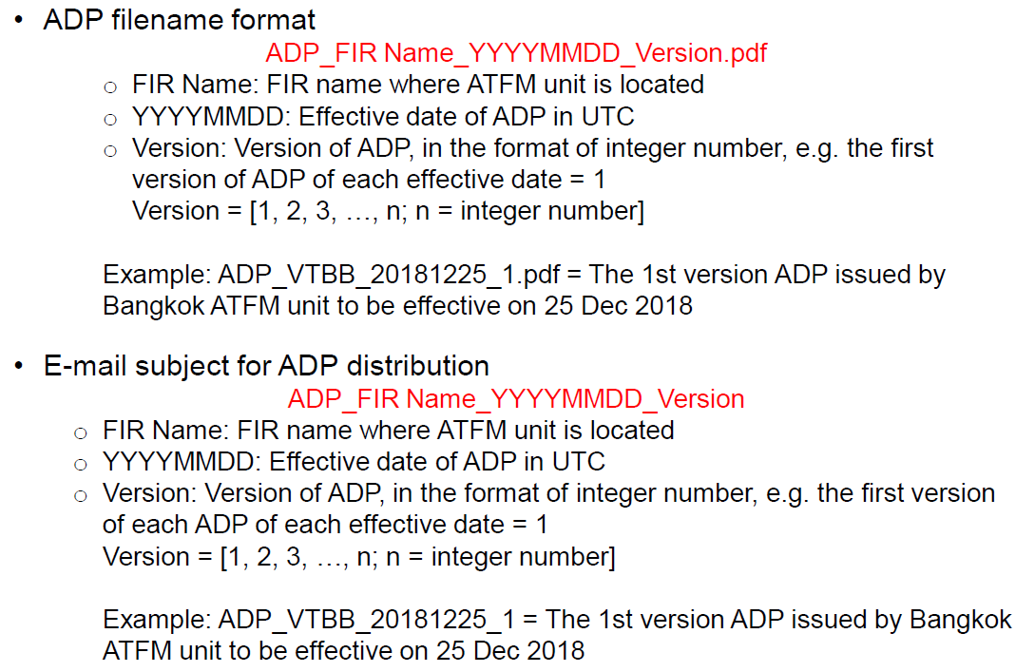

  - The meeting was also advised that currently India share the ADP which includes four FIR’s information regarding ATFM, and Australia share the ADP which includes two FIR’s information and its file name has two FIR’s name.

State | File name | ADP contents
India | Single FIR name | Four FIR’s information
Australia | Two FIR’s name | Two FIR’s information

  - The meeting agreed to take the following action:

Action Item ATFM/IR/SWG/3-01, that
- The Secretariat to discuss with Australia in details at ATFM/SG/9
- The action should be closed no later than ATFM/IR/SWG/4

  - Meeting discussed the ATFM Daily Plan (ADP) exchange between DMN-ATFM Project and NARAHG Project. The meeting agreed to exchange ADP information through email, as an interim mean till the full application of SWIM technology. And the meeting agreed as below.

  - Multi-Nodal State’s ADPs will be distributed to NARAHG States and India.
  - Japan’s ADP will be distributed to Multi-Nodal States by summer 2019.
  - ADPs from China and the ROK will be distributed to Multi-Nodal States by end of 2019 with CRACP system modification.

  - The meeting agreed to take the following action:

Action Item ATFM/IR/SWG/3-02, that
- Analyse the need of ADP distribution of the day when ATFM is not carried
- The action should be closed no later than ATFM/IR/SWG/4

ATFM/ir/swg Roadmap

  - The meeting discussed further activities of Phase 1, ATFM information exchange using conventional protocol, especially on Stage 1, Development and validation. The expected outcomes would be “Validated Standard Operating Procedure (SOP)” and “Validated data exchange method”.

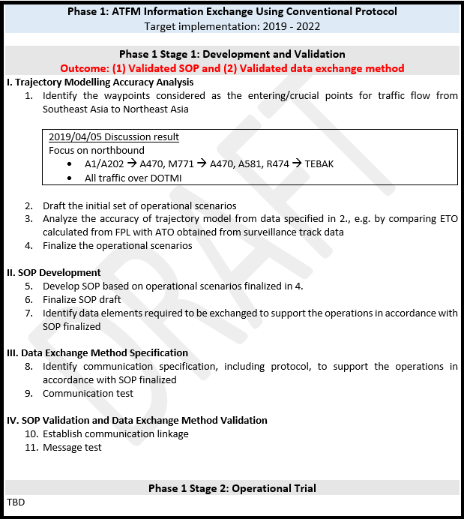

  - The meeting then found out the gap on what to discuss under ATFM/IR/SWG regarding harmonization or interoperability between NARAHG team and Multi-Nodal ATFM team. Thus, the meeting couldn’t reach a consensus on abovementioned roadmap.

  - Since the meeting was not sure that the comments from one of NARAHG team was made on behalf of the team or State, NARAHG team was asked to have an internal coordination and get back to the meeting in this regard. In addition, the meeting noted a sidebar meeting at ATFM/SG/9 to continue to discuss this topic would be beneficial for both teams.

Working paper to Atfm/sg/9

  - The meeting discussed a draft working paper on progress of the ATFM/IR/SWG to ATFM/SG/9 and agreed to include TOR amendment proposal, agreed implementation phases, ATFM Daily Plan (ADP) exchange, and approach to interoperability.

  - The meeting also agreed the following schedule.

- Initial draft submission to the RSO by Friday 12 April
- Distribute the draft by Monday 15 April
- Review the draft by Tuesday 16 April
- Submit the WP to ATFM/SG/9 on 16 April

Agenda Item 6: Work Plan Update

  - The next meeting of ATFM/IR/SGW/4 may be held in the 4Q of 2019 in Thailand, in conjunction with other meeting. In addition, tele-cons may be needed more frequently to discuss the issues further.

Agenda Item 7: Any Other Business

  - No discussion

Closing of the Meeting

  - Mr. Hiroyuki Takata, Regional Officer, ATM, ICAO APAC RSO, thanked the participants on their efforts and contributions as a closing remarks.

---------------------

