FREQUENCY SPECTRUM MANAGEMENT PANEL (FSMP)

Twentieth Working Group Meeting

Bangkok, Thailand, 26 February -7 March 2025

Agenda Item 8: Any Other Business

Investigation of the 15.4 – 15.7 GHz frequency band for Detect and Avoid Systems

(Prepared by Ivan Martin, Jean René Gely (Thales), Christian Fleury, Guillaume Novella (DGAC)
Presented by Guillaume NOVELLA –DGAC))

SUMMARY
This WP continues discussion on frequency bands to support non-cooperative Detect and Avoid (DAA) systems for remotely piloted aircraft systems (RPAS). See FSMP-WG19-WP21. This WP further investigates the possibility to deploy on-board DAA in the 15.4 – 15.7 GHz frequency band since this band has been identified as one ofthe promising bands to fulfill RPAS DAA needs.

- INTRODUCTION
  - FSMP-WG-19-WP21 analysed the suitability of the frequency bands with a radionavigation or aeronautical radionavigation allocation to support RPAS DAA needs.
  - Main RPAS DAA spectrum needs are reminded below:
- Since the objective of the RPAS is to perform international IFR flights in non-segregated airspace, DAA solution should be global. The RPAS air-to-air DAA frequency band should therefore be harmonized on a worldwide basis.
- Due to the inherent safety nature of DAA system, the DAA frequency band should have an aeronautical radionavigation service (ARNS) allocation and appropriate protection must be provided against harmful interference.
  - It has to be noted that RPAS SARPs does not preclude the use of ground based detect and avoid, under the responsibility of the State of the Operator, based on the results of a specific safety risk assessment conducted by the operator which demonstrates how an equivalent level of safety will be maintained. It is anticipated that ground based DAA would rely on primary radars and can share “usual” civil aviation radar frequency bands (for example, 1240 – 1370 MHz, 2.7 – 2.9 GHz, 9 – 9.2 GHz). The coexistence between radars sharing the same band can be ensured through frequency coordination process and separation distance.
  - However, on a nominal basis, fulfilment of ICAO Annex 6 Part IV § 6.20.2.1 mandating an automated collision avoidance system can be done through on-board DAA. This identification of a frequency band to fulill RPAS DAA spectrum needs seems more difficult than for ground based DAA. However, the 15.4 – 15.7 GHz band is considered as a good candidate. Consequently, this WP further explores the opportunity to use the 15.4 – 15.7 GHz band for on-board DAA.
  - At FSMP-WG19, one participant indicated the 15.4 – 15.7 GHz frequency band was used by airborne surface detection equipment (ASDE) radars in its country. To address this point, FMSP-WG19 report indicates that “the meeting agrees to start the analysis on the deployment of on-board DAA, and invites participants to share information on DAA as well as other aeronautical systems operating in candidate bands for the next FSMP meeting”. However, no information has been received regarding the characteristics of ASDE (technical parameters, number and location of radars, etc) operating in the 15.4 – 15.7 GHz band. In order to progress on the investigation of the 15.4 – 15.7 GHz band for on-board DAA, information from ASDE operating in other ARNS frequency bands are taken into account. Characteristics of DAA systems are given in this WP. They are consistent with the ones included from ITU working document towards preliminary draft new recommendation on DAA systems in the 15.4 – 15.7 GHz band.
- DISCUSSION
  - Use of the frequency band 15.4 – 15.7 GHz
    - The table below is an extract of the ITU-R RR about the allocations in the frequency bands 15.4 – 15.7 GHz.

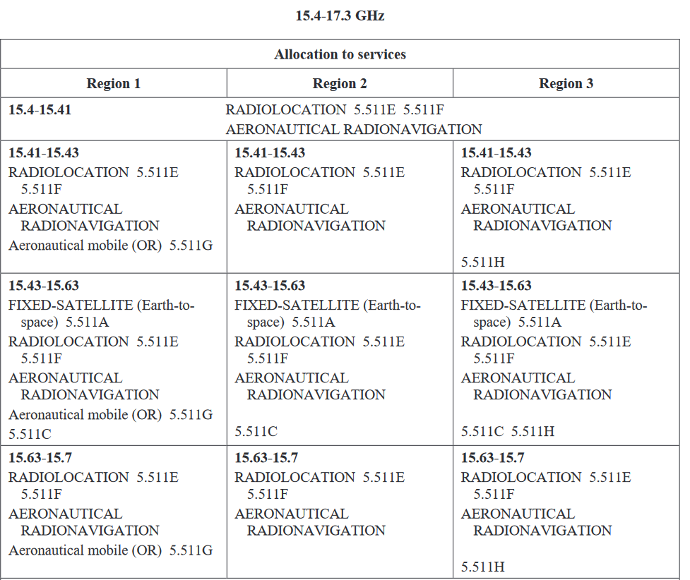
    - It has to be noted that:
- No 5.511E states: “In the frequency band 15.4-15.7 GHz, stations operating in the radiolocation service shall not cause harmful interference to, or claim protection from, stations operating in the aeronautical radionavigation service”. As a consequence, there is not a lot of radiolocation systems operating in the 15.4 – 15.7 GHz band. Those radiolocation systems prefer to use frequencies above 15.7 GHz where the constraint of No 5.511E does not apply.
- The AM(OR)S allocation in Region 1 is quite new (WRC-23). It is a secondary allocation, without any massive deployment foreseen in this band.
- Fixed satellite service (Earth to Space) is used for FSS feeder link. Emissions are therefore localized around FSS ground stations where coexistence with ARNS is ensured through ITU-R Rec S.1340.
    - In the 15.4 – 15.7 GHz frequency band, the terrestrial MIFR contains 61 stations . All of them are part of the ARNS. Stations in Finland are not located on airport, and stations in Sweden are mobile, therefore, they do not correspond to ASDE.
Registering administration | Number of stations
FIN | 45
S | 10
USA | 6

    - The maximum necessary bandwidth of US stations in the MIFR in the 15.4 – 15.7 GHz band and which correspond to ASDE is 2 MHz. This is lower than bandwidth of ASDE systems in ITU-R Rec M.1796 that are reminded in Table 1 (9 – 9.2 GHz band). In addition, ASDE radars typically points below the horizon. It is therefore unlikely that RPAS DAA main beam to be aligned with ASDE radar main beam when the RPA is flying.
 | G8 | G18 | G19
Bandwidth (MHz) | 50 | 50 | 35
Elevation beamwidth (°) | 19 | 9.91 | 9.91
Azimutal beamwidth (°) | 0.35 | 0.37 | 0.37
Table 1: Characteristics of ASDE radars in the 9 - 9.2 GHz frequency band

  - Technical parameters of DAA
    - Technical parameters of DAA has been made available by manufacturers. These technical parameters are contained in Table 2 and were submitted to ITU-R WP-5B to contribute to the development of the DAA recommendation in the band 15.4 – 15.7 GHz.
Parameter | Units | Radar A | Radar B
Platform |  | Airborne | Airborne
Radar type |  | Pulse Modulation | Pulse Modulation
Operating range | km | Up to 15 | Up to 15
Maximum number of airbornes within the same operating area |  | Up to 10 | Up to 20
Ground speed | m/s | Up to 150 | Up to 150
Frequency tuning range | GHz | 15.4-15.7 | 15.4-15.7
Channel selection method between radars |  | SW selectable | SW selectable
Pulse width (1 meter range resolution) | μs | 1 to 20 | 1 to 20
Pulse rise and fall times | μs | < 0.1 | < 0.1
RF emission bandwidth  −3 dB  −20 dB  −40 dB | MHz | 80  90  110 | 80  90  110
Pulse repetition frequency | Hz | - | -
Pulse repetition interval | μs | 30 to 80 | 30 to 80
Average transmitter power (conducted) during emission time | W | 70 | 100
Spurious emission characteristics (conducted) | dBc | SM.329 | SM.329
Receiver bandwidth  −3 dB  Receiver selectivity  −20 dB  −60 dB | MHz | 20  40  80 | 20  40  80
Receiver noise figure | dB | 3 | 3
Protection criteria  (aggregate) I/N | dB | −6 | −6
Antenna pattern | N.A. | See Annex | See Annex
Antenna placement |  | Aircraft | Aircraft
Maximum antenna gain | dBi | 9 | 9
Antenna pointing |  | Per sector | Per sector
Polarization |  | Vertical | Vertical
Field of Regard (FoR) | degrees | +/-110° (typical) up to +/-180° | +/-110° (typical) up to +/-180°
Table 2: Technical characteristics of DAA

  - Solutions for sharing of the 15.4 – 15.7 GHz band between ASDE and DAA
    - DO-366B (Air-to-air DAA radar) contains the following requirement:
The radar shall (REQ:022) be capable of switching automatically between three frequency channels within the utilized band based on interference in the channel and have a minimum of three non-overlapping channels within the band.

    - In the 300 MHz of the 15.4 – 15.7 GHz, considering that the bandwidth for ASDE is maximum 50 MHz, there is still room for enough DAA channels in order to respect DO-366B requirements.
    - The accommodation of the requirement on the number of channel would be facilitated with a dynamic and location dependent choice of the usable channel by on-board DAA.
    - Conditions for the selection of channels to be used by DAA needs to be defined, from the constraints to ensure coexistence between the different applications in this band. This will be done at next step.
- ACTION BY THE MEETING
  - It is believed that the 15.4 – 15.7 GHz frequency band is a good candidate to accommodate DAA needs, in particular regarding its capacity to support worldwide operations. Coexistence between the different services seems to be achievable. Civil aviation would benefit from optimizing its spectrum usage by sharing the aeronautical bands between several aeronautical systems.
  - The meeting is invited to:
- note and review the contents of this working paper;
- continue the identification of constraints and the definition of solution to ensure coexistence between the different systems.
- Include the technical parameters of on-board DAA radar into the RF handbook Vol C, as part of the long term maintenance of ICAO Doc 9718.
- Prioritize the accomodation of on-board DAA needs in this band, considering that this band would be suitable to fulfill the need for worldwide RPAS operation
- Limit the deployment of ASDE in this frequency band
- Coordinate FSMP work with RPAS Panel which has taken the initiative to set up a DAA frequency sub-group without any coordination with FSMP at this stage.
— END —

ANNEX

On-board Detect and Avoid Radar (15.4 – 15.7 GHz)

QUICK REFERENCE

System name | On-board Detect and Avoid Radar
Description | On-board Detect and Avoid Radar refers to equipment assisting the remote pilot to detect and avoid hazards, including sensors, processing units and the interface with the remote pilot. It is a key enabler for the safe and efficient integration of RPAS into non-segregated airspace.
Technologies used | Pulsed
International Spectrum Allocation | Aeronautical radionavigation
ICAO regulations on usage | Annex 10, Annex 6 Part IV

System Summary
On-board Detect and Avoid Radar is one component of the wider DAA system whose objective is to allow the remote pilots to exercise their responsibilities with regards to see and avoid. The DAA system offers the remote pilot three functions to aid in the decision making.

Firstly, the DAA system provides a traffic display function, showing all traffic surrounding the RPA at the range selected by the remote pilot. This aids the remote pilot in exercising the ICAO Annex 2 responsibility to remain vigilant for the purpose of detecting potential collisions with other aircraft.

The DAA system also provides a “remain well-clear” function (“RWC function”), which alerts the pilot of an imminent loss of ‘well clear’, or in other terms: an imminent need to apply the right-of-way requirements of ICAO Annex 2 because without action, the RPA may not be well clear of other aircraft. The function also serves to aid the remote pilot in complying with the right of way rule of ICAO Annex 2.

Lastly, the DAA system provides a collision avoidance function, which, for all its intents and purposes, is
similar to the function that an ACAS provides on a conventional, manned aircraft.

The on-board DAA radar allows to detect the non-cooperative targets.

Equipage and usage
Airspace users operating the equipment: Remotely Piloted Aircraft Systems (RPAS)

Usage: All phases of flight

Additional operational notes:
- NA

Historical information
NA

Reference model for interference studies
System parameters

Parameter | Radar A (Pulsed) | Radar B (Pulsed)
Max transmit power (peak W) | 70 | 100
Average transmit power (conducted) during emission time (W) | 70 | 100
Noise figure (dB) | 3 | 3
Protection criteria for Desensitization I/N (dB)* | -6 | -6

Transmitter emissions mask
Parameter | Radar A | Radar B
RF emission bandwidth (MHz)  -3 dB  -20 dB  -40 dB | 80  90  110 | 80  90  110

Parameter | Radar A | Radar B
Receiver bandwidth (MHz)-3 dB  Receiver selectivity  -20 dB  -60 dB | 20  40  80 | 20  40  80

Antenna pattern
Onboard airborne detect and avoid radars A and B use antennas with MIMO (Multiple Input Multiple Output) fix panel. Therefore, these characteristics are complemented to obtain the complete radiation pattern for one panel. One panel does not allow to obtain the requested Field of Regard (FoR). The FoR of the radar refers to the area that has to be covered by the radar and is defined by the azimuth and elevation angles in regard to the platform coordinates. To obtain the requested FoR, it is necessary to use several panels. Typical FoR for DAA is ±110°, and is obtained by the use of 3 panels (each one covering 80°).

Typical Field of Regard
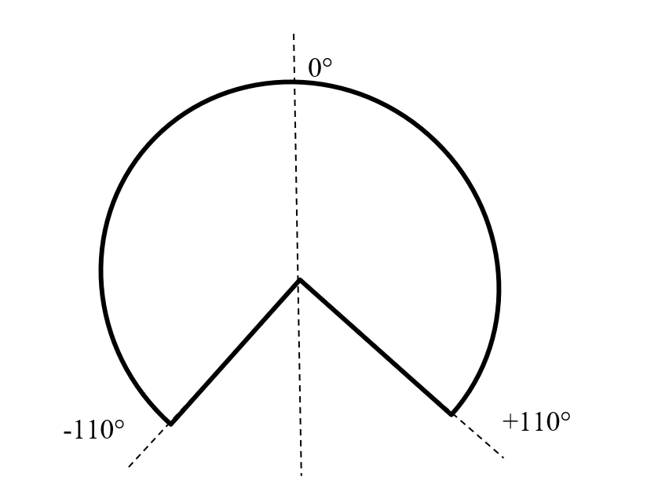

Single Antenna Pattern in azimuth

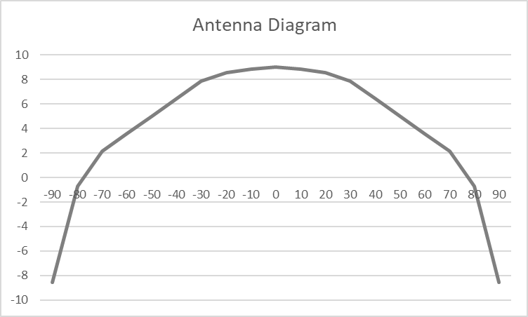
deg
dB

Single Antenna Pattern in elevation
deg

Parameter | Value
Derived antenna pattern | See above
3 dB beamwidth (Deg) | 90
Polarization | Vertical
Maximum gain (dBi) | 9
Antenna FDR (dB)

Technical References:

ICAO
- Annex 10, Vol IV, Part II
- Annex 6 Part IV
RTCA:
- DO-366B: Minimum Operational Performance Standards (MOPS) for Air-to-Air Radar (ATAR) for Traffic Surveillance
EUROCAE:
- ED-271A: Minimum Aviation System Performance Standards For Detect And Avoid Traffic For Remotely Piloted Aircraft Systems In Airspace Classes A-G Under IFR
ARINC characteristic:
- NA
ITU Res./Rec.:
- ITU-R M.[15.4 – 15.7 GHz ARNS] : Characteristics of and protection criteria for detect and avoid radars onboard airborne and aircraft landing systems operating in the aeronauticale radionavigation service in the frequency band 15.4 – 15.7 GHz (Working document towards a preliminary draft new Recommendation)
Other relevant material or developments:

