FREQUENCY SPECTRUM MANAGEMENT PANEL (FSMP)

Nineteenth Working Group Meeting

Bangkok, Thailand, 26 February to 07 March 2025

Agenda Item 5c: Aeronautical band planning – 5000 – 5150 MHz

Sharing of the C2 Link 5030 – 5091 MHz frequency band

(Prepared by Ghislain Sombret, Sergio Bovelli, Christian Fleury, Guillaume Novella
Presented by Guillaume Novella)

SUMMARY
This working paper introduces the first basis of a methodology to assess the coexistence study between terrestrial and satellite systems in the frequency band 5030 – 5091 MHz.

- INTRODUCTION
  - RPAS SARPs are being finalized. RPAS Panel is working on a C2 Link manual which identifies 3 C2 Link systems operating in the same 5030 – 5091 MHz frequency band: ground-based C2 Link, airborne relay C2 Link and satellite-based C2 Link. The coexistence between these different solutions is investigated at Eurocae and RTCA level. The band planning of the 5030 – 5091 MHz for ICAO systems is on the remit of FSMP under job card FSMP.005.03.
  - This working paper introduces a proposition of methodology to assess the coexistence of terrestrial (RTCA DO-362B standard) and satellite (EUROCAE ED-265 standard) systems operating in a same geographical area. Concretely, this working paper proposes to agree on a common methodology that will permit, when the input parameters of all systems are finalized, to determine band sharing criteria allowing the terrestrial and satellite systems to be operated in a same geographical area.
- DISCUSSION
  - Terrestrial and satellite C2 Link structure and potential interference cases
    - Both terrestrial and satellite systems are using a synchronized TDD frame, operating as follow:
- Satellite and GRS transmit and receive on the same time slot
- RPA satellite and RPA terrestrial transmit and receive on the same time slot.
Uplink
Downlink
130 ms
Terrestrial C2 Link: ARS GRS
Satellite C2 Link: AES Satellite
Terrestrial C2 Link: GRS ARS
Satellite C2 Link: Satellite AES

Therefore, the existing interferences cases to consider for coexistence between systems remain the following:
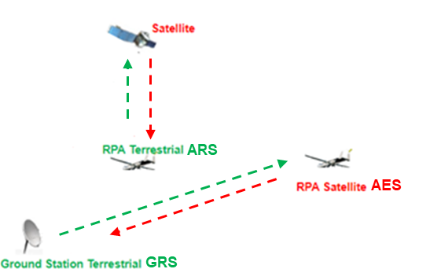
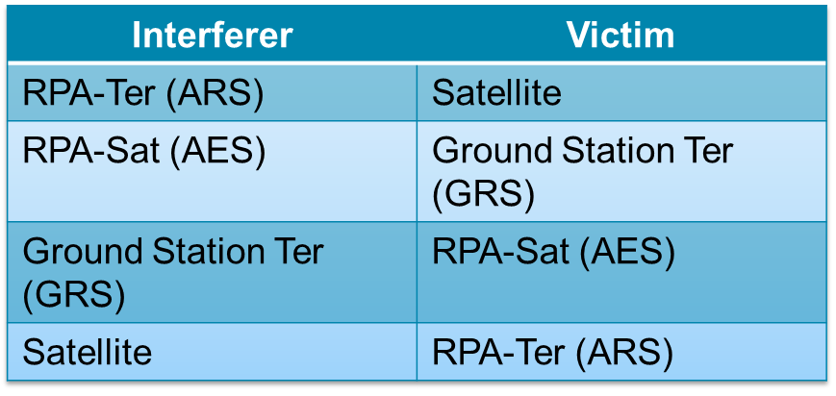
Figure 1: Interference cases considered with synchronous terrestrial and satellite TDD frames
  - Methodology
    - This methodology proposes to consider the interference caused by the transmission of a channel of one system into the channel of another system, with variations of frequency separation between these channels, and to determine the minimum channels separation under which the I/N ratio remains below -6 dB.
    - The minimum frequency gap between interferer channel and victim receiver channel cannot exceed the limit of the spurious emission domain. As a matter of fact, spurious emissions are different by nature than OoB emission and the equivalent white noise model is not applicable. The design of victim receiver should be robust enough to tolerate spurious of the interferer. As a consequence, when the frequency separation required to meet the I/N protection ratio of -6 dB exceeds the interferer spurious emission, the retained frequency separation ensuring coexistence is the minimum of the two values.

    - The proposed methodology consists in computing the I/N ratio for an RPA flying at a given altitude, where “I” is the interfering power received into the victim channel. It could be applied for all interferences cases mentioned in 2.1.1.
$$I=G_{Tx}\left(Ω\right)G_{Rx}\left(Ω\right)FSL\int_{BW_{Rx}}{P_{0}(f+f_{Δ})df}$$
$$N=k_{B}T_{0}BW_{Rx}N_{f}$$
$P_{0}$: Transmitted power spectral density of the interferer
$f_{Δ}$: Frequency separation between interferer channel and victim receiver channel
$G_{Tx}(Ω)$: Emission gain of AES antenna when Ω is the off-axis angle toward GRS
FSL: Propagation losses (Free Space Loss)
$G_{Rx}\left(Ω\right)$: Victim receiver antenna gain

$k_{B}$: Boltzmann constant 1,380 649 × 10−23 in J*K−1
$T_{0}$: Thermal Noise temperature of victim receiver in K
$N_{f}$: Victim receiver noise Figure
$BW_{Rx}$: IF bandwidth of victim receiver

    - The output of the coexistence analysis is, for a given set of inputs parameters, the minimum necessary frequency gap $Δf$ to ensure a I/N ratio lower than 6 dB.
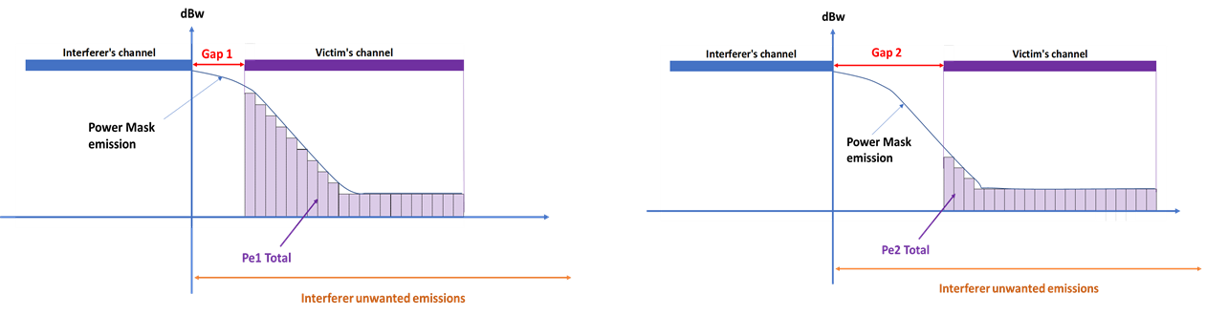
Figure 2: Example of the variation of level of interference computed in with the variation of gap separartion: Gap 1<Gap2, Pe1>Pe2

  - Technical parameters of terrestrial and satellite C2 Link
    - Emission mask ($P_{0}$)
      - AES emission mask is based on the following table:
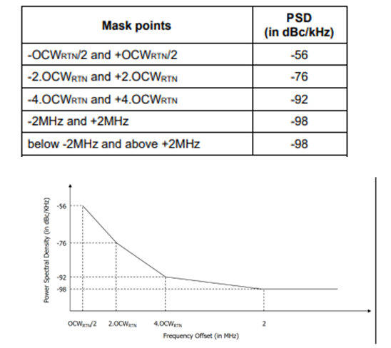
Table 1: AES Mask emission data

      - GRS and ARS emission mask are based on the following table coming from RTCA DO-362B:
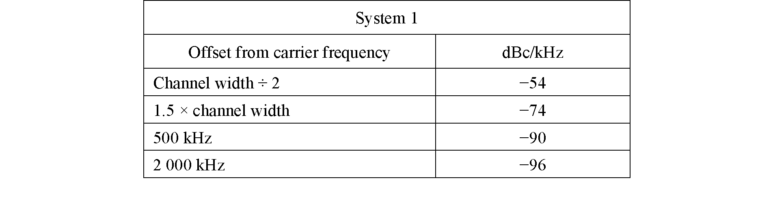
Table 2: GRS and ARS Mask emission data

      - The satellite emission mask applicable to satellite OoB domain can be taken from Rec. ITU-R SM.1541-7, “Unwanted emissions in the out-of-band domain”, applicable for MSS:
$Attenuation (dBsd)= 40*log10 (F/50+1) in 4KHz reference band$, where F is percentage of offset from 0 to 200%
The emission mask applicable to satellite spurious emission domain has been directly taken from Rec. ITU-R SM.329-13, “Unwanted emissions in the spurious domain”, applicable for MSS:
$$Attenuation (dBc) = 43 + 10 log10 P, or 60 dBc, in 4KHz reference band (whichever is less stringent)$$

The border between the Out-of-band and spurious domain are defined in ITU-R Rec SM.1539-2.
The Rec. ITU-R SM.1539-2, “Variation of the boundary between the out-of-band and spurious domains required for the application of Recommendations ITU-R SM.1541 and ITU-R SM.329” provides the separation between the start of Spurious domain and channel central carrier, applicable to AMS(R)S: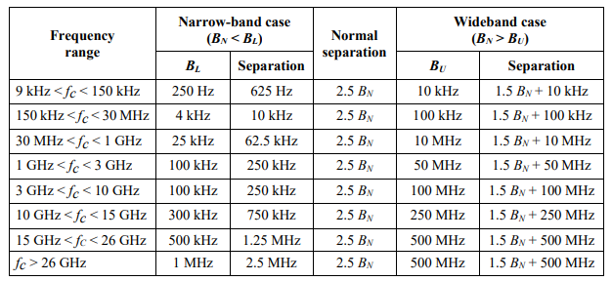
Table 3: Applicable boundaries to determine OoB and Spurious domain applicable for satellite in AMS(R)S
    - Antenna gain

The gain provided by US is given in the table below.
Elevation in degree | Gain dBi
0.5 | 19.0
1.5 | 19.5
2.5 | 20.0
3.5 | 19.5
7 | 17.0
11.5 | 14.0
16 | 11.5
32 | 6.5
64 | 1.5
>75 | 0.5

Table 4 GRS antenna gain from WP5B/161

This table does not represent an antenna pattern of the GRS, and further discussions at RTCA are expected on this particular point.
  - Example
    - To illustrate the reasoning, we apply this methodology to the case of potential up to 2 AES interfering a GRS. At this stage of first approach, when 2 AES are considered, they are assumed to be co-localized. Even though this approach is not realistic, it still permit to consider a multiple worst case scenarios.

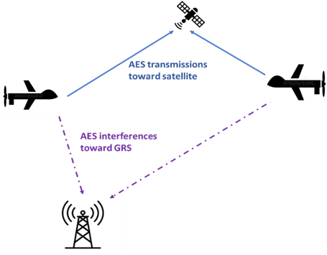
For our example, let’s consider the following cases:
- 2 AES flying at 3000, 1500, 1000, 750, 500, 250 meters altitude
- 1 AES flying at 150 meters altitude

Technical parameter values assumed in this example are given in the table below.
Parameter: | Value
Acceptance criteria: I/N<= -6 dB | -6 dB
GRS temperature for the thermal noise | 290 K
Polarisation attenuation and fuselage attenuation | TBD
Noise figure GRS | 7 dB
GRS channel width | 250 kHz
AES transmitter power per channel width | 10 dBW
AES transmitter channel width | 20 kHz and 140 kHz
Maximum AES Gain for negative elevation | -2 dBi
Table 5: Input parameters used for the example computation

    - The table below provide the computation of the minimum frequency separation needed between AES and GRS channel to ensure protection of GRS from interference caused by AES.

Interferer | Victim | RPA altitude | AES channel width | Separation to meet I/N=-6 dB | AES spurious emission limit (from Tx channel edge) | Retained frequency separation ensuring coexistence
2 AES | 1 GRS | 3000m | 20 kHz | 0 kHz | 240 kHz | 0 kHz
2 AES | 1 GRS | 1500m | 20 kHz | 7 kHz | 240 kHz | 7 kHz
2 AES | 1 GRS | 1000m | 20 kHz | 12 kHz | 240 kHz | 12 kHz
1 AES | 1 GRS | 750m | 20 kHz | 11 kHz | 240 kHz | 11 kHz
1 AES | 1 GRS | 500m | 20 kHz | 17 kHz | 240 kHz | 17 kHz
1 AES | 1 GRS | 250m | 20 kHz | 31 kHz | 240 kHz | 31 kHz
1 AES | 1 GRS | 150m | 20 kHz | 82 kHz | 240 kHz | 82 kHz
2 AES | 1 GRS | 3000m | 140 kHz | 64 kHz | 280 kHz | 64 kHz
2 AES | 1 GRS | 1500m | 140 kHz | 131 kHz | 280 kHz | 131 kHz
2 AES | 1 GRS | 1000m | 140 kHz | 175 kHz | 280 kHz | 175 kHz
1 AES | 1 GRS | 750m | 140 kHz | 168 kHz | 280 kHz | 168 kHz
1 AES | 1 GRS | 500m | 140 kHz | 222 kHz | 280 kHz | 222 kHz
1 AES | 1 GRS | 250m | 140 kHz | 331 kHz | 280 kHz | 280 kHz
1 AES | 1 GRS | 150m | 140 kHz | 478 kHz | 280 kHz | 280 kHz

It has to be noted that those results of the example are based on input parameters of terrestrial and satellite systems given in the section 2.5.2, but the final result could be representative only once these systems will provide finalized input parameters.

    - Limitations of the example:
- For the example presented in section 2.3 we consider an RPAS flying at a constant altitude. In case of variations in the RPA altitude, the RPA terminal gain would vary and change the results of the I over N ratio.
- We have considered AES antenna gain at -2 dBi in the direction of the ground whenever this gain is part of the interference computation. This is a conservative estimation and once the AES antenna pattern will be finalised in the EUROCAE standard we could refine the results.
- The polarisation attenuation and the fuselage attenuation have not been taken into account for these preliminary studies.
- Only free space loss conditions have been taken into account and no further atmospheric attenuation has been considered.
- Signal modulations have not been taken into account (we use square signals).
- No internal system band guard has been taken into account.
- The 3 remaining interference cases shall be considered in next steps.

- ACTION BY THE MEETING
  - The meeting is invited to:
- note and review the contents of this working paper;
- provide further elements, potentially coming from Eurocae WG-105/ RTCA SC-228, regarding the sharing of this frequency band by C2 Link systems;
- provide feedback on the methodology and on the operational scenario which are assumed in this WP;
- invite considering coexistence studies in the 5030 – 5091 MHz band, to identify solutions to accommodate constraints of the different C2 Link systems;
— END —

