Landing strip configuration
For defining the landing strip of an airport, the following assumption are considered:
- the airstrip of an airplane is considered as a straight line of a certain length
- The touchdown point (TDP) is considered at 200 m after the runway threshold
- The glide path angle of 3° is considered (3° is recommended by ICAO but this angle can be reduced down to 2° for some airports)
The following figure 1 show the different point considered in the scenario

ASSUPTIONS OF landing angle
The scenario starts where the aircraft is at an altitude of the 1000ft point (P1000) and end at the touchdown (TDP). The 200 ft (P200) is the point of the final approach where the aircraft is at an altitude of 200 feet.
Figure 1: Representation of the scenario
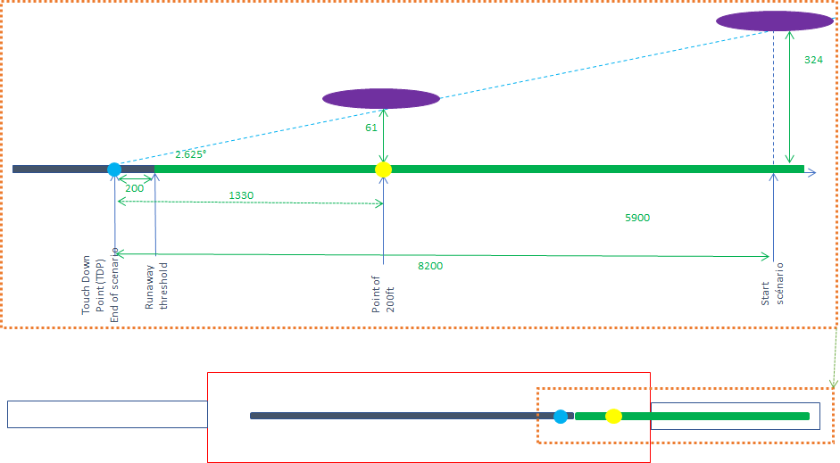

The aircraft descent is normally aligned with the runway. In the final approach phase at 1000 ft until the touchdown zone, the glide slope is considered equal to 3° (3° is recommended by ICAO but this angle can be reduced to 2° for some airports) . Ideally the aircraft will glide on a 3° descent axis but may evolve +/- 0.375°around this ideal descent axis, meaning a minimum angle of 2.625°. By this value, it is possible to define the lowest position along the path of the aircraft according to the distance from the runway threshold.
Considering this angle, the distance from the TDP to the P200 is 1330m (200ft * 1/tan (2.625°))

Protection zone around the landing strip
Based on the intrinsic characteristic of radio altimeter (blocking level) and the characteristic of base station, there is always a minimum distance that appear necessary to ensure the coexistence between each equipment. This distance is named protection zone (PZ). The calculation of this distance is made through
$$Distance={10}^{(\left({e.i.r.p}_{BS}+G_{RA}-B_{RA}-SM-32.4\right)/20)}/f$$
Where
${e.i.r.p}_{BS}$ : e.i.r.p of the BS in the direction of the landing strip (dBm)
$G_{RA}$ : gain of the radio altimeter (dBi)
$B_{RA}$ : blocking level of the RA (dBm)
$SM$ : safety margin (dB)
$f$ : frequency (MHz)

In order to provide a calculation example, the French case is proposed. The following data are given as an example to calculate the dimensions of the protection zone.

- Maximum e.i.r.p of the BS of 78 dBm/100 MHz (power of 53 dBm/MHz and 25 dBi of gain)
- Blocking level of RA of -19 dBm/00 MHz (RTCA report) with a safety margin of 6dB
- Gain of RA equal to 0 dBi in adjacent band
- Frequency of 3700 MHz

Based on that assumptions the required losses become closed to 103 dB and the distance equal to 910m.

A distance of 910 m was taken all around the landing zone. In the width, the distance is taken from the centre of the landing strip. In the length, the distance is taken from the point of final approach (P200). At the end a rectangle around the landing strip is created (see red rectangle in figure 1)

