FREQUENCY SPECTRUM MANAGEMENT PANEL (FSMP)

Eleventh Working Group meeting

Web Meeting, 1 – 12 March 2021

Agenda Item 10: Any Other Business

Considerations for VHF Datalink Spectrum Congestion Mitigations

(Presented by Andrew Roy, ASRI)

SUMMARY
This paper discusses considerations in the work to mitigate current VDL spectrum growth and its subsequent impact on scarce VHF aeronautical spectrum. While some options have been discussed to offload all non-ATS messages, it is recommended to assess the problem as a whole, including what is causing the increase in VDL traffic and attempt to mitigate the source of such data growth.

- INTRODUCTION
  - The VHF Datalink (VDL) systems operating within the VHF band are one of the core connectivity systems for global aviation and the basis of current domestic Controller Pilot Datalink Communications (CPDLC). With the increasing amount of data traffic, different administrations are considering options as the need for spectrum grows to meet this demand. With the possible range of options on the table, the fundamentals of why such traffic is growing should be reviewed to ensure an appropriate outcome for any such process. The ICAO FSMP, in conjunction with the CP-DCIWG, the technical body of the ICAO Communication Panel, are recommended to seek input on this at an international level, inviting input at future meetings to investigate the issue.
- VHF DATALINK TYPES
  - For most operators, mainstream VDL communications are in two varieties:
  - ACARS. The Aircraft Communications Addressing and Reporting System (ACARS) is sometimes called Plain Old ACARS (POA) to distinguish this from the ACARS messaging protocol that can be used on different media. Developed in the 1970’s by the US airlines to carry Airline Operational Control (AOC) traffic, it is still in widespread use today for many airframes or in regions without consistent VDLM2 coverage.
  - VDLM2. VHF Datalink Mode 2 (VDLM2) is the second-generation VHF datalink system, deployed as the successor to POA to increase the performance and functionality of the datalink service. Since its introduction in the 2000’s, it has become standard on new airframes and incorporated by many administrations into their CPDLC functionality for domestic airspace by also carrying Air Traffic Service (ATS) messages.
- GROWTH OF VDL TRAFFIC
  - International operators have noted with some concern over several years about the significant growth of VDL traffic from new airframes. This is not just a slow increase over time due to more modern air platforms but appears to have jumped almost a magnitude for some airframe classes within the last 20 years. This is combined with the continued growth in air traffic from additional aircraft, increasing the capacity requirements for VHF Communications Service Providers (CSPs). The increase in VDL traffic has not only caused congestion to existing VDL networks requiring additional channels to be deployed, but also comes with a price tag to operators to pay CSPs for these messages. Now that CPDLC requirements have been added by several administrations for their domestic National Airspace Systems (NAS) by VDLM2, it has also placed hard latency requirements on CSPs for timely delivery of ATS message, requiring additional capacity control measures to ensure message delivery times are preserved. This has become an acute problem in parts of the Euro region, as recent calls for a solution have demonstrated.
  - Growth of this data traffic is often attributed to AOC messages, primarily generated by the operators for safety and regularity of flight. While AOC traffic volume is larger than ATS messages, such a conclusion misses an important aspect of VDL traffic that has far outpaced AOC messages; aircraft/engines data has seen exponential growth in the last few years from new airframes and advanced aircraft systems. In exploring this further, CSP Collins Aerospace (formerly ARINC) presented a paper at the AEEC DLUF meeting in Feb 2020 on the reasons behind the recent rapid growth of VDL traffic (figure 1).
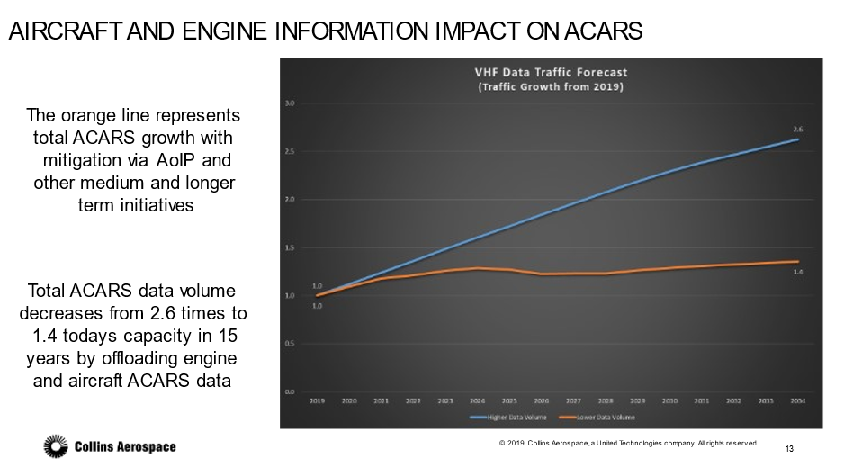
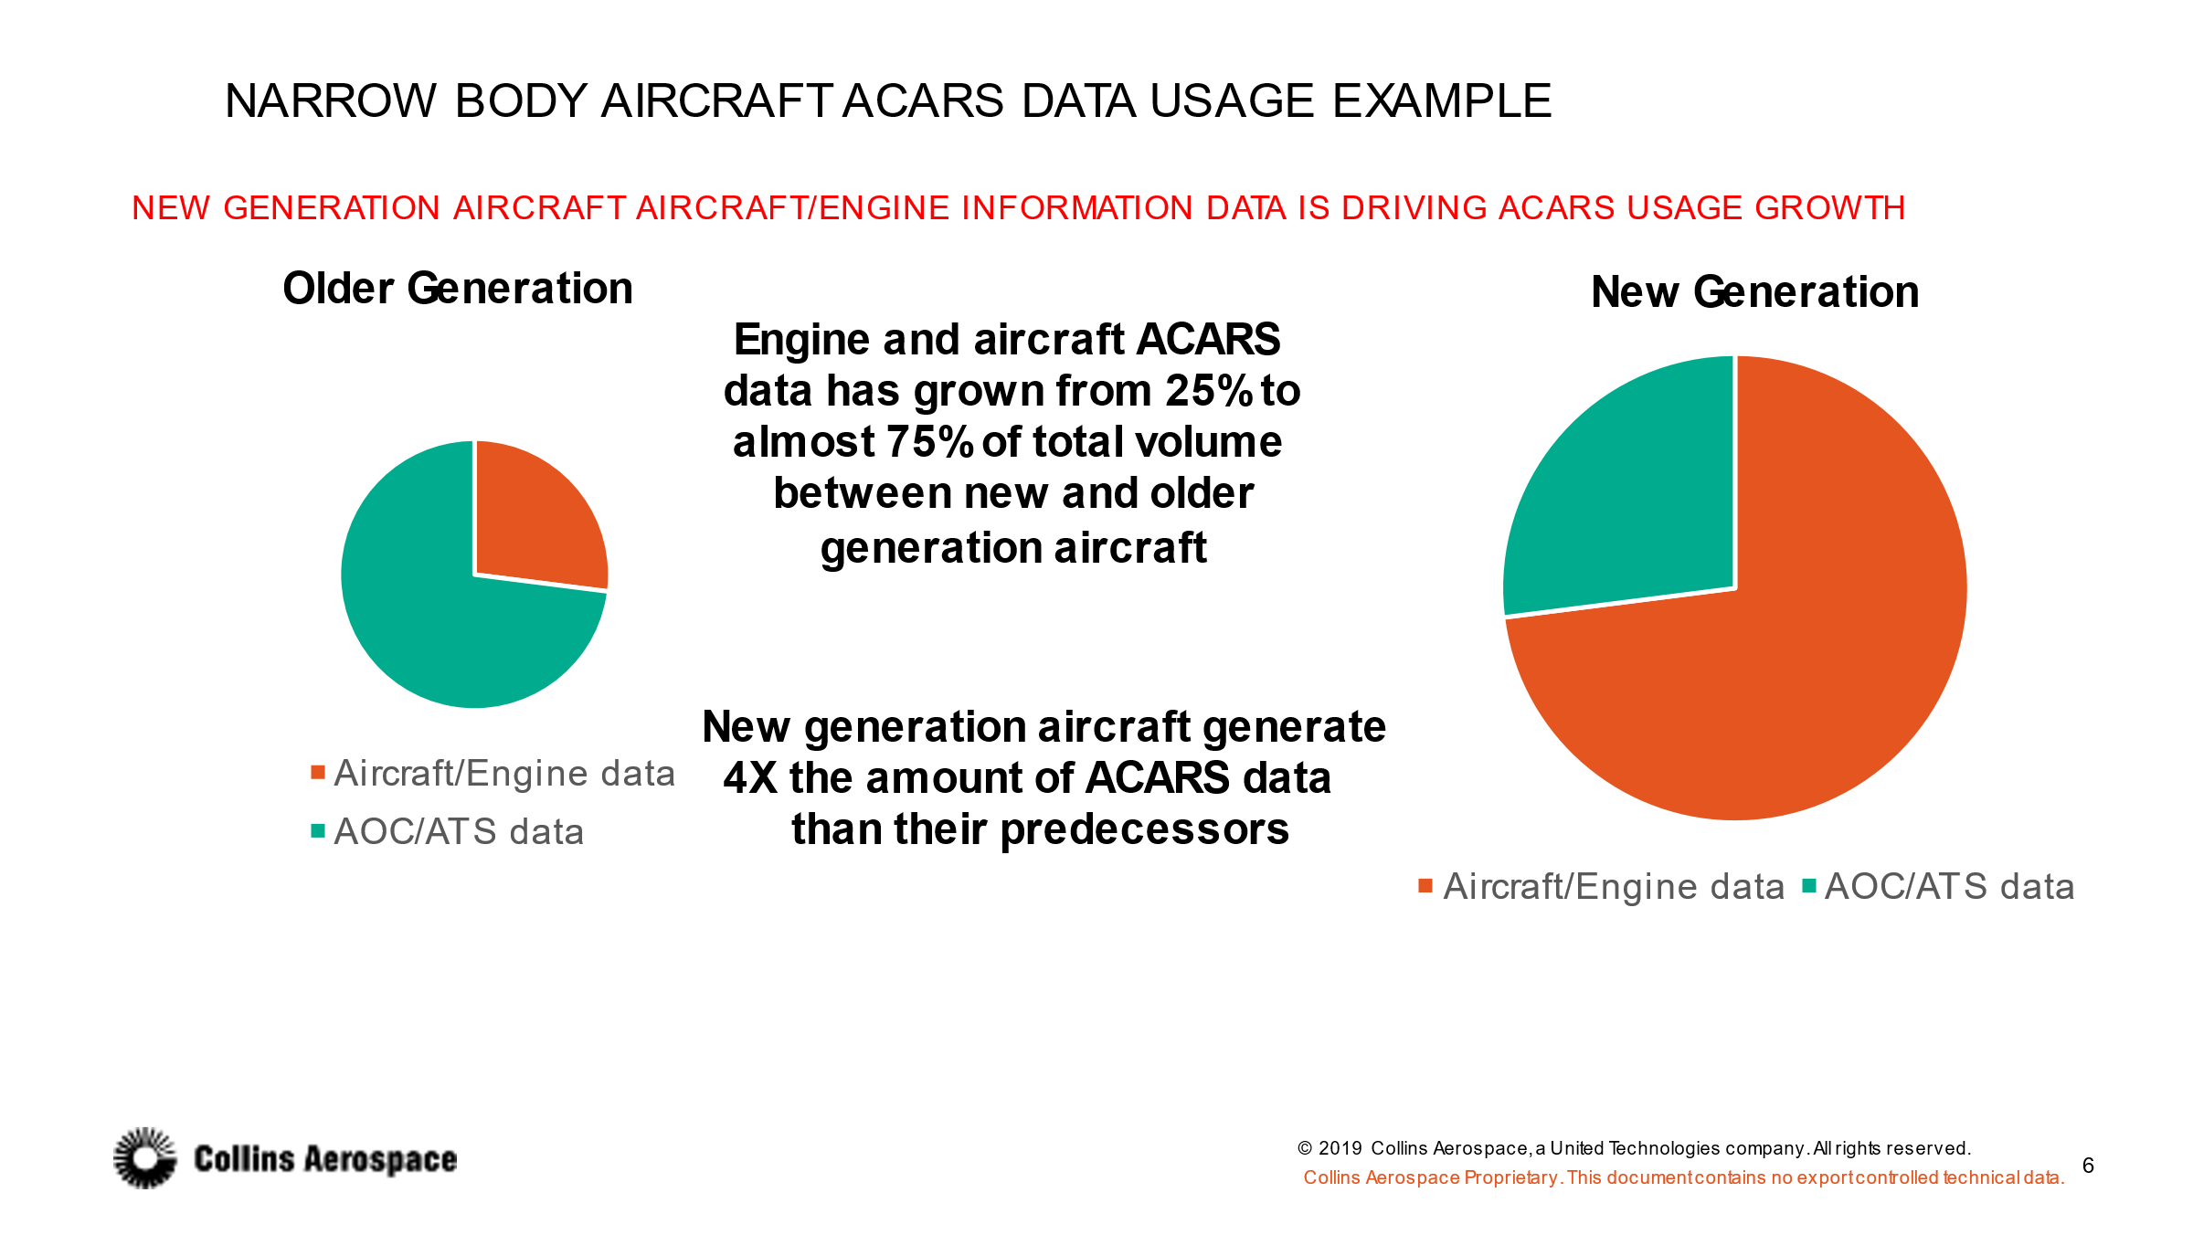
  - One of the core data points from the chart shows how much of the data being generated by new airframes is no longer traditional ATS and AOC data, but aircraft/engine data. When moving from older to newer aircraft in the narrow body example, the ratio of traditional ATS/AOC data to aircraft/engine data inverts from a 75/25 ratio to a 25/75 ratio. This is a significant change to the amount of data generated, showing most of the growth is from neither traditional ATS nor AOC functions, and total a 4x increase in total data transmitted in general. To further demonstrate the point, additional data from the presentation (figure 2) shows how much variance could be possible seen if aircraft/engine traffic data growth was mitigated in some form while leaving traditional ATS/AOC unaffected (in this case, a suggested offloading aircraft/engine data to an alternative media).
Figure 2
Figure 1
- OPTIONS FOR MITIGATING VDL CONGESTION
  - Several options have been raised in the past to maintain/preserve the VDL spectrum, and more recently to maintain links for latency sensitive ATS messages. Offloading of certain VDL message types has been one of the main discussion points and while it may have benefits overall, it also raises questions about to what extent different messages types should, and could, be effectively moved. There have been some suggestions that the majority of non-ATS traffic may be appropriate to be offloaded or separation, include airline AOC traffic used for safety and regularity of flight messages while airborne. However as discussed above, AOC traffic is no longer the dominant growth traffic type from recent airframes and attempting to move this dataset could have a significant negative impact to airline functions. AOC messages using VDL networks are a critical function to many airlines, allowing for an effective way to operate safely and efficiently (one of the very reasons the airlines designed the POA and VDLM2 systems to meet their needs).
  - Permanently separating all AOC traffic from ATS traffic by offloading to a different radio/media would be a drastic step for many operators, raising questions about how such a change in AOC message traffic could be handled, what systems could be safely used for such safety and regulatory of flight messages, levels of comparable operational coverage, etc. It would also be unusual from an operator perspective that the system the airlines initially designed to carry their AOC traffic is now being asked to move to an alternative network.
  - Instead of a blanket offload of non-ATS messages, it is recommended that the problem be reviewed as a complete problem. The source of the concerns and not the symptoms should be targeted as a priority, as well as how certain message types could be selectively offloaded to other mediums while maintaining compatibility with airline requirements. Questions to ask include: what is generating this additional aircraft/engine data, what can be done to reduce VDL traffic as a whole at its source, and then what can be safely and effectively offloaded to other systems in an efficient manner?
  - Additional considerations should also be investigated in the management and message overhead of such data, including:
- The compression of the character-oriented user data. Such processes can reduce the volume of traffic by 60-80%, as seen by a few avionics vendors who are already implementing such processes.
- Optimizing and eliminating the inefficiencies of the ATN ATC traffic. For example, about 50% of the overall ATN traffic is due to the IDRP protocol (exchange of routing information). The other 50% of ATN traffic is used to convey ATC messages but only about half of that 50% carries application payload, the other half being used for KeepAlive messages.
  - Investigating how VDL data can be reduced at the source without throwing additional spectrum or systems at the VDL congestion problem is a critical step in would make systems indirectly more spectrum efficient, but it would also ensure significantly more capacity for future aviation growth, and also save on the costs for international aviation to pay for such data transfer.
  - From the above discussion, there are several recommendations for long-term work:
- A strong focus on mitigating the increased VDL traffic at it source by reducing/slowing total traffic generated.
  - Investigate sources of increased VDL data traffic.
  - Identify and prioritize what is deemed essential to airline operation, and if it is time critical or not.
  - Consider what options can be used to reduce such data during flight.
    - Reduction in data traffic generation
    - Compression of data
    - Message protocol review and improvements
    - Store and forward when suitable alternative means are available from ground infrastructure at airports.
- Review of alternative systems for the offload of suitable data in flight
  - ACARS over IP
  - Other alternatives that are cost effective.
- Exchange of information with the regional ICAO office in Europe on their work through the new ad-hoc group to inform the international community of their progress.
- SUMMARY
  - The issue of VDL spectrum congestion is not a simple problem that can be solved easily. In reviewing what measures can be taken, mitigations should consider not just how to treat the spectrum capacity concerns, but also directly at the source of the data and what can be done to create a more efficient system. Combined with the potential offloading of non-safety, non-time critical data such as a large parts of aircraft/engine data to commercial ground-based networks at airports, would free up scarce aeronautical safety spectrum for safety and regulatory of flight messages such as ATS and AOC.
  - This is a topic that could be explored through ICAO to understand all of the factors, technically and operationally, and to identify possible solutions that would benefit and account for all stakeholders in VDL communications. Ideally such a solution could contain multiple activities, starting with a reduction in message generation and combining with alternate media offload for suitable aircraft/engine messages in an efficient and effective manner. The information developed by the new ad hoc group established by the ICAO regional office in Europe would be very useful in furthering this understanding.
- ACTION BY THE MEETING
  - The meeting is invited to:
- Note the contents of this paper and the data provided.
- Engage with the ICAO CP-DCIWG to assess what may be an effective way forward for a discussion on a shared interest.
- Request for additional data from aircraft, engine and other manufacturers on what measures are being taken to minimize and mitigate aircraft/engine data transmission.
- Exchange of information with the regional ICAO office in Europe on their work through the new ad-hoc group to inform the international community of their progress.

— END —

In Jan 2021, a calling notice was issued by the ICAO Europe regional office for the formation of an Ad Hoc Group to investigate Relieving the Traffic Congestion in the Data-Link sub-band.

