FREQUENCY SPECTRUM MANAGEMENT PANEL (FSMP)

Eleventh Working Group meeting

Virtual Meeting, 01 – 12 March 2021

Agenda Item 2 : WRC-23 Preparations (AI 1.7)

Proposal for a reply liaison statement to ITU-R WP5B regarding the agenda item 1.7

(Presented by Alexandre GUIGNOT)

SUMMARY
Studies regarding the agenda item 1.7 (WRC-23) have been launched by WP5B since July 2020.
In this regards, WP5B is informing ICAO on the progress of work and is seeking guidance on the following three topics:
- The aircraft antenna pattern ,
- The VHF receiver minimum sensitivity requirement,
- And the required link availability performance.
This working document offers a material to respond to WP5B on these three topics. Also, we believe that it is beneficial to address from an ICAO point of view the question of compatibility between AM(R)S and AMS(R)S, and propose to indicate to WP5B that such studies wouldn’t be required within ITU-R.

- INTRODUCTION
During the last WP5B held in November 2020, WP5B sent a liaison Statement to ICAO in order to inform on the progress of the work done by ITU-R on agenda item 1.7 (WRC-23).
In particular, WP5B informed ICAO that a working document towards a preliminary draft new Report ITU-R M.[Space-VHF] is currently being developed.
In order to complete its work, WP5B is seeking guidance from ICAO on three main topics:
- The aircraft antenna patterns ,
- The receiver minimum sensitivity requirement,
- And the required link availability performance.
Attached to this document an annex is provided as a proposed basis for a response to WP5B.
- Available measured pattern for aircraft VHF antenna
The antenna pattern depicted in the draft new Report ITU-R M.[Space-VHF] takes only into account the behaviour of a dipole antenna without the effect of the plane fuselage reflection . In particular, a cosinusoidal behaviour in elevation is depicted, meaning that a theoretical zero is achieved at aircraft zenith (90° elevation) which would lead to the fact that the direction towards the satellite is highly attenuated.
One can find below example of pattern for the VHF COBHAM Blade type Antenna. Radiation patterns of antenna have been measured in the three main plans at 118 / 127 / 137 MHz. Those patterns were measured on a 2 X 1 meter rectangular metallic reflector. They essentially confirm the information already available to WP5B.
It is believed that a more representative antenna pattern should be used, if available through other contributions to this meeting or at future meetings, that takes into account the fuselage reflection. This would help WP5B in defining a more accurate link budget.

118 MHz, Copolar
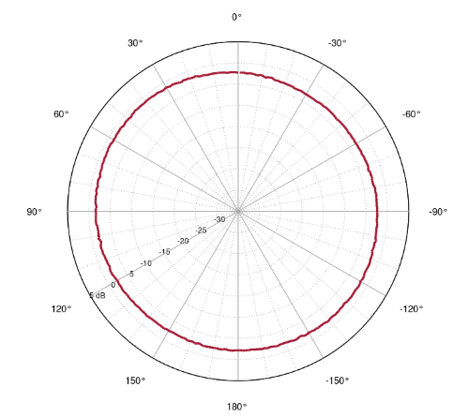  Horizontal plan | 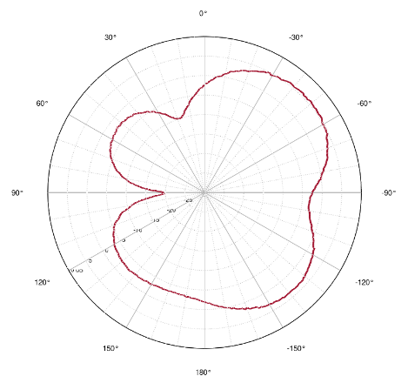  Longitudinal plan | 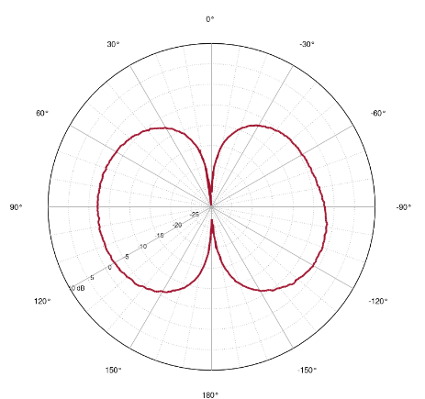  Transversal plan

127 MHz, Copolar
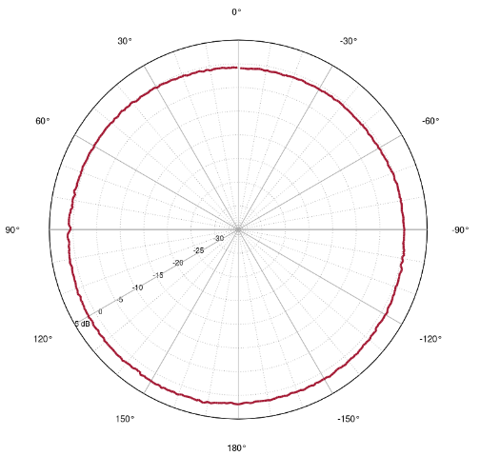  Horizontal plan | 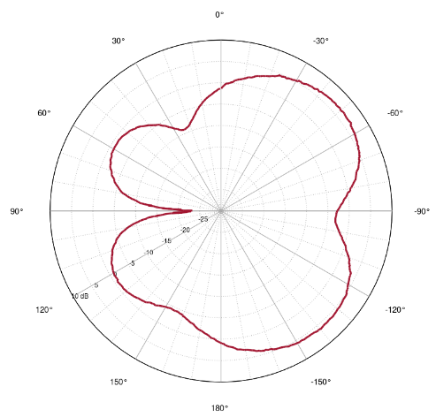  Longitudinal plan | 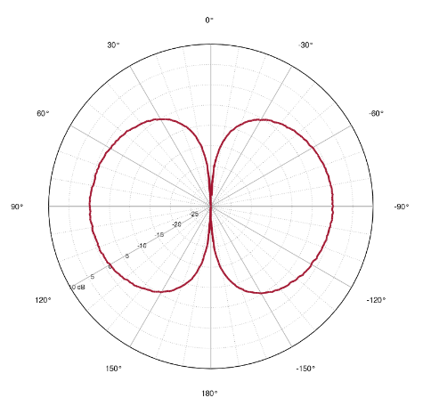  Transversal plan

137 MHz, Copolar
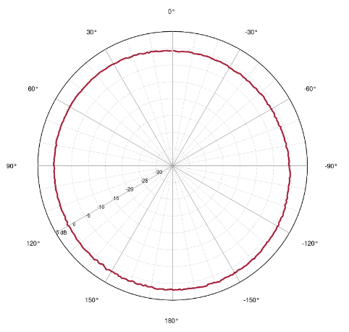  Horizontal plan | 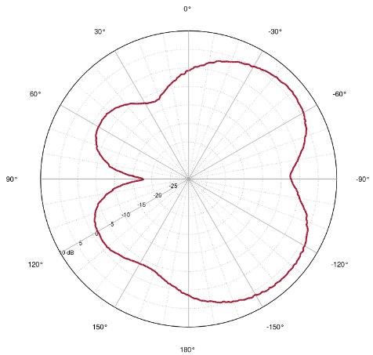  Longitudinal plan | 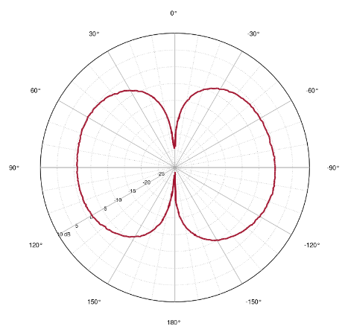  Transversal plan

- Aircraft VHF receiver performance requirement
  - Two different values were noted by ITU-R based on the available literature:
- The first one is coming from the ICAO Annex 10 Volume III Part II (section 2.3.2.2.1). The field strength value of 30 microvolts per meter (- 116 dBW/m2 which becomes -90 dBm through an isotropic antenna) is assumed for planning extended range VHF facilities. The section also recommends a field strength of 75 microvolts per meter (- 109 dBW/m2 which becomes -83 dBm through an isotropic antenna).
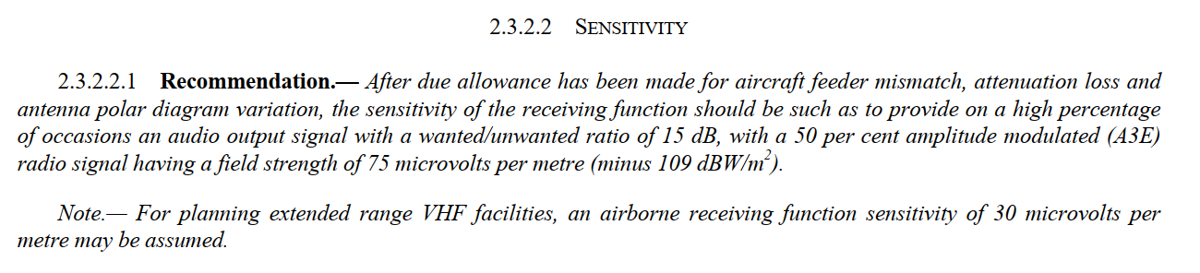
Figure 1: Extract from the section 2.3.2.2.1 of ICAO Annex 10 Volume III
- The second one is coming from aeronautical standards were the value of -93 dBm with a SINAD of 6dB is given.
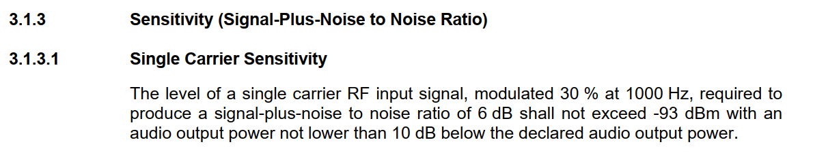
Figure 2: Extract from Aeronautical Standards (ED-23C)

[TBC by Response of the Communication Panel or its working group]

- Ionospheric propagation losses and required availability performance
In the envisaged frequency band, Faraday rotation and scintillation will be very dimensioning in the VHF satellite system design, as they correspond to very significant propagation losses. These two effects depend on factors such as time of year, time of day, solar cycle, and geomagnetic conditions. Unfortunately, the current available models at ITU-R do not provide a granularity that would allow to split the estimation by region, and possibly between day and night period (for instance 18:00-00:00, and 00:00-18:00), which would be very helpful in order to quantify the link availability per period of the day and per location. WP 5B is seeking information from ICAO if a reference availability target can be identified for aeronautical VHF voice communications, and if such a reference could depend upon time and location.

In France, the availability of the VHF ground stations depends on the operational usage (ATC control or ATC information) of the VHF link. For example:
- ATC information: 99,852%,
- ATC control: 99,9991%.
One can note that these values highly depends on the weaker part of the system which is often the fixed service link used.
A satellite aeronautical VHF voice communications system would represent a breakthrough towards so-called “seamless ATM plan”: on the one hand it would possibly make the voice service available worldwide, including over oceanic and remote areas, and on the other hand it could also backup terrestrial stations in case they are affected by a catastrophic event. As such, there is no existing performance requirement for a VHF satellite system, but it is expected that the availability performance should be close to that of the VHF ATC ground stations.
Once a satellite system is designed, its availability performance will be evaluated, and will represent an important input for ANSPs interested by the service. They will define a set of operational measures required in order to reach a given safety objective. It is understood that VHF scintillation is very dimensioning over specific regions (for instance at low latitudes), and is maximum at sunset with very strong variations between day and night periods. Depending on system trade-offs, it may be of interest not to dimension the satellite system to account for the worst case propagation loss, which is very much time and location specific, and to compensate with appropriate measures (like appropriate flight planning) over the concerned regions when affected.
An example of such measure exists in French Polynesia for flights over large oceanic areas using HF communications, which avoid certain time slots in order to avoid facing strong propagation losses.

- Compatibility study between AM(R)S and AMS(R)S
Even if not covered in the WP 5B’s liaison statement, it has to be noted that during the last WP5B, questions were raised about the need to perform a compatibility analysis between the existing terrestrial VHF communications operating under the AM(R)S allocation and the possible future satellite VHF communications that would be operating under a new AMS(R)S allocation.
It should be noted that even if the two services would be used under different “allocations” at ITU-R level, the system on-board the aircraft would not be changed and would communicate with the ground or satellite stations without any discrimination.
A VHF satellite system would likely correspond to relatively low gain and non-directional satellite antennas, which would result in the inability to reuse via satellite any frequency already operated by terrestrial stations within its coverage. In order for interested countries to benefit from a new satellite aeronautical VHF voice communication service, ICAO would have to perform a conventional frequency planning exercise, assigning frequencies to the satellite system over interested regions, so as to ensure compatibility between ground and satellite facilities.
Therefore, from an ICAO perspective there is no need to perform a compatibility study within ITU-R between these two different services, that in reality cover the same system on-board the aircraft.
- ACTION BY THE MEETING
The meeting is invited to:
- note and review the contents of this working paper;
- Complete the elements of the LS to be sent to WP5B.
— END —

Annex

Elements for a liaison to WP5B on SAT VHF (Agenda Item 1.7)

ICAO would like to thank ITU-R WP 5B for its liaison statement related to ongoing studies on space-based aeronautical VHF communications system in the 117.975-137 MHz frequency band, under WRC-23 agenda item 1.7. ICAO reviewed the provided material by WP 5B and would like to provide the following comments and information.

  - Available measured pattern for aircraft VHF antenna

One can find below example of pattern for the VHF COBHAM Blade type Antenna. Radiation patterns of antenna have been measured in the three main plans at 118 / 127 / 137 MHz. Those patterns were measured on a 2X1m rectangular metallic reflector. They essentially confirm the information already available to WP5B. It is believed that a more representative antenna pattern should be used in order to obtain a more accurate link budget, that takes into account the fuselage reflection. [adapt the rest of the text, depending on the availability of additional material regarding measurements of aircraft VHF antenna]

118 MHz, Copolar
Horizontal plan | Longitudinal plan | Transversal plan

127 MHz, Copolar
Horizontal plan | Longitudinal plan | Transversal plan

137 MHz, Copolar
Horizontal plan | Longitudinal plan | Transversal plan

  - Aircraft VHF receiver performance requirement
[TBC by the Communication Panel]

  - Ionospheric propagation losses and required availability performance
No performance requirement exists for a satellite system, but it is expected that the availability performance should be close to that of the VHF ATC ground stations.
Once a satellite system is designed, its availability performance will be evaluated, and will represent an important input for ANSPs interested by the service. They will define a set of operational measures required in order to reach a given safety objective. It is understood that VHF scintillation is very dimensioning over specific regions (for instance at low latitudes), and is maximum at sunset with very strong variations between day and night periods. Depending on system trade-offs, it may be of interest not to dimension the satellite system to account for the worst case propagation loss, which is very much time and location specific, and to compensate with appropriate measures (like appropriate flight planning) over the concerned regions when affected.
An example of such measure exists in French Polynesia for flights over large oceanic areas using HF communications, which avoid certain time slots in order to avoid facing strong propagation losses.
  - AMS(R)S and AM(R)S compatibility
A possible future satellite VHF communications system would be operating under a new AMS(R)S allocation decided by WRC-23 under its Agenda Item 1.7. It is to be noted that even though AM(R)S and AMS(R)S would represent two different ITU-R services within the frequency band 117.975-137 MHz, the same on-board system (for ATC VHF communications) would be used for ground and satellite communications.
A VHF satellite system would likely correspond to relatively low gain and non-directional satellite antennas, which would result in the inability to reuse via satellite any frequency already operated by terrestrial stations within its coverage. In order for interested countries to benefit from a new satellite aeronautical VHF voice communication service, ICAO would have to perform a conventional frequency planning exercise, assigning frequencies to the satellite system over interested regions, so as to ensure compatibility between ground and satellite facilities.
Therefore, from an ICAO perspective there is no need to perform a compatibility study within ITU-R between these two different services, that in reality cover the same system on-board the aircraft.

ICAO looks forward to continued fruitful cooperation with ITU-R WP 5B regarding this work.

